

College of Computer Sciences & Information Technology

Kingdom of Saudi Arabia

Ministry of Higher Education

King Faisal University



Menu Mangment System

# Table of Contents

***1 Introduction***

***2 Objectives***

***3 User Requirements Definition  
3.1. Customer-Facing Requirements  
 3.1.1. Menu Navigation  
 3.1.2. Order Modification  
 3.1.3. Customer Reviews  
3.2. Staff-Facing Requirements  
 3.2.1. Order Visibility for Waitstaff  
 3.2.2. Menu Management (Manager Access)***

***4 System Architecture***

***5 System Requirements Specification  
5.1. Functional Requirements  
 5.1.1. Menu Navigation  
 5.1.2. Order Modification  
 5.1.3. Order Visibility for Waitstaff  
 5.1.4. Menu Management  
 5.1.5. Customer Reviews  
 5.1.6. Reporting & Analytics (Additional)  
5.2. Nonfunctional Requirements  
 5.2.1. Performance  
 5.2.2. Security  
 5.2.3. Scalability  
 5.2.4. Reliability  
 5.2.5. Usability  
 5.2.6. Maintainability***

***6 Process Model***

***7 Design  
7.1. Context Model  
7.2. Process Model  
 7.2.1. Menu Navigation Process  
 7.2.2. Order Modification Process  
 7.2.3. Order Visibility (Waitstaff)  
 7.2.4. Menu Management (Admin)  
 7.2.5. Customer Reviews Process  
 7.2.6. Reporting & Analytics (Optional)  
7.3. Interaction Models  
7.4. Structural Model  
7.5. State Machine Diagram***

***8 Test Cases***

## ***9 Tasks, Durations and Dependencies***

# 

# 1. Introduction

This document outlines the requirements for a new computer system designed to manage our restaurant's menu. Developed for a small team of about four individuals, the system is intended to simplify the process of adding, updating, or removing menu items. It will support item categorization (e.g., appetizers, main courses, desserts) and allow managers to include detailed, pricing, name, and more. The primary goal is to streamline menu management and order processing, enhancing the overall customer and staff experience.

# 2. Objectives

• Ease of Management: Enable managers to update and maintain the menu quickly and accurately.

• Enhanced Customer Experience: Provide an intuitive interface for customers to navigate the menu, customize orders, and leave feedback.

• Improved Service Efficiency: Equip waitstaff with real-time order details to ensure prompt and accurate service.

• Scalability & Reliability: Develop a system that can scale as the business grows while ensuring high performance and security.

# 3. User Requirements Definition

3.1. Customer-Facing Requirements

* Menu Navigation:
* Requirement: The system shall present a user-friendly interface where customers can browse the menu organized into clearly labeled sections (e.g., appetizers, mains, desserts).
* Requirement: The system shall Incorporate search and filtering capabilities to help customers quickly locate items by name, price, categorize.
* Order Modification:
* Requirement: Customers shall be able to easily add or remove items from their orders, adjust quantities, and review their selections before finalizing the order.
* Customer Rating:
* Requirement: Customers shall be able to provide ratings for menu items, which will be available for managers to review and respond to.

3.2. Staff And Manager-Facing Requirements

* Order Visibility for Waitstaff:
* Requirement: The system shall provide waitstaff with real-time access to current orders along with relevant customer details to support timely service.
* Menu Management (Manager Access):
* Requirement: Managers shall have a secure backend interface to update menu items, name, prices, and categorize.

# 4. System Architecture

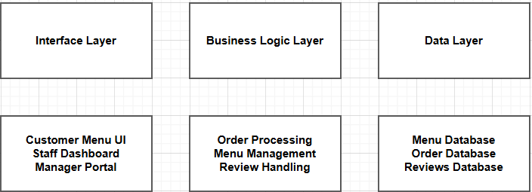

-Interface Layer

* **Customer Menu UI**: Allows customers to browse, search, filter, and place orders.
* **Staff Dashboard**: Displays real-time orders, customer details, and order status.
* **Manager Portal**: Secure interface for adding/updating menu items, prices, and categories.

-Business Logic Layer

* **Order Processing**: Validates orders, updates quantities, and sends to the kitchen.
* **Menu Management**: Handles CRUD (Create, Read, Update, Delete) operations for menu items.
* **Review Handling**: Manages customer feedback, ratings.

-Data Layer

* **Menu Database**: Stores item names, prices, categories, and descriptions.
* **Order Database**: Tracks active/past orders, customer details, and status.
* **Reviews Database**: Stores ratings, feedback, and manager responses.

# 5. System Requirements Specification

5.1. Functional Requirements

1. Menu Navigation:
   1. The system shall provide a user-friendly, searchable interface with clearly defined sections.Support filtering options by category, ingredient.
   2. Support **text-based search** for menu items by name or keyword.
2. Order Modification:
   1. The system shall allow customers to modify orders before confirmation.
   2. Enable adding, removing, or updating items in the cart.
3. Order Visibility for Waitstaff:
   1. The system shall provide real-time order updates to waitstaff.
   2. Display incoming orders with Id number.
4. Menu Management:
   1. The system shall allow managers to update menu items.

4.1.1 Add/remove items, modify name, price, description, and category.

1. Customer Reviews:

5.1 The system shall allow customers to submit ratings.

1. Reporting & Analytics (Additional):
   1. Generate statistical reports on sales that the manager can display total sales and profits along with the average and number of ratings.
   2. Display total sales and profit for each item.

5.2. Nonfunctional Requirements

1. Performance:

* The system should respond promptly to user interactions, even under multiple concurrent users.

1. Security:

* Data must be securely stored and transmitted (e.g., using encryption).
* Implement role-based access control to protect sensitive areas of the system.

1. Scalability:

* Design the system to easily accommodate increases in menu items, orders, and user volume.

1. Reliability:

* Ensure high availability with regular backups, fault tolerance, and disaster recovery plans.

1. Usability:

* The interface should be intuitive, require minimal training, and be accessible on multiple devices.
* Improvement: Adhere to accessibility standards (such as WCAG) to ensure usability for all users.

1. Maintainability:

* The system should be modular to allow for easy updates and enhancements.
* Improvement: Include comprehensive documentation for developers and administrators.

# Use Case

Our team will embark on a journey to create a fantastic system for managing our restaurant’s menu. Imagine a group enthusiastic individuals working together to make menu management a breeze for everyone. Here’s a simplified breakdown of our approach:

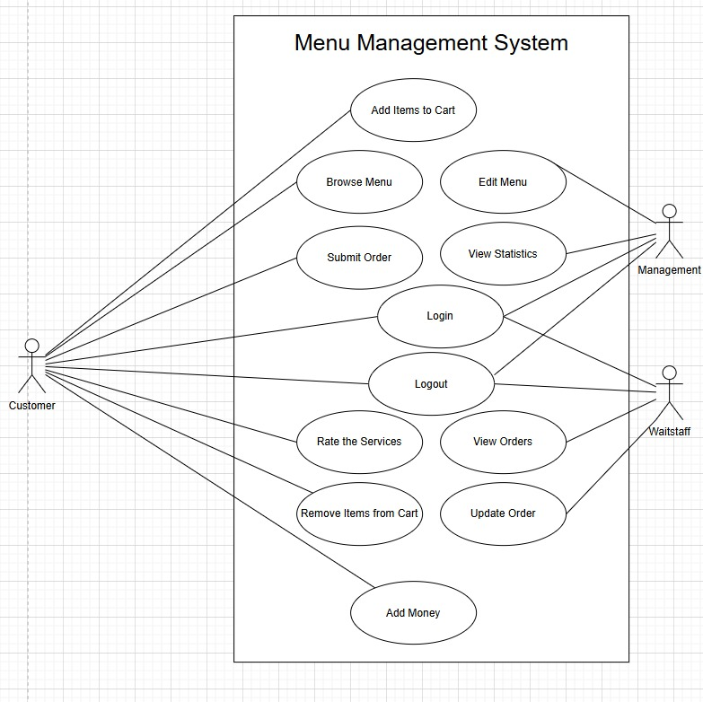

1. Design

7.1. Context Model:

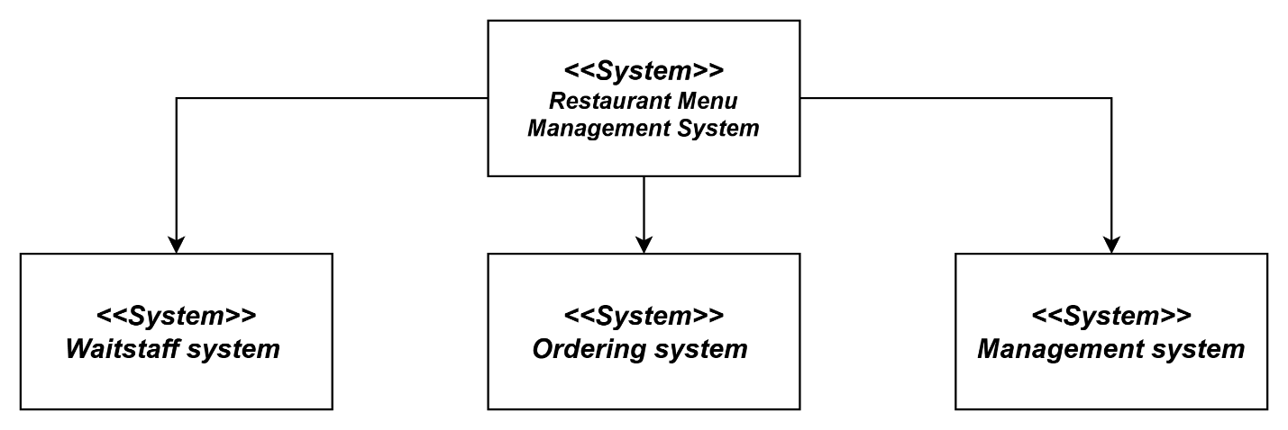

7.2. Process Model:

**7.2.1 Menu Navigation Process 7.2.2 Order Modification Process**

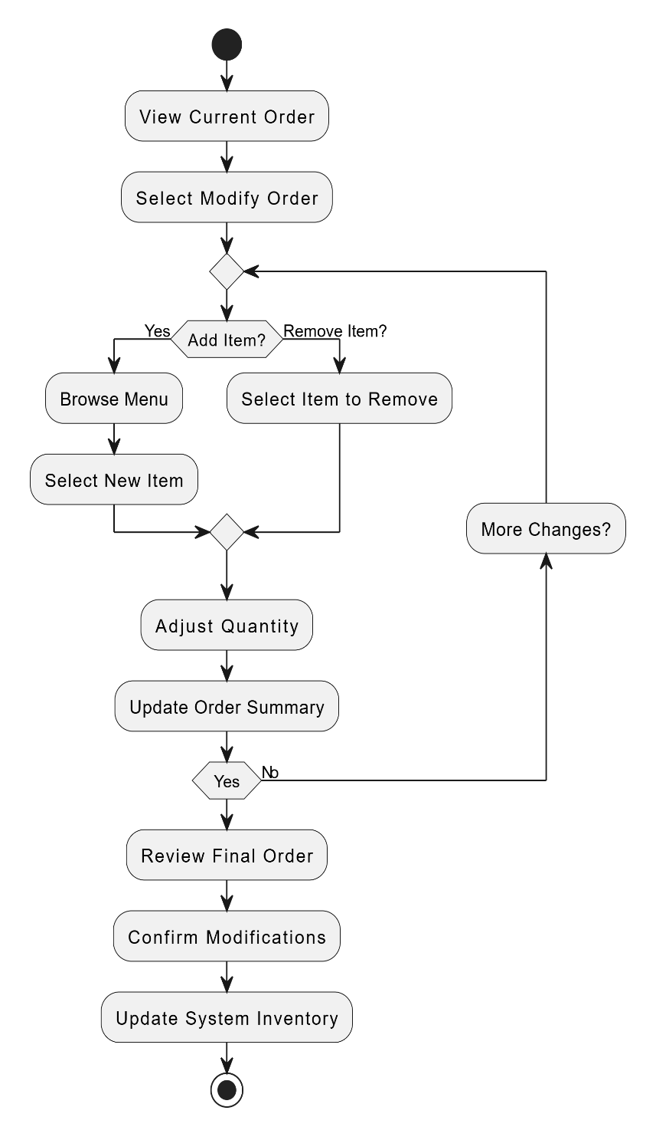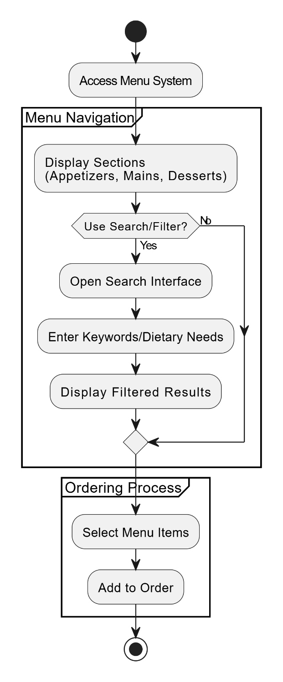

**7.2.3 Order Visibility (Waitstaff) 7.2.4 Menu Management (Admin)**

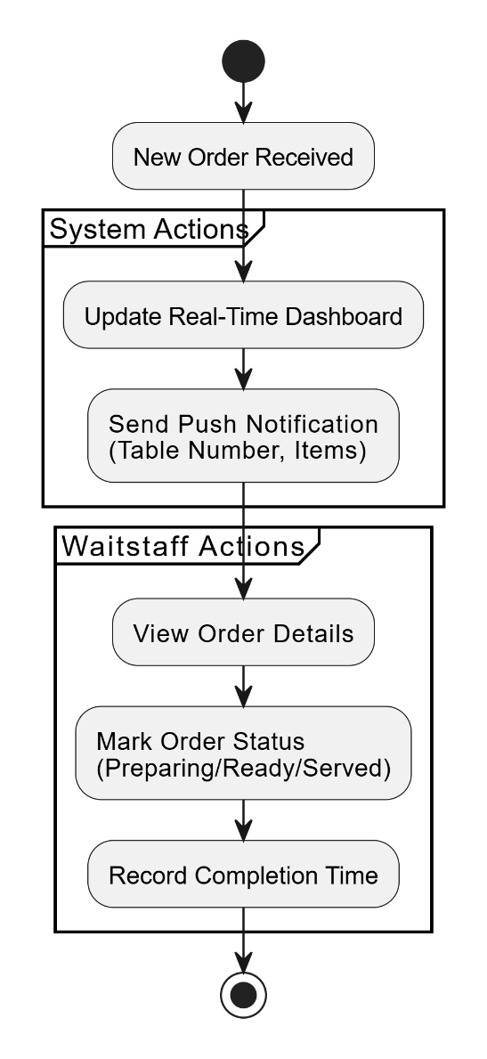

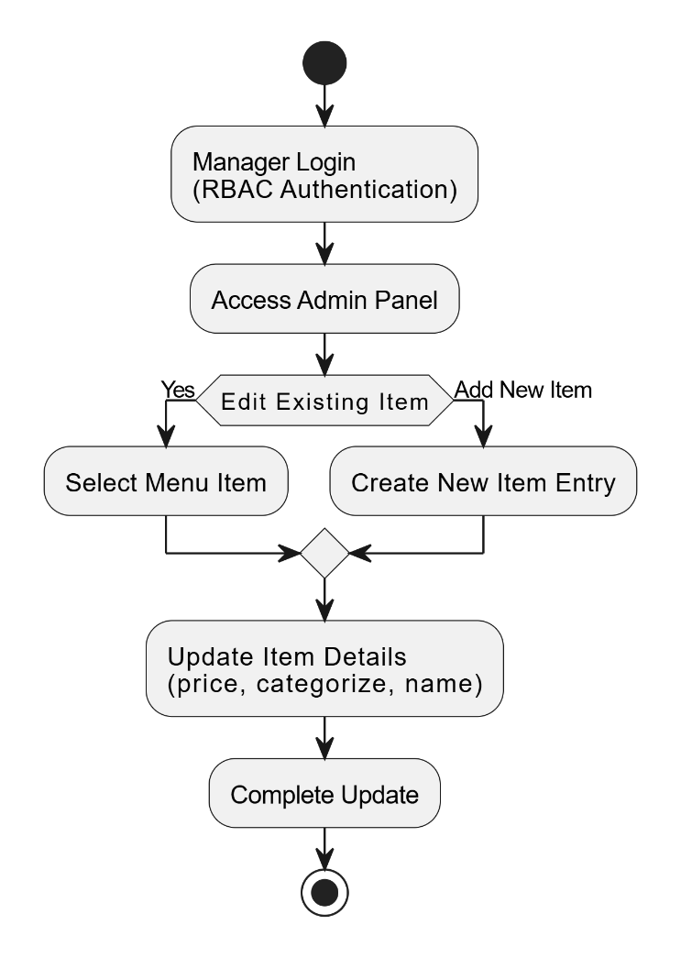

**7.2.5 Customer Reviews Process 7.2.6 Reporting & Analytics**

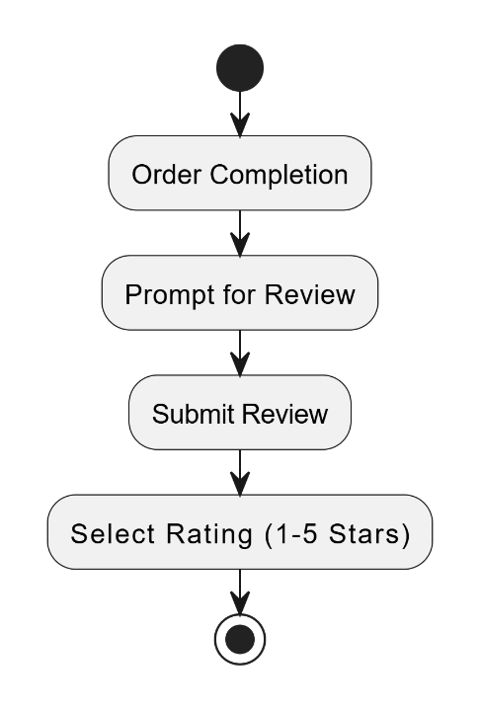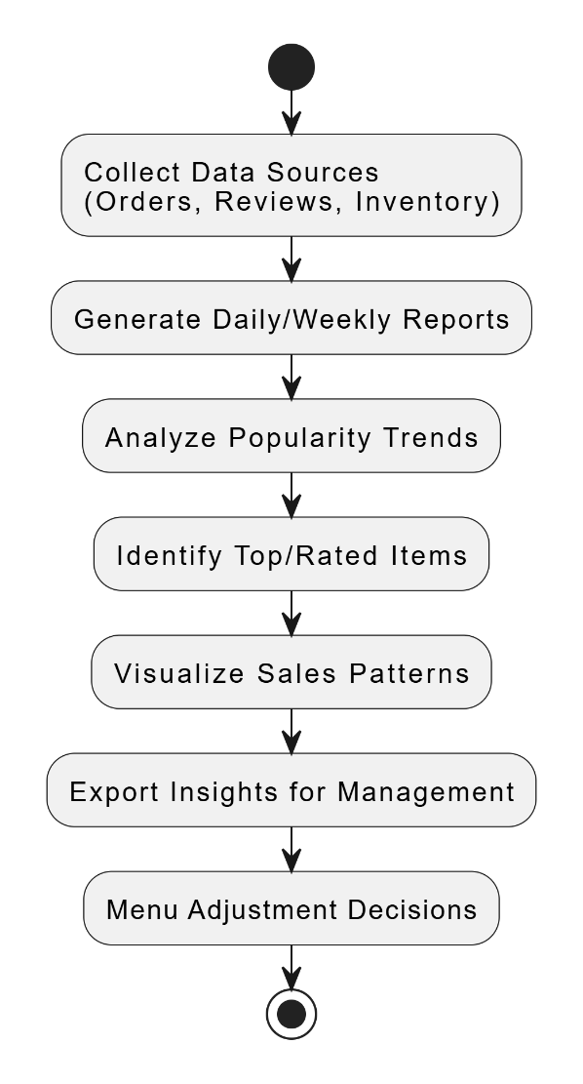

7.3. Interaction models:

**Add item To Cart Sequence**

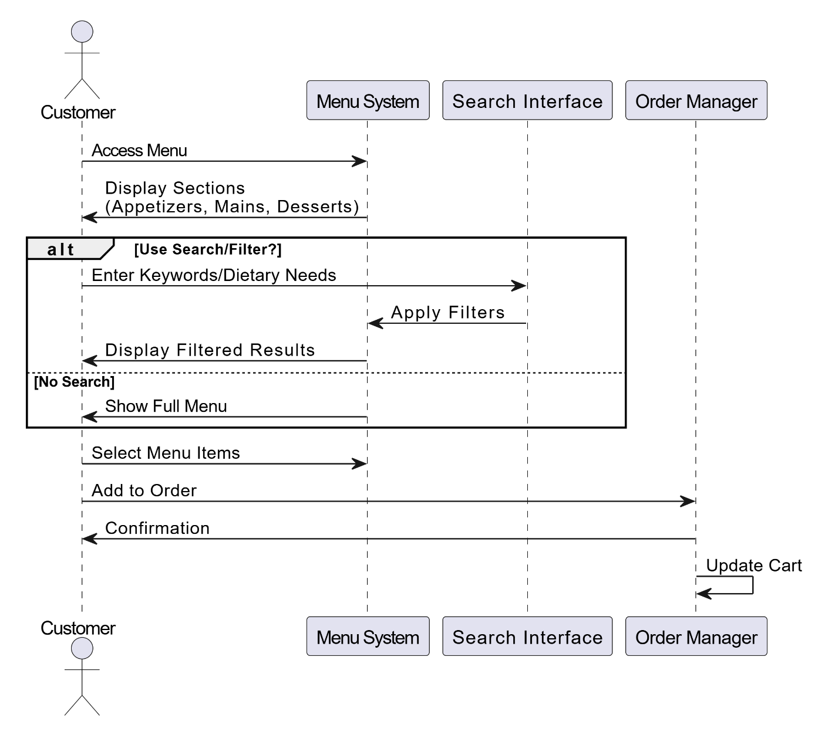

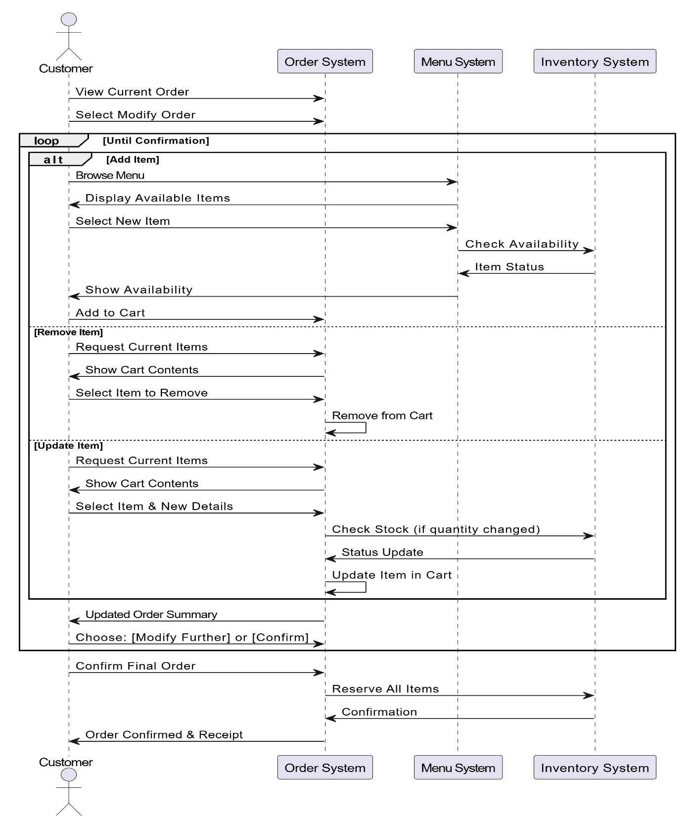**Remove Item From Cart Sequence**

**Rating Servece Sequence**

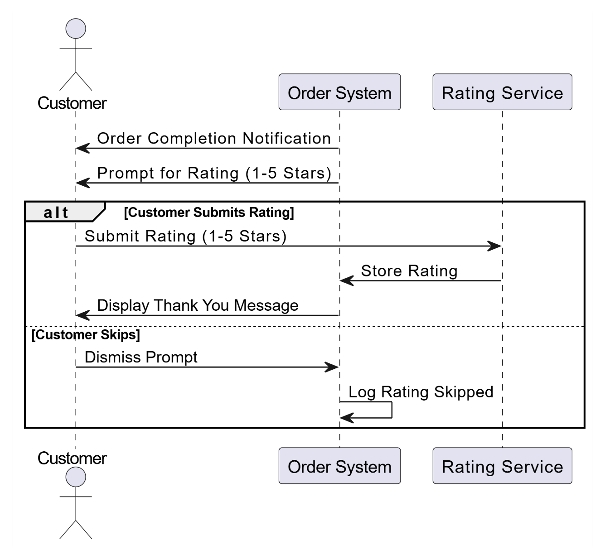

7.4. Structural mode

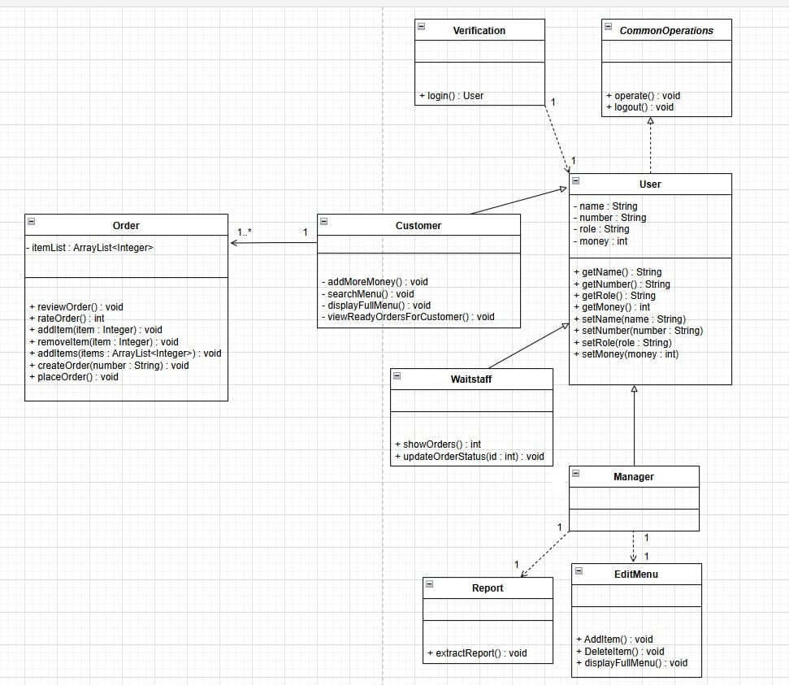

7.5. state machine diagram

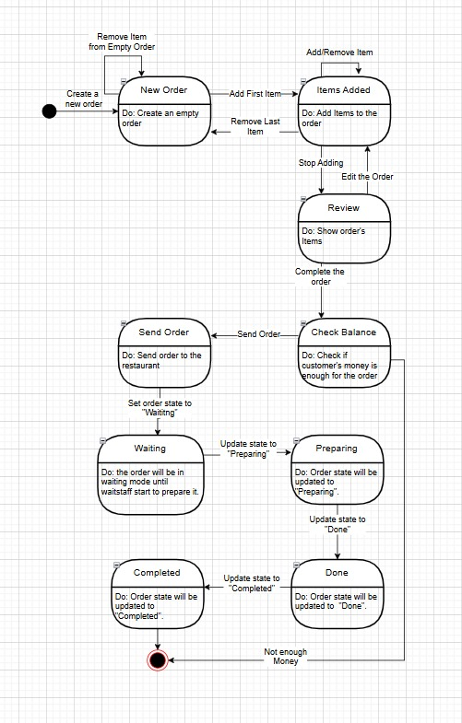

1. Test cases

**Test Case ID:**TC-01 **Functional Requirements:**FR-01 **Test Description:**Check for a product. **Expected Result:**Find the order.  
**Actual Result:**Find the order. **Status:**Check That.

**Test Case ID:**TC-02 **Functional Requirements:**FR-01 **Test Description:**Check for a product not exist. **Expected Result:**Error message displayed.  
**Actual Result:**Error message displayed.  
**Status:**Check That.

**Test Case ID:**TC-03  
**Functional Requirements:**FR-02 **Test Description:**Check adding a product not in the menu. **Expected Result:**Error message displayed. **Actual Result:**No Error message displayed. **Status:**Check That.

**Test Case ID:**TC-04  
**Functional Requirements:**FR-02 **Test Description:**Check Remove an item form an empty bin. **Expected Result:**Error message displayed. **Actual Result:**No Error message displayed. **Status:**Check That.

**Test Case ID:**TC-05 **Functional Requirements:**FR-03 **Test Description:**Check order not available. **Expected Result:**Error message displayed.  
**Actual Result:**No Error message displayed.  
**Status:**Check That.

**Test Case ID:**TC-06 **Functional Requirements:**FR-03 **Test Description:**Check an order. **Expected Result:**Send to the customer complete when it done. **Actual Result:**Send to the customer complete when it done. **Status:**Check That.

**Test Case ID:**TC-07 **Functional Requirements:**FR-04  
**Test Description:**Check update product price, categorize, name.  
**Expected Result:**Change of the price, categorize, name. **Actual Result:**Change of the price, categorize, name.  
**Status:**Check That.

**Test Case ID:**TC-08 **Functional Requirements:**FR-04  
**Test Description:**Check update product not exist.  
**Expected Result:**Error message displayed.  
**Actual Result:**No Error message displayed. **Status:**Check That.

**Test Case ID:**TC-09  
**Functional Requirements:**FR-05  
**Test Description:**Check rating the service. **Expected Result:**Rating goes to the database. **Actual Result:**Rating goes to the database. **Status:**Check That.

**Test Case ID:**TC-10  
**Functional Requirements:**FR-05  
**Test Description:**Check rating the service above 5 or less than 1.  
**Expected Result:**Above 5 equal 5 less than 1 equal 1. **Actual Result:**Above 5 equal 5 less than 1 equal 1.  
**Status:**Check That.

## 9-Tasks, durations, and dependencies

|  |  |  |
| --- | --- | --- |
| Task | Duration (days) | Dependences |
| Introduction(T1) | 5 |  |
| User requirements definition(T2) | 10 |  |
| System architecture(T3) | 5 | T1-T2(M1) |
| System requirements specification(T4) | 5 | T1-T2(M1) |
| use case diagram (T5) | 5 | T4-(M2) |
| Context model(T6) | 5 | T4-(M2) |
| Process model(T7) | 5 | T6(M3) |
| sequence diagrams(T8) | 10 | T7(M4) |
| class diagram(T9) | 5 | T7(M4) |
| state machine diagram(T10) | 5 | T7(M4) |
| implementation(11) | 15 | T7-T8-T9(M5) |
| Testing(T12) | 5 | T11(M6) |
| Chart(T13) | 5 | T12(M7) |

**Activity bar chart**

|  |  |  |  |  |  |  |  |  |  |  |  |  |  |  |
| --- | --- | --- | --- | --- | --- | --- | --- | --- | --- | --- | --- | --- | --- | --- |
| Week 0 1 2 3 4 5 6 7 8 9 10 11 | | | | | | | | | | | | | | |
| ◊ Start | | | | | | | | | | | | | |
| T1 |  |  | | | | | | | | | | | |
|  | | | | | | | | | | | | | |
| T2 |  |  |  | | | | | | | | | | |
| ◊(M1/T1-T2) | | | | | | | | | | | | | |
| T3 |  | |  |  | | | | | | | | | |
|  | | | | | | | | | | | | | |
| T4 |  | |  |  | | | | | | | | | |
| ◊(M2/T4) | | | | | | | | | | | | | |
| T5 |  | | |  |  | | | | | | | | |
|  | | | | | | | | | | | | | |
| T6 |  | | |  |  | | | | | | | | |
| ◊(M3/T6) | | | | | | | | | | | | | |
| T7 |  | | | |  |  | | | | | | | |
| ◊(M4/T7) | | | | | | | | | | | | | |
| T8 |  | | | | |  |  |  | | | | | |
|  | | | | | | | | | | | | | |
| T9 |  | | | | |  |  | | | | | | |
|  | | | | | | | | | | | | | |
| T10 |  | | | | |  |  | | | | | | |
| ◊(M5/T7-T8-T9) | | | | | | | | | | | | | |
| T11 |  | | | | | | |  |  |  | |  | |
| ◊(M6/T11) | | | | | | | | | | | | | |
| T12 |  | | | | | | | | | |  | |  |
| ◊(M7/T12) | | | | | | | | | | | | | |
| T13 |  | | | | | | | | | | | |  |
| Finish ◊ | | | | | | | | | | | | | |

**Staff allocation chart**

