61. How to configure firebase console setup for push notification?
Ans: To use firebase follow the procedure which are mentioned below
- Go to this URL to create project https://console.firebase.google.com/u/0/
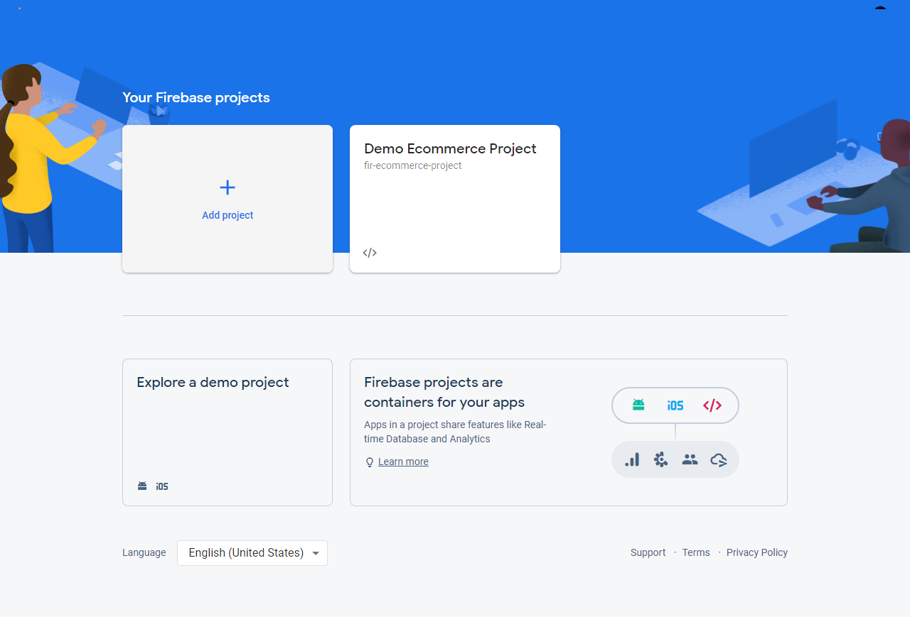

- Enter project name and then click on continue button
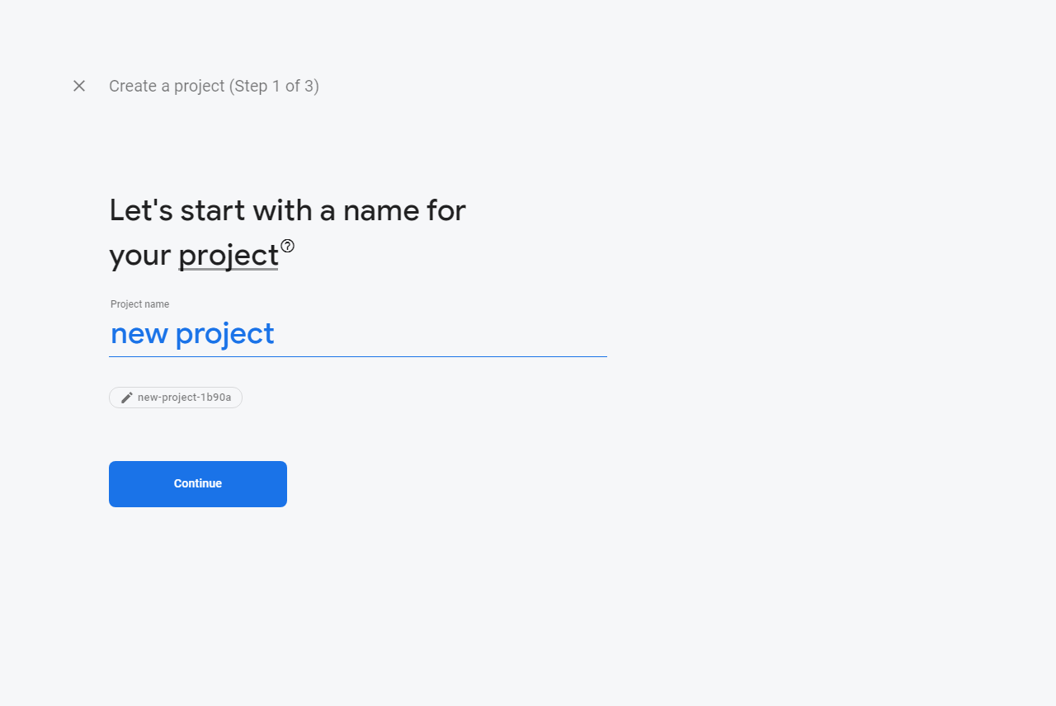

- Disable the Google analytics for this project option and click Create project button
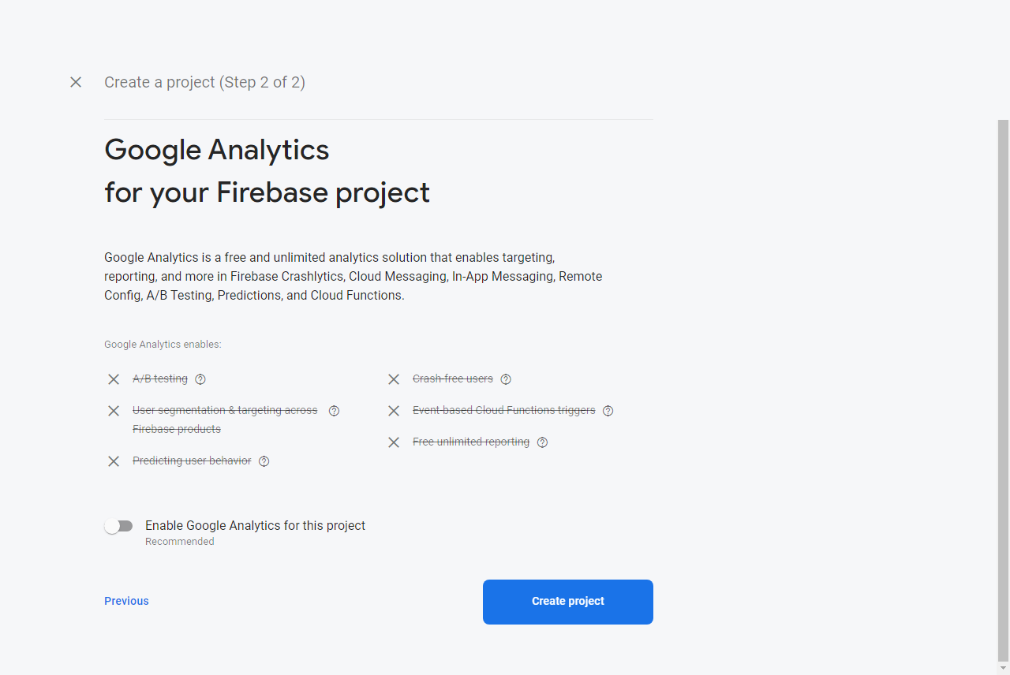

- After then click on continue button
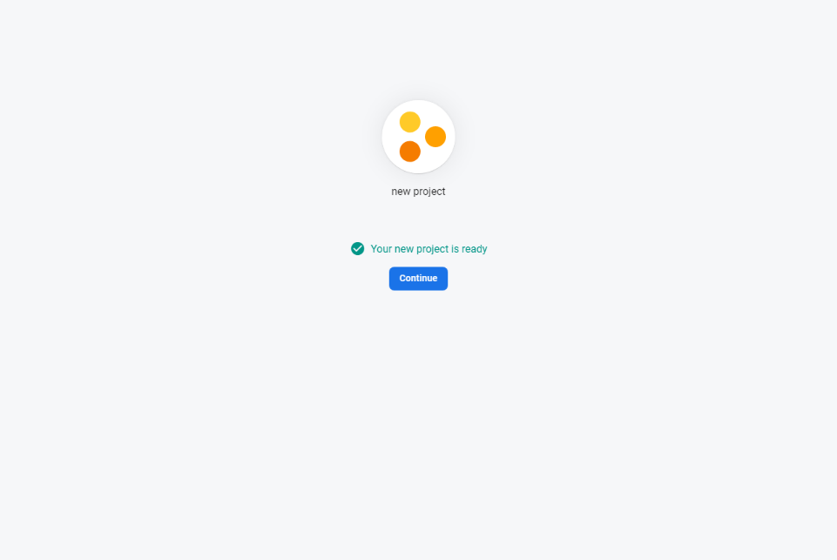

- Now go to project settings to get server key
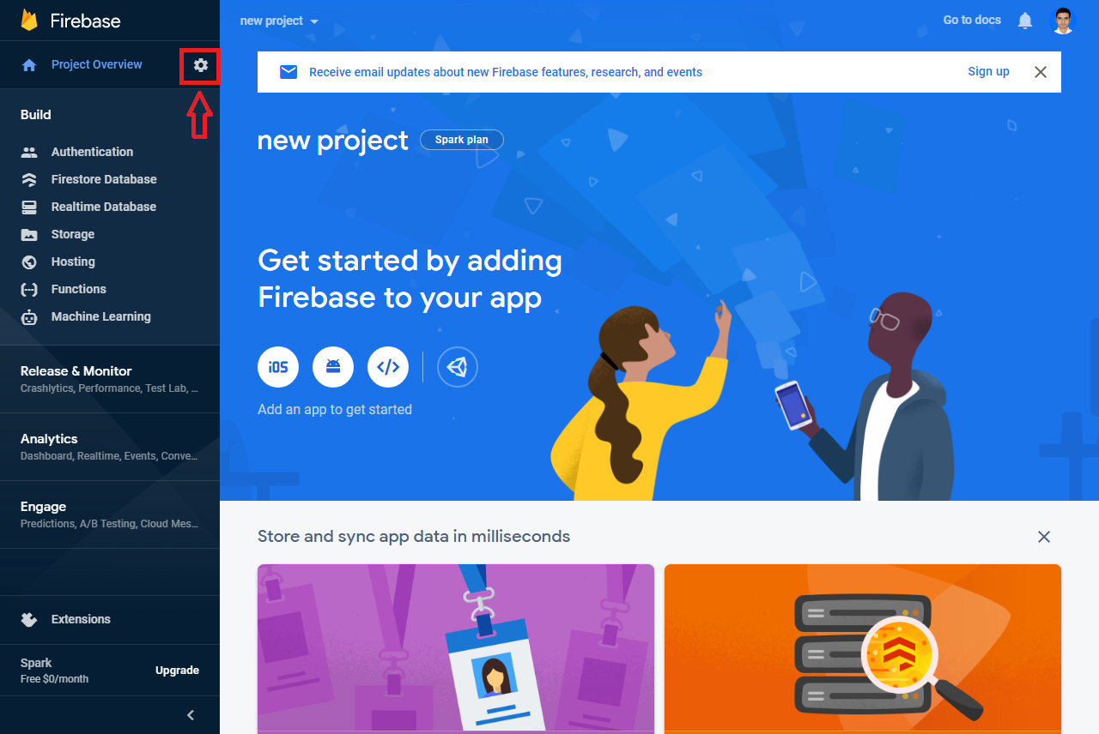

- To get server key click on Cloud Messaging option
