HotelOS
Hotel Operations & Reservation Management Platform
MASTER PRODUCT & EXECUTION PACK | v1.0
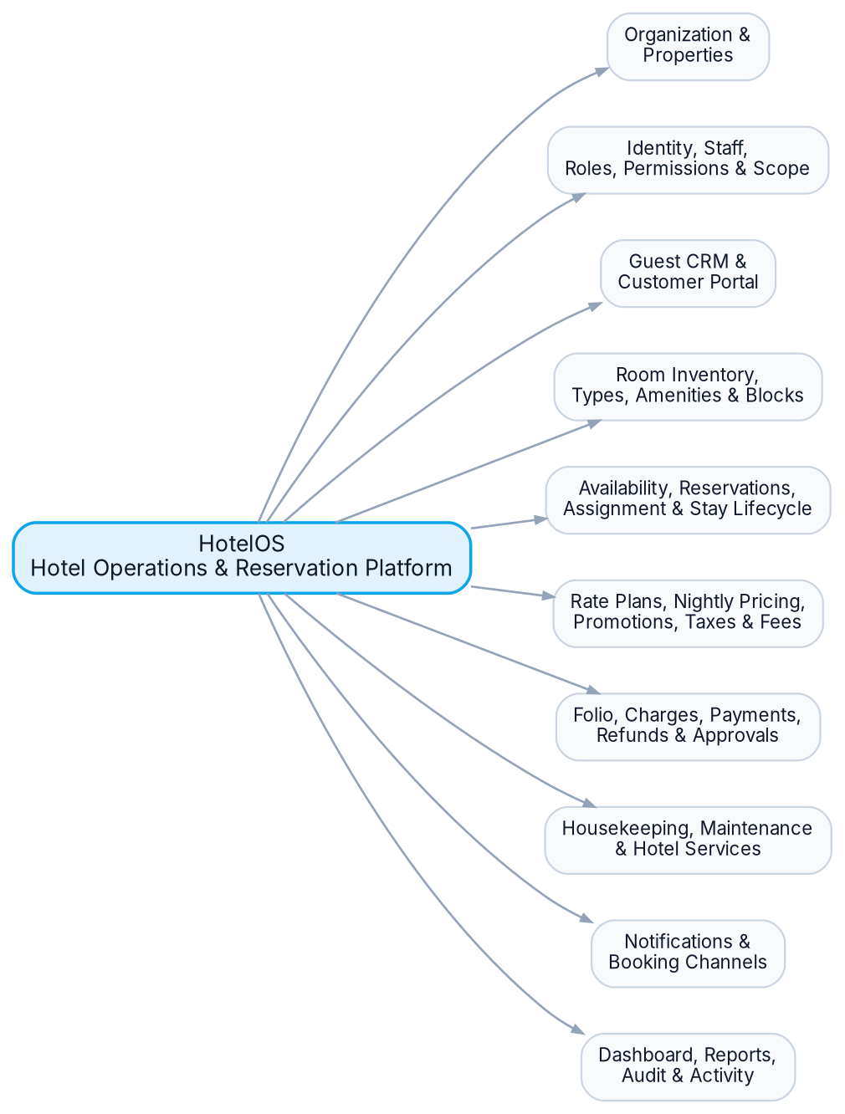
BRD • RSD • ERD • Architecture • Implementation Plan • Task Breakdown • Estimated Hours

1. BRD - Business Definition
Purpose: define what the product is, who uses it, how the business operates, and the rules the system must protect.
Product Vision A multi-organization, multi-property hotel operating platform that unifies inventory, reservations, guest relationships, access control, pricing, folio/billing, payments, housekeeping, maintenance, services, reporting, customer self-service and external booking channels behind an API-first backend.
Business objectives
• Provide one trusted operational source for organizations managing one or many hotel properties.
• Prevent inventory conflicts and preserve reservation, financial and operational history.
• Give each staff member exactly the actions and property scope required by their role and permissions.
• Support direct staff reservations and customer self-service without duplicating business logic.
• Build a financial trail from reservation pricing to folio charges, payments, refunds and approvals.
• Support day-to-day operations after the booking: check-in/out, housekeeping, maintenance and hotel services.
• Create an integration-ready foundation for online payments, notifications and external booking channels.
Business actors and responsibilities
Actor | Primary business responsibility
Platform / Support Admin | Platform support, organization onboarding, audited support access; not invisible unrestricted business access.
Organization Owner / Admin | Organization settings, property access, users, roles, permissions, cross-property reporting.
Property Manager | Property operations, pricing oversight, reports, approvals and staff supervision.
Receptionist / Front Desk | Guests, reservations, room assignment, check-in/out, allowed payment operations.
Accountant / Finance | Folios, payments, refunds, reconciliation and financial reports according to permission scope.
Housekeeping Staff | Assigned rooms/tasks, task status, room cleanliness state.
Maintenance Staff | Maintenance requests, assignment, resolution and room operational blocks.
Guest / Customer | Search availability, book, pay, manage eligible reservations, documents/preferences and service requests.

2. BRD - Organization, Access & Business Rules
Organization model
• Organization is the top business boundary (hotel group/company). Data is strictly scoped by OrganizationId.
• An Organization owns one or more Properties. A Property is the physical hotel/resort operating unit.
• A Property may contain optional Buildings/Wings, Floors, Room Types and Rooms.
• Property owns local operational context such as timezone and currency. Technical timestamps are stored in UTC.
• A user can be granted access to multiple properties; property access is modeled separately from the Identity user record.
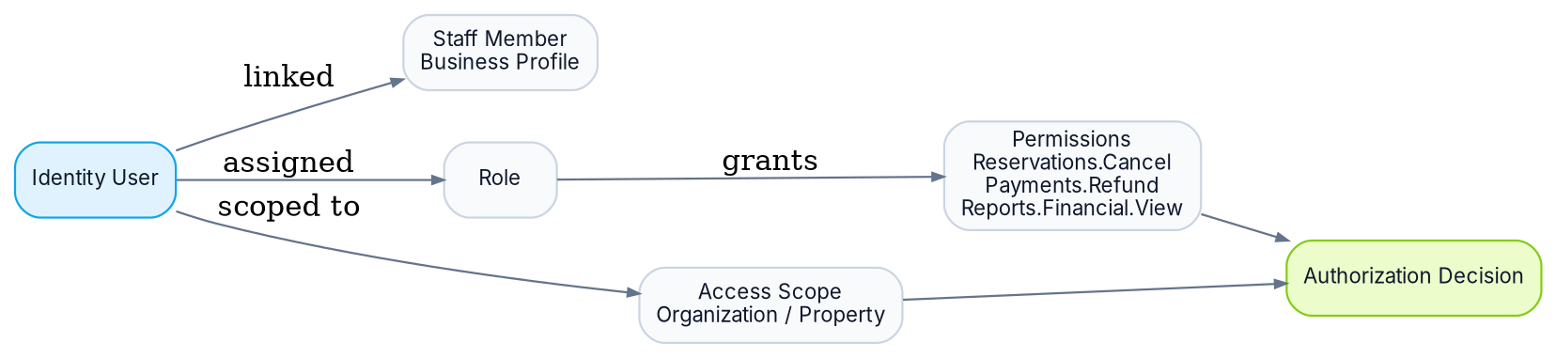
Authorization rule
Decision formula Authorization = authenticated identity + granted permission + resource/property scope + optional approval rule. A role name alone is never sufficient for sensitive operations.
ID | Business rule
BR-001 | Organization data must be isolated from other organizations at every query/write boundary.
BR-002 | Room number must be unique within its property; transactional records are never hard-deleted.
BR-003 | Booking availability is derived from inventory, reservations, room assignments/blocks and operational status - never a stored IsReserved flag.
BR-004 | Public/direct booking reserves Room Type inventory; physical Room assignment may happen later.
BR-005 | No active overlapping room assignment may exist for the same physical room and date range.
BR-006 | Reservation pricing is snapshotted by stay night so later rate-plan changes do not rewrite history.
BR-007 | The training rule remains supported: stays longer than 7 nights can receive the configured 10% automatic discount; richer promotion rules coexist separately.
BR-008 | Reservation lifecycle is controlled: Pending, Confirmed, CheckedIn, CheckedOut; Cancelled and NoShow are terminal alternatives.
BR-009 | Cancelled reservations remain auditable and stop consuming sellable inventory according to cancellation effective state.
BR-010 | Financial state is represented through Folio + Charges + Payments + Refunds, not a single IsPaid flag.
BR-011 | Manual discounts, price overrides and refunds above configured thresholds require approval.
BR-012 | Checkout creates/queues the required housekeeping cleaning work and updates cleanliness workflow.
BR-013 | Maintenance can block a room from sale for a specified period when severity requires it.
BR-014 | Guests may exist without login accounts; a portal Identity account may link to an existing Guest profile.
BR-015 | External booking sources preserve channel and external reference for idempotency/synchronization.
BR-016 | Sensitive business/security changes are written to audit history with actor, time, entity and correlation context.

3. BRD - Core Business Workflows & Scope
Reservation-to-stay workflow
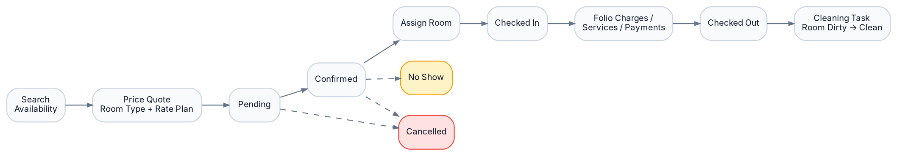
Stage | Required behavior
Availability & quote | Select organization/property, stay dates, occupancy and optional filters. Return sellable room types/rate plans and calculated price quote.
Reservation creation | Create/resolve Guest, reserve room-type inventory, persist nightly price snapshot, create folio and initial room charges, persist source/channel.
Confirmation & payment | Apply confirmation/payment policy. Record partial/full payment. Pending reservations can expire/cancel according to policy.
Room assignment | Assign a physical compatible room without overlap/block. Assignment can be changed with audit trail before/during stay when business rules allow.
Check-in | Validate reservation state/date, assigned room readiness, guest information and required financial conditions; record operator/time.
In-stay operations | Post service/extra charges to folio; process payments; housekeeping/maintenance/service orders operate independently but link back where relevant.
Check-out | Validate/settle folio policy, record checkout, release stay, create cleaning work and preserve final financial snapshot.
Cancellation / No-show | Apply rate-plan cancellation/no-show policy, release inventory, create/adjust charges/refunds where applicable, maintain complete history.
Frozen v1.0 product scope
Capability | Scope
Organization & Property | Organizations, properties, buildings/wings, floors, local timezone/currency/settings.
Identity & Access | ASP.NET Core Identity, staff profile, roles, granular permissions, multi-property scope, approval requests, JWT/refresh token.
Guest & Portal | Guest CRM, optional linked customer account, booking-management APIs, preferences/documents.
Inventory | Room types, amenities, rooms, operational status, housekeeping status, room blocks.
Reservation & Availability | Search/quote, room-type reservation, reservation guests, room assignment, lifecycle, cancellation/no-show, sources/channels.
Pricing | Rate plans, nightly rates, discounts/promotions, taxes/fees, historical price snapshots.
Finance | Folio, charges, payments, partial payment, refunds, outstanding balance, approvals.
Operations | Check-in/out, housekeeping, maintenance, hotel services/add-ons.
Communication & Channels | Notification foundation + provider adapters; external channel model + Booking.com-style adapter phase.
Management | Dashboard/reports, audit log, activity timeline, files/documents, localization-ready settings.

4. RSD - Functional Requirements (Organization, IAM, Inventory)
ID | Requirement | Acceptance / rule
ORG-001 | Create/manage Organizations and Properties with status, code, timezone, currency and settings. | Organization/Property codes unique in defined scope; deactivation does not erase history.
ORG-002 | Support optional Building/Wing and Floor hierarchy. | Rooms may reference Floor; hierarchy changes must not invalidate historical reservations.
IAM-001 | Authenticate staff/customer accounts using ASP.NET Core Identity and API bearer tokens. | Secure password hashing, lockout/email policy as configured; access/refresh token lifecycle.
IAM-002 | Manage roles and granular permissions. | Permission codes are stable business identifiers; role changes audited.
IAM-003 | Grant each user Organization/Property scope independently of role. | Every scoped application query/write must enforce organization and property access.
IAM-004 | Support approval requests for configured sensitive actions. | Request captures operation/entity/value context, requester, approver, status, timestamps.
STAFF-001 | Maintain StaffMember business profile linked one-to-one to an optional/required Identity user according to staff status. | Employee number unique per organization; property assignments supported.
INV-001 | Manage Room Types with code, name, description, occupancy/capacity and amenity relationships. | RoomType belongs to Property; inactive types cannot be newly sold.
INV-002 | Manage physical Rooms with property, type, optional floor, unique room number and operational/housekeeping states. | Operational state and cleanliness state are independent; no IsReserved column.
INV-003 | Manage sellability Room Blocks by room/date/reason/status. | Active overlapping blocks make the room unavailable for assignment/sale.
INV-004 | Manage Amenities and map them to room types/rooms where required. | Amenity master data can be deactivated; historical relationships remain readable.
Core permission catalogue
Permission baseline Hotels.View/Manage; Properties.View/Manage; Rooms.View/Create/Update/Deactivate; RoomTypes.View/Manage; Guests.View/Create/Update/Export; Reservations.View/Create/Modify/Cancel/CheckIn/CheckOut/AssignRoom/OverridePrice; Payments.View/Create/Refund/Void; Housekeeping.View/Assign/Update; Maintenance.View/Manage; Services.View/Manage/Post; Reports.Operational.View; Reports.Financial.View; Users.View/Manage; Roles.Manage; Permissions.Manage; Settings.View/Manage; AuditLogs.View; Approvals.View/Approve.

5. RSD - Functional Requirements (Guest, Reservation, Availability, Pricing)
ID | Requirement | Acceptance / rule
GST-001 | Create/search/update Guest profiles and preserve stay history. | Duplicate resolution uses configured identifiers (phone/email/document); sensitive fields permission-protected.
GST-002 | Link an optional customer Identity account to a Guest profile. | Guest can exist without account; account linkage is audited and unique where required.
RES-001 | Search room-type availability by property, check-in/out, occupancy and filters. | Result excludes unsellable inventory and returns available quantity/rate options.
RES-002 | Generate deterministic price quote by room type, rate plan, nightly prices, discounts/promotions, taxes and fees. | Quote contains line-level/nightly breakdown and expiration/version context where needed.
RES-003 | Create reservation against RoomType, primary guest and stay dates. | Validation: check-out > check-in, occupancy within policy, availability exists, source recorded.
RES-004 | Persist ReservationNight snapshots. | Each stay date stores room rate, discount, taxes/fees and net amount used for historical totals.
RES-005 | Attach additional reservation guests. | Primary guest remains explicit; occupancy counts remain consistent.
RES-006 | Assign/change a compatible physical room. | No overlap with active assignment/block; room type compatibility enforced; operation audited.
RES-007 | Support lifecycle transitions Pending/Confirmed/CheckedIn/CheckedOut/Cancelled/NoShow. | Invalid transitions rejected by domain/application rule; transition actor/time stored.
RES-008 | Cancel reservation subject to rate-plan/cancellation policy and permission/approval rules. | Inventory released; applicable financial adjustment/refund recorded; reservation retained.
RES-009 | Search reservations by number, guest, phone/email, room, dates, status, source and external reference. | Results tenant/property scoped; sensitive fields protected.
RATE-001 | Manage Rate Plans and room-type nightly rates. | Rate plan belongs to property, defines refundability/cancellation policy and active selling window/rules.
RATE-002 | Support automatic discounts/promotions and approved manual adjustments. | Automatic training rule >7 nights => 10% supported as configurable rule; stacking/priority explicitly defined.
RATE-003 | Calculate taxes/fees separately from base room rate and discounts. | Financial breakdown remains explainable and reproducible from snapshot data.
CHAN-001 | Record booking source/channel and optional external reservation ID. | External ID unique within channel/property/organization as defined; repeated integration requests are idempotent.
Availability invariant
No double sell / assignment For a requested stay or assignment, availability must consider room-type inventory, active reservations, physical room assignments, room blocks and operational sellability. Overlap rules are transaction-safe; two concurrent requests must not create conflicting confirmed inventory/assignments.

6. RSD - Functional Requirements (Finance, Operations, Portal, Integration, Reporting)
ID | Requirement | Acceptance / rule
FIN-001 | Create one active Folio for the reservation/stay and support financial line items. | Folio currency matches property/reservation context; financial records are immutable-by-history, corrected via compensating entries/status.
FIN-002 | Post room and service charges to folio with description, amount, tax and source. | Each charge traceable to reservation night/service/manual source.
FIN-003 | Record partial/full payments and calculate outstanding balance. | Payment method/status/reference/time/operator preserved; totals derived from ledger.
FIN-004 | Process refunds/voids with permission and threshold approval. | Refund cannot exceed eligible paid amount; provider/reference and reason retained.
STAY-001 | Check in eligible confirmed reservation. | Room assigned and ready; date/state/guest/financial policy checks pass; actor/time recorded.
STAY-002 | Check out eligible in-house reservation. | Final balance policy handled; checkout recorded; room cleanliness workflow changes and cleaning task is created.
HK-001 | Create/assign/complete housekeeping tasks and manage room housekeeping status. | Task lifecycle and staff assignment audited; cleaning completion can move room to clean/inspection state.
MNT-001 | Create/assign/resolve maintenance requests. | High-severity/out-of-service request can create/synchronize room block.
SVC-001 | Manage hotel service catalogue and service orders. | Billable fulfillment creates/links folio charge; status/quantity/operator preserved.
PORTAL-001 | Customer account can search, quote, create/manage eligible bookings, view folio/payment information and submit allowed actions. | All customer actions limited to linked Guest/account ownership and configured policies.
NOT-001 | Generate notification jobs/events for key business events. | Delivery channel/provider implementation is infrastructure; retries/status stored where required.
INT-001 | Integrate external booking channel through adapter boundary. | Map external reservation IDs, idempotency keys and sync status; internal domain remains provider-independent.
RPT-001 | Operational dashboard: arrivals, departures, in-house guests, occupancy, room readiness, blocks and outstanding operational tasks. | Scoped by organization/property/date.
RPT-002 | Financial dashboard/reports: revenue, payments, refunds, outstanding balance and approved financial KPIs. | Financial permission required; cancelled/refunded semantics explicitly handled.
AUD-001 | Audit sensitive business/security operations. | Actor, time, organization/property, action, entity, correlation context and optional before/after metadata.
DOC-001 | Store guest/business documents through storage abstraction. | Database stores metadata/storage key, not provider-specific implementation assumptions.

7. ERD - Core Commercial & Reservation Data Model
PK/FK labels show the intended relational model; exact indexes/types are finalized during EF Core mapping review.
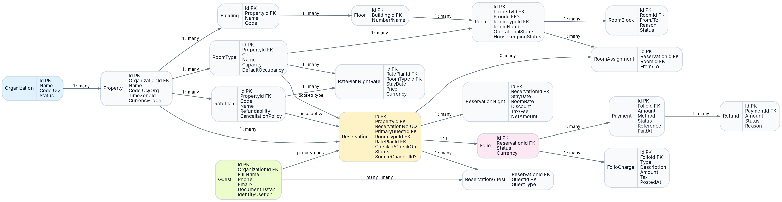
Critical relational decisions
• Reservation books RoomType; RoomAssignment links physical room when assigned. This separates sellable inventory from room allocation.
• ReservationNight is the pricing snapshot and prevents historical totals from changing when RatePlan prices change later.
• Folio is the financial account for the stay; charges, payments and refunds remain independent auditable transactions.
• RoomBlock is date-bounded and independent from reservation state. Operational status is a separate Room attribute.
• Guest is organization-scoped and reusable across stays; ReservationGuest supports multiple occupants.

8. ERD - Identity, Operations, Integration & Audit
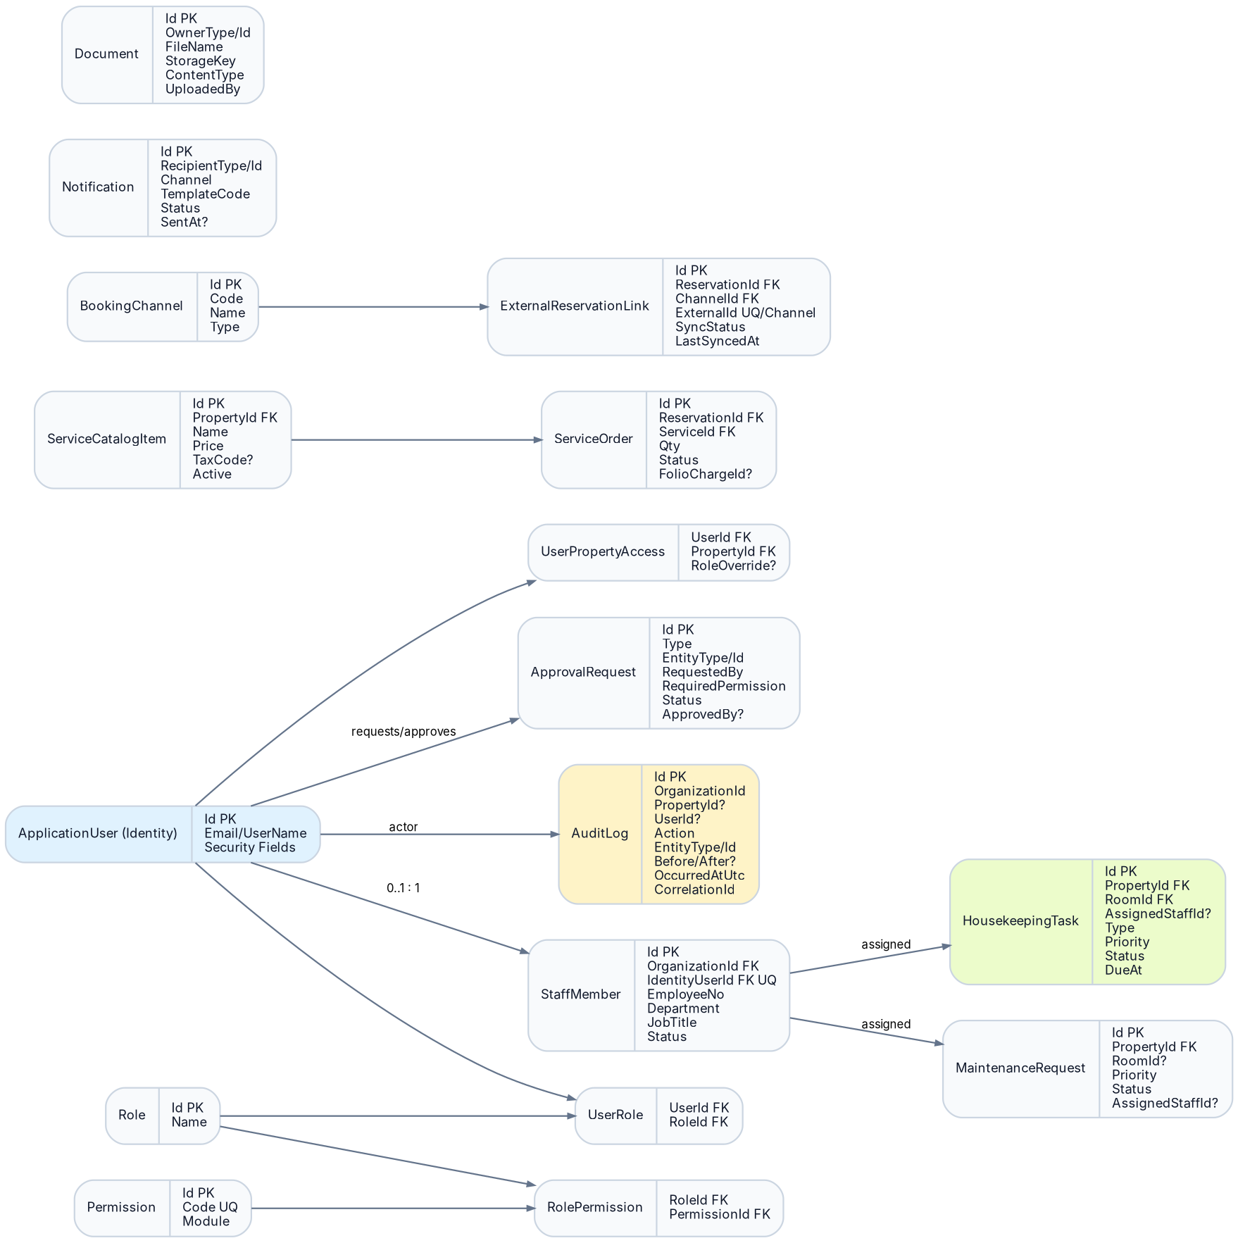
Identity / domain separation
• ApplicationUser is the ASP.NET Core Identity authentication record in Infrastructure. StaffMember is the domain/business employee profile.
• Role grants Permission through RolePermission; UserPropertyAccess controls where the user may exercise permissions.
• ApprovalRequest records sensitive workflow approval without turning authorization into hard-coded role checks.
• HousekeepingTask and MaintenanceRequest reference room/property and optionally StaffMember; they are operational modules, not reservation fields.
• Channel adapters map external reservation identifiers without leaking provider DTOs into Domain/Application.
• AuditLog is optimized for security/business traceability; activity timelines can be derived or maintained separately for user-facing operational history.

9. Technical Architecture & Layer Responsibilities
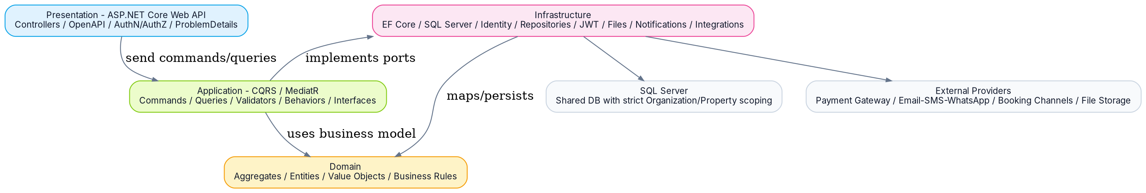
Layer | Responsibility
Domain | Pure business model: reservation lifecycle, pricing invariants/value semantics where appropriate, room/folio/stay rules. No ASP.NET Core, EF Core, SQL Server, MediatR or provider code.
Application | Use cases organized by feature with CQRS. Commands mutate state; Queries read. MediatR dispatch; FluentValidation input validation; pipeline behaviors for validation/logging/authorization as appropriate. Defines infrastructure ports.
Infrastructure | EF Core + SQL Server, DbContext/configurations/migrations, Identity, JWT/refresh-token implementation, repositories/query services, file storage, notifications, payment/channel adapters.
API / Presentation | HTTP contracts, controllers/endpoints, authentication wiring, authorization policies, OpenAPI, versioning, ProblemDetails/global exception handling, request context. No business logic.
Database | Shared SQL Server initially; all business records carry strict organization/property ownership where applicable. Constraints/indexes protect uniqueness and concurrency-sensitive invariants.
Cross-cutting | Structured logging, correlation IDs, audit, current user/tenant context, validation, idempotency, transaction handling, clock abstraction, observability.
Planned solution shape
Projects HotelOS.Domain | HotelOS.Application | HotelOS.Infrastructure | HotelOS.Api | tests: Domain.Tests, Application.Tests, IntegrationTests. Application is feature-oriented internally (Reservations/CreateReservation, Rooms/GetAvailableRooms, Payments/RefundPayment, etc.).
EF Core and database connection placement
• HotelDbContext, IEntityTypeConfiguration<T>, repositories/query implementations and Migrations live in Infrastructure/Persistence.
• Connection string and environment configuration live in the API host configuration (appsettings/User Secrets/environment variables), then AddInfrastructure(configuration) wires UseSqlServer.
• Domain has no EF attributes. Database column types, indexes, unique constraints and relationships are defined through Fluent API configurations.
• Migrations are generated from the Infrastructure DbContext and applied by controlled deployment/startup policy, not hidden inside domain logic.

10. RSD - Security, Data Integrity & Non-Functional Requirements
ID | Area | Requirement
SEC-001 | Authentication | ASP.NET Core Identity; JWT access token + refresh-token lifecycle for API clients. Secrets never committed to source control.
SEC-002 | Authorization | Permission + Organization/Property scope required on business operations; customer account restricted to owned/linked guest resources.
SEC-003 | Sensitive actions | Refund, high manual discount, price override and configured exceptions use approval workflow and audit.
SEC-004 | Data protection | Sensitive guest/document data exposed only to permitted users; logs must avoid secrets/passwords/tokens and minimize PII.
DATA-001 | Tenancy integrity | OrganizationId/property ownership enforced in application query filters/ports and protected by tests; no cross-tenant reads/writes.
DATA-002 | Transactions | Reservation confirmation/assignment/payment state changes use explicit transaction boundaries where multiple writes form one invariant.
DATA-003 | Concurrency | Booking/room assignment conflicts prevented under concurrent requests using database-safe strategy; retry/409 behavior defined.
DATA-004 | Idempotency | External channel/payment write endpoints accept provider/external reference/idempotency keys where duplicate delivery is possible.
DATA-005 | Deletion | Reservations, folios, payments, refunds and audit entries are never hard-deleted. Master data uses Active/Archived status.
PERF-001 | Query performance | Read queries project DTOs, paginate/filter/sort large datasets, use indexes and AsNoTracking where appropriate.
PERF-002 | Target response | Normal indexed CRUD/search endpoints target sub-second server processing under expected training/demo load; heavy reports are separately profiled.
OBS-001 | Observability | Structured logs, correlation/request ID, exception telemetry and health checks. Business audit is separate from diagnostic logging.
LOC-001 | Time | UTC for system timestamps; stay dates/business-day behavior evaluated using Property timezone.
LOC-002 | Currency | Financial records preserve currency code; property defines default currency; no implicit cross-currency arithmetic.
API-001 | Errors | RFC-style ProblemDetails mapping for validation, not-found, conflict, forbidden/domain errors and unexpected failures.
API-002 | Versioning/docs | OpenAPI documents request/response/status/authorization contracts; endpoint versioning strategy established before breaking public portal/integration contracts.
TST-001 | Testing | Domain rule unit tests + application handler tests + real database integration tests for EF mappings, constraints, concurrency, authorization scoping and critical workflows.
OPS-001 | Recovery | Database backup/restore and migration rollback strategy documented for deployed environments; integration failures never silently lose internal state.

11. Implementation Roadmap - Milestones, Dependencies & Outputs
Milestone | Workstream | Primary outputs | Hours
M0 | Product & Architecture Baseline | BRD/RSD/ERD/ADRs/API conventions, repo strategy, naming, DoD | 8-12
M1 | Solution Foundation | 4 projects, references, packages, DI, OpenAPI, ProblemDetails, logging, test projects | 8-12
M2 | Persistence Foundation | SQL Server, EF Core, DbContext, configs, migrations, tenant/property context, base transaction conventions | 10-14
M3 | Identity & Access | Identity, JWT/refresh, staff profile, roles, permissions, property scopes, authorization policies, seed | 18-26
M4 | Organization & Inventory | Organization/property/building/floor, room type, amenity, room, room block | 18-26
M5 | Guest & Customer Accounts | Guest CRM, search/dedup baseline, account link, customer ownership policy, documents foundation | 12-18
M6 | Rate & Availability Engine | Rate plans/nightly rate storage, quote model, taxes/fees/discount rule, availability/search, concurrency tests | 22-32
M7 | Reservation Core | Create/search/get/modify/cancel/no-show, reservation guests, snapshots, source/channel, room assignment | 28-40
M8 | Stay Lifecycle | Check-in/out, state transitions, room readiness, activity, housekeeping trigger | 12-18
M9 | Finance | Folio, room/service charges, payments, outstanding balance, refunds, financial approvals | 22-32
M10 | Hotel Operations | Housekeeping, maintenance, service catalog/orders, room operational integration | 18-26
M11 | Portal & Notifications | Customer booking/manage APIs, notification templates/jobs/provider abstraction | 16-24
M12 | Channel Integration | Channel foundation + one external adapter, mapping/idempotency/sync/error workflow | 18-30
M13 | Reporting & Audit | Operational/financial dashboards, audit, permissions, performance/index review | 16-24
M14 | Hardening & Delivery | Integration tests, security/scoping review, concurrency, seed/demo data, README/API collection, cleanup | 22-32
Dependency path Foundation -> Persistence/IAM -> Organization & Inventory -> Rate/Availability -> Reservation -> Stay/Finance -> Operations -> Portal/Integrations -> Reporting/Hardening. Cross-cutting tests and documentation are updated continuously, not postponed to the end.

12. Task Breakdown - Feature Implementation Template & First Backlog
Definition of a feature task chain
# | Step | Done means
1 | Requirement | Confirm business rule, actors, permissions, scope, errors and acceptance criteria.
2 | Domain | Entity/aggregate/value object changes; invariants and lifecycle rules.
3 | Persistence contract | Define exact repository/query/transaction operations needed; avoid generic repository-by-default.
4 | EF mapping | Configuration, indexes, uniqueness, precision, relationships and migration.
5 | Application contract | Command/Query + response DTO + permission requirement.
6 | Validation | FluentValidation for syntactic/input validation; DB/business rules stay in handler/domain.
7 | Handler | Orchestrate ports/domain; cancellation token; transaction/concurrency/idempotency where needed.
8 | Infrastructure | Repository/query/provider implementation and efficient EF query/projection.
9 | API | Route, request/response, authorization, status codes, ProblemDetails and OpenAPI examples.
10 | Tests | Unit + handler + integration + authorization/scoping + edge/concurrency cases as applicable.
11 | Manual verification | Migration, Swagger happy path, validation, forbidden, conflict/not-found and data review.
12 | Review & commit | Clean-code review, naming/dependencies, no layer violations, commit with feature scope.
Initial implementation backlog - exact order
ID | Task
FND-01 | Create solution/projects/references and solution-wide build rules.
FND-02 | Add Application/Infrastructure dependency registration and API composition root.
FND-03 | Global ProblemDetails exception handling, structured logging and correlation context.
DB-01 | Configure SQL Server connection, EF Core DbContext, migrations project behavior and health check.
IAM-01 | Identity schema/ApplicationUser, roles and initial seed.
IAM-02 | Login/refresh/current-user + JWT validation.
IAM-03 | Permission catalogue, RolePermission, UserPropertyAccess and authorization policy handler.
ORG-01 | Organization + Property + timezone/currency.
INV-01 | Building/Floor + RoomType + Amenity.
INV-02 | Room + states + unique room number per property.
INV-03 | RoomBlock and sellability rules.
GST-01 | Guest profile + search/update + optional account link.
RATE-01 | RatePlan + nightly rates + cancellation policy model.
AVL-01 | Availability query/read model and tests.
QTE-01 | Pricing quote including discount/tax/fee breakdown.
RES-01 | Create Reservation + ReservationNight + Folio + initial charges.
RES-02 | Get/Search reservations and scoped projections.
RES-03 | Room assignment with overlap/transaction safety.
RES-04 | Cancel/NoShow + policy + financial adjustment.
STAY-01 | Check-in.
STAY-02 | Check-out + housekeeping generation.
FIN-01 | Post payments/outstanding balance.
FIN-02 | Refund + approval.
OPS-01 | Housekeeping workflow.
OPS-02 | Maintenance + room block integration.
OPS-03 | Service catalog/order -> folio charge.
PORT-01 | Customer availability/quote/book/manage APIs.
NOT-01 | Notification outbox/job + provider abstraction.
INT-01 | Booking channel model + external adapter/idempotency/sync status.
RPT-01 | Operational dashboard.
RPT-02 | Financial reports.
AUD-01 | Sensitive audit viewer and authorization.
QLT-01 | End-to-end critical-path integration suite + performance/index review + docs/demo data.
13. Estimated Effort - Focused Backend Engineering Hours
Phase | Milestones | Min h | Max h | Included
Product + technical baseline | M0-M2 | 26 | 38 | Docs, architecture, solution and persistence foundation
Secure core platform | M3-M5 | 48 | 70 | Identity/access, organization/inventory, guest/account
Revenue engine | M6-M9 | 84 | 122 | Rates, availability, reservation, stay and finance
Operations | M10 | 18 | 26 | Housekeeping, maintenance, services
Portal + integrations | M11-M12 | 34 | 54 | Customer APIs, notifications, one channel adapter
Management + hardening | M13-M14 | 38 | 56 | Reports/audit, test/security/performance/delivery
Totals
Core operational backend Approx. 176-256 focused hours through M10: secure platform + inventory + guests + rate/availability + reservation + stay + finance + hotel operations.
Full frozen v1.0 backend scope Approx. 248-366 focused hours including customer portal/notifications, one external channel integration, reporting/audit and hardening.
Estimation assumptions
• One experienced developer, focused engineering hours - not calendar time. Includes design while implementing, code review of own work, migrations, validation, tests and Swagger/manual verification.
• Backend only. Frontend/admin portal UI and customer website UI are not included.
• External vendor waiting/approval time is excluded. The channel-integration estimate assumes usable API access and documentation; major certification requirements can change it.
• No shortcuts such as skipping permission scoping, concurrency tests, financial auditability or integration tests. These estimates represent the “respectable system” quality bar defined in this pack.
• Estimates are deliberately ranges. After each milestone design is frozen, tasks can be re-estimated at 1-4 hour granularity.
Recommended working cadence
Session | Goal | Typical output
Architecture/feature discussion | Close business + technical decisions before code | Updated requirement/ADR + task acceptance criteria
Implementation block | One coherent vertical use case | Domain -> Application -> Infrastructure -> API
Verification block | Prove behavior, not only compile | Automated tests + Swagger scenarios + DB review
Review/commit | Keep repository understandable | Clean diff, naming/dependency review, single-purpose commit
14. Architecture Decisions & Definition of Done
ADR | Decision
ADR-001 | Clean Architecture is the solution boundary model; CQRS/MediatR is an Application-layer use-case pattern, not a separate layer.
ADR-002 | Application code is organized by business feature/use case, while dependencies still obey Clean Architecture.
ADR-003 | Shared SQL Server initially; multi-organization data isolation is logical and mandatory in every business access path.
ADR-004 | ASP.NET Core Identity stays in Infrastructure; Domain models StaffMember/Guest separately from authentication records.
ADR-005 | Authorization uses Role -> Permissions + User property scope; sensitive finance/pricing actions can require approval.
ADR-006 | Bookings reserve RoomType inventory; physical room assignment is separate and concurrency protected.
ADR-007 | Availability is derived. Room stores operational and housekeeping state, not IsReserved.
ADR-008 | Pricing uses RatePlan/nightly values and reservation-night snapshots. Financial calculations use decimal + currency context.
ADR-009 | Folio ledger model is the financial source of truth for charges, payments and refunds.
ADR-010 | Transactional/history entities are not hard-deleted; correction is represented by state/compensating operations.
ADR-011 | EF Core mapping is Infrastructure Fluent API; no database annotations in Domain.
ADR-012 | Repositories/query ports are feature/domain-specific when they add a boundary; no generic repository template by default.
ADR-013 | External providers are adapters behind Application ports; provider DTOs/SDKs do not leak into Domain.
ADR-014 | UTC technical timestamps + Property local timezone; Property default currency preserved on monetary transactions/snapshots.
ADR-015 | Audit log is for sensitive/business/security traceability; diagnostic logs remain a separate observability concern.
Definition of Done - every feature
• Business rule and acceptance criteria are explicit before implementation.
• Correct layer ownership; no business logic in controllers and no EF/Identity/provider dependencies in Domain.
• Permission + organization/property scope enforced and covered by tests.
• Input validator and domain/data business validations are separated correctly.
• EF configuration includes required indexes, uniqueness, precision, FK/delete behavior and migration review.
• Command/query honors CancellationToken; write use case has explicit transaction/concurrency strategy when needed.
• API has documented success/error status codes and ProblemDetails behavior in Swagger/OpenAPI.
• Happy path plus critical invalid, forbidden, not-found/conflict and concurrency/financial edge cases tested.
• Logs/audit do not leak secrets; sensitive operations produce required audit records.
• Code compiles warning-clean under agreed rules, naming is clear, duplication is justified/removed, and commit is feature-scoped.
Technical baseline: Aligned with the team-lead CQRS deck: Domain core; Application owns use cases/interfaces and Commands/Queries; Infrastructure owns persistence/external services; Presentation accepts requests; CQRS + MediatR + FluentValidation in Application; EF Core mapping in Infrastructure; controllers contain no application logic.

