
Faculty of Engineering
Alexanderia University
Electrical Engineering Department
Communications and Electronics Engineering
EEC 243 Microprocessors and Interfacing

Mini Project I:
General signal generator

NAME | Section | ID
احمد باسم عبدالسلام ابوكيلة | 1 | 24011105
محمد احمد فكيه طه | 2 | 23010718
محمد ايمن رجب الصايغ | 1 | 23010730
محمد محمود السيد محمد علي شطا | 2 | 23010781

1. Introduction
- In this project, a general signal generator is designed and implemented using MATLAB. The program allows the user to create different types of signals such as DC, ramp, exponential, and sinusoidal signals.
- The user first enters basic parameters like the sampling frequency, time range, and breakpoints. Based on these inputs, the signal is generated as multiple regions, where each region can have a different signal type.
- After generating the signal, the program allows the user to apply operations such as amplitude scaling, time shifting, time reversal, expansion, and compression. The results are then displayed using plots in the time domain.
- This project helps in understanding how signals are created, modified, and analyzed in a simple and interactive way.

2.MATLAB Code Implementation
1. User Input
clear; clc; close all;
fprintf('=== General Signal Generator ===\n\n');

%% =========================
%% 1. GLOBAL PARAMETERS
%% =========================
fs = input('Enter sampling frequency (Hz): ');
while fs <= 0
fs = input('Must be > 0! Enter sampling frequency: ');
end

t_start = input('Enter start time: ');
t_end = input('Enter end time: ');
while t_start >= t_end
t_start = input('Start must be < End! Enter start: ');
t_end = input('Enter end: ');
end

dt = 1/fs;
t_total = t_start:dt:t_end;

%% =========================
%% 2. BREAKPOINTS
%% =========================
num_bp = input('Enter number of breakpoints: ');
while num_bp < 0 || num_bp ~= floor(num_bp)
num_bp = input('Must be non-negative integer! Enter again: ');
end

breakpoints = [];
if num_bp > 0
fprintf('Enter breakpoint positions:\n');
for i = 1:num_bp
bp = input(sprintf('Breakpoint %d: ', i));
while bp <= t_start || bp >= t_end
bp = input('Must be inside range! Enter again: ');
end
breakpoints = [breakpoints bp];
end
breakpoints = unique(sort(breakpoints));
end

all_breaks = [t_start breakpoints t_end];
num_regions = length(all_breaks) - 1;

1.1 Overview
- The first stage of the program is responsible for collecting all necessary input parameters from the user in order to construct the signal. These inputs define the time axis, sampling resolution, and how the signal is segmented into different regions.
- The program ensures that all entered values are valid before proceeding, which improves robustness and prevents runtime errors.
1.2 Input Parameters
The user is asked to provide the following inputs:
1. Sampling Frequency (Fs)
The sampling frequency determines how many samples are taken per second. It directly affects the resolution of the generated signal.
fs = input('Enter sampling frequency (Hz): ');
while fs <= 0
fs = input('Must be > 0! Enter sampling frequency: ');
end
- The program enforces that the sampling frequency must be greater than zero.
- This is important because a zero or negative sampling rate is physically meaningless.
2. Time Range
The user specifies the start and end of the time interval:
t_start = input('Enter start time: ');
t_end = input('Enter end time: ');
while t_start >= t_end
t_start = input('Start must be < End! Enter start: ');
t_end = input('Enter end: ');
end
- The program ensures that the start time is strictly less than the end time.
- This guarantees a valid time axis.
3. Time Vector Construction
dt = 1/fs;
t_total = t_start:dt:t_end;
- The time step ( dt ) is computed as the inverse of the sampling frequency.
- A uniformly spaced time vector is generated, which will be used to build the signal.
4. Breakpoints
Breakpoints define where the signal changes its behavior.
num_bp = input('Enter number of breakpoints: ');
while num_bp < 0 || num_bp ~= floor(num_bp)
num_bp = input('Must be non-negative integer! Enter again: ');
end
- The number of breakpoints must be a non-negative integer.
- Each breakpoint represents a boundary between two signal regions.
5. Breakpoint Positions
breakpoints = [];
for i = 1:num_bp
bp = input(sprintf('Breakpoint %d: ', i));
while bp <= t_start || bp >= t_end
bp = input('Must be inside range! Enter again: ');
end
breakpoints = [breakpoints bp];
end
breakpoints = unique(sort(breakpoints));
- Each breakpoint must lie between start and end.
The program:
- Remove duplicates
- Sorts the breakpoint

6. Region Definition
all_breaks = [t_start breakpoints t_end];
num_regions = length(all_breaks) - 1;
- The full-time interval is divided into multiple regions.
- Each region will have its own signal type.
1.3 Example of User Input
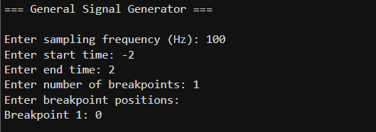
1.4 Error Handling Strategy
Input Type | Validation Rule | Purpose
Sampling Frequency | Fs>0 | Prevent invalid time step
Time Range | Start < end | Ensure valid interval
Breakpoints Count | Integer ≥ 0 | Logical segmentation
Breakpoint Position | between start and end. | Avoid out-of-range errors
1.5 Summary
The user input stage builds the foundation of the entire system by:
- Defining the time axis
- Dividing the signal into regions
- Ensuring all inputs are valid
2. Signal Generation
%% =========================
%% 3. GENERATE SIGNAL
%% =========================

y_total = zeros(size(t_total));

for r = 1:num_regions

fprintf('\n--- Region %d [%.2f -> %.2f] ---\n', ...
r, all_breaks(r), all_breaks(r+1));

% region time
if r < num_regions
idx = t_total >= all_breaks(r) & t_total < all_breaks(r+1);
else
idx = t_total >= all_breaks(r) & t_total <= all_breaks(r+1);
end

t_region = t_total(idx);

%% choose signal
disp('1=DC 2=Ramp 3=Polynomial 4=Exponential 5=Sinusoidal');
type = input('Enter choice: ');

while type < 1 || type > 5
type = input('Invalid! Enter (1-5): ');
end

%% generate region signal
switch type

case 1 % DC
A = input('Amplitude: ');
y_region = A * ones(size(t_region));

case 2 % Ramp
m = input('Slope: ');
b = input('Intercept: ');
y_region = m*t_region + b;

case 3 % Polynomial
a = input('Amplitude: ');
n = input('Power: ');
b = input('Intercept: ');
y_region = a*(t_region.^n) + b;

case 4 % Exponential
A = input('Amplitude: ');
k = input('Exponent: ');
y_region = A * exp(k*t_region);

case 5 % Sinusoidal
A = input('Amplitude: ');
f = input('Frequency: ');
phi = input('Phase: ');
y_region = A * sin(2*pi*f*t_region + phi);
end

% assign to full signal
y_total(idx) = y_region;
end

%% =========================
%% 4. ORIGINAL PLOT
%% =========================
figure;
plot(t_total, y_total, 'LineWidth', 2);
grid on;
title('Original Signal');
xlabel('Time');
ylabel('Amplitude');
2.1 Overview
In this section, the program generates the signal based on the user inputs. The signal is constructed as a piecewise function, meaning it is divided into multiple regions, and each region can have a different signal type.
The number of regions depends on the number of breakpoints entered by the user.
2.2 Signal Initialization
y_total = zeros(size(t_total));
- A zero vector is created to store the final signal.
- It has the same size as the time vector.
- Each region will be generated separately and then stored in this vector.
2.3 Dividing the Signal into Regions
for r = 1:num_regions
- The program loops over each region.
- Each region is defined between two consecutive breakpoints.

2.4 Extracting Region Time
if r < num_regions
idx = t_total >= all_breaks(r) & t_total < all_breaks(r+1);
else
idx = t_total >= all_breaks(r) & t_total <= all_breaks(r+1);
end

t_region = t_total(idx);
- The program selects the time samples that belong to the current region.
- idx is a logical index used to extract only the required portion of time.
- This ensures that each region is processed independently.
2.5 Selecting Signal Type
disp('1=DC 2=Ramp 3=Polynomial 4=Exponential 5=Sinusoidal');
type = input('Enter choice: ');
- The user selects the type of signal for each region.
- The program supports five types of signals.
2.6 Generating Signal in Each Region
The signal is generated based on the selected type:
1. DC Signal
y_region = A * ones(size(t_region));
- Produces a constant signal.
2. Ramp Signal
y_region = m*t_region + b;
- Produces a linear signal.
3. Polynomial Signal
y_region = a*(t_region.^n) + b;
- Produces a polynomial signal of order ( n ).
4. Exponential Signal
y_region = A * exp(k*t_region);
- Produces an exponential signal.
5. Sinusoidal Signal
y_region = A * sin(2*pi*f*t_region + phi);
- Produces a sinusoidal (wave) signal.
2.7 Combining All Regions
y_total(idx) = y_region;
- Each generated region is placed into its correct position in the full signal.
- After the loop finishes, y_total contains the complete signal.
2.8 Plotting the Signal
figure;
plot(t_total, y_total, 'LineWidth', 2);
grid on;
title('Original Signal');
xlabel('Time');
ylabel('Amplitude');
- The final signal is plotted in the time domain.
- This allows visualization of how the signal changes across regions.
2.9 Example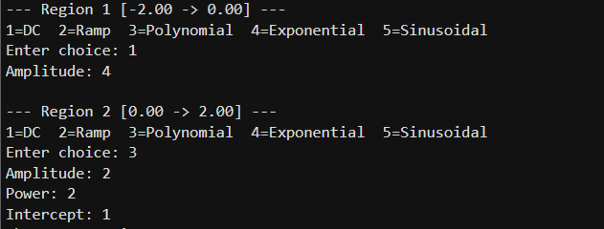
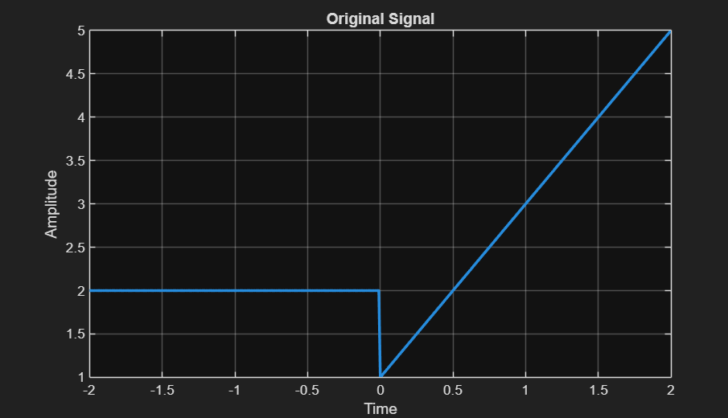
2.10 Summary
The signal generation process:
- Divides the time into regions
- Generates a specific signal in each region
- Combines all regions into one signal
- Displays the final result
3.signal operations
%% =========================
%% 5. OPERATIONS
%% =========================
% Start with the original generated signal
y_new = y_total;
t_new = t_total;

while true
disp('Choose Operation:');
disp('1-Amplitude Scaling');
disp('2-Time Reversal');
disp('3-Time Shift');
disp('4-Expansion');
disp('5-Compression');
disp('6-None');
op_id = input('Enter operation: ');

if op_id == 1
op_val = input('Enter scaling value: ');
elseif op_id == 3
op_val = input('Enter shift value: ');
elseif op_id == 4
op_val = input('Enter expansion factor: ');
elseif op_id == 5
op_val = input('Enter compression factor: ');
else
op_val = 0;
end

[y_new, t_new] = operation(y_new, t_new, op_id, op_val);

%% =========================
%% 6. SIGNAL PROPERTIES
%% =========================
tol = 1e-6;
% 1. Symmetry Check (Even/Odd)
t_min = t_new(1);
t_max = t_new(end);
is_even = false;
is_odd = false;
if abs(t_min + t_max) < tol
y_flipped = flip(y_new);
if all(abs(y_new - y_flipped) < tol)
is_even = true;
end
if all(abs(y_new + y_flipped) < tol)
is_odd = true;
end
end
%% -------- Causality --------
is_causal = all(abs(y_new(t_new < 0)) < tol);
%% -------- PRINT --------
fprintf('\nSignal Properties: ');
if is_even
fprintf('Even, ');
elseif is_odd
fprintf('Odd, ');
else
fprintf('Neither Even nor Odd, ');
end
if is_causal
fprintf('Causal, ');
else
fprintf('Non-Causal, ');
end

%% =========================
%% 7. ENERGY CALCULATION
%% =========================
dt = diff(t_new);
E = sum(abs(y_new(1:end-1)).^2 .* dt);
fprintf('\nSignal Energy = %.6f\n', E);

%% Ask for another operation
another = input('\nDo you want to perform another operation? (1 = Yes, 0 = No): ');
if another == 0
break; % exit the loop
end
end

%% =========================
%% 7. OPERATIONS FUNCTION
%% =========================
function [sig_out, t_out] = operation(sig_in, t_in, op_id, op_val)
switch op_id
case 1 % Amplitude Scaling
sig_out = sig_in * op_val;
t_out = t_in;
case 2 % Time Reversal
sig_out = flip(sig_in);
t_out = -flip(t_in);
case 3 % Time Shift
t_out = t_in + op_val;
sig_out = sig_in;
case 4 % Expansion
t_out = linspace(t_in(1), t_in(end), length(sig_in)*op_val);
sig_out = interp1(t_in, sig_in, t_out, 'linear', 0);
case 5 % Compression
t_out = linspace(t_in(1), t_in(end), floor(length(sig_in)/op_val));
sig_out = interp1(t_in, sig_in, t_out, 'linear', 0);
case 6 % None
sig_out = sig_in;
t_out = t_in;
otherwise
error('Invalid operation');
end
%% plotting
figure;
subplot(2,1,1);
plot(t_in, sig_in, 'LineWidth',2);
title('Input Signal'); grid on;
subplot(2,1,2);
plot(t_out, sig_out, 'LineWidth',2);
title('Output Signal'); grid on;
end
3.1 Overview
After generating the original signal, the program allows the user to apply different operations on the signal. These operations modify either the amplitude or the time axis of the signal.
3.2 Available Operations
The user can choose one of the following operations:
disp('Choose Operation:');
disp('1-Amplitude Scaling');
disp('2-Time Reversal');
disp('3-Time Shift');
disp('4-Expansion');
disp('5-Compression');
disp('6-None');
3.3 Operation Selection
op_id = input('Enter operation: ');
- The user selects the desired operation by entering a number from 1 to 6.
3.4 Loop Control and User Input
another = input('\nDo you want to perform another operation? (1 = Yes, 0 = No): ');
if another == 0
break; % exit the loop
end
- This code prompts the user to continue or stop the program after each operation.
- If the user enters 0, the break statement exits the loop; otherwise, execution continues.

3.5 Applying the Operation
[y_new, t_new] = operation(y_total, t_total, op_id, op_val);
- The operation is applied using a separate function.
- The output is a new signal and possibly a modified time vector

3.6 Operation Implementation
1. Amplitude Scaling
sig_out = sig_in * op_val;
- Multiplies the signal amplitude by a constant.
2. Time Reversal
sig_out = flip(sig_in);
t_out = -flip(t_in);
- Reflects the signal around the vertical axis.
3. Time Shift
t_out = t_in + op_val;
sig_out = sig_in;
- Shifts the signal in time.
- Uses interpolation to calculate new values.
4. Expansion
sig_out = interp1(t_in, sig_in, t_in / op_val, 'linear', 0);
- Stretches the signal in time (slower signal).
5. Compression
sig_out = interp1(t_in, sig_in, t_in * op_val, 'linear', 0);
- Compresses the signal (faster signal).
6. No Operation
sig_out = sig_in;
t_out = t_in;
3.7 Plotting Results
subplot(2,1,1);
plot(t_in, sig_in);
subplot(2,1,2);
plot(t_out, sig_out);
- The program displays:
- Original signal
- Modified signal

4. Signal Analysis
4.1 Overview
After applying operations, the program analyzes the resulting signal by checking its properties and calculating its energy.
4.2 Symmetry (Even / Odd)
% 1. Symmetry Check (Even/Odd)

t_min = t_new(1);
t_max = t_new(end);

is_even = false;
is_odd = false;

if abs(t_min + t_max) < tol

y_flipped = flip(y_new);

if all(abs(y_new - y_flipped) < tol)
is_even = true;
end

if all(abs(y_new + y_flipped) < tol)
is_odd = true;
end
end
- The signal is compared with its flipped version:
4.3 Causality
is_causal = all(abs(y_new(t_new < 0)) < tol);
The program checks if all values before ( t = 0 ) are zero.

4.4 Energy Calculation
%% =========================
%% 6. ENERGY CALCULATION
%% =========================
dt = diff(t_new);
E = sum(abs(y_new(1:end-1)).^2 .* dt);
fprintf('\nSignal Energy = %.6f\n', E);
- The program approximates the integral numerically.
4.5 Output Results
The program prints:
- Whether the signal is even or odd
- Whether it is causal
- The total energy
Examples
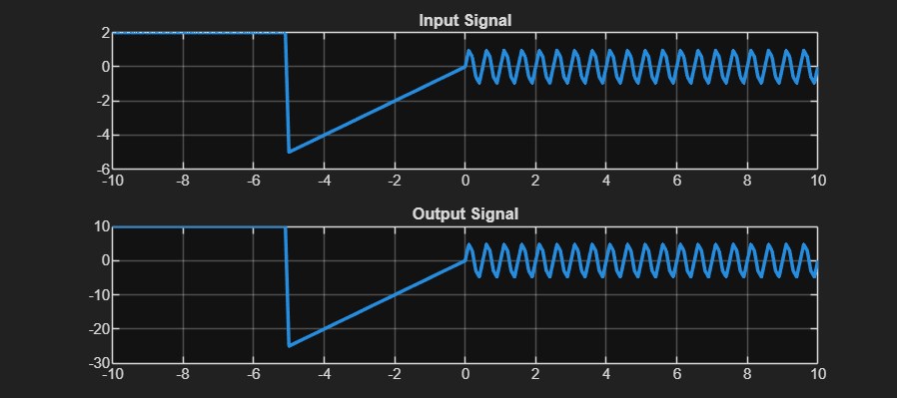
Figure 1: Amplitude Scaling (by 5)
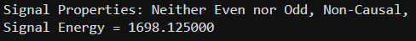

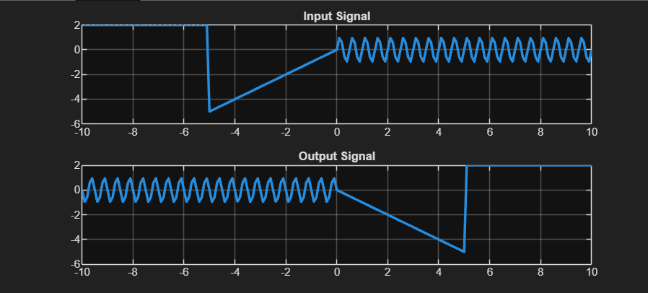
Figure 2: time reversal

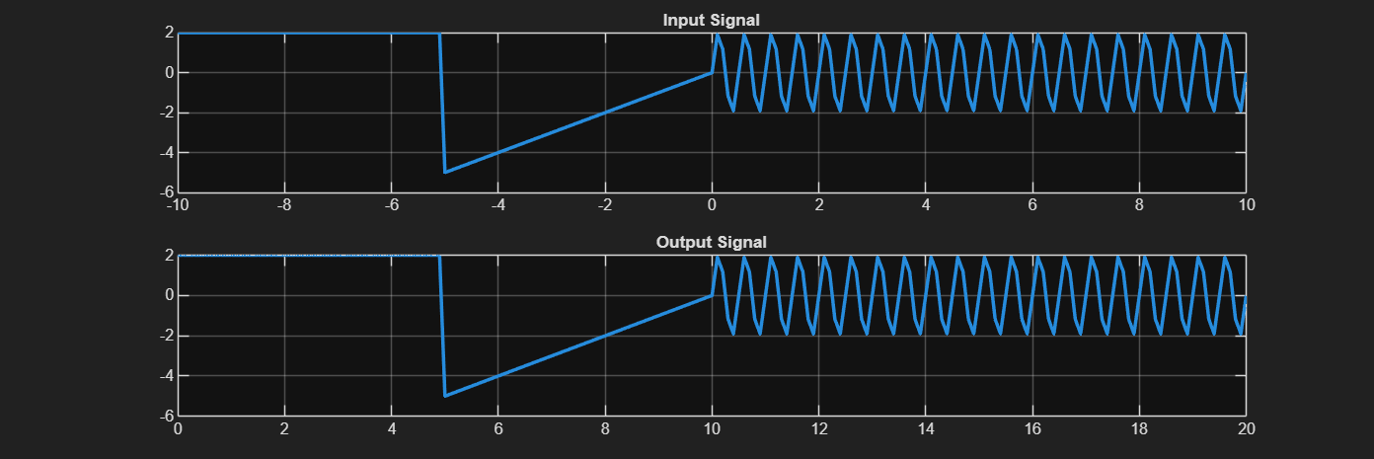
Figure 2: Time Shift (by 10)

