
MCT332s ByLaw2023
Engineering Measurements and Sensors
Fall 2026

Introduction to PC based Sensor Application Trainer & Photo-Diode Experiment
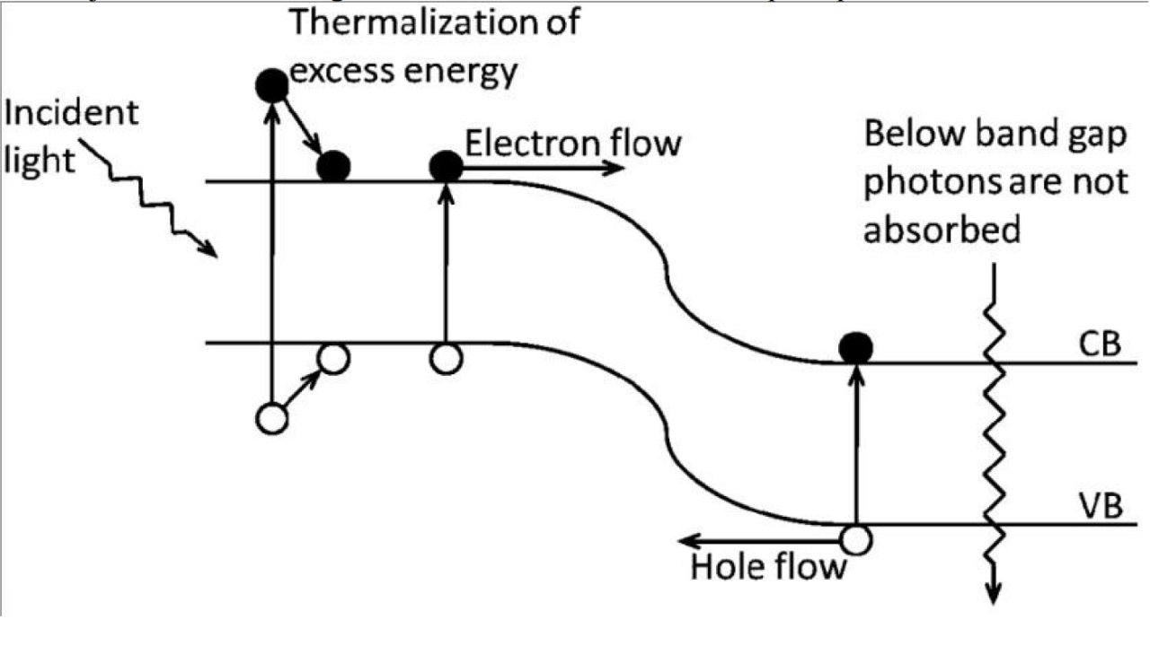
Name: Mohamed Ahmed Hamdy Gad
ID: 2401326 – Section: 3
Mechatronics
Lab 2 Report

Table of Contents

An Introduction 3
Objective 3
Lab Components 3
1. Worktable (CPE-SN2012T) 3
2. Relevant Sensors & Devices to the Experiment 4
Experiment 6
Comments 7
Conclusion 7

An Introduction

This lab introduces the PC-based Sensor Application Trainer used for engineering measurements, focusing specifically on the Photo-Diode sensor. A Photo-Diode is an optical sensor consisting of a semiconductor P-N junction that transforms optical energy into electrical energy through the photoelectric and photovoltaic effects! When light strikes the material, photons with energy greater than the band gap push electrons into the conduction band, leaving holes in the valence band. The resulting electric field accelerates electrons toward the n-layer and holes toward the p-layer, generating an electrical output proportional to the amount of light. These sensors are widely used due to their high linearity, rapid response times, broadband wavelength sensitivity, and also known for their low noise levels!

Objective

- Familiarization with the PC-based Sensor Application Trainer components.
- Analyse the physical interaction between light and semiconductor materials to understand how a Photo-Diode sensor generates current.
- Execute a practical wiring configuration connecting the Photodiode and an optical conversion apparatus on the worktable.
- Take different readings from the device according to different light intensities.

Lab Components

Worktable (CPE-SN2012T)
It’s an Aluminium Profile table + Trolley with four wheels and drawers for storage.
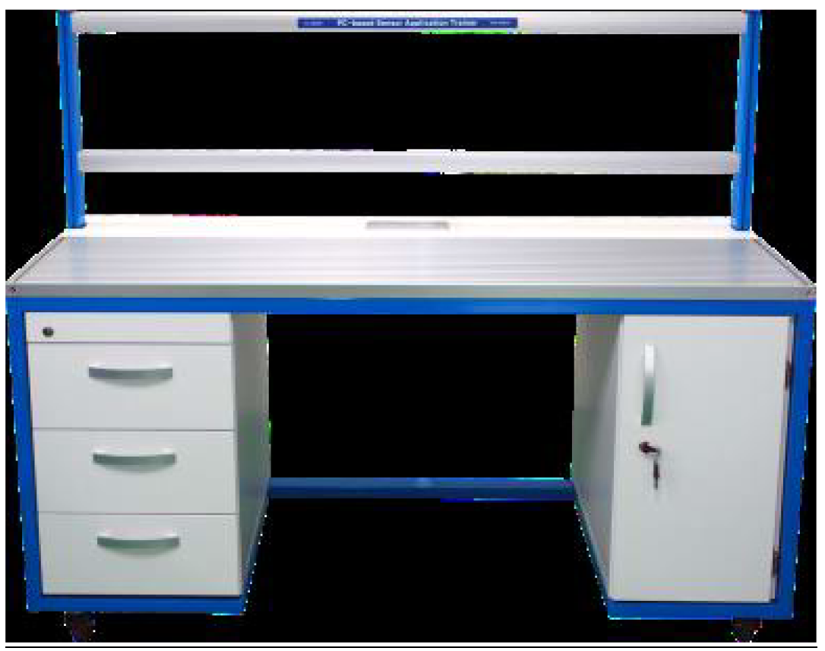
Figure 1 Worktable

Relevant Sensors & Devices to the Experiment
1-2-2 Power Supply (PN-7750)
Provides the optimal power delivery for the components
+ DC 24V Output Terminal: 3 pairs
+ Built-in Overcurrent/voltage (Buzzer)
+ Maximum Current: approximate 5A
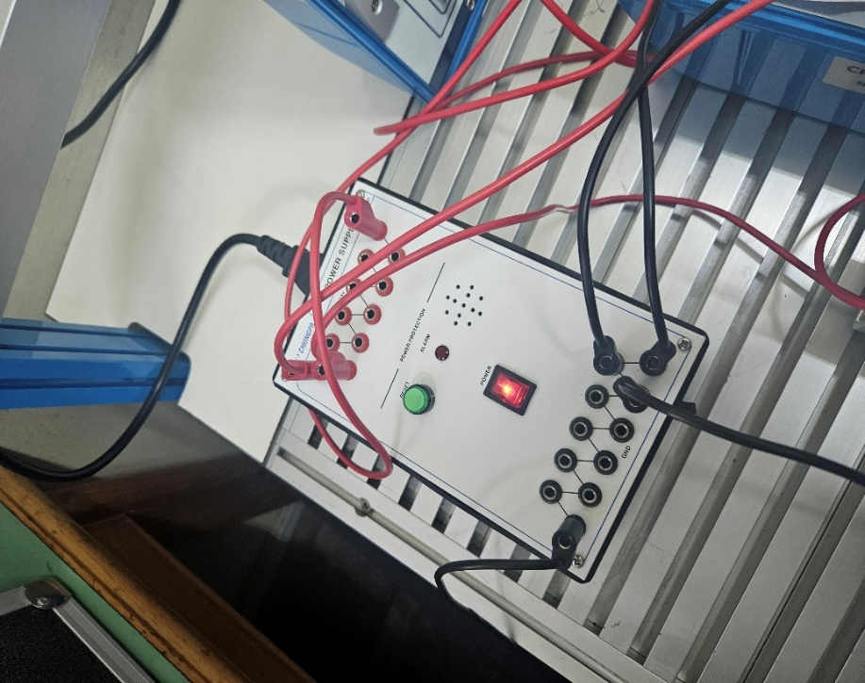
Figure 2 PSU

1-2-10 Photo Diode (CPE-SN2012-M02)
Senses the light intensity and outputs it as a signal
+ Output Type: Current [uA].
+ Discharging Voltage: DC 24V.
+ Built-in Polarity Protection Circuit
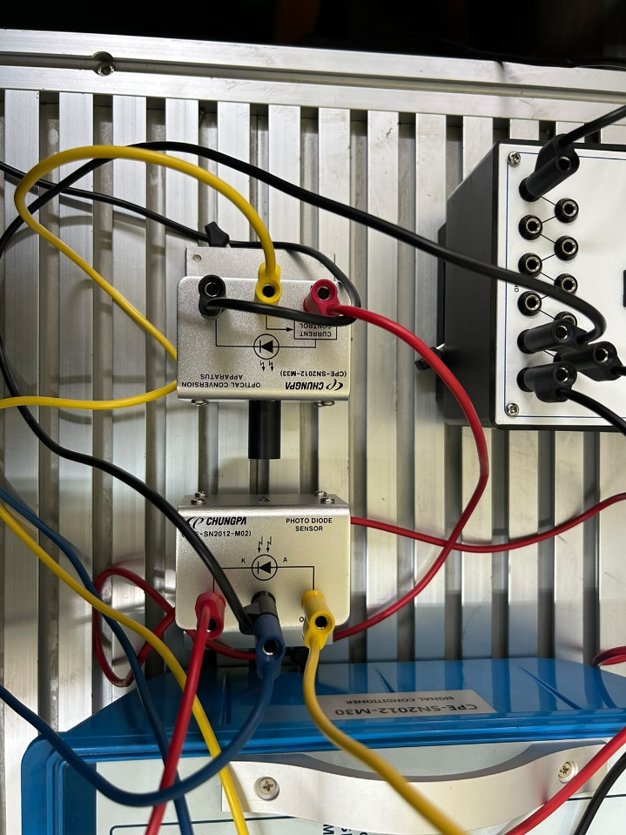
Figure 3 Photo Diode Sensor

A phone’s flashlight LED was used to provide different various intensity light for the photodiode sensor!

1-2-41 Signal Conditioner (CPE-SN2012-M30)
+ Power Source: DC 24V
+ Input Voltage Indication: 0~12V
+ Reference Voltage Indication :0~10V
+ Characteristics
+ 8-range selectable for the characteristics of each sensor
+ Operation of the built-in relay using an output value of sensor
+ Operation of the motor in large load and SOL V/V using relay output

1-2-40 Data Acquisition Module (CPE-MP115A)
+ Self DSO Standard
+ Resolution: 8 Bit
+ Analog Input Range: 0~12.75V
+ Function Generator Module
+ Generation waveform type :5types (Sine, Sawtooth 2 types, Square, Triangle)
+ Frequency output range :2.6~312.5Hz
+ DC Voltage Output Module (D/A Converter Output)
+ Output Level: 0~12.75V
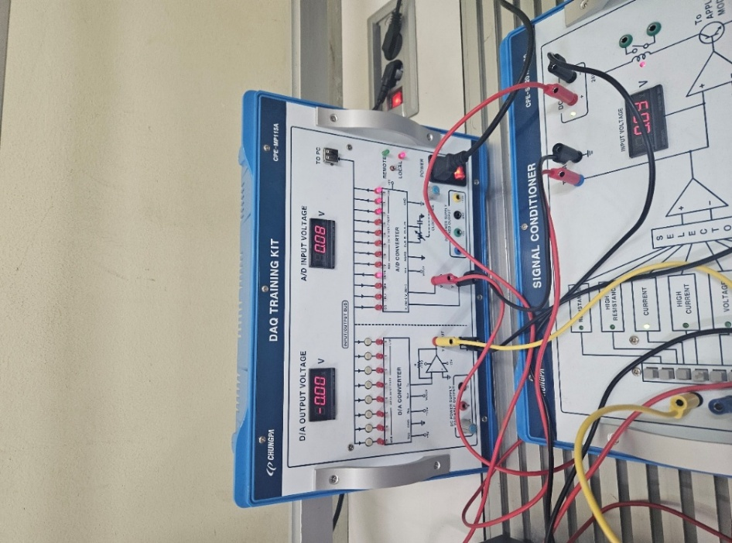
Figure 4 DAQ & Signal Conditioner

Signal conditioner prepares the raw, weak analog electrical current from the photodiode by converting, amplifying and filtering it while DAQ digitizes the clean signal so a computer can record analyze and display the data!

Experiment
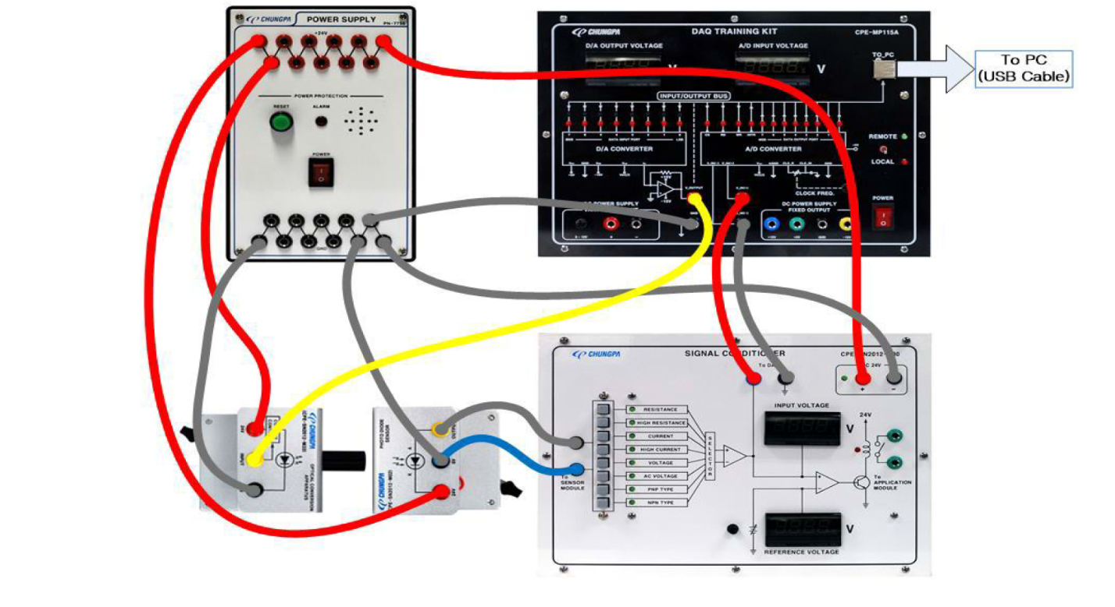
The following wiring diagram was connected:
Figure 5 Wiring Schematic
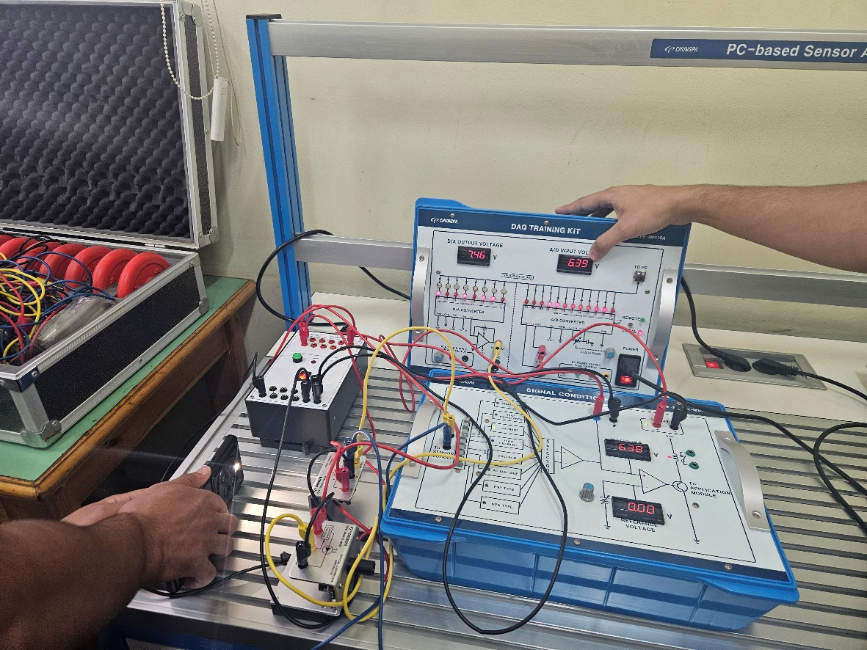
Figure 6 Practical Wiring

The power supply provides the required electrical power to the light source and photodiode circuit through the red and black wires. The light source shines onto the photodiode, which converts the received light intensity into a small electrical signal, which is connected to the signal conditioner, which amplifies and conditions it into a suitable voltage for measurement. The conditioned signal is then connected to the DAQ, which converts it into digital data.
Table 1 Lab Readings
Light Intensity (Phone Flashlight) | Voltage
Lvl 1 | 5.3
Lvl 2 | 7.55
Lvl 3 | 8.9
Lvl 4 | 10.85

Comments
  - The recorded data demonstrates a direct relationship between the intensity of incident light and the resulting voltage output from the Photodiode.
  - This voltage increase confirms the theory that the sensor generates an electrical output proportional to the amount of light it receives.

Conclusion
This laboratory exercise successfully validated the functional principles of the Photodiode. By actively transforming optical energy from the flashlight into electrical energy, the semiconductor P-N junction practically demonstrated the photoelectric and photovoltaic effects. The consistent, rise of the voltage in response to varying light intensities also verifies the sensor's characteristic linearity in measuring optical energy.

