Bilingual Arabic-English Customer Review Sentiment Analysis Using Machine Learning
Mohammad Rouhi Khattab, Salam Al-Buhaisi, and Mohammad Abu Khammash

Abstract- This paper presents a reproducible Arabic-English sentiment analysis prototype for customer-review support. After deduplication, the dataset contains 6,262 records: 2,979 English review sentences from the UCI Sentiment Labelled Sentences collection and 3,283 non-zero Arabic entries from a translated AFINN lexicon. Unicode-aware normalization and character 3-5-gram TF-IDF features were used to compare Logistic Regression with Multinomial Naive Bayes. On a stratified 20% hold-out set, Logistic Regression achieved 74.06% accuracy and 73.53% macro F1. Accuracy was 83.05% on English review sentences and 65.91% on held-out Arabic lexicon entries. The delivered system includes an offline bilingual web interface, command-line prediction, reproducible training, tests, and saved results.
Keywords- sentiment analysis, Arabic NLP, bilingual classification, character n-grams, TF-IDF, machine learning

Arabic Summary
يعرض هذا البحث نظاماً عملياً لتحليل المشاعر في المراجعات العربية والإنجليزية. تتكون البيانات بعد إزالة التكرار من 6,262 سجلاً، منها 2,979 جملة مراجعة إنجليزية حقيقية و3,283 مفردة أو عبارة عربية من معجم AFINN المترجم. استُخدمت خصائص TF-IDF على المقاطع الحرفية، وتمت مقارنة الانحدار اللوجستي مع نايف بايز. حقق النموذج المختار دقة كلية مقدارها 74.06%، مع التأكيد أن التقييم العربي معجمي ولا يمثل بعدُ تقييماً على مجموعة كبيرة من مراجعات عربية طبيعية.

Introduction
Online reviews provide direct evidence about product quality, service failures, and customer satisfaction, but manual reading becomes impractical when review volume grows. Sentiment analysis addresses this problem by assigning polarity to text and is a widely studied application of natural language processing (NLP) [1]. A practical classifier can help an organization screen feedback, identify dissatisfied customers, and prioritize recurring problems without requiring personal identifiers.
Arabic-English support is especially relevant in multilingual environments where customers may switch between Arabic, English, or mixed text. Arabic introduces additional challenges, including optional diacritics, multiple forms of the same letter, rich morphology, dialectal spelling, and right-to-left presentation. Large transformer models can address some of these issues, but they require more data and computing resources. This project therefore investigates whether a compact, fully offline machine-learning pipeline can provide an understandable baseline suitable for an undergraduate AI project.
The contributions are fourfold. First, a reproducible bilingual dataset is assembled from clearly attributed public resources. Second, one character-level TF-IDF representation is used for both scripts. Third, two classic classifiers are compared using a fixed hold-out set and five-fold cross-validation. Fourth, the selected model is deployed through bilingual command-line and local web interfaces. All reported values were generated by the delivered code, and the limitations of the Arabic component are reported explicitly.

Related Work
Pang and Lee [1] describe sentiment analysis as the computational study of opinions and evaluations in text. Traditional supervised systems commonly transform text into sparse features and train linear or probabilistic classifiers. The UCI Sentiment Labelled Sentences dataset was introduced in connection with the work of Kotzias et al. [2] and provides balanced positive and negative sentences from Amazon, IMDb, and Yelp [3]. Its small size and multiple domains make it useful for a transparent classroom baseline.
Lexicon-based approaches use lists of terms with manually assigned sentiment scores. AFINN assigns integer valence values from negative to positive terms and was evaluated for short social-media text [4]. The multilingual software source used in this project distributes translated AFINN lists, including Arabic [5]. Lexicons are computationally efficient, but isolated words cannot represent the complete pragmatics of review sentences, especially negation, sarcasm, and dialect. The Arabic results in this paper must therefore be read as lexicon-term generalization rather than full review-corpus validation.
Modern contextual models such as BERT learn bidirectional representations from large unlabeled corpora and can be fine-tuned for classification [7]. They are a strong future direction, but the present work deliberately uses scikit-learn [6] and interpretable sparse features to keep training reproducible on an ordinary computer without cloud services or specialized hardware.

Dataset and Ethics
The preprocessing script reads the three labelled UCI sources and the Arabic AFINN file, removes empty records, normalizes text, and removes exact duplicates within each language. The final dataset contains 6,262 records. The English portion contains 2,979 review sentences after deduplication. The Arabic portion contains 3,283 non-zero terms or short phrases. Table I summarizes the data used for training and evaluation.
- DATASET COMPOSITION AFTER DEDUPLICATION
Component | Records | Unit
UCI Amazon | 987 | Review sentence
UCI IMDb | 996 | Review sentence
UCI Yelp | 996 | Review sentence
AFINN Arabic | 3283 | Term / phrase
No names, account identifiers, phone numbers, addresses, or health records are required by the system. New institutional data should be anonymized before use. The UCI resource is published under CC BY 4.0, while the multilingual AFINN software source is distributed under the MIT license. The project retains source labels so that performance can be audited separately rather than hidden inside one overall score.

Methodology

Text Normalization and Representation
Text is normalized with Unicode NFKC, lowercasing for Latin text, removal of Arabic diacritics and tatweel, normalization of common alif variants, URL and e-mail replacement, punctuation filtering, and whitespace collapse. The same deterministic function is used during data preparation and inference. This avoids training-serving mismatch and preserves both Arabic and English characters.
Each record is represented using character n-gram TF-IDF with n from 3 to 5, sublinear term frequency, L2 normalization, a minimum document frequency of two, and a maximum of 60,000 features. Character features reduce dependence on language-specific tokenizers and capture useful subword patterns. The selected fitted pipeline retained 20,930 features.

Models and Evaluation
Two classifiers were compared: L2-regularized Logistic Regression with balanced class weights and Multinomial Naive Bayes with additive smoothing. A stratified split retained 5,009 records for training and 1,253 for testing while preserving every language-label combination. Five-fold stratified cross-validation was also run on the complete dataset. Accuracy, macro precision, macro recall, and macro F1 are reported. Model selection used hold-out macro F1 because the combined dataset is not perfectly class-balanced.
The learned task is binary: positive versus negative. The user interface additionally returns neutral/uncertain when the maximum predicted probability is below 0.60. This is an abstention mechanism and is not reported as a learned third class. It prevents weak predictions from being presented as confident decisions, but it should not be confused with a true neutral-sentiment model.

System Implementation
The implementation is written in Python and uses pandas for data handling, scikit-learn for feature extraction and classifiers, joblib for model persistence, and matplotlib for evaluation figures. The training script creates a processed UTF-8 CSV file, compares both pipelines, writes structured JSON metrics, saves all test predictions, selects the best model, and exports charts. A unit-test suite checks Arabic normalization, language detection, and positive/negative predictions in both languages.
Two interfaces are supplied. The command-line program accepts a review and can return either readable bilingual output or JSON. The local web application uses Python's standard HTTP server and therefore adds no web-framework dependency. It runs on localhost, accepts Arabic, English, and mixed text, and shows the bilingual label and confidence. Because the application is offline, review text is not transmitted to an external service.

Results and Discussion
Logistic Regression produced the highest hold-out macro F1 and was selected for delivery. It achieved 74.06% accuracy and 73.53% macro F1. Its five-fold mean accuracy was 74.03% with a standard deviation of 1.29 percentage points. Multinomial Naive Bayes reached 73.50% accuracy and 72.40% macro F1. The close cross-validation and hold-out values suggest that the comparison is stable under the fixed experimental design.
- MODEL PERFORMANCE ON THE HOLD-OUT SET
Model | Acc. | Macro F1 | CV F1
Logistic Regression | 74.06% | 73.53% | 73.38%
Multinomial NB | 73.50% | 72.40% | 72.22%
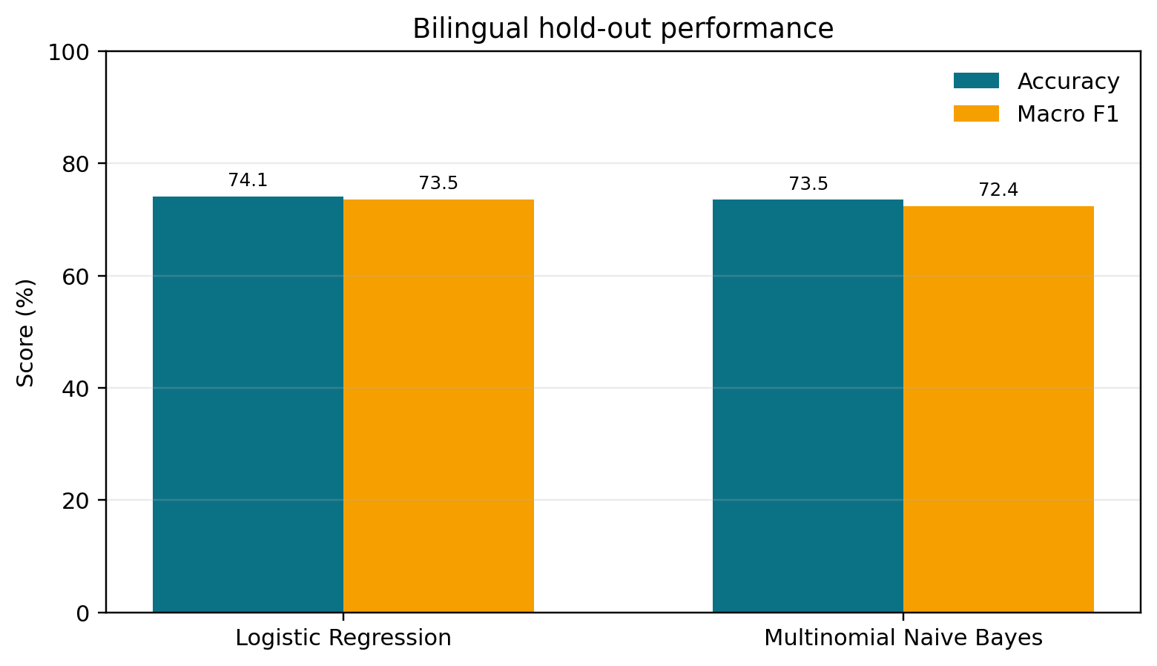
- Hold-out accuracy and macro F1 for both candidate models.
The selected model performed substantially better on English review sentences than on the Arabic lexicon component. English accuracy was 83.05% with 83.02% macro F1. Arabic lexicon accuracy was 65.91% with 62.31% macro F1. Among English sources, accuracy was 85.56% for Amazon, 79.90% for IMDb, and 83.81% for Yelp.
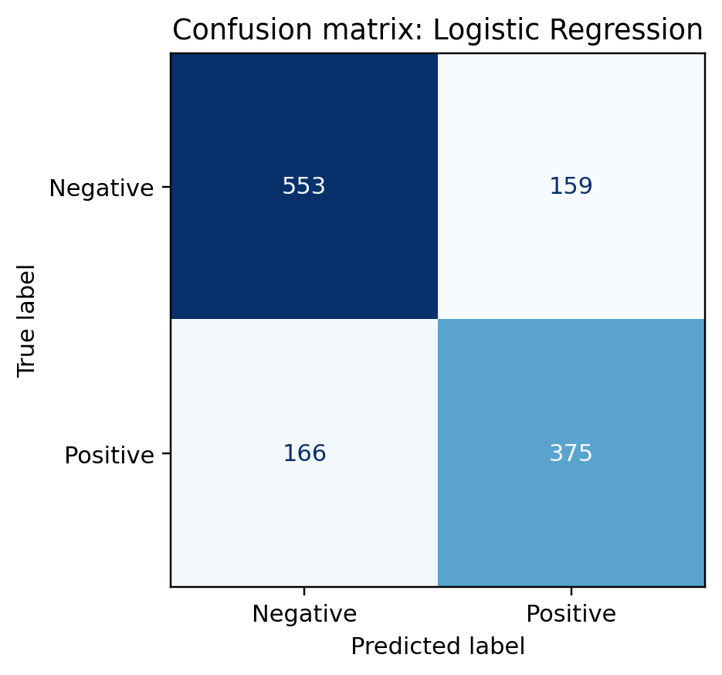
- Confusion matrix for the selected Logistic Regression model.
The confusion matrix contains 553 correctly predicted negative records and 375 correctly predicted positive records. There were 159 false positives and 166 false negatives. Errors were therefore distributed across both classes rather than being confined to one label. The balanced class weights helped Logistic Regression despite the larger number of negative Arabic lexicon entries.
The results show that a compact character-level baseline can support both scripts with one feature pipeline. However, the Arabic and English numbers are not directly equivalent: English test records are natural review sentences, while Arabic test records are translated sentiment terms. The lower Arabic score and this unit mismatch both motivate a dedicated Arabic review corpus rather than stronger claims based on the overall result alone.

Limitations and Future Work
The main limitation is the absence of a large, naturally occurring, manually annotated Arabic customer-review dataset. The translated lexicon does not capture sentence-level negation, sarcasm, word order, Palestinian dialect, Arabizi, or code-switching. The English dataset is also small and limited to three older domains. Random sentence splitting measures in-domain generalization but does not prove transfer to a new organization or time period.
The project also uses binary labels. Its neutral output is only a confidence-based abstention, and probability estimates from simple text classifiers should not be interpreted as calibrated risk without additional validation. Customer-service deployment would require human review, drift monitoring, domain-specific thresholds, and an appeal path for decisions that affect users.
Future work should collect consented, anonymized Arabic and mixed-language reviews from a relevant local domain, define annotation guidelines, measure inter-annotator agreement, and keep a source-separated test set. Word and character features can then be compared with multilingual BERT or an Arabic pretrained model [7]. A genuine three-class dataset should be used if neutral sentiment is required. Explainability can also be improved by highlighting influential n-grams and grouping errors by dialect, topic, and review length.

Conclusion
A complete Arabic-English sentiment-analysis prototype was implemented, tested, and documented. The system combines Unicode normalization, character n-gram TF-IDF, and two classic classifiers in a reproducible pipeline. Logistic Regression was selected with 74.06% overall accuracy, while the English review subset reached 83.05%. The system is suitable as an educational baseline and offline demonstration, but the Arabic lexicon evaluation is not sufficient for claims about real Arabic customer reviews. The delivered code, model, predictions, metrics, figures, interfaces, and paper provide a transparent foundation for collecting stronger local data and evaluating modern multilingual models.

References
- B. Pang and L. Lee, “Opinion mining and sentiment analysis,” Foundations and Trends in Information Retrieval, vol. 2, nos. 1-2, pp. 1-135, 2008.
- D. Kotzias, M. Denil, N. de Freitas, and P. Smyth, “From group to individual labels using deep features,” in Proc. 21st ACM SIGKDD Int. Conf. Knowledge Discovery and Data Mining, 2015, pp. 597-606.
- D. Kotzias, “Sentiment Labelled Sentences,” UCI Machine Learning Repository, 2015, doi: 10.24432/C57604.
- F. A. Nielsen, “A new ANEW: Evaluation of a word list for sentiment analysis in microblogs,” in Proc. ESWC Workshop on Making Sense of Microposts, vol. 718, 2011, pp. 93-98.
- M. Barile, “multilang-sentiment: Multi language AFINN-based sentiment analysis,” GitHub repository, 2021. [Online]. Available: https://github.com/marcellobarile/multilang-sentiment
- F. Pedregosa et al., “Scikit-learn: Machine learning in Python,” Journal of Machine Learning Research, vol. 12, pp. 2825-2830, 2011.
- J. Devlin, M.-W. Chang, K. Lee, and K. Toutanova, “BERT: Pre-training of deep bidirectional transformers for language understanding,” in Proc. NAACL-HLT, 2019, pp. 4171-4186.

