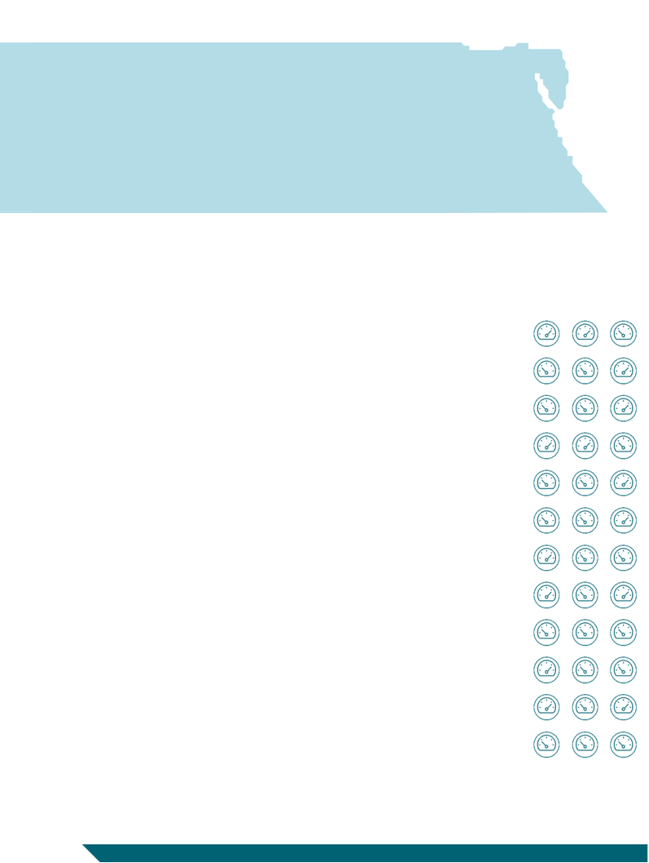
Business Barometer
Issue 75 April – June 2025


Contents

Executive Summary 2
Business Barometer Methodology 6
Business Barometer Index (BBI) 12
I. Performance evaluation and outlook according to the overall index 12
II. Constraints that faced the business community during the quarter under review, and priorities for improving the business environment from the perspective of the sample of firms 16
III. Performance evaluation and outlook according to sub-indices 23
Tables Appendix 27

Sponsored by


cibeg.com


Executive Summary
This edition of Business Barometer presents a periodic assessment conducted by the Egyptian Center for Economic Studies (ECES) of a sample of 120 private sector firms spanning various sectors and sizes. It reflects the business community's views on developments in a number of variables, specifically: production, domestic sales, exports, commodity inventory, capacity utilization, prices, wages, employment, and investment, during the quarter April-June 2025. It also presents its projections for the quarter July-September 2025, and compares the results with the previous quarter (January-March 2025) and the corresponding quarter (April-June 2024). The following is a brief overview of the report's key findings for the quarter under study (April-June 2025).
Better
> 50
Worse
< 50
Neutral Level
50
I I I I I I I I I I I

Evaluating performance and exploring the outlook based on the overall index
- The business performance index for the quarter April-June 2025 surpassed the neutral level
- The expectations index surpassed the neutral level for the upcoming quarter
According to size:
- There is no variation in performance across firm sizes, as the business performance index for all firms exceeded the neutral level.
Sectorally:
- Performance indicators for all sectors exceeded the neutral level, with the exception of the manufacturing sector, which saw the lowest performance among sectors, achieving values below the neutral level.
Challenges:
- Frequent hikes in energy and water prices top the list of constraints facing all firms, followed by the challenges related to higher inflation, then difficulties in dealing with government entities.
- The manufacturing and construction sectors, as well as small and medium-sized enterprises (SMEs), have been the most affected.

The Business Performance Index (BPI) for the quarter under review (April-June 2025) scored values one point above the neutral level, with sub-indices maintaining their good performance. Compared to the previous quarter, the BPI declined by about 7 points, due to a sharp decline in the wage index after a significant jump in the previous quarter, and to a decline in the production, sales, and capacity utilization indices, although they still registered values above the neutral level.

The Performance Expectations Index for the quarter July-September 2025 also recorded values 4 points above the neutral level, which is attributed to expectations that all sub-indices will surpass the neutral level, reflecting the expected stability of the indices at the same performance as the current quarter, with the exception of the tourism, communications, and financial services sectors, whose sub-indices are expected to rise during the upcoming quarter.


According to size:
There is no variation in performance across firm sizes. The business performance index for all firms exceeded the neutral level during the quarter under study, recording lower values than the previous quarter, but better than the corresponding quarter. This reflects the consistent good performance of all sub-indices and the improvement in the export index for large firms during the current quarter.

Sectorally:
Performance indicators for all sectors exceeded the neutral level, with the exception of the manufacturing sector, which saw the lowest performance, scoring values below the neutral level. Meanwhile, the performance index for the construction sector recorded values at the neutral level.
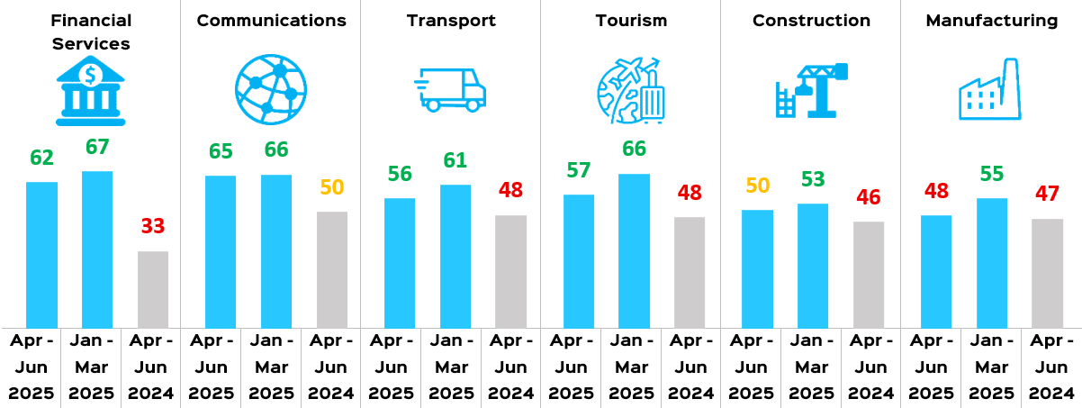

The manufacturing sector recorded the lowest performance, with values two points below the neutral level and seven points lower than the previous quarter, albeit one point better than the corresponding quarter. This is primarily due to the decline in all sector indices below the neutral level during the quarter under review, and compared to the previous quarter, reflecting the decline in production and export indices. It is also due to the sharp decline in the wage index and the decrease in domestic sales, especially for food industries and ready-made garments, due to the decline in demand with the end of Ramadan and the holidays and the approaching end of the school year.

The telecommunications sector registered the best performance, exceeding the neutral level by 15 points, but one point lower than the previous quarter and 15 points better than the corresponding quarter. This is attributed to the recovery of all sector indices, particularly exports, with expanded access to the African markets and decline in intermediate input prices compared to the previous quarter.


Challenges and priorities from the business community's perspective:
The recurring increases in energy and water tariffs continue to top the list of constraints facing all firms during the quarter under study.

Higher energy and water tariffs top the list of constraints facing all businesses, particularly in the manufacturing and tourism sectors. The result is an increase in production costs, particularly in energy- and water-intensive activities, and productive activities in general, representing an additional burden on firms. Challenges related to rising inflation ranked second, followed by difficulties in dealing with government agencies, which ranked third. The business community suffers from slow procedures and red tape, along with the presence of numerous judicial police officers in most government agencies, opening the door to corruption and unofficial payments. In fourth place came unclear future economic policy directions and lack of disclosure of the State's future economic intentions. These constraints hinder firms’ ability to formulate future plans. Furthermore, there is a lack of a long-term vision, especially regarding investment and debt.
Although energy and water tariffs and high inflation top the list of constraints facing all businesses, small and medium-sized enterprises (SMEs) specifically face a greater number of challenges than large firms.

The key priorities to focus on from a business perspective are: reconsidering energy and water tariffs, controlling inflation, disclosing future economic policy directions, maintaining efforts to resolve tax system problems, along with facilitating government procedures.
Finding solutions to address inflation, revisiting energy and water prices, and disclosure of future economic policy directions topped the list of priorities for all firms. Meanwhile, the remaining priorities varied, with economic policy consistency coming at fourth place for large firms, while improving the tax system came at fourth place for SMEs.

Main Macroeconomic Developments: *
- Globally: Global growth forecasts continue to decline, with low and uneven growth and multiple challenges facing the global economy.
- Locally: There are signs of macroeconomic stability during the first half of 2025, due to improved tourism and Ras El-Hekma investments, a narrowing foreign exchange gap, and a decline in inflation. Structural reforms need to be completed to maximize benefits from macroeconomic stability and enhance the resilience of the Egyptian economy.

* For more details on the latest global, regional and local financial developments, refer to the monthly financial report (Financial Markets Snapshot).



About ECES
The Egyptian Center for Economic Studies (ECES) is an independent, non-profit think tank that conducts specialized economic research, drawing on international experience and constructive discussions among various stakeholders. ECES’s main objective is to propose sound economic policies, and institutional and legislative reforms that contribute to sustainable development in Egypt, all on the basis of combined economic efficiency and social justice.

ECES Board of Directors
Chairman: Omar Mohanna, Chairman of: Egypt-US Business Council (EUSBC), Chubb Insurance Egypt, Prometeon Tyre Egypt Co. (Pirelli), Coca-Cola HBC Egypt & the United Bank
Vice Chairman: Tarek Tawfik, Chairman, Cairo Poultry
Secretary General: Mohamed Kassem, Chairman, World Trading Co., Egypt
Treasurer: Alaa Hashim, Founder and Excutive Partner, TRANSCENDIUM

Ahmed Abou Ali, Partner, Hassouna & Abou Ali Law Offices
Ahmed Fikry Abdel Wahab, General Manager and CEO, EGA - Egyptian German Automotive
Hussein Choucri, Chairman and Managing Director, HC Securities and Investment
Sherif ElKholy, Partner and Co-head of the Middle East & North Africa, Actis
Aladdin Sabaa, Chairman of Basata E-Payments and Basata Finance.
Mohamed Zakaria Mohie El Din, Chairman and Managing Director, National Company for Chemical Industries – NASYDCO
Hisham El Khazindar, Co-Founder and Managing Director, Qalaa Holdings

ECES Honorary Chairpersons
Galal El Zorba, Chairman of Nile Holding Co.
Hazem Hassan, Chairman, KPMG Hazem Hassan Management Consultants

ECES Staff
https://eces.org.eg/en/eces-team/
Abla Abdel-Latif, PhD, Executive Director and Director of Research  Sahar Aboud, PhD, Principal Economist  Rama Said, Senior Economist  Racha Seif El-Dine, Senior Economist  Ahmed Dawoud, Economist  Mohamed Hosny, Economist  Marian Adel, Economist  Sondos Samir, Research Analyst  Aya Saleh, Research Analyst  Israa Adel, Research Analyst  Youssef Nasr, Research Analyst  Mahmoud Mohamed, Research Analyst  Ahmed Habashy, Data Analyst  Abdelrahman Eleshaky, Data Analyst  Osama ElShamy, Data Analyst  Mohamed Abdellatef, Data Analyst | Ahmed Fathy, Field Researcher  Hossam Khater, Field Researcher  Mohamed Khater, Field Researcher  Yasser Selim, Managing Editor  Fatma Al-Zahraa Ali, Senior Editor/ Translator  Ebrahim El-Embaby, IT Manager  Walied El-Torky, Digital Communication Manager  Mohamed Abdel-Hakam, Communication Specialist  Mohamed Leheta, Finance and Administration Manager  Miral Michel, Assistant to the Executive Director  Amani Medhat, Research and Executive Assistant  Mohamed Atef, Administrative Assistant  Hussein Mohamed, Support Staff  Tarek Attia, Support Staff  Mohamed Gamal, Support Staff  Walid Ibrahim, Support Staff  Amr Mohamed, Support Staff


Report Details

Business Barometer Methodology
To complement its efforts in providing integrated information that reflects the developments witnessed by the Egyptian economy in general and the business community in particular, the Egyptian Center for Economic Studies (ECES) has been issuing its Business Barometer (BB) since 1998. The BB provides a quarterly assessment of the performance of a sample of private firms covering various sectors and sizes. This assessment reflects the opinion of the business community regarding developments across a set of variables during the quarter under review, and sheds light on its outlook for the development of the same set of variables in the next quarter.
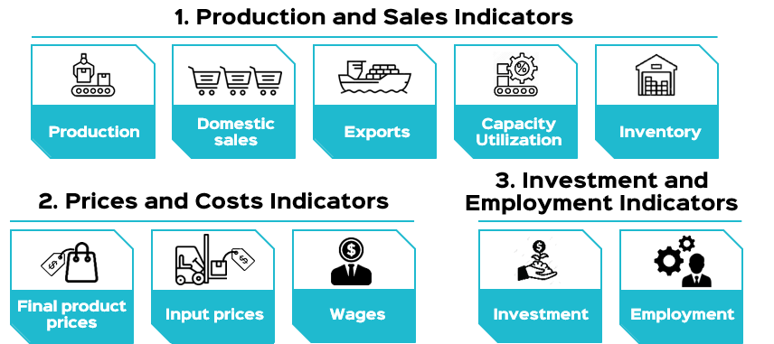

The significance of this issue of the Business Barometer increases in light of the challenges the business community has faced since early 2020, starting with the COVID-19 pandemic, followed by a recovery accompanied by many challenges in 2021, the Russian-Ukrainian war in early 2022, and most recently, the war in Gaza and geopolitical unrest in the Red Sea since October 2023, which has exacerbated these challenges. Therefore, it is important to track the impact of these developments.
This report presents an evaluation of the sample firms’ performance during the quarter (April-June 2024) and their expectations for the quarter (July-September 2024).
The report begins with an overview of the macroeconomy at both the global and local levels, it then presents the performance evaluation and expectations at the level of the overall index, followed by to the constraints faced by the business community during the study period, and the priorities for improving the business climate from the sample firms’ perspectives. Finally, the report concludes with an evaluation of performance and expectations at the level of the sub-indices.
The Business Barometer is based on the results of a periodic survey conducted by the center every three months on a fixed sample of 120 private sector firms distributed as follows:
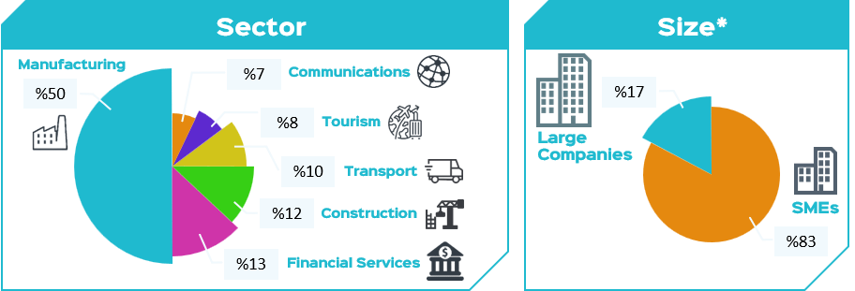


- The analysis evaluates the performance of the sample firms during the study period and their expectations for the next quarter, compared to the results of the previous quarter and the corresponding quarter of the previous year.
- Performance and expectations are evaluated on two levels: the overall index results and the sub-indices’ results.
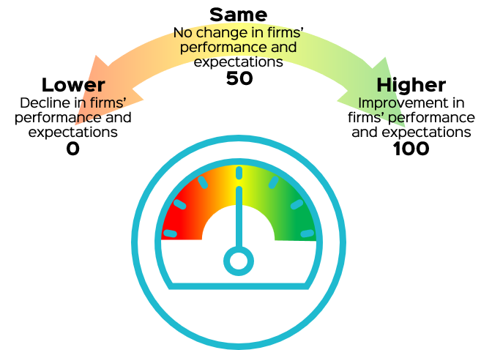
- The Business Barometer Index represents a simple average of a set of sub-indices for the variables mentioned in the questionnaire. The overall index takes values greater than, less than, or equal to the neutral level (50 points).

The index is calculated for each variable using this equation: | 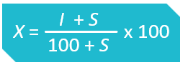 | where I is the share of firms reporting an increase and S the share of firms reporting “same.”

Regarding the constraints and priorities for improving the business climate:
Firms evaluate the severity of each constraint, with the rating ranging from zero (not impactful) to four (highly impactful). Firms are allowed to choose more than one constraint. Regarding the priorities for improving the business climate, firms rate the priorities, with the rating for each axis ranging from zero (not important) to four (high priority). Firms are allowed to choose more than one axis as a priority for improving the business climate.
Next, a weighted average is calculated based on the number of firms and their evaluation of the constraint/priority across the entire sample.
All averages for constraints/priorities are re-evaluated to range between zero and one, followed by normalization of the new averages for all constraints/priorities. This allows for ranking the constraints/priorities in descending order according to their severity, with 100% being the most severe constraint and the highest priority.


Macroeconomic Overview
Globally: Global growth forecasts continue their downward trend, with low and uneven growth and multiple challenges facing the global economy.
Global growth forecasts continued to decline, ranging between 2.3% and 3% in 2025, due to persistent uncertainty resulting from protectionist trade policies and geopolitical tensions. This decline reflects the slowdown in expected growth rates, which are set to reach 1.5% for advanced economies and stabilize at 4% for emerging and developing markets. This is compounded by expectations of a sharp decline in international trade volumes and investment flows, as well as increased borrowing burdens.
Global inflation is expected to continue its downward trajectory, from an annual average of 5.9% in 2024 to 4.2% in 2025, as a result of lower commodity prices, and relative decline of energy prices following increased oil production outside the OPEC+ alliance and weak global demand. However, risks still surround the paths of inflation and growth, especially if geopolitical tensions, rising trade protectionism, and climate change shocks persist. Accordingly, central banks in both advanced and emerging economies have adopted a cautious approach to monetary policy.
The composite Purchasing Managers' Index (PMI) continued to grow for the sixth month in a row, recording 51.7 points in June 2025, driven by growth in manufacturing production and slower growth in services activity. Thus, the index for the second quarter of 2025 is expected to be approximately 51.2 points, representing a decline of about 0.6 points compared to the previous quarter and around 1.8 points compared to the corresponding quarter in 2024. Although the index surpassed the neutral level, confidence in the manufacturing and services sectors declined, and labor demand saw a significant decline, reflecting global economic pressures.

Locally: There are signs of macroeconomic stability during the first half of 2025 due to improved tourism, Ras El-Hekma investments, and a narrowing foreign exchange gap. However, completing structural reforms is essential to maximize benefits from macroeconomic stability and enhance the resilience of the Egyptian economy in the face of crises.
The fourth review by the International Monetary Fund (IMF) has been concluded, under which a $1.2 billion tranche would be disbursed to complete the economic reform program. The Fund expects economic growth to continue at around 3.6% by end of 2024/25, driven by improved foreign direct investment in the North Coast and the mining and manufacturing sectors. It also expects inflation to decline, net foreign exchange reserves to improve, and debt-to-GDP ratio to decline, driven by investments in Ras El-Hekma. However, the debt burden remains high, narrowing the fiscal space for targeted social spending.
To build on economic stability and enhance resilience in the face of global challenges, the Fund stressed the need to complete structural reforms. Most importantly, the state must rapidly withdraw from non-strategic activities, complete the removal of energy subsidies, improve governance and oversight of off-budget entities, and continue to avail a business environment that ensures fair competition between the state and the private sector. Finally, there is a need to integrate climate change efforts into strategic plans.


The following section includes a brief overview of developments in the most important macroeconomic indicators, based on the latest data available up to the date of this report.

I. GDP Growth
- GDP grew at a rate of 4.7% in the third quarter of fiscal year 2024/2025 (January - March 2025), representing an increase of approximately 11% compared to the previous quarter and 115% compared to the corresponding quarter of the previous fiscal year (2023/2024). This increase is due to the positive contribution of net exports to growth, which offset the slight decline in the contribution of household consumption, in addition to the recovery of growth in non-oil manufacturing, tourism, and communications and information technology. Growth was inhibited by the continued decline in Suez Canal activity due to ongoing geopolitical tensions, as well as the declining performance of the extraction sector.
Figure 1: Real GDP Growth (2015/2016 – Q2 2024/2025)

Source: Ministry of Planning and Economic Development

II. Inflation
- Following the increased average annual headline inflation rate for the entire republic over the previous three months, it declined to 14.4% in June, compared to about 16.5% in May 2025. This reflects the fading impact of the shocks resulting from the fuel price hike in April 2025, which increased the cost of land transportation, services and consumer goods, especially pharmaceutical products. It also mirrors the fading effect of the seasonal increase in demand for food commodities after the end of Ramadan and the holidays (Central Agency for Public Mobilization and Statistics, 2025).
To sustain the downward trend in inflation, the Monetary Policy Committee of the Central Bank of Egypt decided, in its meeting on Thursday, July 10, 2025, to maintain the overnight deposit and lending rates, and the rate of the Central Bank's main operation, at 24.00%, 25.00%, and 24.50%, respectively. It also decided to keep the credit and discount rate at 24.50%.


Figure 2: Inflation and Key Interest Rates

Sources: Central Bank of Egypt, Monthly Statistical Bulletin; Press release on the exceptional meeting of the Monetary Policy Committee on March 6, 2024; CAPMAS, Monthly Bulletin of Consumer Price Indices, various issues.

III. Foreign transactions
Balance of payments: The July-March period of fiscal year 2024/25 saw the balance of payments shift from an overall surplus of approximately $4.1 billion to an overall deficit of $1.9 billion. This is due to a decline in net capital inflows and financial transactions to $7.7 billion during the mentioned period, compared to $20 billion during the period July-March 2023/2024, thanks to investments in Ras-El-Hekma.
The current account deficit declined by 22.6% to approximately $13.2 billion during July-March 2024/25, compared to $17.1 billion during the same period of the previous fiscal year, due to an 82.7% increase in remittances from Egyptians working abroad, reaching $26.4 billion, and growth by 23.0% in tourism revenues, recording $12.5 billion. The significant increase in non-oil commodity exports contributed to a 56.9% increase, reaching $25.6 billion.
The improvement in the current account was offset by the increased deficit in the petroleum trade balance due to the rise in petroleum imports to about $10.3 billion, and non-petroleum imports to $28 billion, as well as the decline in Suez Canal revenues by 54.1% to reach $2.6 billion only (Central Bank of Egypt, 2025).
Net foreign assets: Net foreign assets of the banking sector (both central bank and commercial banks) rose by approximately $1.2 billion to $14.7 billion in May 2025, compared to $13.6 billion in April 2025. This increase was driven by an improvement in net foreign assets at commercial banks, reaching their highest level since February 2021 (Cabinet, 2025).
Net international reserves: Net international reserves grew to $48.7 billion at the end of June 2025, compared to $48.525 billion at the end of May. Thus, average net reserves during the last quarter of fiscal year 2024/2025 (April-June 2025) increased by approximately 2% compared to the previous quarter, and by approximately 9% compared to the corresponding quarter of fiscal year 2023/2024.
- The value of the Egyptian pound against the US dollar stabilized during the quarter under study (April-June 2024/2025) at 50.38, representing a recovery of approximately -0.1% for the pound compared to the previous quarter, while representing a decline of approximately 6% compared to its value in the corresponding quarter of fiscal year 2023/2024 (Figure 3).



Figure 3: Net International Reserves and Exchange Rate

Sources: Central Bank of Egypt, Monthly Statistical Bulletin, various issues; Ministry of Finance, Monthly Financial Report, various issues.

IV. Public Finance
The overall deficit in the State's general budget as a percentage of GDP decreased during the period July-May 2024/2025 to -6.9% compared to -7.3% in the corresponding period of the previous fiscal year. This is due to:
- Public revenues rising by 1.3% to EGP 2,246.6 billion, driven by a 36% increase in tax revenues.
- Public expenditures increasing by approximately 25.2% to EGP 3,408.7 billion, while public spending continued to be controlled at a ceiling of EGP 1 trillion (Ministry of Finance 2025).
- According to the Ministry of Finance, the debt-to-GDP ratio decreased from 89.4% in June 2024 to 85% in June 2025, as a result of a decline in domestic debt by approximately eight percentage points and external debt by approximately 2.7 percentage points.


Business Barometer Index (BBI)
Evaluation
Outlook

I. Performance evaluation and expectations according to the overall index
The business performance index continued to surpass the neutral level during the quarter under study, with varying performance across sectors.
1-1 Overall index
The Business Performance Index for the quarter under study (April - June 2025) exceeded the neutral level by one point, as most indices surpassed this threshold, reflecting stable performance in the previous quarter. Compared to the previous quarter, the business performance index declined by about 7 points due to a sharp decline in the wage index following a significant jump during the previous quarter, as well as a decline in the production, sales, and capacity utilization indices, albeit still above the neutral level (Figure 1-1).
The performance expectations index for the quarter July-September 2025 also recorded higher values than neutral by 4 points, one point less than the previous quarter, and two points higher than the corresponding quarter. This is attributed to expectations of an increase in all indices above the neutral level due to current stable performance, with the exception of the tourism, communications, and financial services sectors, whose sub-indices are expected to rise during the upcoming quarter (Figure 1-2).

 |  | Apr-Jun |  | Jul-Sep |  | Oct-Dec |  | Jan-Mar | Apr-Jun |  | Jul-Sep |  | Oct-Dec | Jan-Mar* | Apr-Jun** | Jul-Sep | Oct-Dec | Jan-Mar | Apr-Jun | Jul-Sep | Oct-Dec | Jan-Mar | Apr-Jun | Jul-Sep | Oct-Dec | Jan-Mar | Apr-Jun | Jul-Sep | Oct-Dec | Jan-Mar |  | Apr-Jun | Jul-Sep | Oct-Dec | Jan-Mar | Apr-Jun | Jul-Sep
 | 2018 |  |  |  |  |  |  | 2019 |  |  |  |  |  | 2020 |  |  |  | 2021 |  |  |  | 2022 |  |  |  | 2023 |  |  |  |  | 2024 |  |  |  | 2025

Figure 1.1. Past Performance
Figure 1.2. Outlook
Development of the Overall Business Barometer Index

Source: Survey results.
* Data for January-March 2020 are unavailable due to the pandemic-related lockdown.
** Data for April-June 2020 are unavailable due to the pandemic-related lockdown


1-2 The index according by firm size
Performance is consistent across different sizes of firms, as the business performance index for all firms exceeded the neutral level during the quarter under study, recording lower values than in the previous quarter, although higher than the corresponding quarter. This reflects the stable performance of all sub-indices, with an improvement in the export index for large firms compared to the previous and corresponding quarters (Figure 1-3).
The expectations index (for July-September 2025) also exceeded the neutral level for all firms, recording 3 points higher for large firms, but 4 points lower than in the previous quarter, and 1 point higher than in the corresponding quarter. As for small and medium enterprises, the expectations index recorded higher values than the neutral level by 4 points, similar to the previous quarter, and two points higher than the corresponding quarter. This is due to expectations of stable performance during the upcoming quarter (Figure 1-4).

Large Firms | Figure 1.3. BBI by Firm Size  Past Performance | SMEs
 | Apr – Jun 2025
 | Jan – Mar 2025
 | Apr – Jun 2024

Large Firms | Figure 1.4. BBI by Firm Size Outlook | SMEs
 | Jul – Sep 2025
 | Apr – Jun 2025
 | Jul – Sep 2024
Source: Survey results.
1-3 The index according to economic sectors
The performance index for all sectors exceeded the neutral level except for manufacturing, which recorded values below the neutral level and the lowest performance among all sectors. Meanwhile, the values for the construction sector came at the neutral level, while telecommunications reported the best performance during the quarter under study. Compared to the previous quarter, the business performance index declined for all sectors. The sharpest decline came in tourism, followed by manufacturing industries (Figure 1-5).
Figure 1.5. BBI by Economic Sectors - Past Performance
Financial Services |  |  |             Communications |  |  | Transport |  |  | Tourism |  |  | Construction |  |  | Manufacturing
Apr - Jun 2025 | Jan - Mar 2025 | Apr - Jun 2024 | Apr - Jun 2025 | Jan - Mar 2025 | Apr - Jun 2024 | Apr - Jun 2025 | Jan - Mar 2025 | Apr - Jun 2024 | Apr - Jun 2025 | Jan - Mar 2025 | Apr - Jun 2024 | Apr - Jun 2025 | Jan - Mar 2025 | Apr - Jun 2024 | Apr - Jun 2025 | Jan - Mar 2025 | Apr - Jun 2024
Source: Survey results.

The following is an analysis of performance of the economic sectors during the quarter under study, based on the sample's responses, and compared to the previous and corresponding quarters:
- The manufacturing industries sector recorded the lowest performance of all sectors, with values below the neutral level by two points, and less than the previous quarter by 7 points, albeit higher than the corresponding quarter by one point. This is primarily due to production, sales, and export indices falling below the neutral level during the quarter under review, and their decline compared to the previous quarter. This decline is due to lower demand, particularly after the end of the holidays and the school year, which was clearly evident in the ready-made garment and food industries.
- The construction sector posted values at the neutral level during the quarter under review, which is 3 points lower than the previous quarter and 4 points higher than the corresponding quarter. This is attributed to the stability of all indices during the quarter under review, as a result of continued demand for housing in resorts and new cities, and the launch of new projects in El-Wahat [Oases] and the North Coast. Furthermore, the government's infrastructure, road, and new city projects played a significant role in the sector's recovery. Rising input prices remain the sector's biggest challenge during the current quarter.
- The tourism sector posted higher values than neutral by 7 points, and lower than the previous quarter by 9 points, albeit 9 points higher than the corresponding quarter. This is attributed to the recovery in inbound tourism to Egypt during the quarter under study, higher occupancy rates in hotels and tourist resorts, increased demand for airline reservations, and a rise in outbound tourism due to the Hajj and Umrah seasons, in addition to an increase in domestic tourism with the arrival of the summer and the end of the school year.
- The transport sector reported higher values than neutral by 6 points, 5 points lower than the previous quarter and 8 points higher than the corresponding quarter. This improvement is attributed to increased import and export activity. The period under study witnessed an increase in refrigerated land transport, in addition to increased tourism activity, particularly beach tourism.
- The telecommunications sector reported the best performance during the quarter under study, reporting values exceeding the neutral level by15 points. It performed one point lower than the previous quarter, and 15 points better than the corresponding quarter. This is attributed to the recovery of all sector indices, especially exports, declining intermediate input prices compared to the previous quarter, and the continued increase in demand for IT services. Meanwhile, the country continues to expand infrastructure, develop railway facilities, and increase government tenders in this respect. In addition, the higher demand for educational and training programs played a role in the sector’s recovery.
- The financial services sector recorded higher values than the neutral level by 12 points, with performance lower than the previous quarter by 5 points, and 26 points higher than the corresponding quarter. This is due to the recovery of all sector indices as a result of increased trading volumes due to stable monetary policies, lower interest rates, and increased financial flows into the market.

On the outlook side, the expectations index exceeded the neutral level for all sectors, with the telecommunications sector reporting the best values:

- The outlook index for the manufacturing sector exceeded the neutral level by 4 points, with values higher than the previous and corresponding quarters. This is due to expectations that all sub-indices will remain stable during the upcoming quarter.

- Expectations for the construction sector surpassed the neutral level by 4 points, with an expected performance 7 points lower than the previous quarter and 2 points higher than the corresponding quarter. This is due to stable indices, continued implementation of the Reconciliation Law, relative price stability for both inputs and units, expectations of lower interest rates in banks, more investment in the real estate sector, and increased sales during the summer due to the vacations of workers abroad, as well as the government's infrastructure projects.
- Expectations of the tourism sector were optimistic, with values surpassing the neutral level by two points, albeit less than the previous and corresponding quarters. This increase is due to expectations of continued tourism activity, particularly domestic tourism during the summer and holiday seasons, as well as conference tourism. However, foreign tourism is expected to decline following the end of the Hajj season.
- Expectations for the transportation sector exceeded the neutral level by two points, albeit lower than the previous and corresponding quarters. This is due to the stability of all indices, expected stable trade activity, and expectations that tourism will remain at the same level as the previous quarter. Improvements in other sectors also played a significant role in the sector's increased activity.
- The expectations index for the telecommunications sector reported the best performance, exceeding the neutral level by 13 points, with values higher than the previous and corresponding quarters. This is driven by expectations of increased service exports to foreign markets, particularly Africa, the country's drive to develop infrastructure and utilities through national projects, and increased demand for information technology products.
- The expectations index for the financial services sector recorded 7 points above the neutral level, although lower than the previous and corresponding quarters. Listed firms showed positive performance in the previous period, in addition to expectations of new government IPOs. Declining inflation and rising foreign currency inflows also augment confidence in the Egyptian market (Figure 1-6).
Figure 1.6. BBI by Economic Sectors - Outlook
Financial Services |  |  | Communications |  |  |             Transport |  |  | Tourism |  |  | Construction |  |  | Manufacturing
Apr - Jun 2025 | Jan - Mar 2025 | Apr - Jun 2024 | Apr - Jun 2025 | Jan - Mar 2025 | Apr - Jun 2024 | Apr - Jun 2025 | Jan - Mar 2025 | Apr - Jun 2024 | Apr - Jun 2025 | Jan - Mar 2025 | Apr - Jun 2024 | Apr - Jun 2025 | Jan - Mar 2025 | Apr - Jun 2024 | Apr - Jun 2025 | Jan - Mar 2025 | Apr - Jun 2024
Source: Survey results.




II. Constraints that faced the business community during the quarter under review, and priorities for improving the business environment from the perspective of the sample of firms

2-1 Constraints faced by the business community during the quarter under study
The recurring increases in energy and water tariffs topped the list of constraints that faced all firms during the quarter under study, followed by the challenges related to high inflation, and difficulties in dealing with government agencies.
Figure 2-1 shows the main constraints that faced the business community during the quarter under study (April–June 2025), ranked by their severity from the perspective of the sample of firms.
Higher energy and water tariffs topped the list of constraints that faced all firms during the quarter under study, as continuous rises in energy and water tariffs leads to higher production costs, especially for energy- and water-intensive activities, and production activities in general, which represents an additional burden on firms. High inflation came in second place, as it negatively impacts the business community on both the supply and demand sides, in addition to the workers' constant demands for higher wages and lack of cash liquidity for investment. Difficulties in dealing with government agencies came in third, as it negatively impacts the business community due to slow procedures, bureaucracy, and employee treatment, in addition to the multiplicity of judicial police officers in many government agencies, opening the door wide to corruption and unofficial payments. In fourth place came uncertainty regarding future economic policy directions and lack of disclosure of the country's future economic directions as a constraint that prevents firms from developing future plans. Also, there is the absence of a long-term vision, especially with regard to investment and debt. The high fees of government services came in fifth place, as the disparity in policies across governorates and border crossings in terms of fees or logistical restrictions (such as transit permits) led to changing costs and operational processes, and reduced profit margins for firms.



Figure 2.1. Constraints facing the Business community during the Quarter under Review
(According to a Normalized Index based on Significance of Priorities)

Source: Survey Results.
Note: Some indicators were newly introduced starting from the study quarter.
The numbers refer to the percentage of firms that identified specific obstacles, and firms could select more than one obstacle.

2-1-1 Constraints according to the size of firms
Besides energy and water tariffs and high inflation topping the list of constraints for all firms, there is variation in the order of constraints according to the size of the firms. In general, small and medium enterprises face more challenges compared to large firms.
With regards to large firms, high rates of inflation topped the list of constraints, followed by high energy and water tariffs in second place, difficulties in dealing with government agencies in third place, then uncertainty about future economic policy directions.
For small and medium enterprises, higher energy and water tariffs topped the list of constraints, followed by high inflation rates in second place, unclear future economic policy directions in third place, then difficulties in dealing with government agencies.
Figure 2-2 shows the main constraints faced by both large and small and medium-sized enterprises during the quarter under study (April-June 2025), ranked by their severity from the perspective of the sample of firms.

Large Firms | Figure 2.2. Constraints Facing the Business Community during the Quarter under Review according to Firm Size | SMEs
 | High energy and water costs
 | Export procedures
 | Increased government fees
 | Government procedures
 | Taxation system
 | High inflation
 | Difficulty in finding qualified labor
 | Customs
 | Unstable economic policies
 | Power outage
 | Lack of information on domestic and foreign markets
 | Other
 | Government contracts don’t give priority to locally manufactured products
 | Unfair competition from the State
 | Difficulty in obtaining funding
 | Economic policy uncertainty
 | Exchange rate
 | Transportation and logistics

Source: Survey Results.
Note: Some indicators were newly introduced starting from the study quarter.

2-1-2 Constraints according to economic sectors
The views of economic sectors regarding the main constraints faced varied. High energy and water tariffs were the most severe constraint that faced the manufacturing and tourism industries sectors, while high inflation led the constraints for the construction, transportation, and communications sectors, but was reported as an additional constraint for the tourism sector. The challenges associated with unclear future directions of economic policy was at the forefront of the constraints facing the financial services sector (Figure 2-3).

 | Financial Services | Communications | Transport | Tourism | Construction | Manufacturing
High energy and water costs
Increased government fees
Government procedures
Export procedures
Taxation system
Difficulty in finding qualified labor
High inflation
Customs
Unstable economic policies
Power outage
Lack of information on domestic and foreign markets
Other
Economic policy uncertainty
Difficulty in obtaining funding
Transportation and logistics
Exchange rate
Government contracts don’t give priority to locally manufactured products
Unfair competition from the State







!
Figure 2.3. Constraints Facing the Business Community during the Quarter under Review according to Economic Sector

Source: Survey Results.
Note: Some indicators were newly introduced starting from the study quarter.



2-2 Priorities for improving the business climate in Egypt (according to the views of the sample of firms)
The most important priorities to focus on from a corporate perspective: Controlling inflation, revisiting energy and water prices, disclosing the directions of future economic policies, and continuing efforts to solve tax system problems, with the need to facilitate government procedures.

Revisiting energy and water tariffs led the priorities that the sample of firms see as necessary, because they are increased at close intervals, up to at least twice a year, which increases cost and decreases business volume. This is followed by addressing high inflation due to its negative impact on all sectors, the need to disclose future economic policy directions so firms can build future plans for projects, then continuing to solve the problems related to the tax system and preventing double taxation. Then comes ceasing the retroactive inspection of previous years, and facilitating government procedures with the aim of promoting economic growth (Figure 2-4).
Figure 2.4. Priorities to Improve the Business Environment in Egypt
(A Normalized Index based on Significance of Priorities)

Source: Survey Results.
Note: Some indicators were newly introduced starting from the study quarter.


2-2-1 Priorities according to firm sizes
Comparing priorities according to firm sizes reveals the following:

Priorities varied depending on the size of the firms. For large firms, addressing high inflation rates should come first, followed by a tariff revisit of energy and water, then facilitation of government procedures in third place, solving the problems of the tax system in fourth place, and finally reforming the customs system in fifth place. Small and medium enterprises see revisiting the tariffs of energy and water as a top priority, followed by addressing high inflation, then disclosure of future economic policy directions in third place. Then comes solving the problems of the tax system in fourth place, and facilitation of government procedures in fifth place (Figure 2-5).
Large Firms | Figure 2.5. Priorities to Improve the Business Environment in Egypt According to Firm Size  (A Normalized Index based on Significance of Priorities) | SMEs
 | Economic policy consistency
 | Facilitating government procedures
 | Transportation and logistics
 | Taxation system
 | Reducing government service fees
 | Inflation
 | Exchange rate
 | Reducing energy and water costs
 | Customs
 | Providing qualified labor
 | Facilitating export procedures
 | Reducing power outages
 | Providing funding services
 | Other
 | Providing information on domestic and foreign markets
 | Giving priority to locally-manufactured products in government contracts
 | Avoid unfair completion from the State
 | Disclosure of future economic policies

Source: Survey Results.
Note: Some indicators were newly introduced starting from the study quarter.



2-2-2 Priorities according to economic sectors
The manufacturing and tourism sectors agree that their top priority is revisiting energy and water tariffs, while disclosure of future economic policy directions topped the priorities of the financial service sector. The need to address inflation was one of the top priorities of the construction sector and represented an additional priority for the tourism sector. Solving tax system problems was a top priority for the telecommunications sector, while reducing fees of government services was a top priority for the transport sector (Figure 2-6).








Figure 2.6. Priorities to Improve the Business Environment in Egypt According to Economic Sector

(A Normalized Index based on Significance of Priorities)
 | Financial Services |  | Communications |  |  |  |  |  | Transport | Tourism | Construc  tion | Manufacturing
Economic policy consistency
Facilitating government procedures
Transportation and logistics
Taxation system
Reducing government service fees
Inflation
Exchange rate
Reducing energy and water costs
Customs
Providing qualified labor
Facilitating export procedures
Reducing power outages
Providing funding services
Other
Providing information on domestic and foreign markets
Giving priority to locally-manufactured products in government contracts
Avoid unfair completion from the State
Disclosure of future economic policies

Source: Survey results.



Business community expectations based on its vision regarding the government's directions over the coming period.

Expectations of higher energy and water tariffs, and a decrease in the duration of power outages, with stable interest rates, exchange rate, and other variables during the upcoming quarter, according to the views of the sample of firms. (Figure 2-7).
Figure 2.7. Outlook of the Business Community toward Aspects of Improvement, based on Current Government Orientation
(According to the same Methodology of the Business Barometer)



Source: Survey results.
Note: Some indicators were newly introduced starting from the current quarter.


III. Performance evaluation and expectations according to sub-indices
3.1. Performance evaluation

The indices of production, domestic sales, and capacity utilization exceeded the neutral level during the quarter under study, but saw a decline from the previous quarter, albeit higher than the corresponding quarter. Large firms scored 5 points higher than neutral in the export index, and higher than the previous and corresponding quarters, while recording in commodity inventory lower values than neutral by 7 points, and less than the previous and corresponding quarters.

Small and medium enterprises scored higher values than neutral by 5 points in the export index, and less than the previous quarter by 5 points, but better than the corresponding quarter by 8 points. Meanwhile, they scored values below the neutral level by 8 points in the commodity inventory index, and less than the previous quarter by 5 points, although higher than the corresponding quarter by 3 points.
Figure 3.1. Production and Sales Indices
According to Firm Size - Performance Evaluation
Large Firms |  |  |  | SMEs
 | Jan – Mar 2025 |   Production | Jan – Mar 2025
 | Oct – Dec 2024 |  | Oct – Dec 2024
 | Jan – Mar 2024 |  | Jan – Mar 2024
 | Jan – Mar 2025 | Domestic Sales | Jan – Mar 2025
 | Oct – Dec 2024 |  | Oct – Dec 2024
 | Jan – Mar 2024 |  | Jan – Mar 2024
 | Jan – Mar 2025 | Exports | Jan – Mar 2025
 | Oct – Dec 2024 |  | Oct – Dec 2024
 | Jan – Mar 2024 |  | Jan – Mar 2024
 | Jan – Mar 2025 |   Capacity Utilization | Jan – Mar 2025
 | Oct – Dec 2024 |  | Oct – Dec 2024
 | Jan – Mar 2024 |  | Jan – Mar 2024
 | Jan – Mar 2025 |       Inventory* | Jan – Mar 2025
 | Oct – Dec 2024 |  | Oct – Dec 2024
 | Jan – Mar 2024 |  | Jan – Mar 2024
Source: Survey results.
* The index for inventory is inverted to indicate the negative impact of its increase on businesses. Hence, a higher inventory index indicates lower inventory and vice versa.


The final product price and wage indices for all firms exceeded the neutral level.
The final product prices index for all firms exceeded the neutral level, reflecting price stability during the quarter under study. The wage index exceeded the neutral level by 4 points during the quarter under study, but declined from the previous quarter (Figure 3-2).

Figure 3.2. Price and Production Cost Indices
by Firm Size – Performance Evaluation
Large Firms |  |  |  | SMEs
 | Jan – Mar 2025 |   Final Product Prices | Jan – Mar 2025
 | Oct – Dec 2024 |  | Oct – Dec 2024
 | Jan – Mar 2024 |  | Jan – Mar 2024
 | Jan – Mar 2025 |   Input Prices* | Jan – Mar 2025
 | Oct – Dec 2024 |  | Oct – Dec 2024
 | Jan – Mar 2024 |  | Jan – Mar 2024
 | Jan – Mar 2025 |   Wages | Jan – Mar 2025
 | Oct – Dec 2024 |  | Oct – Dec 2024
 | Jan – Mar 2024 |  | Jan – Mar 2024
Source: Survey results.
* The index for inputs is inverted to indicate the negative impact of price increases on the overall index. Hence, a lower index indicates higher prices and vice versa.

Stable investment and employment indices for all firms
- For large firms, the investment index during the quarter under study scored higher values than the neutral level by one point, and less than the previous and corresponding quarters. The employment index scored values at the neutral level and below the previous and corresponding quartiles.

- With regards to small and medium-sized enterprises, the investment Index came at the neutral level, recording a decrease compared to the previous quarter. However, it scored the same values as the corresponding quarter. Meanwhile, the employment index scored higher values than neutral by one point, and higher than the previous and corresponding quarters (Figure 3-3).

Figure 3.3. Investment and Employment Indices
by Firm Size – Performance Evaluation
Large Firms |  |  |  | SMEs
 | Jan – Mar 2025 | 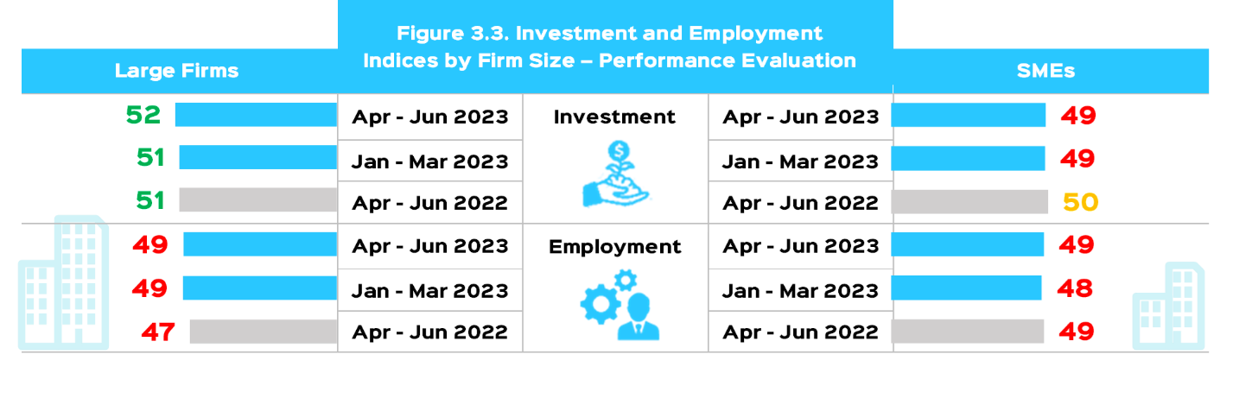  Investment | Jan – Mar 2025
 | Oct – Dec 2024 |  | Oct – Dec 2024
 | Jan – Mar 2024 |  | Jan – Mar 2024
 | Jan – Mar 2025 | Employment | Jan – Mar 2025
 | Oct – Dec 2024 |  | Oct – Dec 2024
 | Jan – Mar 2024 |  | Jan – Mar 2024
Source: Survey results.


3.2. Performance Expectations
All firms are expected to perform above neutral during the coming quarter, given that most sub-indices are expected to remain stable.
Expectations of large firms regarding production and capacity utilization during the quarter July - September 2025 were higher than neutral, but less than the previous and corresponding quarters. Meanwhile, expectations for domestic sales and exports scored values lower than the previous quarter, but higher than the corresponding quarter. Expectations indicated an increase in the commodity inventory index from the neutral level and both the previous and corresponding quarters.
The expectations of small and medium enterprises for domestic sales and inventory came higher than the neutral level and compared to the previous and corresponding quarters, while expectations for production and capacity utilization were lower by one point compared to the previous quarter, although better than the corresponding quarter by 4 points. Meanwhile, expectations for the export index were lower than the previous and corresponding quarters (Figure 3-4).

Figure 3.4. Production and Sales
Indices by Firm Size – Outlook
Large Firms |  |  |  | SMEs
 | Apr – Jun 2025 |   Production | Apr – Jun 2025
 | Jan – Mar 2025 |  | Jan – Mar 2025
 | Apr – Jun 2024 |  | Apr – Jun 2024
 | Apr – Jun 2025 | Domestic Sales | Apr – Jun 2025
 | Jan – Mar 2025 |  | Jan – Mar 2025
 | Apr – Jun 2024 |  | Apr – Jun 2024
 | Apr – Jun 2025 | Exports | Apr – Jun 2025
 | Jan – Mar 2025 |  | Jan – Mar 2025
 | Apr – Jun 2024 |  | Apr – Jun 2024
 | Apr – Jun 2025 |   Capacity Utilization | Apr – Jun 2025
 | Jan – Mar 2025 |  | Jan – Mar 2025
 | Apr – Jun 2024 |  | Apr – Jun 2024
 | Apr – Jun 2025 |       Inventory* | Apr – Jun 2025
 | Jan – Mar 2025 |  | Jan – Mar 2025
 | Apr – Jun 2024 |  | Apr – Jun 2024
Source: Survey results.
* The index for inventory is inverted to indicate the negative impact of its increase on businesses. Hence, a higher inventory index indicates lower inventory and vice versa.

All firms expect final product prices and wages to rise above the neutral level.
The final product price index declined compared to the previous and corresponding quarters, but exceeded the neutral level, driven by the higher input price index from the previous and the corresponding quarters.

In the meantime, small and medium enterprises expect a stable wage index at the same values as the previous quarter and higher than neutral level by two points, albeit less than the corresponding quarter by one point. The expectations of large firms came one point higher than the previous quarter and two points lower than the corresponding quarter (Figure 3-5).

Figure 3.5. Prices and Production Cost
Indices by Firm Size - Outlook
Large Firms |  |  |  | SMEs
 | Apr – Jun 2025 |   Final Product Prices | Apr – Jun 2025
 | Jan – Mar 2025 |  | Jan – Mar 2025
 | Apr – Jun 2024 |  | Apr – Jun 2024
 | Apr – Jun 2025 |   Input Prices* | Apr – Jun 2025
 | Jan – Mar 2025 |  | Jan – Mar 2025
 | Apr – Jun 2024 |  | Apr – Jun 2024
 | Apr – Jun 2025 |   Wages | Apr – Jun 2025
 | Jan – Mar 2025 |  | Jan – Mar 2025
 | Apr – Jun 2024 |  | Apr – Jun 2024
Source: Survey results.
* The index for inputs is inverted to indicate the negative impact of price increases on the overall index. Hence, a lower index indicates higher prices and vice versa.

The investment and employment expectations indices for all firms remained stable at the neutral level.

All firms expect the investment index to exceed the neutral level as well as the previous and corresponding quarters by one point. They also expect the employment index to exceed the previous quarter by one point, similar to the corresponding quarter, and to record higher values than neutral by one point (Figure 3-6).

Figure 3.6. Investment and Employment
Indices by Firm Size - Outlook
Large Firms |  |  |  | SMEs
 | Apr – Jun 2025 |     Investment | Apr – Jun 2025
 | Jan – Mar 2025 |  | Jan – Mar 2025
 | Apr – Jun 2024 |  | Apr – Jun 2024
 | Apr – Jun 2025 | Employment | Apr – Jun 2025
 | Jan – Mar 2025 |  | Jan – Mar 2025
 | Apr – Jun 2024 |  | Apr – Jun 2024
Source: Survey results.


Tables Index

Table A1: Survey Results: Summary of all firms’ performance evaluation at the sectoral level (January - February - March 2025)¹

Table A2: Survey Results: Summary of all firms’ outlook at the sectoral level (April - May - June 2025)¹

1 Numbers represent percent of total responses. Higher, same, and lower may not add up to 100 due to rounding.
2 Equal to the simple average of the variables' indices. The index's method of calculation is provided in the appendix.


Tables Appendix
Table A3: Survey Results: Summary of all firms’ past performance (by size)
(January - February - March 2025)¹

Table A4: Survey Results: Summary of all firms’ outlook (by size)
(April - May - June 2025)¹
1 Numbers represent percentage of total responses. Higher, same, and lower may not add up to 100 due to rounding.
2 Equal to the simple average of the variables' indices. The index's method of calculation is provided in the appendix.



Business Barometer

Issue 75 April – June 2025



Performance Evaluation during the period April – June 2025
and Outlook for the period July – September 2025
from the Business Community’s point of view

Sponsored by



IMF, World Economic Outlook, July 2025.
World Bank, Global Economic Prospects, June 2025.
ibid.
IMF, World Economic Outlook, July 2025
ibid.
https://www.spglobal.com/marketintelligence/en/mi/research-analysis/global-economic-expansion-gains-momentum-in-march-Apr24.html
Ministry of Planning, Economic Development and International Cooperation. 2025 Quarterly GDP Bulletin for the third quarter of fiscal year 2024/2025: Analysis of growth rates, investment and sectoral performance.
Central Agency for Public Mobilization and Statistics, Monthly Bulletin of Consumer Price Indices, various issues.
Central Bank of Egypt. 2025. Monetary Policy Committee Press Release, July 10, 2025.
Central Bank of Egypt. 2025. Press release on the performance of the balance of payments during the period July-March of the fiscal year 2024/2025.
Cabinet. 2025. Net foreign assets in the banking sector rose by approximately $1.2 billion to $14.7 billion in May 2025, compared to $13.6 billion in the previous month.
Ministry of Finance, Monthly Financial Report, July 2025.

