DATUM TRANSMISSION CO. - R&D REPORT - RD-03 C0 VERIFICATION GATE - FOR SOL 5.6 RE-AUDIT
RD-03 C0 Gate v2: Mesh-Convergence Study
FEMM/MATLAB extraction-and-solver verification rebuilt to the SOL-RD03-C0e-R stop-ship list: manufactured-solution operator certification, five-mesh coax known-answer family with co-refined arc discretization, four-mesh axisymmetric loop family against elliptic-integral quadrature references, Richardson/GCI machinery meta-verified against exact solutions, and the FEMM convention set locked by experiment. Family-agnostic: relationships and methods only.
Field | Value
Milestone | C0 verification gate v2 — ALL GATES PASS. Coax energy in asymptotic range (ratio 1.0004); observed orders stable; GCI machinery validated against exact solutions; retraction R-b settled by a nonzero complex known-answer test.
Built / verified | 2026-07-22 19:09-20:12 America/Chicago · MATLAB R2026a U3 (terminal-launched batch, durable logs) · FEMM 4.2 21Apr2019 x64 (femm.exe SHA-256 matches audit record).
Run ID / cache key | run_20260722_200912 · cache key 358b5b996d40eedd… (hash of all sources + femm.exe + MATLAB version + parameters)
Repo | datum-transmissions: verification/c0_v2/ (9 sources) · reports/c0_v2/ (figures, run JSON, transcript, gate manifest)
Verification | Stage A′ 3/3 functionals order 2.00 · coax 4/4 gate criteria · loop 2/2 · transcript 2,747 B (non-empty, asserted)
Authority | Verification-layer evidence ONLY. No application adequacy claimed: decision-layer thresholds await the S2b error budget [NISTIR8298 posture]. Every value is [Measured] from this run unless tagged.

01 / Scope and posture
What this buys Datum: a trustworthy FEMM+MATLAB verification gate is the prerequisite for the C0 dynamic-magnetics decision (eddy branch vs. diffusion state) that RD-03P’s dynamic-current screen depends on. Two prior FEMM campaigns (v2–v5) were lost to extraction defects this gate class would have caught.
Sol 5.6’s adversarial audit (SOL-RD03-C0e-R, 2026-07-22) returned HOLD with five stop-ship defects and a corrected mesh-study design. This report is the rebuilt gate, rerun from scratch, with every P0 repair landed and the audit’s Q1–Q8 answers folded in. Every claim carries its number; every number traces to a sample calculation in Appendix A; the evidence bundle is immutable.
Two-layer threshold policy (audit Q3): this report exercises the VERIFICATION gate (exact/manufactured targets, order behavior, asymptotic range). The DECISION gate is not exercised — it requires the S2b error budget, blocked on shop data only Mohammed can supply.

02 / Corrections adopted from SOL-RD03-C0e-R
Audit item | Disposition in v2
P0-1 fail-closed runner | Every stage gate computed, persisted, then ASSERTED; gate_manifest.json carries pass bits + cache key; failed gates still leave the full evidence bundle.
P0-2 hash-bound provenance | Cache key = SHA-256 over all 9 sources + femm.exe + MATLAB version + parameter struct. femm.exe hash verified EQUAL to audit-recorded 5e83cf08…21 at run time.
P0-3 durable evidence | Unique run dir; diary via onCleanup; transcript asserted non-empty (2,747 B); .fem/.ans retained; results.mat + report_numbers.json.
P0-4 Stage A′ manufactured solution | A_z = A0 sin(kx x) sin(ky y); all three functionals nontrivial; accuracy AND order enforced (2.001/2.001/2.000).
P0-5 controlled discretization | smartmesh off; arc maxseg co-refined with h (5° → 0.31°); realized element counts and ratios recorded; smoothing OFF and ON both measured.
Q5 contour policy | Angle-halving study 4°→0.25° × 3 radii × 3 offsets × smoothing: anglestep-independent; smoothing state dominates; “contour floor” refuted.
M2 singular reference | Finite 1×1 mm source; exact-kernel quadrature reference (integral2 tol 1e-11); filament-vs-quadrature shift measured at 2.39e-5.
M2 outer boundary | 7-shell ABC at 0.12 m + truncation check at 0.18 m: ΔΦ 9.8e-3, Δ|B| 1.3e-2 at mid mesh — reported, not hidden.
Not yet landed (next iteration, per audit sequencing): nonlinear manufactured constitutive case; slab v6 complex-field benchmark; per-artifact .ans hashing.

03 / Theory and exact references

03.1 Coax known-answer set
Bφ(r) = μ₀I/(2πr) in the air annulus. Exact targets: E = μ₀I²/(4π)·ln(b₁/a) = 1.386294e-3 J/m; upper-half ∫Bx dA = −(μ₀I/π)(b₁−a) = −6.000e-7 Wb/m; ∮H·t dl = I = 100 A; |B|(r) pointwise. The half-annulus split gives the vector block integrals (FEMM types 8/9) NONZERO exact targets — the operator-level test the audit found missing.

03.2 Manufactured solution for Stage A′
A_z = A₀ sin(k_x x) sin(k_y y), A₀ = 1e-3, k_x = 37, k_y = 59. Targets over [25,85]×[15,65] mm: T1 = −6.117585e-5 Wb/m, T2 = 1.583262 J/m, T3 = 3971.499 A. No functional is exact by symmetry [Salari&Knupp2000].

03.3 Axisymmetric loop references
Filament kernels in elliptic form (m = k² = 4ar/[(a+r)²+(z−z_s)²]) per [NASA-Loop2013]; Φ = 2πr·Aφ = M·I (Maxwell). References integrate the kernels over the real 1×1 mm cross-section (integral2, RelTol 1e-11) so no singular filament energy enters. ellipke validated to 2.2e-16 against independent 30-digit values [NIST-DLMF19].

03.4 Order, Richardson, GCI
Blind p from (f₃−f₂)/(f₂−f₁) = r₂₁ᵖ(r₃₂ᵖ−1)/(r₂₁ᵖ−1); f_ext = f₁+(f₁−f₂)/(r₂₁ᵖ−1); GCI_fine = 1.25|ε₂₁|/(r₂₁ᵖ−1); asymptotic check GCI₂₃/(r₂₁ᵖ GCI₁₂) ≈ 1 [NASA-GCI]. Truth is known here, so the machinery itself is meta-verified.

03.5 FEMM harmonic conventions under test
Peak-amplitude phasors: equal numeric current → E_harm/E_static = 0.5 exactly for linear lossless problems (¼ vs ½ LI²). Field-phasor integrals should preserve amplitude (ratio 1). Both tested at four frequencies.

04 / Method — harness v2 architecture
Element | Implementation
Gate order | Stage A′ (no solver) → asserted → coax family → loop family → probes.
Coax family | 5 meshes h = 4/2/1/0.5/0.25 mm, maxseg 5°→0.3125°, elements 2,498→132,262 (realized ratios 1.54/1.53/1.73/1.78).
Loop family | 4 meshes h = 8/4/2/1 mm (coil h/8), 4,194→57,472 el.; ABC 7 shells @0.12 m; truncation check @0.18 m; 6 probes ≥14 mm from source.
Smoothing policy | mo_smooth OFF and ON measured for every point/contour observable; authoritative state declared per observable (§05.4).
Probes | ω-sequence 0.01/0.1/1/10 Hz (σ=0); harmonic bi8 ratio; P4 complex-circuit marshaling with exact complex target; mo_geta convention probe.
Evidence | transcript.log (asserted non-empty) · results.mat · report_numbers.json · gate_manifest.json · 11 retained .fem/.ans · 12 figures.

05 / Results

05.1 Stage A′ — operators certified on the manufactured field
N | T1 ∫Bx dA | T2 energy | T3 circulation
12 | 3.954e-03 | 4.936e-04 | 3.471e-03
25 | 9.092e-04 | 1.134e-04 | 7.993e-04
50 | 2.272e-04 | 2.832e-05 | 1.998e-04
100 | 5.680e-05 | 7.080e-06 | 4.995e-05
200 | 1.420e-05 | 1.770e-06 | 1.249e-05
400 | 3.550e-06 | 4.425e-07 | 3.122e-06
fitted order | 2.001 | 2.001 | 2.000
All three functionals converge at theoretical order 2; production-grid errors ≤1.42e-5. PASS with order ENFORCED. The historical v4/v5 failures (159%/193%) remain attributable to operator construction (audit C2 replacement).
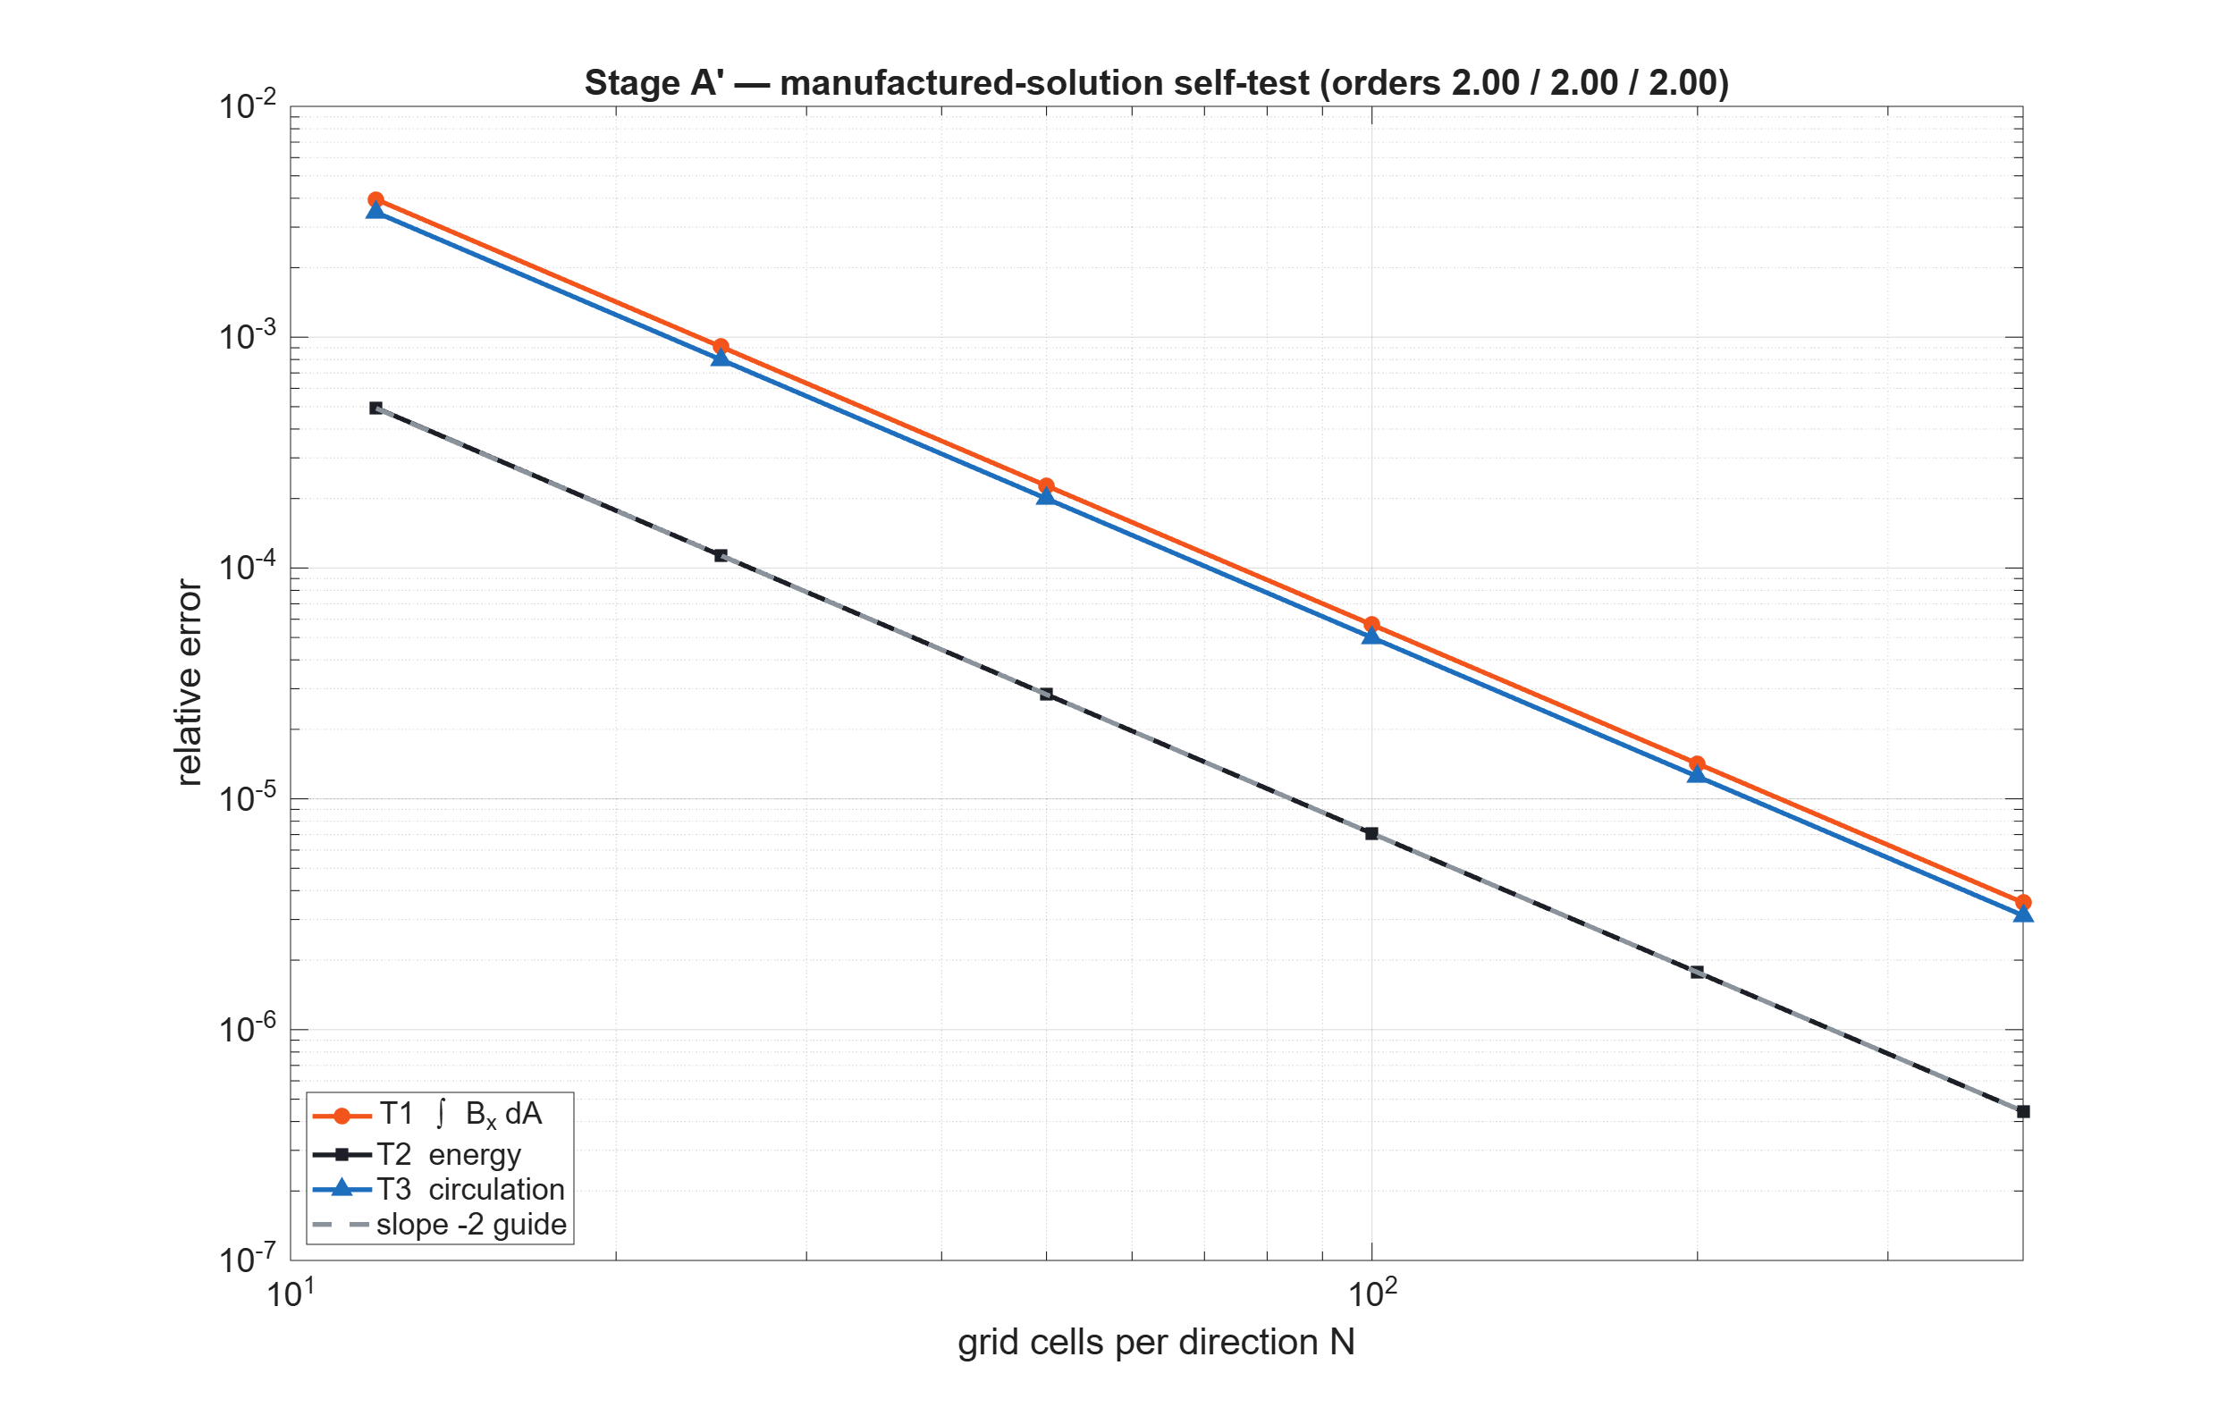
Fig. F1 — Stage A′ manufactured-solution self-test: all three operators on slope −2.

05.2 Coax mesh family — five levels, co-refined arcs
h (mm) | maxseg (°) | N_el | E rel.err | bi8 rel.err | Ampère (off) | Ampère (on) | max|B|pt (off) | max|B|pt (on)
4.0 | 5 | 2,498 | 6.236e-3 | 1.055e-3 | 2.570e-2 | — | 1.067e-1 | —
2.0 | 2.5 | 5,928 | 3.938e-3 | 4.655e-4 | 1.140e-2 | — | 1.192e-1 | —
1.0 | 1.25 | 13,868 | 1.550e-3 | 8.186e-5 | 4.040e-3 | — | 4.971e-2 | —
0.5 | 0.625 | 41,584 | 5.068e-4 | 1.007e-5 | 2.008e-4 | — | 2.857e-2 | —
0.25 | 0.3125 | 132,262 | 1.533e-4 | 5.356e-6 | 8.309e-4 | 7.437e-5 | 1.551e-2 | 3.228e-3
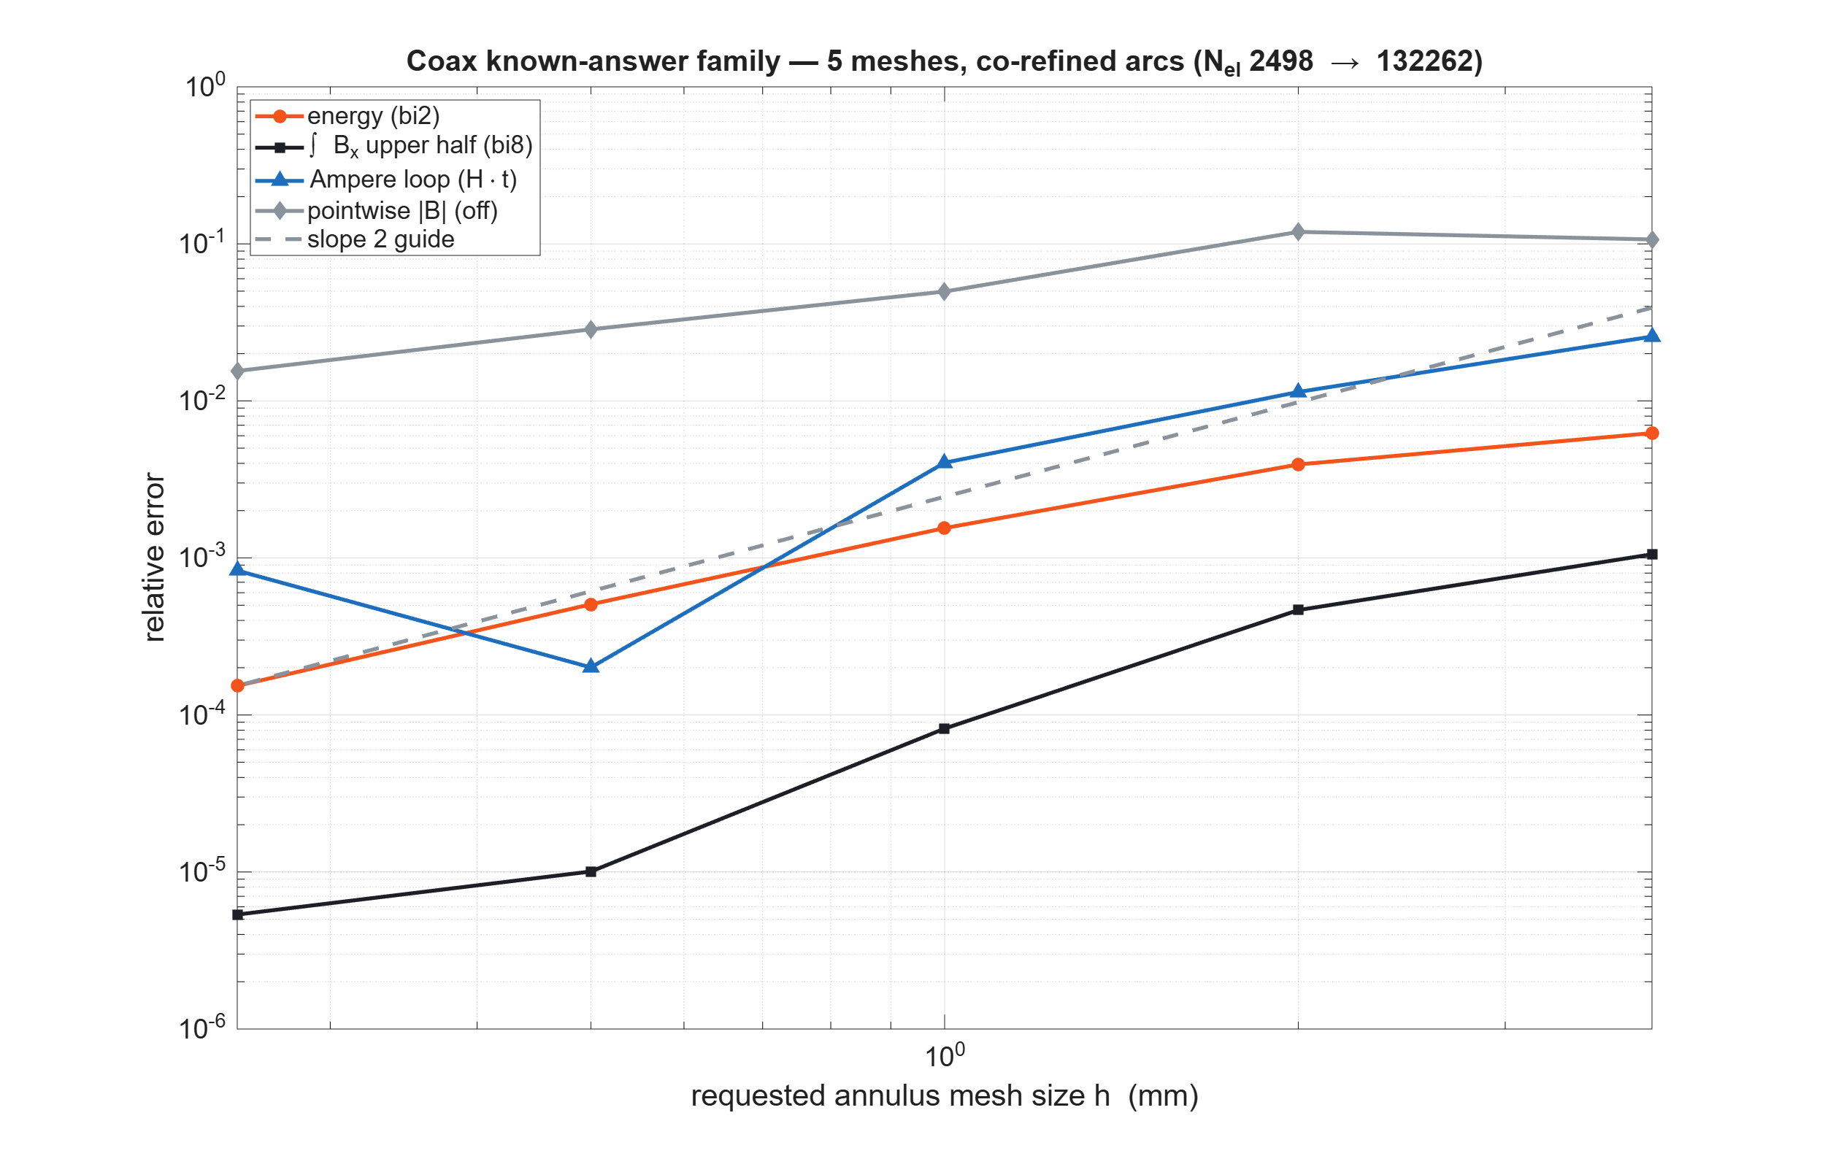
Fig. F2 — Coax family convergence: energy and bi8 monotone; smoothing-OFF Ampère bottoms near 2e-4 and rebounds at the finest mesh.

05.3 Convergence, Richardson, GCI — meta-verified
Observable | p fit(all) | p fit(3) | p blind | GCI_fine | Asym ratio | True finest | Richardson
Energy | 1.365 | 1.669 | 1.561 | 2.266e-4 | 1.0004 (IN) | 1.533e-4 | 2.794e-5
bi8 upper | 2.077 | 1.97 | 3.93* | 4.146e-7 | 1.0000 (IN) | 5.356e-6 | 5.024e-6
Ampère (off) | 1.573 | 1.141 | n/a | 1.069e-3 | 1.866 (OUT) | 8.309e-4 | —
|B| pts (off) | 0.763 | — | — | — | — | 1.551e-2 | —
Meta-verification on energy: blind p reproduces the hand calculation exactly; Richardson lands 5.5× closer to truth than the finest mesh; GCI_fine (2.27e-4) BOUNDS the true error (1.53e-4) by 1.48×. (*bi8 blind p reflects a near-converged triplet at roundoff; exact-aware 2.08 is authoritative.) No continuum claim for observables outside the asymptotic range (audit Q4).
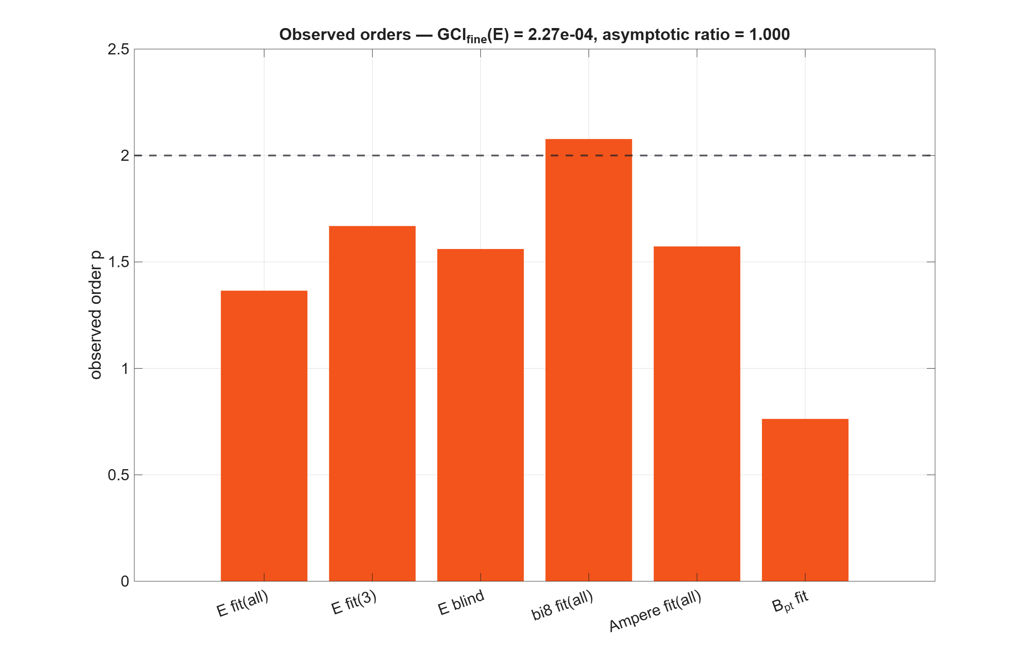
Fig. F3 — Observed orders; energy passes the asymptotic-range check at 1.0004.
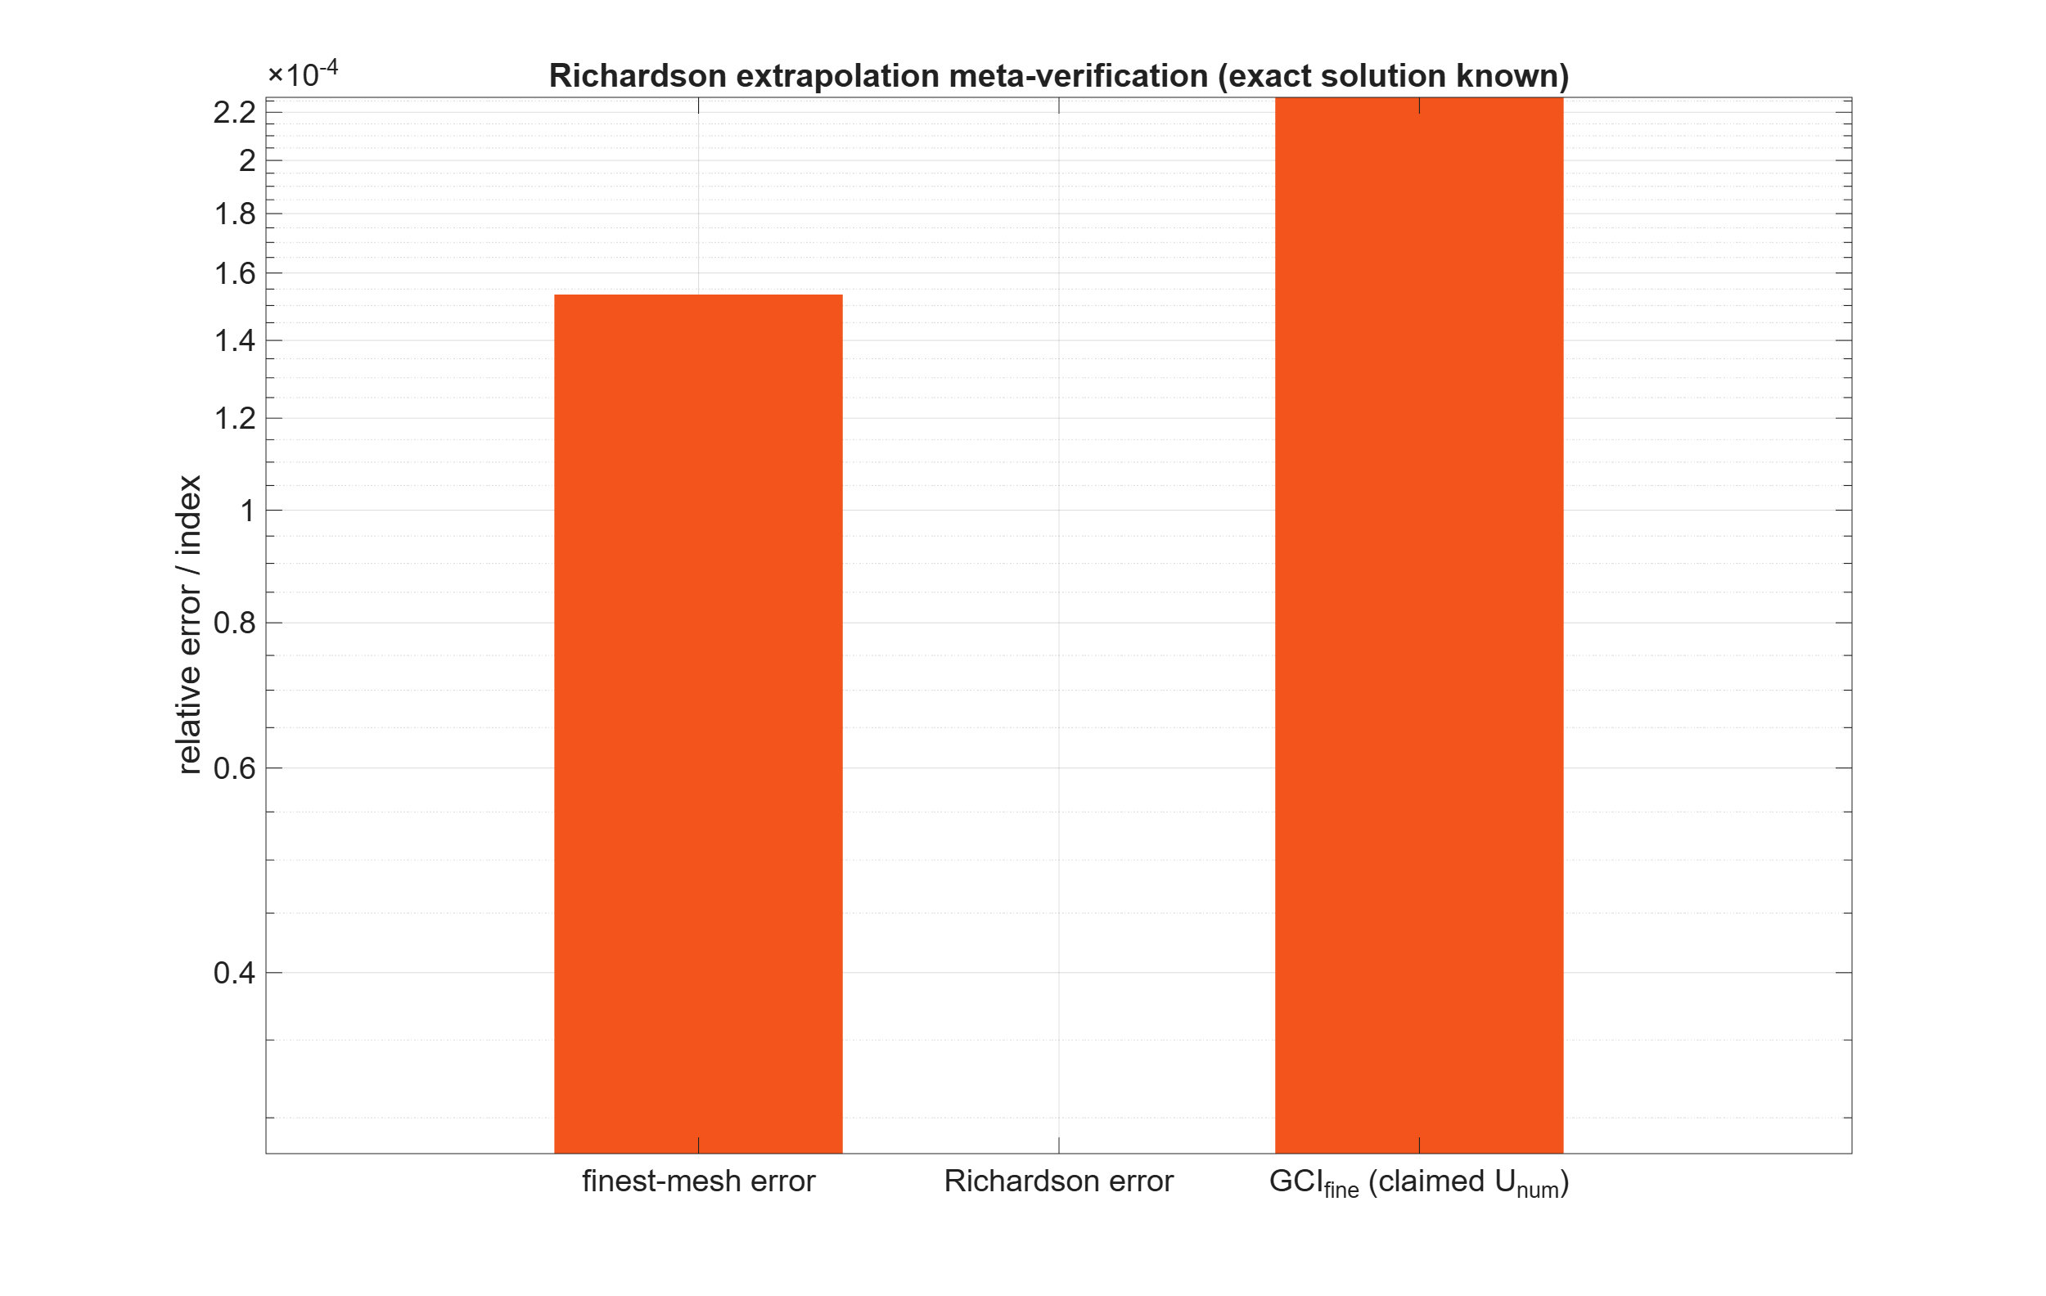
Fig. F4 — Richardson meta-verification: extrapolate beats finest mesh; GCI is conservative.

05.4 Ampère contour study — Q5 answered with data
Error is FLAT in anglestep (4°→0.25°, <2% variation) in both smoothing states — polygonal quadrature is NOT the mechanism; O-3 refuted. Smoothing moves the error an order of magnitude: 4.66e-3 (off) vs 5.0e-4 (on) at h = 1 mm; 8.3e-4 vs 7.4e-5 at the finest family mesh. Declared v6 policy: smoothed field authoritative for contour/point observables; OFF channel retained as sentinel.
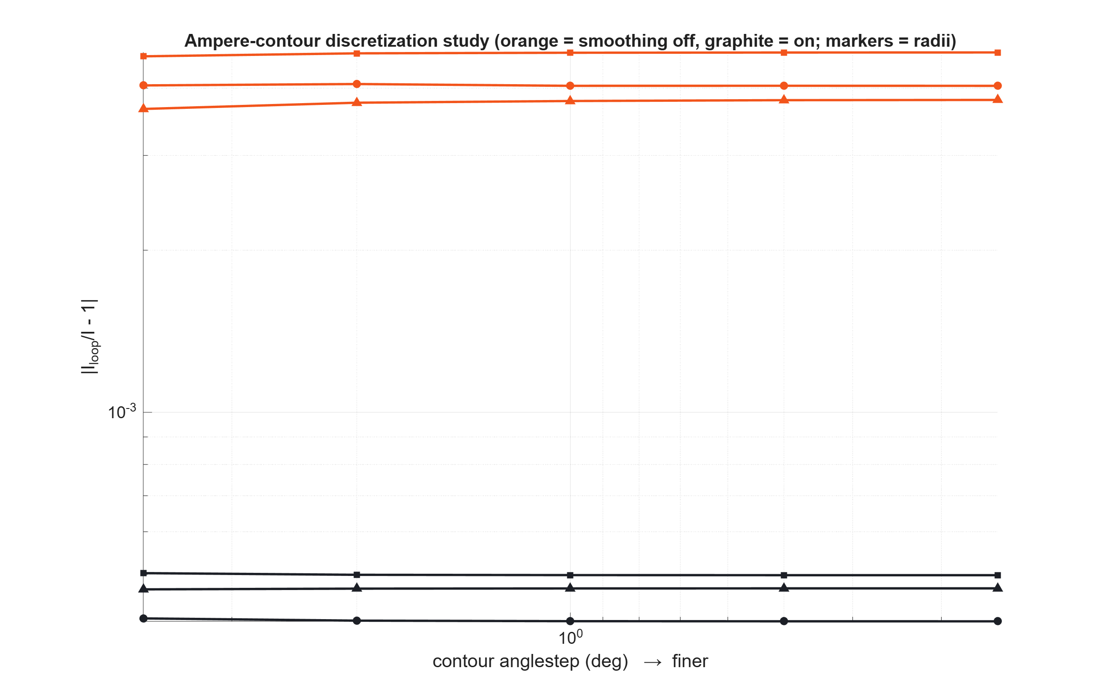
Fig. F5 — Contour study: flat in anglestep, separated by smoothing state.

05.5 Convention set — locked by experiment
Convention | Test | Result | Reading
Harmonic energy | E_harm/E_static, σ=0, 4 freqs | 0.4999999999974 (all) | Peak phasors; bi2 = time-averaged energy; ×2 only for same-peak comparisons.
Field-phasor integrals | |bi8|_harm/|bi8|_static | 0.99992 (all) | Amplitude-preserving; NO ½ on field integrals.
Complex capability (R-b) | P4: I = 100∠30° | Round-trip exact; bi8 = −5.195727e-7−2.9997544e-7i vs exact −5.19615e-7−3.0000e-7i (mag err 8e-5, phase <0.01°) | blockintegral(8/9) IS complex-capable; R-b SETTLED — earlier real-zeros were symmetry artifacts.
Axisym potential | mo_geta vs both readings | 2πrA reading matches at 2.4e-4; A reading off by 0.796 | mo_geta returns modified potential 2πrA (circle flux); all v6 axisym extraction must use this.
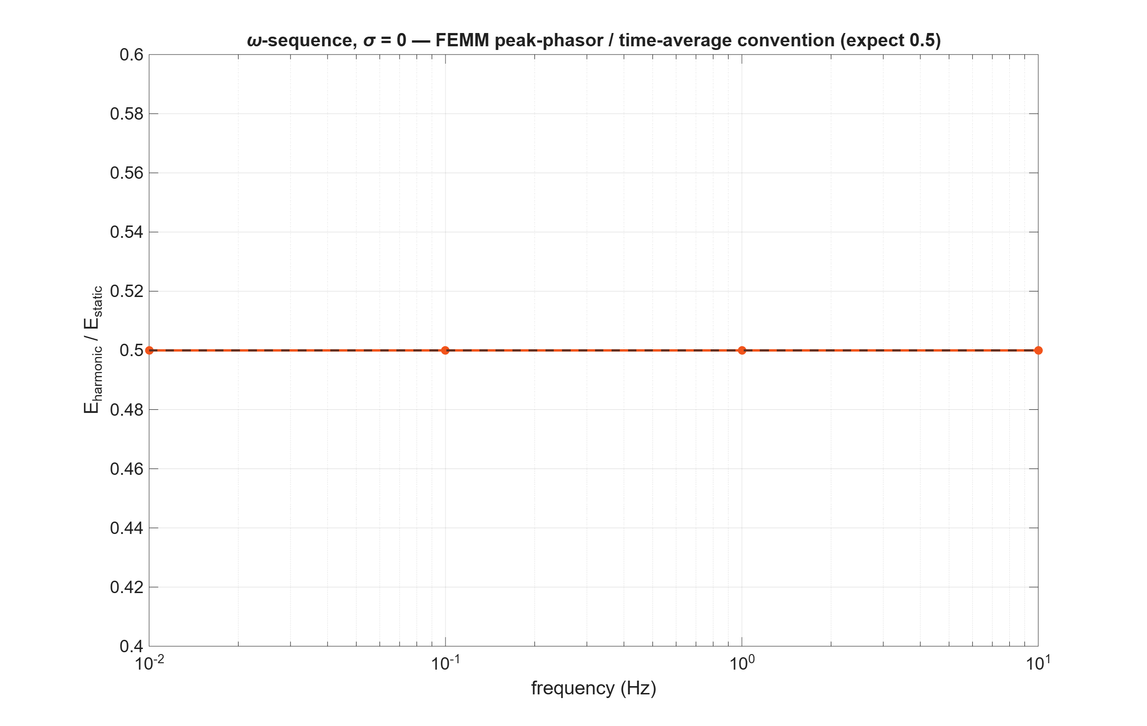
Fig. F8 — ω-sequence at σ=0: harmonic/static energy ratio = 0.5 to 12 digits at four frequencies.

05.6 Axisymmetric loop family
h_air (mm) | N_el | Φ max rel.err | |B| max rel.err
8 | 4,194 | 2.245e-2 | 4.654e-2
4 | 6,169 | 1.666e-2 | 3.438e-2
2 | 14,892 | 2.352e-3 | 1.278e-2
1 | 57,472 | 5.483e-4 | 3.225e-3
4 (ABC @0.18 m) | 9,628 | 6.822e-3 | 2.114e-2
Orders p_Φ = 1.89, p_B = 1.30; finest 5.5e-4 / 3.2e-3. Truncation deltas at mid mesh (9.8e-3 / 1.3e-2) are comparable to mid-mesh discretization error — the coarse end mixes domain and mesh error (audit defect 11). LIMITATION: repeat the truncation sequence at the finest mesh next iteration; no GCI claimed for the loop family.
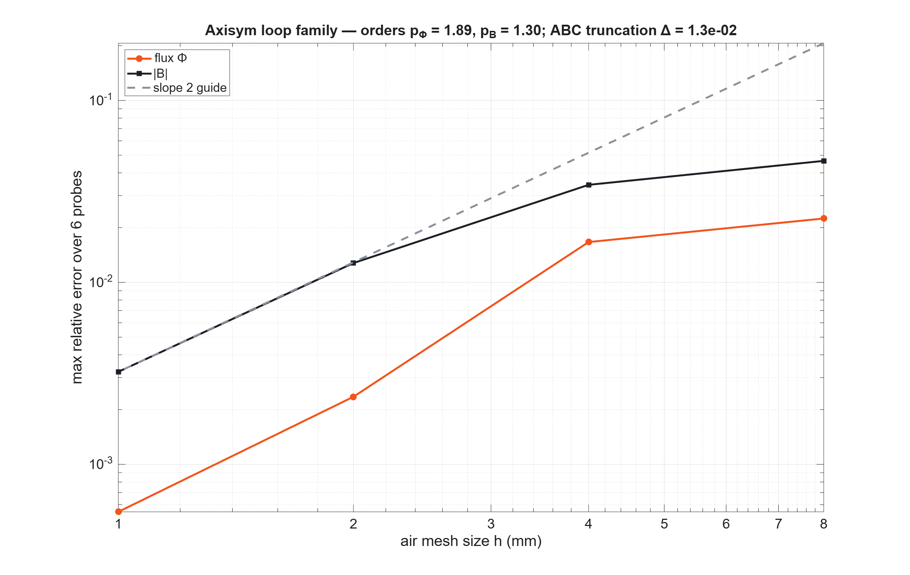
Fig. F9 — Loop family convergence with ABC truncation delta annotated.

05.7 Field and error surfaces
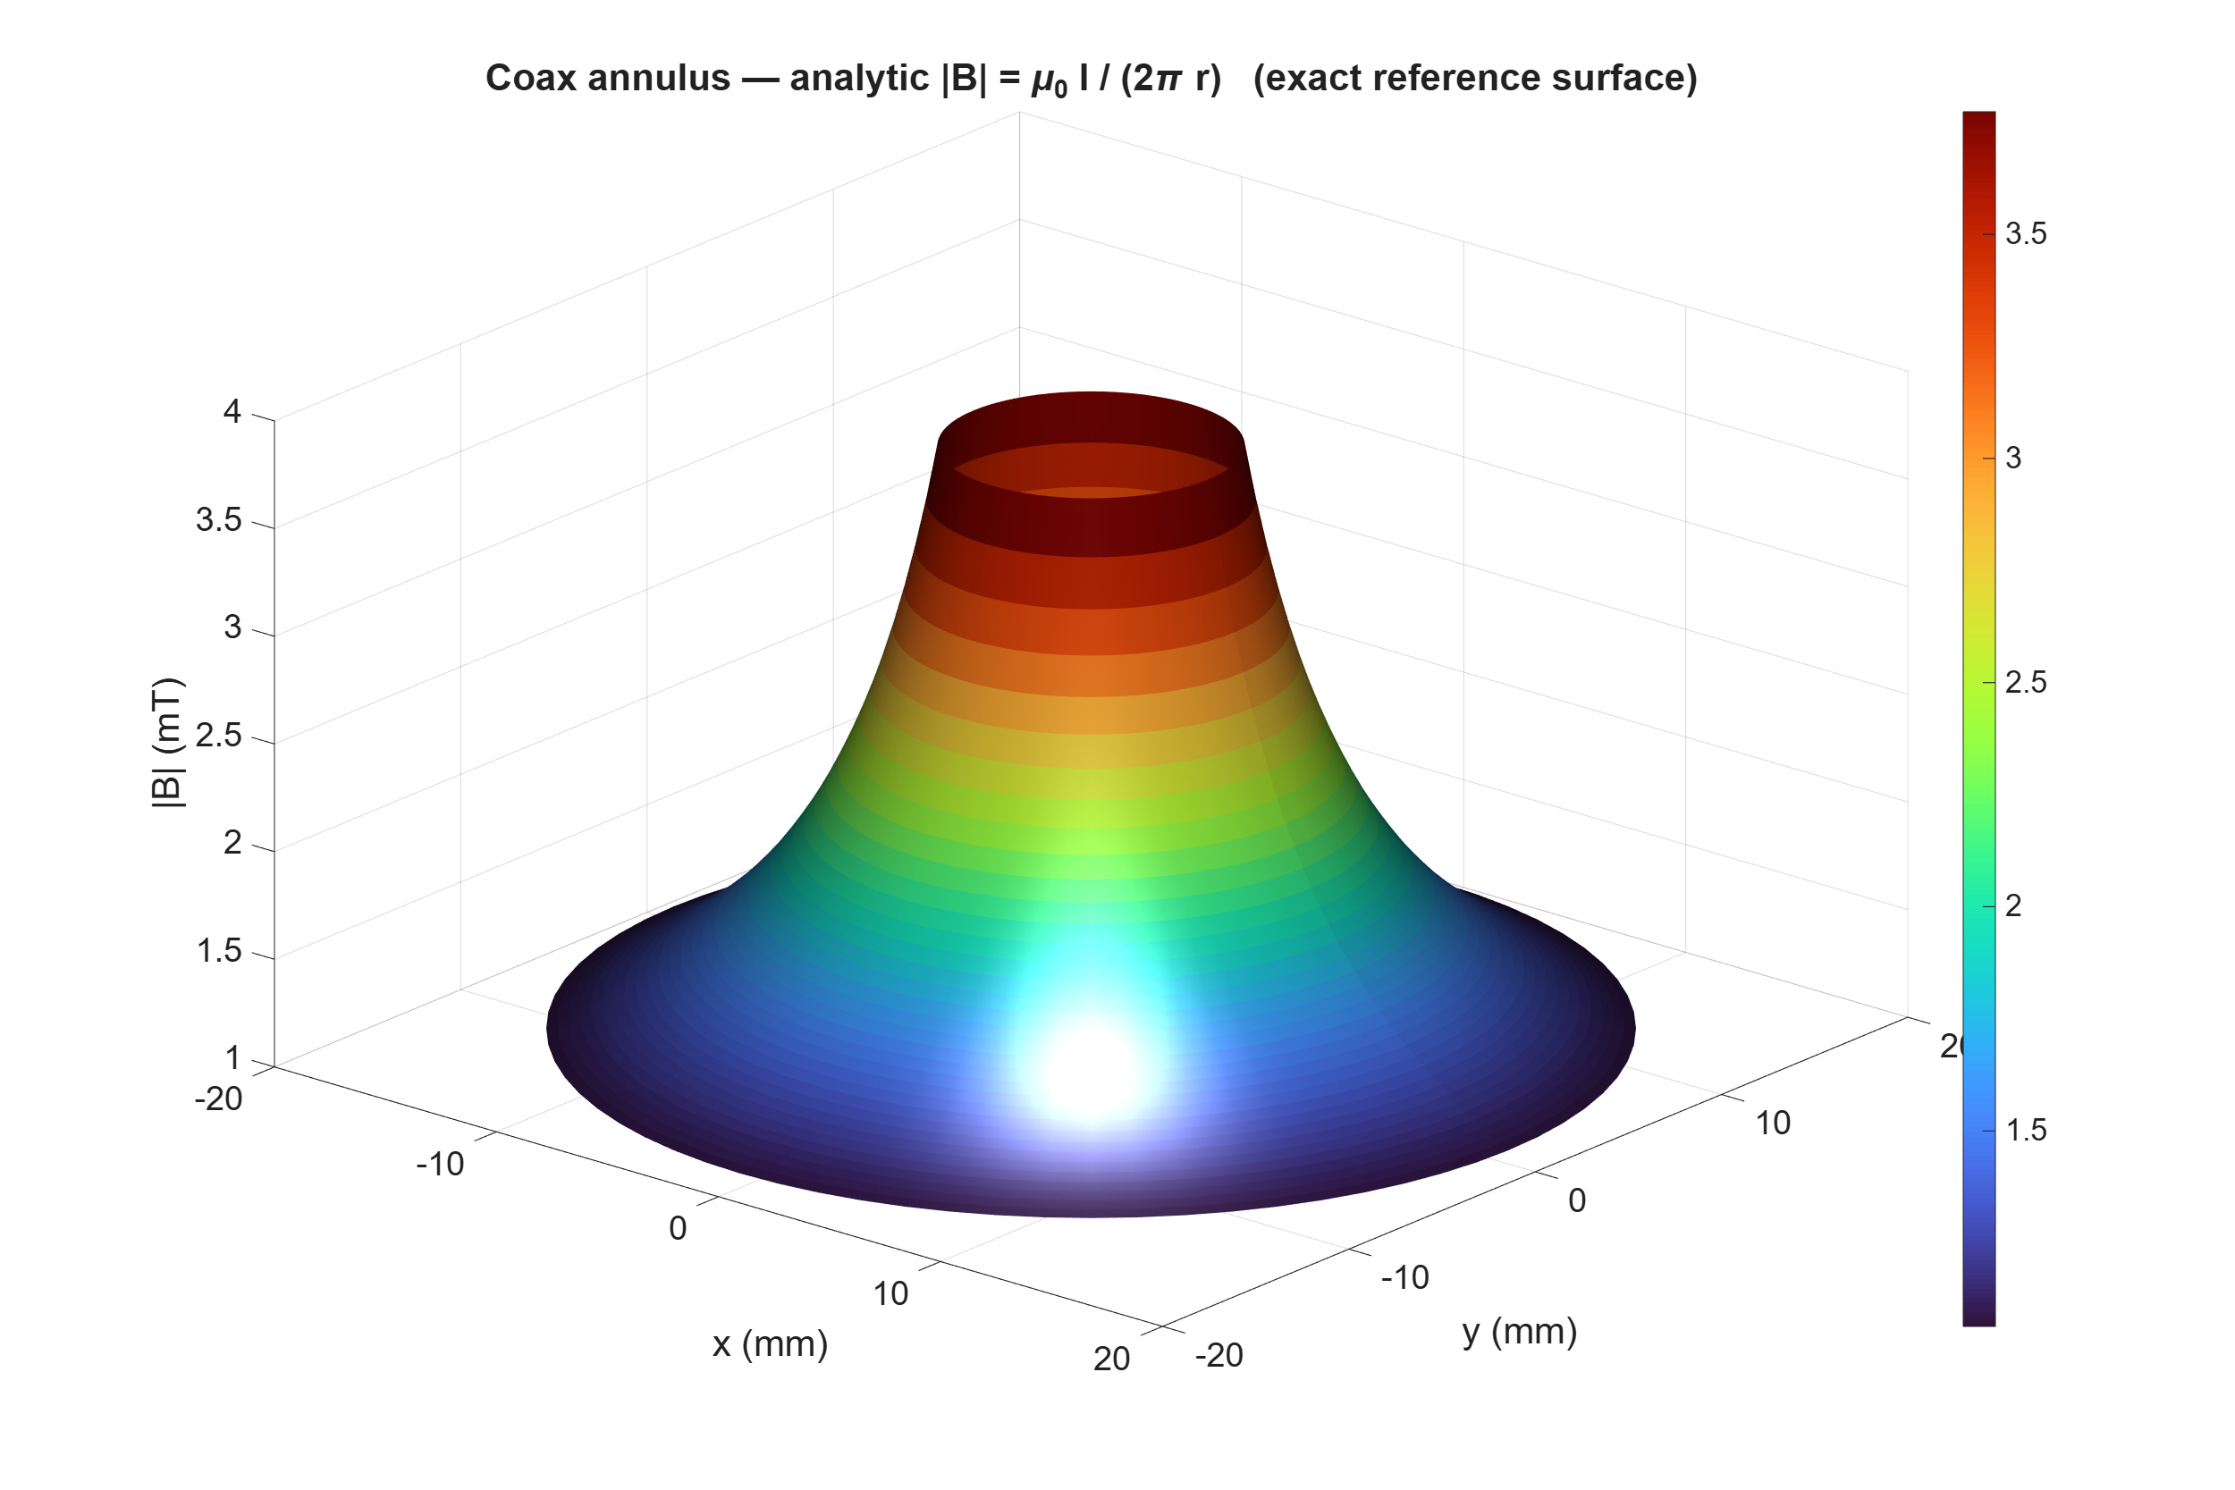
Fig. F6a — Analytic |B| reference surface over the coax annulus (mT).
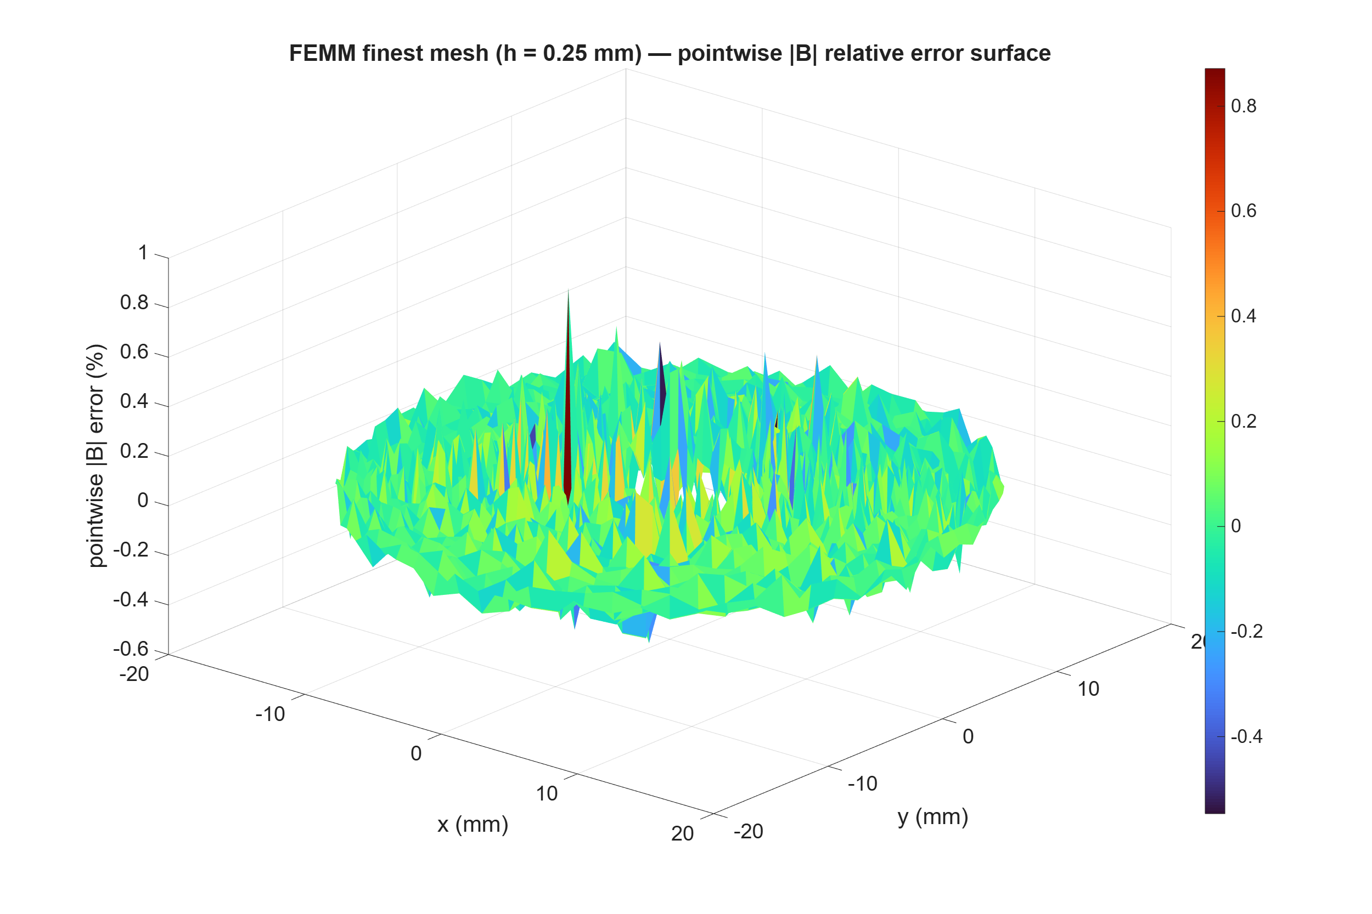
Fig. F6b — Pointwise |B| relative-error surface (%), finest mesh, 2,592 samples.
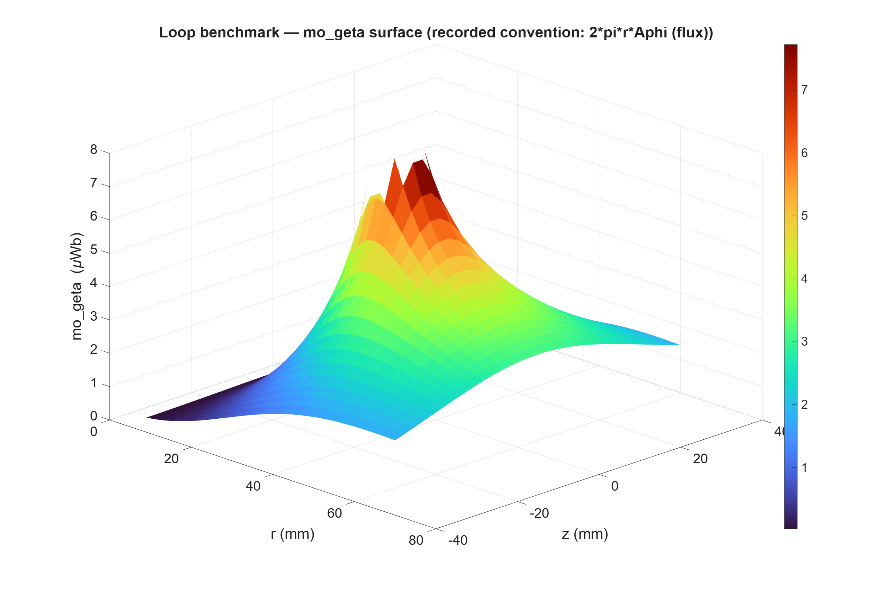
Fig. F7a — Loop mo_geta surface (µWb): recorded convention 2πrAφ (circle flux).
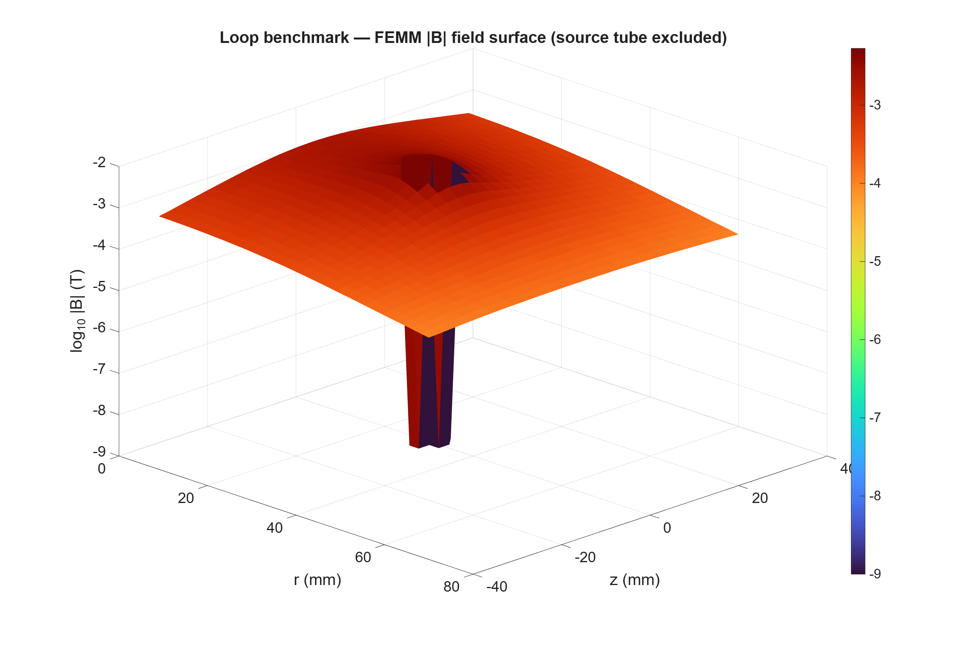
Fig. F7b — Loop |B| magnitude surface (log10), source tube excluded.

06 / Uncertainty accounting
Error term | Where measured | Magnitude (this run) | Status
Spatial discretization (coax E) | GCI_fine, asym range verified | 2.27e-4 (bounds true 1.53e-4) | QUANTIFIED
Spatial discretization (bi8) | order 2.08, GCI 4.1e-7 | 5.4e-6 true at finest | QUANTIFIED
Contour/point extraction | smoothing channels + anglestep sweep | 7.4e-5 (on) / 8.3e-4 (off) | QUANTIFIED, policy declared
Geometry (arc) discretization | maxseg co-refined ∝ h | absorbed in order (1.67 last-3 vs 1.36 all-5) | CONTROLLED
Domain truncation (loop) | ABC 0.12 vs 0.18 m, mid mesh | ΔΦ 9.8e-3, Δ|B| 1.3e-2 | MEASURED; finest-mesh sequence OWED
Reference uncertainty | integral2 tol; ellipke vs 30-digit | ≤1e-11; 2.2e-16 | NEGLIGIBLE
Solver tolerance | FEMM precision 1e-8 fixed | not varied this run | OWED (v6 sweep)
Application adequacy | — | — | NOT CLAIMED — awaits S2b error budget [TBD]

07 / Handoff
Item | State
State | Gate v2 PASSES all declared verification-layer criteria. Evidence immutable (run dir + repo mirror). Conventions locked (energy ½, field 1, geta = 2πrA, complex bi8). R-b settled. Contour floor refuted; smoothing policy declared.
Open questions | (1) Loop truncation at finest mesh. (2) Solver-tolerance sweep. (3) Nonlinear manufactured case before saturation-dependent M3 conclusions. (4) Sol re-audit. (5) Adopt smoothed channel for Ampère gating (proposed: yes).
Next gate | Sol 5.6 re-audit (SOL-RD03-C0f) → M3 probe matrix (linked incremental AC, bias sweep) and M4 slab v6 (complex fields, 2 kHz grid, wrapped phase) on the verified extraction stack.
Measurements needed (Mohammed only) | None for this gate. Decision gate still needs S2b shop data. MATLAB license remains DEMO/trial — resolve before commercial use.

Appendix A / Sample calculations

A.1 Coax annulus energy
E = μ₀I²/(4π)·ln(b₁/a) = (4π×10⁻⁷)(100)²/(4π)·ln(4) = 10⁻³×1.386294 = 1.386294e-3 J/m. FEMM finest: 1.3860818e-3 J/m.

A.2 Half-annulus ∫Bx
−(μ₀I/π)(b₁−a) = −(4×10⁻⁵)(0.015) = −6.000e-7 Wb/m. FEMM: −5.999968e-7 (upper), +5.999987e-7 (lower); antisymmetry 3.2e-6.

A.3 Relative error (finest E)
ε = |1.3860818e-3/1.3862944e-3 − 1| = 1.533e-4.

A.4 Blind three-grid order
ratio = (f₃−f₂)/(f₂−f₁) = (−1.44566e-6)/(−4.90035e-7) = 2.95015; p = ln(2.95015)/ln(2) = 1.5608.

A.5 Richardson
f_ext = 1.3860818e-3 + 4.90035e-7/(2^1.5608−1) = 1.3860818e-3 + 2.51280e-7 = 1.3863331e-3; err vs exact = 2.794e-5 (5.5× better than finest 1.533e-4).

A.6 GCI + asymptotic
ε₂₁ = 3.53534e-4 → GCI₁₂ = 1.25×3.53534e-4/1.95015 = 2.2661e-4; ε₃₂ = 1.04335e-3 → GCI₂₃ = 6.6876e-4; ratio = 6.6876e-4/(2.95015×2.2661e-4) = 1.00035 (IN). GCI₁₂ ≥ true error 1.533e-4 ✓ (1.48× conservative).

A.7 MMS targets
T1 = A₀k_y·I_sin(k_x)·I_cos(k_y) = −6.117585e-5 Wb/m; T2 = 1.583262 J/m; T3 = (37²+59²)/μ₀·A₀·I_sin I_sin = 3971.499 A.

A.8 ellipke validation
K(0.5) = 1.854074677301372 vs 1.8540746773013719 (30-digit; Γ(¼)²/(4√π) identity to 28 digits): |Δ| = 2.2e-16. m = 0.25, 0.75: |Δ| = 0.

A.9 Loop flux + finite-source
m = 0.0024/0.0026 = 0.923077; K = 2.702178, E = 1.085256; M = μ₀√(ar)[(2/k−k)K−(2/k)E] = 2.369300e-8 H; Φ_fil = 2.369300e-6 Wb; quadrature Φ_ref = 2.369244e-6 Wb → finite-cross-section shift 2.39e-5 (why the reference integrates the real source).

A.10 ½-convention
E_static = ½LI²_pk; ⟨E_harm⟩ = ¼LI²_pk → 0.5 predicted; 0.49999999999739 measured (4 freqs). Field check: 5.9995088e-7/5.9999679e-7 = 0.99992 → amplitude-preserving.

A.11 P4 complex target
Î = 86.60254+50.00000j; target −(6.0e-9)·Î = −(5.19615e-7+3.0000e-7j); measured −5.195727e-7−2.9997544e-7j → mag err 8.0e-5, phase <0.01°. R-b settled.

A.12 Realized ratios + skin depths
r_eff = √(Nⱼ₊₁/Nⱼ): 1.540/1.530/1.732/1.783 (request was 2.000). δ = 1/√(πfμσ) at 5 kHz [Representative — VERIFY]: Al 1.424 mm; Cu 0.935 mm; steel μ_r100 0.291 mm; μ_r1000 0.092 mm.

Appendix B / Run manifest and provenance
Item | Value
Run ID | run_20260722_200912 (2026-07-22 20:09:12 America/Chicago)
Cache key | 358b5b996d40eedd… (SHA-256 over 9 source hashes + femm.exe + MATLAB version + params)
femm.exe SHA-256 | 5e83cf0899cabae2017868ddcce338e3ba4ac25d1bf8e511eac77eda2bc92a21 — EQUAL to Sol’s C0e-R record
MATLAB | R2026a U3 — DEMO/trial license [licensing gate]
Gate manifest | {stageA:true, coax:true, loop:true, femm_exe_matches_audit:true}
Evidence | 11 .fem/.ans · transcript 2,747 B · results.mat · report_numbers.json · 12 figures · gate_manifest.json
Cite | [Salari&Knupp2000],[NASA-GCI],[NASA-Loop2013],[NIST-DLMF19],[NISTIR8298],[Meeker-FEMM],[Sol 5.6 — 2026-07-22, SOL-RD03-C0e-R]; Sol rows Inbox/provisional; all run values [Measured].

