Scriptable Render Pipeline Overview
Tim Cooper, 一月 31, 2018
技术
The Scriptable Render Pipeline (SRP), introduced in 2018.1 beta,is a way of configuring and performing rendering in Unity that is controlled from a C# script. Before writing a custom render pipeline it’s important to understand what exactly we mean when we say render pipeline.
What is a Render Pipeline
“Render Pipeline” is an umbrella term for a number of techniques used to get objects onto the screen. It encompasses, at a very high level:
- Culling
- Rendering Objects
- Post processing
In addition to these high level concepts each responsibility can be broken down further depending on how you want to execute them. For example rendering objects could be performed using:
- Multi-pass rendering
  - one pass per object per light
- Single-pass
  - one pass per object
- Deferred
  - Render surface properties to a g-buffer, perform screen space lighting
When writing a custom SRP, these are the kind of decisions that you need to make. Each technique has a number of tradeoffs that you should consider.
Demo Project
All the features discussed in this post are covered in a demo project located on GitHub
The Rendering entry point
When using SRP you need to define a class that controls rendering; this is the Render Pipeline you will be creating. The entry point is a call to “Render” which takes the render context (described below) and a list of cameras to render.
1  2  3  4 | public class BasicPipeInstance : RenderPipeline  {  public override void Render(ScriptableRenderContext context, Camera[] cameras){}  }
The Render Pipeline Context
SRP renders using the concept of delayed execution. As a user you build up a list of commands and then execute them. The object that you use to build up these commands is called the ‘ScriptableRenderContext’. When you have populated the context with operations, then you can call ‘Submit’ to submit all the queued up draw calls.
An example of this is clearing a render target using a command buffer that is executed by the render context:

1  2  3  4  5  6  7  8  9 | // Create a new command buffer that can be used  // to issue commands to the render context  var cmd = new CommandBuffer();  // issue a clear render target command  cmd.ClearRenderTarget(true, false, Color.green);  // queue the command buffer  context.ExecuteCommandBuffer(cmd);
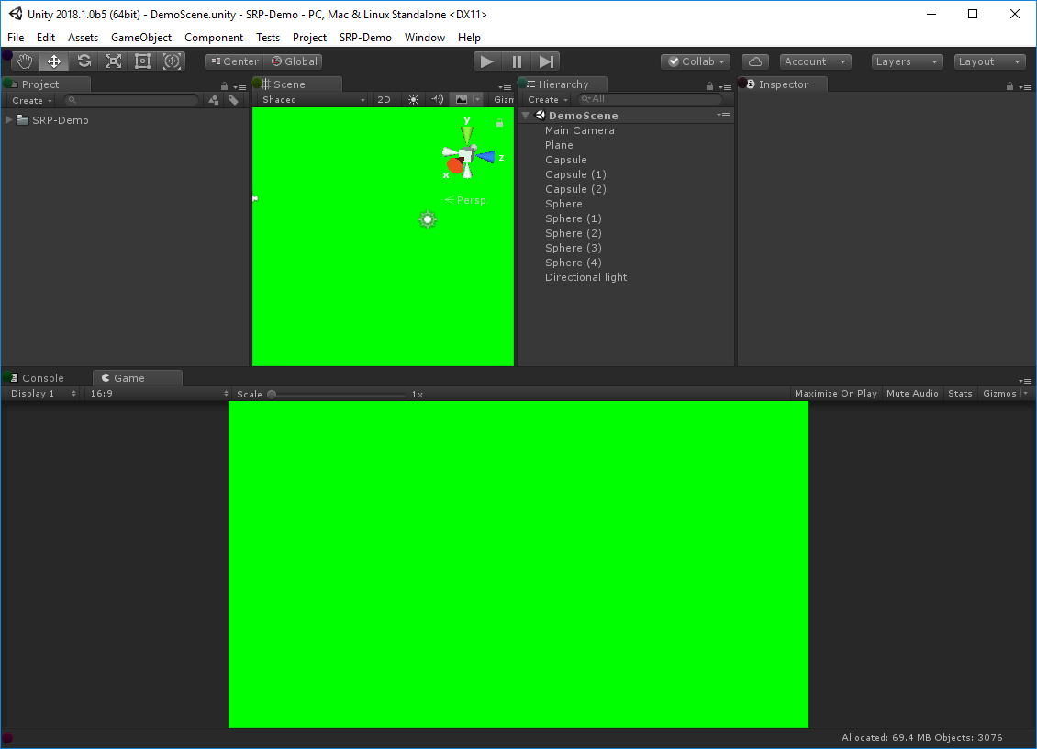
A not very exciting example of a render pipeline :)
Here’s a complete render pipeline that simply clears the screen.
Culling
Culling is the process of figuring out what to render on the the screen.
In Unity Culling encompasses:
- Frustum culling: Calculating the objects that exist between the camera near and far plane.
- Occlusion culling: Calculating which objects are hidden behind other objects and excluding them from rendering. For more information see the Occlusion Culling docs.
When rendering starts, the first thing that needs to be calculated is what to render. This involves taking the camera and performing a cull operation from the perspective of the camera. The cull operation returns a list of objects and lights that are valid to render for the camera. These object are then used later in the render pipeline.
Culling in SRP
In SRP, you generally perform object rendering from the perspective of a Camera. This is the same camera object that Unity uses for built-in rendering. SRP provides a number of API’s to begin culling with. Generally the flow looks as follows:
1  2  3  4  5  6  7  8  9  10  11  12  13  14  15 | // Create an structure to hold the culling paramaters  ScriptableCullingParameters cullingParams;  //Populate the culling paramaters from the camera  if (!CullResults.GetCullingParameters(camera, stereoEnabled, out cullingParams))  continue;  // if you like you can modify the culling paramaters here  cullingParams.isOrthographic = true;  // Create a structure to hold the cull results  CullResults cullResults = new CullResults();  // Perform the culling operation  CullResults.Cull(ref cullingParams, context, ref cullResults);
The cull results that get populated can now be used to perform rendering.
Drawing
Now that we have a set of cull results, we can render them to the screen.
But there are so many ways that things can be configured, so a number of decisions need to be made up front. Many of these decisions will be driven by:
- The hardware you are targeting the render pipeline to
- The specific look and feel you wish to achieve
- The type of project you are making
For example, think of a mobile 2D sidescroller game vs a PC high end first person game. These games have vastly different constraints so will have vastly different render pipelines. Some concrete examples of real decisions that may be made:
- HDR vs LDR
- Linear vs Gamma
- MSAA vs Post Process AA
- PBR Materials vs Simple Materials
- Lighting vs No Lighting
- Lighting Technique
- Shadowing Technique
Making these decisions when writing a render pipeline will help you determine many of the constraints that are placed when authoring it.
For now, we’re going to demonstrate a simple renderer with no lights that can render some of the objects opaque.
Filtering: Render Buckets and Layers
Generally, when rendering object has a specific classification, they are opaque, transparent, sub surface, or any number of other categories. Unity uses a concept of queues for representing when an object should be rendered, these queues form buckets that objects will be placed into (sourced from the material on the object). When rendering is called from SRP, you specify which range of buckets to use.
In addition to buckets, standard Unity layers can also be used for filtering.
This provides the ability for additional filtering when drawing objects via SRP.
1  2  3  4  5  6  7  8  9  10  11  12 | // Get the opaque rendering filter settings  var opaqueRange = new FilterRenderersSettings();  //Set the range to be the opaque queues  opaqueRange.renderQueueRange = new RenderQueueRange()  {  min = 0,  max = (int)UnityEngine.Rendering.RenderQueue.GeometryLast,  };  //Include all layers  opaqueRange.layerMask = ~0;
Draw Settings: How things should be drawn
Using filtering and culling determines what should be rendered, but then we need to determine how it should be rendered. SRP provides a variety of options to configure how your objects that pass filtering should be rendered. The structure used to configure this data is the ‘DrawRenderSettings’ structure. This structure allows for a number of things to be configured:
- Sorting – The order in which objects should be rendered, examples include back to front and front to back.
- Per Renderer flags – What ‘built in’ settings should be passed from Unity to the shader, this includes per object light probes, per object light maps, and similar.
- Rendering flags – What algorithm should be used for batching, instancing vs non-instancing.
- Shader Pass – Which shader pass should be used for the current draw call.
1  2  3  4  5  6  7  8  9  10  11  12 | // Create the draw render settings  // note that it takes a shader pass name  var drs = new DrawRendererSettings(Camera.current, new ShaderPassName("Opaque"));  // enable instancing for the draw call  drs.flags = DrawRendererFlags.EnableInstancing;  // pass light probe and lightmap data to each renderer  drs.rendererConfiguration = RendererConfiguration.PerObjectLightProbe | RendererConfiguration.PerObjectLightmaps;  // sort the objects like normal opaque objects  drs.sorting.flags = SortFlags.CommonOpaque;
Drawing
Now we have the three things we need to issue a draw call:
- Cull results
- Filtering rules
- Drawing rules
We can issue a draw call! Like all things in SRP, a draw call is issued as a call into the context. In SRP you normally don’t render individual meshes, instead you issue a call that renders a large number of them in one go. This reduces script execution overhead as well as allows fast jobified execution on the CPU.
To issue a draw call we combine the functions that we have been building up.
1  2  3  4  5  6  7 | // draw all of the renderers  context.DrawRenderers(cullResults.visibleRenderers, ref drs, opaqueRange);  // submit the context, this will execute all of the queued up commands.  context.Submit();
This will draw the objects into the currently bound render target. You can use a command buffer to switch the render target if you so wish.
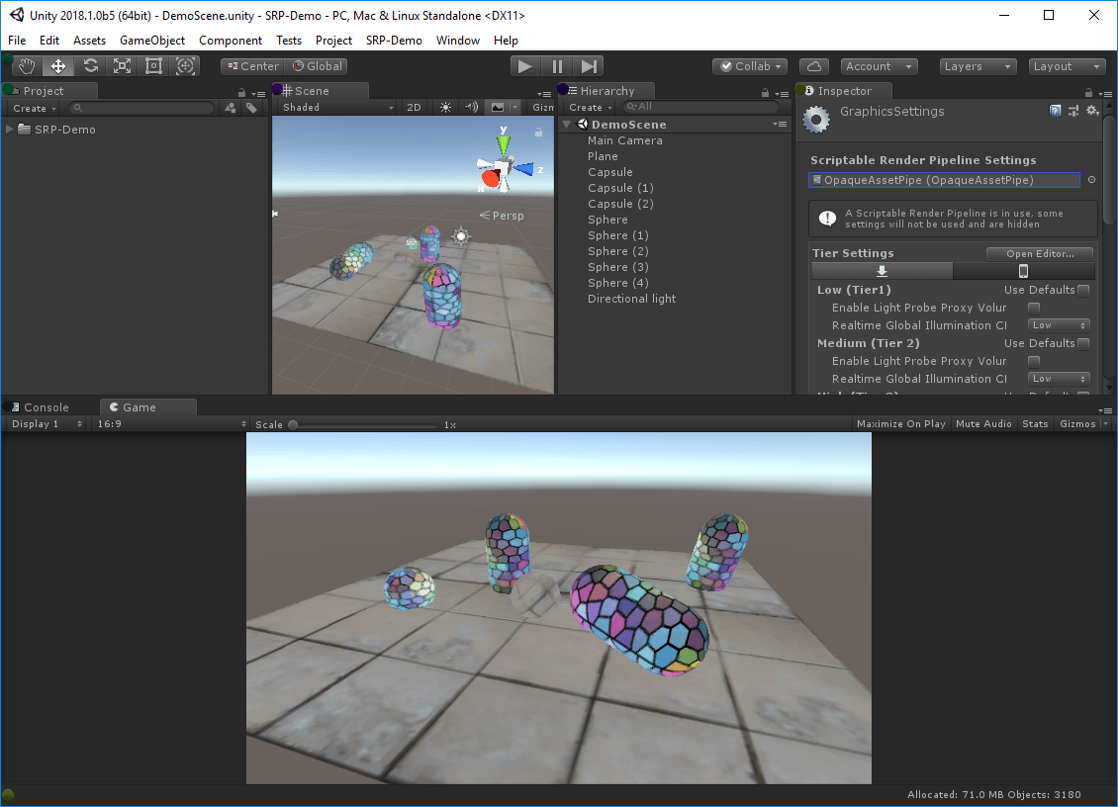
A renderer that renders opaque objects can be found here:
https://github.com/stramit/SRPBlog/blob/master/SRP-Demo/Assets/SRP-Demo/2-OpaqueAssetPipe/OpaqueAssetPipe.cs
This example can be further extended to add transparent rendering:
https://github.com/stramit/SRPBlog/blob/master/SRP-Demo/Assets/SRP-Demo/3-TransparentAssetPipe/TransparentAssetPipe.cs
The important thing to note here is that when rendering transparent the rendering order is changed to back to front.
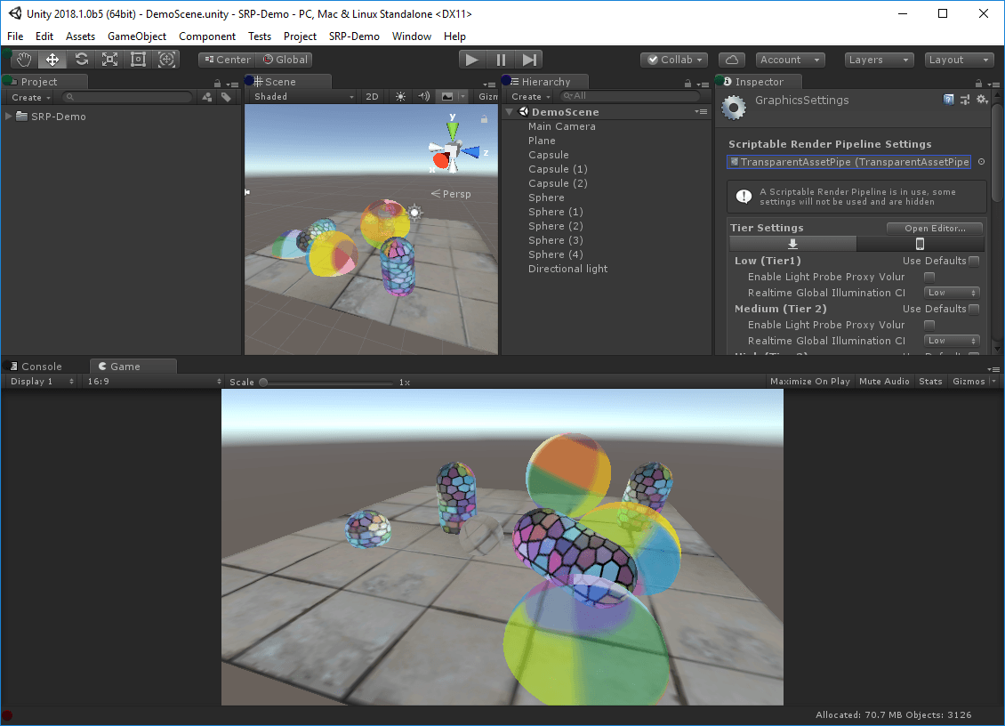
We hope that this post will help you get started writing your own custom SRP. Download the 2018.1 beta to get started and let us know what you think on this forum thread!
Spotlight Team Best Practices: Making believable visuals in Unity
Rinaldo Tjan, 三月 9, 2018
技术
Being part of the Spotlight Team, I am fortunate to be involved in some very interesting projects. The Spotlight Team at Unity works on games together with our customers and a significant part of my role is to help developers achieve the desired look and quality for their projects. I get to hear many stories from all across the industry and can identify common issues that content creators are facing. Several of the projects I have worked on aimed for fairly realistic visuals. Given the project’s art contents, how do we make a scene in Unity that will look believable?
There are a multitude of topics that need to be covered in order to make believable visuals. In this post I’m going to discuss lighting and render settings. Further down the post I’ll also share our Spotlight Tunnel Sample Scene and explain how you can use it to learn and experiment.
Preparing Unity render settings
Understanding how Unity’s rendering features can be used to realistically mimic the real world will help you to achieve your project’s visual goal.
Linear rendering mode
In simple terms, this sets Unity to do lighting and shading calculations using physically accurate math before transforming the final output into the format that works best for monitors.
To specify a gamma or linear workflow,
go to Edit > Project Settings > Player and open Player Settings.
Then go to Other Settings > Rendering and change the Color Space to Linear.
Defining your color space should be one of the earliest decisions in your project, because of the drastic impact on the final shading and lighting results.
Rendering mode.
In the Spotlight Tunnel Sample Scene, we use deferred rendering path. This allows content creators to work with multiple dynamic lights efficiently, combined multiple reflection cubemaps, and have the ability to use the existing Screen Space Reflection features in Unity 2017+.
To set this, go to Graphic Settings > Rendering Path or Camera > Rendering Path
You can find more information about render modes refer in this part of Unity documentation.
High Dynamic Range (HDR) Camera.
When rendering believable lighting, much like in real life, content creators will be dealing with lighting values and emissive surfaces that have a brightness higher than 1 (high dynamic range). These values then need to be remapped to the proper screen range (this is called tonemapping). This setting is crucial to allow the Unity camera to process these high values and not clip them.
To enable this, select the main camera on the scene and ensure that HDR is checked in the inspector tab for the selected camera.
HDR Lightmap encoding. (optional)
The Spotlight Tunnel sample scene didn’t use baked lighting, however, if you’re planning to work with High intensity (HDR) baked lighting, we recommend that you set the lightmap encoding to HDR lightmap to make sure the baked light result is consistent.
The option can be found under Edit > Project > Player settings > Other settings > Lightmap encoding (Unity 2017.3+ only).
Detailed information for Lightmap encoding can be found in the manual.
Tonemapper for your Scene (part of Post Processing Stack).
To display HDR lighting properly, a tonemapper needs to be enabled in the project.
Make sure to install Unity Post Processing Stack (version 1) from the Asset Store first.
Create a Post Process Profile Asset in your project and configure it as follows:
- Enable Color Grading > Tonemapper > ACES
(Academy Color Encoding Standards)
- Enable Dithering. Dithering allows the Scene to alleviate banding artifact introduced by 8 Bit/channel output from HDR Scene. Modern engines use this technique to circumvent the limitation of 16M color output. Leave the rest of settings in tonemapper alone for now.
- Select the “Main Camera” and add component Post Processing Behaviour.
- Assign the Post Process profile previously created to the profile slot. If you want to use Post Processing Stack Version 2, please refer to the readme of the package as it is currently in Beta.
- Enable Image effect for viewport.
This enables you to see the tonemapper all the time while working with the Scene view.
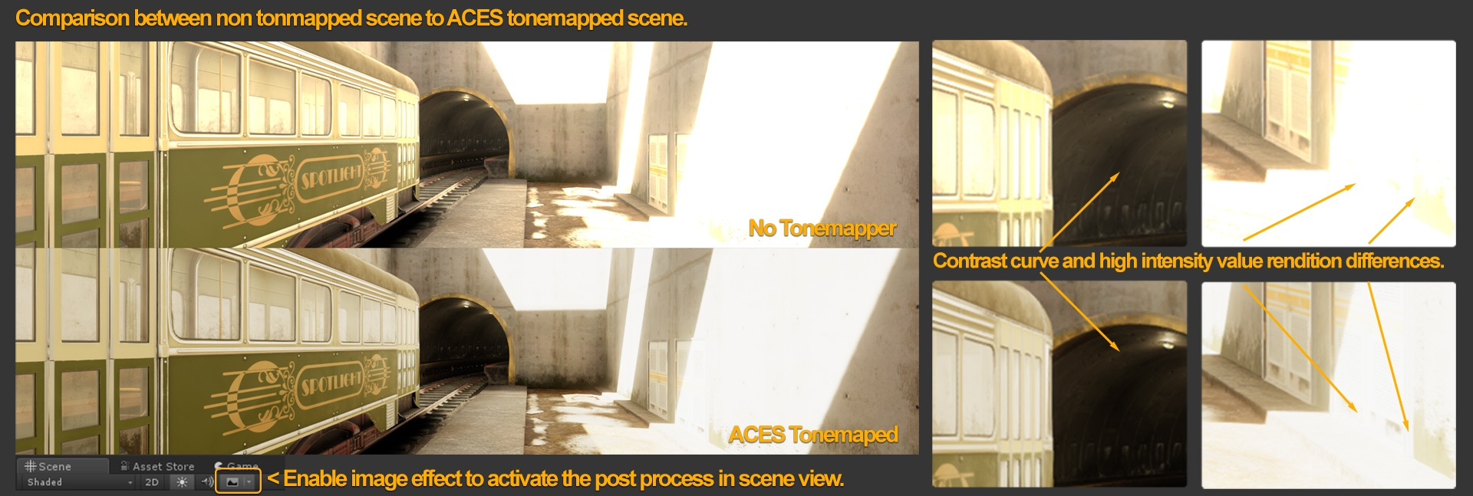Notice the highlight rendition and the dark tunnel value separation improvements in the tonemapped Scene. If you look at the non-tonemapped Scene, you can see how the highlights didn’t converge to a unified color. (the yellowish burning sun in this case).
This setup essentially tries to replicate how a digital camera captures a scene with a fixed exposure (without exposure adaptation / eye adaptation features enabled).
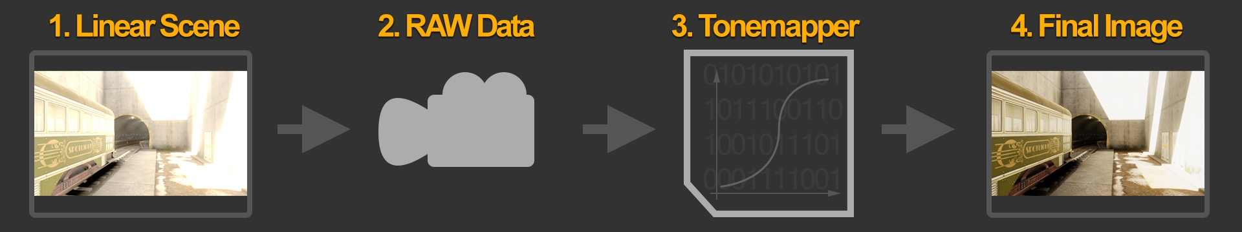At this point, content creators have achieved a proper foundational scene rendering setup that should give believable results with a wide range of content.
Lighting and setup
Unity caters to lots of different lighting strategies/systems and project scenarios. We recommend that you check out our extensive documentation on lighting modes and setup to understand all the different options.
However, for fast iteration and simplicity, responsive visual feedback is necessary.
For this reason, the Spotlight Tunnel Sample Scene is using real-time lighting with Realtime Global Illumination (GI). This will give us a nice range of specular response, good bounce lighting, and let us change our lights on the fly.
Realtime lighting with Realtime GI + Light Probe
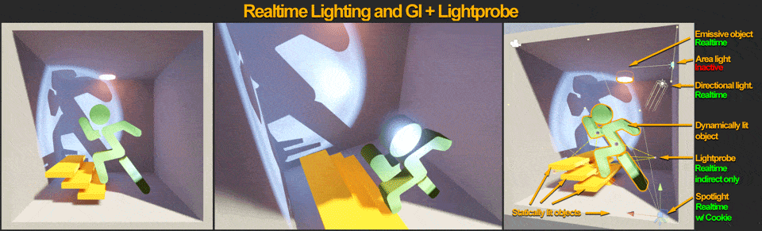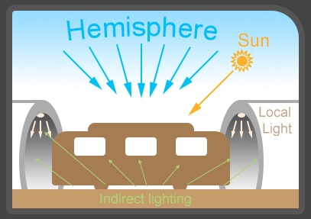
Going back to the lighting itself, a typical Scene, at daytime, with outdoor areas, can be broken down to 3 lighting components:
- Hemisphere (Sky contribution).
- Direct lights (Sun + Local lights).
- Indirect illumination (GI lighting).
At this stage, content creators are assumed to have meshes that are properly textured, and an assembled Scene.
Outdoor lighting and setup
Initial Hemisphere lighting
First component for outdoor lighting is Hemisphere lighting, called Environment Lighting in Unity. This is a fancy word for skylight. Night sky has minimal contribution, while daytime sky has very bright contribution. Hemisphere settings can be found under the Lighting tab (Window > Lighting > Settings > Environment).
For a start, procedural skybox material would be prefered instead of HDRI cubemap. Create a new material in the project, name it SkyMaterial and then set it to Skybox / Procedural.
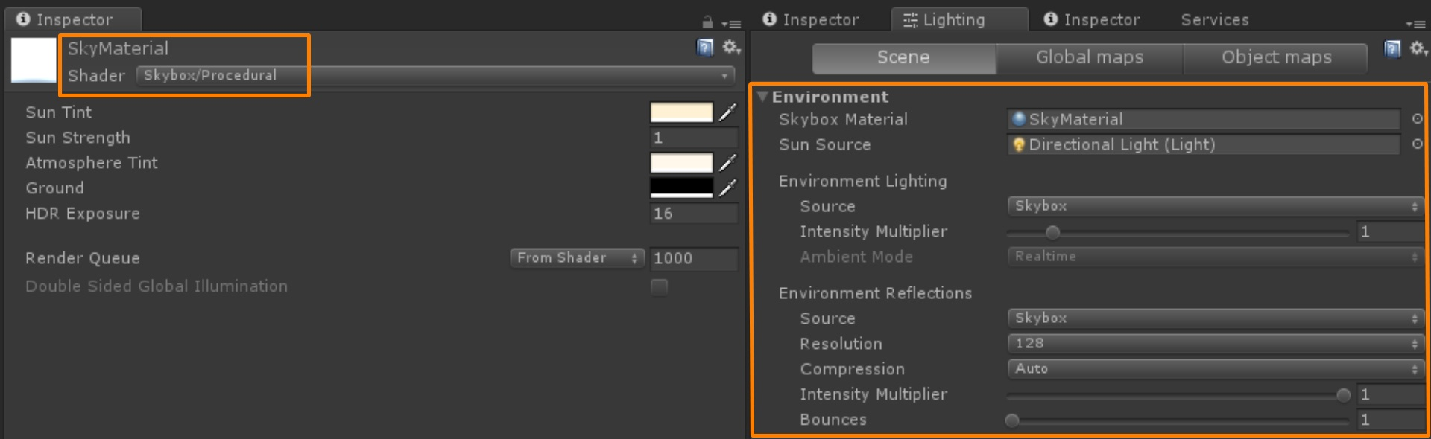
Assign it to Environment Skybox Material inside Lighting tab > Scene.
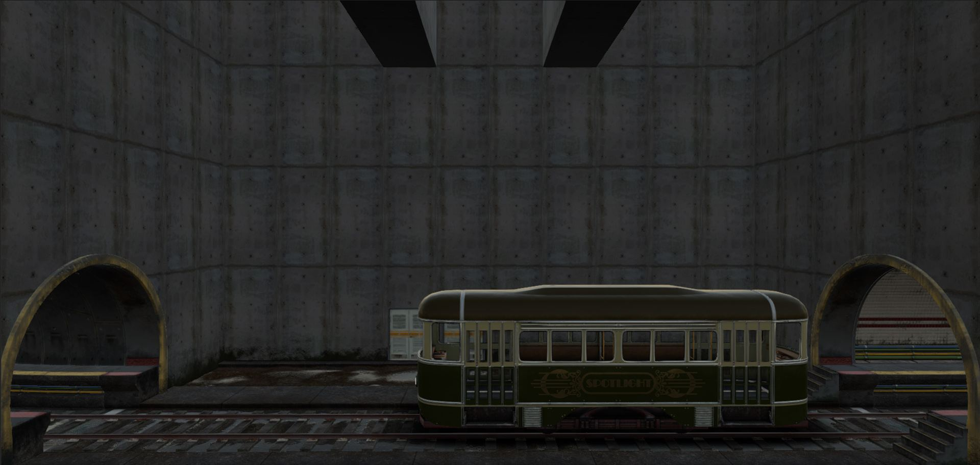
At this point the Scene is somewhat lit. There is ambient, but not exactly proper hemisphere lighting. We’ll leave this alone for now.
Directional Light
Typical sunlight or moonlight is a light source close to infinity distance and has parallel light direction and shadow. They’re usually represented by a directional light.
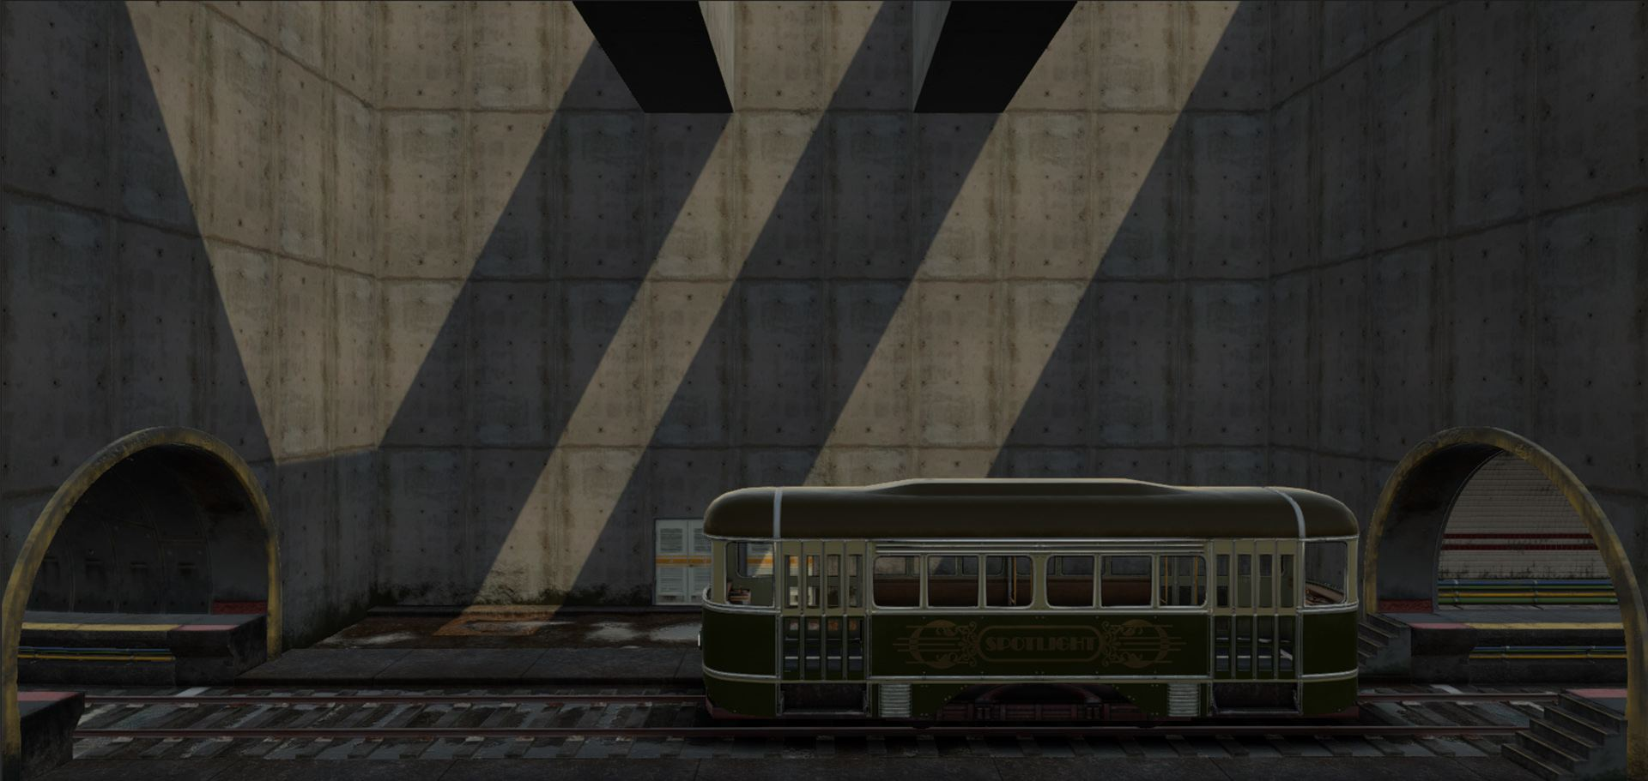
Indirect Illumination / Global Illumination.
Directional light + ambient alone won’t create believable lighting. Proper hemisphere lighting requires occlusion of the skylight lighting. We also need to simulate sunlight bouncing off subjects in the scene. The sky currently renders a single color value to the Scene making it flat. This is where Realtime Global Illumination or Baked Lighting is required to calculate occlusion and indirect bounce lighting. In order to achieve that, follow these steps:
- Make sure all meshes that need to contribute to the Realtime GI or baking are flagged with Enable Lightmap Static and Reflection Probe Static. These would typically be large static meshes.
- Next, enable Realtime Global Illumination (Leave at default-medium settings) in the Lighting tab > Scene > Realtime Lighting.
- Hit Generate Lighting or check Auto Generate.
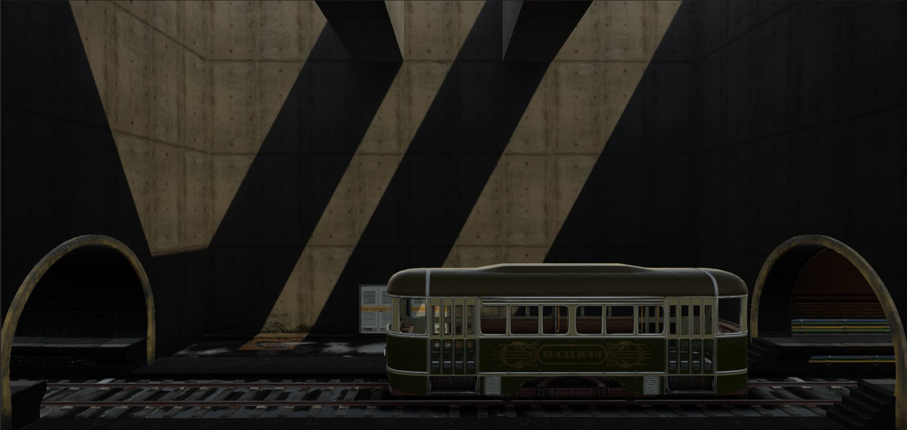
Whoa, the Scene is now dark after light generation has finished. To make matters worse, some elements of the Scene are out of place – notice the Tram and the door on the background.
The static objects in the Scene currently have proper occlusion for hemisphere and indirect bounce response from the directional light, however, the rest of the objects lack a proper lighting setup.
Light Probes and Reflection Probes.
For dynamic objects or non-lightmap objects to receive Realtime/Baked Global Illumination, there needs to be light probes distributed in the Scene. Make sure to distribute light probe groups in the Scene efficiently near the areas where dynamically lit objects are located or will pass (such as player). Learn more about Light Probe Group in the manual.
Hit Generate Lighting again or wait for the precomputation to finish if Auto Generate is checked.
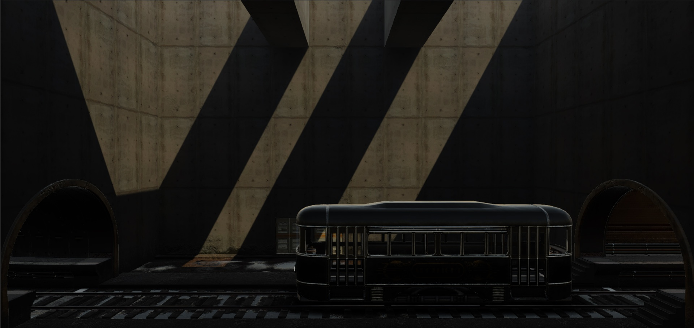The Tram and the background door are grounded better, but reflections look out of place. Sky reflection is all over the place and shows up inside the tunnel. This is where reflection probes comes in. Efficiently place reflection probes with proper coverage in the Scene as needed. In the Scene above, one reflection probe for the main room is sufficient and two for each tunnel interior.
128 pixels Cubemap Resolution using box projection usually is a good baseline for typical cases and will keep memory and reflection bake times happy.
Here’s more information about Reflection Probe.
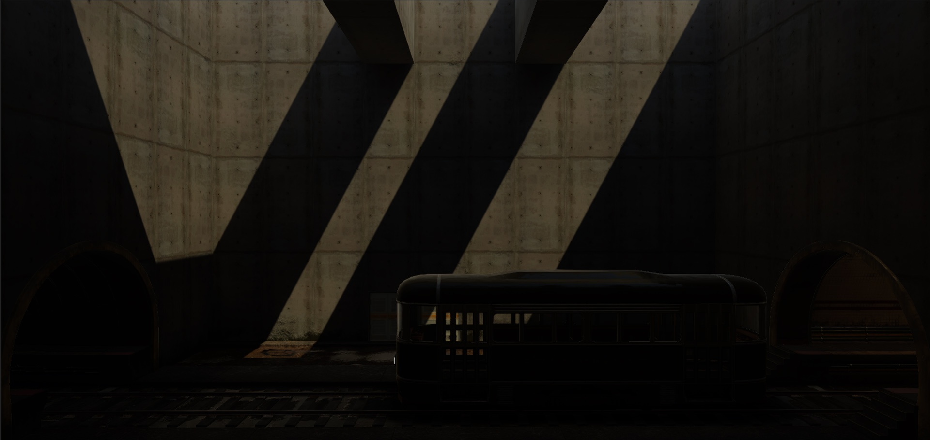The Scene now looked properly grounded and cohesive, an important part of a believable Scene. But everything is even darker than before and nowhere near believable quality.
HDR Lighting Value
Many content creators don’t realize that, in reality, hemisphere lighting and sunlight are very bright light sources. They’re much brighter than the value 1. This is where HDR lighting comes into play.
For now, turn off the directional light and then set the SkyMaterial Exposure to 16.
This will give you a good idea what proper hemisphere lighting does to a Scene.
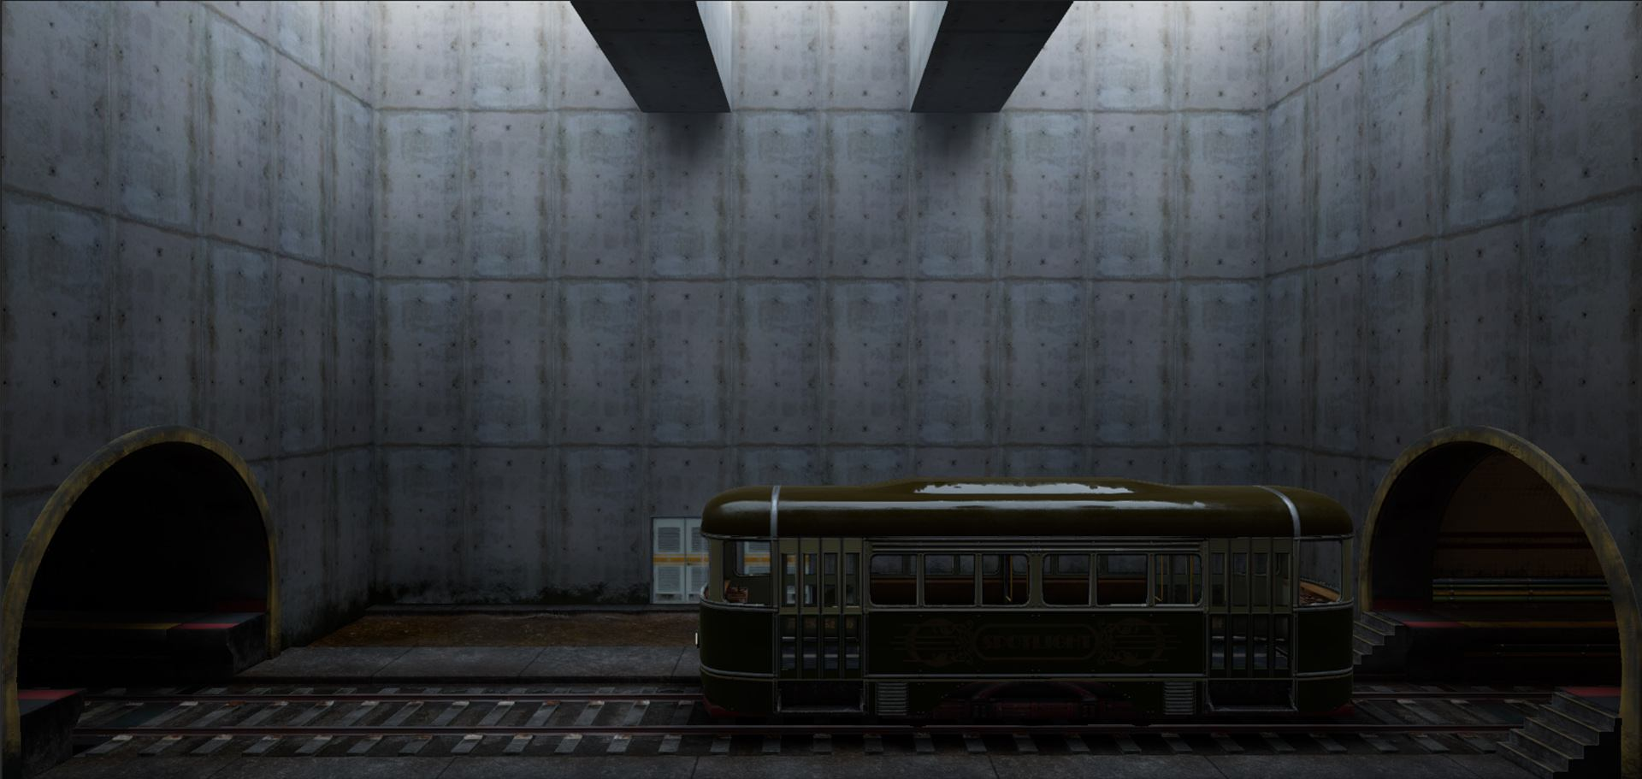Things start to look believable. Think of this state as a cloudy day, where sunlight is completely diffused in the sky, so there’s no directional light.
At this point, you can reintroduce sunlight back into the Scene at a much higher value. Try Intensity 5 for a start. Despite the sun looking nearly white, it’s important that directional light color is chosen properly as the impact of indirect color from the strong sun can dramatically change the look of the Scene.
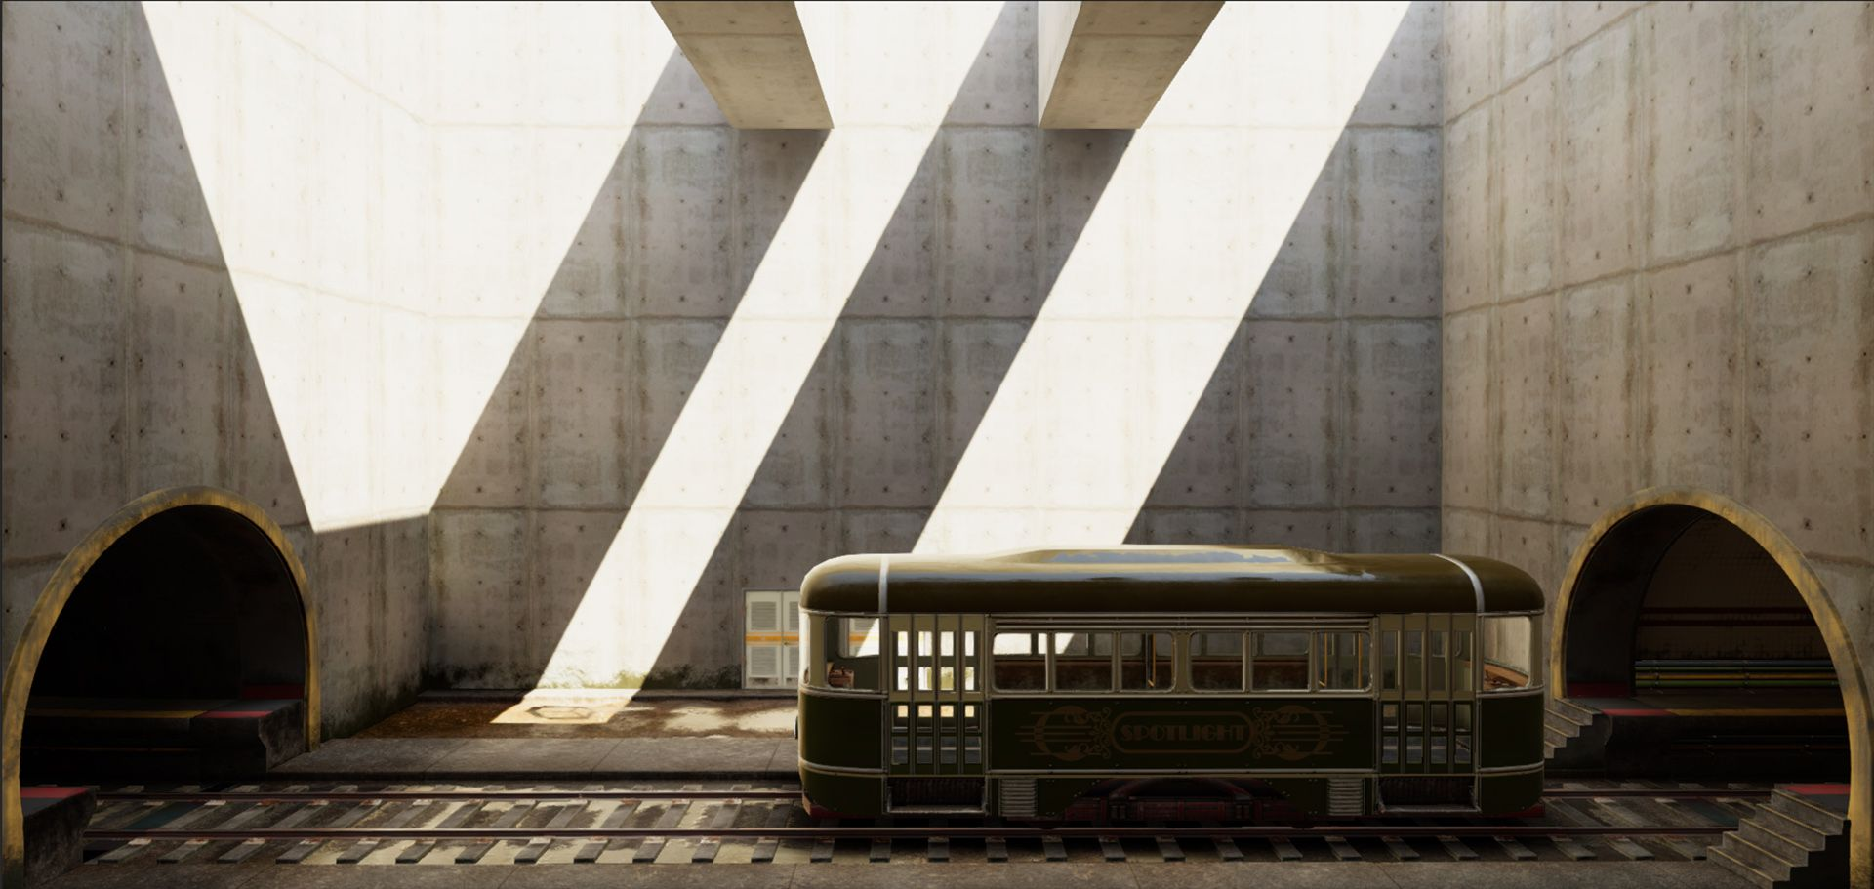Now the sun (directional light) looks like a high energy light as expected from real life. The Scene looks quite believable at this point.

