

**American International University- Bangladesh**

**CSC 3215: Web Technologies**

**CO1 and CO3 Evaluation**

**Project Report**

**Summer2019-2020**

**Project Title: Payroll System**

**Section: F**

|  |  |
| --- | --- |
| Student Name | Student Id |
| ALAM, MUNTASIR | 17-34712-2 |
| HASAN, MAHMUDUL | 17-34580-2 |
| RUMI, FAHIMA AFRIN | 17-33558-1 |
| AHMED, SHARIF | 17-33173-1 |

**Introduction:**

*Managing accounts and maintaining proper records of employee’s time and attendance to prepare payroll manually is a complex and longtime process. We are doing this project for companies to make their time short, task easier and to reduce their cost. This web application will calculate employee’s salaries accurately and quickly. This web application will provide a complete solution of a company’s payroll needs.*

**Background Study:**

*For classes, attributes and relations between the classes this website has been studied.*

***Reference:***

<https://www.freeprojectz.com/uml/payroll-management-system-class-diagram>

<https://www.freeprojectz.com/entity-relationship/payroll-management-system-er-diagram>

<https://www.freeprojectz.com/uml/graphical-payroll-system-class-diagram>

*For designing user interface (UI):*

***Reference:*** Youtube tutorials & Google.

**Requirement Analysis:**

1. **User Category:**

There are 2 types of Users here. They are:

* Admin
* Manager
* Employee

1. **Feature List:**

* In this project the “Admin” has the following features:
* Login
* Logout
* Add Salary
* Edit Salary
* Delete Salary
* Search Salary
* Add User
* Edit User
* Delete User
* Search User
* Add Working Time
* Edit Working Time
* Delete Working Time
* Search Working Time
* Add Payment
* Edit Payment
* Delete Payment
* Search Payment
* In this project the “Manager” has the following features:
* Login
* Logout
* Add Salary
* Edit Salary
* Delete Salary
* Search Salary
* Add User
* Edit User
* Delete User
* Search User
* Add Working Time
* Edit Working Time
* Delete Working Time
* Search Working Time
* Add Payment
* Edit Payment
* Delete Payment
* Search Payment
* In this project the “Employee” has the following features:
* Login
* Logout
* Self Edit
* Self Salary View
* Self Working Time View
* Self Payments View

**Design:**

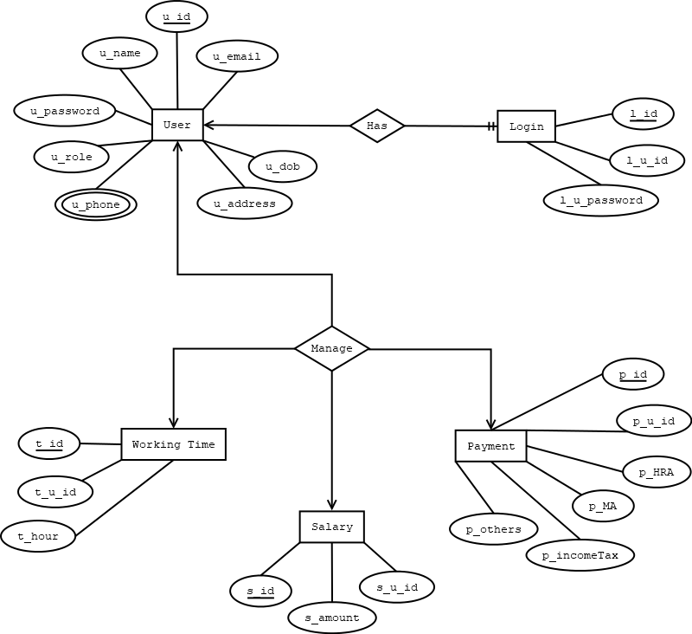

**Fig:** E-R Diagram

**Tools Used:**

To develop this project, we have used the following:

• Photoshop CS6 (For designing demo layout)

• XAMPP

• DIA (For drawing diagram)

• Sublime Text 3

• Google Chrome (Used chrome developer tool)

• GitHub

**System Images against the Specification:**



**Fig-1:** This is the Login Page

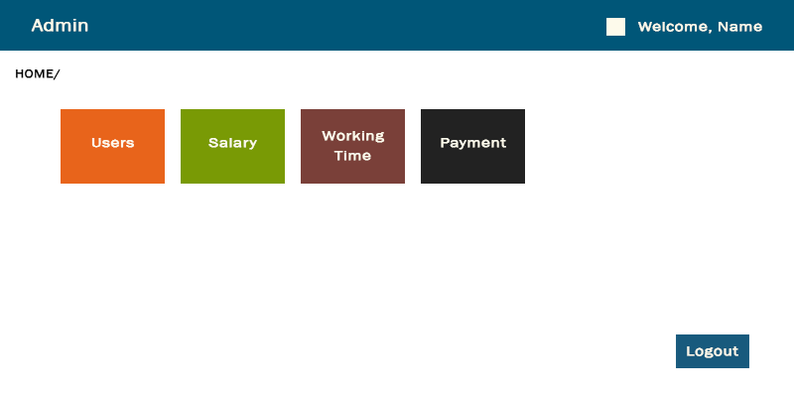

**Fig-2:** This is the Home Page of Admin

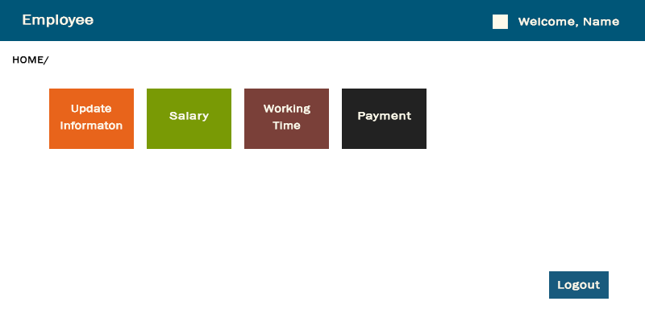

**Fig-3:** This is the Home Page of Employee

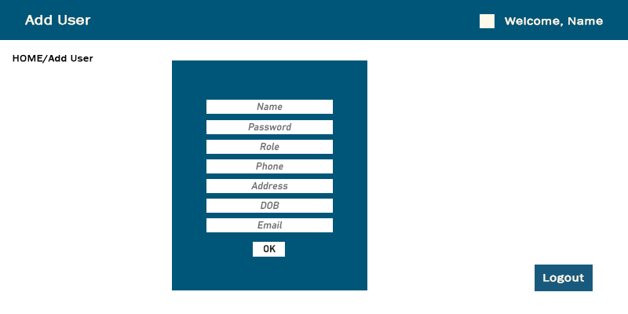

**Fig-4:** This is the User Add Page. Only Admin & Manager can add new users

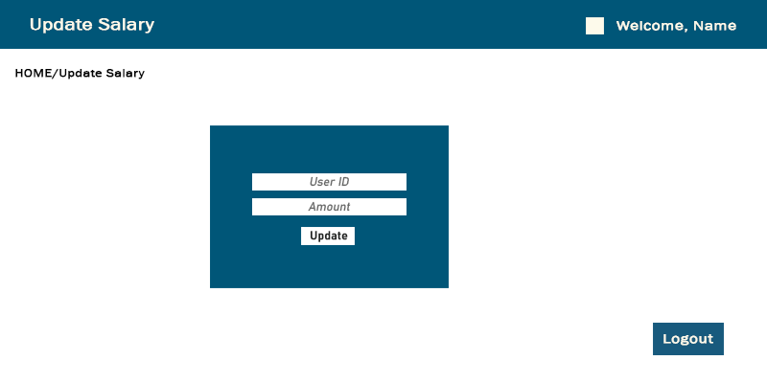

**Fig-5:** This is the Salary Update Page. Only Admin & Manager can update salary

**Impact of this Project:**

Most companies can use this payroll system to keep thousands data of employees in secure. They can choose this system as it can help them by providing additional data and analysis to make this information more useful to their business. Another impact of this web application is- an industry can customize detailed reports including each aspect of the company’s payroll.

**Limitations and Possible Future Improvements:**

Limitations are- we cannot store user absence and vacation granting/ duration/ rejection.

Possible future improvement- While updating this the user absence and vacation granting/ duration/ rejection features will be added.

|  |  |  |  |  |  |
| --- | --- | --- | --- | --- | --- |
| **CO1 and CO3Evaluation: Project Report Evaluation** | | | | | |
| **Project Proposal**  **(5)** | **Background**  **Study**  **(5)** | **Requirement Analysis**  **(5)** | **Entity**  **Diagram**  **(5)** | **System Images**  **against the**  **Specification (5)** | **Total (25)** |
|  |  |  |  |  |  |
|  | | | | | |