ФЕДЕРАЛЬНОЕ ГОСУДАРСТВЕННОЕ АВТОНОМНОЕ ОБРАЗОВАТЕЛЬНОЕ УЧРЕЖДЕНИЕ ВЫСШЕГО ОБРАЗОВАНИЯ

**«САНКТ-ПЕТЕРБУРГСКИЙ НАЦИОНАЛЬНЫЙ ИССЛЕДОВАТЕЛЬСКИЙ УНИВЕРСИТЕТ ИНФОРМАЦИОННЫХ ТЕХНОЛОГИЙ, МЕХАНИКИ И ОПТИКИ»**

**Факультет безопасности информационных технологий**

**Дисциплина:**

«Операционные системы»

**ОТЧЕТ ПО ЛАБОРАТОРНОЙ РАБОТЕ №2**

**«Membomb»**

**Выполнила:**

Студент группа N32511

Бехит Мохаммед М.

Студент группа N32532

Эльгандур Йахиа А

**Проверил:**

Ханов А.Р.

Санкт-Петербург

2023 г.

ЗАДАНИЕ

1. Написать программу выделения памяти и заполнения ее нулями с

шагом, равным размеру страницы памяти (mmap, VirtualAlloc)

2. Составить график свободной памяти

3. Ознакомиться с работой демона OOM Killer в Linux

4. Достичь сообщения о невозможности выделить память в Windows

OOM Killer (Out-Of-Memory Killer) is a mechanism used in the Linux operating system that automatically terminates processes to prevent running out of available memory.

When a Linux system starts up, it reserves some of the available memory for the kernel. The remaining memory is available to processes. However, if all available memory resources are occupied by processes and the kernel cannot perform operations

I/O or other mission-critical tasks, then the OOM Killer kicks into action.

OOM Killer scans the list of processes, looking for those that use a lot of memory and are not critical to the operation of the system.

It then selects one of these processes and terminates it, freeing the memory it occupied. This allows the system to continue running despite the exhaustion of available memory.

When choosing a process to terminate, OOM Killer takes into account some factors such as the size of the process, how long it took to run, and how much memory it used.

In our lab on Linux, OOM Killer will find the file with membomb and forcibly quit it.

**Код на linux;**

#include <stdio.h>

#include <stdlib.h>

#include <string.h>

#include <unistd.h>

#include <sys/mman.h>

int main()

{

int size = 100*1024*1024;

while(1){

char *ly = mmap(NULL, size, PROT_READ | PROT_WRITE, MAP_PRIVATE | MAP_ANONYMOUS, 0, 0);

for(int i = 0; i< size; i+=4096);

{

ly[i]=0;

}

system ("free -m >> ly.text");

}

return = 0;

}

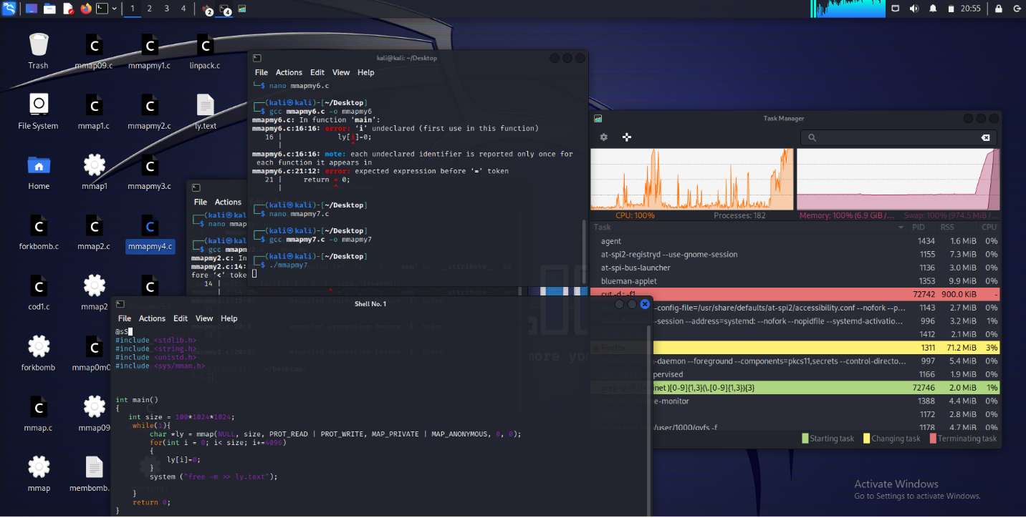

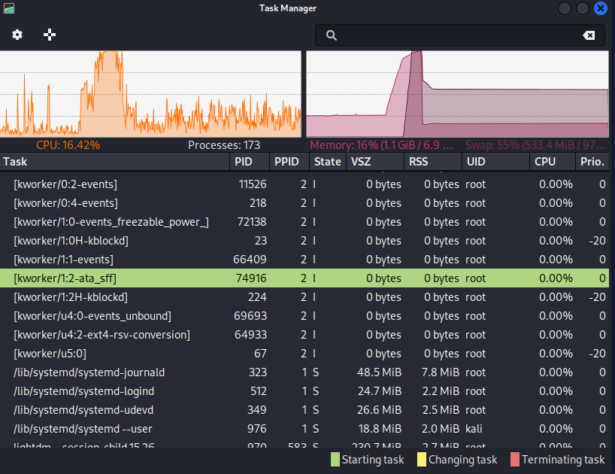

**Код на Windows:**

#include "windows.h"

#include "stdio.h"

#define SIZE 4096

#define AMOUNT 1000

void membomb()

{

MEMORYSTATUSEX statex;

statex.dwLength = sizeof(statex);

GlobalMemoryStatusEx(&statex);

}

int main() {

while (1) {

LPVOID ly = VirtualAlloc(0, SIZE * AMOUNT, MEM_RESERVE, PAGE_READWRITE);

ly = VirtualAlloc(ptr, SIZE * AMOUNT, MEM_COMMIT, PAGE_READWRITE);

if (ly != NULL) {

int* int_ly = (int*)(ly);

for (int i = 0; i < 1024 * AMOUNT; i++) {

int_ly[i] = 1;

}

getmembomb();

}

}

return 0;

}

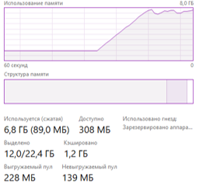

**Вывод**

OOM Killer (Out-Of-Memory Killer) is a mechanism used in the Linux operating system that automatically terminates processes to prevent running out of available memory.

When a Linux system starts up, it reserves some of the available memory for the kernel. The remaining memory is available to processes. However, if all available memory resources are occupied by processes and the kernel cannot perform operations

I/O or other mission-critical tasks, then the OOM Killer kicks into action.

OOM Killer scans the list of processes, looking for those that use a lot of memory and are not critical to the operation of the system.

It then selects one of these processes and terminates it, freeing the memory it occupied. This allows the system to continue running despite the exhaustion of available memory.

When choosing a process to terminate, OOM Killer takes into account some factors such as the size of the process, how long it took to run, and how much memory it used.

In our lab on Linux, OOM Killer will find the file with membomb and forcibly quit it.