**Documentation**

Jeremy Matthews

Colorado State University Global

CSC-CSC450 – Programming III

Dr. Reginald Haseltine

Due Date: 06/23/2024

**C++ Source Code**

/*

*String_Concatinator.cpp

*

* Created on June 16, 2024

* Author: Jeremy Matthews

*/

#**include** <iostream>

#**include** <string>

int main() {

// Declare variables for the input strings and the result

std::string str1, str2, result;

// Loop to take inputs and concatinate strings three times

**for** (int i = 0; i < 3; ++i) {

std::cout << "Enter the first string: ";

std::getline(std::cin, str1); // Use getline to handle spaces

// Prompt user for the second string input

std::cout << "Enter the second string: ";

std::getline(std::cin, str2);

// Concatinate the two strings

result = str1 + str2;

// Output the concatinate result

std::cout << "Concatinated string: " << result << std::endl;

// Separator line for readability

std::cout << "____________________________" << std::endl;

}

// Return 0 indicate successful execution

**return** 0;

}

**Execution Screenshot of String_Concatinator.cpp**

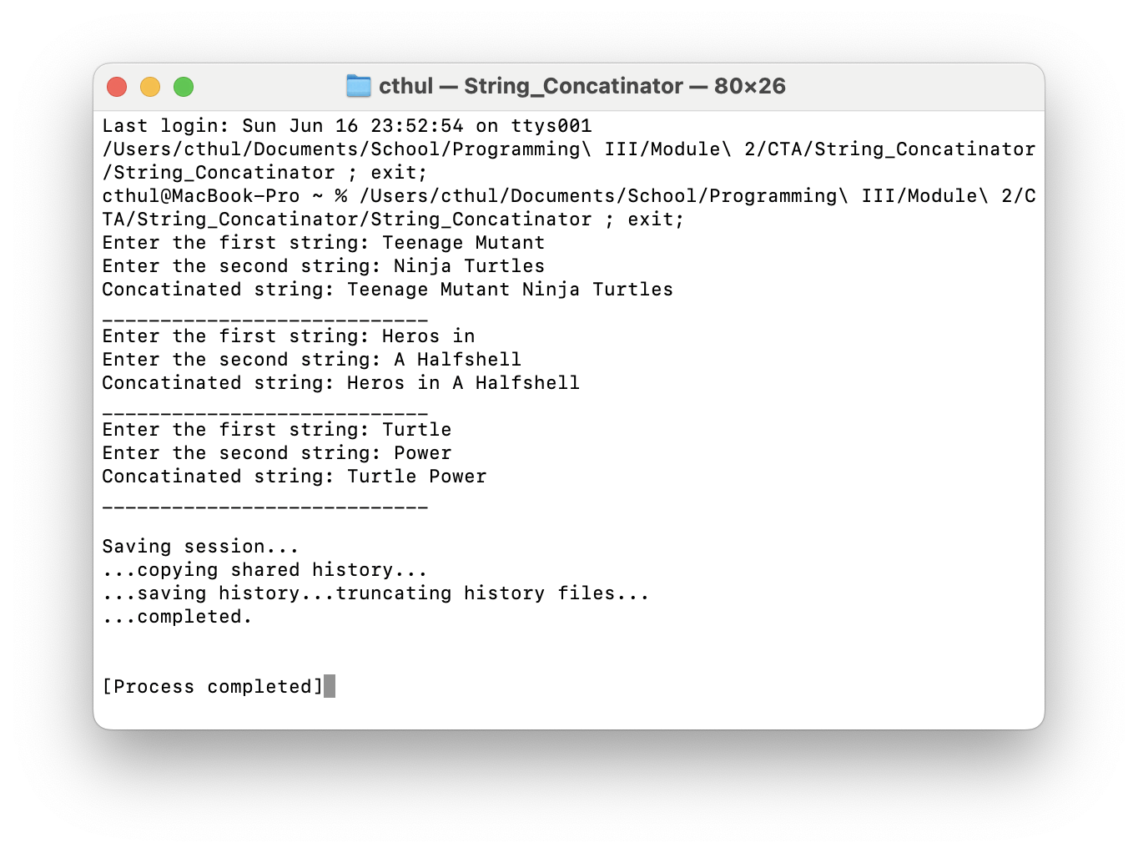

**Github Repository**

<https://github.com/m9dful1/String_Concatinator>

