**Documentation**

Jeremy Matthews

Colorado State University Global

CSC-CSC450 – Programming III

Dr. Reginald Haseltine

Due Date: 06/16/2024

**C++ Source Code**

/*

* personInfo.cpp

*

* Created on: Jun 13, 2024

* Author: Jeremy Matthews

*/

#**include** <iostream>

#**include** <string>

int main() {

// Variables to hold the person's information

std::string firstName, lastName, streetAddress, city, zipCode;

// Prompting user to enter the information

std::cout << "Enter the first name: ";

std::getline(std::cin, firstName);

std::cout << "Enter the last name: ";

std::getline(std::cin, lastName);

std::cout << "Enter the street address: ";

std::getline(std::cin, streetAddress);

std::cout << "Enter the city: ";

std::getline(std::cin, city);

std::cout << "Enter the zip code: ";

std::getline(std::cin, zipCode);

// Printing the entered information

std::cout << "\nFictional Person Information:\n";

std::cout << "First Name: " << firstName << "\n";

std::cout << "Last Name: " << lastName << "\n";

std::cout << "Street Address: " << streetAddress << "\n";

std::cout << "City: " << city << "\n";

std::cout << "Zip Code: " << zipCode << "\n";

**return** 0;

}

**Execution Screen Shots of personInfo.cpp**

**Enter First Name**

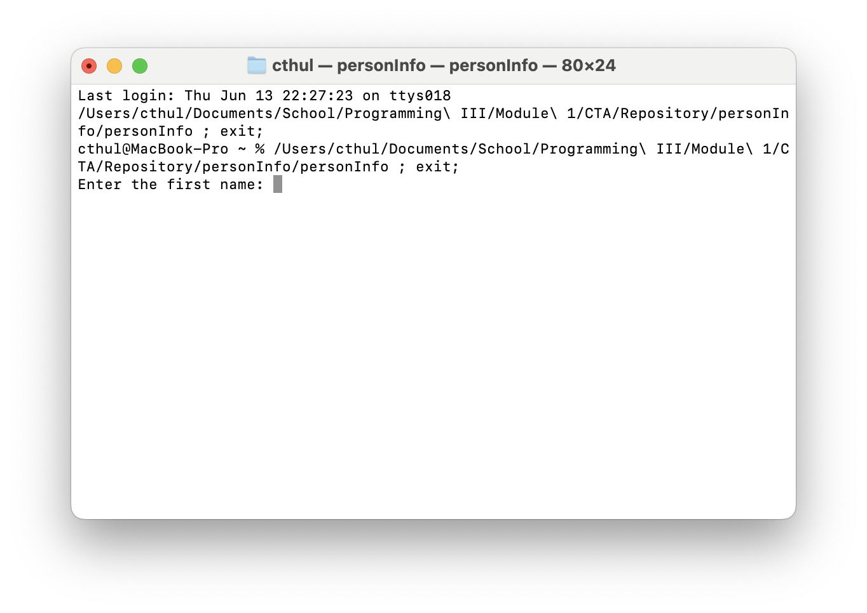

**Enter Last Name**

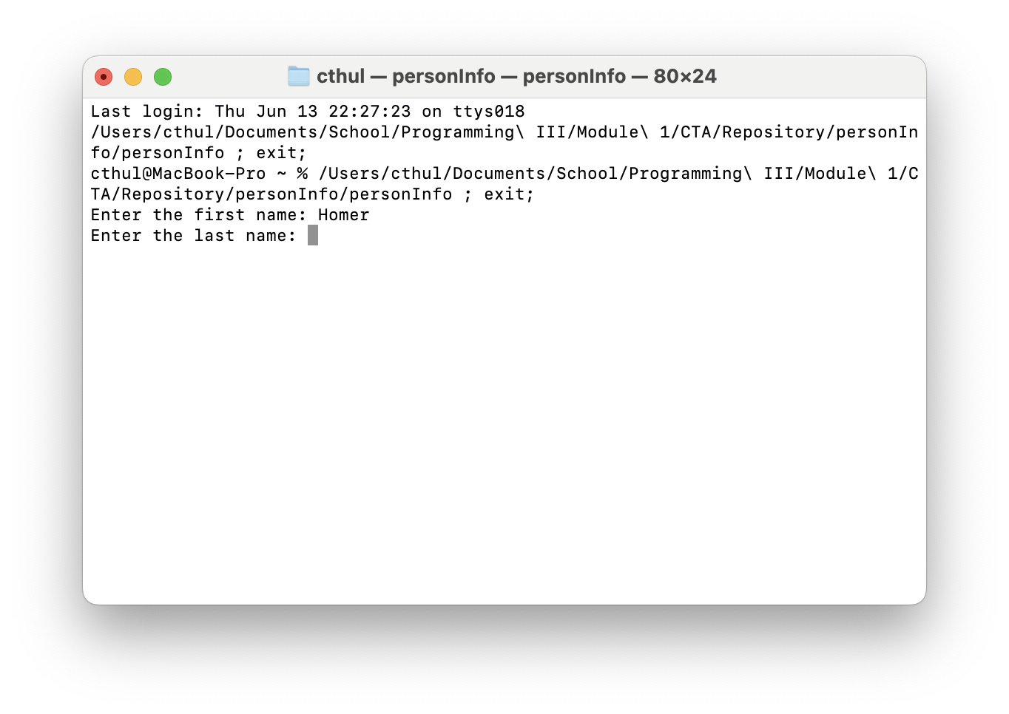

**Enter Street Address**

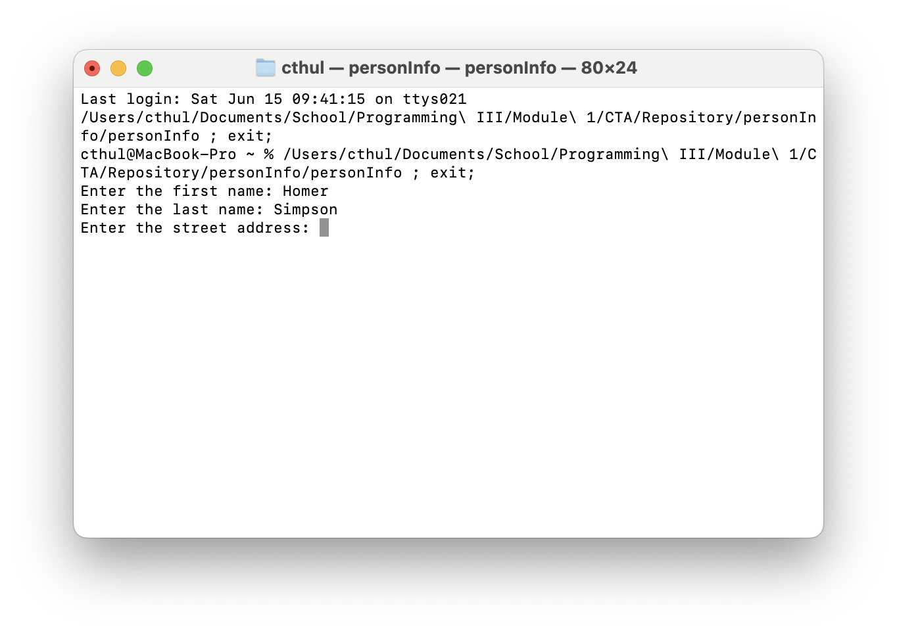

**Enter City**

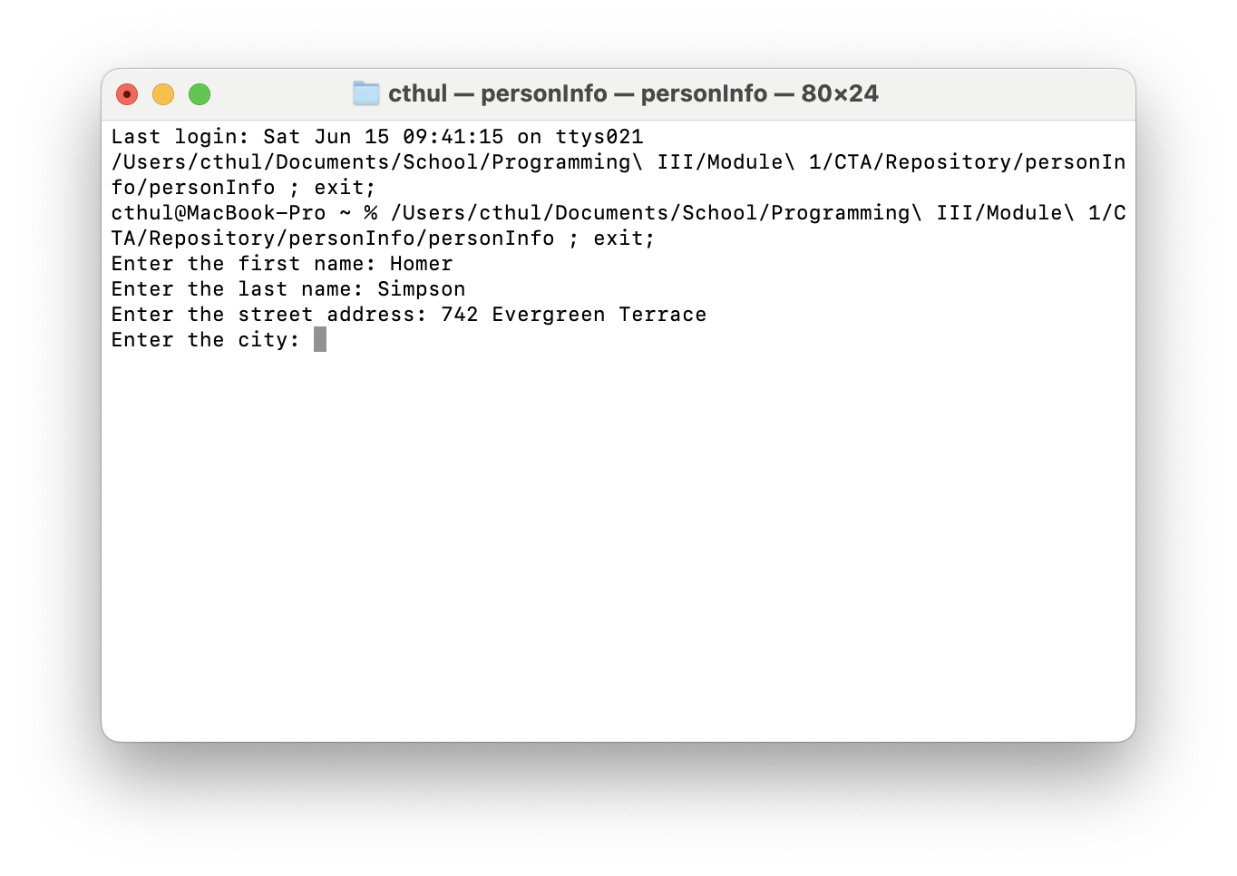

**Enter Zip Code**

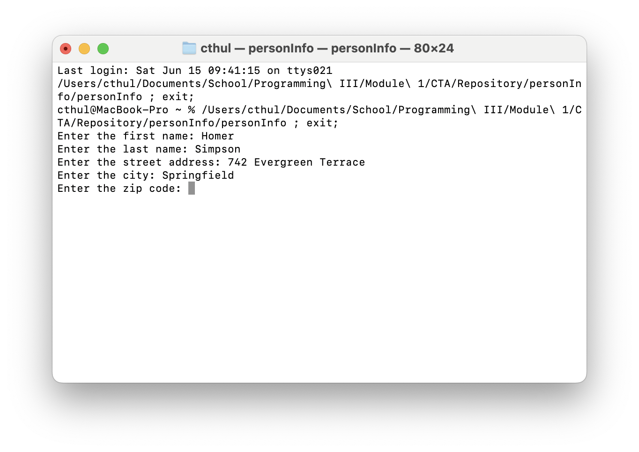

**Print Results**

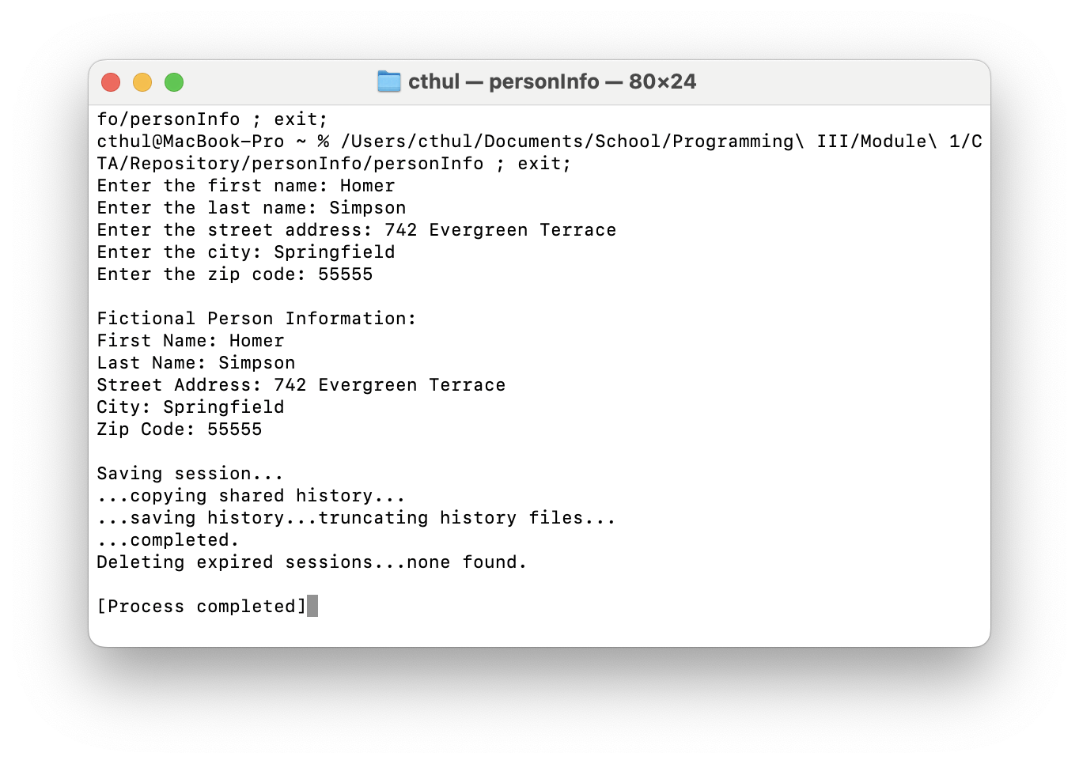

**Execution Screen Shot of CSC450_CT1_mod1-1.cpp**

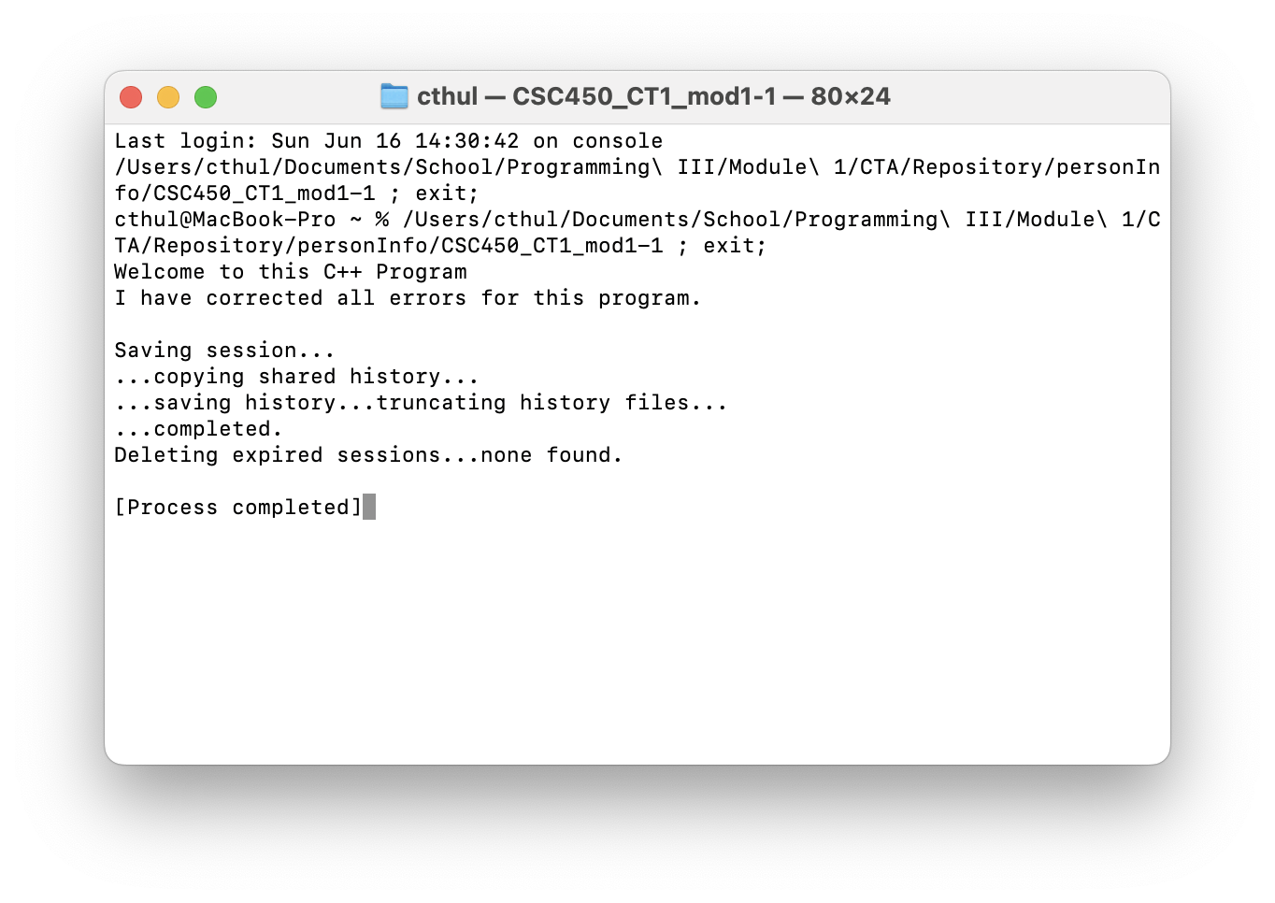

**Execution Screen Shot of CSC450_CT1_mod1-2.cpp**

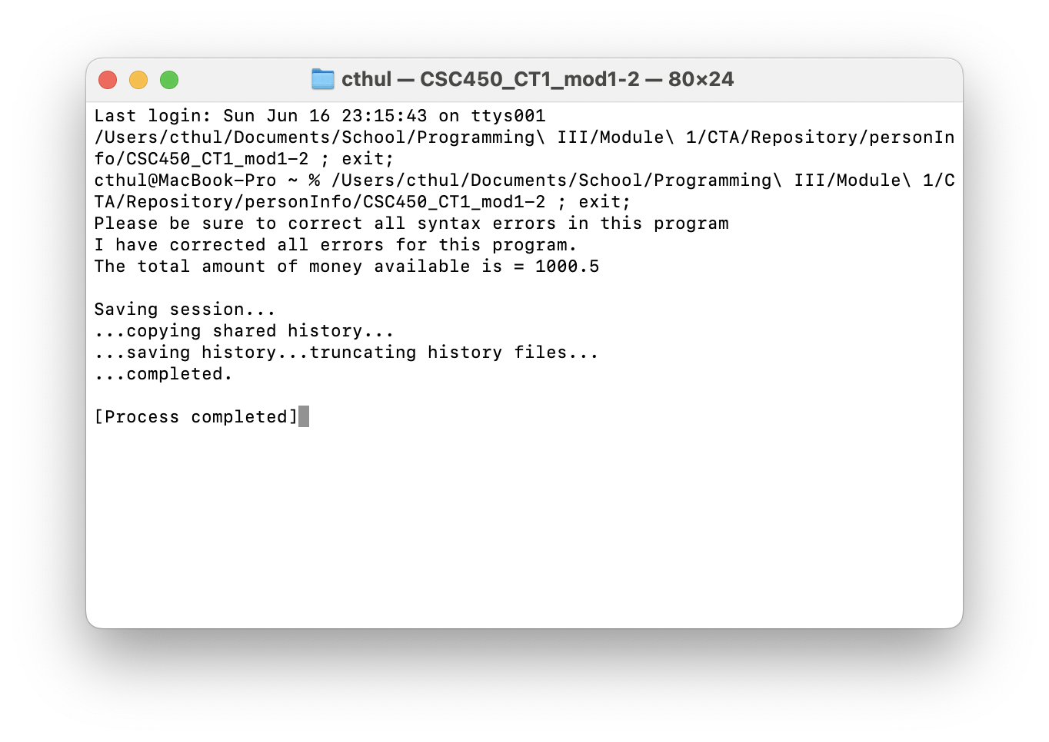

**Github Repository**

