# Some thoughts around prevalent AI scepticism [From Quora answers]

Some answers I wrote regarding the AI hysteria that is being created using misinformation, fake news and sensationalism.

### My answer to “Artificial intelligence will or may lead to an unanticipated crisis if it starts to code itself? How true is it?”

Originally answered here: https://qr.ae/TSC6dR

Chill!! People who are asking such questions need to first of all stop worrying and stop reading media articles trying to scare them.

We are decades (maybe centuries) away from totally automating tasks which require such high level of mental capability. Present Artificial Intelligence can at best approximate tasks which require 2–3 seconds of human decision making that is all. Also most AI we have developed right now is not [Artificial general intelligence - Wikipedia](https://en.wikipedia.org/wiki/Artificial_general_intelligence)

(the one which you watch on movies) but task specific algorithms. We have not even created Terminator/Skynet 0.0.1 yet.

To answer your question directly, it might be a problem if AI starts implementing a better AI itself, thus increasing its capability at a superhuman rate making humans obsolete. But this is like hundreds of other low probability doomsday scenarios like an Alien civilization attacking and colonizing us or Earth’s capability to support life getting over. So no point worrying about it in real life.

### My answer to “What is Deepfake technology?”

Originally answered here: https://qr.ae/pNnxiL

Deepfake is essentially creating fake images/videos/audio/text using Deep Learning techniques.

For example, if you remember a recent viral app which used to create images of how a person would look if they were old or applied makeup, the images it was creating were fake images generated by AI.

However, the term “Deepfake” is generally used for describing negative usage of such technologies.

So you can have someone’s face placed in an objectionable photograph, someone being made to speak fake things they never said in a video and a fake audio in someone’s voice or just a fake news article using Generative Deep Learning algorithms.

For example there are websites where objectionable videos of celebrities are created by morphing their faces into existing pornography using Deep Learning. There is also danger of a video being made with a politician being made to say something that they have not using such technology to sway the public opinion.

It isn’t that such fake photographs or videos or audio cannot be created by humans. They can be and have been created in the past and even now. Just that Deep Learning algorithms bring “automation” to it, that is they can now be created in large quantities without human involvement.

I will put some examples here which you can see and understand how AI can generate video/image/text samples :

**Generating Videos Using Deep Learning**

[First order model](https://aliaksandrsiarohin.github.io/first-order-model-website/)

:

Video:

<https://raw.githubusercontent.com/AliaksandrSiarohin/first-order-model/master/sup-mat/vox-teaser.gif>

**Generating Images Using Deep Learning**

Semi-supervised StyleGAN: Disentanglement is through mutual information loss. Propose new metrics for measuring disentanglement in generator. Take-away: small amount of supervision is enough for disentanglement and high-res generation [@NVIDIAAI](https://twitter.com/NVIDIAAI?ref_src=twsrc^tfw) [pic.twitter.com/FDh26WbiQQ](https://t.co/FDh26WbiQQ)

— Anima Anandkumar (hiring) (@AnimaAnandkumar) [March 12, 2020](https://twitter.com/AnimaAnandkumar/status/1237993418405466112?ref_src=twsrc^tfw)

[Animesh Garg on Twitter](https://twitter.com/animesh_garg/status/1237756934662623232/photo/1)

**Generating Text Using Deep Learning**

[Better Language Models and Their Implications](https://openai.com/blog/better-language-models/)

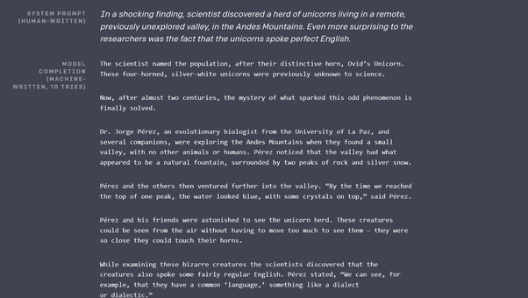

### My answer to “Should we be worried about deep fakes and the misuse of facial recognition?”

Originally answered here: https://qr.ae/Tx6CUl

I think the only aspect of Artificial Intelligence that can disrupt our world for a very long time to come is going to be DeepFakes. The reason is not because the technology is itself very harmful, the reason is because humans are emotional and don’t really put a thought before believing and sharing videos or voice messages. You could basically generate photos , videos and voice clips of a person doing/saying whatever you want using these techniques. I will not be surprised if fake media created by these technology be used to instigate violence or bad faith. In a world where fake news is widespread and fake news busters can spread fake news too, it is going to be big challenge to tackle Deepfakes.

The misuse of facial recognition is actually somewhat fearmongering and luddism. It probably makes the world somewhat less private, but every technology since the invention of cameras has done so for a very long time and its a continuing trend since years. I think the probability of using Face Recognition for bad purposes is not that high. That said, I think there are already regulations in place in various countries to make sure Facial Recognition cannot be used to harm people.

### My answer to “Why Deep mind AI of Google failed to answer 1+1+1+1+1+1+1?”

Originally answered here: <https://qr.ae/pNnedF>

Many assumptions in the question appear wrong:

1. Deepmind is a company, its not an AI.
2. The way you refer to AI, it feels like you are talking about [Artificial general intelligence – Wikipedia](https://en.wikipedia.org/wiki/Artificial_general_intelligence).

Most AI we have in the world (and most of what Deepmind builds) is [Weak AI - Wikipedia](https://en.wikipedia.org/wiki/Weak_AI)

* AGI (Artificial General Intelligence) is a theoretical future where computers can learn any new task when presented to them like humans, is decades if not centuries away. Weak AI means a Computer needs to be programmed to perform one task, like detecting cavity in teeth or playing Atari games.
* Weak AI variant for problems like “1 + 1 + 1 … “ exists. That is simple mathematical expression parsing and evaluation. What Deepmind was trying to do was to use a Weak AI model generally used to look for features in language (LSTMs are the algorithm) to solve mathematical problems. All it tells is Weak AI algorithms to extract features on Natural Language cannot learn to solve Mathematical problem as of now.
* Please don’t read pop sci articles on AI like these: [Google's DeepMind Failed A High School Level Math Test: What Does This Mean?](https://www.techtimes.com/articles/241193/20190410/googles-deepmind-failed-a-high-school-level-math-test-what-does-this-mean.htm) . They are just not informative enough and misguide.

### My answer to “What you think about "Data Scientists Automated and Unemployed by 2025?" article?”

Link to original answer : <https://www.quora.com/What-you-think-about-Data-Scientists-Automated-and-Unemployed-by-2025-article/answers/16871059>

The so called Data Scientists who use off the shelf Machine Learning algorithms on simple data WILL be automated pretty soon, infact Amazon/Azure/Google ML services already do so. To be frank, calling sklearn.fit_predict with different parameters is not really hard and is kind of repetitive.   
The real world is slightly different, A lot of real world Data Scientists are actually Data Mungers, who clean/transform the data (which is really hard to automate), and then Hyperparameter adjusters who apply black box algorithms on top of it (which is easy to automate).  
Other easy repetitive tasks, which involve simple repetitive work and involve humans for the hack of it (say Data Entry Operators, Customer Support chat people, ) are being automated at a steep rate too. Surprisingly, some aspects of art (some form of painting, music, lyrics writing) is being automated too, which I thought was impossible to.  
The day to day tasks of actual Data Scientists, say working at Facebook AI research and Google Brain (writing different Artificial Intelligence agents) will be one of the last to be automated, as it is generally very hard. So I think they will be one of the last in last in the  line of losing "survival of the fittest" battle to Machines. A time when Machine can deduce algorithms is still far off in future.

### My answer to “What will be the need for humans if we automate everything with machine learning and robotics? What will humans do in the future?”

Link to original answer here: https://www.quora.com/What-will-be-the-need-for-humans-if-we-automate-everything-with-machine-learning-and-robotics-What-will-humans-do-in-the-future/answer/Muktabh-Mayank

Why is it necessary for humans to work ? Do any other species of plants and animals work jobs ? Don’t other species live ? Is the only purpose of human existence to make Excel and Powerpoint sheets or write Python code ? These are deep metaphysical questions which are more philosophical and have no real (only theoretical ) answers. Also this is not my answer.

The more practical answer is that automation has always been coming, jobs have always been automated. Shoe Makers were automated by factories and chariot drivers and horse tamers were automated by cars. What always happens is new jobs were created every time (factory workers, car drivers) requiring lesser number of humans, so that humans could engage in more intellectually demanding fields. The same is happening now, with incoming AI technology, jobs are changing. The difference is that while it took generations earlier for a change to reflect, people will see drastic changes in their lifetime (that’s probably the only challenge I see, people will not really be able to “settle” on a career for all their lives pretty soon and will require to learn-unlearn many times in their lifetime) . **The (wrongful) fear is because we see only one aspect of it, not the other side. AI does automate stuff, but sum of human achievements is not a Zero Sum game, it will grow larger.** While you might not be required to enter data in Excel (one random example) searching web due to AI, a bigger intellectual challenge can be taken over by same person than Excel data entry (like say solving Cancer).

### My answer to “Will data science and machine learning get automated leading to lesser opportunities for data scientists”

Originally answered here: https://www.quora.com/Will-data-science-and-machine-learning-get-automated-leading-to-lesser-opportunities-for-data-scientists-as-per-https-www-datasciencecentral-com-profiles-blogs-data-scientists-automated-and-unemployed-by-2025-update/answer/Muktabh-Mayank

Yes. (2025 is not the date I think its going to happen, but its inevitable and will happen in near future). They will be to a good extent. So will be Software Developers, designers, manual workers, teachers, linguists, musicians, game developers etc,etc. There are already rudimentary projects like [Turning Design Mockups Into Code With Deep Learning](https://blog.floydhub.com/turning-design-mockups-into-code-with-deep-learning/) which can turn a design mockup into HTML/CSS code, [carpedm20/ENAS-pytorch](https://github.com/carpedm20/ENAS-pytorch) which can design neural networks without a Data Scientist, [Why AutoML Is Set To Become The Future Of Artificial Intelligence](_blank) , system which can generate new characters for games, [Microsoft AI can translate Chinese to English just as accurately as humans](http://www.business-standard.com/article/international/microsoft-ai-can-translate-chinese-to-english-just-as-accurately-as-humans-118031500414_1.html) , [Baidu's Deep Voice can clone speech with less than four seconds of training | Computing](https://www.computing.co.uk/ctg/news/3028065/baidus-deep-voice-can-clone-speech-with-less-than-four-seconds-of-training) and multiple such projects.

OpanAI’s new project can generate programs given specs : https://www.youtube.com/watch?v=utuz7wBGjKM

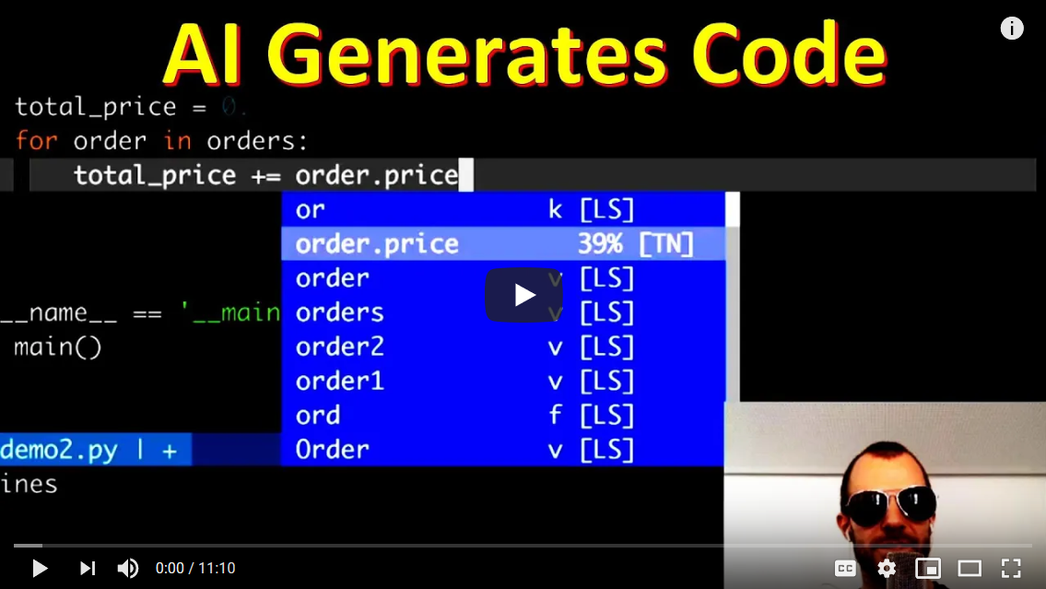

Look at the artificially drawn faces by latest GANs , designers will find it harder to compete with the new quality. https://youtu.be/XOxxPcy5Gr4



AI will impact every job profile which exists as of now, Data Scientists no exception, automating some or a lot of work people spend their time on. For a lot of time these systems will become a <Man + Machine> AI systems rather than just a Human working before stuff is totally automated. So its not like everyone becomes redundant day 1, but they will eventually.

Full Automation of any field is going to take way longer than 2025 IMHO. That said, yes a lot less people will be needed for the same task as of today. Then what will people do you ask ? newer more complex tasks.

Automation is not a new phenomenon. Think about the railway breaks a long time back: https://youtu.be/EEUkmP2nyxo

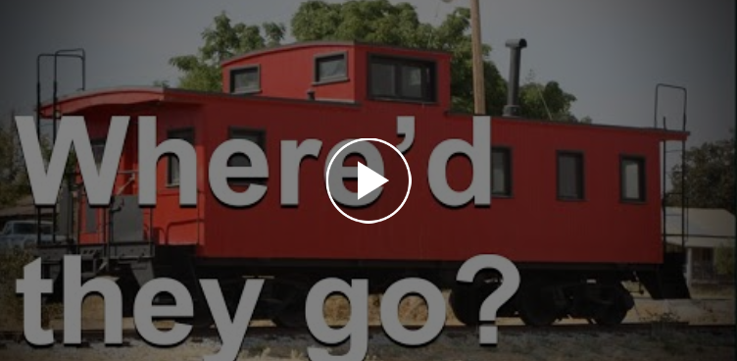

So much work was once needed to just stop the train. A lot lesser work is needed today to run/stop the train and not just that, slowly trains are moving towards full automation, but right now they are in a <man + machine> stage. A lot of jobs will stay in this phase for sometime before full automation kicks in. But unlike railways, which take generations to move from one stage of automation to another, AI is causing changes at a phase at a very high rate.

What is the effect on a general Data Scientist (or any white/blue collared worker for that matter):

1. Adapt to AI. Automation has started, but AI aided jobs will stay for a few more years than non-AI jobs. So while no plain X jobs by 2025, X + AI jobs might be around till 2030.
2. Things wont be like earlier generations where one skill learnt gets you a job for entire life. One needs to be open to learning new skills and get started in the middle of life.
3. Average level of education needed will be high. Think of it, 50 years back “High School” was all the education needed for most jobs. Now its somewhere between high school and graduation. Masters and Research might look like the next frontier, but these degrees are too slow and broad. Coursera like courses will become more important in catching new skillsets. You might already see people doing that a lot.
4. With more uncertainty in jobs, millenials probably will want to be a less “spend-y” and more frugal. You can see things happening already [6 reasons why more millennials aren't buying homes](https://www.businessinsider.in/6-reasons-why-more-millennials-arent-buying-homes/articleshow/59005530.cms) and will actually increase. AI is just a trend in a longer cycle of Automation and millenials are at a point in history where education+society was according to old norms but automation has reached a point where jobs have become uncertain. Younger people will be smarter.