My thoughts on some perennial economic topics of India :

### Q. How does the rise in inequality distort Indian society?

Originally answered here: <https://qr.ae/pND8Oj>

Wealth/Income Inequality is not necessarily a bad thing. However, there are some consequences of these that make the society unstable. IMO campaign against “wealth inequality” should actually be a campaign against excessive “gatekeeping/rent-seeking” behavior. Gatekeeping/rent-seeking is when the privilege induced by wealth inequality starts translating into suppressing fair competition and meritocracy. The distortion in society you attribute to wealth inequality is actually created by the . However, “end wealth inequality” makes a better political pitch and hence everyone gets on-boarded onto that wagon.

Wealth Inequality has its advantages too. It creates many able people who can take risks to do innovation rather than a single entity {state in communism} say. When a single entity does innovation [in science, business, technology ] on part of entire population, just one failure could make the entire system crash. Many individuals tinkering things gets a lot of innovation into the system without the risk of failure. The more innovation is, the more possibility of creative disruption and wealth redistribution to new people. This is one of the core premise of Stephen Pinker’s book Enlightenment Now. {Must read btw, I liked it a lot}.



Stephen Pinker shows that liberalism [earlier classic liberalism which evolved into neoliberalism] which evolved from renaissance ideas has been making human life better everyday statistically, despite many of us thinking otherwise.

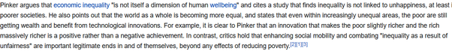

We have seen inequality in the world rise and still humans getting a better life each progressing year. So technically, its clear that inequality is not bad directly.

However, gatekeeping does come up as a side effect of inequality. This is something that Professor Pinker doesn’t talk about in his book a lot, but one cannot deny such a thing. So for example, a rich person may use their contacts to influence behavior away from a less rich person. In more brute terms, this would be done by just overriding “meritocratic” criteria {like how its shown in legendary scene of movie Deewar, “I am sorry, the other candidate knew someone who knew someone, we cannot give you the job” } :

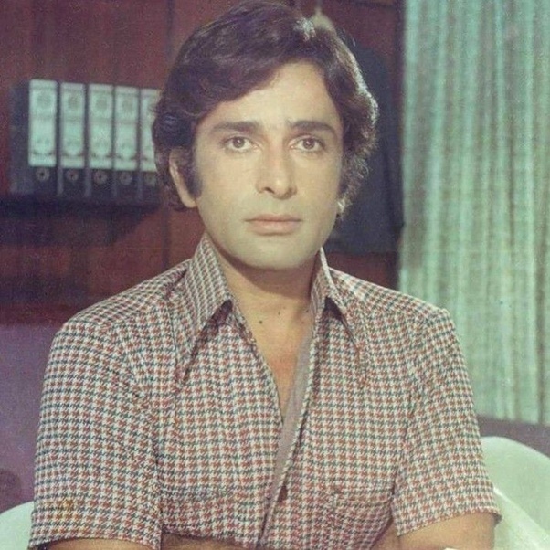

Or more cleverly changing the meritocratic criteria to something the poorer person cannot afford. So new criterion added for qualifying jobs, which specifically the less fortunate cannot afford to get good at. In movie Deewaar, the job was a clerk, but think of such things happening in jobs in administration and bureaucracy.

The same thing could happen with government and private contracts, honors, scholarships and many other things reducing the power of someone who is less rich than the other. Merit can be overridden with credentials quite easily and most people would continue to think they are in a meritocracy while they are playing a rigged game. And then one day common people suddenly wake up to the reality and would want to change society overnight making things worse for all.

The other thing that can be used to “gatekeep” is fear. They know that the risk tolerance of the poor masses is low, so if they can make anything which is good for the masses more fearful than it actually is, the poor masses would deny the advantage despite of all the positives. Indians have been kept away from entrepreneurship and businesses by Indian Communist intellectuals [who despise themself as rationalist] portraying business as bad and stock market as sin and economy as something driven by import-export. We might laugh at it as it sounds like conspiracy theory, but ask a common man and he is still skeptical of private companies and trusts government and its slow bureaucracy more. Indian middle class came out of this mindset after the 1991 economy liberalization, but our poor masses and traditional industry like agriculture workers are still stuck in this mentality. Inequality doesn’t distort the society, but when software engineers are making 21st century salaries and farmers get low money like 1980s for their products, software engineers will have much more risk appetite and be able to take risks. Unfortunately, a lot of “experts” in the country think that sticking to the status quo is better than letting farmers take some risk of market economy.

There are many ways to address [not avoid] these situations like how different countries are solving it :

A. Welfare state like in Europe.

B. Cultural defense like in the US. US has a cultural orientation to achieve C below. Whether the cultural thing works or US moves towards A is still to be decided.

C. Tying the incomes of poor and the rich in some way through government policy or molding national culture to achieve it so that one getting strong means other getting strong too like in Taiwan and China. China is a mixture of A and C.

[What I feel is a good way to achieve it in India in future would be a mixture of A, B or C depending upon which among US and China is the world power in future and our own situation ]

We now know three things :

1. Societies which prospered have had inequality. There should be better off people who can take different risks bringing about innovation.
2. However, inequality can lead to rent seeking in things outside money which can sometimes make common people dissatisfied. Dissatisfaction makes society unstable. Basically few people are jealous of another person’s wealth, but most feel bad if the rich person uses their wealth [or influence of wealth] to get ahead in things where they feel the rich person is not as good.
3. Another thing inequality creates is different risk appetites of rich and poor people. If something that makes good money for poor can be somehow shown to be risky, the poor would willingly give it up, letting the rich take all advantage of the proposition.

Let us now understand the Zero Sum game that people associate with inequality [and why its irrelevant in the current world].

Basically in a capitalist system, people assume :

Earnings - expenditures - Wages [Labor Income] = Profits [Market Income]

Now since everyone is greedy [something on which communism and libertarian thought agree] , the only way to make more money is increase earnings [so expand the market of the country to abroad], reduce expenditures [get cheaper machinery and land from whosoever offers it at the best price] and when both of these saturate, workers and shareholders would on opposite ends as one would try to increase the Labor share [wages] and the other will try to maximize profits [profits]. So when the economy reaches a saturation point, workers and investors are shown to be fighting in a zero sum game where rich grow richer by taking away poor persons’ wages. BTW, that is not totally false when we look at the times of industrial revolution in England and Europe. [Working and Living Conditions](https://firstindustrialrevolution.weebly.com/working-and-living-conditions.html)

. The entire philosophy of Communism came out of this ill treatment of workers. There is no doubt that the workers need enough money to survive at the least, by survive I mean [Food, Shelter, Health, Education], if a capitalist system cannot provide that, it would collapse like in 20th century Russia or China. So if a capitalist system is surviving, it has at least found a equilibrium where workers don’t have to worry about “survival”.

This “model” of inequality, however, is now redundant because : A. Most first world countries have removed need to worry for survival and developing countries are quickly following them. B. Most new capitalist wealth [specially in big tech is not being generated by dividents/profits but by growth investing [Growth investing - Wikipedia](https://en.wikipedia.org/wiki/Growth_investing)

].

Indian worker is not one defined person, there are people living in pre-1990s socialist India in some industries [with socialism level ‘according to their needs’ low wages] and there are people writing blockchain as well. This actually creates a very different income distribution, which should be India’s primary aim to solve. ***India still has to complete solving problem of providing everyone with necessities before we focus full on solving a first world problem like “income inequality”.*** If we are unable to bring all sectors of economy in the same economic system soon, we will have to solve dual problems of income inequality for some segments of society and survival for other segments. We are lucky to blessed with an growing economy so that these problems are not pinching us hard right now, but we should build policies which aim to achieve equilibrium during the period of high growth.

We are not doing bad btw :

[Report: India Lifted 271 Million People Out Of Poverty In A Decade [Infographic]](https://www.forbes.com/sites/niallmccarthy/2019/07/12/report-india-lifted-271-million-people-out-of-poverty-in-a-decade-infographic/?sh=44d7ec262284)

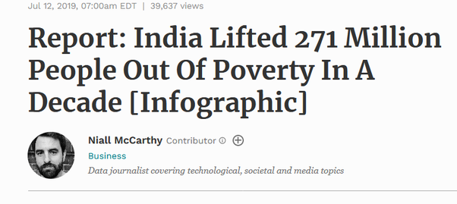

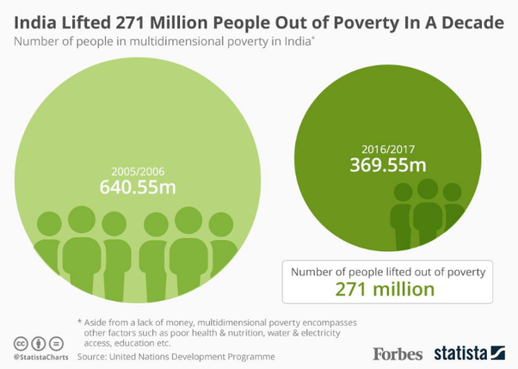

With new reforms being introduced in traditional sectors of economy, you should think that India will eventually have a structure like the west has today and China is soon approaching :



But what about eventual capitalist systems where all economies eventually reach, where workers are earning enough to not have survival issues ? Where should workers invest the extra cash they earn ? Should there be worker protectionism [say minimum wage or protection of traditional industries] or workers need to look after themselves? Are the workers supposed to create a moat just like investors do ? When in a society people are earning enough to live, the next question is where do they spend ? While most investors will hardly indulge in spending just for the heck of it and will invest their money, workers are encouraged to buy stuff. As J J McCullough says, middle class [which is now the default worker class in OECD] is based on three proponents :

[https://youtu.be/OsUEbN6NZr0](https://youtu.be/OsUEbN6NZr0)



These words might sound bad, but they are not . “Anxiety” is basically the push that makes people work hard to make sure their family continues to have a good living. “Consumerism” is buying things to make life better for family and “Conformism” is doing what rest of middle class is doing to make life better.

***How India will build the new culture of its upcoming middle class around Consumerism and Conformism will define how we solve the problem of inequality.*** We would either go the China way or go the Scandinavian/Russian way or the West Europe way. Referring to observations of the paper [Capitalist Systems and Income Inequality](https://stonecenter.gc.cuny.edu/research/capitalist-systems-and-income-inequality/)

going forth.

Please look at the following curve, India lies with other “developing economies” like Mexico, Brazil etc in the fourth Quarter. This basically means we are still a partially traditional economy and partially modernized one. [Only somewhat modernized economies listed here].

The Y axis is proper wealth inequality [compositional inequality or Mathematically Gini Index, Y=1 means all welath with one person and Y = 0 means everyone with same money] and X axis basically tells if the “source of income” of rich and poor are the same or different. [1 being totally different]. Right now India’s rich primarily make money from investing in stocks, real estate and other safe financial instruments while poor make money by selling their time on agricultural fields and workshops, so its near 1 from India obviously if you have been reading my answer.

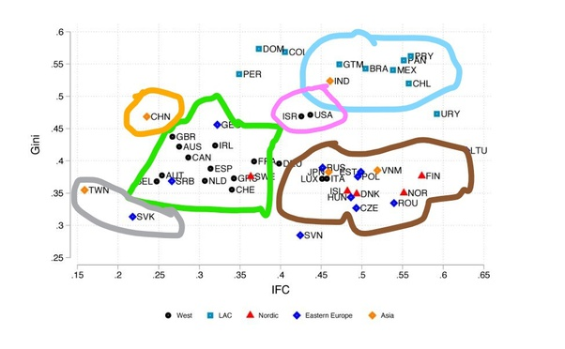

You can see clusters of countries, like West Europe in Green, East Europe and Scandinavia in brown cluster, Taiwan and Slovakia in a unique cluster and China in its unique cluster and Israel and America in one. East and West Europe clusters depend upon welfare state to address inequality. I think with the free market type approach India now has, it would eventually reach a US like situation [mixed consumerism/investing culture]. For China like situation, India would have to mandate workers [or create a culture] to spend in a way that mirrors how the rich spend their money [Investing in low but non-zero risk financial products and not consuming goods with all the money they earn] .

### Q. What if India would be full of foreign companies and no Indian company?

Originally answered here : https://qr.ae/pNaHms

It won’t be possible to have no Indian companies at all. A nation cannot just be a market (like what happened during colonialization) or a market+sweatshop (like how people would imagine a situation like this to happen in modern world) forever. Let’s discuss both these scenarios :

**Colonial Times (Colony is just a oligopoly market for foreign companies):**

One cannot eliminate all Indian companies even during colonial rule, you would always require help of local entrepreneurs and businessmen. There were many British business owned stooges in India during colonial times. So even in a colony, there will be either subsidiary companies or suppliers despite we trying to push out all Indian companies. But we have had an extreme low of influence of Indian businesses in our market.

The closest to having no local companies and only foreign company India reached was during the British colonial rule (and the East India “Company” rule before that). Not all the companies and businessmen were British or European, but most of the important ones were. Regulations and tariffs were used to not just pay Indian merchants with money extracted from Indian farm revenue thus making India’s money supply low, but also there goods were made less competitive so that they could not compete in Europe or even in India.

India’s cotton businesses were for example forced to close to keep only British businesses in the European and even Indian market. [Textile manufacture during the British Industrial Revolution - Wikipedia](https://en.wikipedia.org/wiki/Textile_manufacture_during_the_British_Industrial_Revolution" \l "East_India_Company)



Cotton made Bengal probably the richest province in India and once it lost its trade advantage, the money supply to Bengal was greatly reduced. Similarly, Indigo, Salt and other exports of India were actively thwarted and India’s gold was taken away as British company’s were more competitive than Indian counterparts due to regulation. Think of it, buying a product made in UK was cheaper than local Indian products. [Economy of India under Company rule - Wikipedia](https://en.wikipedia.org/wiki/Economy_of_India_under_Company_rule" \l "Trade)

So an extractive economy where British Government could make laws to make British companies more competitive essentially did wipe out Indian companies. Let’s talk about Bengal in particular, Bengal had a better per capita income pre-British conquest than all of Europe and Britain itself. It was possibly more industrialized too. In a few centuries of trade deficit and many man made famines ([Great Bengal famine of 1770 - Wikipedia](https://en.wikipedia.org/wiki/Great_Bengal_famine_of_1770)

, [Bengal famine of 1943 - Wikipedia](https://en.wikipedia.org/wiki/Bengal_famine_of_1943)

) , it was poor super densely populated Indian state (due to its poor populations from erstwhile industrial nodes and their supply hinterlands) which had to move to a desperate measures like communist governments to keep the society from falling apart from lack of wealth. There is a reason India went full “no to international trade” during 1947–1991. I don’t think I need to explain why India will not want to become a colony anymore.

**Modern Times (Less income countries are markets + sweatshops for large first world companies)**

In modern times, an alternative way is possible to reach close to the theoretical point of having no local companies at all. That way is for a low income company to become a sweatshop for companies of first world companies. First world companies have high labor rates so they enter low income countries to manufacture. This manufacturing capability can expand to make prices of their product/services much more competitive/high quality to enter markets of third world country too, eliminating companies serving third world countries. Rising incomes in the third world country would make more foreign countries rush to cater the demand of middle class as the local company ecosystem for this country would have been shrunk to give a credible competitor.

This process is not at all bad for the third world country btw. Incomes rise, People come out of poverty, good quality products are available for cheap. Adam Smith’s “The invisible hand” profits both parties involved. India has lived in this type of a bubble during 2000–2012 say. [Economic development in India - Wikipedia](https://en.wikipedia.org/wiki/Economic_development_in_India)

. You can say some phase of this continues even today. Everyone loved working at Microsoft and eating at McDonald’s during this time. (I remember this too well as I joined workforce around 2012, when the trend had started dieing after the world had witnessed 2008 economic downturn). There are proponents of opening up many other guarded sectors of Indian economy to free trade to let incomes go up even more. An Indian milkman still earns much less than say an Indian who does Data Entry in a IT company. There is some action on it too, where Indian government keeps relaxing FDI limits for different sectors. One can thus surely ask, why not just go all in on full trade ? just let incomes rise, we loose business capabilities locally but large companies sure employ many people with more sturdiness to cycles of economic downturns. A job in a large MNC is safer than a job at a startup.

The reason is perfect efficiency (absolute free trade in this case) is good in short term and can be used to increase income and competitiveness, but is not really a good long term strategy. [Muktabh Mayank's answer to How far can India go to keep the Chinese players, who are well en-trenched in the global tech supply chain, off the Indian market without prejudicing its own growth?](https://www.quora.com/How-far-can-India-go-to-keep-the-Chinese-players-who-are-well-en-trenched-in-the-global-tech-supply-chain-off-the-Indian-market-without-prejudicing-its-own-growth/answer/Muktabh-Mayank) . While the linked answer of mine is more theoretical, I will give a practical example of what happens if we let free trade fully take over, where world leader MNCs are sure to beat out local Indian companies in terms of quality and price (or both). {If you think on lines of ohh, Indian companies should step up and compete against these giants, why give them a break, read my answer here: [Muktabh Mayank's answer to How does a company that sells a powerful software package like MS Office survive when others offer a free equivalent package?](https://www.quora.com/How-does-a-company-that-sells-a-powerful-software-package-like-MS-Office-survive-when-others-offer-a-free-equivalent-package/answer/Muktabh-Mayank) . TLDR is that a business with better ecosystem and knowledge advantage cannot be defeated most of the times. We need to help our local companies stay competitive while avoiding building a monopoly for them. }

So, the problem with the countries which took this model of being just a market and a sweatshop killing local companies to the extreme is eventual [Middle income trap - Wikipedia](https://en.wikipedia.org/wiki/Middle_income_trap)

. No doubt the per capita income goes up by a lot and that too comparatively faster than developing ones own industrial/business ecosystem (China is quickly disrupting the narrative of indigenous ecosystem based development is slow btw) . Major case studies for such economies are 1. Thailand and 2. Brazil. Thailand is very interesting. [Economy of Thailand - Wikipedia](https://en.wikipedia.org/wiki/Economy_of_Thailand) is one of the best economies of Asia. It has decent per capita income (much better than an average Asian country) and even a welfare state. It is a manufacturing base of cars, electronics and jewellery. Do you know of any Thai car companies ? No. Most of these are MNCs. Luckily the tourism sector of Thailand is innate and cannot be really a fully foreign run sector like agriculture sector of India. Look at its neighbors and Thailand dwarfs them economy wise just moving with and supporting free trade. Probably a mini model of what a India moving on similar lines would look like. What is the harm in being like Thailand you ask ? No ecosystem to take them ahead of where they are now. They have a huge sovereign fund which they can probably use to fund their people, but there is a very small software ecosystem, a very small deeptech ecosystem, a very small startup ecosystem (say compared to much poorer Indonesia: [7 Best Famous Startup Indonesia](https://www.mime.asia/7-best-famous-startup-indonesia/) ) , the things that would drive the future of growth. People have been engaged in industrial manufacturing jobs that suffered a jolt due to the pandemic and launch of electric vehicles. Tourism went down due to the pandemic and now you have widespread social unrest. [Tensions Mount In Thai Protests As Bangkok Braces For Major Rally](https://www.ibtimes.com/tensions-mount-thai-protests-bangkok-braces-major-rally-3087932)



When people don’t see growth in their personal lives they get frustrated with authority. This is how classic Middle Income Trap works. Look at Brazil and you will see parallels too.

**Conclusion:**

OK. That’s what I wanted to say, not having local companies reduces chances of people being lucky and getting rich. In colonial times, it was also accomplished by abject poverty. In modern times, not having large local business ecosystem doesn’t make people poor, in fact they start doing better quite fast. However, with this stability/peace of mind, it also reduces risk-taking capability. As Zuckerberg says, “Biggest risk is not taking any risk at all”. [How Mark Zuckerberg thinks about risk — and what you can learn from it](https://www.policygenius.com/blog/mark-zuckerberg-facebook-risk-advice/)

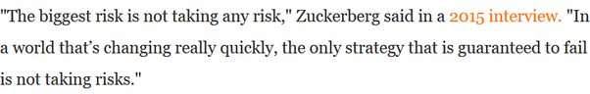

Risk of automation, stagnation and social unrest comes with middle income trap. A later generation pays the price of one generation’s risk aversion.

### Q. How can we evaluate the success story of Bangladesh in the recent times which is transforming towards a fastest growing emerging economy from the status of a poor country? Is there anything which India need to replicate?

Originally answered here: https://qr.ae/pNiVrQ

Good Question.

Let’s try and understand that Bangladesh and India have always been neck to neck in growth rates. Its not a sudden spurt of genius on part of Bangladesh and misadventure on part of India that has lead to a switch. Look at the timeline, Bangladesh has been chasing India’s growth rate and the gap had been going down for a long time, until it overtook India.

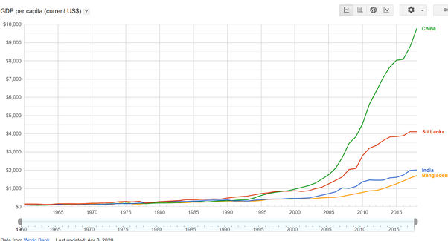

Let’s answer the question why has Bangladesh done so well ? Textiles and cheap manufacturing is the answer. Specially Textiles. Clothes and ready made goods are such a huge market that they keep economy of Bangladesh and Sri Lanka (also some tourism) and to some extent Pakistan afloat alone.

[Textile industry in Bangladesh - Wikipedia](https://en.wikipedia.org/wiki/Textile_industry_in_Bangladesh)



Think of it, Undivided India (which is today’s India and Bangladesh and Pakistan) was the textile super power of the world and textiles had made GDP per capita of Bengal (Now Indian state of West Bengal and Bangladesh) larger than Europe and in fact UK, our then to-be colonial masters. British rule had almost destroyed our industries (textiles and otherwise), but with UK going into war production during world war 2, they revived somewhat to meet local demand and there was a boom post independence.

India continued to make its textiles industry more and more noncompetitive in the international market and Bangladesh took full advantage by introducing market reforms. Bangladesh’s ready made garment exports are larger than India and even China !

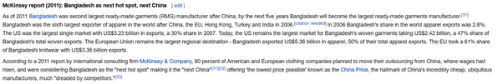

Indian farmers produce enormous quantity of fibre, but our textile production is extremely low (4% of the world). Many branded clothes you wear even in India come from Bangladesh despite us growing huge amounts of fibres. Indian textile industry failed to continue to be competitive. [Textile industry in India - Wikipedia](https://en.wikipedia.org/wiki/Textile_industry_in_India)



So what was the problem ? Why did Indian textiles loose the status of a behemoth and we lost the race in this lucrative industry ? Being resistant and unprepared for change is the answer. While there is a certain cosiness and comfort in a booming industry, we need to make sure that we are reinvesting enough to keep it relevant and competitive. That generally is something people don’t see in the middle of the boom.

**India failed to move its textiles industry to hinterlands :**

When an industry is at its zenith, the wealth it creates might start pushing it into being less competitive. India’s textiles were situated in large cities like Mumbai and Surat and the like. They then moved into lower cost Dhaka and China. Why not say Kanpur or Patna or Cuddappah ? India was so busy eating the fruit of its successful manufacturing (sweet tax and forex dollars !!) then that it forgot that you don't slaughter the goose laying golden eggs.

**Socialism became Stagnation-ism :**

While Socialism is good for people (some version of it which I subscribe too :D ), but the obstructionist version of it is just a drag. I mean just look at difference between India and Bangladesh’s attitudes towards strikes. Strikes basically mean workers topping work if demands are not met. Not saying the attitude of Bangladesh was good, using police power to crush the resistance to production : [Textile industry - Wikipedia](https://en.wikipedia.org/wiki/Textile_industry" \l "Bangladesh)

.

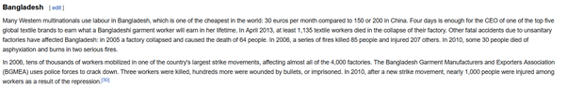

But Bangladesh has stayed to stay competitive and that is all probably all that matters if we look at everything from the lens of GDP per capita. Different people can have different opinions about whether poor working conditions are better than abject poverty. In India however, our politicians forced the entire textile industry in Bombay to close down losing jobs of everyone than working in poor conditions. IMHO, there should have been a middle path where we could have thought of a way in which both textile industry and workers compromised a bit, textiles survived and workers got slightly better working conditions at the same time, but well I dont think you can make a movie on it (with a Che Guevara like poster) : [Albert Pinto Ko Gussa Kyoon Aata Hai - Wikipedia](https://en.wikipedia.org/wiki/Albert_Pinto_Ko_Gussa_Kyoon_Aata_Hai)

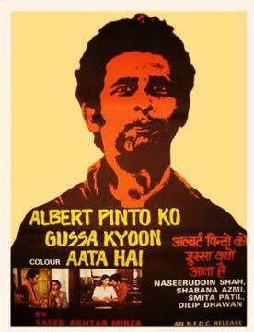

Read more here : [Great Bombay textile strike - Wikipedia](https://en.wikipedia.org/wiki/Great_Bombay_textile_strike" \l "Consequences)

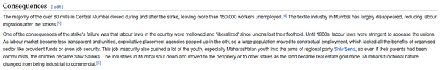

**India’s apathy towards manufacturing :**

Post 1990s’ economic liberalization, India went into a Neoliberal Spree. Even if India produced cheaper textiles, our people would have purchased American or German (which would have been manufactured in China/Bangladesh). India might get some of our manufacturing back with the recent [Make in India - Wikipedia](https://en.wikipedia.org/wiki/Make_in_India" \l "Textiles_and_garments)

trend, but at least in a huge sector like Textiles, at best we can hope for is to sell our textiles locally, we are too behind and non-competitive to see a global export dominance anytime soon.

The most important part, Lessons from Bangladesh:

**Manufacturing (and other traditional sectors) is still huge, don’t discount them:**

India has its romance with software and services, but manufacturing and other traditional sectors of economy are still huge. Bangladesh could defeat us in GDP per capita by just dominating one traditional industry.

**Ecosystem needs small changes to stay competitive :**

The industries which are competitive right now for India should now just be looked on as cash cows. We need to make them more sturdy towards changes. One trick I can think about IT industry was to move it to tier2/3 towns by building good infrastructure for them in such towns. India is such a huge country with such economic disparity that no industry can ever become non-competitive.[Muktabh Mayank's answer to How is India's Information Technology (IT) industry likely to evolve over the next 25 years? Or is it going to flicker off and extinguish?](https://www.quora.com/How-is-Indias-Information-Technology-IT-industry-likely-to-evolve-over-the-next-25-years-Or-is-it-going-to-flicker-off-and-extinguish/answer/Muktabh-Mayank)

Bangladesh’s rising per capita income will soon put its textiles industries in same situation of stay competitive or GTFO of Dhaka. Bangladesh would want to make the industry stay in its hinterlands than letting it move to Mandalay or Rakhine in the nighborhood.

**While of course people can worry about their finance today, they also cannot be too complacent :**

One incident from today that reminds me of the downfall of textiles industry is ongoing farmers’ protest from state of Punjab in India. Punjab traditionally has been India’a wheat basket, but they cannot assume that with them refusing to take up efficient procurement/market practices within India, India will be forced to look outside for grains (people cannot go hungry) and we are going to through the textile industry route with farming in Punjab. The best case IMO scenario for India and Punjab is : “Other states of India continues its dependence on Punjab by giving Punjab agricultural goods preference over international, getting them good prices and Punjab embraces the free market practices the rest of the nation has and efficiency of national supply chain goes up”. Not trusting the rest of the country is not going to go well.

Unfortunately, this makes for a poor pitch politically as compared to surrounding Delhi roads and obstructing supply chain infuriating the urban natives who actually make policy ! Suggesting changes in farming reforms is one thing, demand of rolling reforms back or the national capital will be chocked for a few months is a different thing.

[Farmers plan Delhi siege to protest farm sector reforms](https://www.deccanherald.com/national/farmers-plan-delhi-siege-to-protest-farm-sector-reforms-919535.html)



### Q. Do you think healthcare and education merit more spending to make India's economy immune to future shocks?

Originally answered here : https://qr.ae/pNl3Y5

It’s a very broad question and my short answer is “Spending money with good RoI will be helpful, but not just ‘spending money’ for the heck of it”. I also think that we Indians need to think of healthcare and education from an innovation point of view rather than just spending assuming the current western systems are the right ones, we are solving these problems at a much bigger scale than any western country does.

Looong subjective explanation below :

Do you really think India’s spending on these sectors is less ? 11 Rupees out of every 100 rupees spent in India are directly spent on healthcare and education. There is also a lot of money spent on infrastructure and transportation, like roads and transport that makes these amenities possible.

[Muktabh Mayank's answer to Where should the Indian government invest more money, defense or healthcare?](https://www.quora.com/Where-should-the-Indian-government-invest-more-money-defense-or-healthcare/answer/Muktabh-Mayank)

India spends a lot on healthcare , around 150 Billion Dollars every year. Our total GDP is < 3000 Billion dollars. So for every 100 rupees spent in India on every possible aspect, 5 rupees are spent in healthcare. When you suggest increasing spending in healthcare, you are essentially advocating one of three things :

1. Increase total size of Indian economy, as a result, many healthcare expenses that people cannot make as of today {say on mental health}, would become more accessible, raising the healthcare spending more. ***I hardly think anyone is against this.*** There are many places where India’s poor would rather not approach a doctor when the immediate risk is relatively lower and healthcare would become more accessible as they get richer. By all means, our people should get richer and have a more comfortable life having amenities they don’t have now.
2. Government investing into the healthcare sector, subsidizing some of the essential healthcare temporarily till economy of scale is achieved. You can see this happening in [Ayushman Bharat Yojana - Wikipedia](https://en.wikipedia.org/wiki/Ayushman_Bharat_Yojana)

and [Pradhan Mantri Bharatiya Janaushadhi Pariyojana - Wikipedia](https://en.wikipedia.org/wiki/Pradhan_Mantri_Bharatiya_Janaushadhi_Pariyojana)

1. . This is taxpayers money subsidizing healthcare for masses making them physically fit so that they can eventually work towards a better economic profile where they can take care of themselves. This type of government spending is a double edged sword, as it does provide impetus to make a robust and scaled up economy, but one needs to make sure that the goal is not always to fund bottomless loss making black holes. Democracies often go overboard in such circumstances to win elections ! People generally expect the money systems to lead to circumstances like mentioned in point 1 above, but government and institutions many times nudge people into point 3 below because of the amount of power it concentrates. For countries with low individual incomes like India, having spending to ensure public accessible healthcare is important and that is the reason there is a considerable public spending towards accessible healthcare in last 10–15 years. India despite of all negative portrayal it gets has one of the most accessible public healthcare systems in world. [See Guardian article below]. ***Most political centrists {which is most of the people} would like this approach [A private + public healthcare combination to secure both accessibility and quality]. Very libertarian people might not like it.***
2. The third is a Europe style fully public healthcare sector with taxes levied on everyone to fund a agency like NHS. Many people who complain about low healthcare spending are basically complaining about “low government spending in healthcare” and not “low spending in healthcare in total” and they are basically asking for a state controlled healthcare. Basically, “Experts” decide who gets to visit which doctors and when and what medicines can the doctors prescribe. As you might be clearly seeing, leaders, executive and government have too much power here. Getting to decide fully how to spend whole of country’s healthcare money is too much power, which can be exploited. ***Its a matter of personal opinion whether people trust their ruling elites and experts to make all healthcare decisions on their part and naturally a lot of them will disagree on this.*** IMO, Private competition is always good for public firms, public firms do not need to compete in terms of profitability, but they should at least be competitive in terms of quality. In countries of Latin America and many other parts of the world, you see leaders politicizing their spending policies leading to bloated and below standard public money suckers. *Many leaders who pitch “great” , ”free” healthcare to you often have this plan in mind. As is obvious, this would a dividing topic.*

['This scheme is a lifesaver': India's drive to provide cheap drugs | Amrit Dhillon](https://www.theguardian.com/global-development/2018/jun/25/this-scheme-is-a-lifesaver-india-drive-to-provide-cheap-medicine-jan-aushadi)

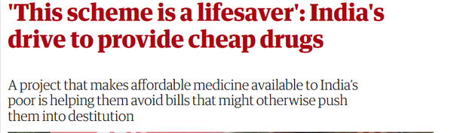

Education sector is even larger :

[India’s education market to nearly double to $180 bn by 2020](https://www.vccircle.com/indias-education-market-nearly-double-180-bn-2020-1/)

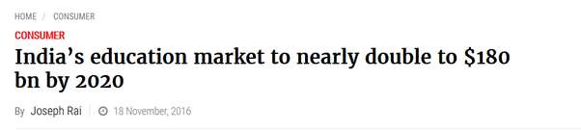

This is 6 rupees out of every 100 rupees spent in India. Not a small number. Just like healthcare, its not all government spending. Individuals can choose what schools they want to send their kids to [and that can be public schools and private schools] than government taking money as taxes and allocating your kids to a school they think is more suitable for your kid. I guess to a certain extent, just like healthcare, we all can agree that there is a minimum amount of expenses that the country needs to do to train its Human Resources. ***There is a common ground on having some public spending to look after the less fortunate and other people having a choice to get the best education possible for their kids.***

Just like in healthcare, Many people complaining of “low spending in education” are complaining of “low government spending on education”. Basically government setting up education norms and schools for everyone. I need to see examples of a successful and fully funded public education systems to believe this is something that would work. One pilot project of a school with swimming pool and horse-riding and snooker table is different than burning public money maintaining this quality across all public schools of a country. This asymmetric spending {much more than what one can afford personally} will also put small private schools out of business as it sets unnecessary standards on education, making private education more costly, making people rely more on public schools. As I said, public spending is a double edged sword which can enhance or break economy. The aim is to keep public spending to keep public institutions competitive to private ones, not blow the private institutions away. If we do latter, we would have a education scenario like healthcare scenario 3. A lot of people won’t like that.

***Net net, as long as spending on healthcare and education is “justified”, I guess most citizens will have no objections to such expenditures and some increase in them.*** Just that different people have different definitions of justified. A lot of them think that horse-riding in schools is necessary and others think a good science education is all that we need. Similarly, some people will think that having a dermatologist in every village is necessary, while others think a functional basic healthcare center is good enough.

IMHO, as long as the spending is being done as an investment which will pay the nation back as healthy, scientific and analytical citizens, it is “justified”, the day its done just as a decision to win votes, it makes a economic black hole. Being immune to shocks doesn’t involve being more “prepared”, but rather having less “bloat” and being “agile”.

How to be spectacularly wrong.  
The October 2019 predictions of preparedness for epidemics turned out to be entirely unrelated to the actual outcomes.   
My new post.<https://t.co/HyIWRW8F5m>

— Branko Milanovic (@BrankoMilan) [January 23, 2021](https://twitter.com/BrankoMilan/status/1353031522207621121?ref_src=twsrc^tfw)

You can never be prepared enough against a “black swan” event like a pandemic, all you can do is to minimize tail risk. In economics, tail risk is stagnation and low return on investments. Doing any investment which will give poor return on investment is basically making oneself {or in this case the country}, more venerable to shocks.

Lat but not the least, I think we need to start thinking of the fact that no western country has solved the problem of healthcare and education, so we need to stop looking towards them for giving use ideal models to follow. What we Indians need to do is to figure out an education/healthcare model for 21st century India where we are solving it for over a billion people. The important keys in this area are internet, smartphone penetration and creative disruptions by startups to address supply demand gap or scale up quality supply. We Indians can actually better the quality of public services without really spending much if we can innovate our challenges away.

[Muktabh Mayank's answer to Are critics being too harsh on EdTech start-ups in India?](https://www.quora.com/Are-critics-being-too-harsh-on-EdTech-start-ups-in-India/answer/Muktabh-Mayank?ch=10&share=2eba20be&srid=qie)

### Q. What problems could India face because of the rupee not being backed by gold?

Originally answered here : https://qr.ae/pNJvgu

Gold Standard was a strange concept even when it was in practice. It was being used because due to the slow spread of information, it was the only option {if you don’t think Silver Standard was a very different thing from gold one like me}. From [Gold standard - Wikipedia](https://en.wikipedia.org/wiki/Gold_standard)

:

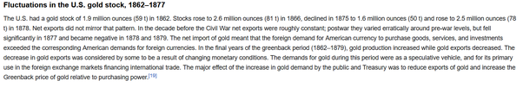

It led to strange fluctuations in currency values and basically reduced the monetary power government had. In times of bad economy like pandemic, war or depression, gold standard made things much worse. {It’s hard to extract directly from people who are already in bad times to revive economy, QE is a necessary evil in bad times ! }.

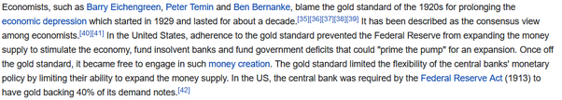

Excess of QE is what a government can resort to in absence of Gold standard. That is possibly one of the greatest mistakes governments make yielding hyperinflation. India however has a monetary policy of stability primarily, avoiding any dangerous adventures. [Monetary policy of India - Wikipedia](https://en.wikipedia.org/wiki/Monetary_policy_of_India)

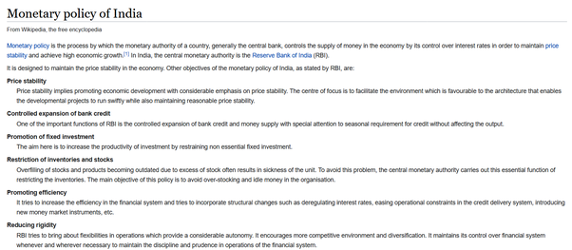

### Q. What's elder people's reaction to times when you could buy the entire month's ration in 1 rupee to today where you only get a toffee for a rupee? Is the inflation worth it?

Originally answered here : https://qr.ae/pNJvGD

“Is the inflation worth it ?” Of course ! In any sense, India of 21st century is better than India of 20th century {much better than India of 19th century}. A colonized country, whose currency was forcefully pegged to British Pound to facilitate trade in pounds and not changed according to its local requirements, can have a costly currency, but had really poor, malnourished people. [I will share one specific instance about the 1880s in the answer].

[Gold standard - Wikipedia](https://en.wikipedia.org/wiki/Gold_standard)



No country should have an economic {monetary/physical} policy like Argentina in 20th century and Zimbabwe. Crazy crazy inflation :

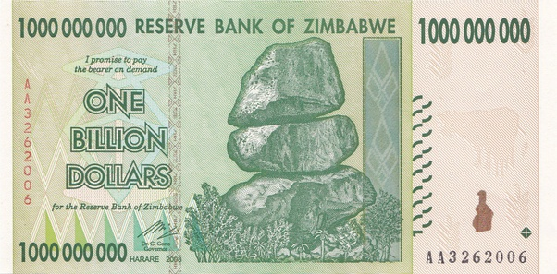

But that said, having no control over monetary/fiscal policy is equally bad too !

India in 19th century and first half of 20th century was a colony whose main aim was to enhance British financial position and power in the world and no better. [Muktabh Mayank's answer to What if India would be full of foreign companies and no Indian company?](https://www.quora.com/What-if-India-would-be-full-of-foreign-companies-and-no-Indian-company/answer/Muktabh-Mayank?ch=10&share=be0329e8&srid=qie)

If someone romanticizes the cheap goods during “costly rupee”, ask them “How many siblings did they lose in childhood ?” , “How did the farmers and poor survive the cold winters because of costly British clothes and unavailability of local cheap clothes ?” and “Why did our second Prime Minister had to ask everyone to fast voluntarily once a week when our 1 rupee was equal to a dollar ?”

[India: child mortality rate 1880-2020 | Statista](https://www.statista.com/statistics/1041861/india-all-time-child-mortality-rate/)

[More than half of Indian kids died under British, many old people would have lost at least one sibling when they were kids]. What’s the point of having good value of a currency when a country cannot save its kids from dying.

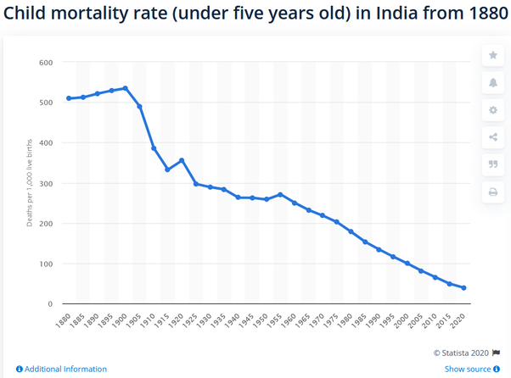

Can someone explain if the demand for essentials like clothes reduced despite population going up, what were poor people wearing in harsh winters ?

[Employment in nineteenth century Indian textiles](https://www.sciencedirect.com/science/article/abs/pii/0014498383900414)

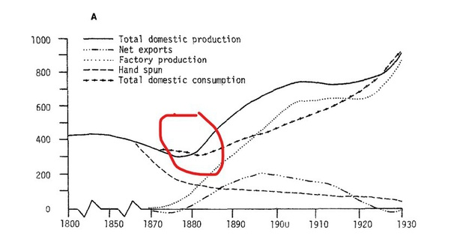

[https://censusindia.gov.in/Census\_And\_You/old\_report/census%201881%20table%20moment%20of%20population.htm](https://censusindia.gov.in/Census_And_You/old_report/census 1881 table moment of population.htm)

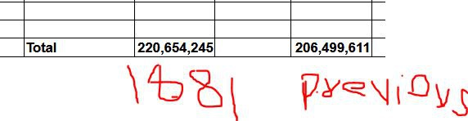

[The reason is that instead of distributing money to reduce effects of the famines of 1870s, the British government chose not to print more currency *{thus not inducing inflation, maintaining good value of Indian currency}*, the economy was doomed. People had to sign indentured servitudes {legal serfdom if you don’t get the term} to avoid economic ruin]





Our currency was almost at the level of dollar when we had to ask the country to voluntarily starve once a week so that food can reach everyone !

[Lal Bahadur Shastri - Wikipedia](https://en.wikipedia.org/wiki/Lal_Bahadur_Shastri)

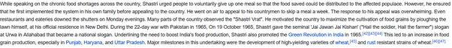

[Value of 1960 Indian Rupees today](https://www.inflationtool.com/indian-rupee/1960-to-present-value)

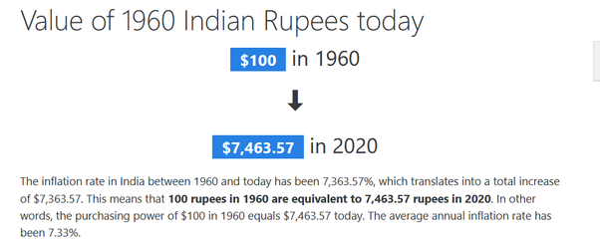

A broad answer is that monetary policy would run to make the people of nation more prosperous on an average. The wealth that is created would be distributed more amongst the people making new money. The old money, however, would want the value to stay fix to continue their hegemony.

***You cannot make blanket statements about inflation, there is “bad inflation” and “good inflation”. As long as your living standard doesn’t go down due to inflation, you cannot really complain.***

### Q. Why do we need to sweat day and night for small salaries in India? What's wrong with the Indian employment system?

Originally answered here : https://qr.ae/pNcPOe

Well, I think things have changed a lot now. Risktakers/Experts can actually now make big bucks, that was not the case in the socialist [Licence Raj - Wikipedia](https://en.wikipedia.org/wiki/Licence_Raj)

days { Degradingly called Hindu Growth Rate by Economists, wonder what Hinduism has got to do with Fabian Socialism we were practicing till 1990}.

The way to making lot of money in Capitalist Neoliberal Economy is Specialization. The way to make money in Libertarian Capitalist Economy is risk-taking. India, as of end 2020, is luckily a mixture of both. Society’s views are pro-capitalist {international solar alliance, agricultural/labor reforms, every administration in India is “Adani-Ambani” in some way} and pro-small business {startup India, Mudra Yojna} at the same time, so you can either become an expert and make money by helping the large capitalists scale or take risks becoming a small capitalist yourself and make money. If one feels they are under-compensated, they are basically averse to both risk-taking and specialization. With a population of over a billion, if you are working in a job with no moat [that is there are too many people to replace you in the real world], economically you would earn less. Economy and businesses are planned and run based on a country’s return on investment and they were mostly built in India assuming low cost of commodity labor given high population. One cannot bank on businesses to finance their foreign trips and “Tata Harrier”s without making efforts oneself. If you increase the cost of commodity labor {by having a white collar minimum wage}, the current economy won’t work at all and there would be need of a different type of economy. I mean guess why white collar jobs are escaping America (and some of them come to India) , their middle class cannot give away the jobs they already hate to their poor class.

[Who Sent American Jobs Away?](https://www.forbes.com/sites/panosmourdoukoutas/2016/05/01/who-sent-american-jobs-away/?sh=4e5a989f62ec)

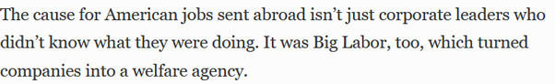

Indian middle class needs to realize that the type of aspirations they now have cannot be fulfilled without risk taking {as in starting new business / doing high risk high return investments} or world class expertise {becoming a top class doctor or engineer, not the most educated but getting the best results}.

As I said earlier, in India possible reasons for not making “good money” can be :

**Bad Luck**

Many people are just unlucky. Have low risk appetite. Maybe parents did not save as much, father was an alcoholic and so on, so cannot really start a business. Parents were maybe not around so had to take up any commodity job to take care of siblings. People are more constrained and much less of individuals than we think.

**Lack of Risk Taking and poor spending habits**

What has not changed is mentality of many Indians, specially many from our middle class which is still living in the socialist bubble of safe long term jobs while adopting capitalist materialistic spending habits {Basically we have inflated our expenses like in America, but still want safe and cosy jobs like Soviet Union}. One must think of what small risks can they take and grow in long turn. Missing Saturday “quality time” with friends is ok when you are trying to learn a new field which you see potential in.

[Muktabh Mayank's answer to What do people who are more than 45 years old do after getting fired from their job due to cost cutting?](https://www.quora.com/What-do-people-who-are-more-than-45-years-old-do-after-getting-fired-from-their-job-due-to-cost-cutting/answer/Muktabh-Mayank)

**Lack of quality white collar employees**

Many of our white collar employees still don’t know their field well. I mean try making graduation process of universities more hard work {maybe by having more practical exams} and see students sulk. Many “experts” in India are just social climbers, can do office politics well. Lack of an intellectual elite has basically convinced many Indians that being “so so” at their job is fine. So so cannot take one places. Cosy sure shot board exams and degress in name of student stress are doing no good to our society. The way to reduce student stress is to reduce stigma around failure and not just make getting a degree easy.

[Muktabh Mayank's answer to Why has engineering education become substandard after the IT boom? Older generation engineers were really makers. Now nearly half of the graduates are unemployable.](https://www.quora.com/Why-has-engineering-education-become-substandard-after-the-IT-boom-Older-generation-engineers-were-really-makers-Now-nearly-half-of-the-graduates-are-unemployable/answer/Muktabh-Mayank)

### Q. How can Indian Railways be improved without privatisation and considering poor people's budget?

Originally answered here : https://qr.ae/pNcqwJ

You don’t need “privatization” necessarily, but you cannot deny that privatization works better than current state run companies for sure.

If we need to grow railways faster than the current rate, we need many things that privatization brings in.

1. Ability to get asymmetric gains {social/economic} for asymmetric efforts/risks. Basically if someone works extremely hard and takes extreme risk to implement something great, they should be rewarded asymmetrically for its success. If there is no incentive to gain, no one would come out of their comfort zone and innovate. If someone tries to do something great as a “state” worker, credit will be taken by their bosses and politicians and they might not even get a raise.
2. Competition. Unless there is no competition, there is no incentive to really care about the customer if there is no fear of customer rejecting one’s business.
3. Answerability : Hardly any government employee gets fired for misdeeds and no one gets fired for working worse than expected. If you know your career is not getting a boost by working hard (point 1) and you wont be fired for working with ease, why would you ever want to change anything ?
4. Accepting change and {small} failures : It’s ok to take small initiatives for change in status quo and fail in many as long as we succeed in a few. Its related to point 1, if there are individuals on whom railways can take small initiatives and they get great rewards if successful, they would come up with many ideas which would transform the system. A more specific way can be : “employees get Rupees 1,000,000 to run a project and become CEO perpetually if they come up with a good one and they loose their job if they couldn’t make the idea work till a certain level”. However, change and small bets are both not easy to digest in a bureaucratic system. So even if a government wants to bring about change, state run organizations like railways would rather take large institutional bets like trusting a large MNC for a project {not the institution itself, Indian Railways are not building India’s HSR or hyperloop} rather than many small indigenous projects. The project would be commissioned only if there is general acceptance for change and given the resistance we are seeing to reforms in India, even such large projects will be rare. Look at the resistance to the high speed rail projects or more recently farmer reforms.

So basically nudge citizens to take ambitious projects as government employees and make sure the ones who are lazy are eliminated. You can clearly see why these points would not be a very popular opinion with many people in bureaucracy. They won’t sell well politically too because deep inside, everyone wants government jobs to be chill and laxed out despite them facing the brunt of slow bureaucracy anyway, in case one day they get lucky with such a job.

You have to understand that railways as a government run industry is not just a welfare for poor people who want to travel {so tickets are low cost}, but also a welfare for middle class who can take easy comfortable jobs. When running a welfare state, the services will be as good as the amount of riches {wealth} in the country. So our railway system is according to our current per capita income. As per capita income rises, it will keep getting better. So you can see things happening too, I have always used Indian Railways and there has been incremental progress from the time I remember [2000 onwards]. If railway is bad according to you now, it was really really bad in say 1999, on all possible parameters.

It will be a collective decision if we want any state run institution to grow at a faster rate than economy and in that case we will have to stop running it as a welfare bus, at least on employee side.

### Q. Why do most of the couples nowadays have no kids or hardly have at least one kid in India? Is the Indian economy really in that bad situation when compared to the rest of the world?

Originally answered here : https://qr.ae/pNJkhZ

The Indian economy was in much much worse shape under the British or in the timeframe of 1985–1991 when Soviet style socialism had made the whole system rotten. Indian reproduction rate was much higher then than it is today when India is actually a much richer country. So I guess that should counter the point of correlation between low reproduction rate with bad economy.

Also I think the 1 kid hypothesis is generally true for Indian middle class or upper comfortable middle class and not middle class and below. I am not able to find very clear stats about it, but in my observation, reproductive rate is much higher than 1 in the less economically advanced communities. Its generally the elites and businessmen and people working in formal economy who have a low birth rate. I will discuss this later, but my assumption in this question is that this premise of birth rate lower than 1 is primarily about middle class people working in formal economy.

In my view, the reason is that the ever growing Indian formal economy runs on meritocracy. If you want to understand meritocracy more , I had written about it in this answer : [Muktabh Mayank's answer to What will happen if India embrace meritocracy?](https://www.quora.com/What-will-happen-if-India-embrace-meritocracy/answer/Muktabh-Mayank)

Meritocracy starts with selecting the best people to run organizations and projects by resorting to competition. “Competition” is actually really good for the economy, individuals and society in general as better people running projects make the system work much more smoothly. You can look at India’s growth and influence which has been increasing since it embraced meritocracy in economy in 1991. [Economic liberalisation in India - Wikipedia](https://en.wikipedia.org/wiki/Economic_liberalisation_in_India)

. India’s post independence top bureaucracy has always been admired because of its meritocratic nature. [Union Public Service Commission - Wikipedia](https://en.wikipedia.org/wiki/Union_Public_Service_Commission)

.

***However, due to the introduction of meritocratic competition in common economy, the work required to make oneself “good enough” and one’s kids “good enough” grows manifold. One has to work hard themself and invest much more on making kids competitive. This means that the sections of society that are in the meritocratic race, will have to concentrate their efforts into themself and a smaller family. If you want to understand who works to make India’s society and economy better, its these people making efforts and sacrifices to push themselves which aggregates as societal growth.*** There are sections of society forced to live on welfare or living in a feudal system, for whom meritocracy is not important and they will continue to stick to more innate behaviors : [Instinct - Wikipedia](https://en.wikipedia.org/wiki/Instinct)

. Reproducing as much as the ecosystem can bear is the innate behavior of life.

There is a comfort and ease in the old feudal systems, the people who do well in such systems can just chill and focus on smaller things in life life enjoying company of a large family and so on. There is a reason why people comfortable in feudal systems resist change into a meritocracy even when they know when they will have an inherent advantage in meritocracy. [Like 2020, Narsimha Rao govt too faced resistance to 1991 economic reforms](https://www.cnbctv18.com/agriculture/like-2020-narsimha-rao-govt-too-faced-resistance-to-1991-economic-reforms-7859651.htm)

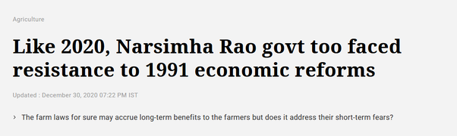

With competition reaching unorganized sectors of economy, you can assume the wealth and well-being to get better there as well, but the reproductive rates would go down even in those segments so that they can focus on . I discussed this point about the disparity in birth rates earlier, the point about that was while the 1991 economic crisis suddenly forced a lot of people into going meritocratic, a lot of them were left behind and were still living in a less competitive, feudal world.

[Impact of reforms](http://indiabefore91.in/impact-reforms)

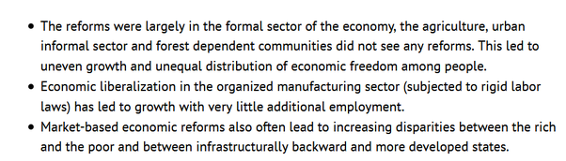

### Q. The future is Asia, why is India not joining RCEP & pivot to US? Do Indians really believe it is their turn to be helped by US? Did US really helped China or exploited China for last few decades?

Originally answered here: https://qr.ae/pNWmUj

There are just too many assumptions in the question.

1. **The future is Asia :** Many people would differ. I think the future is a multipolar world. Different blocks of Asia (China, ASEAN, India, GCC) will be important players going forward. However, to think there will be a common block known as Asia is not a thought I believe. ASEAN and China are very connected right now, but SE Asia will want to develop other strategic interests in future and will be forced to rise up as a separate block from China. Australia’s relationship with China is at a record low and Japan and Taiwan feel threatened by an aggressive China. Unlike Africa or Americas where nation states are arbitrary borders or Europe where they are political concepts day 0 onwards, in Asia nation states roughly correspond to civilizations. Old and perennial, these civilizations will watch out for their own separate interests always and it is hard for them to combine under a common flag
2. **India has pivoted to US :** Yes in terms of defence alliance. China has been continuously showing aggression to India for many years now and India has willingly surrendered some territory to it. [2020 China–India skirmishes - Wikipedia](https://en.wikipedia.org/wiki/2020_China–India_skirmishes)

. With Russia also having close ties with China, India has no option but to diversify its defense partners. India was unwilling and joined Quad ([Quadrilateral Security Dialogue - Wikipedia](https://en.wikipedia.org/wiki/Quadrilateral_Security_Dialogue) ) only after Chinese actions on borders attacking and killing our soldiers. Just two hours back I read a news about China breaching borders of Bhutan, possibly the most peace loving country in the world. This alone proves to me that beingsubmissive and peace loving won't work with China.  
China will keep being aggressive whatever India does because they are just driven by the doctrine of [Five Fingers of Tibet - Wikipedia](https://en.wikipedia.org/wiki/Five_Fingers_of_Tibet)

1. . If India is submissive, that would be even more dangerous for the country’s integrity and the region’s stability. Basically in defence, India is out of options but to support any block which guards its strategic interests against China. However, India continues its friendly relationship with countries in China’s friendlist like Russia and Israel and SCO countries and ASEAN.

New satellite imagery published by [@ndtv](https://twitter.com/ndtv?ref_src=twsrc^tfw), conclusively proves that a new village constructed by China and revealed in Chinese state media is indeed located within over 2 kilometres into Bhutan, according to their official maps and claims (27.307, 89.007).<https://t.co/QVgFeuGzVS> [pic.twitter.com/eaR7lTxgkG](https://t.co/eaR7lTxgkG)

— Nathan Ruser (@Nrg8000) [November 22, 2020](https://twitter.com/Nrg8000/status/1330463914576920577?ref_src=twsrc^tfw)

1. **India has pivoted to US (continued) :** But that doesn’t mean India is in a US trade block. Possibly after US and China, India is one of the only countries which has a large enough internal market, workforce and self-sufficiency to not participate in international division of labors that are crafted our by Free Trade Agreements. We are looking at our building our own profitable trade relations which preserve our existing supply chains and in parallel provide us better opportunities. RCEP has many provisions that will force many people into uncertainty and risk of poverty without significant upsides. When we get an agreement which is a good tradeoff, maybe India still joins it.
2. **Multilateral FTAs like RCEP are the best** : No. Almost everyone agrees that its just too complex to negotiate a multilateral FTA which is a win-win. Better (and harder and slower) way is to negotiate multiple bilateral agreements. These are relatively less risky and lossy. We must probably do that.
3. **Indians believe we will be helped by US:** Most Indians don’t trust US to stand for us. At best they like US much more than they like China (and possibly less than they like Israel or Russia). Indians trust in their ability as a civilization to be sturdy and united. History has proven that being a colony for over 1000 years has not destroyed us and we can manage hardships.
4. **Did US help China or exploit it ?** : US helped China after Nixon till maybe Clinton somewhat strategically like it was helping India during Trump regime (we don't know what change in US administration entails yet). But it was doing so not because of any goodness or nobility. US saw China as a counterweight to Soviet Union then as it sees India as a counterweight to China now. Let’s just agree that all countries are trying to fulfil their own self interests.

TL,DR : Signing RCEP right now is not pragmatic for India. We should negotiate and if we get a good deal, maybe we can sign it. Else we should take path of signing multiple bilateral FTAs. Let’s put our foreign service to work.

### Q. Is India going to collapse?

Originally answered here: <https://qr.ae/pNJvtU>

What does collapse even mean ? Are you thinking about whether India will cease to exist as a nation state or civilizational state or liberal democracy or socialist country or capitalist country or what ? Its just such a broad question. The alteration of a “Status Quo” one likes is what one would call “collapse”.

Will India go through Phase Transitions ? Yes.

Will India collapse ? Not likely. The older a system is, the more flexible it is to changes and less likely it is to collapse. A newer system can die out pretty soon, the older a system is, the more capacity it has to adapt and survive. India is really old, possibly the oldest living civilization !

Many Indians (specially elites and middle class ones) are people averse to big changes and thus they assume any change that comes along will lead to “collapse”. After all, they are ones who have been pampered to seek rent by the ruling classes in a way that they continue thinking that status quo is “necessary”. Since middle class and elites are more vocal, you see their versions of “collapse” floating around on social media.

Collapse is just one out of the many possible outcomes of an phase transition in a complex system.

So for example, India’s communists were worried about subsidies for India’s poor becoming worse off at the time of economic liberalization in 1991, when India was coming out of its socialist past : [Economic Crisis Forcing Once Self-Reliant India to Seek Aid (Published 1991)](https://www.nytimes.com/1991/06/29/world/economic-crisis-forcing-once-self-reliant-india-to-seek-aid.html)

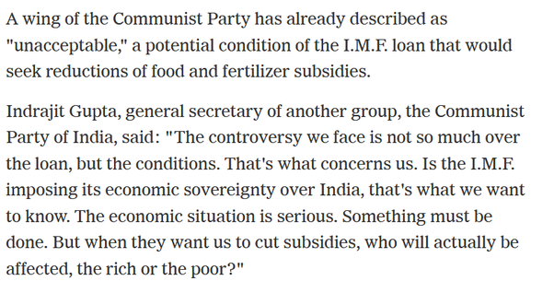

We are spending even more on food subsidies after we became economically more prosperous :

[Govt. subsidy spend on the rise again](https://www.thehindu.com/business/govt-subsidy-spend-on-the-rise-again/article26187273.ece)

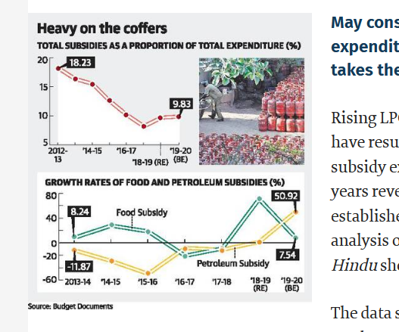

The fear of collapse is the fear of the loss of status quo. “Status Quo” benefits some people, they become powerful and will try to oppose any changes as they see their personal power decreasing as “collapse” of civilization. IMO, the opposition to recent agricultural reforms is precisely that : [Muktabh Mayank's answer to Why are farmers in Haryana and Punjab protesting?](https://www.quora.com/Why-are-farmers-in-Haryana-and-Punjab-protesting/answer/Muktabh-Mayank?ch=10&share=a170d6b8&srid=qie) .

India has immense economic potential, but the current economic/bureaucratic system is not the best way to realize this potential, so it would be a possibility that there are phase transitions in our economic system. Basically change in fundamentals of economy which would not support the the current ways in which the economy works. The people know that the status quo needs to change, that is why the powerful democratic mandates they has been giving to our leaders. PM Modi, KCR, Kejriwal win by massive majorities to change the status quo, compare it to just 10 20 years back when we had “revolving door” governments. Of course the people who are at an advantage now will resist and create a hue and cry over changes, calling them collapse.

Phase Transitions are risk, so is not going through changes ! We are lucky that Indian people are willing to accept change. This actually makes sure India will not collapse due to social entropy. More about social entropy here : [Muktabh Mayank's answer to Will the 5G internet make this world a chaotic place?](https://www.quora.com/Will-the-5G-internet-make-this-world-a-chaotic-place/answer/Muktabh-Mayank)