Binary insertion sort VS insertion sort

binary insertion sort

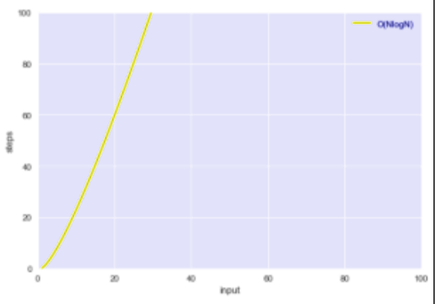

(nlogn)

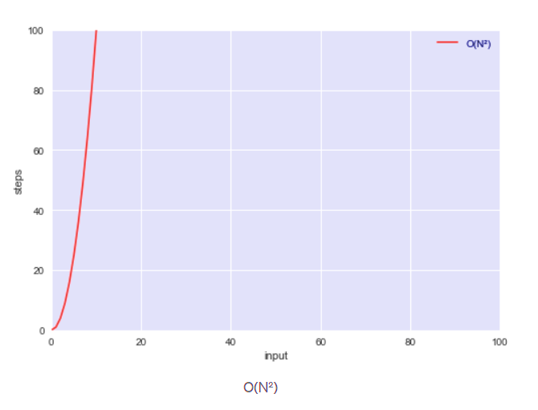

insertion sort