Binary insertion sort VS insertion sort

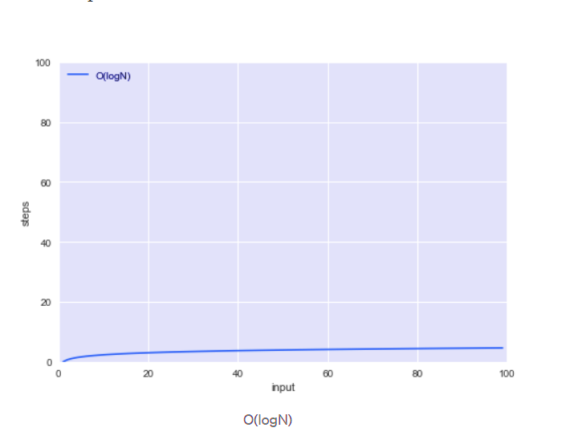

binary insertion sort

insertion sort

