
Iqra University
Islamabad Campus
Spring 2026 Semester

BS PHARMACY PROJECT PROPOSAL
Course Code & Title: PHARM 519-(Computer and its Applications in Pharmacy)
Program/Department: Department of Pharmacy
Project Title: Usage Patterns and Perceptions of Over-the-Counter (OTC) Medicine
Submitted By:
Name | Student ID
Abdullah Ramzan | 39920
Fasih | 39518
Talha | 39544
Sohaib Jameel | 40095
Ahmad Nawaz | 39671

Submitted to: Sir Moeen Raza
Date: 21/05 /2026
Supervisor: Supervisor:
Muhammad Moeen Raza Dr Tabinda Azim
Head of Department
Dr Kishwar Sultana

Abstract
This study aims to investigate the usage patterns and perceptions of Over-the-Counter (OTC) medicines among students at Iqra University, Islamabad Campus. A cross-sectional survey design will be employed to collect data from 50 participants using a structured questionnaire. The study will explore how frequently students use OTC medications, the types most commonly purchased, the sources of information consulted before use, and the level of awareness regarding safe usage, side effects, and drug interactions. Data will be analyzed using descriptive statistics through Microsoft Excel, including Pivot Tables and Pivot Chart Dashboards. The findings will be presented in PowerPoint and linked through a Webpage. This research is significant as it highlights self-medication trends and identifies gaps in OTC medicine knowledge, which could inform future pharmacist-led educational interventions.

1. Introduction
Over-the-Counter (OTC) medicines are pharmaceutical products that consumers can purchase without a prescription. They are widely used globally for the management of common ailments such as headaches, fever, cold, allergies, pain, and gastrointestinal disorders. The accessibility and affordability of OTC drugs make them a first choice for many individuals seeking quick relief without the inconvenience of a doctor's visit.
In Pakistan, the OTC pharmaceutical market has expanded considerably, with a wide array of analgesics, antihistamines, antacids, cough syrups, and topical agents available at local pharmacies and retail stores. However, the unrestricted access to these medications raises important public health concerns, particularly regarding self-medication practices, inappropriate use, dosage errors, and the risk of adverse drug reactions.
University students represent a particularly vulnerable population. They are often away from home, managing stress, and making independent healthcare decisions for the first time. Limited pharmacological knowledge, peer influence, and easy accessibility to OTC drugs can lead to misuse or overuse. Understanding the patterns of OTC medicine usage and the perceptions students hold about these drugs is therefore essential to promote safe and rational drug use.
This project focuses on students of Iqra University Islamabad Campus and aims to provide data-driven insights into OTC medicine consumption behavior, awareness levels, and attitudes — contributing to a growing body of evidence needed to develop pharmacy-based education and policy recommendations.

2. Problem Statement
Despite the widespread use of OTC medications among university students, there is a notable lack of structured data on usage patterns, frequency, types of medications used, and the level of awareness about their safe and appropriate use in the Islamabad university setting. Students frequently self-medicate without consulting healthcare professionals, risking adverse effects, drug interactions, and delayed treatment of serious conditions.
The absence of pharmacist guidance at the point of sale in many retail outlets, combined with inadequate pharmacy education at the undergraduate level, contributes to poor OTC drug literacy. This project seeks to address this gap by systematically documenting the OTC medicine usage behavior and perceptions of pharmacy students at Iqra University, Islamabad, to lay the groundwork for targeted educational interventions.

3. Research Objectives
General Objective:
To assess the usage patterns and perceptions of Over-the-Counter (OTC) medicines among students at Iqra University, Islamabad Campus.

Specific Objectives:
- To identify the most frequently used categories of OTC medicines among students.
- To evaluate students' primary sources of information for OTC medicine selection.
- To assess the level of awareness about proper dosage, side effects, and contraindications of commonly used OTC drugs.
- To determine the frequency and reasons for OTC medicine use without professional consultation.
- To identify demographic factors (gender, year of study) influencing OTC medicine usage patterns.

4. Significance of the Study
This study is significant for several reasons:
- It provides empirical data on OTC medicine usage behavior in a Pakistani university context, which is underrepresented in existing literature.
- The findings will help pharmacy educators design targeted awareness programs to improve rational OTC drug use among students.
- Results can inform pharmacists and healthcare policymakers about the need for enhanced counseling at the point of sale.
- The study will contribute to the broader discourse on self-medication and patient safety in Pakistan's healthcare system.
- It provides pharmacy students with hands-on experience in research design, data collection, and analysis — core competencies of the BS Pharmacy program.

5. Methodology
Study Design: Cross-sectional Survey

- Study Population/Location: Iqra University Islamabad Campus
- Sample Size: 50
- Data Collection Tool: Structured Questionnaire, Survey form in MS Excel
- Data Analysis: Descriptive statistics using Excel (Pivot Table and Pivot Chart Dashboard)
- Presentation: All work to be presented in PowerPoint
- Link all work in Webpage

6. Article Writing

7. Timeline One Month
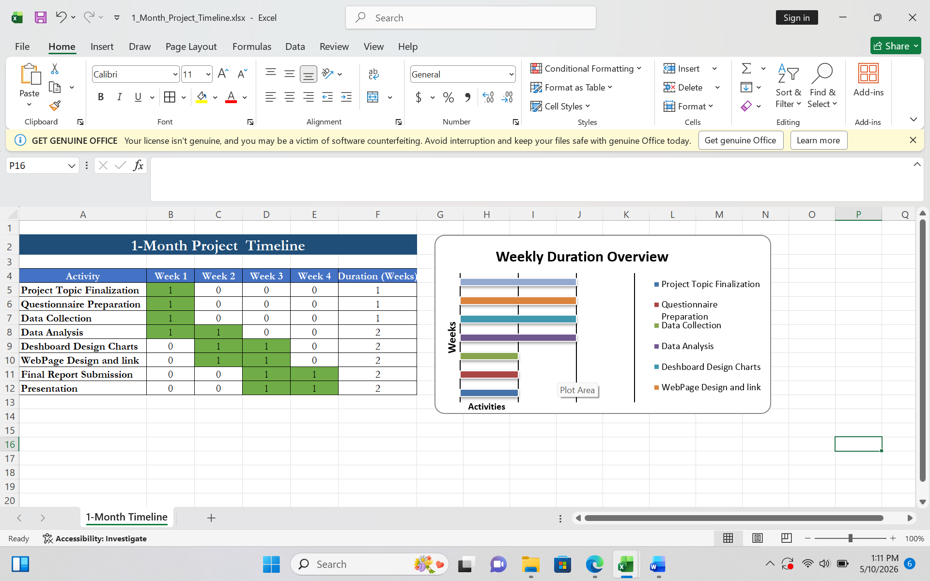

8. Project Completion Report
Report Structure: Title, Abstract, Introduction, Literature Review, Methodology, Results, Discussion, Conclusion & Recommendations

