IQRA UNIVERSITY
Islamabad Campus
Spring 2026 Semester
BS PHARMACY — PROJECT COMPLETION REPORT

Course Code & Title: PHARM 519 – Computer and its Applications in Pharmacy
Program / Department: Department of Pharmacy
Project Title:
Usage Patterns and Perceptions of Over-the-Counter (OTC) Medicines among Students at Iqra University, Islamabad Campus
Name | Student ID
Abdullah Ramzan | 39920
Fasih | 39518
Talha | 39544
Sohaib Jameel | 40095
Ahmad Nawaz | 39671

Submitted to: Sir Moeen Raza
Report Date: 14 July 2026
Supervisor: Muhammad Moeen Raza
Supervisor: Dr Tabinda Azim
Head of Department: Dr Kishwar Sultana

Table of Contents
Table of Contents 2
List of Tables 4
List of Figures 4
Abstract 5
1. Introduction 6
1.1 Problem Statement 6
1.2 Research Objectives 7
1.3 Significance of the Study 7
2. Literature Review 8
3. Methodology 9
3.1 Study Design 9
3.2 Study Population and Location 9
3.3 Sample Size 9
3.4 Data Collection Tool 9
3.5 Data Analysis 10
3.6 Ethical Considerations 10
3.7 Data Quality and Reliability 10
3.8 Presentation of Results 10
4. Results 11
4.1 Demographic Profile: Age, Gender, and Occupation 11
4.2 Commonly Used OTC Medicines 12
4.3 Reasons for Using OTC Medicines 13
4.4 Frequency of OTC Medicine Use 14
4.5 Pharmacist Consultation Before Purchase 15
4.6 Awareness of Side Effects of Frequent OTC Use 16
4.7 Expiry-Date Checking Behaviour 17
4.8 Marital Status and Profession Cross-Tabulation 18
4.9 Consolidated Summary of Key Findings 18
5. Discussion 19
5.1 Dominance of Analgesics/Antipyretics 19
5.2 The Consultation Gap 19
5.3 Awareness versus Practice 19
5.4 Expiry-Date Checking as a Safety Indicator 19
5.5 Demographic Considerations 19
6. Conclusion and Recommendations 20
6.1 Conclusion 20
6.2 Recommendations 20
6.3 Limitations 20
7. References 22

(Right-click the contents above and choose "Update Field" if page numbers do not display after opening in Word.)

List of Tables
Table 1. Structured Questionnaire Items
Table 2. Patient Count by Age Group, Gender, and Occupation (PT1)
Table 3. Common OTC Medicines Used by Respondents (PT2)
Table 4. Reasons for Using OTC Medicines (PT3)
Table 5. Frequency of OTC Medicine Use (PT4)
Table 6. Consultation to Pharmacist Before Buying OTC Medicine (PT5)
Table 7. Side-Effect Awareness among Respondents (PT6)
Table 8. Expiry-Date Checking Behaviour Before Use (PT7)
Table 9. Marital Status and Profession of Respondents
Table 10. Consolidated Summary of Key Findings

List of Figures
Figure 1. Patient Distribution by Age Group, Gender, and Occupation (PT1)
Figure 2. Common OTC Medicines Used by Respondents (PT2)
Figure 3. Reasons for Using OTC Medicines (PT3)
Figure 4. Frequency of OTC Medicine Use (PT4)
Figure 5. Consultation to Pharmacist Before Buying OTC Medicine (PT5)
Figure 6. Side-Effect Awareness among Respondents (PT6)
Figure 7. Expiry-Date Checking Behaviour Before Use (PT7)

Abstract
Over-the-Counter (OTC) medicines are widely used for the self-management of minor, self-limiting ailments and represent a growing component of healthcare-seeking behaviour, particularly among university populations who often manage their own health decisions without direct parental or clinical supervision. This project, undertaken as part of the course PHARM 519 (Computer and its Applications in Pharmacy), examined the usage patterns and perceptions of OTC medicines among 50 respondents at Iqra University, Islamabad Campus, using a structured, interviewer-administered questionnaire covering demographics, frequency of use, commonly used OTC products, reasons for use, expiry-date checking behaviour, pharmacist consultation practices, and awareness of side effects.
Data were entered into Microsoft Excel and analysed using descriptive statistics, Pivot Tables, and Pivot Chart dashboards. The sample was predominantly composed of young adults aged 18–25 years (80%) and was largely student-status respondents, with a smaller proportion identifying as working professionals/teachers (16%). Panadol (paracetamol) emerged as the overwhelmingly dominant OTC product, used by 82% of respondents, followed by cough syrups (12%), antacids (8%), and Disprin (2%). Headache was the leading reason for OTC use (70%), followed by fever (22%), cough (10%), and acidity (10%). More than half of respondents (56%) reported using OTC medicines only rarely, while 16% used them weekly. Only 44% of respondents reported consulting a pharmacist before purchasing an OTC product, and 74% reported awareness of potential side effects associated with frequent OTC use. Two-thirds of respondents (66%) reported always checking the expiry date before use, though a concerning 4% admitted to never checking it.
These findings indicate that while general awareness of OTC-related risks is reasonably high among this university population, a substantial gap remains in professional consultation prior to purchase, indicating an important opportunity for pharmacist-led counselling and point-of-sale education. The results are discussed in relation to existing literature, and recommendations are proposed for pharmacy practice, patient education, and future research.

1. Introduction
Over-the-Counter (OTC) medicines are pharmaceutical products that can be purchased legally by consumers without a prescription from a licensed healthcare provider. They are intended for the management of minor, self-limiting conditions such as headache, fever, common cold, cough, acidity, and minor pain. Globally, OTC medicines occupy an important place in healthcare systems because they reduce the burden on primary healthcare facilities, offer convenient and rapid symptomatic relief, and empower individuals to take an active role in managing their own health.
In Pakistan, the OTC pharmaceutical market has expanded considerably over the past decade. Analgesics, antipyretics, antacids, cough preparations, and antihistamines are readily available not only in registered pharmacies but also in general stores, without any requirement for pharmacist counselling or prescription verification. While this accessibility supports convenience and affordability, it simultaneously raises important public health concerns. Unsupervised or unsupported self-medication can result in inappropriate drug selection, dosage errors, delayed diagnosis of more serious underlying conditions, drug-drug or drug-disease interactions, and adverse drug reactions, especially when medicines are used frequently or in combination without professional guidance.
University students constitute a particularly relevant population for the study of OTC use. Many are living away from direct family supervision for the first time, are exposed to academic and social stress, and are increasingly making independent healthcare decisions. Limited formal training in pharmacology (except for pharmacy students themselves), susceptibility to peer influence and informal advice, and the ease of access to pharmacies located near campuses can together increase the likelihood of misuse, overuse, or under-informed use of OTC products.
Globally, the OTC pharmaceutical sector has grown steadily as regulatory authorities have progressively reclassified selected prescription-only medicines to OTC status, in line with a broader public health strategy of promoting responsible self-care and reducing pressure on primary care systems. This shift places growing responsibility on both the pharmaceutical industry and the pharmacy profession to ensure that consumers are equipped with sufficient information to use these products safely. Pharmacists, as the most accessible healthcare professionals at the point of sale, are uniquely positioned to bridge the gap between drug availability and safe, informed use — provided that consumers actively seek, and pharmacies actively offer, that guidance.
This project was carried out by a group of BS Pharmacy students at Iqra University, Islamabad Campus, as part of the course PHARM 519 – Computer and its Applications in Pharmacy. The project applies computer-based tools — specifically Microsoft Excel Pivot Tables and Pivot Chart dashboards — to collect, organise, analyse, and visually present survey data on OTC medicine usage patterns and perceptions among a sample of the university community. Beyond its immediate research value, the project also serves an educational purpose central to the course: developing practical competency in structured data collection, digital survey design, pivot-based statistical summarisation, and dashboard-driven data visualisation, which are increasingly relevant skills within modern pharmacy practice and pharmacoepidemiological research. This report presents the background, methodology, results, and interpretation of the findings, and concludes with recommendations relevant to pharmacy education and practice.

1.1 Problem Statement
Despite the widespread and growing use of OTC medications among university students, there is a notable lack of structured, locally generated data on usage patterns, frequency of use, the specific types of medications used, and the level of awareness regarding their safe and appropriate use within the Islamabad university setting. Students frequently self-medicate without consulting healthcare professionals, which carries the risk of adverse effects, drug interactions, and delayed treatment of underlying or serious conditions. The absence of consistent pharmacist guidance at the point of sale in many retail outlets, combined with variable levels of health literacy among the general student population, contributes to gaps in OTC drug knowledge. This project addresses this gap by systematically documenting OTC medicine usage behaviour and perceptions among a sample of students (and a smaller group of staff/teachers) at Iqra University, Islamabad, to lay the groundwork for targeted educational interventions.

1.2 Research Objectives
General Objective:
- To assess the usage patterns and perceptions of Over-the-Counter (OTC) medicines among students at Iqra University, Islamabad Campus.
Specific Objectives:
- To identify the most frequently used categories of OTC medicines among students.
- To evaluate the frequency with which students and staff use OTC medicines.
- To assess the level of awareness regarding side effects associated with frequent OTC medicine use.
- To determine the extent to which respondents consult a pharmacist before purchasing OTC medicines.
- To assess expiry-date checking behaviour as an indicator of safe medication practice.
- To examine demographic factors (age, gender, occupation) associated with OTC medicine usage patterns.

1.3 Significance of the Study
- Provides empirical, locally generated data on OTC medicine usage behaviour in a Pakistani university context, an area that remains underrepresented in the existing literature.
- Helps pharmacy educators design targeted awareness programmes to improve rational OTC drug use among students.
- Informs pharmacists and healthcare policymakers of the need for enhanced counselling at the point of sale.
- Contributes to the broader discourse on self-medication and patient safety within Pakistan's healthcare system.
- Provides BS Pharmacy students with hands-on experience in research design, questionnaire development, data collection, and Excel-based data analysis — core competencies of the BS Pharmacy programme.

2. Literature Review
Self-medication with OTC products is a well-recognised global phenomenon, and the World Health Organization has long acknowledged responsible self-care as a legitimate component of healthcare systems, provided it is supported by adequate consumer information and, where possible, pharmacist involvement. The WHO's guidelines for the regulatory assessment of medicinal products for use in self-medication emphasise that OTC products should be accompanied by clear labelling and that pharmacists play a central role in guiding safe and appropriate use.
Research conducted among university student populations in South Asia and other developing regions has consistently reported a high prevalence of self-medication, most commonly for headache, fever, cough, cold, and gastrointestinal complaints — a pattern that closely mirrors the reasons for use identified in the present study. Analgesics and antipyretics, particularly paracetamol-based products, are typically reported as the most frequently used OTC category, reflecting both their perceived safety profile and their easy availability without prescription.
A recurring theme across this body of research is the gap between the availability of OTC medicines and the extent of professional consultation before their use. Many studies report that a substantial proportion of student respondents rely on personal experience, family advice, or pharmacy staff recommendations rather than formal pharmacist counselling. This pattern raises concerns because it removes an important safety checkpoint at which dosage appropriateness, contraindications, and potential drug interactions could otherwise be reviewed.
Awareness of side effects and safe-use practices, such as checking expiry dates, tends to vary considerably between study populations. Populations with some degree of health-related education — such as pharmacy, medical, or nursing students — generally demonstrate higher awareness levels than the general student population, though this awareness does not always translate into consistent consultation behaviour. This distinction is particularly relevant to the present study, since the majority of respondents were affiliated with a health-sciences-focused institution, which may partly explain the relatively high (74%) reported awareness of side effects observed here.
Within Pakistan specifically, the regulatory environment for OTC products is governed by the Drug Regulatory Authority of Pakistan (DRAP), which maintains a defined schedule of medicines permitted for sale without prescription. In practice, however, enforcement at the retail level is inconsistent, and products that are technically prescription-only are frequently sold over the counter without verification, effectively widening the pool of medicines accessed through informal self-medication. This regulatory gap is particularly relevant to analgesics, antibiotics, and certain cough preparations, and forms an important part of the context in which the present study's findings — particularly the low rate of pharmacist consultation — should be interpreted.
Comparative studies from neighbouring countries and other low- and middle-income settings similarly report that convenience, cost savings, and time constraints are the most frequently cited reasons for bypassing formal consultation, rather than a deliberate disregard for safety. This is a useful lens through which to interpret the consultation gap identified in this project: the behaviour is less likely to reflect ignorance of risk and more likely to reflect a rational, if suboptimal, trade-off that many respondents make when the perceived severity of their symptoms (headache, mild fever) is low.
Gender-related differences in self-medication behaviour have also been documented in the literature, with some studies reporting slightly higher rates of OTC use among male respondents and others reporting no significant difference, suggesting that gender effects on OTC behaviour are context-dependent rather than universal. The present dataset, in which 64% of respondents were male, provides a further, locally relevant data point for this discussion, although the cross-sectional design used here does not permit strong causal conclusions to be drawn regarding gender as a determinant of usage frequency.
Overall, the existing literature supports the view that OTC medicine use among university populations is common, generally centred on minor self-limiting conditions, and characterised by a persistent gap in pharmacist consultation, despite reasonably good general safety awareness. This project's findings, presented in Section 4, are considered against this broader background in the Discussion (Section 5).

3. Methodology

3.1 Study Design
A cross-sectional survey design was adopted for this study, allowing the collection of usage-pattern and perception data from a defined population at a single point in time.

3.2 Study Population and Location
The study population consisted of students and staff members of Iqra University, Islamabad Campus. All respondents were approached and interviewed on campus.

3.3 Sample Size
A target sample size of 80 respondents was proposed at the outset of the project; however, due to time and access constraints during the one-month data collection window, a final sample of 50 valid, fully completed responses was obtained and used for analysis.

3.4 Data Collection Tool
Data were collected using a structured, interviewer-administered questionnaire developed by the project team and delivered through a survey form built in Microsoft Excel. The questionnaire recorded the respondent's location, age, gender, frequency of OTC use, the specific OTC product(s) used, the reason(s) for use, expiry-date checking behaviour, pharmacist consultation behaviour, and awareness of side effects associated with frequent OTC use. The full set of questionnaire items is summarised in Table 1.
Table 1. Structured Questionnaire Items
No. | Question | Response Options
1 | Age | Numeric (years)
2 | Gender | Male / Female
3 | How often do you use OTC medicines? | Weekly / Monthly / Rarely / Never
4 | Common OTC used (multiple selection allowed) | Panadol / Disprin / Cough Syrup / Antacids / Others
5 | Reason for using OTC | Headache / Fever / Cough / Acidity
6 | Do you read the expiry date before use? | Always / Sometimes / Never
7 | Do you consult a pharmacist before buying OTC? | Yes / No
8 | Are you aware of side effects of frequent OTC use? | Yes / No

3.5 Data Analysis
Collected responses were entered into Microsoft Excel and organised into a structured dataset. Descriptive statistical analysis was performed using Excel Pivot Tables, and the results were visualised through Pivot Chart dashboards for each survey item (age/gender/occupation distribution, common OTC used, reasons for use, frequency of use, pharmacist consultation, side-effect awareness, and expiry-date checking behaviour). Frequencies and percentages were calculated for each response category out of the total valid sample (n = 50); items that permitted multiple selections (common OTC used and reason for use) may sum to more than 100% of respondents.

3.6 Ethical Considerations
Participation in the survey was voluntary, and respondents were informed of the purpose of the study before data collection. No personally identifying clinical information was collected beyond basic demographic details (age, gender, occupation, marital status), and respondent names recorded during data entry were used only for internal record-keeping and quality control, not for analysis or reporting. As this was a student-led, course-based project rather than a clinical trial or interventional study, formal ethical review board approval was not sought; however, standard principles of informed participation and confidentiality were observed throughout data collection.

3.7 Data Quality and Reliability
To maintain data quality, all questionnaires were administered face-to-face by trained members of the project team, which reduced the risk of misunderstood questions and incomplete responses compared with an unsupervised, self-administered format. Responses were entered directly into the structured Excel survey form to minimise transcription error. Internal consistency checks were performed by cross-referencing selected variables — for example, the number of respondents reporting pharmacist consultation (Table 6) was verified against the corresponding entries in the raw respondent-level dataset (Document 3) and found to match exactly (22 of 50), supporting the reliability of the pivot-table summarisation process used in this report.

3.8 Presentation of Results
In line with the original project proposal, all analysis outputs (Pivot Table dashboards and charts) were compiled and are intended for presentation in PowerPoint format, with supporting materials linked through a project webpage. This document constitutes the final written project completion report, and reproduces each Pivot Chart as an individual, enlarged figure alongside its corresponding table in Section 4 for ease of reference.

4. Results
A total of 50 valid responses were collected and analysed. The results are presented below by survey theme, drawing directly from the Excel Pivot Table dashboards produced for this project.

4.1 Demographic Profile: Age, Gender, and Occupation
The sample was predominantly young, with 80% of respondents (n = 40) falling in the 18–25 year age group and 20% (n = 10) in the 26–40 year age group; no respondents under 18 years were recorded. Of the 50 respondents, 32 (64%) were male and 18 (36%) were female. By occupation, 42 respondents (84%) were students, while 8 (16%) were staff members/teachers.
Table 2. Patient Count by Age Group, Gender, and Occupation (PT1)
Age Group | Male | Female | Student | Job/Teacher
Less than 18 | 0 | 0 | 0 | 0
18–25 | 29 | 11 | 40 | 0
26–40 | 3 | 7 | 10 | 8
Total | 32 | 18 | 50 | 8

Note: the Job/Teacher figures reflect the 8 respondents identified as staff members (profession = Teacher) within the raw dataset; the remaining 42 respondents were recorded as students, consistent with the cross-tabulation in Table 8.
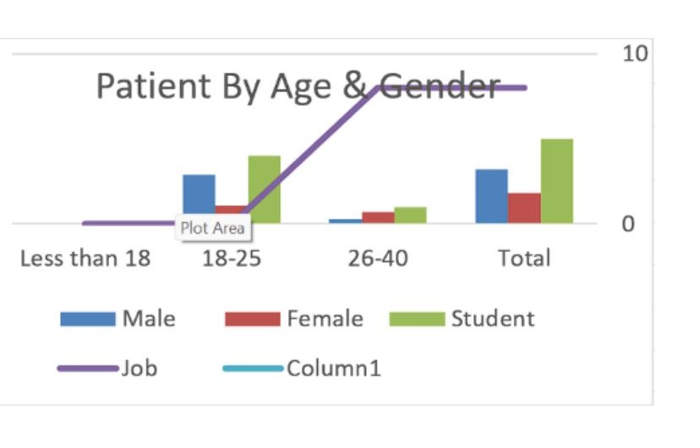
Figure 1. Patient Distribution by Age Group, Gender, and Occupation (PT1).

4.2 Commonly Used OTC Medicines
Panadol (paracetamol) was by far the most commonly used OTC product, reported by 41 of 50 respondents (82%). Cough syrup was reported by 6 respondents (12%), antacids by 4 respondents (8%), and Disprin by 1 respondent (2%). As the question allowed multiple selections, several respondents reported using more than one OTC category.
Table 3. Common OTC Medicines Used by Respondents (PT2)
OTC Medicine | Count | Percentage of Respondents
Panadol | 41 | 82%
Cough Syrup | 6 | 12%
Antacids | 4 | 8%
Disprin | 1 | 2%
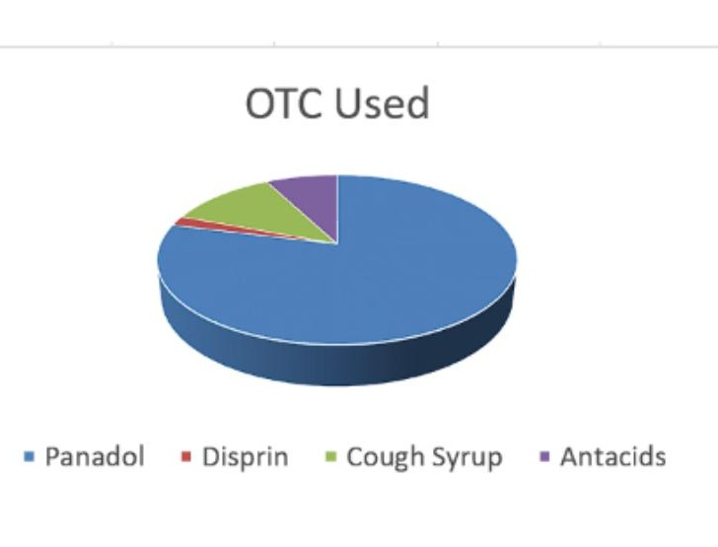
Figure 2. Common OTC Medicines Used by Respondents (PT2).

4.3 Reasons for Using OTC Medicines
Headache was the leading reported reason for OTC medicine use, cited by 35 respondents (70%), followed by fever (11 respondents, 22%), and cough and acidity (5 respondents each, 10%).
Table 4. Reasons for Using OTC Medicines (PT3)
Reason | Count | Percentage of Respondents
Headache | 35 | 70%
Fever | 11 | 22%
Cough | 5 | 10%
Acidity | 5 | 10%
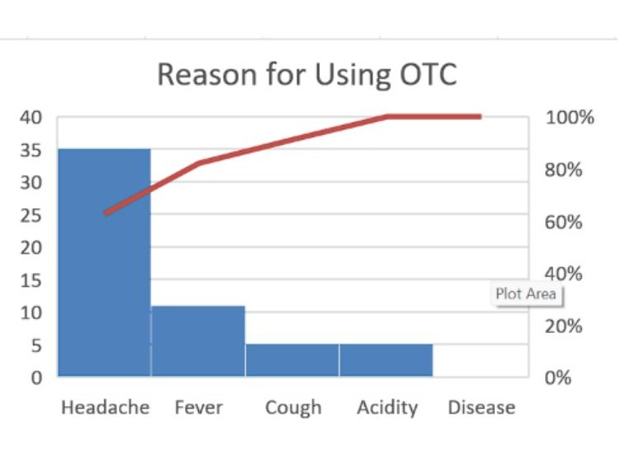
Figure 3. Reasons for Using OTC Medicines (PT3).

4.4 Frequency of OTC Medicine Use
More than half of respondents (28, 56%) reported using OTC medicines only rarely. Monthly use was reported by 14 respondents (28%), and weekly use by 8 respondents (16%). No respondent reported never using OTC medicines.
Table 5. Frequency of OTC Medicine Use (PT4)
Frequency | Count | Percentage
Weekly | 8 | 16%
Monthly | 14 | 28%
Rarely | 28 | 56%
Never | 0 | 0%
Total | 50 | 100%
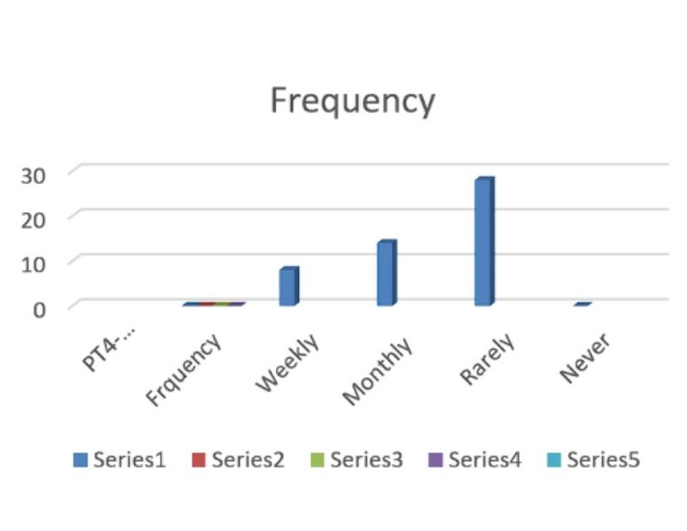
Figure 4. Frequency of OTC Medicine Use (PT4).

4.5 Pharmacist Consultation Before Purchase
Only 22 of 50 respondents (44%) reported consulting a pharmacist before purchasing an OTC medicine, while the majority, 28 respondents (56%), reported purchasing without prior consultation.
Table 6. Consultation to Pharmacist Before Buying OTC Medicine (PT5)
Consultation | Count | Percentage
Yes | 22 | 44%
No | 28 | 56%
Total | 50 | 100%
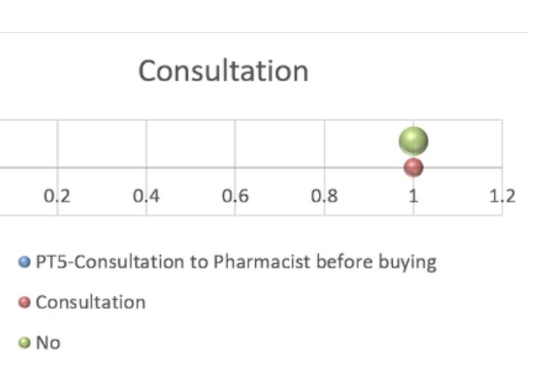
Figure 5. Consultation to Pharmacist Before Buying OTC Medicine (PT5).

4.6 Awareness of Side Effects of Frequent OTC Use
The majority of respondents, 37 out of 50 (74%), reported being aware of potential side effects associated with frequent OTC medicine use, while 13 respondents (26%) reported no such awareness.
Table 7. Side-Effect Awareness among Respondents (PT6)
Awareness | Count | Percentage
Yes | 37 | 74%
No | 13 | 26%
Total | 50 | 100%
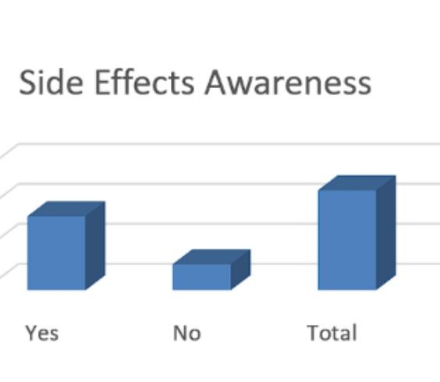
Figure 6. Side-Effect Awareness among Respondents (PT6).

4.7 Expiry-Date Checking Behaviour
Two-thirds of respondents (33, 66%) reported always checking the expiry date before using an OTC medicine, 15 respondents (30%) reported doing so only sometimes, and 2 respondents (4%) reported never checking the expiry date.
Table 8. Expiry-Date Checking Behaviour Before Use (PT7)
Response | Count | Percentage
Always | 33 | 66%
Sometimes | 15 | 30%
Never | 2 | 4%
Total | 50 | 100%
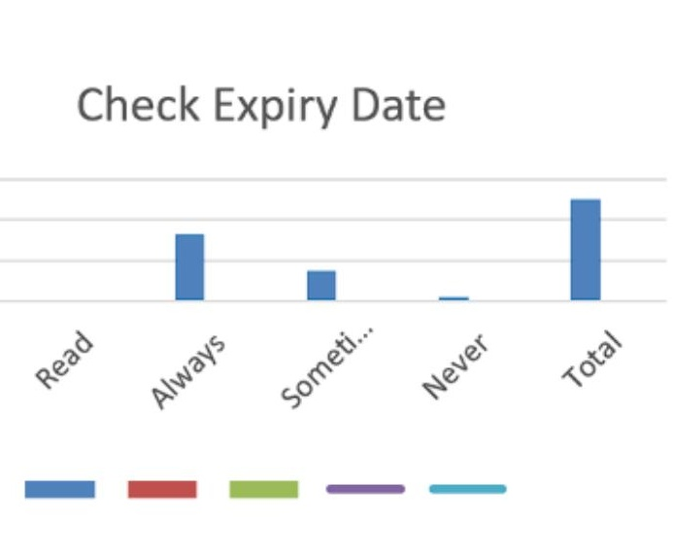
Figure 7. Expiry-Date Checking Behaviour Before Use (PT7).

4.8 Marital Status and Profession Cross-Tabulation
An additional cross-tabulation of the raw respondent-level dataset was performed to characterise the sample further by marital status and profession. The large majority of respondents (43, 86%) were single, and 42 (84%) held student status, confirming that the sample was overwhelmingly composed of the student population that the project intended to target, supplemented by a small group of married teaching staff.
Table 9. Marital Status and Profession of Respondents (derived from raw dataset)
Category | Count | Percentage
Single | 43 | 86%
Married | 7 | 14%
Student | 42 | 84%
Teacher / Staff | 8 | 16%

All 50 respondents were recruited from a single location — Iqra University, Islamabad Campus — consistent with the study's defined population and location as set out in the project proposal.

4.9 Consolidated Summary of Key Findings
Table 10 below brings together the headline result from each survey theme, providing a single reference point for the key statistics discussed throughout this report.
Table 10. Consolidated Summary of Key Findings (n = 50)
Survey Theme | Key Finding
Age distribution | 80% aged 18–25; 20% aged 26–40
Gender distribution | 64% male; 36% female
Occupation | 84% students; 16% teachers/staff
Most common OTC medicine | Panadol — 82%
Leading reason for use | Headache — 70%
Most common frequency | Rarely — 56%
Pharmacist consultation | Only 44% consult before purchase
Side-effect awareness | 74% aware
Always checks expiry date | 66%
Never checks expiry date | 4%

5. Discussion
The findings of this project provide a locally grounded snapshot of OTC medicine usage behaviour and perceptions within a Pakistani university setting, and are broadly consistent with patterns reported in the wider literature on self-medication among student populations.

5.1 Dominance of Analgesics/Antipyretics
The overwhelming preference for Panadol (82%) and the predominance of headache (70%) and fever (22%) as reasons for use reflect the well-established global pattern in which paracetamol-based analgesics/antipyretics are the most commonly self-administered OTC category. This is consistent with their favourable safety profile at recommended doses, wide availability, low cost, and general public familiarity, all of which make them a natural first choice for managing minor, self-limiting symptoms common in academic and daily life, such as tension headaches associated with study-related stress.

5.2 The Consultation Gap
A key finding of this study is that only 44% of respondents consulted a pharmacist before purchasing an OTC medicine. This is a clinically meaningful gap: even for products generally regarded as low-risk, pharmacist consultation provides an opportunity to screen for contraindications, drug interactions (for example, with existing chronic medication), inappropriate frequency of use, and masking of symptoms that may indicate a more serious underlying condition. The fact that this gap persists even within a health-sciences-affiliated population (the majority being pharmacy or other health-related students) suggests that consultation behaviour is influenced not purely by knowledge, but also by convenience, perceived low risk of common OTC products, and possibly by informal reliance on personal pharmacological knowledge among pharmacy students themselves.

5.3 Awareness versus Practice
Notably, awareness of side effects (74%) was considerably higher than the rate of pharmacist consultation (44%), indicating a disconnect between knowing that risks exist and translating that knowledge into a protective behaviour such as seeking professional advice before purchase. This awareness-practice gap is a recurring theme in health behaviour research generally, and highlights that educational interventions should not stop at improving knowledge alone, but should also address the practical and attitudinal barriers that prevent students from acting on that knowledge.

5.4 Expiry-Date Checking as a Safety Indicator
The relatively high proportion of respondents who reported always checking the expiry date (66%) is an encouraging safety indicator, suggesting reasonably good baseline medication-safety literacy in this sample. However, the finding that 4% of respondents reported never checking the expiry date, and 30% only sometimes doing so, indicates that this basic safety practice is not yet universal and would benefit from reinforcement through simple, low-cost educational messaging.

5.5 Demographic Considerations
The sample skewed young (80% aged 18–25) and was predominantly composed of single, student-status respondents (86% and 84% respectively), which is expected given the university-based sampling location. The inclusion of a smaller subgroup of married teaching staff (14%; 16% by profession) provides limited but useful comparative context, though the small size of this subgroup (n = 8) limits the extent to which meaningful demographic comparisons (for example, between students and staff, or by marital status) can be drawn from this dataset alone.

6. Conclusion and Recommendations

6.1 Conclusion
This project successfully applied computer-based data collection and analysis tools to investigate OTC medicine usage patterns and perceptions among 50 respondents at Iqra University, Islamabad Campus. The findings show that OTC medicine use in this population is common, centred predominantly on analgesic/antipyretic use (particularly Panadol) for headache and fever, and occurs mostly on a rare-to-monthly basis. While general awareness of the risks of frequent OTC use is reasonably good (74%) and basic safety practices such as expiry-date checking are common (66% always check), pharmacist consultation before purchase remains low (44%), representing the single most important gap identified by this study. These findings support the original problem statement of the project proposal: that self-medication with OTC products is common among university populations, and that structured local data is valuable in identifying specific, actionable gaps in safe-use behaviour.

6.2 Recommendations
- Pharmacist-led counselling: Retail pharmacies operating near or within university campuses should be encouraged to actively offer brief consultation for OTC purchases, rather than relying on customers to request it.
- Targeted educational campaigns: Given the awareness-practice gap identified in this study, campus health awareness sessions should focus specifically on translating existing knowledge of OTC risks into consistent consultation and safe-use behaviour, rather than solely on knowledge transfer.
- Expiry-date safety messaging: Simple, low-cost reminders (posters, orientation materials, or social media messaging) should reinforce the importance of always checking expiry dates, targeting the 34% of respondents who do not consistently do so.
- Peer-led interventions for pharmacy students: Given the university's focus on pharmacy education, pharmacy students could be engaged as peer educators to promote responsible OTC use among the wider student body.
- Expansion of sample size: Future iterations of this project should aim to reach the originally targeted sample size of 80 or more respondents, and consider stratified sampling across additional departments to improve the generalisability of demographic comparisons.
- Inclusion of additional variables: Future questionnaires could capture additional information such as source of drug information (pharmacist, family, internet, advertisement), history of self-reported adverse effects, and specific dosage practices, to provide a more complete picture of self-medication behaviour.

6.3 Limitations
- The final sample size (n = 50) was smaller than the originally targeted 80 respondents, which may limit the statistical power and generalisability of the findings.
- All data were self-reported by respondents and were not independently verified, introducing the possibility of recall or social-desirability bias, particularly for sensitive items such as side-effect awareness and consultation behaviour.
- Data collection was limited to a single institution (Iqra University, Islamabad Campus), which limits generalisability to other university or community populations.
- The cross-sectional design captures usage patterns at a single point in time and cannot establish causal relationships between demographic factors and OTC use behaviour.

7. References
1. World Health Organization. Guidelines for the Regulatory Assessment of Medicinal Products for Use in Self-Medication. Geneva: WHO; 2000.
2. World Health Organization. The Role of the Pharmacist in Self-Care and Self-Medication. Geneva: WHO; 1998.
3. Iqra University, Islamabad Campus, Department of Pharmacy. BS Pharmacy Project Proposal — Usage Patterns and Perceptions of Over-the-Counter (OTC) Medicine, PHARM 519, Spring 2026.
4. Project primary data: Structured questionnaire responses collected from 50 respondents, Iqra University, Islamabad Campus, Spring 2026 (project dataset).

