# GCBM Installation Guide – Nov. 14, 2019

Contents

GCBM Installation Guide – Nov. 14, 2019 1

Introduction 2

Step 1: Install Python 2

Existing Python Installation 2

New Python Installation 3

Step 2: Install Microsoft Access Database Driver 3

Step 3: Install Visual C++ Redistributable Packages 4

Step 4: Update GCBM Run Script 5

Step 5: Test GCBM 5

# Introduction

This document will guide you through the steps for installing the Python 3.7 environment required for running the pre- and post-processing tools for GCBM.

You might already have Python installed on your computer, especially if ArcGIS is installed. In that case, follow the instructions in the section “Existing Python Installation.”

If Python is not already installed, follow the instructions in the section “New Python Installation.”

# Step 1: Install Python

## Existing Python Installation

1. Locate your existing Python 3.7 installation (where python.exe is located). If you have both 32 and 64-bit versions installed (common with ArcGIS), find the path to the 64-bit version.
2. From a command prompt in the python_3_installer directory, type:

install_modules_only <python path>

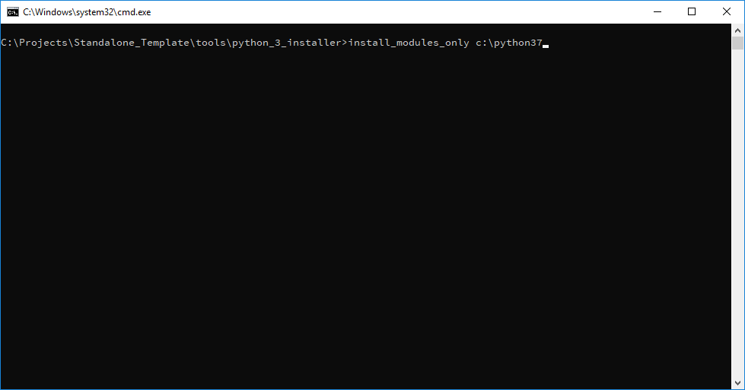

## New Python Installation

1. Verify that you have no existing Python 3.7 installation – it is not usually possible to install the same version in two different locations.
2. From a command prompt in the python_3_installer directory, type:

install_python [optional install path]

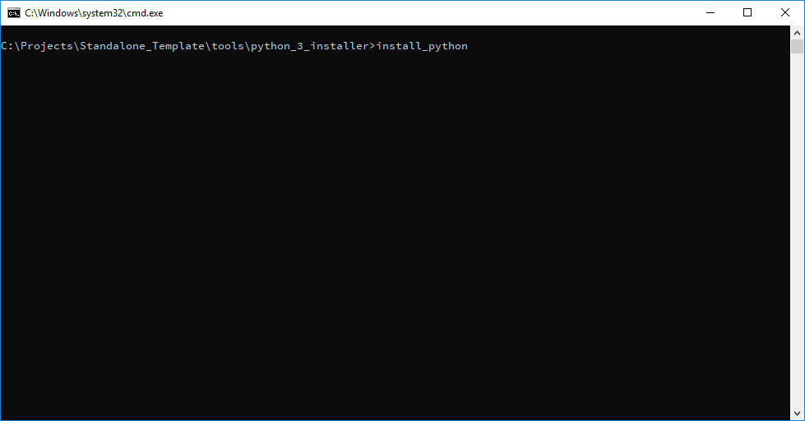

Python will be installed by default into C:\Python37.

# Step 2: Install Microsoft Access Database Driver

Skip this section if you have Microsoft Access installed.

If you do not have Microsoft Access installed, you will need to install a driver to connect to this type of database. Double-click python_3_installer\installers\AccessDatabaseEngine_x64.exe.

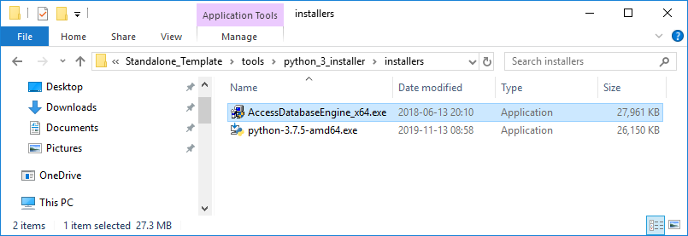

# Step 3: Install Visual C++ Redistributable Packages

Install the C++ packages required to run GCBM and supporting tools:

Double-click tools\VC_redist\install_vcredist.bat

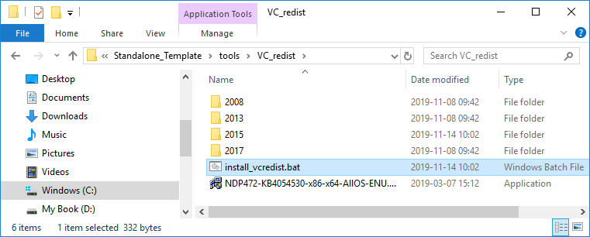

# Step 4: Update GCBM Run Script

Edit run_all.bat and update the Python path to the one used in the Python installation step, and the platform bit-ness to match your version of MS Access if needed:

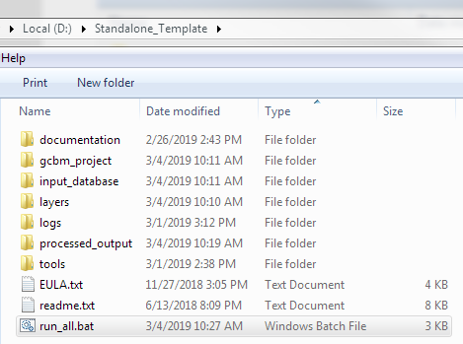

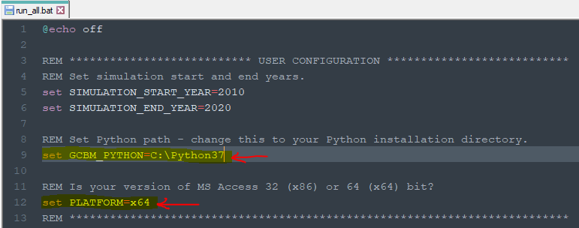

# Step 5: Test GCBM

Double-click the run_all.bat file to run GCBM – if the installation steps were performed correctly, the preprocessing tools, GCBM model, and postprocessing tools should run without any error messages.