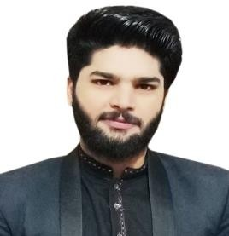[Muhammad Waqas]

[Bhalwal district Sargodha ,pakistan] | [+971 58 873 4208] | [[ranawaqas12@gmail.com](mailto:ranawaqas12@gmail.com)]

**Languages: Urdu, English. punjabi**

[Job for Security Guard]

# Experience

I Have worked in security guard filed from last 6 years in Pakistan with great capabilities.

|  |
| --- |
| **[Security Guard]**  **Meezan Bank**: **2017-2019**  I worked as a security guard at Meezan Bank for three years.  **Royaltan Hotel** : **2019-2021**  Also I worked as a security guard at Meezan Bank for past two years with great experience.    Recently I worked as a security guard at Meezan Bank for past two years with great experience. |
| Skills & Abilities   * Proven ability to maintain a high level of vigilance and alertness, ensuring the safety and security of premises, personnel, and assets. * Proficient in using security equipment such as CCTV cameras, access control systems, and alarm systems to effectively monitor and respond to security threats. * Demonstrated expertise in conducting thorough security patrols, promptly identifying and addressing potential security breaches or suspicious activities. |

# Education

|  |
| --- |
| **[Govt degree school bahlwal]** — [Matric] |
| I have completed my matriculation education from govt school bhalwal with  high awards, and honors. |