**Bookee**

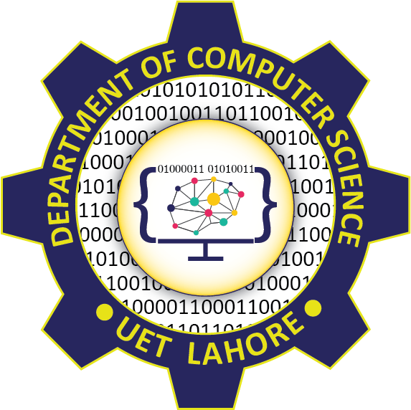

Session: 2021 – 2024

**Submitted by:**

Danish Akram 2021-CS-123

Muhammad Jawad Haider 2019-CS-149

**Supervised by:**

Miss Maida Shahid

Department of Computer Science

**University of Engineering and Technology**

**Lahore Pakistan**

**Table Of Contents**

|  |  |
| --- | --- |
| Page Number | Content |
| 3 | Description |
| 3 | Deliverables |
| 3 | Technology |
| 3 | Resources |

**Description:**

It is a place where you can see what your friends are reading and vice versa. You can create bookshelves to organize what you've read (or want to read). You can comment on each other's reviews. You can find your next favorite book. And on this journey with your friends you can explore new territory, gather information, and expand your mind.

**Deliverables:**

Following wil be some important features available to our users:

1. See what your friends are reading.

2. Tracking about the books your are reading, what you have read, and what you want to read.

3. Our application will analyze a collection of books and will suggest according to your taste.

4. User can get reviews about the books from organic users.

5. User can find the top books suitable for him.

**Technology:**

It will be a web based application. We plan to use following technology in this project: Vue (Vuetify) Framework and JavaScript

**Resources:**

Following resources are required for our project: Sequelize and mySQL database.