Appendix B
Flight Management System
Logical View

Version 1.0

Revision History
Date | Version | Description | Author
01/06/15 | 1.0 | Compilation of Logical View | Matthew King  Michael Kong

Table of Contents
1.1 Package Diagram 4
1.1.1 booking package 4
1.1.2 com package 5
1.1.3 helpers package 5
1.1.4 interaction package 6
1.1.5 main package 6
1.1.6 profile package 7
1.1.7 report package 8
1.1.8 role package 9
1.2 Class Diagrams 10
1.2.1 Overview 10
1.2.2 Bookings, Flights, Fleet and Services Classes 10
1.2.3 Reporting Subsystem Classes 11
1.2.4 Role Classes 12
1.2.5 Role and Controller Classes 12
1.2.6 System Classes 13
1.3 State Diagrams 14
1.3.1 Overview 14
1.3.2 UserController.java 14
1.3.3 SystemAdministratorRole.java 14
1.4 Data Dictionary Error! Bookmark not defined.

Logical View

Package Diagram
These Diagram show the packages within the proposed Flight Management System. The diagrams also show the classes contained within each package as well as the dependencies of each package.

booking package

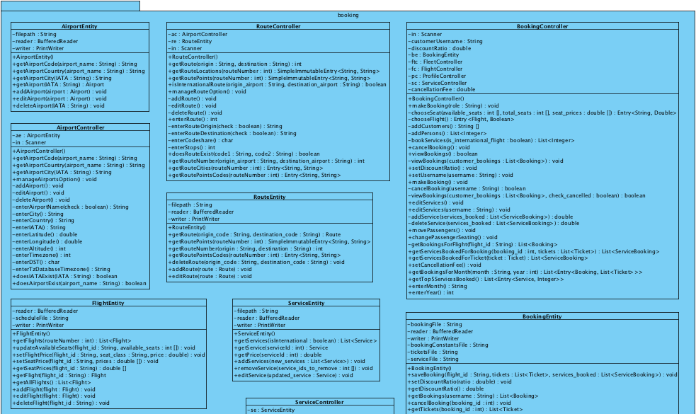
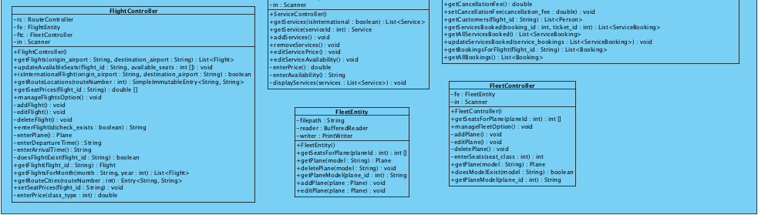

com package

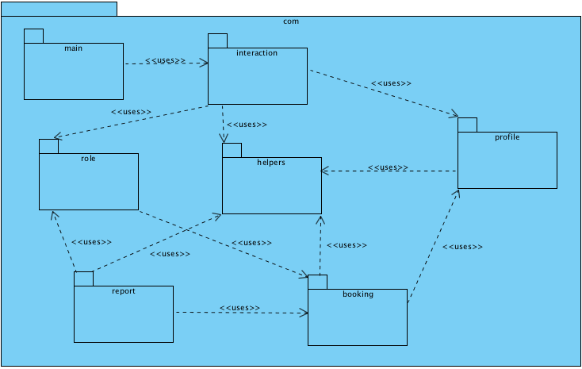

helpers package

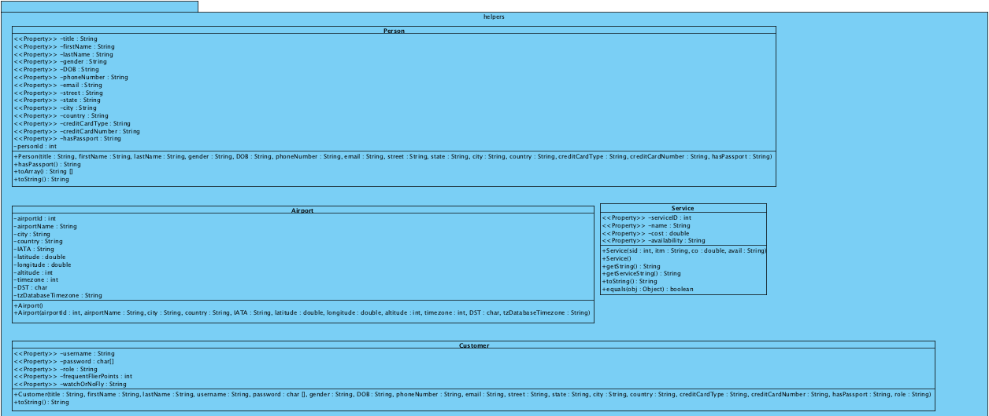
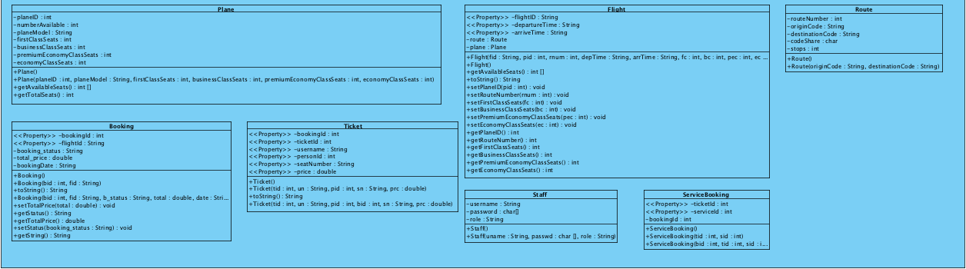

interaction package

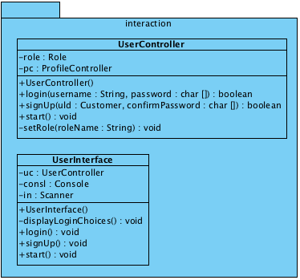

main package

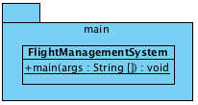

profile package

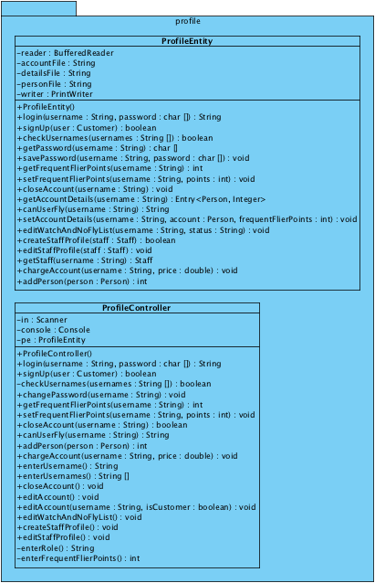

report package

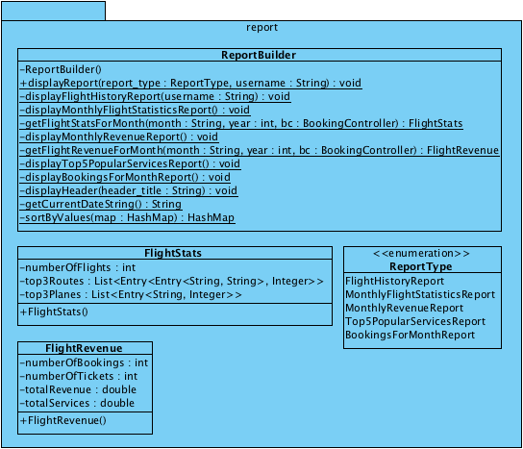

role package

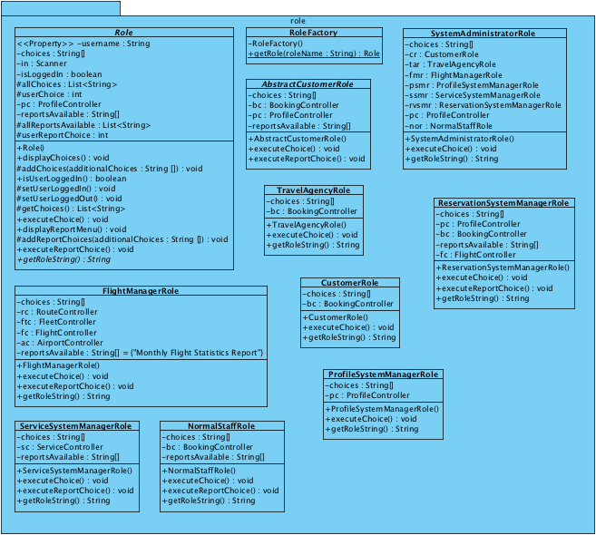

Class Diagrams

Overview
This section contains the Class diagrams that form part of the Logical View. These class diagrams have been refined using the BCE (Boundary Control Entity) framework model. Refining the system classes using the BCE framework assists in providing the earlier adopted layered architectural structure for the system.

The framework model is made up of three types of classes –
- Boundary – These classes model interaction between the outside world and the system
- Control – These classes model control of one or more use cases and contain core business logic and rules for the system
- Entity – These classes represent domain classes and typically map directly to a database table

The class diagrams below do not contain attributes or methods for clarity’s sake. A full description of the class can be found in the package diagram or the data dictionary.

Bookings, Flights, Fleet and Services Classes
Class diagram showing the classes involved in bookings, flights, fleet (planes) and services.
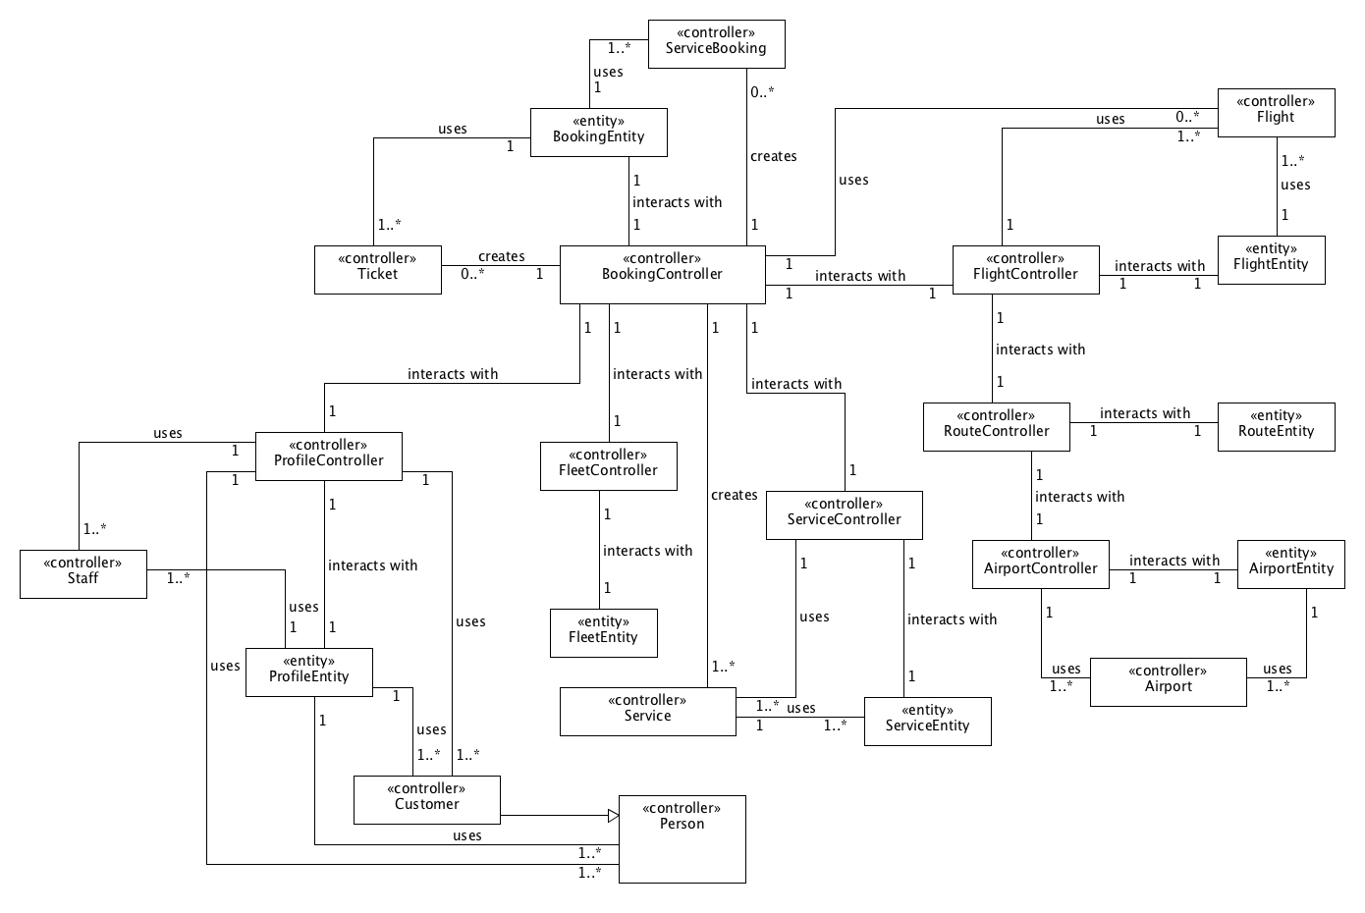

Reporting Subsystem Classes
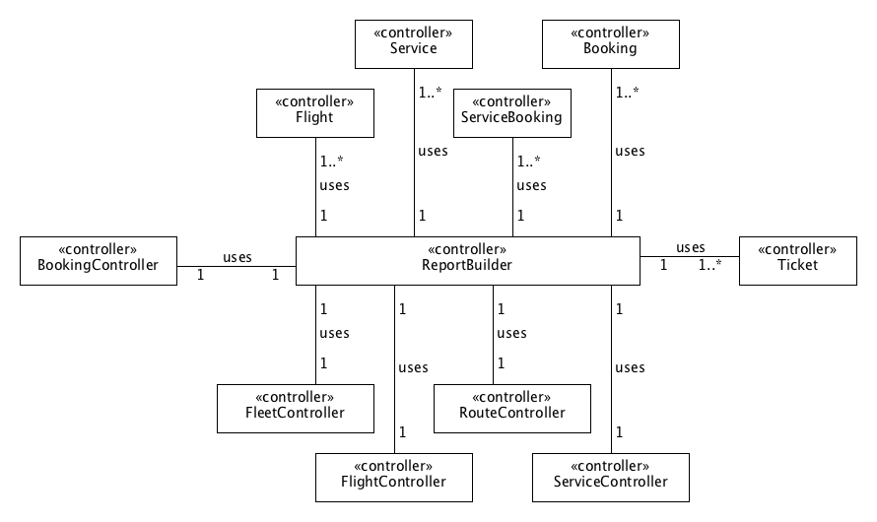
Class diagram of the reporting subsystem

Role Classes
Class diagram showing the classes that represent the various roles within the system.
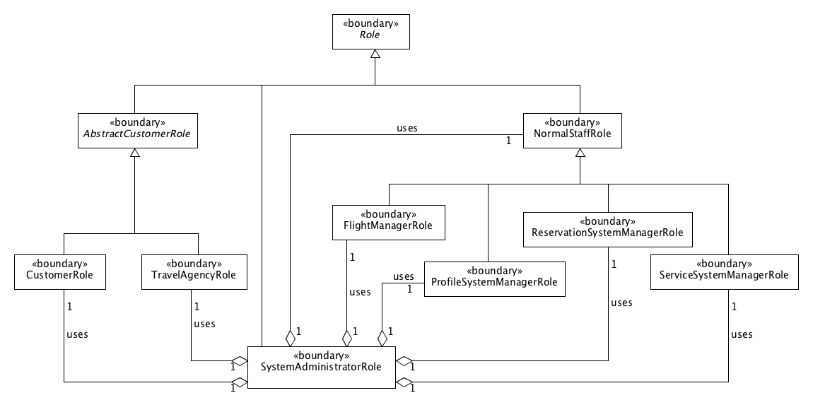

Role and Controller Classes
Class diagram that show the interaction between the role classes and the controller classes.
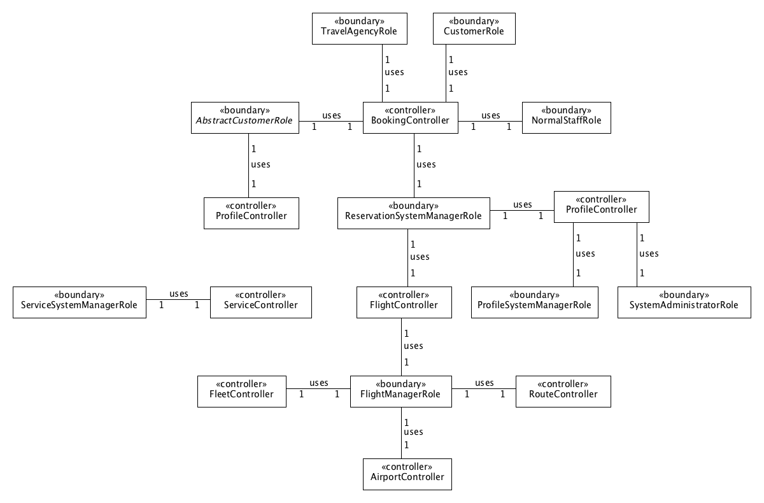

System Classes
Class diagram that shows the skeleton of the system. Login, signup, logout and role delegation functionality are done here.
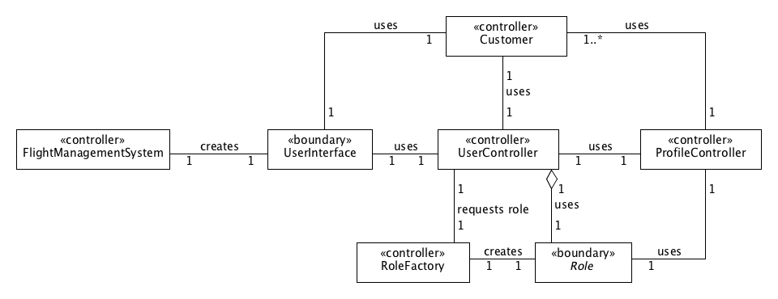

State Diagrams

Overview
This section contains the state diagrams that form the final part of the Logical View. These diagrams represent objects and their transitions throughout their life within the system. All objects that respond to an event, human or system triggered are included in these diagrams.

Since the Flight Management System is mainly an information processing system, the objects within it do not possess complex states. Working on the Boundary-Controller-Entity framework, most of the classes contain methods which process data and pass the data to another class either for displaying or writing to database. Therefore, we only have two classes that have sufficiently different states and can change states during the execution of the system: SystemAdministratorRole.java and UserController.java.

UserController.java
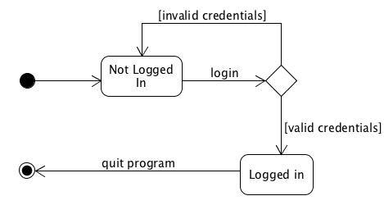

SystemAdministratorRole.java
