Canotacus OSI Modeli Layer-neri het.

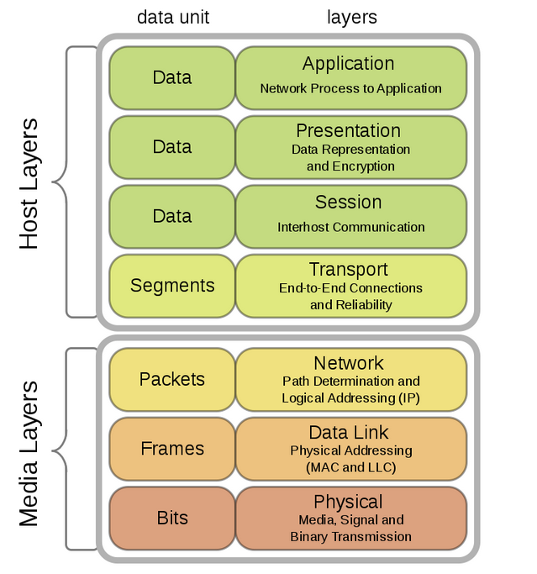

Canci texnologianer@ bnoroshvumen OSI modelnerov, OSI model@ baxkacac e 7 makardakneric, kardacvum e amena verevic nerqev, Ays modeli amen mi makardak@ cuyc e talis texnologiakan process@ cancin verabervox,

7rd Application shert@ patasxanatue HTTP, FTP protokolov ashxatox cancayin procesi hamar,

Applicationi tak ashxatumen ayn bolor sarqer@ voronq chunen kodavorman mexanizmner

(cryptographic).

Presentation layer, 6rd Shertn e modeli, ays Layeri tak ashxatumen HTTPS, SSL, FTPS protokolner@, Petq e nshel vor ays Layeri tak gorce tevum Cryptographic process@,

Session shert, OSI Modeli 5rd makardakuma ashxatum, Ays makardakum e texi unenum erku keteri mijev miacnam process@, inchpisinene NetBIOS, vorin patkanum e hasarakayin faylayin… Klient server *SQL* miacum@.

4rd Makardakum, Transport texnalogianneri ashxatanqi hamar. Aystexen ashxatum Transport protokolner, TCP and UDP voronq tvalner texapoxel A ketic B ket.

OSI Modeli 3rd makardakum gtnvum e Network makardak@ vor@ tuyl e talis, Ashxatacnel “IP” ev ”ICMP” (Hamarvum e diagnostic protocol, “PING” orinak) protokolner.

2rd Layer kochvuma Data Link Layer, Ashxatum e MAC/LLC hasciavorman process@, Nayev ashxatum e ARP protokol@, vortexel nayev ashxatum e RAR protokol@. Petq e nshel vor Layer 2-@ miayn ashxatum e Local Area Networki cancum.

LLC-n bacvum e “Logical Link Control” – Henc MAC Hascei verabervox hascen e.

Layer 1. Araji makardakum nerkayacvac e texnologiakan, Miacman process@ inch exanakov e mianum fizikapes sarqavorum@ cancin,

Orinak, Hasarak kabelov (UTP LAN), Optikakan (WiFi).

Canotacum PDU modeli het.

PDU Layer@ bacvum e “Process Data Unit”

Cuyc e talis te vor makardakum tvyal@ inch tesq uni. Baxkacacen 4 makardakic. nuynisk akrdacvumen nerqevic verve.

4. DATA Makardak@ da patrasti tvyal e. Orinak – “Hello” <- da patrasti tvyal e. Vernakan tvyali ardzunk e.

4rd makardak@ hamapatasxan e OSI Modeli verevi 3 makardakner@, 7, 6,5.

3. Segment / Datagrama. Da TCP protokolov uxarkvox kam stacvox mi elementar simvol e.

1 segment = H <- orinak.

***1 Datagraman = 1 Simvol***

PDU Makardaki errord@ hamapatasxan e OSI modeli 4rd Layeri het.

3.RD Packet, da ayn makardakn e vorte texi e unenum hasceavorum. Ira mej patkanum en IP-ner, UDP,TCP Protolner, nayev patkanum e iranic sax verve (Data, Transport/Segment).

OSI modeli 3rd shertina padkanum

1. Frame/Bit. Araji makardak@ havasa r OSI modeli araji ev erkrord Layernerin.

Biter@ dzevavorvox 0 ev 1-nen