**Bloch sphere simulator**

Links:

GitHub: <https://github.com/dolnaaa/bloch-sphere>

Bloch sphere simulator: <https://www.bloch-sphere.app/>

**Technical Description**

The simulator’s purpose is to visualize the evolution of a single qubit’s quantum state on the Bloch sphere. This simulator is a Next.js project bootstrapped with create-next-app, making it highly performant, modular, and easy to extend. Developers can clone or fork the open-source repository on GitHub to adapt it for their own learning tools or research needs.

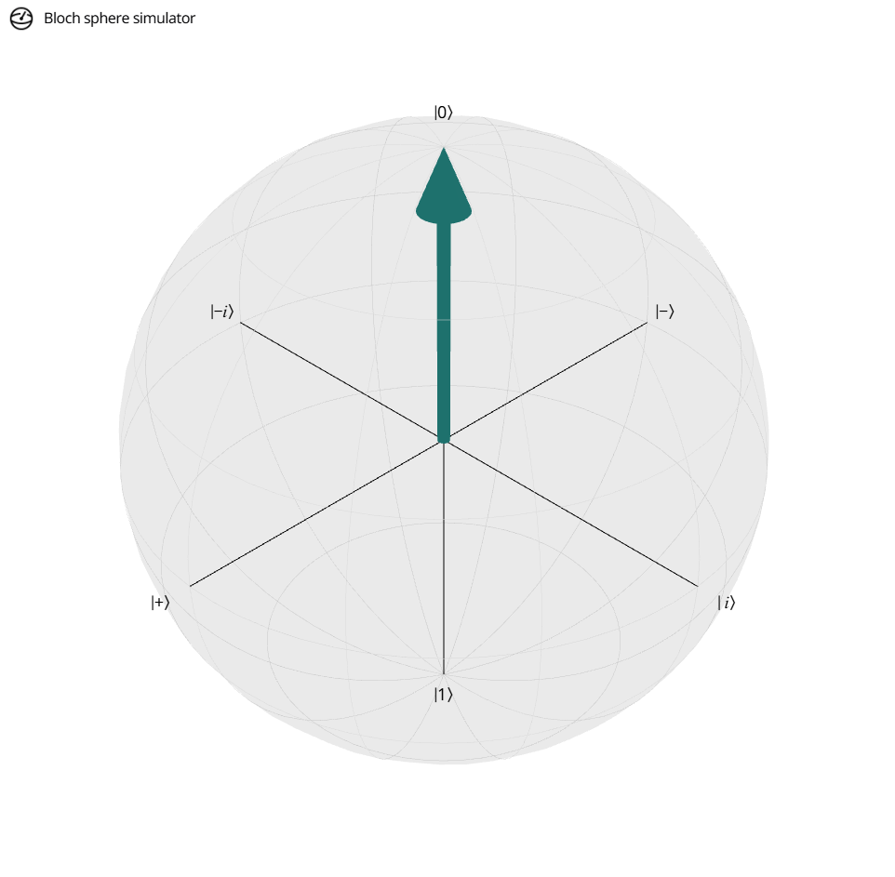

**Features**

**3D Interactive Visualization:**

* Users can rotate the Bloch sphere using mouse or touch gestures.
* The qubit's state is shown as a vector pointing from the origin to a point on the sphere’s surface.

**Gate Simulation:**

* Several common quantum gates—including X (Pauli-X), Y, Z, H (Hadamard), S, and T—can be applied directly to the qubit by clicking the corresponding buttons in the interface.
* Each gate’s effect is visually reflected as a rotation or transformation of the qubit state vector on the Bloch sphere, demonstrating how gates correspond to unitary operations.
* Users can also define and apply custom unitary gates by specifying a custom 2×2 matrix. This allows for the simulation of arbitrary single-qubit operations beyond the built-in set, making the tool useful not just for basic education but also for exploring more advanced or experimental gate effects.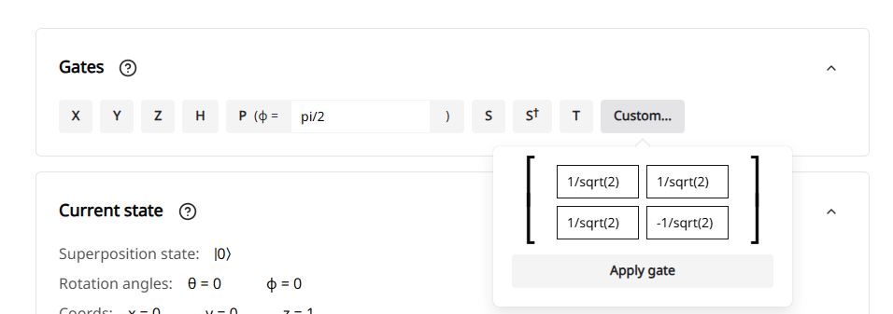

**Current state:**

The app displays the current state in real time, including:

* The label of the quantum state
* Rotation angles on the Bloch sphere:  
  + θ (theta) — inclination from the Z-axis
  + ϕ (phi) — azimuthal angle from the X-axis
* Cartesian coordinates (x, y, z) corresponding to the position on the sphere

This information provides precise insight into how a quantum state evolves and where it lies on the Bloch sphere.

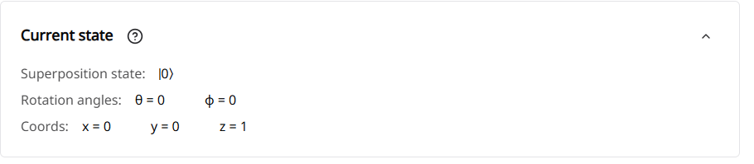

**Preset States:**

* The app includes buttons to reset the qubit to state |0⟩ or custom.
* Useful for quickly jumping to and examining the effects of operations on key basis and superposition states.

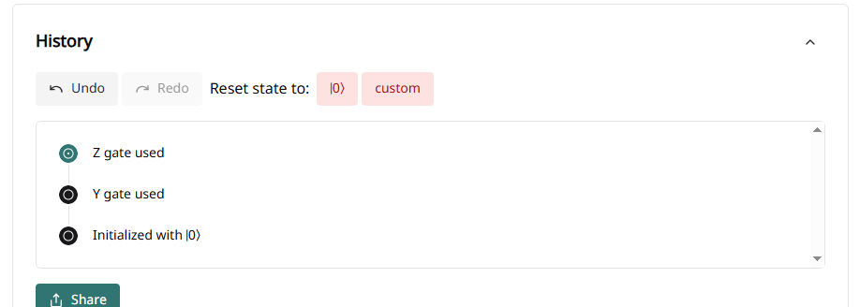

**Open Source:**

* The app is open-source and hosted on GitHub, enabling developers or educators to fork and modify it for custom use cases or enhancements.

#### **Advantages:**

* **Highly Visual and Interactive:** Ideal for understanding abstract quantum concepts like superposition and quantum gate action through concrete, visual feedback.
* **Accessible Anywhere:** Runs entirely in the browser—no downloads, installations, or logins required.
* **Beginner-Friendly:** Clean UI with simple controls and informative labels make it ideal for classroom demonstrations or self-learning.
* **Real-Time Feedback**: Immediate visual feedback upon applying operations helps reinforce the connection between mathematical representations and their physical interpretations

#### **Disadvantages:**

* **Limited to Single Qubits**: The simulator focuses solely on single-qubit states, lacking the capability to model multi-qubit systems or entanglement phenomena.
* **Absence of Measurement Simulation**: While it visualizes state evolutions, the tool does not simulate quantum measurements or display probabilities associated with different outcomes.
* **No Export Functionality**: Users cannot export simulations or visualizations for use in presentations or further analysis.