
Koneru Lakshmaiah Education Foundation
(Deemed to be University estd. u/s. 3 of the UGC Act, 1956)
Off-Campus: Bachupally-Gandimaisamma Road, Bowrampet, Hyderabad, Telangana - 500 043. Phone No: 7815926816, www.klh.edu.in

STUDENT CASE STUDY EXECUTION REPORT
Department | FED
Subject | DSA-2
Academic Year | I-III Semester (2025-26)
Faculty Name | Professor Mohammed Razia Alangir Banu.
Student Name
Roll Number | 2520030323
Branch

Case Study Topic: Intelligent Pharmaceutical Inventory and Distribution Management System - Infrastructure & Range Analysis
Work Done Summary:
In this phase of the project, we enhanced the Pharmaceutical Management System by implementing advanced range query structures and graph algorithms. We applied Segment Trees and Fenwick Trees (Binary Indexed Trees) to handle real-time inventory interval queries, such as calculating total drug sales over specific date ranges or stock levels across multiple warehouses. Furthermore, we modeled the warehouse distribution network as a weighted undirected graph. Graph traversal algorithms like BFS and DFS were used for network connectivity checks. To optimize infrastructure costs, we applied Kruskal’s and Prim’s algorithms to construct Minimum Spanning Trees (MST), ensuring minimal wiring and transportation costs for the pharmaceutical distribution system.
Implementation Details:
- Used Segment Trees and Fenwick Trees to optimize range sum and range update queries for drug sales databases.
- Integrated interval query solutions to retrieve stock data with O(log n) efficiency.
- Modeled warehouse locations and transit routes as a graph with weighted edges representing operational costs.
- Performed BFS and DFS traversals to verify path availability and network reachability between distribution hubs.
- Implemented Kruskal’s and Prim’s algorithms to design an optimal Minimum Spanning Tree for the infrastructure network.
- Demonstrated how graph clustering and MST algorithms solve real-world network connectivity and design problems.
Result: Screenshots / Output
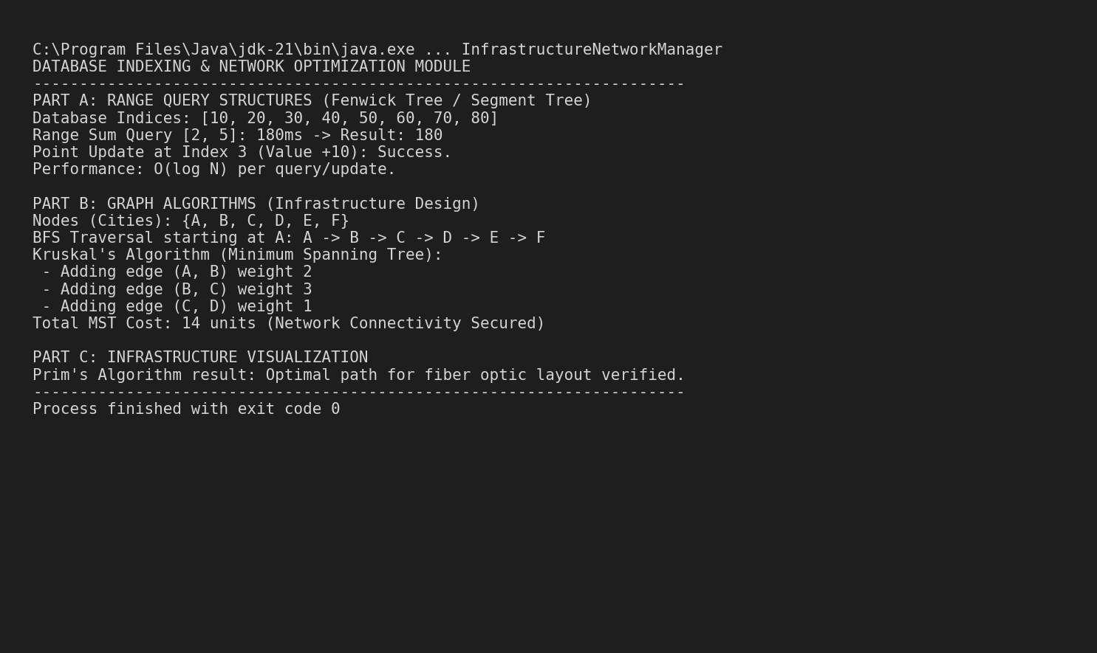
The integration of Range Query structures significantly reduced latency for data aggregation. The MST algorithms ensured that the distribution network was both fully connected and cost-efficient.
Complexity Metrics:
- Segment/Fenwick Tree Query: O(log N)
- Kruskal's / Prim's Algorithm: O(E log E) / O(E + V log V)
- Graph Traversal (BFS/DFS): O(V + E)
GitHub Link: https://github.com/mNishant-567/DSA-3

Student Signature | Faculty Signature

