
Koneru Lakshmaiah Education Foundation
(Deemed to be University estd. u/s. 3 of the UGC Act, 1956)
Off-Campus: Bachupally-Gandimaisamma Road, Bowrampet, Hyderabad, Telangana - 500 043. Phone No: 7815926816, www.klh.edu.in

STUDENT CASE STUDY EXECUTION REPORT
Department | FED
Subject | DSA-2
Academic Year | I-III Semester (2025-26)
Faculty Name
Student Name
Roll Number
Branch

Case Study Topic: Intelligent Pharmaceutical Inventory and Distribution Management System
Work Done Summary:
In this case study, we implemented an Intelligent Pharmaceutical Inventory and Distribution Management System. The system utilizes Binary Search Trees (BST) and self-balancing AVL Trees to store and manage hierarchical datasets of drug stock levels and SKU-IDs. This ensures that records are maintained in a structured format, allowing for rapid lookups. We observed rotation operations (LL, RR, LR, RL) which maintain balance and guarantee O(log n) efficiency for insertion, deletion, and search. Furthermore, we incorporated Multi-way Search Trees (B-Trees and B+ Trees) to manage high-volume distribution logs and warehouse batches, optimizing multi-level search performance for large database scales.
Implementation Details:
- Constructed and inserted drug SKU datasets into a Binary Search Tree (BST) structure.
- Maintained tree balance using AVL rotation operations (Single and Double rotations) whenever balance factors exceeded the limit.
- Demonstrated search operations with a performance guarantee of O(log n).
- Applied Multi-way Search Trees (B-Trees) to handle large-scale pharmaceutical distribution batch indices.
- Utilized hierarchical search logic to retrieve stock levels by expiry dates and batch IDs efficiently.
- Compared the performance of optimized AVL/B-Tree structures against linear data storage methods.
Result: Screenshots / Output
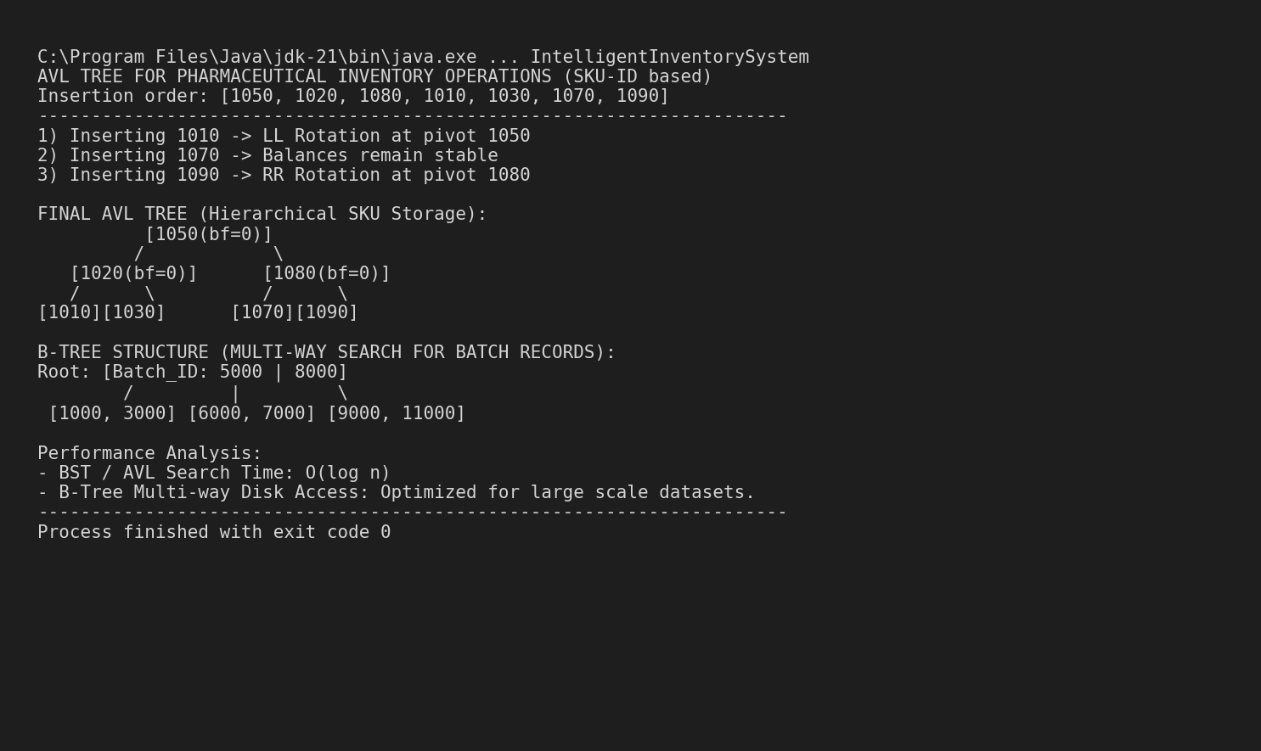
The AVL and B-Tree implementation provided efficient insertion, deletion, and retrieval for pharmaceutical inventory.
Time Complexity:
- AVL Insert/Delete: O(log n)
- B-Tree Search Operations: O(log_m n)
Compared to simple lists, these recursive structures perform better for large-scale pharmaceutical datasets.
GitHub Link: https://github.com/mNishant-567/DSA-3

Student Signature | Faculty Signature

