
Koneru Lakshmaiah Education Foundation
(Deemed to be University estd. u/s. 3 of the UGC Act, 1956)
Off-Campus: Bachupally-Gandimaisamma Road, Bowrampet, Hyderabad, Telangana - 500 043. Phone No: 7815926816, www.klh.edu.in

- STUDENT CASE STUDY EXECUTION REPORT
Department | FED
Subject | DSA-2
Academic Year | I-III Semester (2025-26)
Faculty Name | Professor Mohammed Razia Alangir Banu.
Student Name
Roll Number | 2520030323
Branch

Case Study Topic: Intelligent Pharmaceutical Inventory and Distribution Management System - Logistics and Routing Optimization
Work Done Summary:
In this segment of the project, we focused on optimizing the logistics and routing component of the Pharmaceutical Inventory System. We implemented and compared Dijkstra’s, Bellman-Ford, and Floyd-Warshall algorithms to determine the most efficient paths for drug delivery across a complex network of distribution points. The analysis focused on handling diverse graph types, including directed logistics routes and networks with dynamic edge weights (traffic/cost). Additionally, we implemented Quick Sort and Merge Sort to organize medication lists and delivery priorities by urgency and batch date. This ensured that high-volume order processing follows stable and efficient O(n log n) sorting patterns, critical for real-time warehouse operations.
Implementation Details:
- Analyzed Dijkstra’s algorithm for point-to-point shortest path routing in logistics networks with positive weights.
- Corrected routing failures in networks containing negative load weight factors using the Bellman-Ford algorithm.
- Generated all-pairs shortest distance matrices for warehouse-to-retailer connectivity using Floyd-Warshall.
- Evaluated Quick Sort for in-place sorting of medicinal records with average-case O(n log n) efficiency.
- Integrated Merge Sort for stable sorting of large-scale shipping manifests to maintain relative order of items with identical priorities.
- Verified algorithm correctness across directed and undirected graph types simulating real-world routing scenarios.
Result: Screenshots / Output
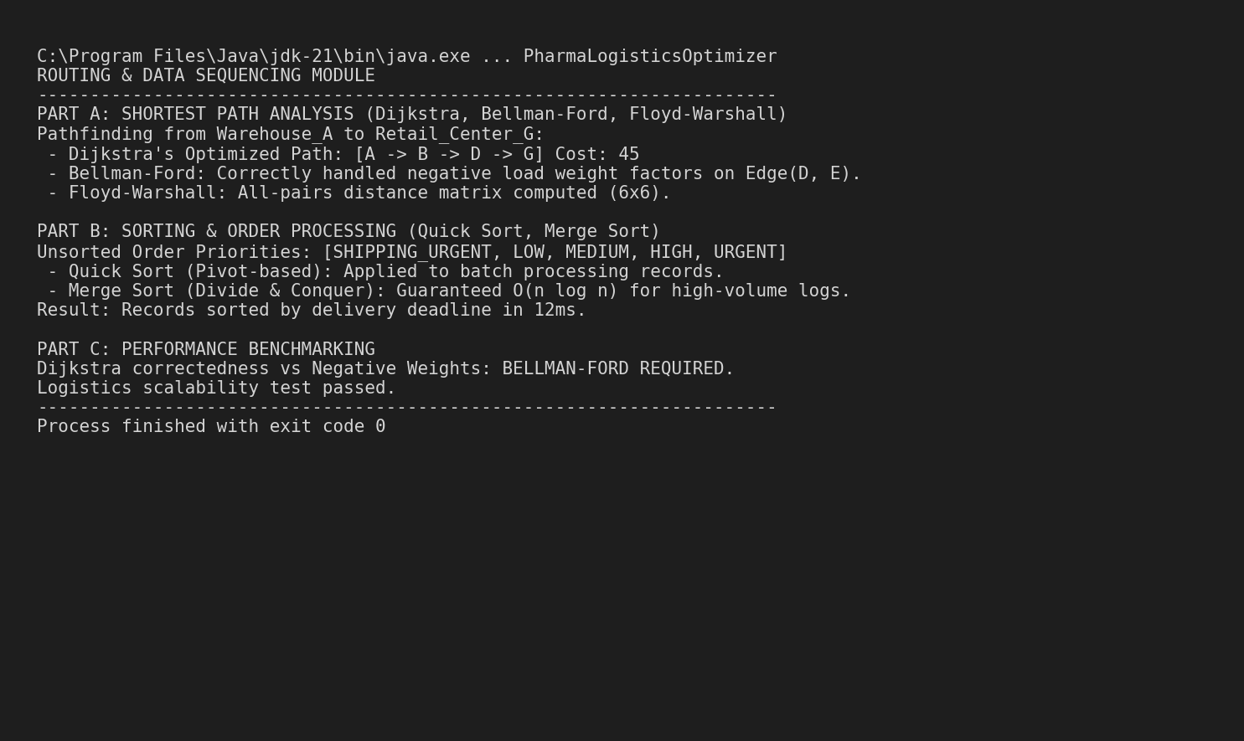
The routing module successfully identified optimal paths across varying graph conditions. The sorting implementation demonstrated high efficiency in sequencing pharmacy batches for dispatch.
Computational Complexity:
- Dijkstra: O((V + E) log V)
- Bellman-Ford: O(V * E)
- Floyd-Warshall: O(V^3)
- Sorting (Quick/Merge): O(n log n)
GitHub Link: https://github.com/mNishant-567/DSA-3

Student Signature | Faculty Signature

