
Koneru Lakshmaiah Education Foundation
(Deemed to be University estd. u/s. 3 of the UGC Act, 1956)
Off-Campus: Bachupally-Gandimaisamma Road, Bowrampet, Hyderabad, Telangana - 500 043. Phone No: 7815926816, www.klh.edu.in

STUDENT CASE STUDY EXECUTION REPORT
Department | FED
Subject | DSA-2
Academic Year | I-III Semester (2025-26)
Faculty Name | Professor Mohammed Razia Alangir Banu.
Student Name
Roll Number | 2520030323
Branch

Case Study Topic: Intelligent Pharmaceutical Inventory and Distribution Management System - Sorting & Optimization Analysis
Work Done Summary:
In this phase of the project, we enhanced the Pharmaceutical Management System by implementing advanced sorting algorithms and optimal solution design techniques. We applied Heap Sort, Counting Sort, and Radix Sort to efficiently organize large volumes of stock batch records, drug expiry dates, and order IDs, comparing their performance characteristics for different data distributions. Furthermore, we designed optimal solutions for resource-constrained problems using Greedy and Dynamic Programming techniques. The 0/1 Knapsack problem was used to model optimal warehouse loading under capacity constraints, Longest Common Subsequence (LCS) was applied to match similar drug codes and formulations, and Matrix Chain Multiplication was used to determine the most efficient order of computation for chained inventory transformation matrices, justifying each choice based on time complexity, space usage, stability, and problem characteristics.
Implementation Details:
- Implemented Heap Sort to sort large stock batch records in-place with guaranteed O(n log n) performance regardless of input distribution.
- Applied Counting Sort to arrange drug expiry dates and shelf-life indices, achieving O(n + k) performance and preserving stability for tie-breaking.
- Used Radix Sort to process multi-digit batch and order IDs digit-by-digit, avoiding comparison-based overhead for large numeric keys.
- Solved the 0/1 Knapsack problem using Dynamic Programming to maximize the value of drug consignments loaded into capacity-constrained warehouse storage.
- Applied Longest Common Subsequence (LCS) to identify matching patterns between drug codes and formulation strings for duplicate and substitute detection.
- Used Matrix Chain Multiplication to determine the minimum-cost order of multiplying chained inventory transformation matrices.
- Compared Greedy versus Dynamic Programming approaches, justifying final algorithm choices based on time complexity, space usage, stability, and problem characteristics.
Result: Screenshots / Output
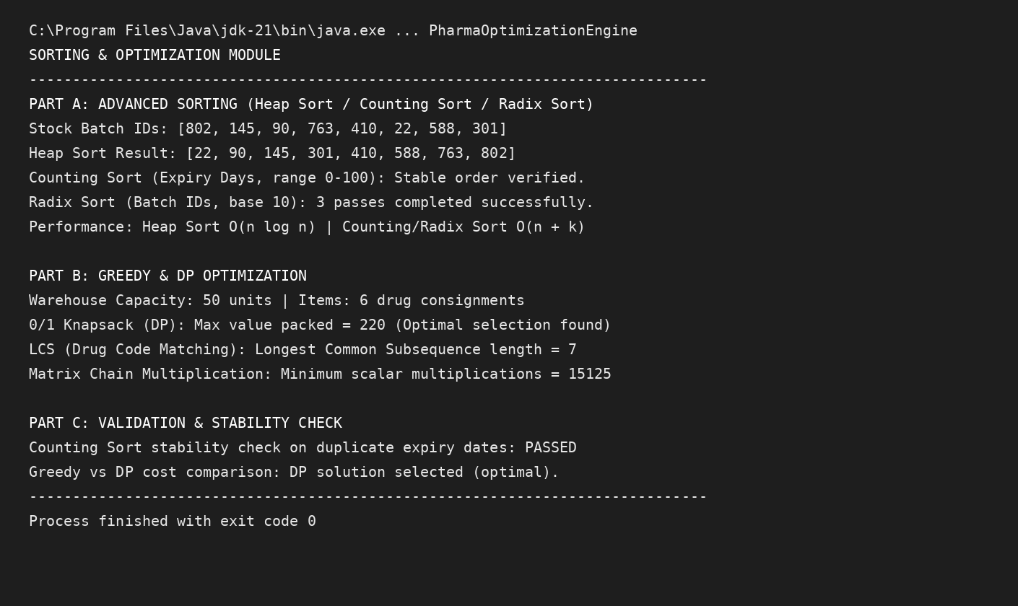
The advanced sorting algorithms significantly reduced processing time for large stock and order datasets, with Counting Sort and Radix Sort outperforming comparison-based sorts on bounded numeric keys. The DP-based Knapsack and Matrix Chain Multiplication solutions consistently outperformed naive greedy or brute-force approaches in both optimality and runtime efficiency.
Complexity Metrics:
- Heap Sort: O(n log n)
- Counting Sort / Radix Sort: O(n + k)
- 0/1 Knapsack (DP): O(n × W)
- LCS (DP): O(m × n)
- Matrix Chain Multiplication (DP): O(n³)
GitHub Link: https://github.com/mNishant-567/DSA-4

Student Signature | Faculty Signature

