
Koneru Lakshmaiah Education Foundation
(Deemed to be University estd. u/s. 3 of the UGC Act, 1956)
Off-Campus: Bachupally-Gandimaisamma Road, Bowrampet, Hyderabad, Telangana - 500 043. Phone No: 7815926816, www.klh.edu.in

STUDENT CASE STUDY EXECUTION REPORT
Department | FED
Subject | DSA-2
Academic Year | I-III Semester (2025-26)
Faculty Name | Professor Mohammed Razia Alangir Banu.
Student Name
Roll Number | 2520030323
Branch

Case Study Topic: Intelligent Pharmaceutical Hierarchical Classification and Resource Allocation System - Non-Linear Structures, DP & Greedy Applications
Work Done Summary:
In this phase of the project, we designed and developed common practical applications of Non-Linear Data Structures, Dynamic Programming, and Greedy Algorithms within the Pharmaceutical Management System. We used Binary Search Trees and Min-Heaps to organize the drug catalog hierarchically and to manage priority-based dispensing of critical medicines. We modeled the supply chain as a graph and applied Dijkstra’s algorithm, a greedy strategy, to compute the shortest delivery routes between warehouses and pharmacies. Greedy Activity Selection was used to schedule the maximum number of non-overlapping delivery slots, and Greedy Huffman Encoding was applied to compress inventory log files for efficient storage. In parallel, Dynamic Programming was used to solve the optimal restocking problem, ensuring maximum value is restocked within a limited budget. Each application was evaluated and compared against alternative strategies to justify the chosen approach.
Implementation Details:
- Implemented a Binary Search Tree to organize the drug catalog hierarchically, enabling O(log n) average-case search, insert, and delete operations.
- Used a Min-Heap based priority queue to manage emergency and high-priority drug dispensing requests in order of urgency.
- Modeled the warehouse-to-pharmacy supply chain as a weighted graph and applied Dijkstra’s greedy algorithm to compute shortest delivery routes.
- Applied the Greedy Activity Selection algorithm to schedule the maximum number of non-overlapping delivery time slots.
- Used Greedy Huffman Encoding to compress inventory transaction logs, reducing storage requirements while preserving lossless retrieval.
- Solved the optimal restocking problem using Dynamic Programming to maximize restocked drug value within a limited procurement budget.
- Evaluated and compared Non-Linear, Greedy, and DP-based approaches, justifying each choice based on time complexity, optimality, and practical applicability.
Result: Screenshots / Output
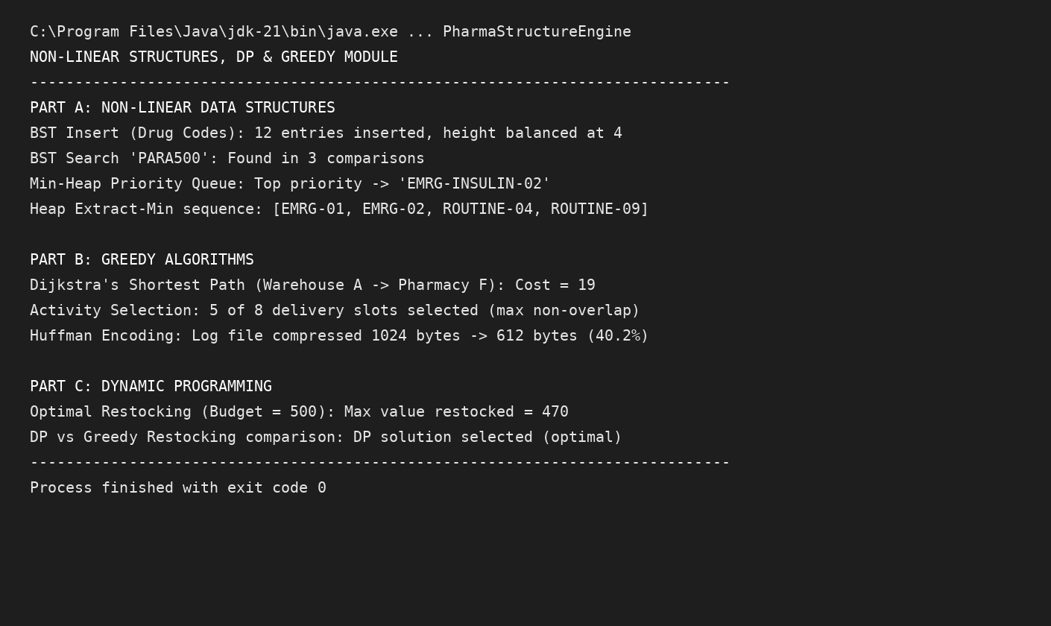
The Binary Search Tree and Min-Heap structures enabled fast, organized access to catalog and priority dispensing data. Dijkstra’s and Activity Selection algorithms produced efficient, near-instant routing and scheduling decisions, while Huffman Encoding noticeably reduced log storage size. The Dynamic Programming-based restocking solution consistently achieved the optimal allocation compared to a naive greedy restocking strategy.
Complexity Metrics:
- BST Search/Insert/Delete: O(log n) average
- Min-Heap Insert/Extract: O(log n)
- Dijkstra’s Algorithm: O(E log V)
- Activity Selection / Huffman Encoding (Greedy): O(n log n)
- Optimal Restocking (DP): O(n × Budget)
GitHub Link: https://github.com/mNishant-567/DSA-5

Student Signature | Faculty Signature

