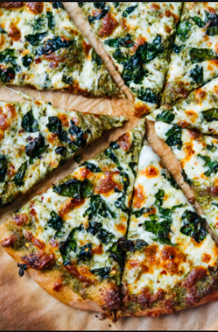

Kale Pesto Pizza

This kale pesto pizza recipe is a perfect weeknight meal! Kale lovers will appreciate the crispy kale on top, too. You can change up the toppings if you’d prefer, though! Recipe yields one large, 12-inch pizza or two smaller, 9-inch pizzas.

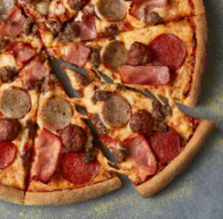

Meateor

A light portion of BBQ sauce topped with pork meatballs, ground beef, sausage, pepperoni, smoky bacon. 249kcal / large slice / classic crust.

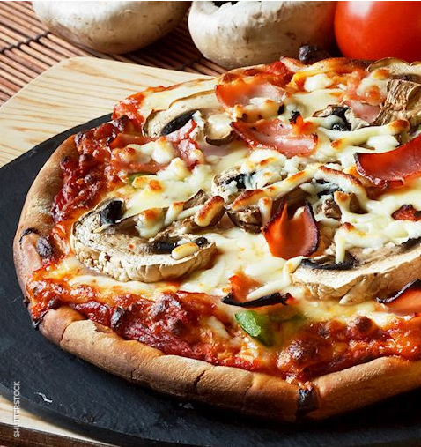

Prosciutto e funghi pizza

Prosciutto e funghi is a pizza variety that is topped with tomato sauce, mozzarella, thin slices of prosciutto cotto, and mushrooms. Some varieties can be topped with olives or served drizzled with olive oil.

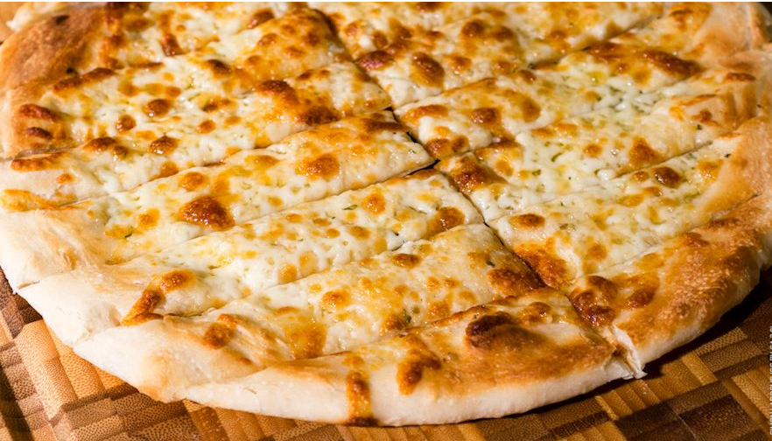

Garlic fingers

is a popular food item throughout Atlantic Canada. Even though it looks like a pizza, garlic fingers are cut in strips or fingers instead of being cut into slices like a regular pizza. The dish consists of pizza dough that is topped with cheese, garlic butter, and parsley.

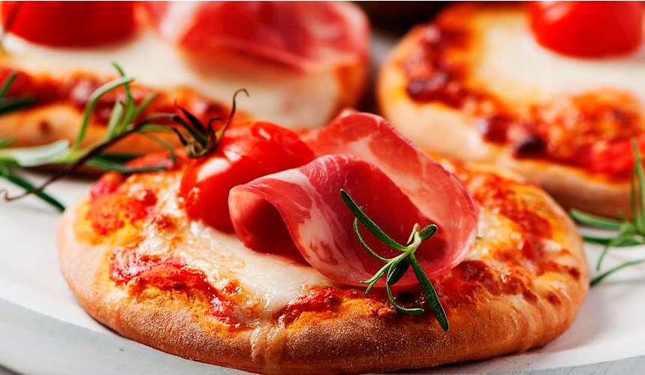

Pizzetta

Pizzetta is a small version of pizza that varies in size and shape, so some pizzettas can even be prepared in the shape of a heart. It is made in the same way as a regular, large pizza, consisting of a dough base (or puff pastry) topped with sauces, cheeses, and various additional ingredients.