主修---EXCEL MC
Name: ( ) Class:
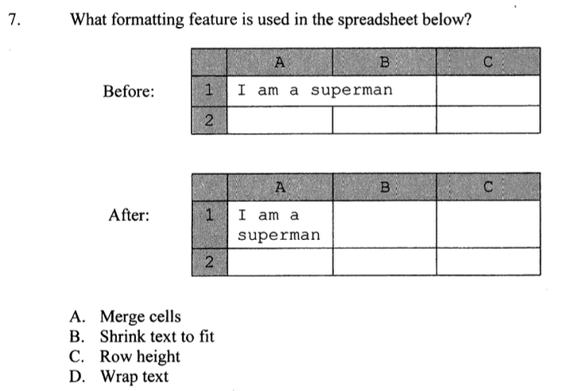
2012
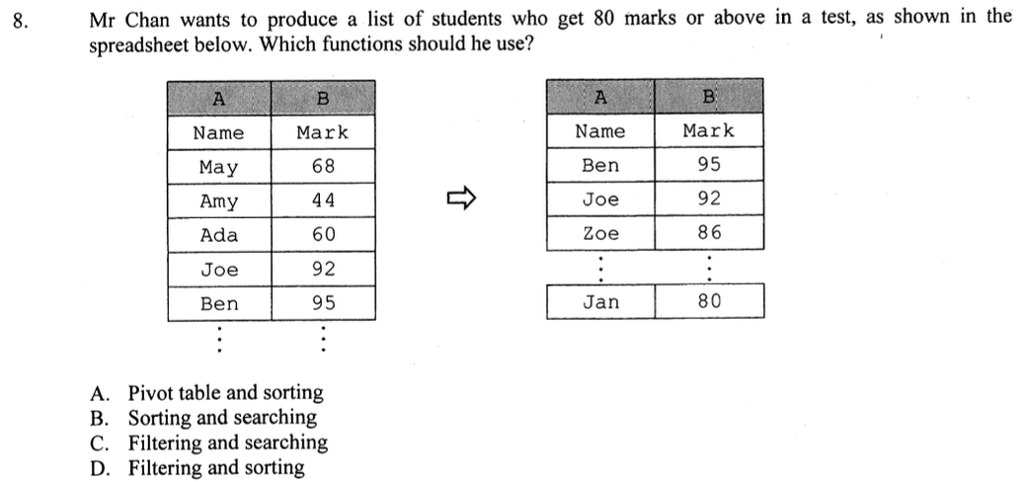

2013
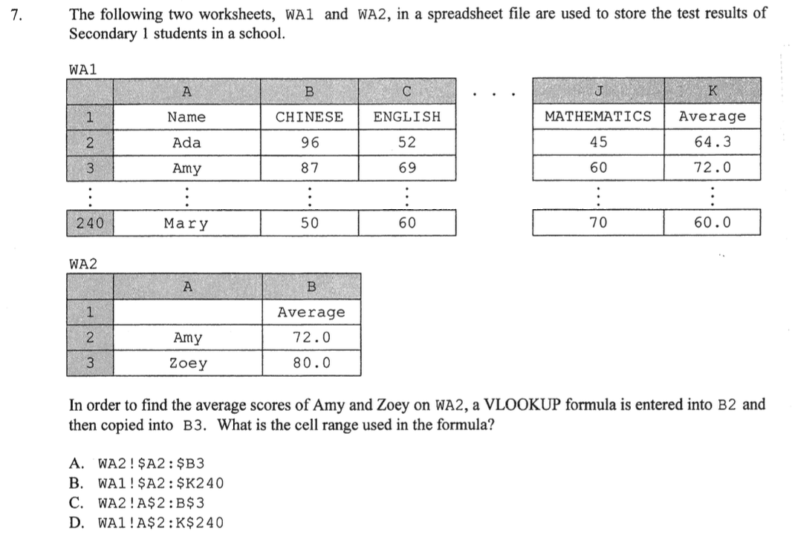
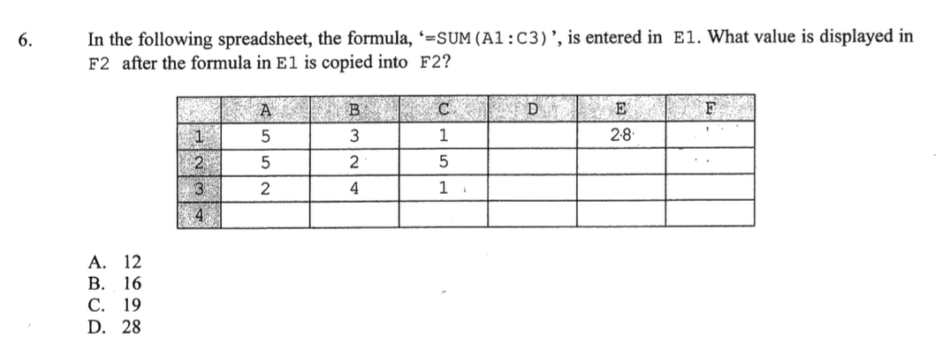
2014
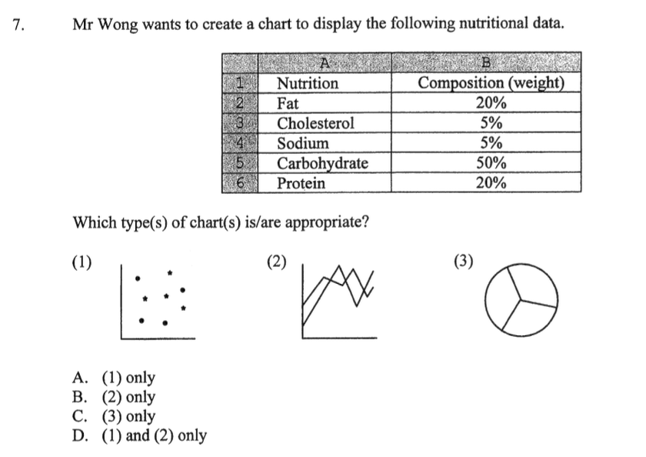
2015
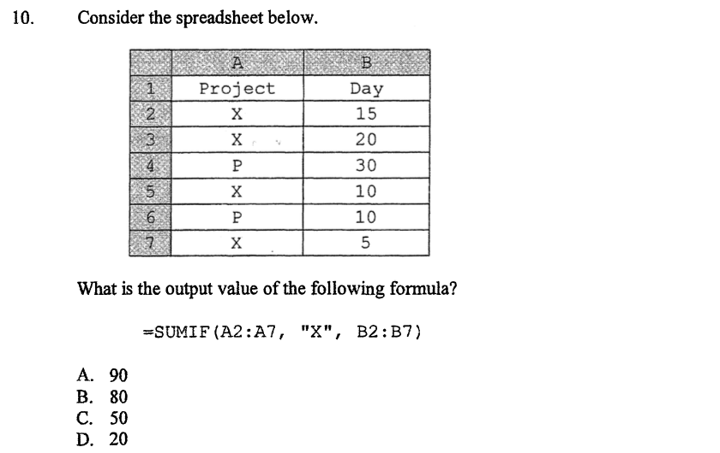

2016
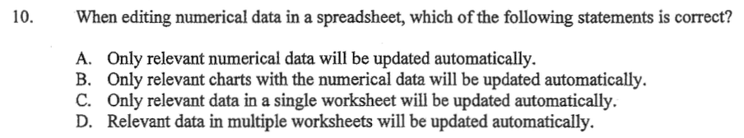
2017
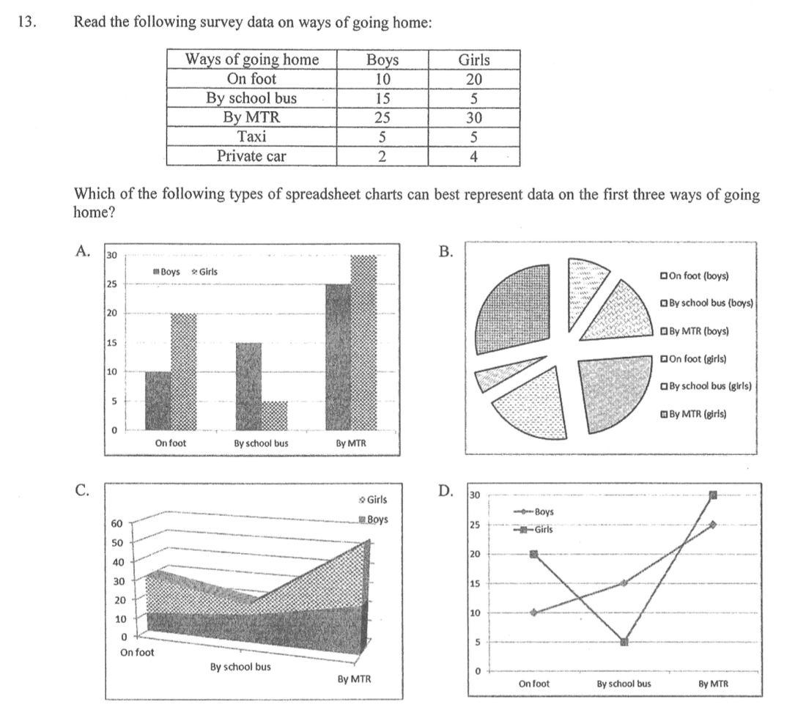
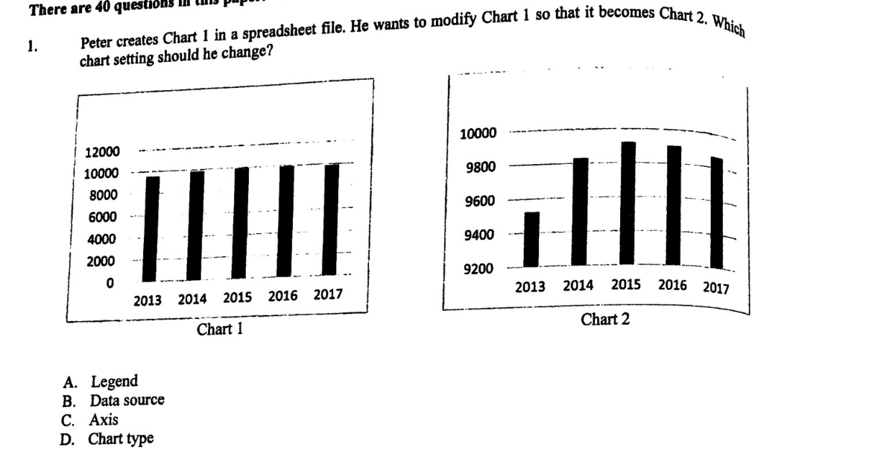
2018
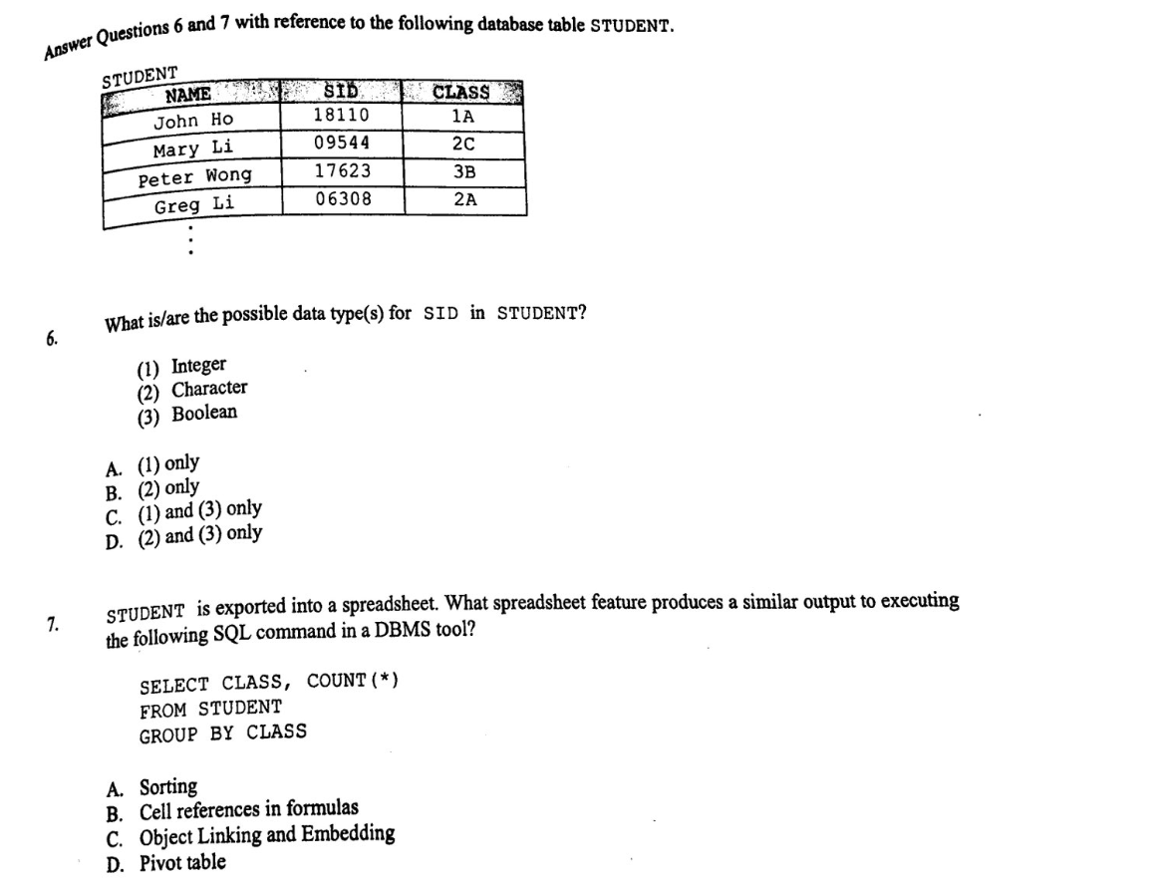
2019
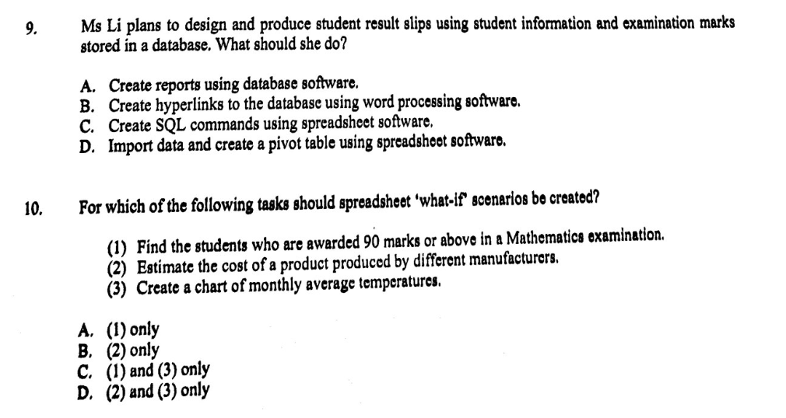
2020
2021
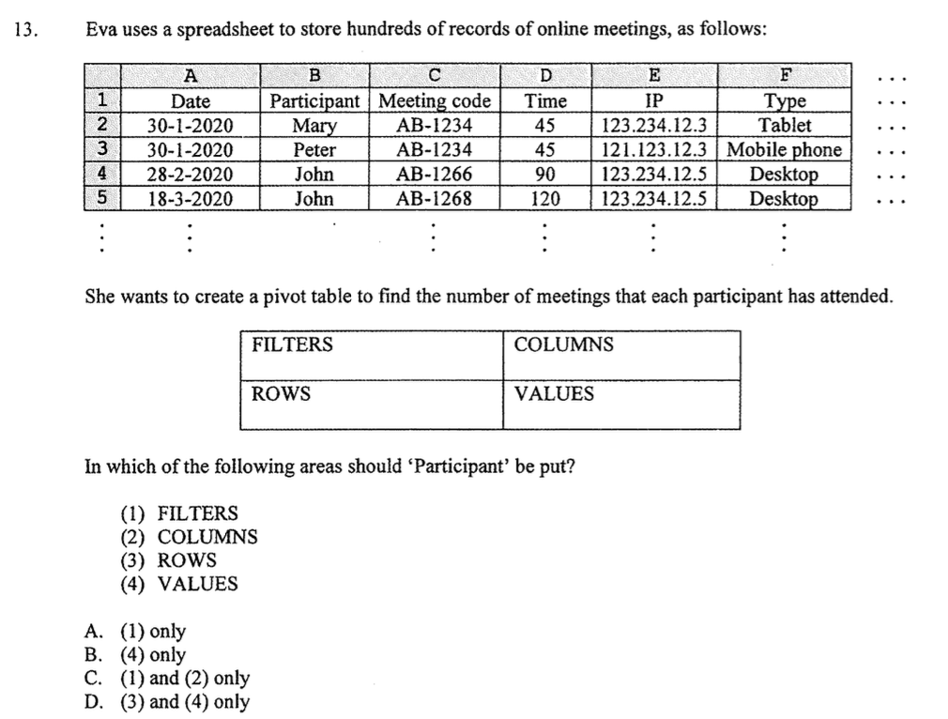
2022
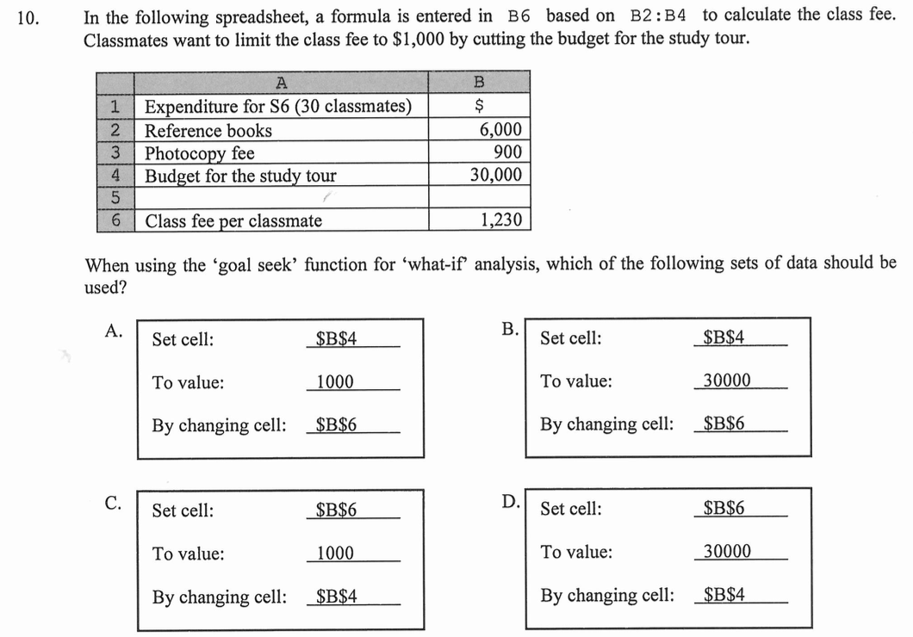
2023
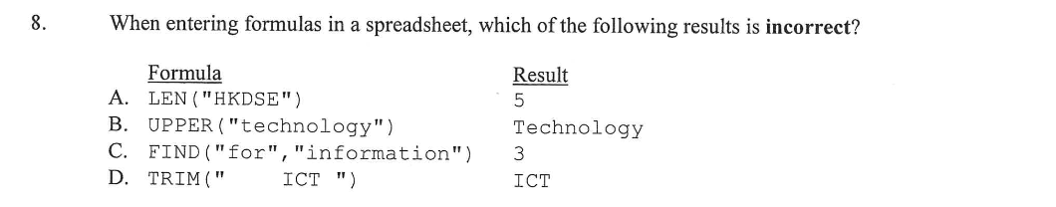
ANS
2012: 7.D (25%)、8.D (83%)
2013: 7.D (32%)
2014: 6.A (55%)、7.C (97%)
2015: 10.C (84%)
2016: 10.D (51%)
2017: 13.A (91%)
2018: 1.C (68%)
2019: 6.B (49%)、7.D (33%)
2020: 9.A (39%)、10.B (58%)
2021: 13.D (28%)
2022: 10.C (74%)
2023: 8.B (57%)

