[derekb.lowe@gmail.com](mailto:derekb.lowe@gmail.com)

<https://blogs.sciencemag.org/pipeline/about-derek-lowe>

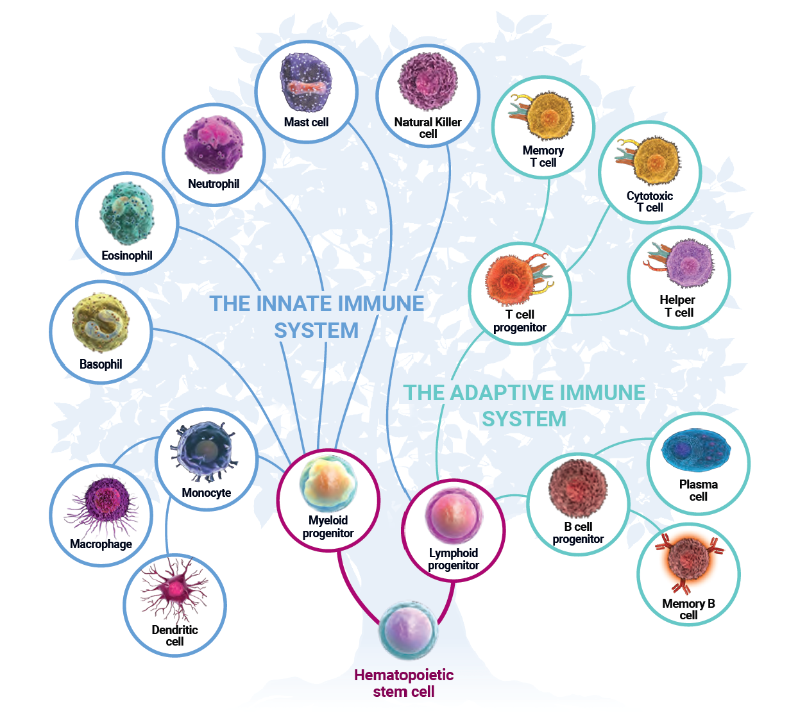

<https://www.frontiersin.org/articles/10.3389/fendo.2019.00265/full>

<https://www.creative-diagnostics.com/Autoimmunity.htm>

Email: [info@creative-diagnostics.com](mailto:info@creative-diagnostics.com)

