AMERICAN TRUCK SIMULATOR
AI Visual Hand-Tracking Steering Wheel | Complete User Manual
Zero Installation Required * Plug-and-Play Portable Edition * Full 900° Rotation * Phone Webcam Ready
------------------------------------------------------------------------

1. Quick Start in 60 Seconds (Zero Tech Hassle)
Welcome to your virtual driving cockpit! This software turns any ordinary webcam or smartphone camera into an ultra-precise, enterprise-grade truck steering wheel. You do NOT need to install Python, drivers, or any programming software. Everything is pre-bundled and configured to run straight out of the folder.
• Step 1: Extract the Zip File: Extract the downloaded 'ATS_Hand_Steering_Portable.zip' folder anywhere on your computer (for example, on your Desktop).
• Step 2: Double-Click 'run.bat': Inside the extracted folder, double-click the file named 'run.bat'. A tracking camera window with a futuristic HUD steering wheel and digital gauges will immediately pop up!
• Step 3: Launch American Truck Simulator: Open ATS. The game automatically recognizes your hand movements as a smooth, real Xbox 360 controller.
• No ATS installed yet?: No problem! Simply double-click 'play_demo.bat' to test drive an interactive 3D Highway Truck Simulation right on your laptop screen!
[ONE-TIME DRIVER TIP] First-time controller setup: If this is the very first time running the virtual controller, double-click 'install_gamepad_driver.bat' to install the official Windows ViGEmBus controller driver. It only takes 5 seconds and only needs to be done once.

2. Visual Hand Gestures Guide (Drive Like a Real Trucker)
Sit comfortably about 1.5 to 3 feet in front of your camera. Raise both hands into the air as if holding a real 14-inch truck steering wheel. The AI will instantly lock onto your hands and draw responsive neon tracking rings around them.

A. Steering & 900° Hand-Over-Hand Rotation
• Turn Left: Lower your left hand and raise your right hand. Your truck smoothly steers to the left.
• Turn Right: Lower your right hand and raise your left hand. Your truck smoothly steers to the right.
• Full 900° Enterprise Wheel Rotation: Unlike basic webcams that break when hands cross over, our Polar Tangential Torque Engine allows you to fully rotate hands 180°, 360°, and even perform hand-over-hand hairpin turns smoothly!
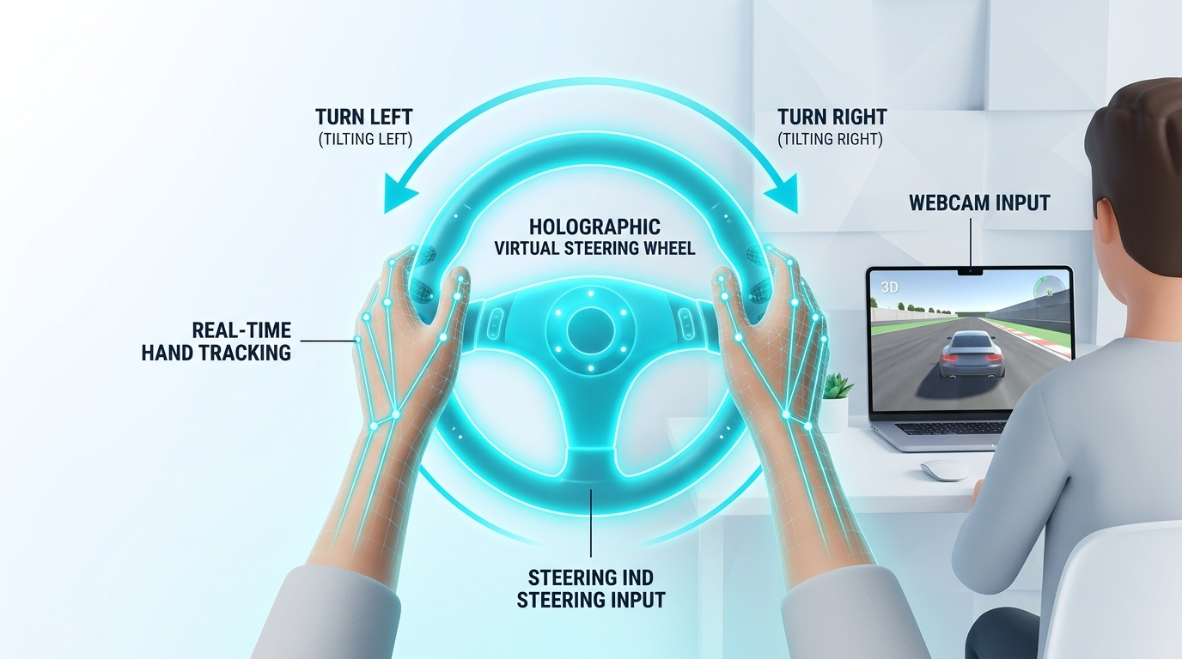
Figure 1: Natural Steering Grip & Full Hand-Over-Hand Continuous Wheel Rotation

B. Dynamic Pedals (Pinch to Accelerate & Brake)
You don't need physical floor pedals! Use intuitive finger pinches (bringing your thumb tip and index fingertip together):
1. Right Hand Pinch = GAS (Accelerator): Pinch your right thumb and index finger together. The closer your fingers touch, the more throttle your truck delivers (0% to 100% analog response). Open your fingers to release the gas pedal.
2. Left Hand Pinch = BRAKE / REVERSE: Pinch your left thumb and index finger together. Your truck firmly applies the brakes. When stopped, holding this pinch engages reverse gear.
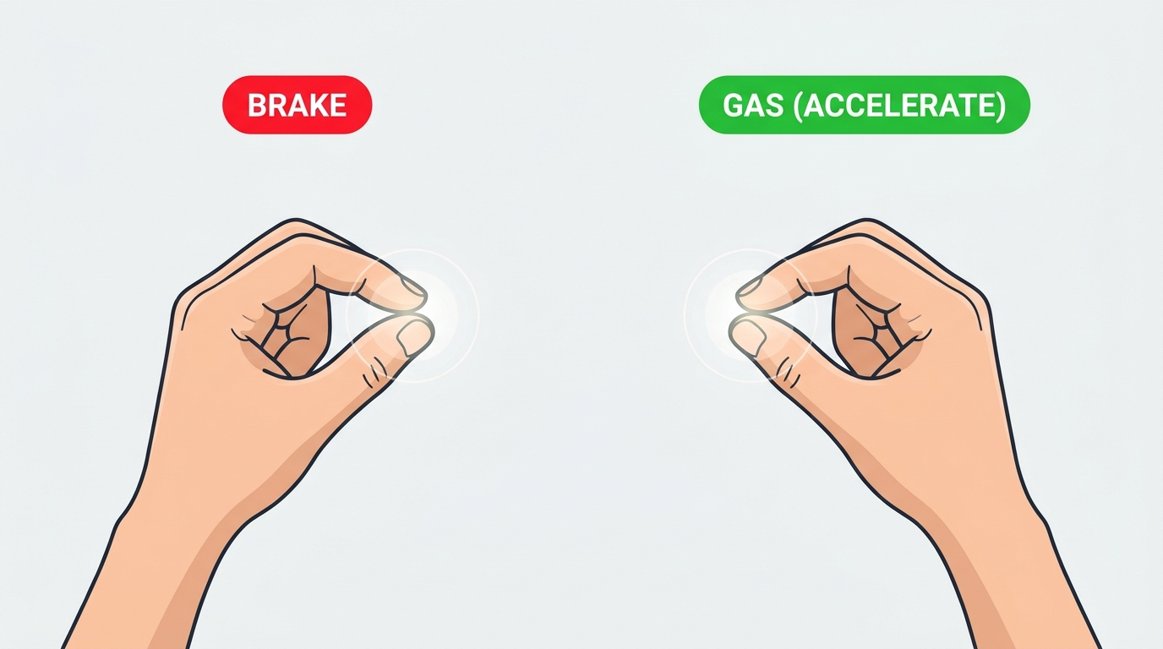
Figure 2: Analog Throttle & Brake Pedals via Micro-Pinch Gesture

C. Honking the Horn & Turn Indicators (Blinkers)
• Honk Truck Horn (H): Just like hitting the center of a real steering wheel, push either hand forward toward the virtual center horn button. A loud truck horn honk triggers in ATS, and the on-screen HUD flashes 'HORN ACTIVE' in bright amber!
• Turn Blinkers ([ and ]): Flick your left index/thumb outward to toggle your Left Turn Signal. Flick your right index/thumb outward to toggle your Right Turn Signal. The dashboard indicators will flash with audio clicks in ATS!
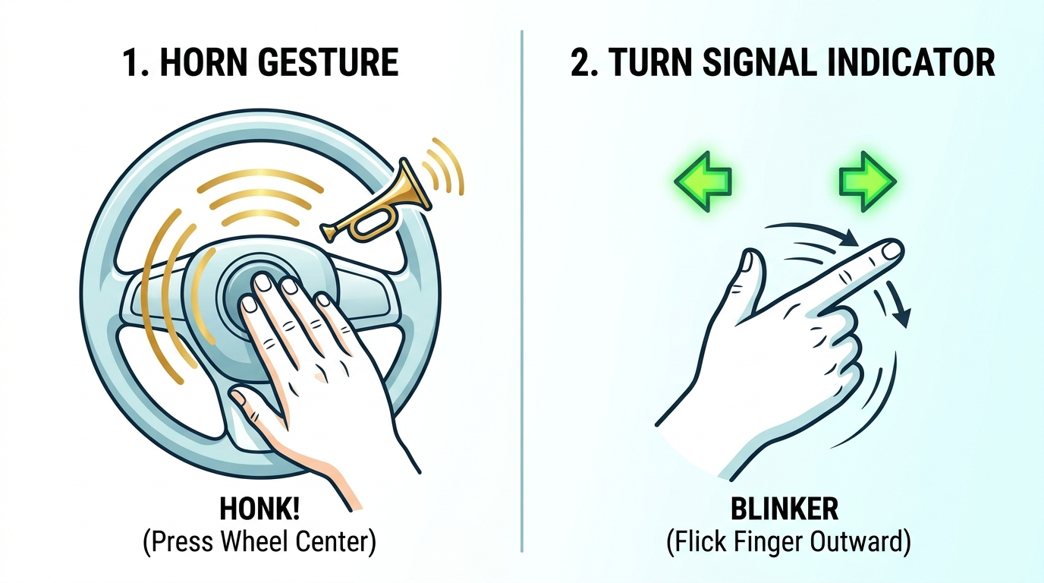
Figure 3: Interactive Horn Center Push and Outward Turn Signal Gestures

3. Using Your Phone as a Webcam (High-Speed & Zero Latency)
If your gaming laptop doesn't have a webcam, or if you want superior 60 FPS video tracking quality, use your Android or iPhone! Phone cameras have exceptional clarity and ultra-wide lenses perfect for hand tracking.
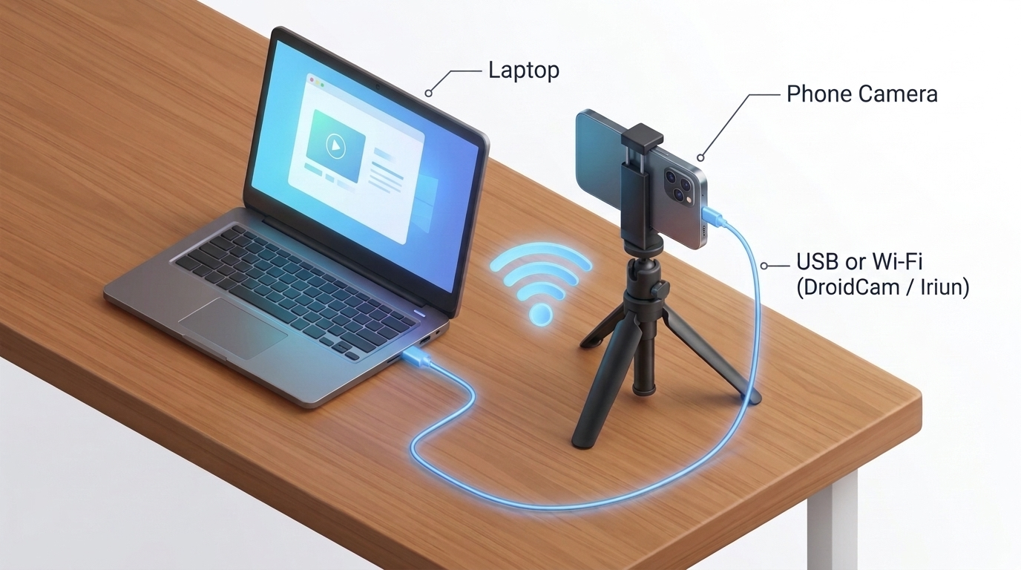
Figure 4: Gaming Laptop & Smartphone Camera Setup (USB or Wi-Fi)
• Method A: DroidCam (Recommended - 60 FPS USB)
1. Install free 'DroidCam' on your phone (Google Play Store / Apple App Store).
2. Install the free DroidCam Windows client on your PC.
3. Connect your phone with a USB charging cable and select 'USB' in DroidCam.
4. Double-click 'run.bat' - the hand tracker automatically detects and uses DroidCam immediately!
• Method B: Iriun 4K Webcam (Alternative)
1. Install 'Iriun Webcam' on phone and PC.
2. Connect both to the same home Wi-Fi network (or via USB cable).
3. The camera appears as Camera Index 0 or 1 seamlessly.
• Method C: IP Webcam (Direct Network Stream)
If using the popular 'IP Webcam' app on Android:
1. Tap 'Start Server' at the bottom of the app on your phone.
2. Note the Wi-Fi IP address shown on the phone (e.g., http://192.168.1.15:8080/video).
3. Open 'config.py' in Notepad and set PHONE_STREAM_URL = 'http://192.168.1.15:8080/video'.
4. Save and run 'run.bat'!

4. Playing in American Truck Simulator (Single Screen / PiP Mode)
Do you have only one monitor or laptop screen? Here is how to play ATS with your camera HUD visible at all times:
• Step 1: In ATS Graphics Settings, set Display to 'Borderless Window': In American Truck Simulator, open Options -> Graphics -> Set Display Mode to 'Borderless Window' (or Fullscreen Window).
• Step 2: Press [O] to switch to Compact PiP (Picture-in-Picture) Overlay: When running 'run.bat', press the 'O' key on your keyboard. The tracking window instantly transforms into a sleek, semi-transparent 320x240 Always-On-Top Mini PiP floating in the top-right corner of your screen!
• Step 3: Play Seamlessly: ATS will fill your entire display, and your live hand tracking HUD will float right above your truck windscreen like a real digital cockpit rearview mirror!

5. Interactive Highway Simulator Demo (No ATS Needed!)
Want to test your hand driving skills before installing ATS? We built a full standalone highway simulator directly into the app!
1. Double-click play_demo.bat.
2. A realistic highway appears with road perspective, speed lines, 12-speed truck transmission, dashboard gauges, and dynamic steering response.
3. Steer, pinch to accelerate to 70 MPH, brake, honk the horn with [H], and signal lane changes with [ [ ] and [ ] ]!

6. Complete Controls & Hotkey Quick Reference
Action | Hand Gesture | In-Game Binding | Screen Indicator
Steer Left / Right | Tilt hands or rotate hand-over-hand (900°) | Xbox Left Joystick X | Rotating wheel angle (°), Bar
Accelerate (Gas) | Right hand Thumb + Index Pinch | Xbox Right Trigger (RT) | GAS: 0% -> 100% green gauge
Brake / Reverse | Left hand Thumb + Index Pinch | Xbox Left Trigger (LT) | BRAKE: 0% -> 100% red gauge
Honk Horn | Push either hand towards center | Key [H] (Air Horn [N]) | Bright Amber 'HORN' alert
Left Turn Blinker | Flick Left Thumb outward | Key [ [ ] | Green Left Blinker <<
Right Turn Blinker | Flick Right Thumb outward | Key [ ] ] | Green Right Blinker >>
Mini PiP Overlay | Press keyboard key [O] | Window Toggle | Shrinks / Expands Always-on-Top HUD
Reset Wheel Center | Press keyboard key [R] | Recalibrate Center | Re-centers wheel angle to 0°
Switch Engine Mode | Press keyboard key [M] | Tracker Mode | Standard <-> Enterprise 900°
Quit Application | Press keyboard key [Q] or [ESC] | Exit | Gracefully closes tracking

7. Troubleshooting & FAQs
Q: The camera doesn't detect my hands or loses them frequently.
A: Make sure your room has good lighting in front of you. Avoid having a bright window directly behind your back. Sit 1.5 to 3 feet from the lens with your hands clearly visible in the camera frame.
Q: ATS does not turn when I move my hands.
A: In American Truck Simulator -> Options -> Controls, check that the top input box says 'Keyboard + Controller (Xbox 360 For Windows)'. If you don't see it, run 'install_gamepad_driver.bat' inside the folder and restart ATS.
Q: Steering feels too fast or too slow.
A: You can adjust steering sensitivity in two ways:
1. Inside ATS: Go to Options -> Controls -> adjust 'Steering Sensitivity' and 'Steering Non-Linearity' sliders.
2. In config.py: Open 'config.py' with Notepad and change STEERING_SENSITIVITY = 1.0 (higher = faster, lower = slower).
Q: How do I switch camera if I have multiple webcams?
A: Open 'config.py' in Notepad and set CAMERA_INDEX = 1 (or 2). If using an IP Webcam stream, paste your phone's URL into PHONE_STREAM_URL = 'http://192.168.1.XX:8080/video'.

Happy Trucking & Safe Hauling on American Highways! Enjoy your new hand-tracking steering wheel!

