Israel Bejar

May 8 2024

**Sprint 1 Assignment**

Team board links: <https://itm350scrumteam4.atlassian.net/jira/software/projects/IST4/boards/1>

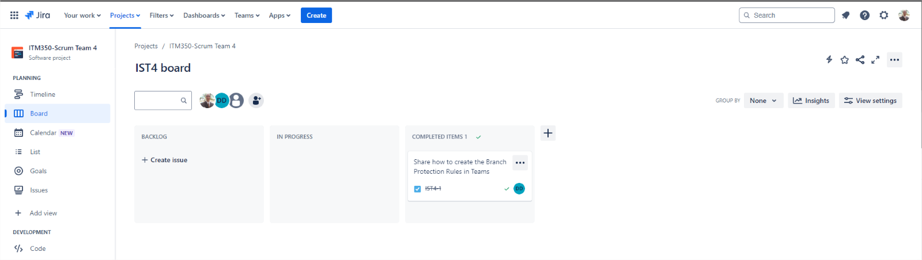

A link to your personal repo

<https://github.com/JesusBejar/itm350-Jesus-test>

A link to your team repo

<https://github.com/JesusBejar/itm-Group4-bb>

A screenshot of the branch protection rules checked off

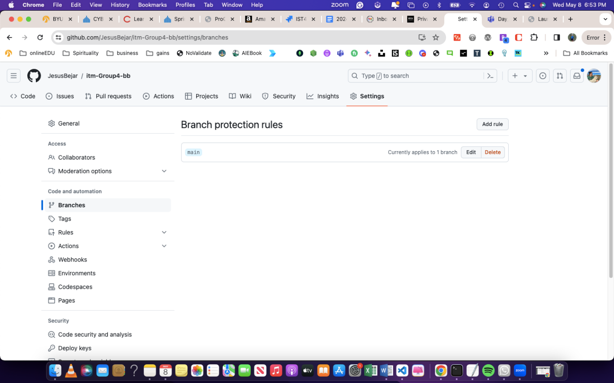

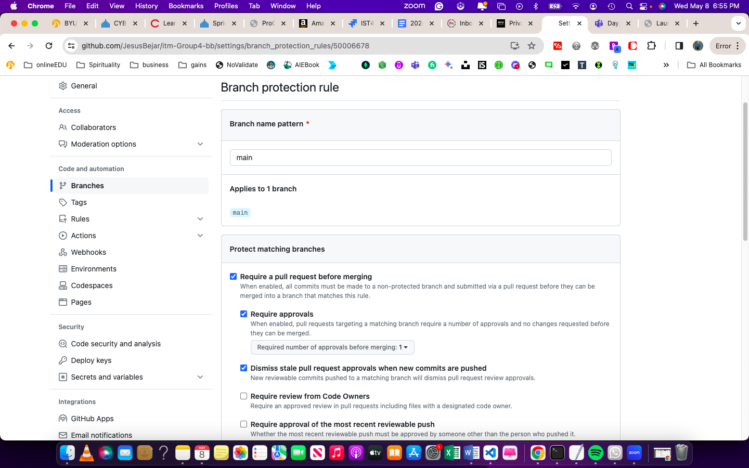

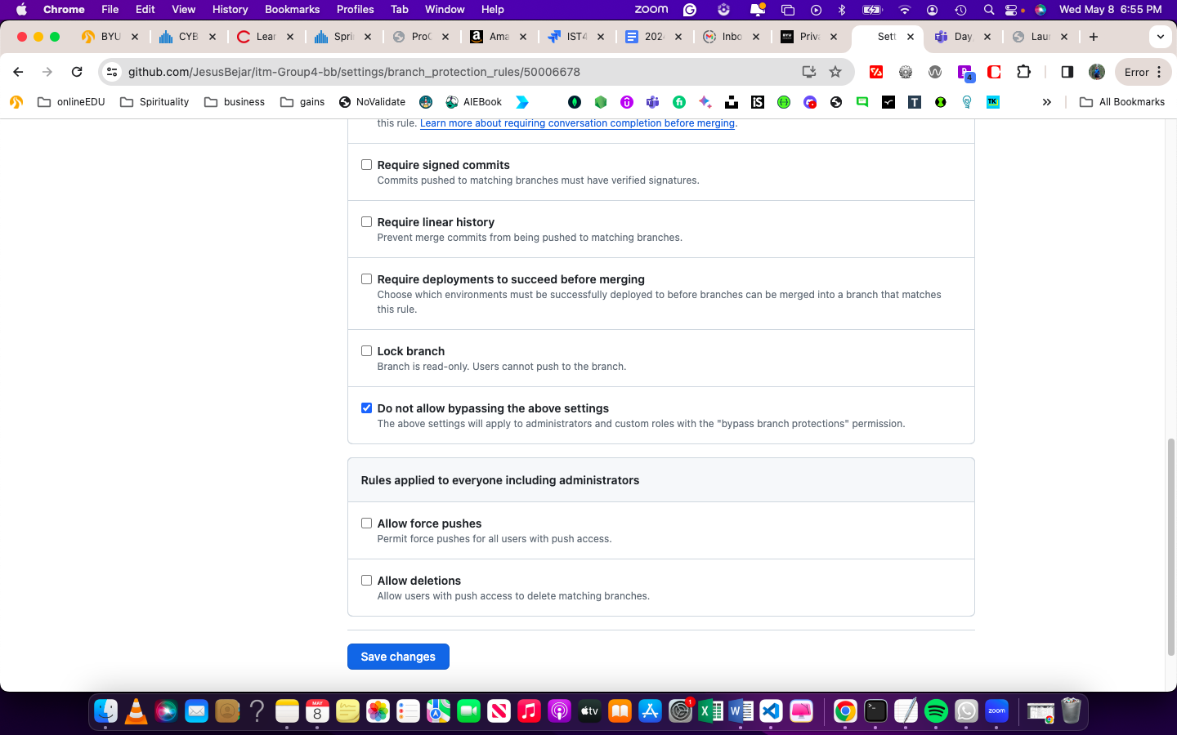

A screenshot of your merged pull request

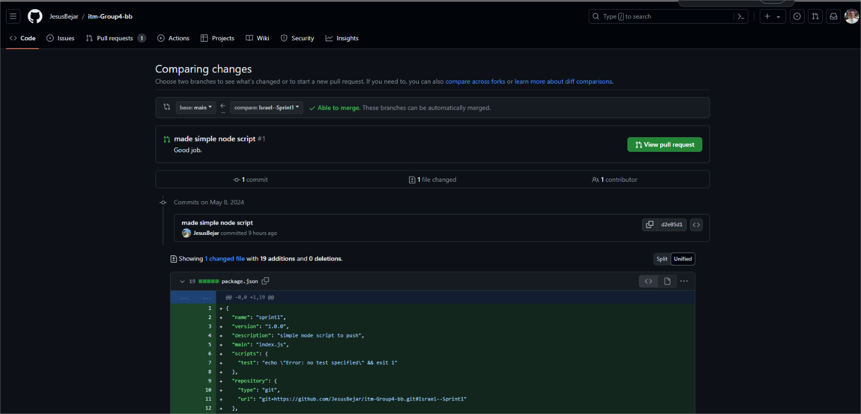

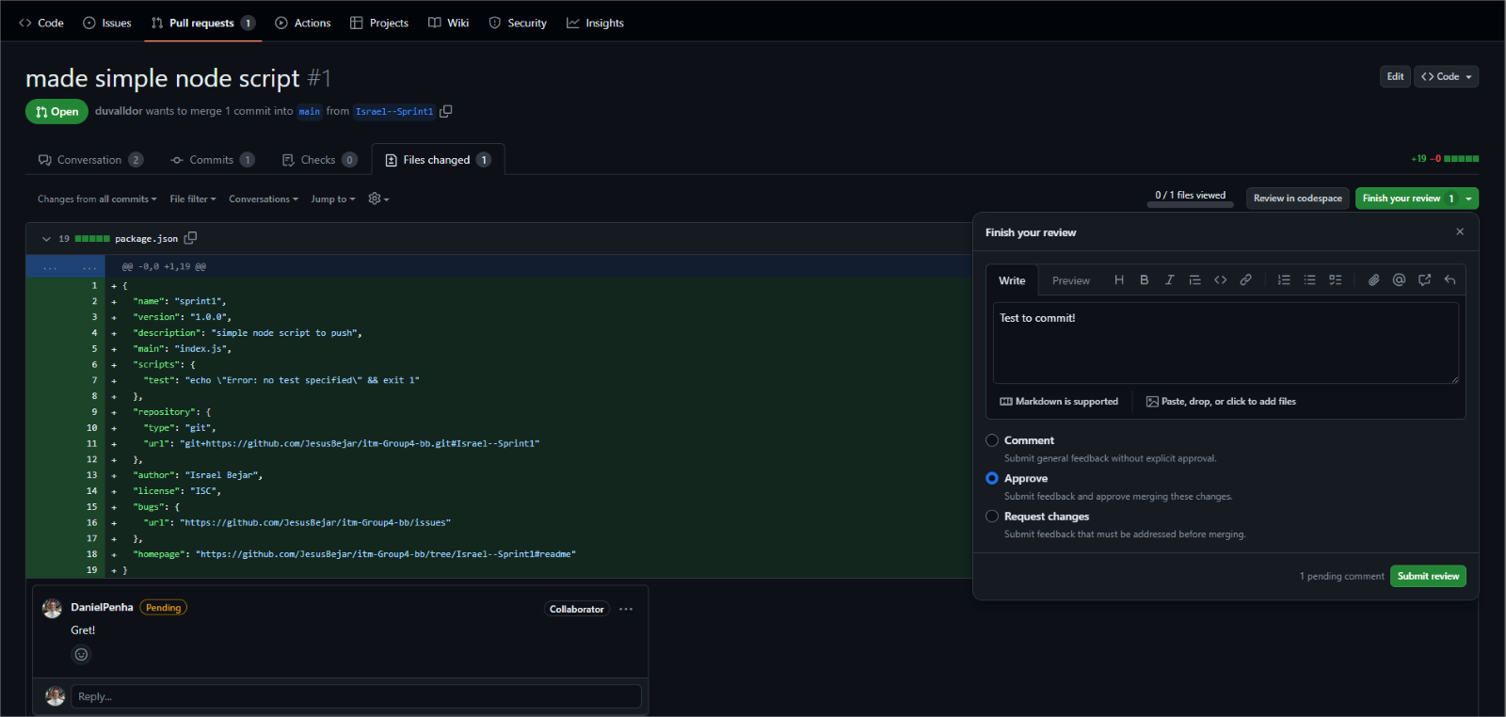

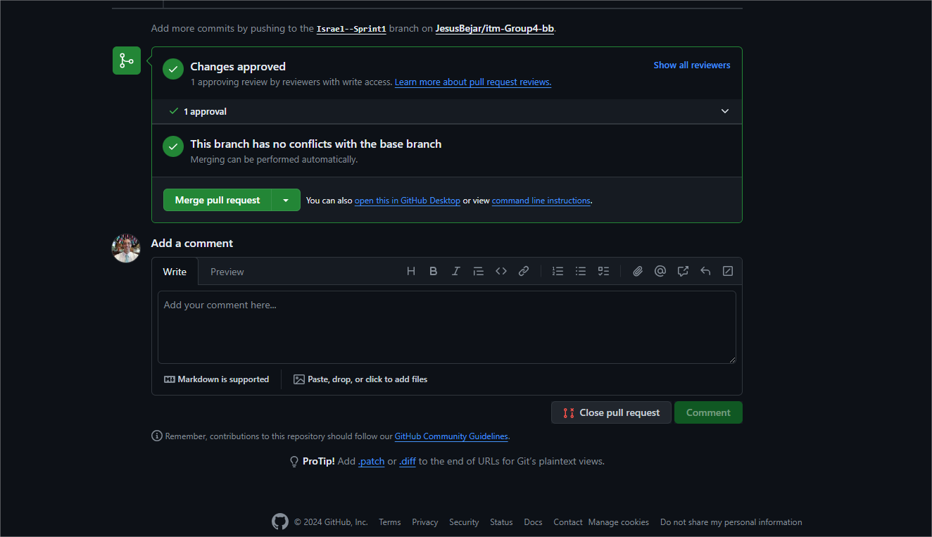

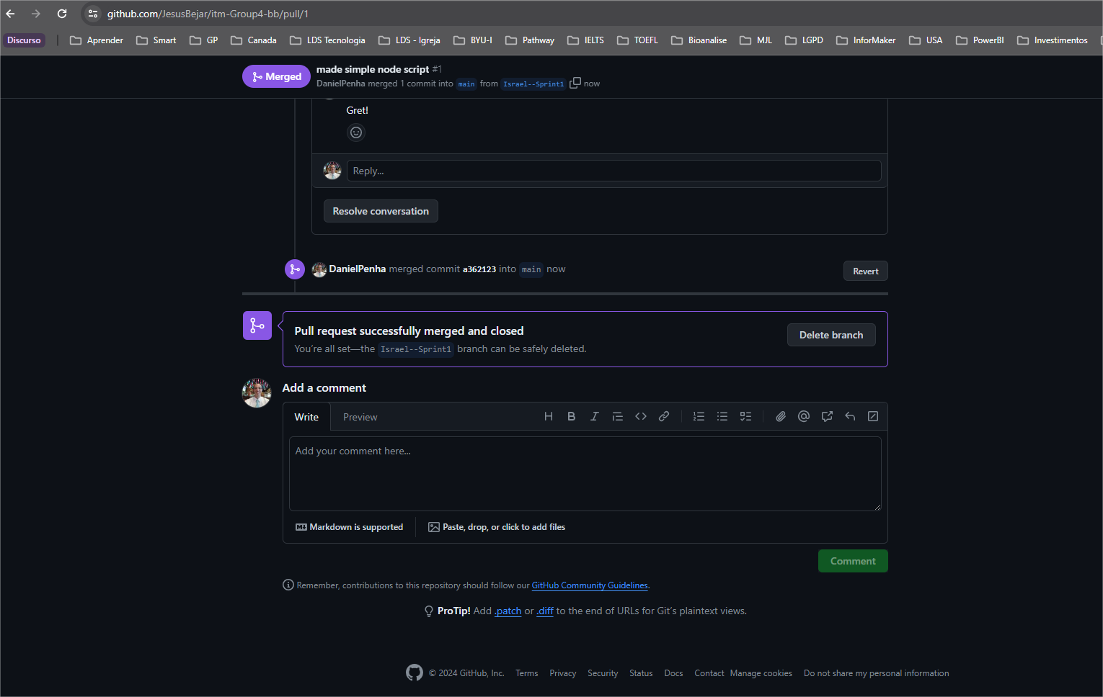

A screenshot of your terminal with the node --version and npm --version commands run

