1. IS 69.280000E-18

BF 308.6

VAF 100

CJE 939.8E-15

CJC 893.100000E-15

PT VBE=0.7

IB 5.84E-07

IC 4.13E-05

VCE 6.00E+00

2.

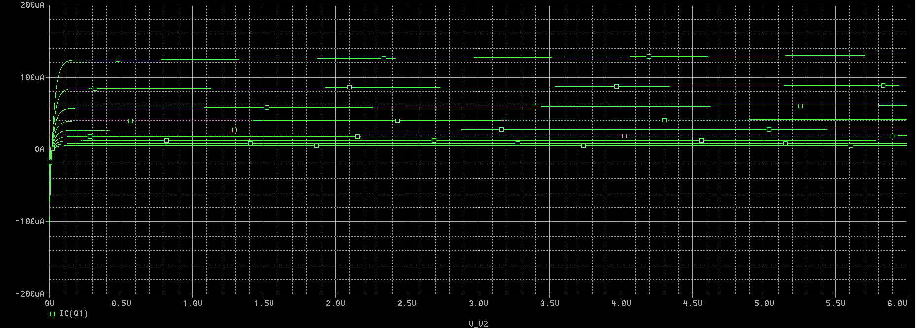3.

- Caracteristicile sunt distantate exponential pe verticala

- In punctul de tensiune Early VA

- Ic=b\*Is(1+Vce/Va)\*e^(Vbe/Vt)

4.

Vce1=1.5V;

Ic1=125.589\*10^-6 A

Vce2=3V

Ic2=127.467\*10^-6 A

R0=ΔVce/ΔIc=(Vce2-Vce1)/(Ic2-Ic1)=(1.5/1.878)\* 10^6=0.799 MΩ

VA=(Vce2\*Ic1-Vce1\*Ic2)/(Ic2-Ic1)=(3\*125.589\*10^-6 -1.5\*127.467\*10^-6)/1.878=(185.566/1.878) \*10^-6=98.810\*10^-6 V

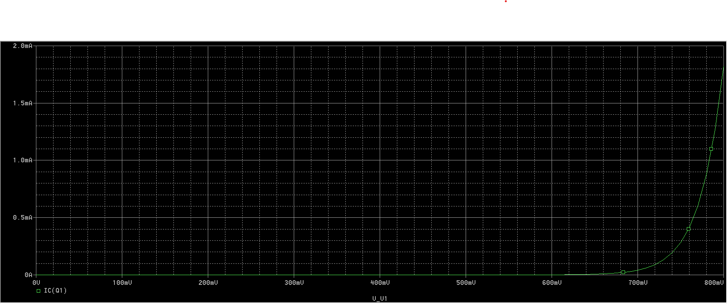

5.

Gm=(Ic2-Ic1)/(Vbe2-Vbe1)=Ic / Vt=40 Ic(mA/V)

-este o exponentiala