**結合知識檢索來進行心理健康狀況檢測(The Detection of Mental Health Conditions by Incorporating Knowledge Retrieval)**

動機

心理健康狀況的問題日益嚴重，不但患者本身面臨巨大的風險，同時也為全球帶來極高的經濟負擔[1-4]。一些研究顯示，如果患者可以被及早發現，將可以減少精神疾病對我們社會的影響，並降低經濟成本[5, 6]。所以如何盡早偵測到心理疾病就成為很關鍵的課題。而近年來越來越普及且貼近人們生活的社群媒體，就成為研究者們常用來預測心理健康狀況的資料來源[7-9]。然而，過去的研究多只著重於使用者在社群媒體上發布的內容[10, 11]，但醫生判斷精神疾病還會依靠專業的知識和測驗工具[12, 13]。所以本研究希望能藉由導入這些工具和知識，來有效的提升模型對於心理健康狀況的預測效能。

相關研究

近年來有許多研究收集了來自社群媒體上的大量資料，其中Cohan等人[14]利用了正則表示，自動且大量的收集自我報告確診的用戶資料，共有九個類別，並為這些確診用戶找到相應的控制用戶。這讓我們能夠藉由這個資料集，來驗證我們的方法。過去有許多研究都著重於改善模型的架構[15, 16]，或藉由使用社群媒體上不同的資料型態[10, 11, 17-19]，來提升模型對疾病的預測能力。但在其他的領域中，早就有研究藉由引入外部的知識[20, 21]，來提升模型的效果。而Meta AI團隊更是在預訓練語言模型的基礎上，開發出Dense Passage Retrieval (DPR)[22]這個能有效檢索相關知識的方法，並且在問答和生成的領域裡[23]，都獲得非常優秀的結果。

方法

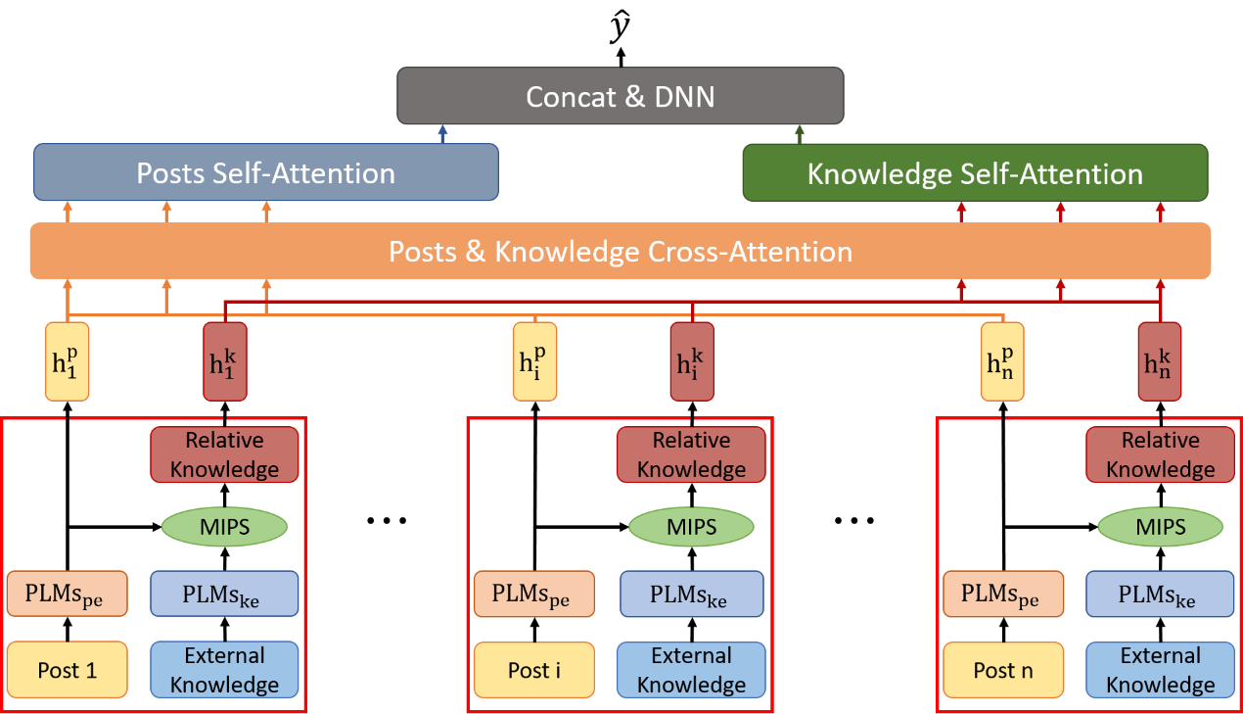

我們從心理健康的檢測工具、維基百科心理健康相關的條目、以及心理健康的權威書籍DSM-5[13]中收集心理健康相關的外部知識的片段。並在此之上，我們使用大量且不設限的維基百科資料，當成普通常識，來測試加上普通常識能否提升心理健康狀況的預測。我們藉由預訓練語言模型來特徵提取使用者發文和外部知識片段的高維表示，並使用DPR[22]來檢索與使用者發文相關的外部知識。DPR是利用發文內容與知識片段的高維表示間的內積，來計算出兩者之間的相似度，並最終獲得與發文內容相關的知識片段。找到相關的知識片段後，使用幾種經典的注意力機制[24]，來建構我們的深度學習模型。我們對於資料集中的九種精神健康狀況，都使用二元分類的方式對每種心理健康狀況進行預測，最後可以得到每個用戶是否患有該心理健康狀況的結果。

實驗

我們與過去的研究[14, 25]的F1分數進行比較，並在所有心理健康狀況的預測上，都超越了過去研究的實驗結果。結果如同表一所示，在表中我們可以發現到，單純使用預訓練語言模型來對發文內容進行特徵提取，並且加上注意力機制，就已經能夠打敗過去研究的模型效能。而引入心理相關的知識片段，則可以更進一步的提升模型的效能。最終在思覺失調症的預測上，比過去最好的結果高出了10%以上，即使扣除預訓練語言模型的影響，也高出將近3%。這個結果顯示，引入心理相關的知識可以有效的提升心理健康狀況的預測，這對於提早偵測心理疾病這個任務，是一個很有意義的結果。

|  |  |  |  |  |  |  |  |  |  |
| --- | --- | --- | --- | --- | --- | --- | --- | --- | --- |
|  | Depress. | ADHD | Anxiety | Bipolar | PTSD | Autism | OCD | Schizo. | Eating |
| LR | 59.00 | 51.02 | 62.34 | 61.87 | 69.34 | **55.57** | **59.49** | 56.31 | 70.71 |
| SVM | 58.64 | 50.08 | 61.69 | 61.30 | **69.91** | 55.35 | 58.56 | **57.43** | **70.91** |
| FastText | 58.38 | 48.80 | 60.17 | 56.53 | 61.08 | 49.52 | 54.16 | 46.73 | 63.73 |
| HAN | **68.28** | **64.27** | **69.24** | **67.42** | 68.59 | 53.09 | 58.51 | 53.68 | 63.94 |
| Only_Post | **68.34** | **64.50** | **69.65** | **68.71** | **73.77** | **62.05** | **67.13** | **65.75** | **72.16** |
| +TK | 68.50 | 61.89 | 68.84 | 67.10 | 72.61 | 60.59 | 62.41 | 63.68 | 69.46 |
| +PK | 68.86 | 63.05 | 69.10 | 69.59 | 72.19 | 61.53 | 65.54 | 64.90 | 71.86 |
| +TK +S | 69.86 | 63.45 | 70.12 | 68.91 | 72.17 | 60.46 | 65.62 | 63.72 | 69.48 |
| +PK +S | **70.73** | 65.03 | **71.04** | 69.70 | 74.12 | 61.77 | **67.28** | 66.26 | **74.91** |
| +PK +C | 69.67 | **65.59** | 70.91 | **70.83** | **75.69** | **62.97** | 66.80 | **68.17** | 72.99 |

1. World Health Organization, The WHO special initiative for mental health (2019-2023): universal health coverage for mental health. 2019, World Health Organization.

2. World Health Organization, Comprehensive mental health action plan 2013–2030. 2021, World Health Organization,, .

3. Z. Steel, C. Marnane, C. Iranpour, T. Chey, J. W. Jackson, V. Patel, and D. Silove, The global prevalence of common mental disorders: a systematic review and meta-analysis 1980-2013*.* Int J Epidemiol, 2014. **43**(2): p. 476-93.

4. V. Patel, S. Saxena, C. Lund, G. Thornicroft, F. Baingana, P. Bolton, D. Chisholm, P. Y. Collins, J. L. Cooper, J. Eaton, H. Herrman, M. M. Herzallah, Y. Huang, M. J. D. Jordans, A. Kleinman, M. E. Medina-Mora, E. Morgan, U. Niaz, O. Omigbodun, M. Prince, A. Rahman, B. Saraceno, B. K. Sarkar, M. De Silva, I. Singh, D. J. Stein, C. Sunkel, and J. UnUtzer, The Lancet Commission on global mental health and sustainable development*.* Lancet, 2018. **392**(10157): p. 1553-1598.

5. V. Bird, P. Premkumar, T. Kendall, C. Whittington, J. Mitchell, and E. Kuipers, Early intervention services, cognitive-behavioural therapy and family intervention in early psychosis: systematic review*.* Br J Psychiatry, 2010. **197**(5): p. 350-6.

6. J. Treasure and G. Russell, The case for early intervention in anorexia nervosa: theoretical exploration of maintaining factors*.* Br J Psychiatry, 2011. **199**(1): p. 5-7.

7. Glen Coppersmith, Mark Dredze, Craig Harman, and Kristy Hollingshead. From ADHD to SAD: Analyzing the language of mental health on Twitter through self-reported diagnoses. in *Proceedings of the 2nd workshop on computational linguistics and clinical psychology: from linguistic signal to clinical reality*. 2015.

8. Sean Macavaney, Anjali Mittu, Glen Coppersmith, Jeff Leintz, and Philip Resnik. Community-level research on suicidality prediction in a secure environment: Overview of the CLPsych 2021 shared task. in *Proceedings of the Seventh Workshop on Computational Linguistics and Clinical Psychology: Improving Access*. 2021.

9. Adrian Benton, Margaret Mitchell, and Dirk Hovy. Multitask Learning for Mental Health Conditions with Limited Social Media Data. in *Proceedings of the 15th Conference of the European Chapter of the Association for Computational Linguistics: Volume 1, Long Papers*. 2017.

10. Tao Gui, Liang Zhu, Qi Zhang, Minlong Peng, Xu Zhou, Keyu Ding, and Zhigang Chen. Cooperative multimodal approach to depression detection in twitter. in *Proceedings of the AAAI conference on artificial intelligence*. 2019.

11. Guangyao Shen, Jia Jia, Liqiang Nie, Fuli Feng, Cunjun Zhang, Tianrui Hu, Tat-Seng Chua, and Wenwu Zhu. Depression detection via harvesting social media: A multimodal dictionary learning solution. in *IJCAI*. 2017.

12. James N Butcher, John R Graham, Yossef S Ben-Porath, Auke Tellegen, WG Dahlstrom, and Beverly Kaemmer, MMPI-2: Manual for administration, scoring, and interpretation (Rev. ed.)*.* Minneapolis, MN: University of Minnesota, 2001.

13. American Psychiatric Association, Diagnostic and Statistical Manual of Mental Disorders. 5th ed. 2013, Washington, DC.

14. Arman Cohan, Bart Desmet, Andrew Yates, Luca Soldaini, Sean MacAvaney, and Nazli Goharian. SMHD: a Large-Scale Resource for Exploring Online Language Usage for Multiple Mental Health Conditions. in *Proceedings of the 27th International Conference on Computational Linguistics*. 2018.

15. Zheng Ping Jiang, Sarah Ita Levitan, Jonathan Zomick, and Julia Hirschberg. Detection of mental health from reddit via deep contextualized representations. in *Proceedings of the 11th International Workshop on Health Text Mining and Information Analysis*. 2020.

16. Ankit Murarka, Balaji Radhakrishnan, and Sushma Ravichandran. Classification of mental illnesses on social media using RoBERTa. in *Proceedings of the 12th International Workshop on Health Text Mining and Information Analysis*. 2021.

17. Munmun De Choudhury, Michael Gamon, Scott Counts, and Eric Horvitz. Predicting depression via social media. in *Seventh international AAAI conference on weblogs and social media*. 2013.

18. Glen Coppersmith, Mark Dredze, and Craig Harman. Quantifying mental health signals in Twitter. in *Proceedings of the workshop on computational linguistics and clinical psychology: From linguistic signal to clinical reality*. 2014.

19. Andrew G Reece and Christopher M Danforth, Instagram photos reveal predictive markers of depression*.* EPJ Data Science, 2017. **6**(1): p. 15.

20. Marjan Ghazvininejad, Chris Brockett, Ming-Wei Chang, Bill Dolan, Jianfeng Gao, Wen-tau Yih, and Michel Galley. A knowledge-grounded neural conversation model. in *Proceedings of the AAAI Conference on Artificial Intelligence*. 2018.

21. Dongfang Li, Baotian Hu, Qingcai Chen, Weihua Peng, and Anqi Wang. Towards medical machine reading comprehension with structural knowledge and plain text. in *Proceedings of the 2020 conference on empirical methods in natural language processing (EMNLP)*. 2020.

22. Vladimir Karpukhin, Barlas Oguz, Sewon Min, Patrick Lewis, Ledell Wu, Sergey Edunov, Danqi Chen, and Wen-tau Yih. Dense Passage Retrieval for Open-Domain Question Answering. in *Proceedings of the 2020 Conference on Empirical Methods in Natural Language Processing (EMNLP)*. 2020.

23. Patrick Lewis, Ethan Perez, Aleksandra Piktus, Fabio Petroni, Vladimir Karpukhin, Naman Goyal, Heinrich Küttler, Mike Lewis, Wen-tau Yih, and Tim Rocktäschel, Retrieval-augmented generation for knowledge-intensive nlp tasks*.* Advances in Neural Information Processing Systems, 2020. **33**: p. 9459-9474.

24. A. Vaswani, N. Shazeer, N. Parmar, J. Uszkoreit, L. Jones, A. N. Gomez, L. Kaiser, and I. Polosukhin, Attention Is All You Need*.* Advances in Neural Information Processing Systems 30 (Nips 2017), 2017. **30**.

25. Ivan Sekulic and Michael Strube, Adapting Deep Learning Methods for Mental Health Prediction on Social Media*.* W-NUT 2019, 2019. **14**(162.2): p. 322.