Site map:

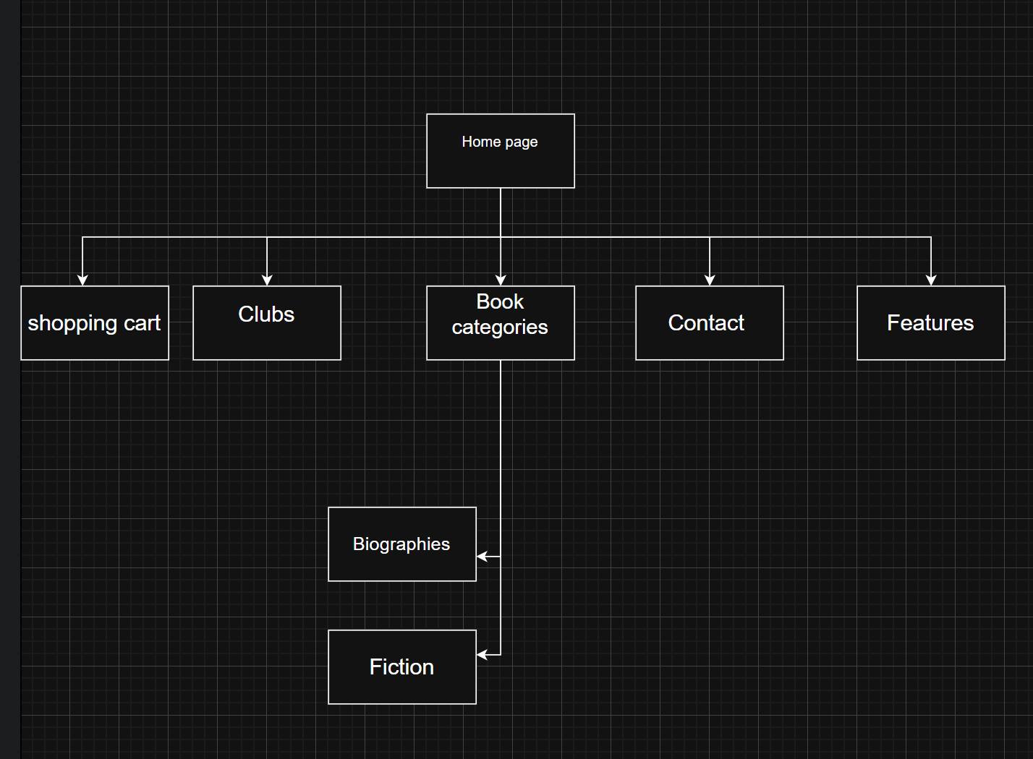

Story Board:

Problem definition:

How can we give the library experience to those who either don't want to go to a traditional library or don't have that is near them.

Recommended solution:

The solution is to create a book store website that will provide the traditional library experience in a digital form. This means every service that a library can provide, will be provided here and more.

Benefits:

* Searching for a specific book
* Buying books
* Joining one of the many book clubs that exist, where you can have discussions with other members.