DEVPILOT AI

API Specification
Technical Documentation
REST API contract for the approved DevPilot AI business flow: Authentication, Email Verification, Problems, AI Debugging, Knowledge Base, Similarity Search, Challenges, GitHub, Code Review, Telegram, AI Gateway, and Administration.

Version | 1.0
Backend | ASP.NET Core Web API
Database | SQL Server
Backend Hosting | MonsterASP
Frontend | Undefined yet
Frontend Hosting | Cloudflare Pages
Email Provider | Brevo

Contents
Architecture Overview 4
Platform Summary 4
Access Model 5
1. General Rules 6
Generic Error Response 6
2. Authentication & Email Verification 7
Register – Request 7
Register – Process 8
Verify Email – Requests 8
Security 8
3. User / Profile 9
4. Problems & Debugging 10
Create Problem – Request 10
Debug – Processing 11
Debug – Response Example 11
Feedback 12
5. Search & Similarity 13
Search Query Parameters 13
Similarity Signals 13
6. Knowledge Articles 14
Article Response Contents 14
Article Versioning 14
7. Challenges 15
Start Challenge – Process 15
Evaluation Criteria 15
8. GitHub 16
Repository Debug – Request 16
9. AI Code Review 17
Request 17
10. Telegram 18
11. AI Gateway 19
Generate – Request 19
Gateway Responsibilities 19
Provider Behavior 20
12. Admin 21
Possible Article Actions 21
13. Status / Enums 22
14. HTTP Status Codes 23
15. Security Requirements 24
16. Token Optimization Rules 25
17. Article Evolution Rules 26
18. GitHub Challenge Flow 27
19. API Implementation Order 28
20. Final API Flow 29

Architecture Overview
DevPilot AI is delivered as an ASP.NET Core Web API hosted on MonsterASP, backed by SQL Server. The frontend (technology not yet decided) is served from Cloudflare Pages and communicates with the API over JSON/HTTPS. The API integrates with Brevo for email, GitHub for repositories and webhooks, Telegram for the bot, and multiple LLM providers through an internal AI Gateway.
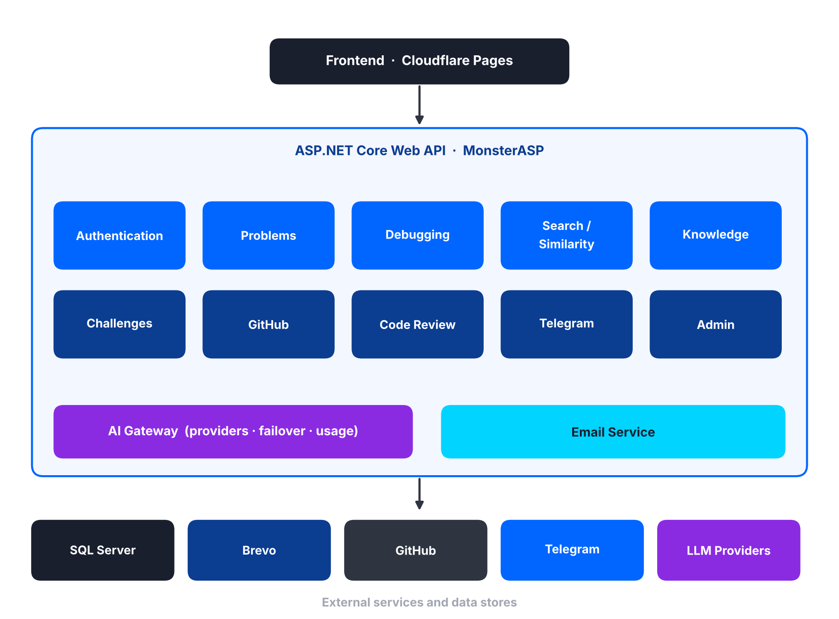
Figure 1 – System architecture and final API flow

Platform Summary
Layer | Technology / Role
Backend | ASP.NET Core Web API – all business logic, authentication, orchestration
Database | SQL Server – users, problems, attempts, articles, challenges, AI usage
Backend hosting | MonsterASP (Docker is not part of this hosting layer)
Frontend | Not yet defined
Frontend hosting | Cloudflare Pages (Cloudflare Turnstile used for abuse protection)
Email | Brevo – verification and password-reset emails
External services | GitHub (OAuth, repositories, webhooks), Telegram (bot webhook), LLM providers (via AI Gateway)

Access Model
Three access levels apply across the API. Public endpoints include article browsing/search and selected integration webhooks. Protected endpoints require a bearer access token. Admin endpoints require Administrator authorization.
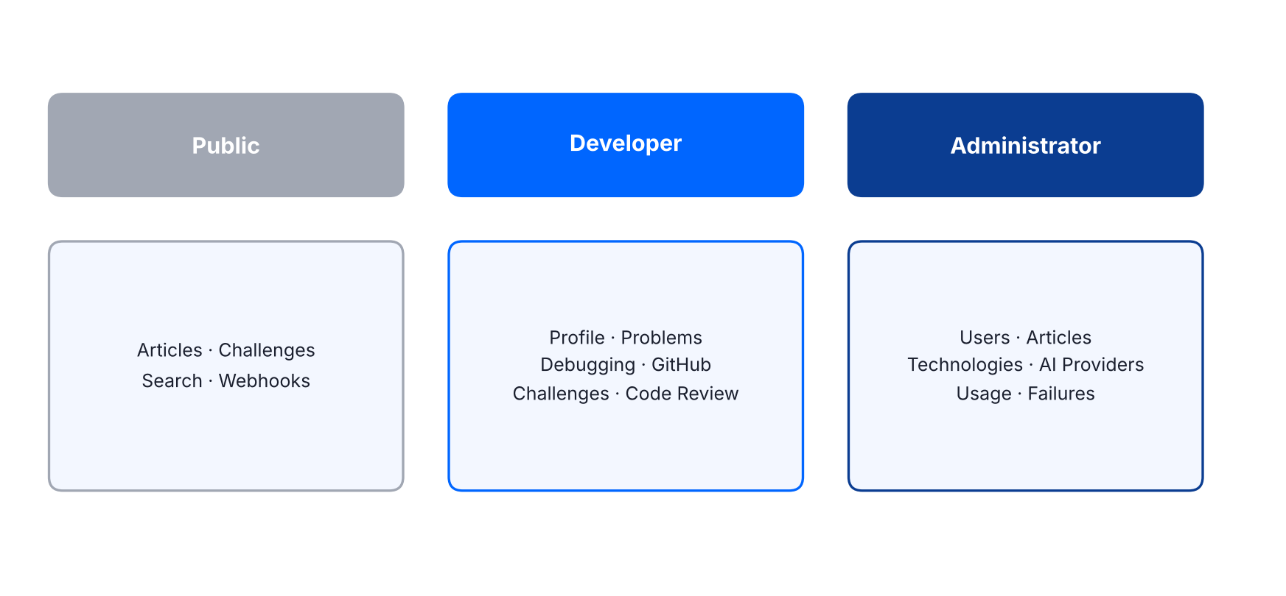
Figure 2 – Access levels and responsibilities

1. General Rules
Rule | Value
Base path | /api
Format | JSON over HTTPS
Authentication | Bearer access token for protected endpoints
Roles | Developer, Administrator

Generic Error Response
{
"success": false,
"errorCode": "ERROR_CODE",
"message": "Safe user-facing message",
"requestId": "correlation-id"
}

2. Authentication & Email Verification
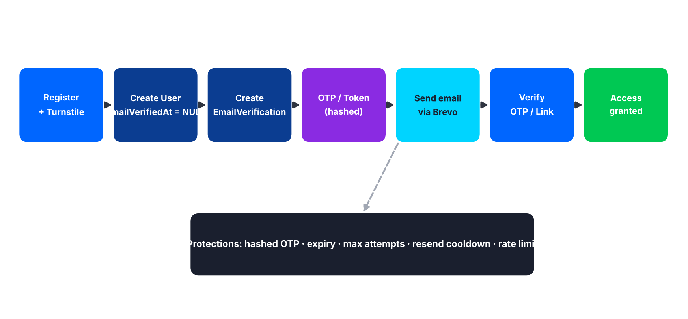
Figure 3 – Registration and email verification flow
Method | Endpoint | Access | Purpose
POST | /api/auth/register | Public | Create developer account and start email verification
POST | /api/auth/verify-email | Public | Verify OTP or verification token
POST | /api/auth/resend-verification | Public | Invalidate active verification and send a new OTP/link through Brevo
POST | /api/auth/login | Public | Authenticate verified developer
POST | /api/auth/refresh | Refresh token | Issue new access token
POST | /api/auth/logout | Authenticated | End session
POST | /api/auth/forgot-password | Public | Send reset email through Brevo without revealing account existence
POST | /api/auth/reset-password | Public (valid reset token) | Reset password

Register – Request
{
"name": "Mahmoud",
"email": "developer@example.com",
"password": "StrongPassword",
"turnstileToken": "..."
}

Register – Process
- Validate input.
- Create User with EmailVerifiedAt = NULL.
- Create EmailVerification record.
- Generate OTP or verification token.
- Send verification email through Brevo.
- Return verification-required result.

Verify Email – Requests
OTP request:
{
"email": "developer@example.com",
"code": "483921"
}

Link request:
{
"token": "verification-token"
}

On success:
- Mark EmailVerifications.VerifiedAt.
- Set Users.EmailVerifiedAt.
- Invalidate active verification.
- Allow authenticated access.

Security
- Store OTP/token hashes, not raw OTP values.
- Apply expiration.
- Apply maximum attempts.
- Apply resend cooldown/rate limiting.
- Never expose Brevo credentials to frontend.

3. User / Profile
Method | Endpoint | Access | Purpose
GET | /api/users/me | Developer | Returns current developer profile
PATCH | /api/users/me | Developer | Updates profile
GET | /api/users/me/problems | Developer | Returns current developer's problem history
GET | /api/users/me/challenges | Developer | Returns challenge attempts and results
GET | /api/users/me/integrations | Developer | Returns integration status

4. Problems & Debugging
Method | Endpoint | Access | Purpose
POST | /api/problems | Developer | Create a new technical problem
POST | /api/problems/{problemId}/requests | Developer | Add another request/input while the problem is unresolved
POST | /api/problems/{problemId}/debug | Developer | Run AI debugging
POST | /api/problems/{problemId}/attempts/{attemptId}/feedback | Problem owner | Submit result of an attempt
GET | /api/problems/{problemCode} | Owner or public view | Owner, or public article/knowledge view per visibility rules
GET | /api/problems/{problemId}/history | Owner | Requests, attempts, feedback, successful solutions

Create Problem – Request
{
"title": "JWT returns 401",
"description": "...",
"errorMessage": "401 Unauthorized",
"stackTrace": "...",
"technologyHint": "ASP.NET Core"
}

Debug – Processing
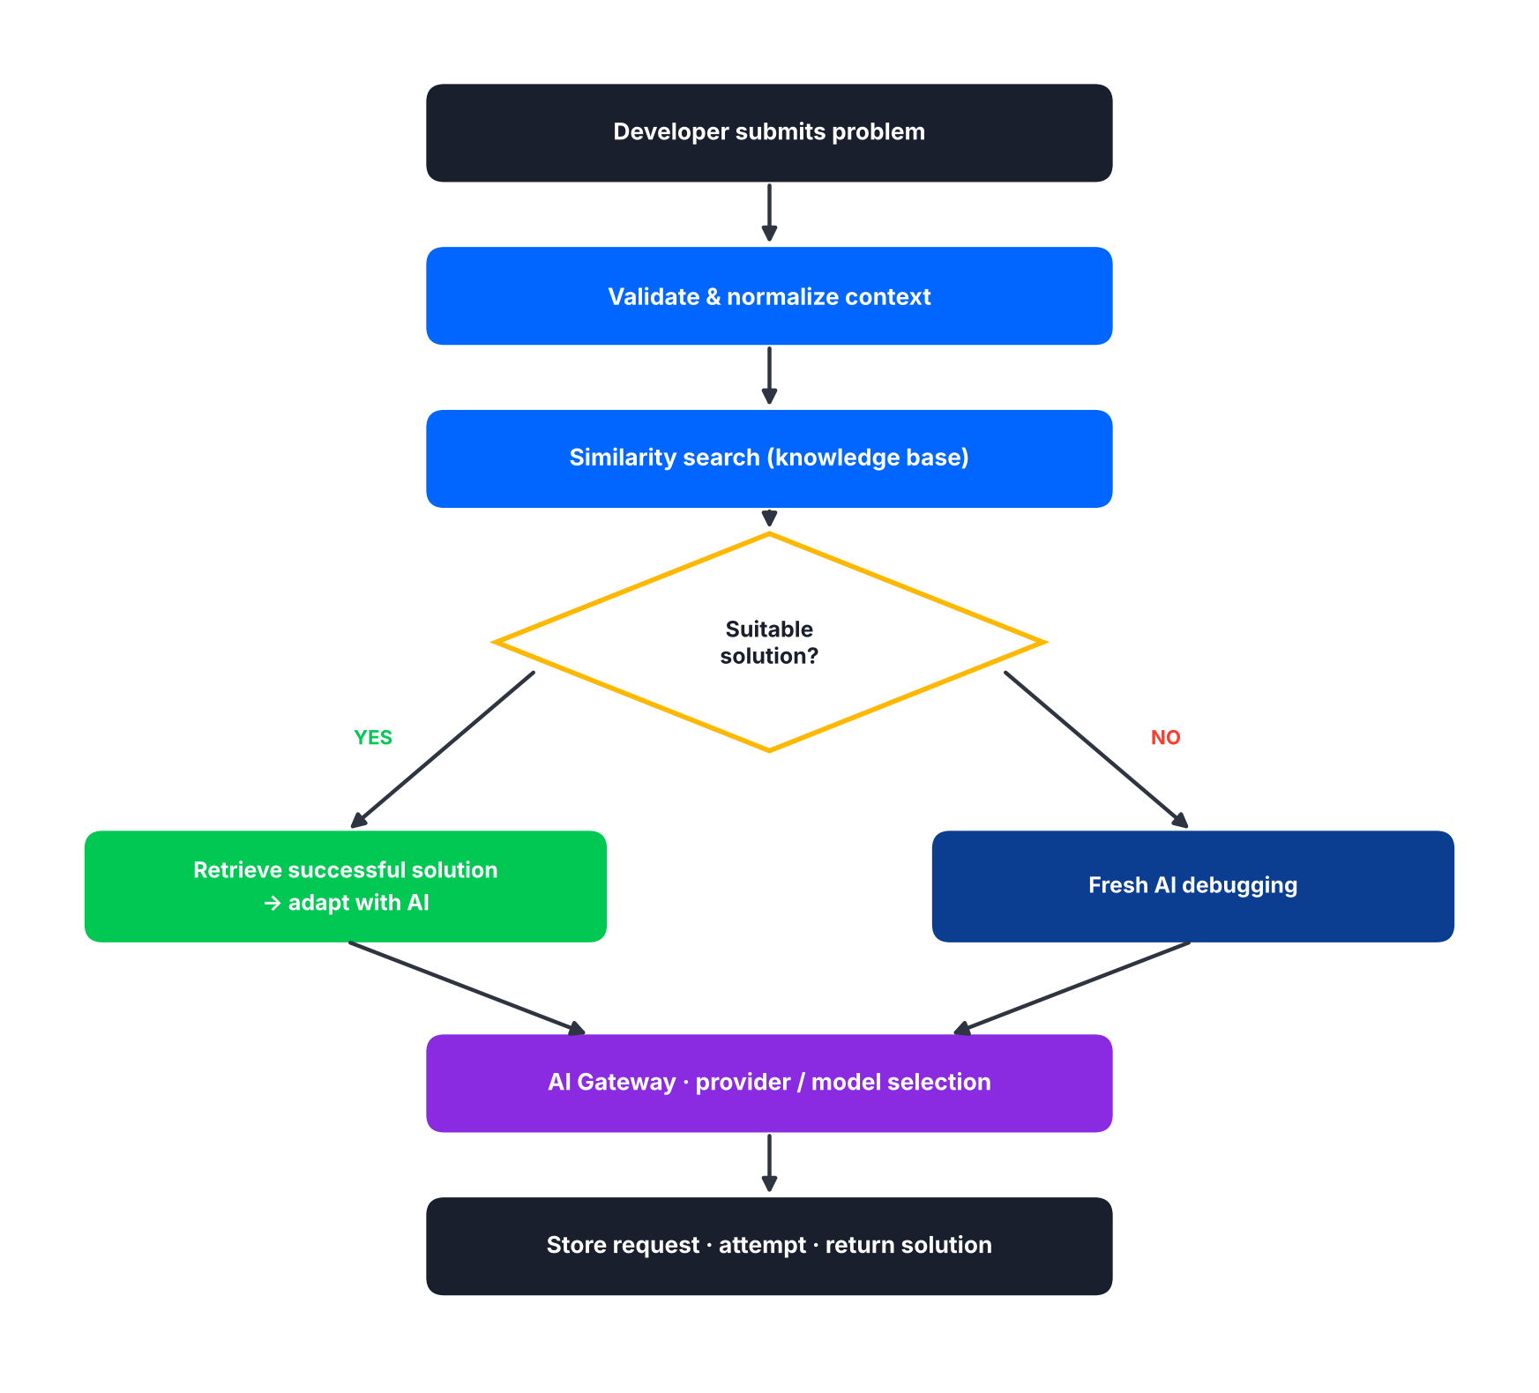
Figure 4 – Debugging decision flow (similarity first, AI second)
- Validate input.
- Normalize technical context.
- Search similar historical problems.
- Evaluate similarity.
- Retrieve successful reusable solutions when appropriate.
- Build optimized AI context.
- Call AI Gateway.
- Select available provider/model.
- Validate/normalize response.
- Store AI request/response.
- Store DebuggingAttempt.
- Return solution.

Debug – Response Example
{
"success": true,
"data": {
"attemptId": 12,
"attemptNumber": 1,
"rootCause": "...",
"solution": "...",
"whyItWorks": "...",
"similarProblems": [
{
"problemCode": "DEV-000102",
"similarityScore": 0.94
}
]
}
}

Feedback
Request:
{
"result": "Solved",
"comment": "..."
}

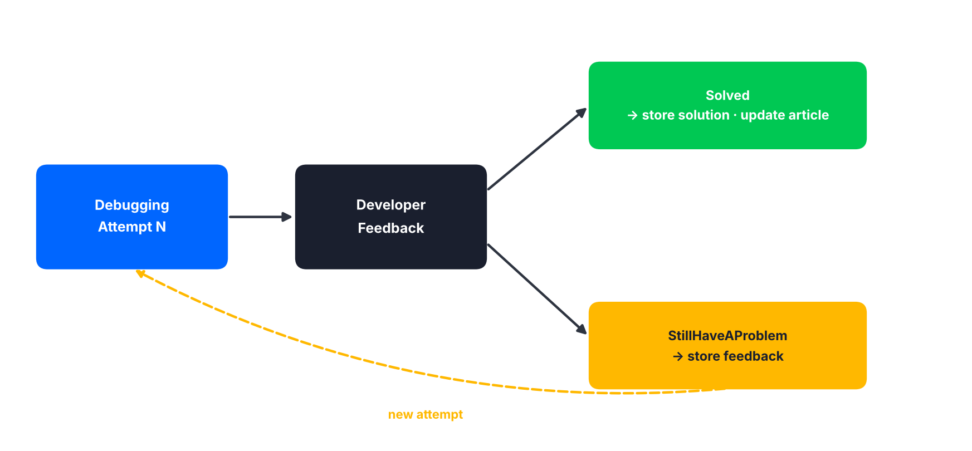
Figure 5 – Feedback outcomes and retry loop
Result | Behavior
Solved | Mark problem solved. Store successful solution. Update knowledge/article workflow.
StillHaveAProblem | Store feedback. Start another debugging attempt.

5. Search & Similarity
Method | Endpoint | Access | Purpose
GET | /api/problems/search | Public / Protected (configured visibility) | Search problems
POST | /api/search/similar-problems | Authenticated | Semantic/keyword search before unnecessary LLM processing

Search Query Parameters
Parameter | Description
q | Free-text query
technology | Technology filter
tag | Tag filter
problemCode | Exact problem code
error | Error message text
page | Page number
pageSize | Items per page
sort | Sort order

Similarity Signals
The similarity system considers:
- Problem description
- Error messages
- Stack traces
- Code context
- Technology/framework
- Tags
- Previously successful solutions

6. Knowledge Articles
Method | Endpoint | Access | Purpose
GET | /api/articles | Public | List articles
GET | /api/articles/{articleId} | Public | Get article
GET | /api/articles/{articleId}/versions | Administrator | List versions
GET | /api/articles/{articleId}/versions/{versionId} | Administrator | Get a specific version
POST | /api/problems/{problemId}/article/generate | Internal workflow / Administrator | Generate article from problem
POST | /api/articles/{articleId}/regenerate | Internal workflow / Administrator | Regenerate article

Article Response Contents
- Problem code
- Problem
- Error/code context
- Root cause
- Step-by-step solution
- Explanation of each step
- Best practices
- Prevention
- Statistics
- Related problems
- Practice challenge when available

Article Versioning
- New successful knowledge can generate a new ArticleVersion.
- Previous versions are preserved.
- Current article points to CurrentVersionId.

7. Challenges
Method | Endpoint | Access | Purpose
GET | /api/challenges | Public | List challenges
GET | /api/challenges/{challengeId} | Public | Get challenge (never expose the complete solution)
POST | /api/challenges | Authenticated or internal AI workflow | Create/generate challenge from a solved problem
POST | /api/challenges/{challengeId}/start | Developer | Start a challenge attempt
GET | /api/challenges/attempts/{attemptId} | Attempt owner | Get attempt
POST | /api/challenges/attempts/{attemptId}/evaluate | Attempt owner / internal workflow | Evaluate attempt

Important
GET /api/challenges/{challengeId} must not expose the complete solution.

Start Challenge – Process
- Verify authentication.
- Create ChallengeAttempt.
- Create/prepare GitHub repository when permitted.
- Associate repository with attempt.
- Return challenge repository/environment information.

Evaluation Criteria
- Build/test results
- Functional correctness
- Requirement completion
- Code quality
- Security
- Performance
- Architecture
- Understanding of original problem
- Best practices

8. GitHub
Method | Endpoint | Access | Purpose
GET | /api/github/connect | Developer | Starts OAuth
GET | /api/github/callback | OAuth callback | Must validate state
GET | /api/github/repositories | Developer | Repositories available through GitHub permissions
GET | /api/github/repositories/{repositoryId}/files | Developer | Retrieve only relevant repository context (query: branch, path)
POST | /api/github/repositories/{repositoryId}/debug | Developer | Debug using selected repository files
POST | /api/github/challenges/{challengeId}/repository | Developer | Create/initialize the challenge repository
POST | /api/github/webhook | GitHub only | Receive Push and Pull Request events; must validate authenticity

Repository Debug – Request
{
"branch": "main",
"paths": ["Program.cs", "AuthService.cs"],
"problemDescription": "JWT returns 401"
}

Token efficiency
The API should avoid sending unnecessary files to the LLM.

9. AI Code Review
Method | Endpoint | Access | Purpose
POST | /api/code-review | Developer | Start a code review
GET | /api/code-review/{reviewId} | Review owner / Administrator | Get review and findings

Request
{
"repositoryId": 55,
"branchName": "main",
"pullRequestNumber": 18,
"files": ["src/Services/AuthService.cs"]
}

Review may identify | Finding response includes
Bugs | FilePath
Security issues | Severity
Performance issues | Category
Code smells | Problem
SOLID violations | Suggestion
Maintainability
Architecture concerns
Best practices

10. Telegram
Method | Endpoint | Access | Purpose
POST | /api/telegram/webhook | Telegram | Receive bot messages
GET | /api/telegram/status | Developer | Integration status

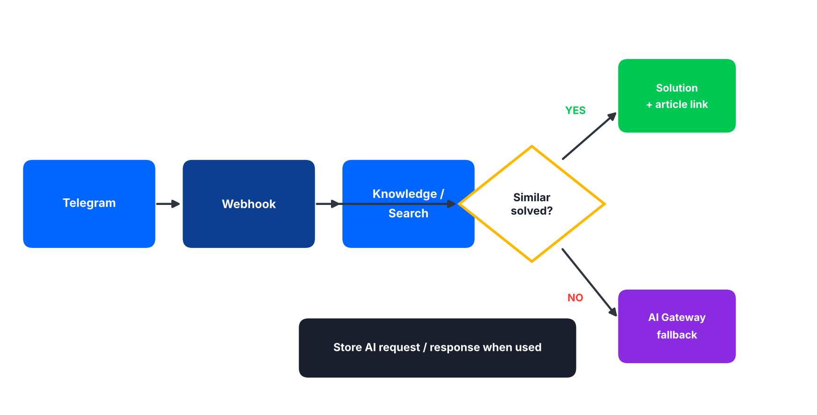
Figure 6 – Telegram answer flow

11. AI Gateway
Internal
These endpoints are internal and should not be publicly exposed.

Method | Endpoint | Access | Purpose
POST | /api/ai/generate | Internal | Central AI operation entry point
GET | /api/admin/ai/providers/health | Administrator | Provider health
GET | /api/admin/ai/providers | Administrator | List providers
POST | /api/admin/ai/providers | Administrator | Add provider
PATCH | /api/admin/ai/providers/{providerId} | Administrator | Update provider
GET | /api/admin/ai/usage | Administrator | Usage
GET | /api/admin/ai/failures | Administrator | Failures

Generate – Request
{
"operationType": "Debugging",
"problemId": 1001,
"context": "..."
}

Gateway Responsibilities
- Provider selection
- Model selection
- Usage tracking
- Retry
- Failover
- Response normalization
- Prompt version selection

Provider Behavior
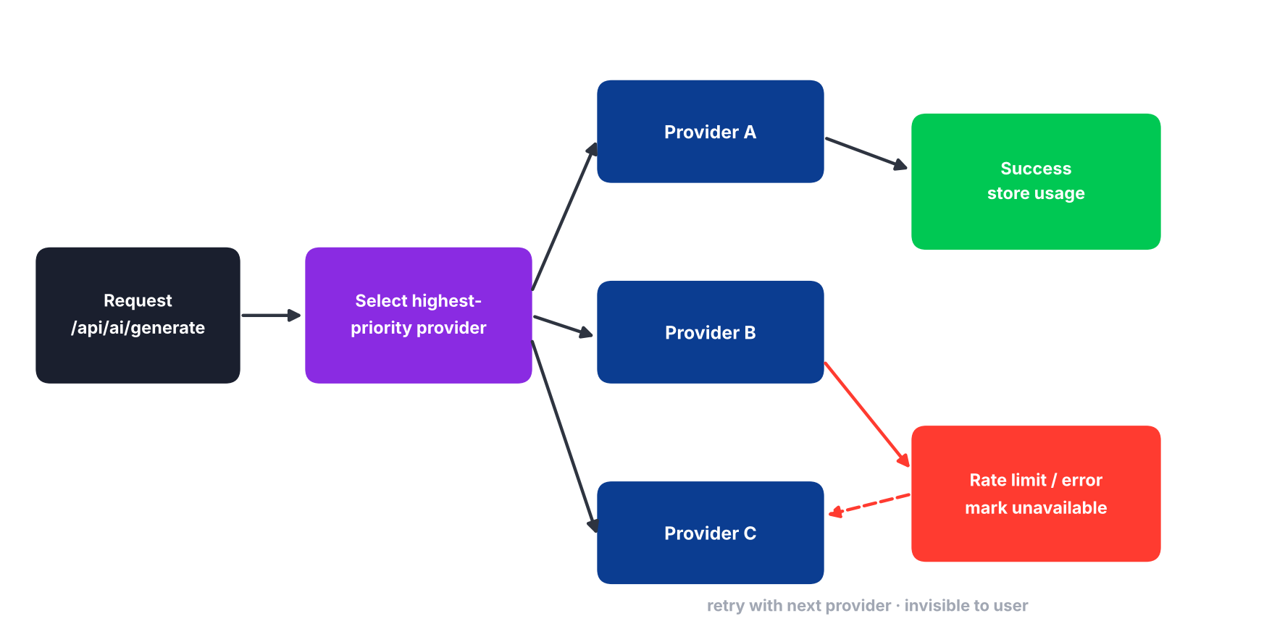
Figure 7 – Provider selection and failover
- Select highest-priority available provider/model.
- Call provider.
- On success, store usage.
- On rate limit/error, mark provider/model temporarily unavailable.
- Retry with next available provider.
- Do not expose internal switching to user.

Credentials
Provider credentials must never be returned.

12. Admin
Method | Endpoint | Access | Purpose
GET | /api/admin/users | Administrator | List users
GET | /api/admin/users/{userId} | Administrator | Get user
PATCH | /api/admin/users/{userId} | Administrator | Update user
GET | /api/admin/problems | Administrator | List problems
GET | /api/admin/problems/{problemId} | Administrator | Get problem
GET | /api/admin/articles | Administrator | List articles
PATCH | /api/admin/articles/{articleId} | Administrator | Article actions
GET | /api/admin/technologies | Administrator | List technologies
POST | /api/admin/technologies | Administrator | Add technology
PATCH | /api/admin/technologies/{technologyId} | Administrator | Update technology

Possible Article Actions
- Approve
- Hide
- Request regeneration
- Change publication state

13. Status / Enums
Enum | Values
VerificationMethod | OTP, Link
ProblemStatus | Active, Solved
FeedbackResult | Solved, StillHaveAProblem
ChallengeDifficulty | Easy, Medium, Hard
ChallengeAttemptStatus | Started, Submitted, Evaluating, Evaluated, Completed, Failed
AIRequestStatus | Pending, Success, Failed, RateLimited, Cancelled
ReviewStatus | Pending, Analyzing, Completed, Failed
ArticleStatus | Draft, Published, Archived, NeedsReview

14. HTTP Status Codes
Code | Meaning
200 | OK
201 | Created
204 | No Content
400 | Bad Request
401 | Unauthorized
403 | Forbidden
404 | Not Found
409 | Conflict
422 | Unprocessable Entity
429 | Too Many Requests
500 | Internal Server Error
502 | Bad Gateway
503 | Service Unavailable

15. Security Requirements
- HTTPS only.
- Secure authentication and authorization.
- Validate all request data.
- Rate limit abuse-sensitive endpoints.
- Use Cloudflare Turnstile where appropriate.
- Never expose AI provider API keys to frontend.
- Never expose GitHub tokens to frontend.
- Store GitHub credentials securely/encrypted.
- Store OTP/token as hashes.
- Expire verification/reset records.
- Apply resend cooldown.
- Validate GitHub webhook authenticity.
- Use least-privilege GitHub permissions.
- Keep private repository data private.
- Do not place sensitive credentials inside AI prompts.
- Centralized exception handling.
- Never return internal stack traces in production.

16. Token Optimization Rules
Every new request is normalized and checked against the knowledge base before any fresh AI call. A suitable stored solution is retrieved and adapted; otherwise fresh AI debugging runs (see Figure 4).
The system must:
- Search knowledge before fresh AI calls.
- Reuse successful solutions.
- Send only relevant repository files.
- Cache reusable output where appropriate.
- Track token/request usage.
- Save successful adaptations.
- Use multiple providers with failover.

17. Article Evolution Rules
When multiple successful solutions exist:
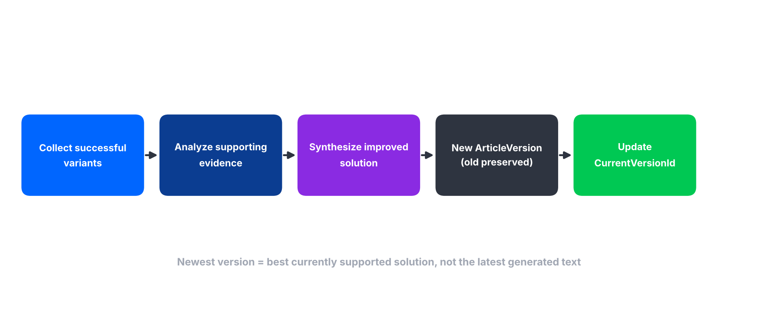
Figure 8 – Article evolution
- Collect successful variants.
- Analyze supporting evidence.
- Synthesize improved solution.
- Generate new ArticleVersion.
- Preserve previous versions.
- Update CurrentVersionId.

Principle
The newest version should represent the best currently supported solution, not simply the most recently generated text.

18. GitHub Challenge Flow
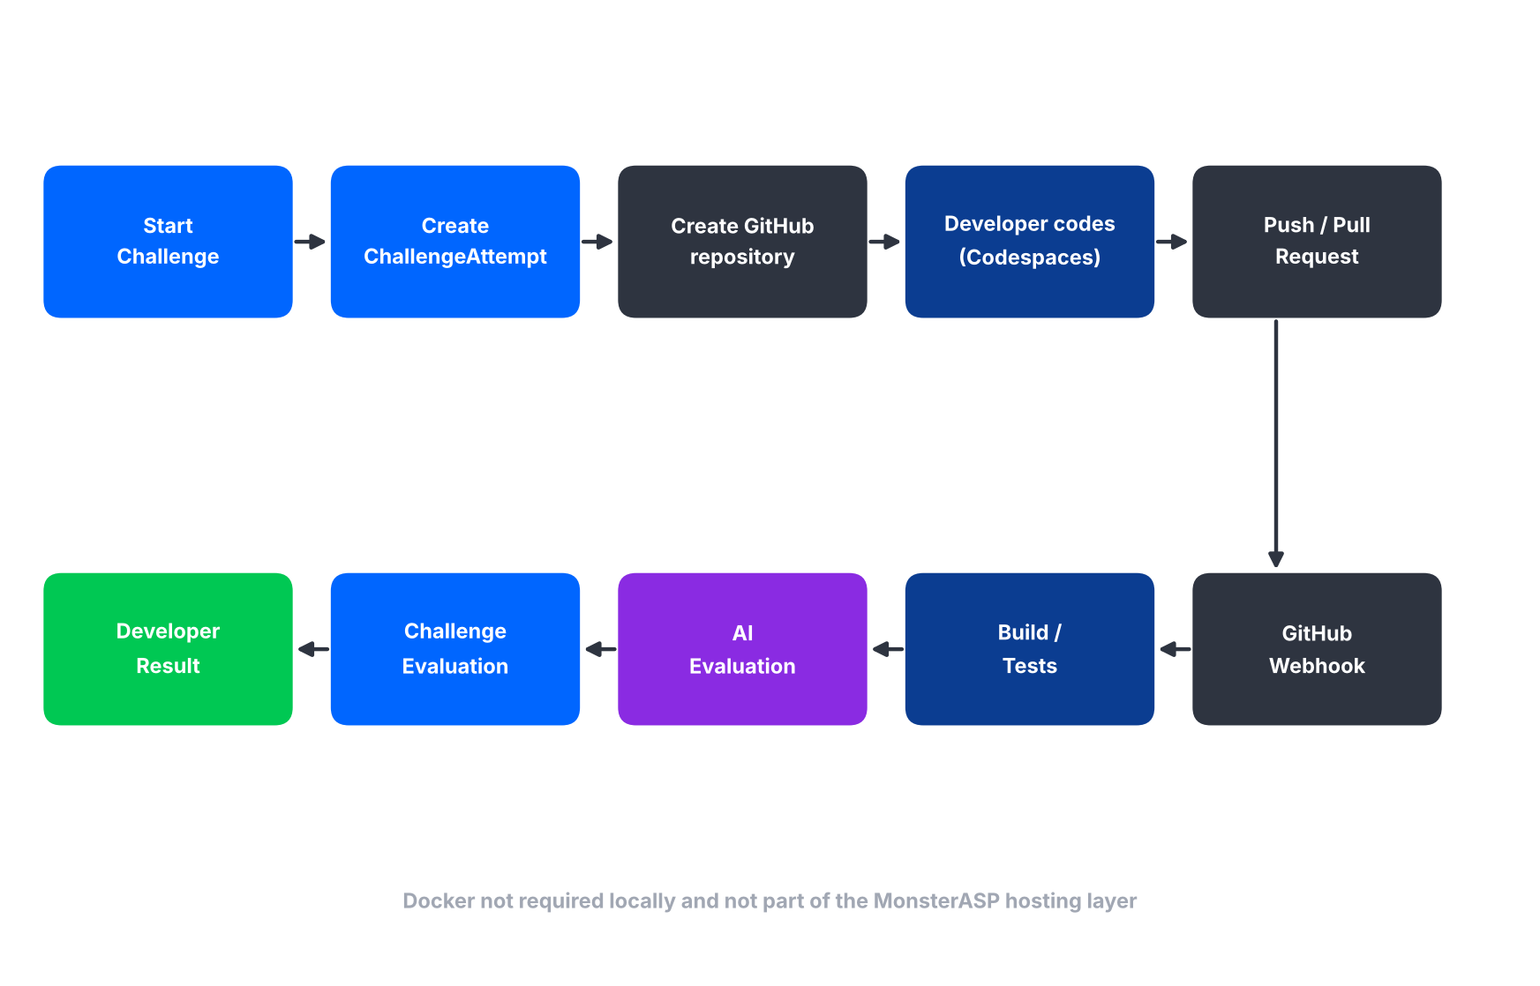
Figure 9 – Challenge lifecycle from start to developer result
Online development may use GitHub Codespaces / Dev Containers. Docker is not required on the developer's local machine and is not part of the MonsterASP hosting layer.

19. API Implementation Order
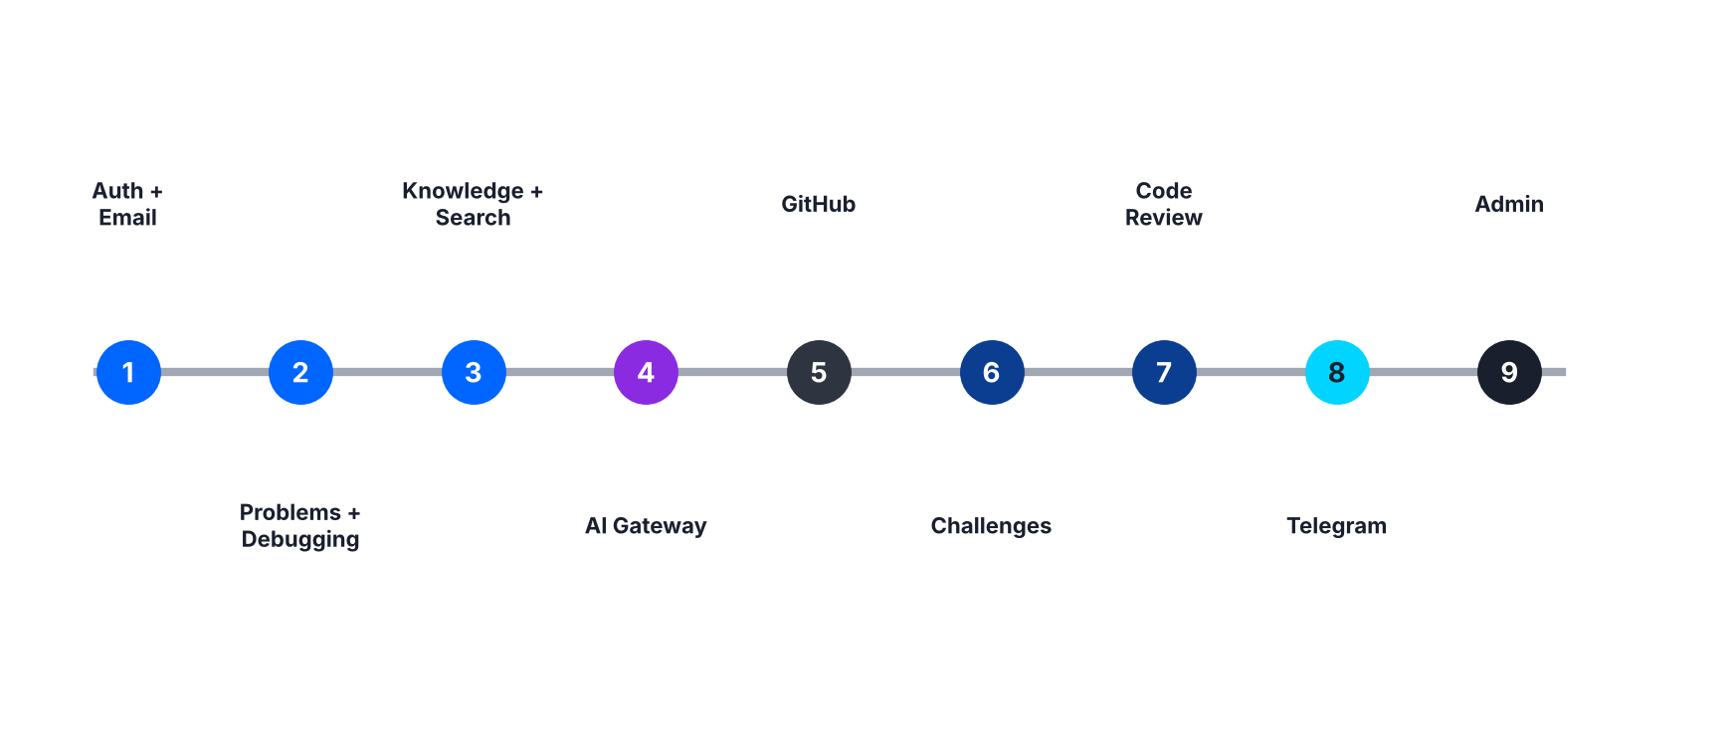
Figure 10 – Implementation roadmap
Phase | Scope
1 | Authentication + Email Verification
2 | Problems + Debugging + Feedback + History
3 | Knowledge Base + Search + Similarity
4 | AI Gateway + Provider Management + Usage
5 | GitHub OAuth + Repository Access + Webhooks
6 | Challenges + GitHub Challenge Repository + Evaluation
7 | AI Code Review
8 | Telegram
9 | Admin

20. Final API Flow
The frontend calls the ASP.NET Core Web API, which exposes the Authentication, Problems, Debugging, Search / Similarity, Knowledge, Challenges, GitHub, Code Review, Telegram and Admin modules. These rely on the AI Gateway and the Email Service, which in turn connect to SQL Server, Brevo, GitHub, Telegram and the LLM providers.
Figure 11 – Final API flow

