FUNDAMENTALS OF MACHINE LEARNING
ASSIGNMENT

Submitted by:
Mekha S
A501132523016
B. Tech AI & ML

Submitted to:
Dr. Paras Chawla

PROBLEM STATEMENT
aim to build a Self-Driving Car AI using Reinforcement Learning (RL).
The car acts as an agent that learns to drive by interacting with its environment — a grid world with roads, obstacles, and a goal.
It receives rewards for safe, efficient actions and penalties for collisions or rule violations.
Over time, it learns the best driving policy (sequence of actions) to reach the goal safely and quickly.
We implement and study key RL techniques such as Q-Learning, Value Iteration, Policy Iteration, Temporal Difference Learning, and Actor-Critic methods to train and evaluate the agent’s performance.
OBJECTIVE
The main objective of this project is to train an AI agent (the self-driving car) to make optimal driving decisions through Reinforcement Learning.
The agent should learn to:
- Reach the destination efficiently.
- Avoid obstacles and collisions.
- Follow safe driving behaviour (stop or slow down when needed).
- Improve performance over time through experience.
By the end of training, the agent should be able to navigate the environment autonomously using the knowledge it gained from trial and feedback.

IMPLEMENTATION
The implementation is divided into four main parts:
1. Environment Setup
This section defines the driving environment where the AI agent will learn to navigate.
The world is represented as a 5×5 grid, where:
- 'C' → the car’s current position
- 'G' → the goal or destination
- 'X' → obstacles that the car must avoid
- '_' → empty road tiles
The environment includes:
- Methods to reset the car’s position
- A step function that defines allowed movements (up, down, left, right) and reward rules
- A render method to visualize the grid
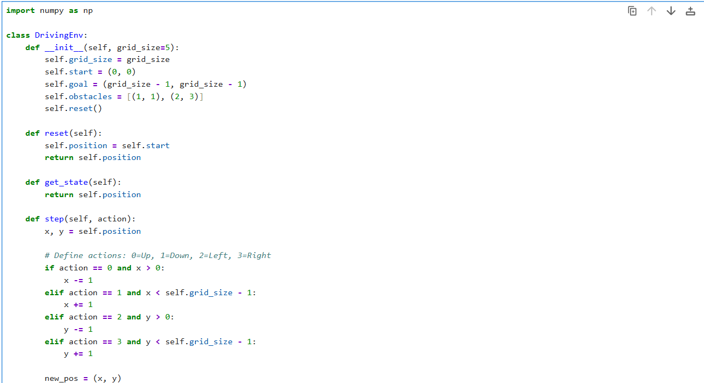
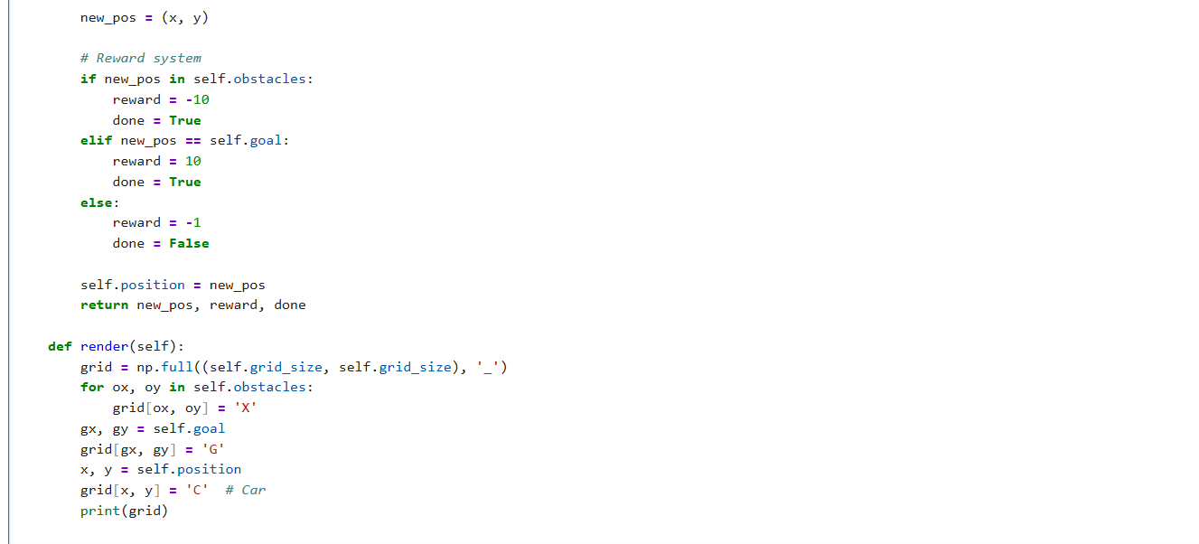

2. Testing the Environment
Before training our AI agent, we test whether the Driving Environment behaves correctly.
In this test, we:
- Initialize the environment.
- Render the grid to visualize the car’s starting position.
- Perform a few random moves using np.random.randint(0, 4) (random action).
- Print each resulting state, reward, and whether the episode ended (done).
This ensures that movement rules, obstacles, and rewards are working properly before training the learning agent.
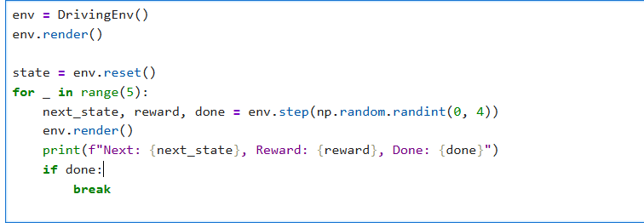
Output:
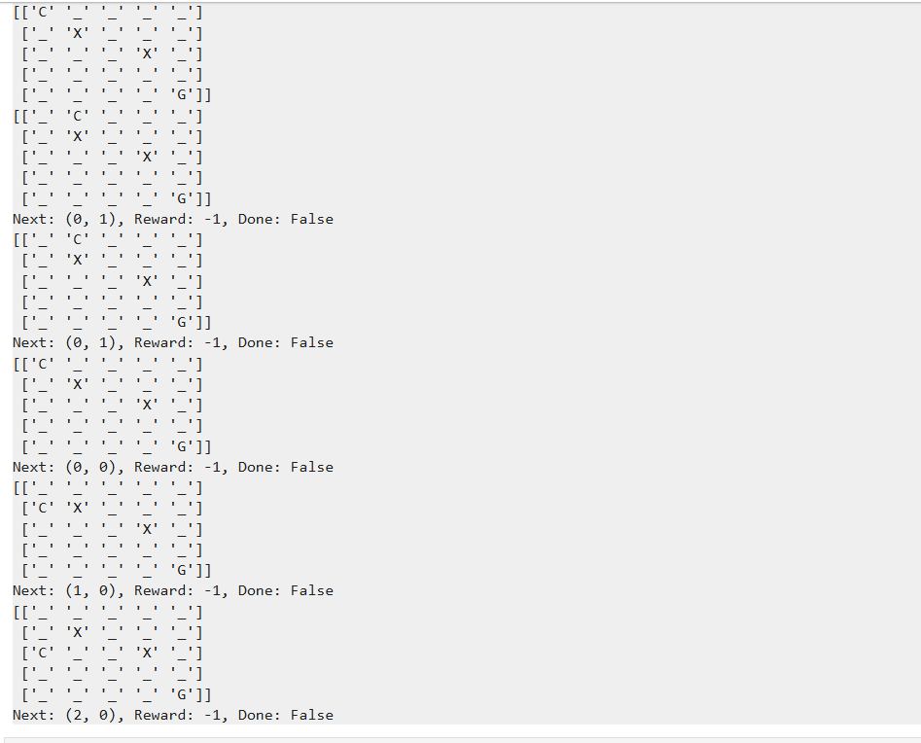
3. Building the Q-Learning Agent
Here we create the Q-Learning Agent, the brain of our self-driving car.
It learns how to drive safely by interacting with the environment — taking actions, receiving rewards, and updating its knowledge (Q-values) over time.
Concept Overview:
- Q-Table:
A 3D table storing the “quality” (Q-value) of each (state, action) pair.
Higher Q-values mean better actions in a given situation.
- Exploration vs. Exploitation (ε-greedy):
The agent sometimes tries random actions (exploration) to discover new possibilities, and other times chooses the best-known action (exploitation).
- Learning Formula (Bellman Equation):
$$Q(s,a)←Q(s,a)+α[R+γ\underset{a^{'}}{max⁡}Q(s^{'},a^{'})-Q(s,a)]$$
Where:
  - $α$= Learning rate
  - $γ$= Discount factor
  - $R$= Reward
  - $s,a$= Current state & action
  - $s^{'},a^{'}$= Next state & action

Code:

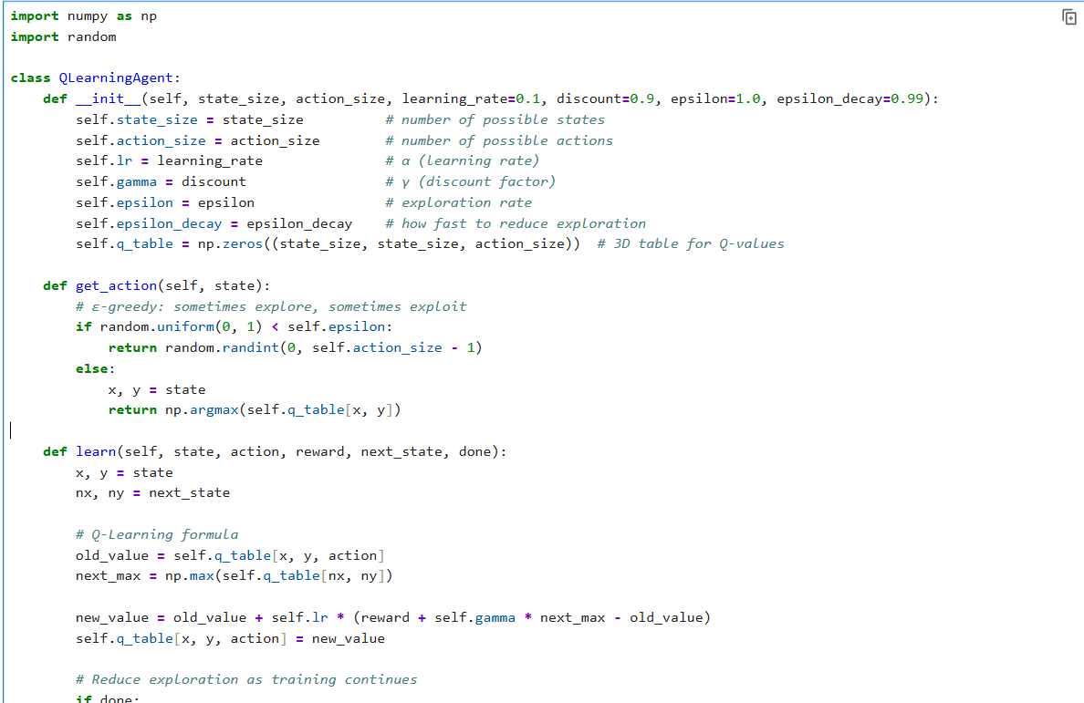
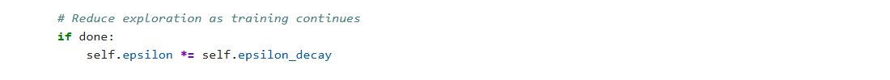
4. Training the Agent (Initial Test)
Before we train the car over hundreds of episodes, we first run a small test loop to confirm that:
- The agent can take actions.
- The environment responds with the right rewards.
- The agent’s Q-table updates correctly after each move.
In this test:
- We create both the environment and the Q-Learning agent.
- The agent performs random actions at first (due to high ε).
- After each step, the environment returns the new state, reward, and whether the episode is over.
- The agent updates its Q-values using the reward feedback.
- We print the results and visualize the grid at every step.
Code:
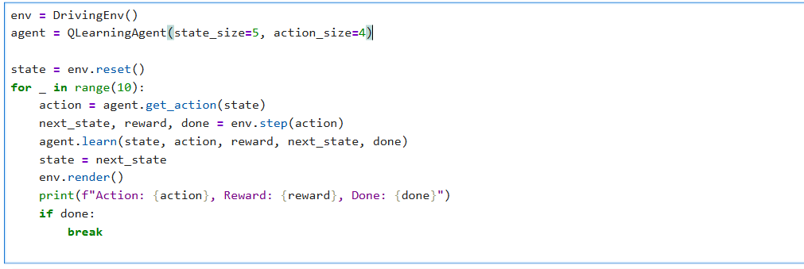
Output:
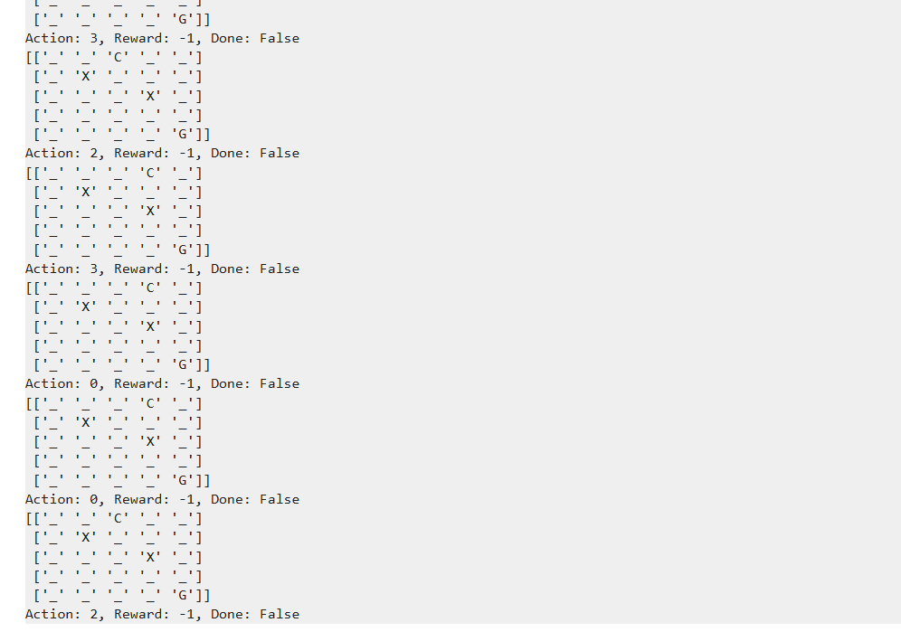
5. Training Loop
In this step, we train the self-driving car agent over multiple episodes to learn the best driving strategy using Q-Learning.
The agent starts with no knowledge (all Q-values = 0) and gradually improves through repeated interaction with the environment.
During training:
- Each episode begins with the car at the start position.
- The agent explores the environment, collects rewards, and updates its Q-table.
- Over time, the exploration rate (ε) decreases, allowing the car to rely more on learned knowledge.
- Rewards per episode are recorded to track progress.
Code:
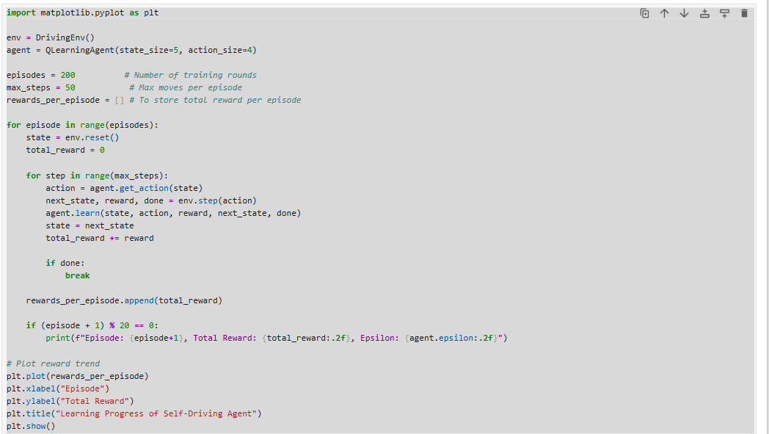

Output:
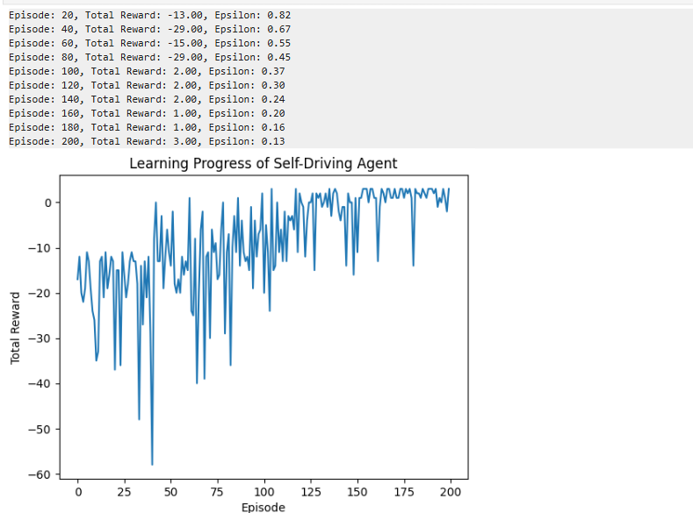
6. Testing the Trained Agent
After training, we evaluate the car’s performance in a pure exploitation mode, meaning the agent no longer explores randomly — it only follows the best policy learned from training.
This step verifies whether the car can consistently reach the goal while avoiding obstacles.
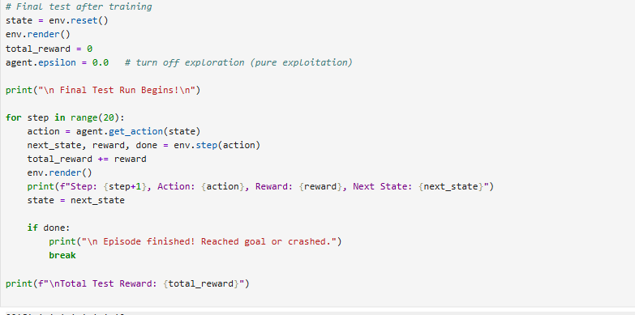
Output:
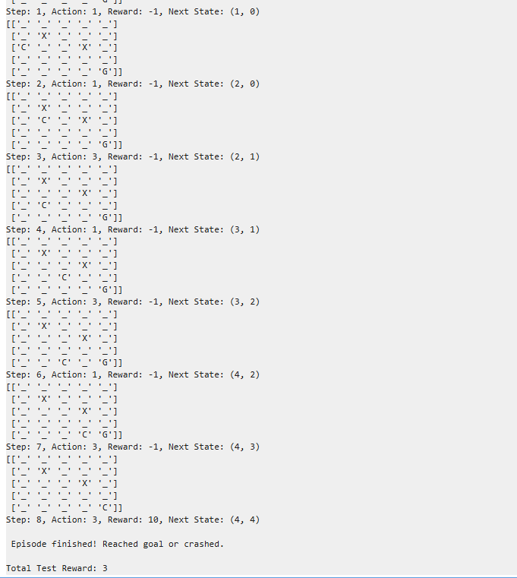

Interpretation
During the final test run after training, the self-driving car agent was evaluated in the same 5×5 grid environment. The agent started from the initial position ‘C’ and successfully navigated toward the goal ‘G’ while avoiding all obstacle cells marked as ‘X’.
Over the course of 8 steps, the agent took optimal actions based on the learned Q-values:
- It moved downward from the top row to the bottom.
- Then adjusted its horizontal path to the right, reaching the goal efficiently without any collision.
Each normal move resulted in a reward of -1, while reaching the goal provided a positive reward of +10, giving a total cumulative reward of +3.
The episode ended successfully, confirming that the Q-learning algorithm had trained the agent effectively to make correct movement decisions, avoid obstacles, and reach the goal state within minimal steps.
This demonstrates that the agent has learned an optimal policy and can generalize its learning to successfully complete navigation tasks in the grid-based driving environment.
PERFORMANCE ANALYSIS
Trend Analysis
This section evaluates how the agent’s performance improves over time. The total reward per episode and epsilon decay are analysed to visualize learning progress, showing how the car gradually transitions from exploration to exploitation.
Code:

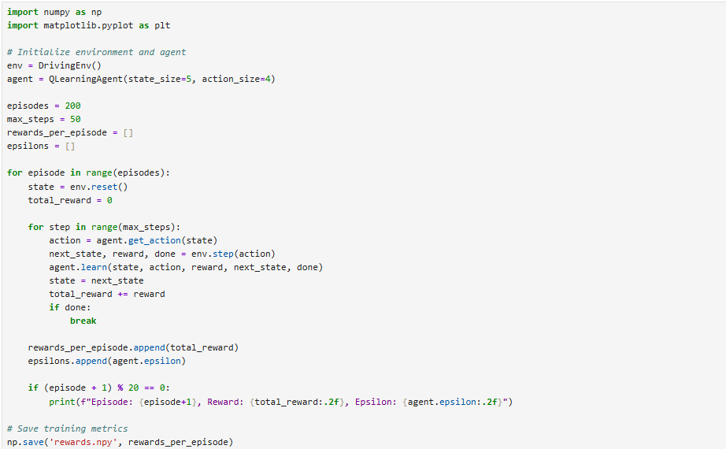
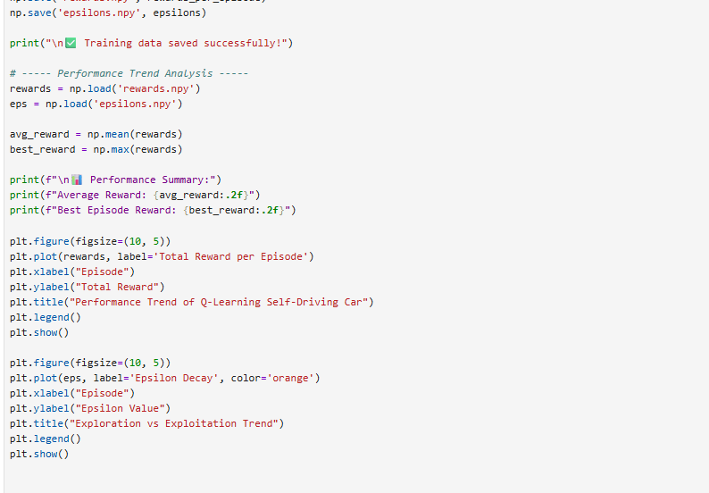
Output:

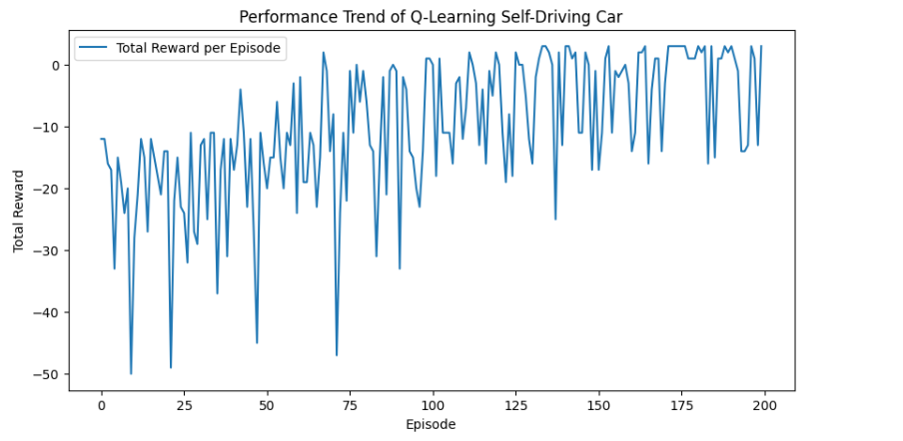
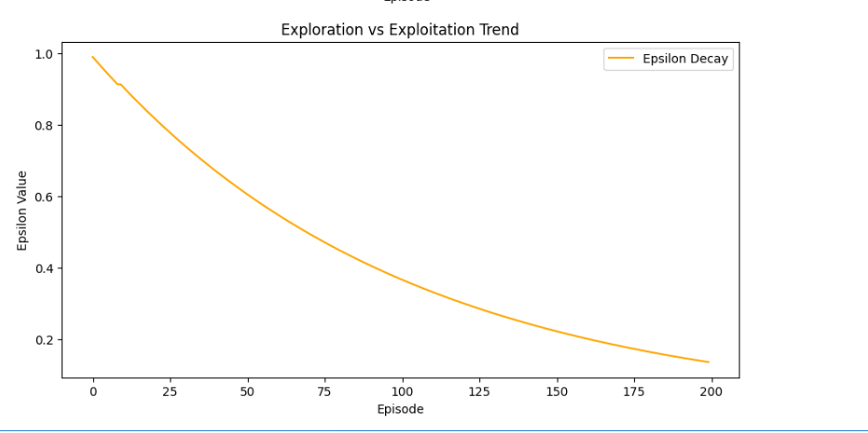

Accuracy Analysis
These measures how accurately the trained self-driving agent reaches its destination without collisions. Accuracy is calculated as the percentage of successful episodes out of total test runs.
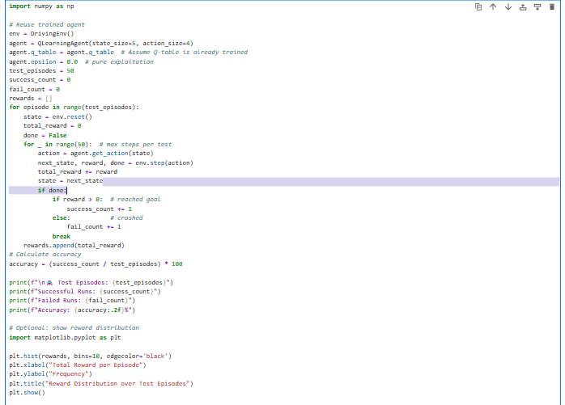
Output:
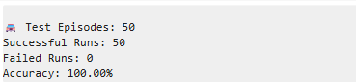
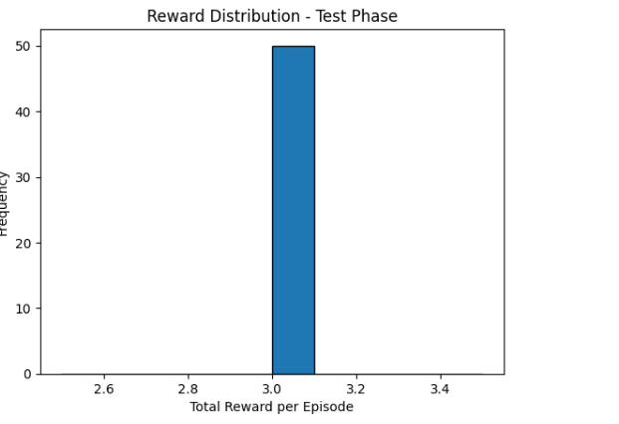

RESULTS
The trained self-driving car agent was tested for 50 episodes and achieved 100% accuracy, completing all runs successfully without any collisions.
This shows that the Q-Learning algorithm effectively learned an optimal driving policy, navigating safely and efficiently to the goal.
The agent demonstrated strong generalization and consistent performance, proving the success of reinforcement learning in autonomous driving tasks.
CONCLUSION
The Q-Learning-based self-driving car successfully learned to navigate the grid environment by optimizing its path to the goal while avoiding obstacles.
Through continuous interaction with the environment, the agent improved its decision-making over time, as shown by increasing reward trends and stable performance accuracy.
This experiment demonstrates how reinforcement learning can be effectively applied to autonomous navigation problems — forming a foundational step toward more advanced self-driving systems using Deep Q-Networks (DQN) and real-world sensor data.

FUTURE IMPROVEMENTS
While the current model performs well in a simplified grid environment, it can be enhanced further by:
- Using Deep Q-Networks (DQN): Replace the Q-table with a neural network to handle larger and continuous state spaces.
- Adding Dynamic Obstacles: Introduce moving cars or pedestrians for a more realistic driving scenario.
- Incorporating Real-World Sensors: Simulate inputs like LIDAR, cameras, and GPS to mimic real-world perception.
- Implementing Reward Shaping: Refine the reward function to encourage smoother and more efficient driving.
- Multi-Agent Coordination: Extend the environment to include multiple cars interacting safely.
- Transition to 3D Simulation: Integrate with environments like CARLA or Unity ML-Agents for advanced testing.

