1. Login page:

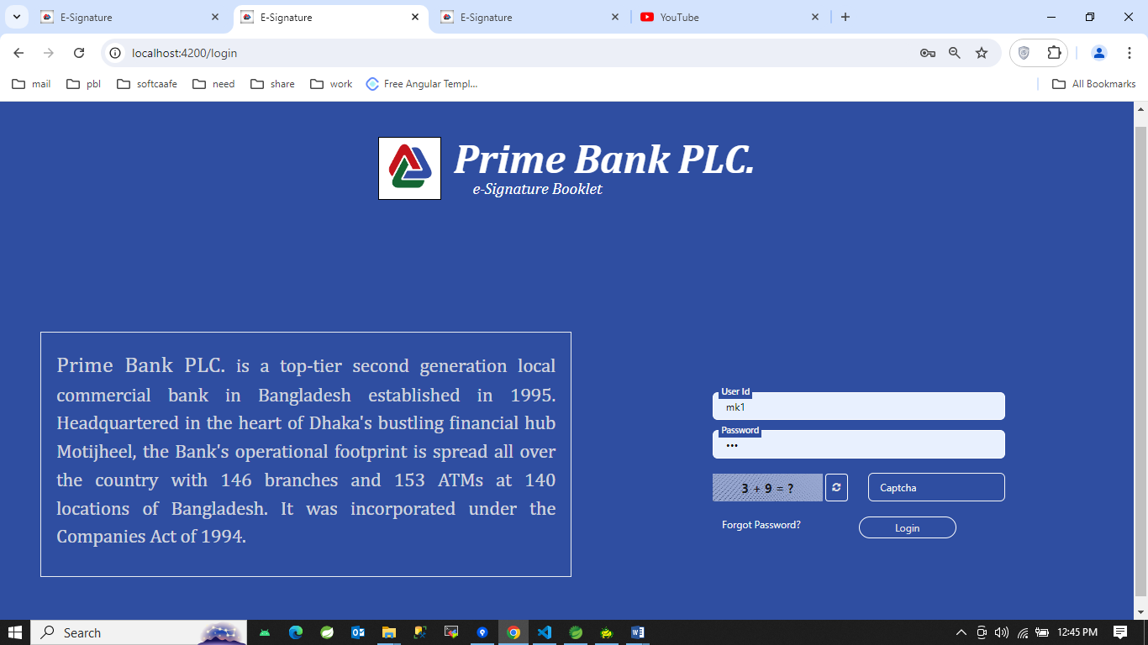

1. Forgot password:
2. 1st section:

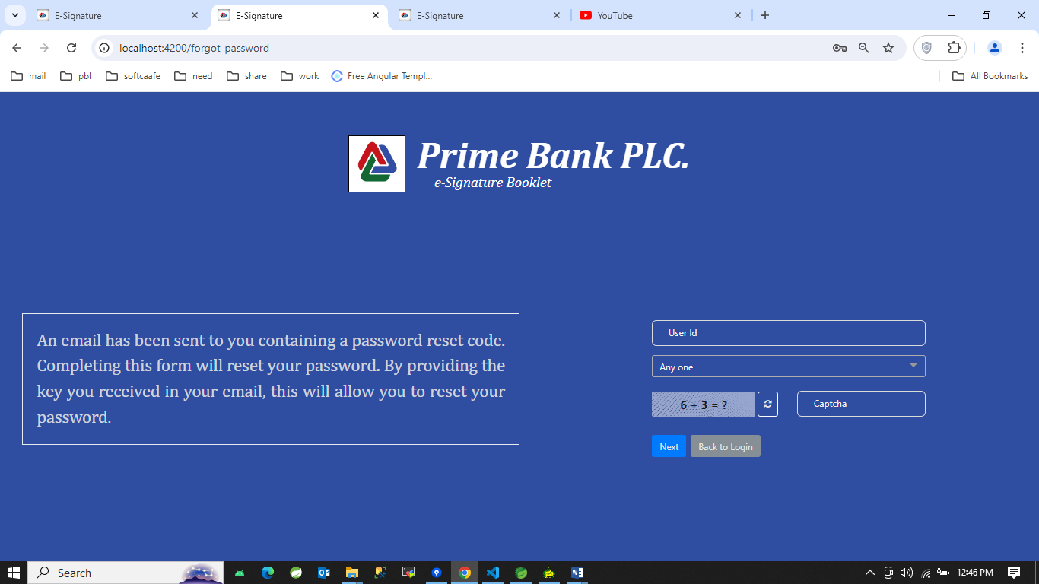

1. 2nd Section: After matching user Id and Question Answer, clicking Next Button

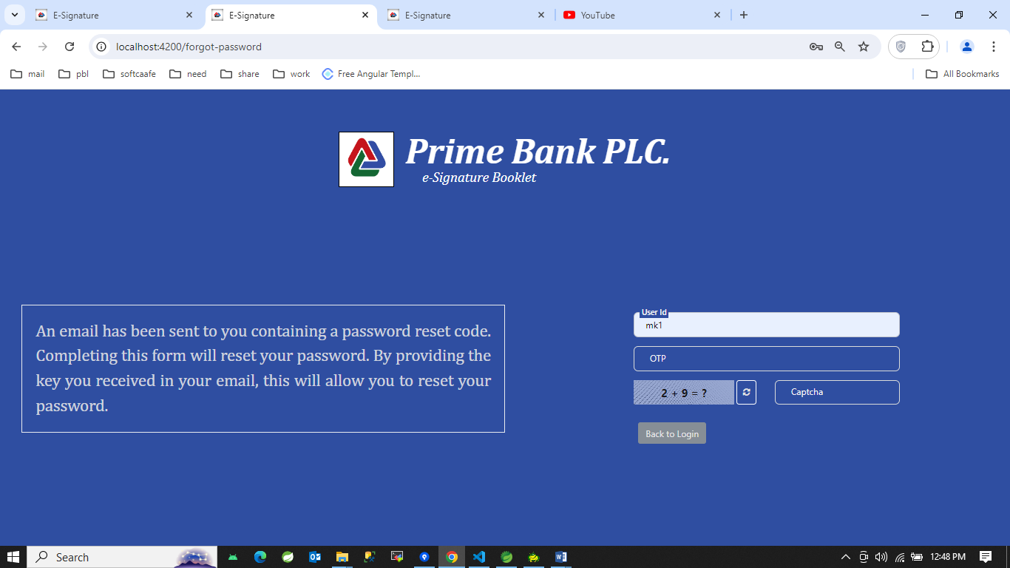

1. 3rd section: After matching the otp which is gave by mail

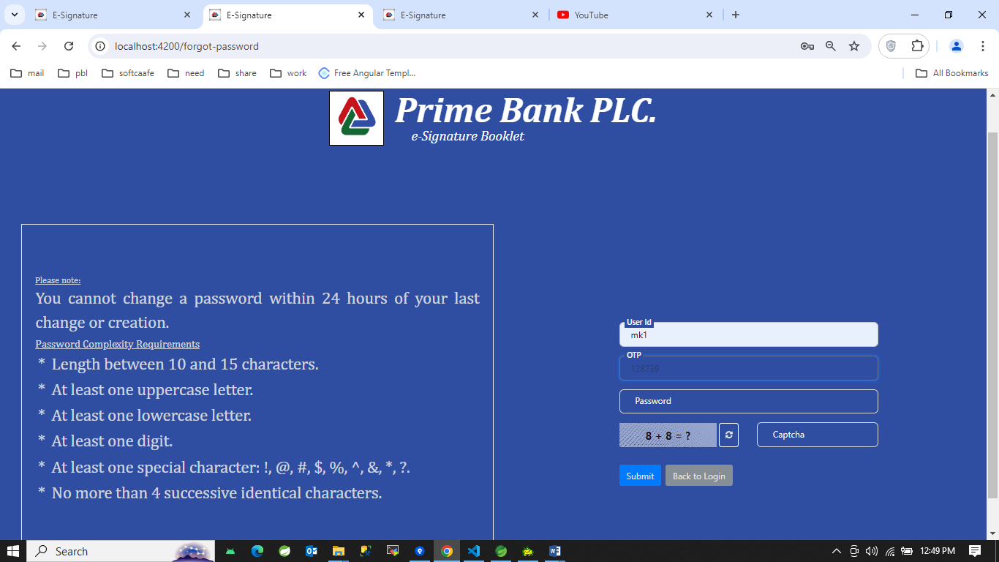

1. Clicking login button
2. 1st General notice

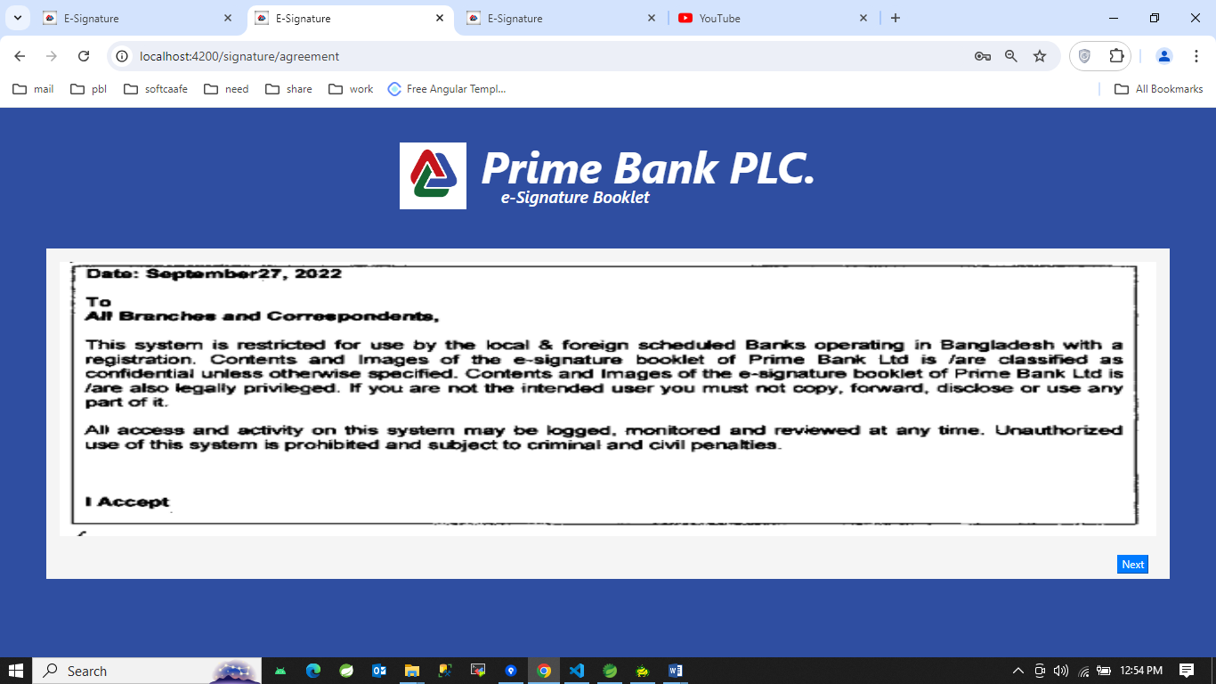

1. 2nd MD instruction: clicking Next button

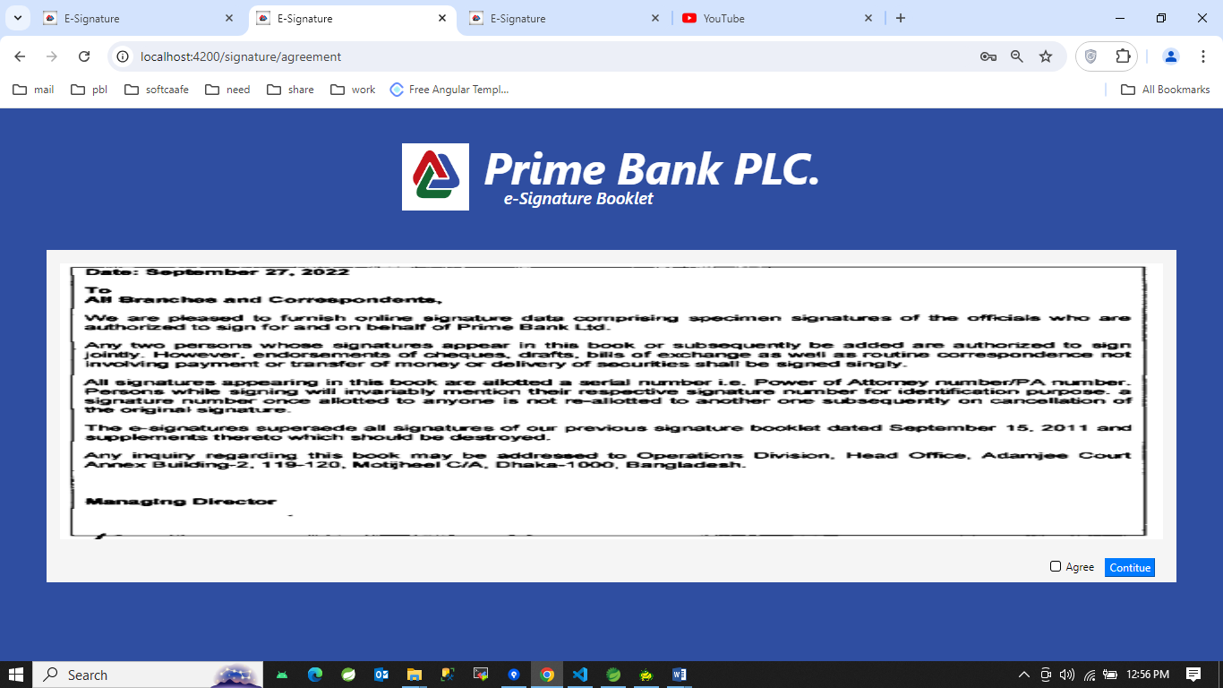

1. 1st application view after successful login

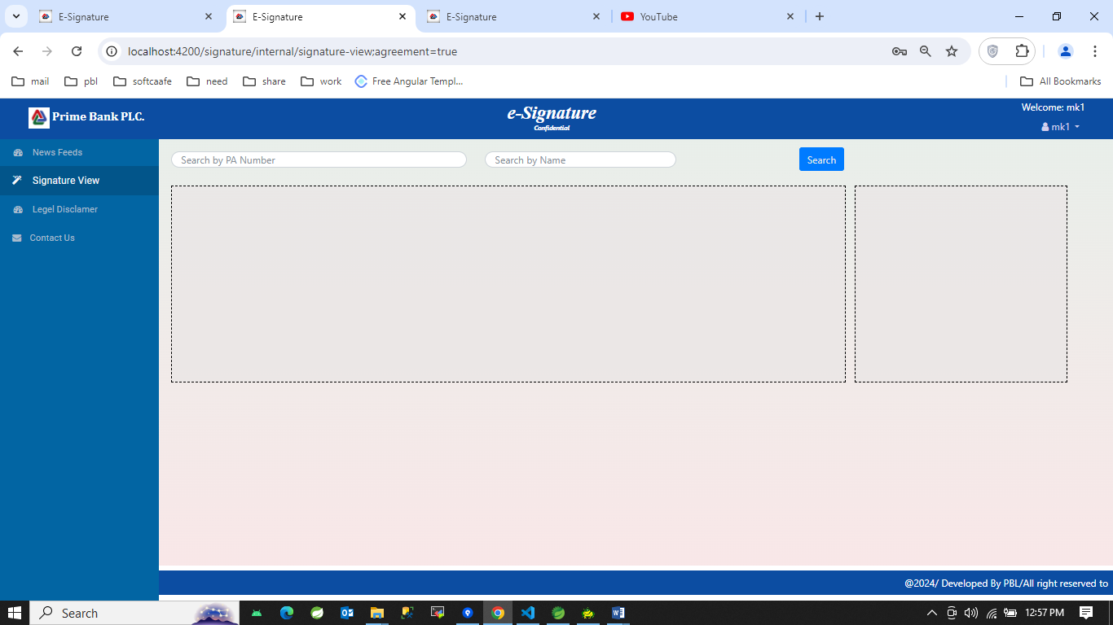

1. In news feeds section

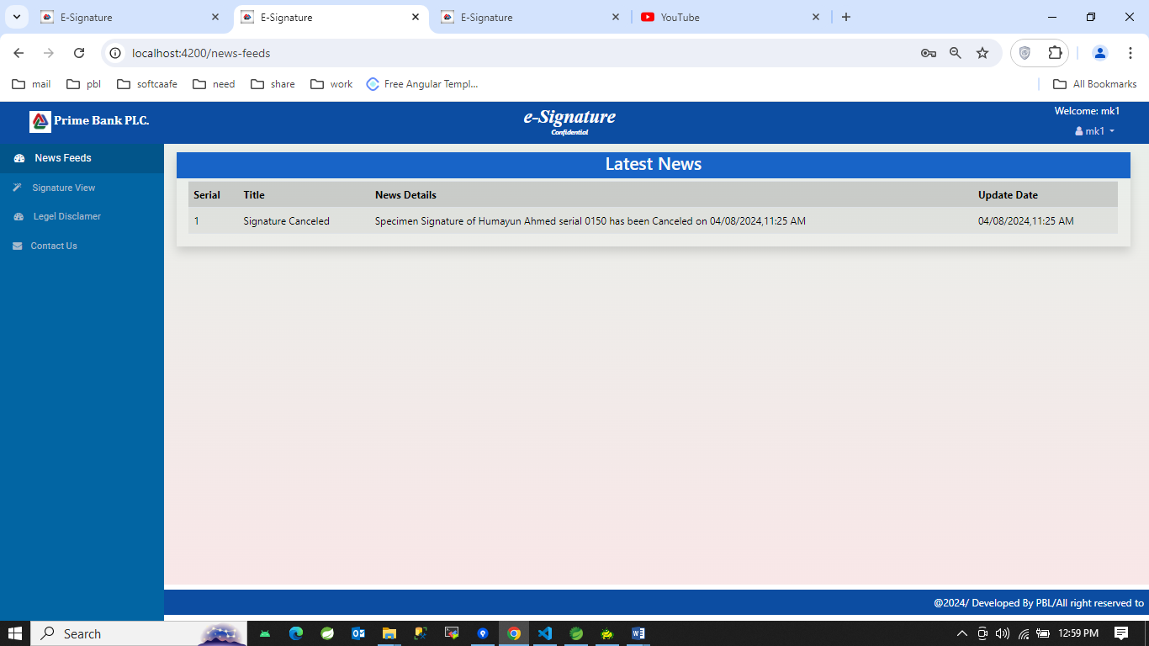

1. In signature view section
2. 1st look:

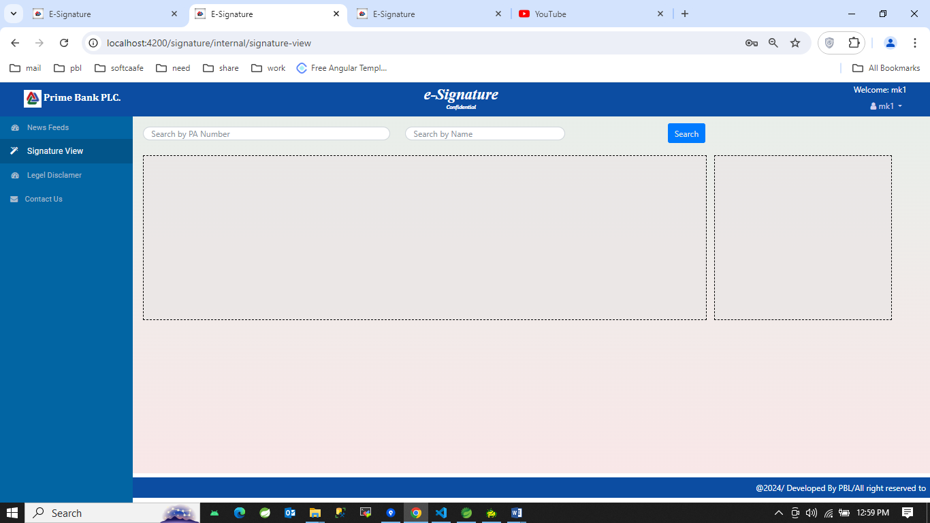

1. Active signature look:

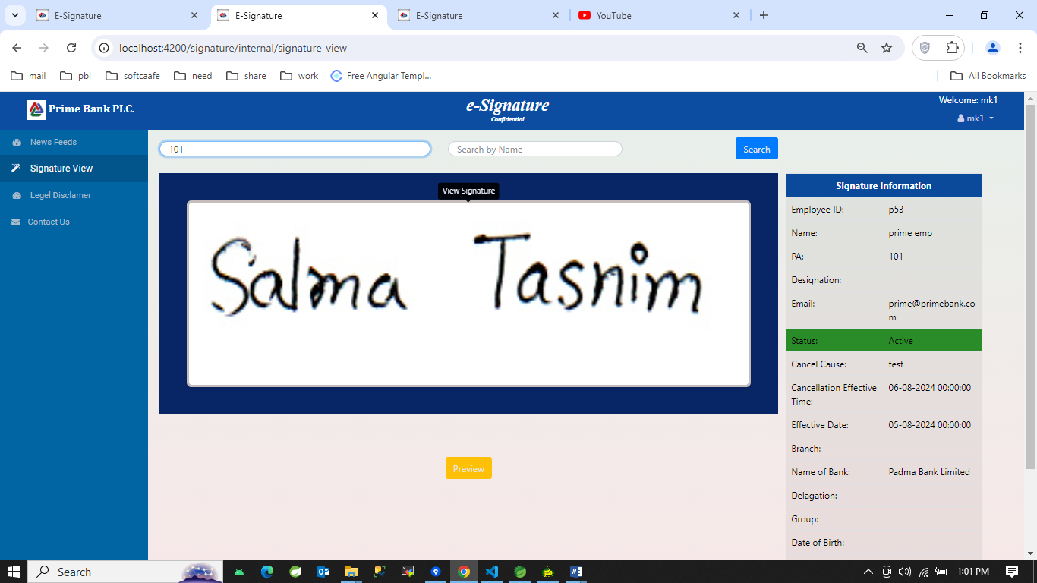

1. Inactive signature look:

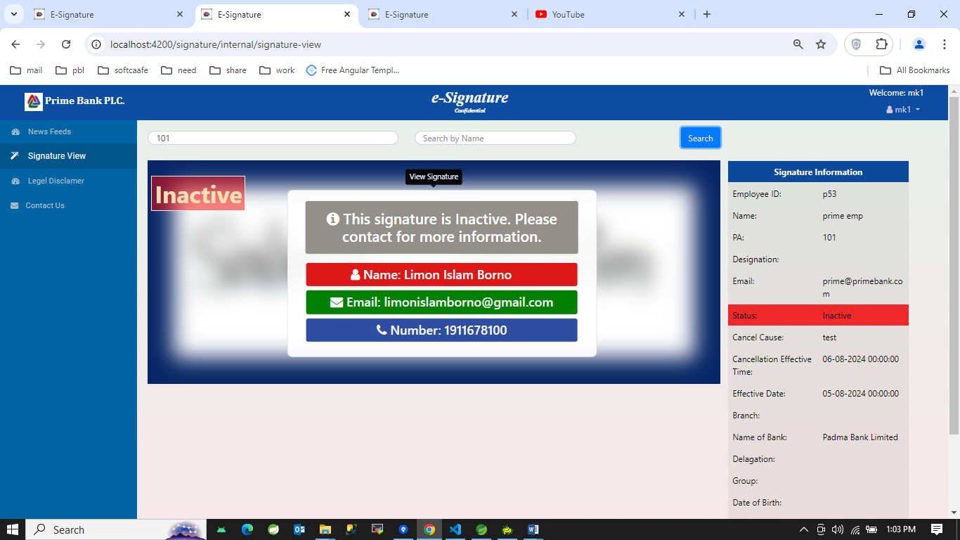

Note: Cancel and Inactive signature view are same.

1. Legal declaimer section:

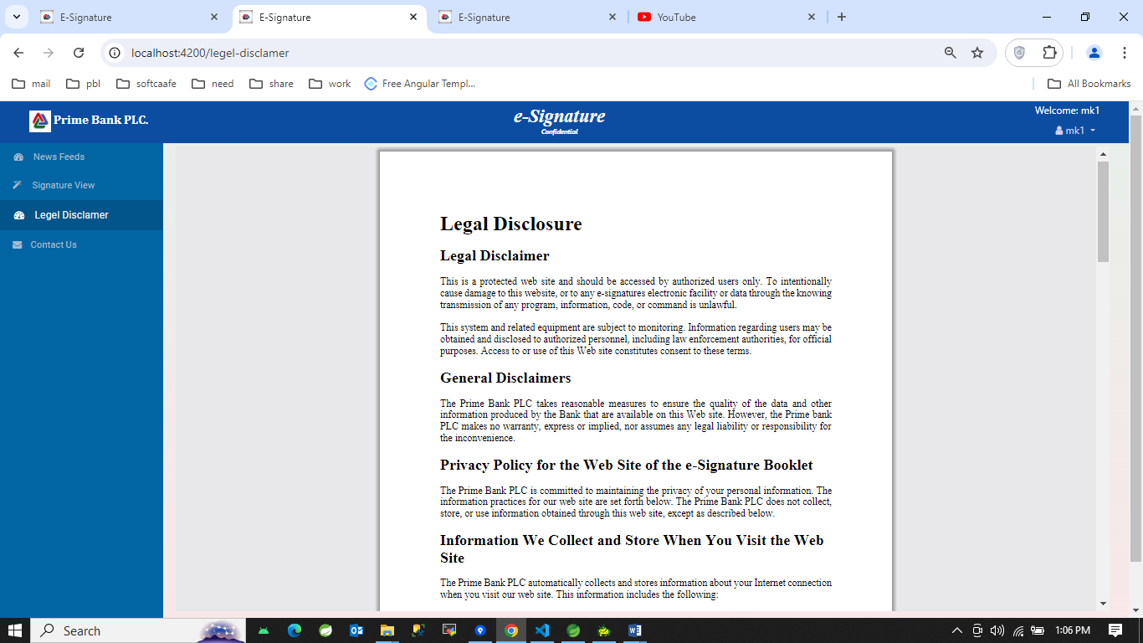

1. Contact us section:

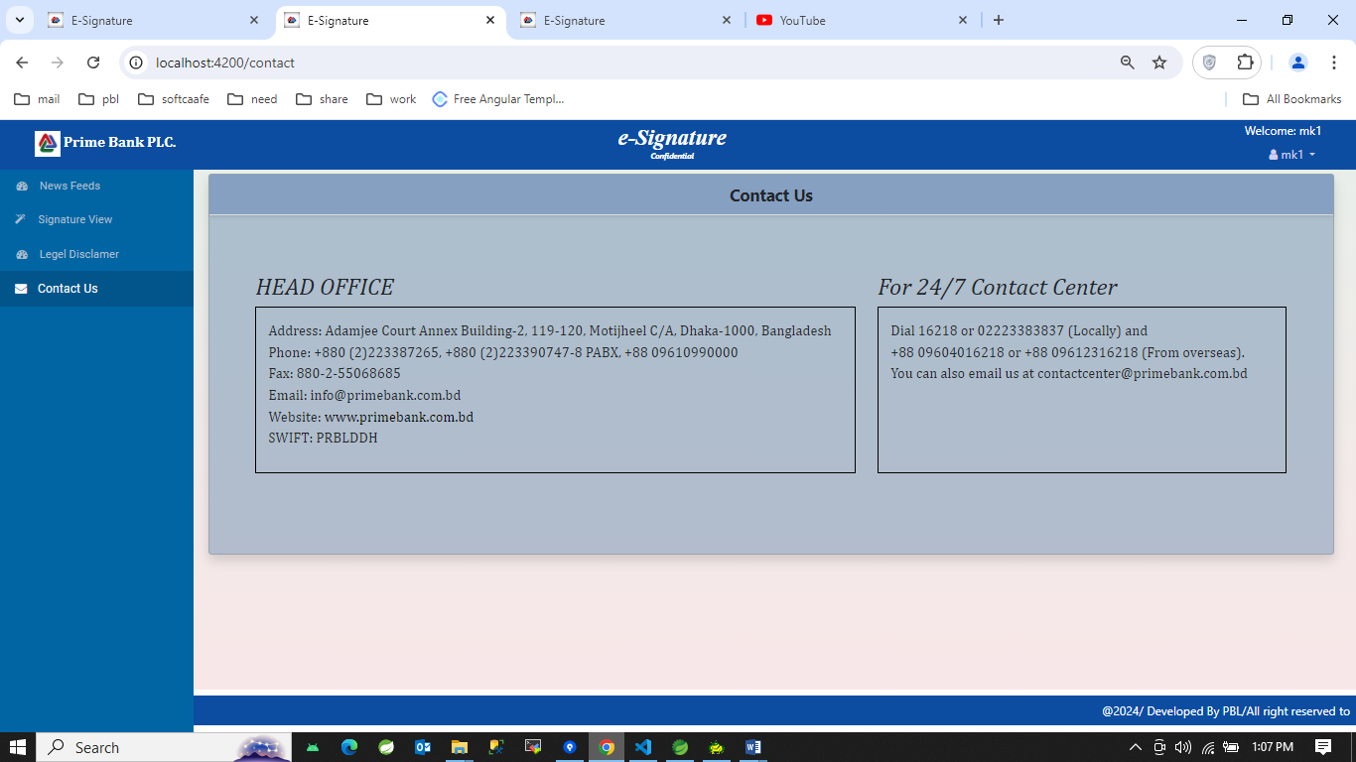

1. Profile section:

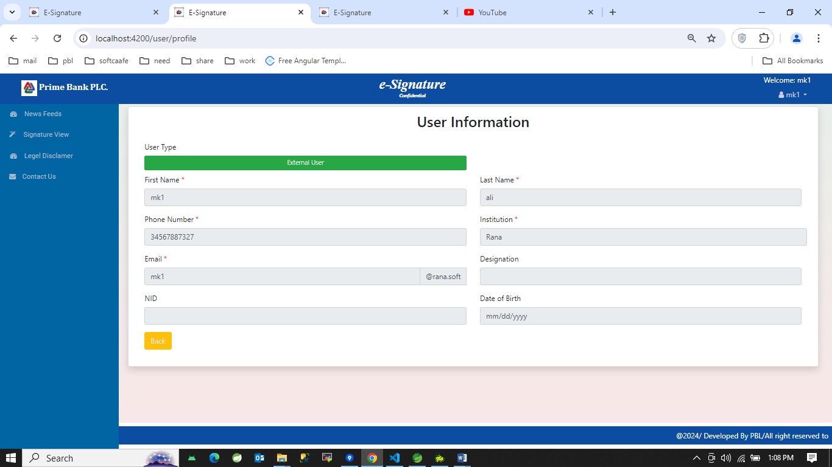

1. Change Password section:

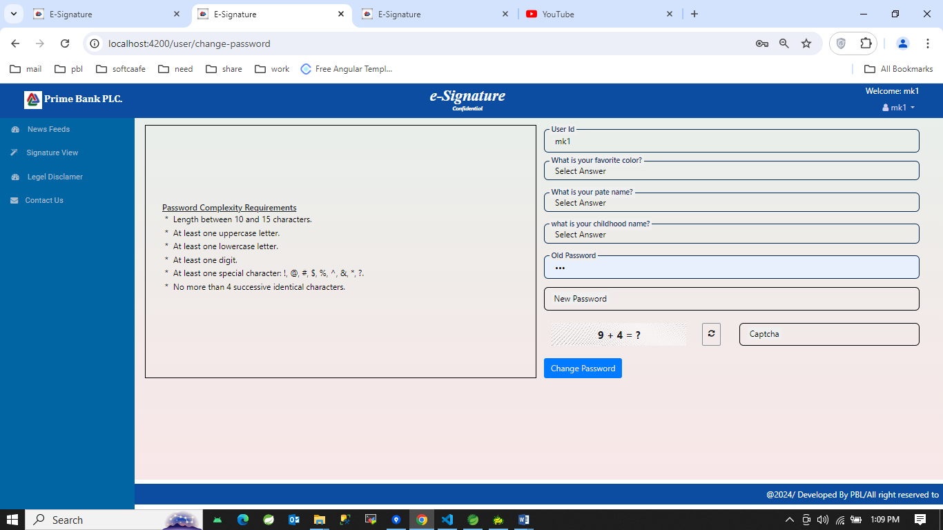

1. Request section:
2. 1st look:

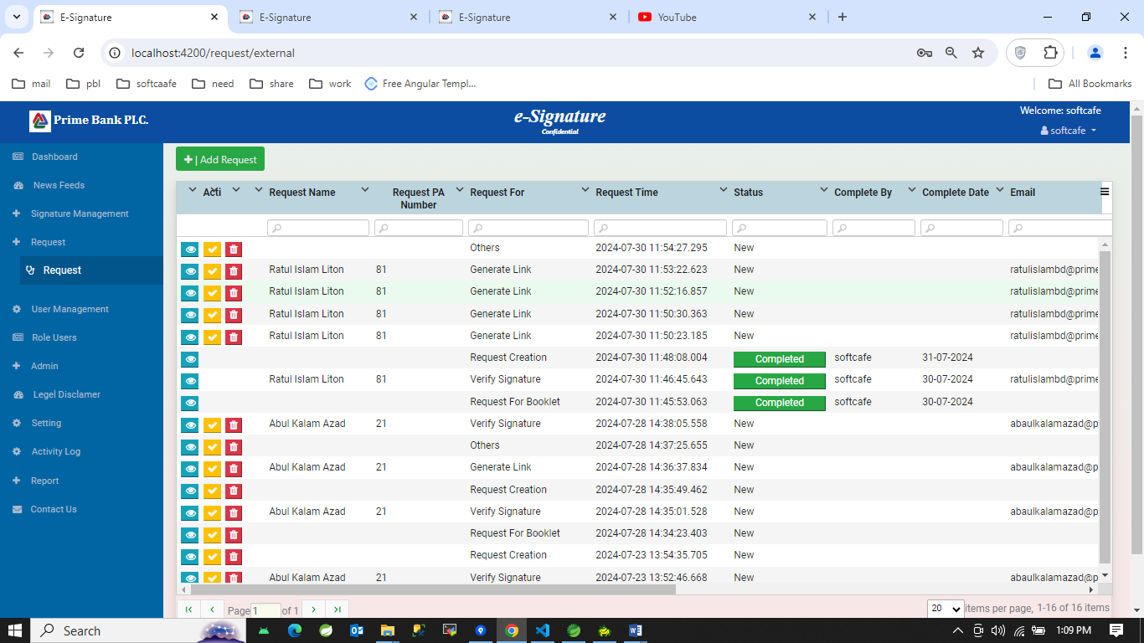

1. 2nd look: add request button click

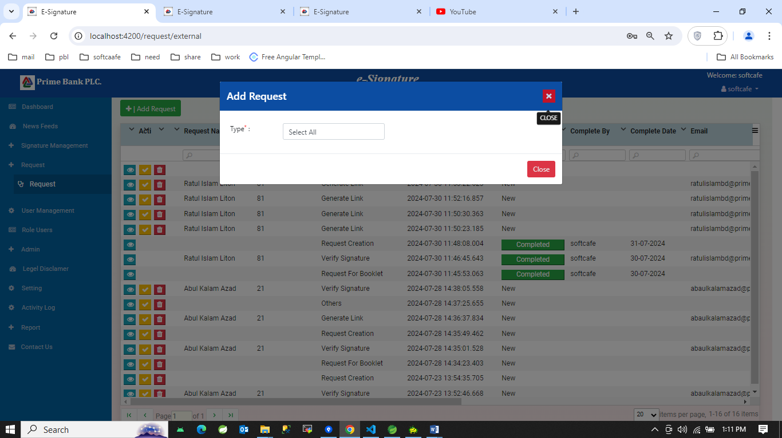

1. Selecting type is Request for booklet:

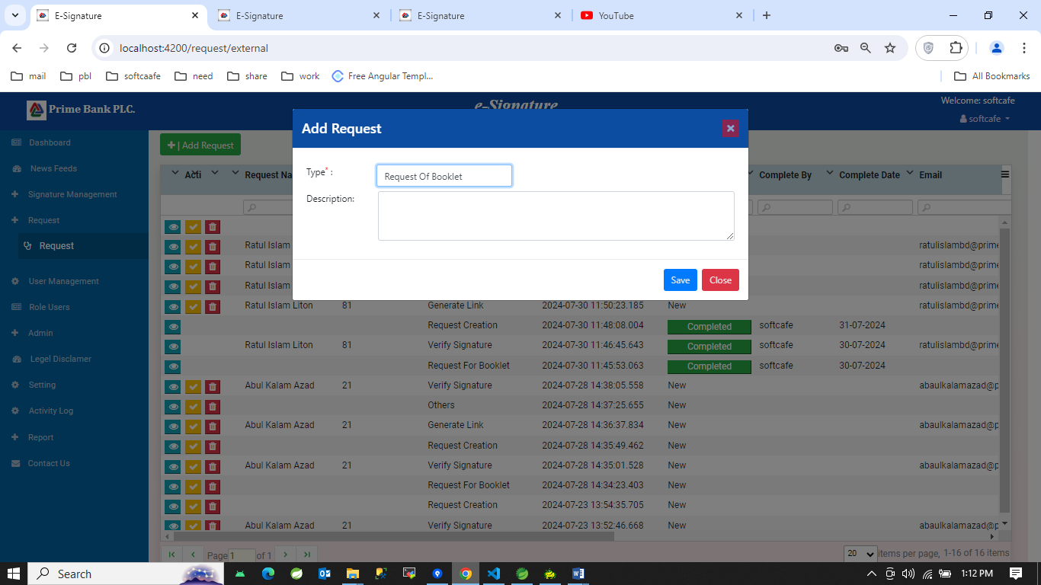

1. Selecting type is Verify signature and pa number:

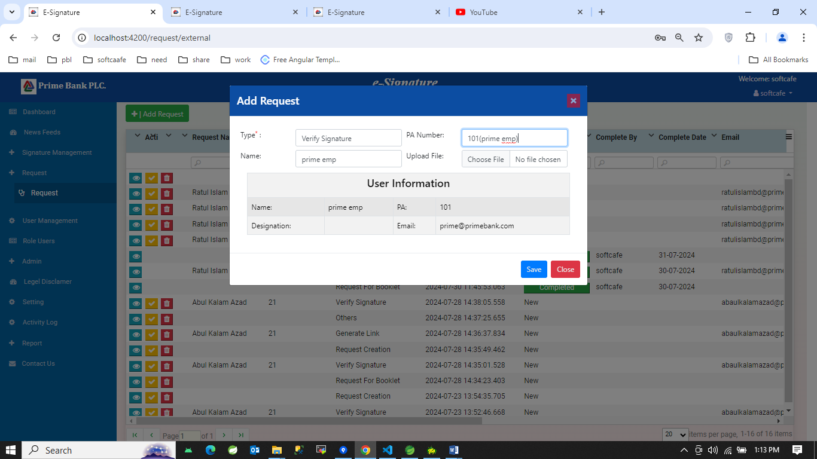

1. Selecting type is Request creation and Request For options:

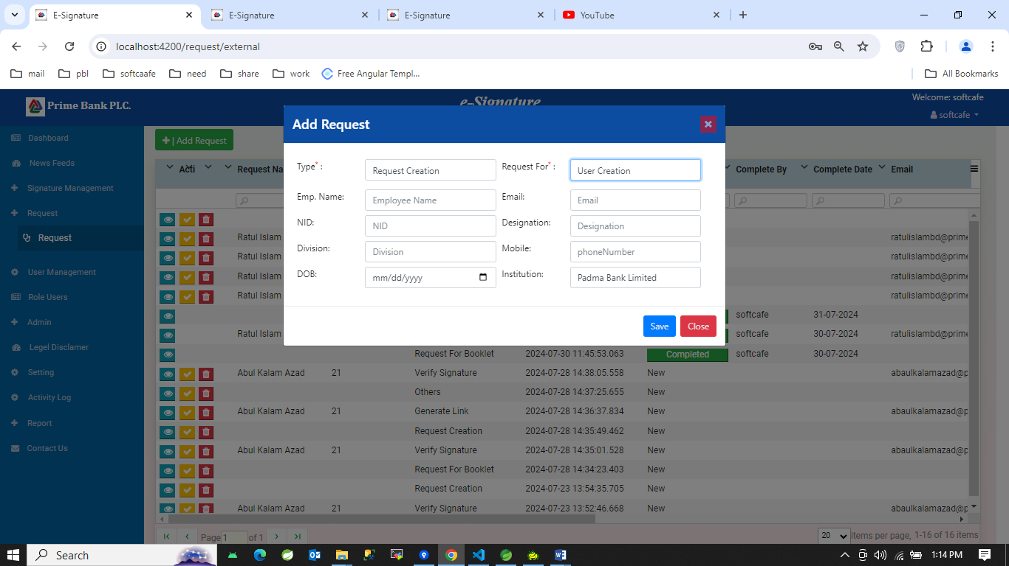

1. Selecting type is Generate Link and Link Type options:

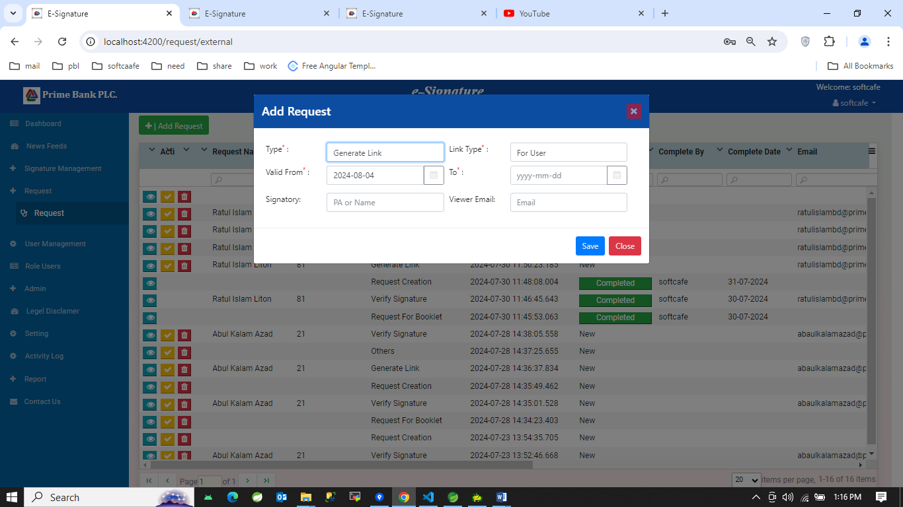

1. Selecting type is others:

