Steps to setup override reason for Account Holder branch to make approval on ATM card request:

1. Open **Admin** > **Configuration** > **Transaction Configuration**
2. Select **Add / Edit ATM Card Request**
3. Open **Override Reasons**

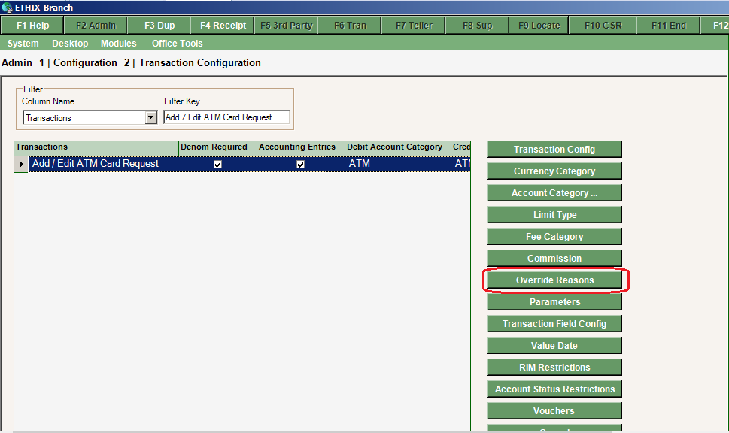

1. On **Override Reasons** section press **Add**

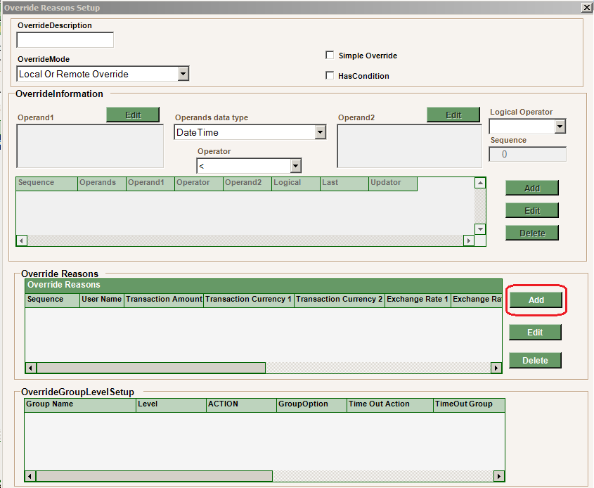

1. Set the fields as the screenshot then press **Add**

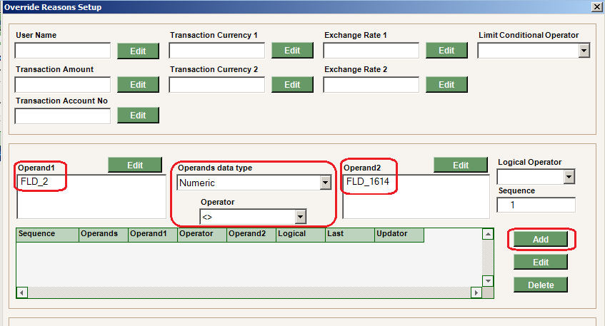

1. On **Override Reason Group Level Setup** section press **Add**

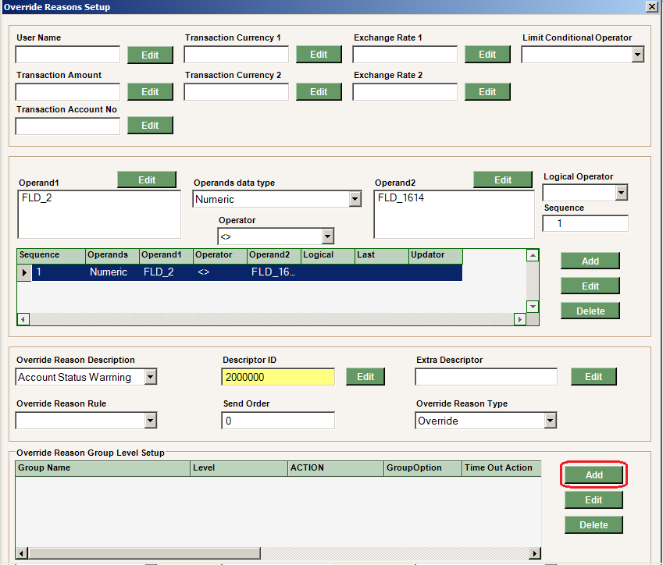

1. Select the required group (i.e. GFSSupervisrors) then Press **Ok**

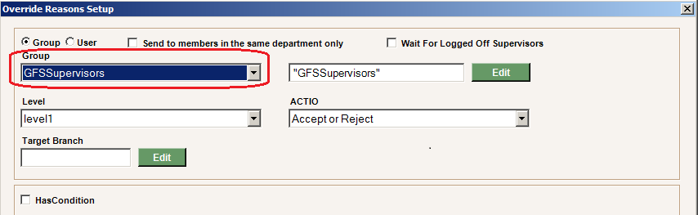

1. On **Override Reason Setup** press **F12**

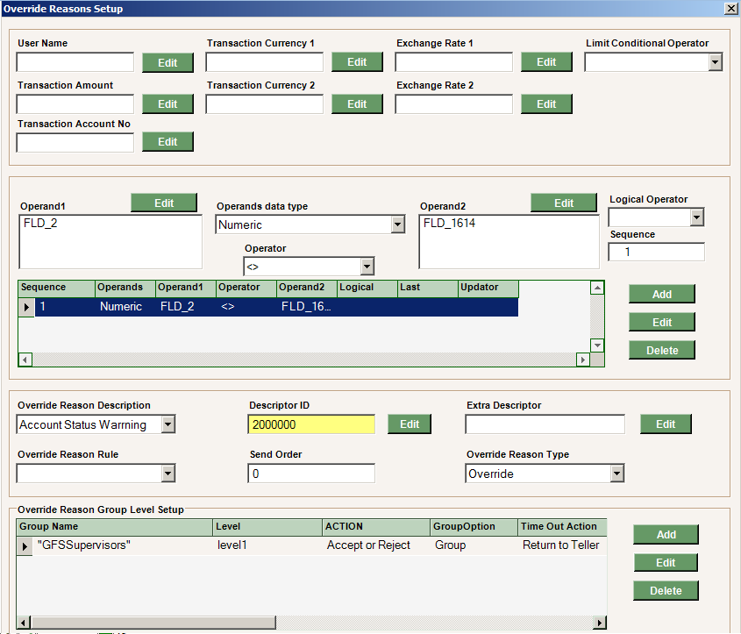

1. Finally Press **F12**

