PPS

MINI – PROJECT

USING C

Project Name: Puppy Adoption Centre Management Software

By:

Mihika Tripathi

RA2111050010007

CSE – BCT – Q1

DESCRIPTION:

This a project written in C Programming Language using File Input/Output operations. It is used to maintain the records of the puppies in a puppy adoption centre.

Details Recorded are:

1. Puppy Code – For unique identification
2. Birthdate – For owners to celebrate birthdays
3. Age – To take timely health care and other physical needs
4. Puppy Name – For Records Purposes
5. Owner Name – For Records Purposes
6. Price – That varies according to breed

The following records can be Inserted, Searched and Updated using the program.

Libraries Used:

1. stdio.h – For scanf() and printf().
2. stdlib.h – For system() and exit().
3. conio.h – For fopen(), fclose(), fread(), fwrite() and fseek().

#include <stdio.h>

#include <stdlib.h>

#include <conio.h>

void insert();

void search();

void update();

struct puppies

{

    int pupcode;

    int birthdate;

    int pupage;

    char pupname[20];

    char ownername[20];

    float price;

};

struct puppies puppy;

void main()

{

    int choice;

    while (choice != 4)

    {

        printf("\t\*\*\*\*\*\*\*\*\*\*\*\*\*\*\*\*\*\*\*\*\*\*\*\*\*\*\*\*\*\*\*\*\*\*\n");

        printf("\t  'WELCOME TO PUPPY.CO DATABASE'\n");

        printf("\t\*\*\*\*\*\*\*\*\*\*\*\*\*\*\*\*\*\*\*\*\*\*\*\*\*\*\*\*\*\*\*\*\*\*\n\n\n");

        printf("\t\*\*\*\*What would you like to do?\*\*\*\*\n\n");

        printf("\t~1: Insert Puppy record~\n");

        printf("\t~2: Search Puppy record~\n");

        printf("\t~3: Update Puppy record~\n");

        printf("\t~4: Exit~\n\n");

        printf("\tEnter Your Choice : ");

        scanf("%d", &choice);

        switch (choice)

        {

        case 1:

            system("cls");

            insert();

            break;

        case 2:

            system("cls");

            search();

            break;

        case 3:

            system("cls");

            update();

            break;

        case 4:

            exit(1);

            break;

        default:

            printf("\n\t\t!!! You Entered The Wrong Choice !!!\n\n");

        }

        getchar();

    }

}

void insert()

{

    FILE \*fp;

    fp = fopen("puppyco.txt", "a+");

    printf("\n\n\t~~~ENTER NEW PUPPY DATA~~~");

    printf("\n\n\tEnter Puppy Code : ");

    scanf("%d", &puppy.pupcode);

    printf("\n\tEnter Birth Date : ");

    scanf("%d", &puppy.birthdate);

    printf("\n\tEnter Puppy Age : ");

    scanf("%d", &puppy.pupage);

    fflush(stdin);

    printf("\n\tEnter Puppy Name : ");

    gets(puppy.pupname);

    printf("\n\tEnter Owner Name : ");

    gets(puppy.ownername);

    printf("\n\tEnter Price : ");

    scanf("%f", &puppy.price);

    fwrite(&puppy, sizeof(puppy), 1, fp);

    {

        printf("\n\n\tPuppy Details Recorded Sucessfully !!!\n");

    }

    fclose(fp);

    fflush(stdin);

    printf("\n\t\tRecord Updated !!!\n\n");

}

void search()

{

    int code, flag = 0;

    FILE \*fp;

    fp = fopen("puppyco.txt", "r");

    if (fp == NULL)

    {

        printf("\n\t\tError : File Does Not Exist !!! ");

        return;

    }

    printf("\n\n\tEnter Puppy Code To Search : ");

    scanf("%d", &code);

    while (fread(&puppy, sizeof(puppy), 1, fp) > 0 && flag == 0)

    {

        if (puppy.pupcode == code)

        {

            flag = 1;

            printf("\n\tSearch Sucessfull And Puppy Details Is as follows");

            printf("\n\n\tPuppy Code\tBirth Date\tAge\tPuppy Name\tOwner Name\tPrice\n");

            printf("\t%d\t\t%d\t\t%d\t%s\t\t%s\t\t%.4f\n\n\n", puppy.pupcode, puppy.birthdate, puppy.pupage, puppy.pupname, puppy.ownername, puppy.price);

        }

    }

    if (flag == 0)

    {

        printf("\n\n\t\t!!! No Record Found !!!\n\n");

    }

    fclose(fp);

}

void update()

{

    int code, flag = 0;

    FILE \*fp;

    fp = fopen("puppyco.txt", "r+");

    if (fp == NULL)

    {

        printf("\n\t\tError : File Does Not Exist");

        return;

    }

    printf("\n\n\tEnter Puppy Code of the Puppy Details To Update : ");

    scanf("%d", &code);

    printf("\n\n\t\t \*\*\* Previously Stored Puppy Details for the Puppy Code \*\*\*\n");

    while (fread(&puppy, sizeof(puppy), 1, fp) > 0 && flag == 0)

    {

        if (puppy.pupcode == code)

        {

            flag = 1;

            printf("\n\n\tPuppy Code\tBirth Date\tAge\tPuppy Name\tOwner Name\t\tPrice\n");

            printf("\t%d\t\t%d\t\t%d\t\t%s\t\t%s\t\t\t%.4f\n\n\n", puppy.pupcode, puppy.birthdate, puppy.pupage, puppy.pupname, puppy.ownername, puppy.price);

            printf("\n\t\t\*\*\* Update the Puppy Details \*\*\*\n\n");

            printf("\n\tEnter Puppy Code : ");

            scanf("%d", &puppy.pupcode);

            printf("\n\tEnter Birth Date : ");

            scanf("%d", &puppy.birthdate);

            printf("\n\tEnter Puppy Age : ");

            scanf("%d", &puppy.pupage);

            fflush(stdin);

            printf("\n\tEnter Puppy Name : ");

            gets(puppy.pupname);

            printf("\n\tEnter Owner Name : ");

            gets(puppy.ownername);

            printf("\n\tEnter Price : ");

            scanf("%f", &puppy.price);

            fseek(fp, -(long)sizeof(puppy), 1);

            fwrite(&puppy, sizeof(puppy), 1, fp);

            printf("\n\n\t\tDetails Updated\n\n\n");

        }

    }

    if (flag == 0)

    {

        printf("\n\t\tError : Something Went Wrong !!!\n\n");

    }

    {

        printf("\n\n\tPuppy Details Recorded Sucessfully !!!\n");

    }

    fclose(fp);

    fflush(stdin);

    printf("\n\t\tRecord Updated !!!\n\n");

}

Inserting Record:

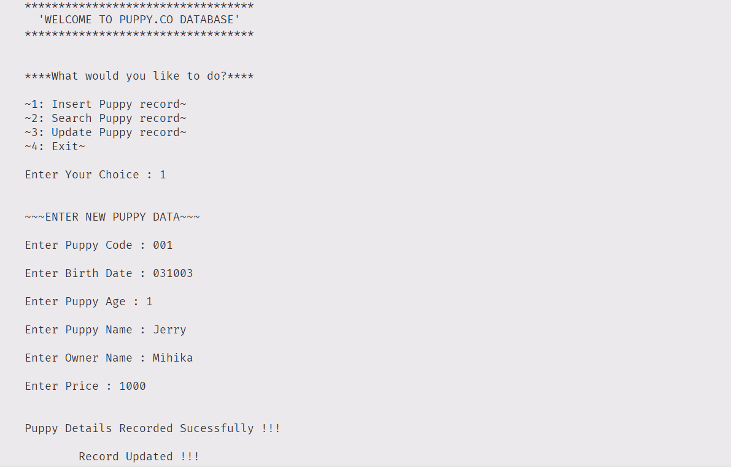

Searching Record:

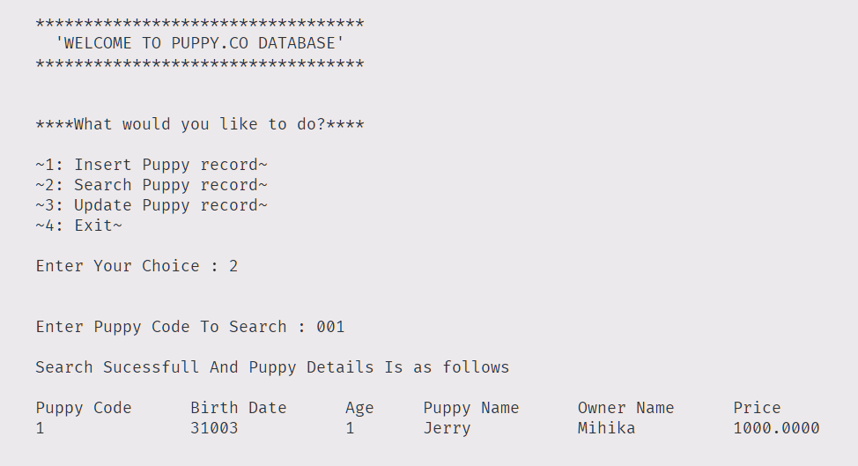

Updating Record: 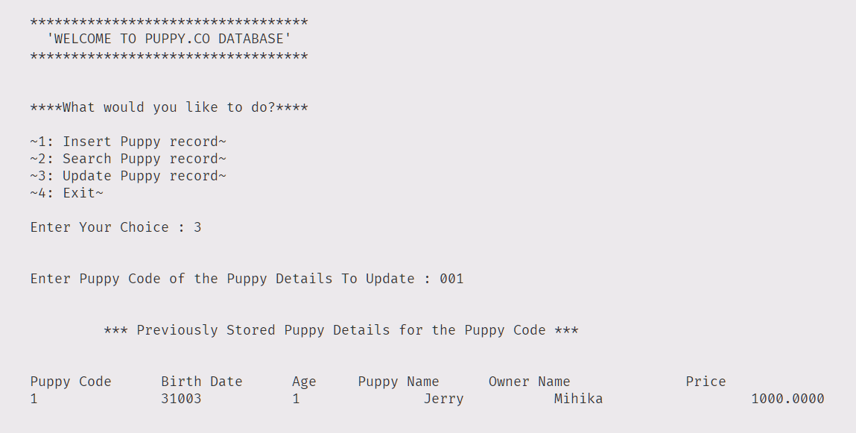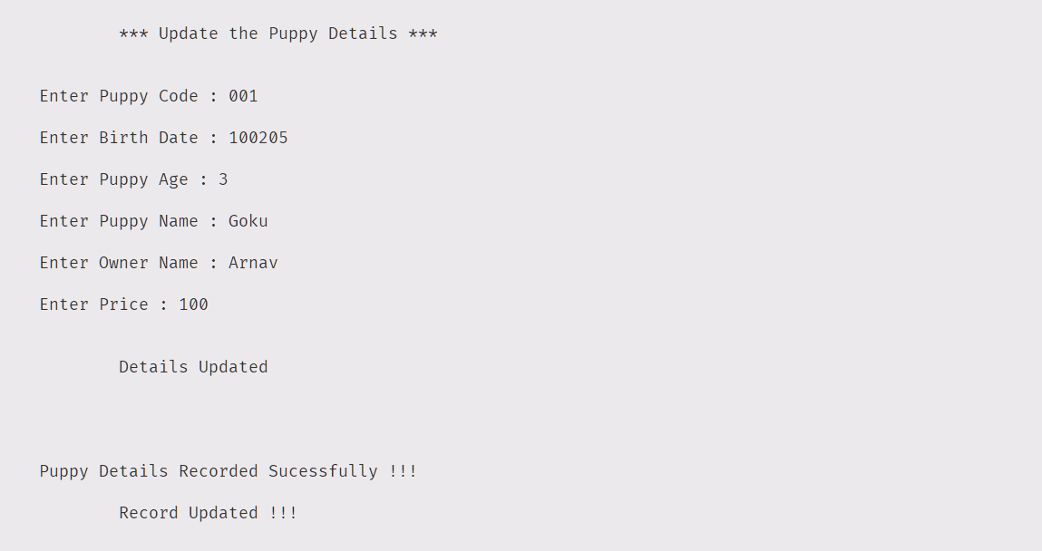

Searching Updated Record: