ATS (Applicant Tracking System)
SELECTECH Quick Start Guide

This tool provides you with instructions on accessing and using basic functionality in the ATS. For best results please use Internet Explorer Version 7 or better.

Logging in to the ATS system:
- Enter the URL for your admin system: https://erc1.ercdataplus.com
- Enter your username in the username field and enter your password in the password field
- The homepage to the ATS system will appear

Additional Help and Training:

Online Selectech Audio/Visual Help

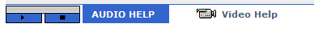
ERC Dataplus Support Contact
Customer Support
(203)750-5897
support@ercdataplus.com

Selectech Web Training Modules
Please paste the following link into your browser:
http://ercdataplus.com/video-training/Selectech-Training.htm

Navigation:

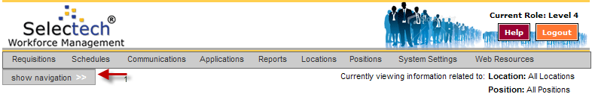

- Click on the show navigation menu ⁽¹⁾

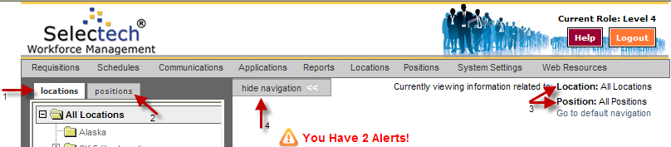

- You can navigate to specific locations and positions using the locations tab ⁽¹⁾ or the positions tab ⁽²⁾ in the navigation window
- To select a location or position find it in the location/position tree and click on the specific location or position you wish to view
- You can make sure you have selected the correct location/position by looking in the Location and Position fields ⁽³⁾ on your dashboard
- Once you have made your selection click on hide navigation ⁽⁴⁾ to close the window

Dashboard:

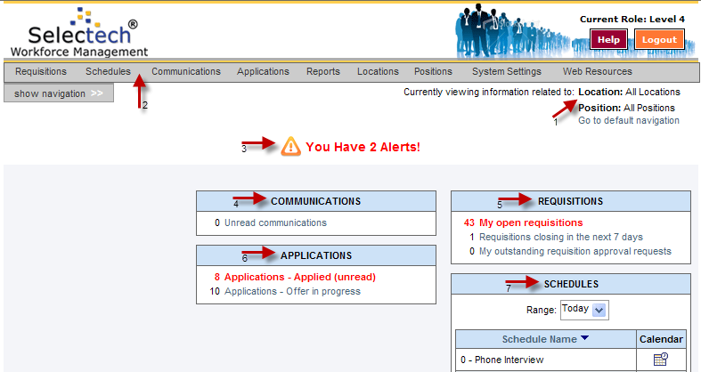

- The information shown on the Dashboard is directly related to the Location and Position information displayed ⁽¹⁾
- You have the ability to change your navigation settings or access the data you have access to in the ATS from your Dashboard screen ⁽²⁾
- If you have set any alarms you will see them displayed on the top of the screen ⁽³⁾
- You can set the information displayed in the Communication ⁽⁴⁾, Requisitions ⁽⁵⁾, Applications ⁽⁶⁾, and Schedules ⁽⁷⁾ menus
  - The links in the menus bring you directly to information for the Location and Position selected
- Please see Personal Settings section for information on how to personalize the Dashboard

Personal Settings:

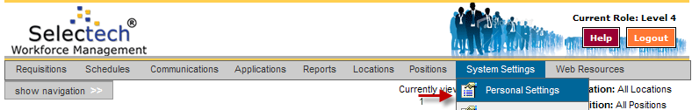

- Move your cursor over System Settings on the top menu bar
- Click on the Personal Settings ⁽¹⁾ option
- On the Navigation tab you can set the default Location and Position of your navigation window as well settings related to the information you are shown
- On the Dashboard tab you can select the information that will be displayed on your individual dashboard upon logging in to the ATS by clicking the checkbox next to the data you would like included on your dashboard
  - You can turn alarms on/off for the information that is displayed by clicking Alarm Off or Alarm On
- You have the ability to change your password on the Security tab
- You must click Save Changes before navigating to any other screen

Breadcrumb Trail:

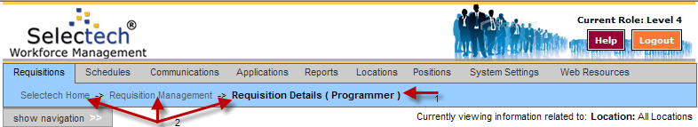

- The breadcrumb trail ⁽¹⁾ shows the path you have taken to view data. As you narrow down the search all previous screens become links ⁽²⁾ for easy navigation
- The breadcrumb trail should be used for navigation rather than the browsers back or forward button in order to ensure all work is saved correctly
Viewing/Printing Resumes:

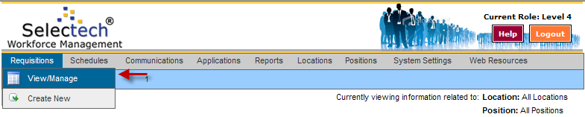

- Move your cursor over Requisitions on the top menu bar
- Click on the View/Manage option which will list all open requisitions
- From this screen you can see the number of applicants for any of your open positions
- To view resumes, click on the “view” link under the applications column
- Select the applicant(s) whose resumes you would like to view/print by clicking the checkbox
- In the drop down select View/Print/Email Resumes and click continue
- The candidate(s) resume(s) will appear in the window
- To view download the resume by clicking the “Click Here” link
- To print Click the “Send to Printer” icon
- Select a printer and click Ok

Communicating with applicants:

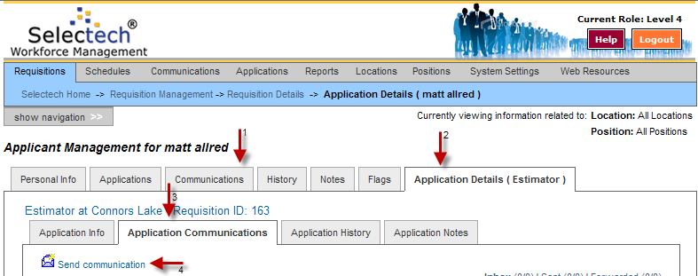

- Move your cursor over Requisitions on the top menu bar
- Click on the View/Manage option which will list all open requisitions
- From this screen you can see the number of applicants for any of your open positions
- Select the applicant you want to communicate with
- You can either click the Communications tab ⁽¹⁾ or in the Application Details tab ⁽²⁾ select Application Communications ⁽³⁾
- Select Send Communication ⁽⁴⁾
- You can select a template by clicking the Communications Template link or compose a custom message by filling out the Subject Line and the Message field
- Once all fields are filled in click Send Communication

Updating Dispositions:

- Critical to update applicant disposition status for applicant flow log/EEO reporting.
- Move your cursor over Requisitions on the top menu bar
- Click on “View/Manage”
- From this screen you can see the number of applicants for any of your open positions
- Select the applicant whose disposition you would like to update by clicking their last name
- On the Application Info tab under the Application Details tab update the disposition using the Disposition drop down menu
- Click Save Changes

