**12CS30015 and 12CS30035**

Data and Analysis

**Data Rate Throughput Forwarding Delay**

1024 KBPS AVG : 75195.0822646 SD : 431.243148511 AVG : 5.14661927917 SD : 0.00674876404294 AVG : 0.375233 SD : 0.0552777742045

512 KBPS AVG : 60744.6222301 SD : 254.038360393 AVG : 5.14388210643 SD : 0.00607368051284 AVG : 0.389343 SD : 0.0579708594123

256 KBPS AVG : 39135.4647762 SD : 175.305088927 AVG : 5.0934674266 SD : 0.00342366717315 AVG : 0.378733 SD : 0.0919545915167

128 KBPS AVG : 20765.4581121 SD : 29.0563322239 AVG : 4.95219446635 SD : 0.0135917914634 AVG : 0.331364 SD : 0.0218453867899

32 KBPS AVG : 12178.3943384 SD : 36.8612335524 AVG : 5.04971420477 SD : 0.0582867569302 AVG : 1.017811 SD : 0.497977818029

64 KBPS AVG : 10624.4401405 SD : 17.7338058486 AVG : 4.80859787847 SD : 0.0267153355551 AVG : 0.3224278 SD : 0.0415122926313

16 KBPS AVG : 18287.6676817 SD : 31.0407597466 AVG : 4.19615772433 SD : 0.191284861397 AVG : 1.453071 SD : 0.329059643088

The above values are obtained by seeding the Pseudo Random Number Generator in the udp-echo.cc file and taking the average and standard deviation of each performance parameter. The seeding is done by taking the epoch time as the seed.

The Data obtained is then plotted in three graphs for each performance parameters using GNUPlot. The commands for the generation of the graph are given in the .txt files attached.

script.py : It parses the trace files and calculates the performance parameters (avg and std. Deviation) for the 10 runs of each individual data generation rate.

outputscript.sh : It generates the data(3 Performance Parameters for all Data Gen. Rates ) in a tabulated form in output.txt by using script.py

|  |  |  |
| --- | --- | --- |
| **Data Generation Rate** | Packet Size | Time Delay between 2 packets |
| 16 KBPS | 8 KB | 0.5 secs |
| 32 KBPS | 16KB | 0.5 secs |
| 64 KBPS | 32KB | 0.5 secs |
| 128 KBPS | 32KB | 0.25 secs |
| 256 KBPS | 32KB | 0.125 secs |
| 512 KBPS | 32KB | 0.0625 secs |
| 1024 KBPS | 32KB | 0.03125 secs |

The graphs and the individual analysis is given below

Throughput:

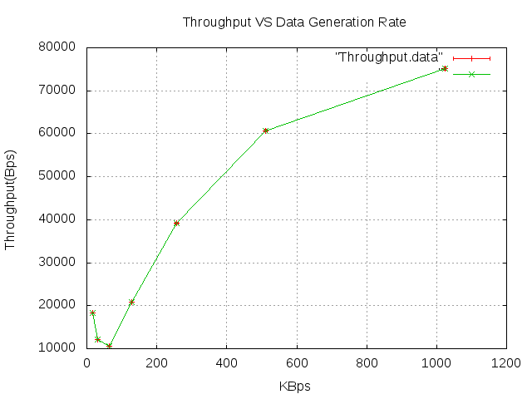

Analysis:

Throughput (average amount of data bits successfully transmitted per unit time) decreases with increase in data rate till 64KBPS and then increases from there. The standard deviation is negligible to be visible in the graph with respect to the scales used.

The Throughput decreases from 16 KBPS to 64 KBPS because the size of the packet is increasing and the time delay between 2 consecutive UDP Packets is the same. So,more time is taken to transmit the data between two nodes but after 64 KBPS the packet size remains the same while the time delay decreases. So, the Throughput increases till 1024 KBPS.

Forwarding Delay:

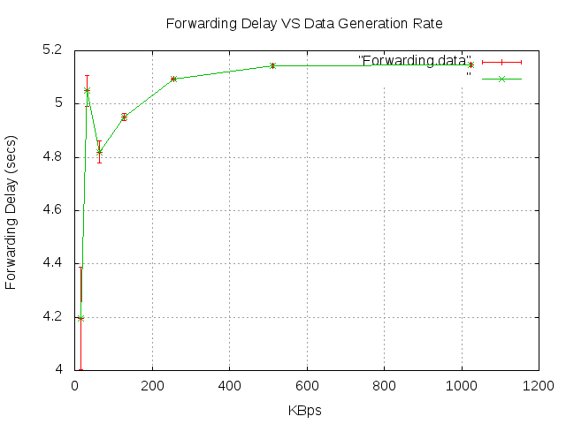

Analysis:

Forwarding Delay (Average end-to-end delay (including the queuing delay and the transmission delay) experienced by the CSMA frames) broadly increases with increase in data rate tll 256 KBPS and then remains almost constant till 1024 KBPS with only a slight increase. Forwarding Delay also exhibits a decrease for 64 KBPS.

Jitter:

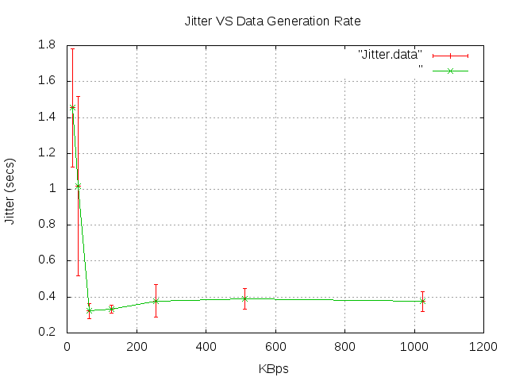

Analysis:

​ Jitter is the variation in individual frame delay. Jitter decreases with increase in Data Generation Rate till 64 KBPS and then almost remains constant till 1024 KBPS.