Raspberry Pi
Memory and I/O Throughput – A Study
https://github.com/ma16/rpio
– Version {draft}
This document was created with LibreOffice (Version 5.1.4.2 on Ubuntu 16.04.1 LTS).
The acompanied program is written in C++ and compiled with GCC by GNU make.
The test case execution and evaluation is performed by Perl scripts.
The 3D-bar images in this document were created in Perl with GD::Graph::bars3d by Jeremy Wadsack.

Motivation
The Raspberry Pi provides, besides others, several I/O pins, paired with a reasonable amount of memory (RAM) and a Linux operating system. Thus, data sampling becomes quite easy even for user-space applications. This projects tries to estimate an upper bound for the I/O throughput.

Copyright (c) 2016, ma16. All rights reserved.
Redistribution and use in source and compiled forms with or without modification, are permitted provided that the following conditions are met:
— Redistributions of source code must retain the above copyright notice, this list of conditions and the following disclaimer.
— Redistributions in compiled form must reproduce the above copyright notice, this list of conditions and the following disclaimer in the documentation and/or other materials provided with the distribution.
This documentation is provided by the copyright holders and contributors "as is" and any express or implied warranties, including, but not limited to, the implied warranties of merchantability and fitness for a particular purpose are disclaimed. In no event shall the copyright holders or contributors be liable for any direct, indirect, incidental, special, exemplary, or consequential damages (including, but not limited to, procurement of substitute goods or services; loss of use, data, or profits; or business interruption) however caused and on any theory of liability, whether in contract, strict liability, or tort (including negligence or otherwise) arising in any way out of the use of this documentation, even if advised of the possibility of such damage.
Table of Contents
1 Motivation 3
2 Classification 4
3 Setup 5
4 Test Cases 6
5 Peek / Poke / Copy — Word 7
6 Copy Buffer 8
7 Fill Buffer 9
8 Peek — Timer / Level / Event 10
9 Peek / Poke / Reset — Event 11
10 Read Timer 12
11 Read Level 13
12 Read Event 14

- Motivation
One of the interesting things about the Raspberry Pi is its wide range of peripheral devices – which are often only found on micro-controllers – paired with a reasonable amount of available memory (RAM) and a Linux operating system. This enables the development of applications for data sampling as on any other Linux system.
This project tries to determine the maximum I/O throughput for the Raspberry Pi in order to estimate its fitness for data sampling. The maximum I/O throughput should be considered as upper bound for data sampling, rather than an actually achievable sampling rate. – In order to estimate the sampling rate, a data signal would be required. However, this project simply accesses peripheral registers and ignores the sampled values.
Following three peripheral registers are of interest within the scope of this project:
- The System Timer Counter's (§12) lower 32 bits (CLO) at bus address 7e00:3000_{H}.
- The GPIO Pin Level 0 (§6, GPLEV0) at bus address 7e20:0034_{H}.
- The GPIO Pin Event Detect Status 0 (§6, GPEDS0) at bus address 7e20:0040_{H}.
Please refer to the section §6 and §12 in the “BCM2835 ARM Peripherals” document for details.
Since data sampling involves storing the sampled data into RAM also memory throughput is measured.

- Classification
The tests can be categorized, depending on data source and destination, as follows:
0 | : | 1 | 0 | → | [dst] |  | Store (constant) value at address dst.
0 | : | N | 0 | → | (dst,dst+N] | i=0..N-1: | Store (constant) value at address dst+i.
1 | : | 0 | [src] | → | 0 |  | Fetch value at address src. Ignore value.
1 | : | 1 | [src] | → | [dst] |  | Fetch value at address src and store at address dst.
1 | : | N | N × [src] | → | (dst,dst+N] | i=0..N-1: | Fetch value at address src and store at address dst+i.
N | : | 0 | (src,src+N] | → | 0 | i=0..N-1: | Fetch value at address src+i. Ignore value.
N | : | 1 | (src,src+N] | → | N × [dst] | i=0..N-1: | Fetch value at address src+i and store at address dst.
N | : | N | (src,src+N] | → | (dst,dst+N] | i=0..N-1: | Fetch value at address src+i and store at address dst+i.
All operations are aligned 32-bit word operations. An address may be the address of a peripheral register or a virtual RAM address in user space. A RAM address-range (addr,addr+N] is hereby called a buffer. If a RAM address is involved, this address is page-aligned. If a buffer is involved, the start address of the buffer is page-aligned.
All test cases are performed by iterator (Iter.) access (if there are any buffers). That is, a 32-bit iterator is used as index in order to read from and to write to a buffer.
Two test cases are performed by Libc calls. To copy a buffer (§6), the library function memcpy is called. To fill a buffer (§7), the library function memset is called.
All test cases support so-called operation-blocks of size M. Such a block of operations is used to minimize iterator overhead (i.e. increment, compare, branch). That is, M=1..256 (C⁠+⁠+) operation (i.e. 0:1,1:0,1:1) are executed in a sequence before an iterator is checked (manual loop-unrolling).
Test cases involving buffers are performed on varying buffer sizes N=2¹,2²,..,2²⁴. Operation-blocks of size M are never greater than buffer-sizes N.

- Setup
The tests have been performed on a Raspberry Pi Zero (Pi-0) and on a Raspberry Pi 2B (Pi-2).
Raspbian serves as Linux operating system, in particular the 2016-10-06 release which is a Raspbian 8.0 (Jessie) on a Linux kernel 4.4.21.
A fresh Raspbian image was installed, for the Pi-0 and the Pi-2 each. None of the default systems settings were changed. However, the package “libboost1.55-dev” needs to be installed before the project can be compiled.
The project's program was compiled with Raspbian's GCC compiler (version 4.9.2-10) with optimization enabled (-O3) and debug-checks disabled (-DNDEBUG). For additional information refer to the project's Makefile.
All tests run as single thread on the ARM core. No DMA (§4²) is involved. The process priority was not changed (nice, chrt). No cpu-set was assigned (taskset).
The results presented in this document cover 8000:0000_{H} 32-bit word operations for pure memory tests and 800:0000_{H} 32-bit word for all others. For example, a test case that uses an 1:0000_{H}-word buffer in a pure memory test, was repeated 8000_{H} times; a test case that uses a 2-word buffer, was repeated 4000:0000_{H} times. The test cases were clocked (time taken) when all repetitions had finished.
For more information see the source code.

- Test Cases
The subsequent chapters illustrate and present the results of the test cases as follows:
§5: Peek / Poke / Copy — Word: This is a pure RAM test to estimate the maximum throughput for 1:0, 0:1 and 1:1 mode. The result may help to judge (by comparison) the other pure RAM tests.
§6: Copy Buffer: This is a pure RAM test to estimate the maximum throughput for N:N mode with varying N. The result may help to judge (by comparison) the other pure RAM tests. The test includes Libc's memcpy as benchmark (i.e. as reference value).
§7: Fill Buffer: This is a pure RAM test to estimate the maximum throughput for 0:N mode. The result provides an upper bound for sampling peripheral register (including storing their values into RAM). The test includes Libc's memset as benchmark (i.e. as reference value).
§8: Peek — Timer / Level / Event: This is a pure peripheral test to estimate the maximum throughput in 1:0 mode for each of the given three peripheral addresses.
§9: Peek / Poke / Reset — Event: This is a pure peripheral test to estimate the maximum throughput for the Event register. Other than the Timer and Level registers, the Event register keeps holding a value until it is explicitly reset. Reset is performed by writing back the last read value (which is actually a copy operation).
§10: Read Timer: This test estimates the maximum throughput when sampling the Timer register to a buffer (1:N). The test is performed for a number of varying buffer sizes N.
§11: Read Level: This test estimates the maximum throughput when sampling the Level register to a buffer (1:N). The test is performed for a number of varying buffer sizes N.
§12: Read Event: This test estimates the maximum throughput when sampling the Event register to a buffer (1:N). The test is performed for a number of varying buffer sizes N.
The throughput on the following pages is given in millions of 32-bit word operations per second (MS). For example, a value of 12.5 MS means 12.5 million 32-bit word operations per second (which are 50 MB/s).
- Peek / Poke / Copy — Word
The peek (1:0), poke (0:1) and copy (1:1) operations are executed by Iter., and in operation-blocks of size M.
Pi-0 | Pi-1
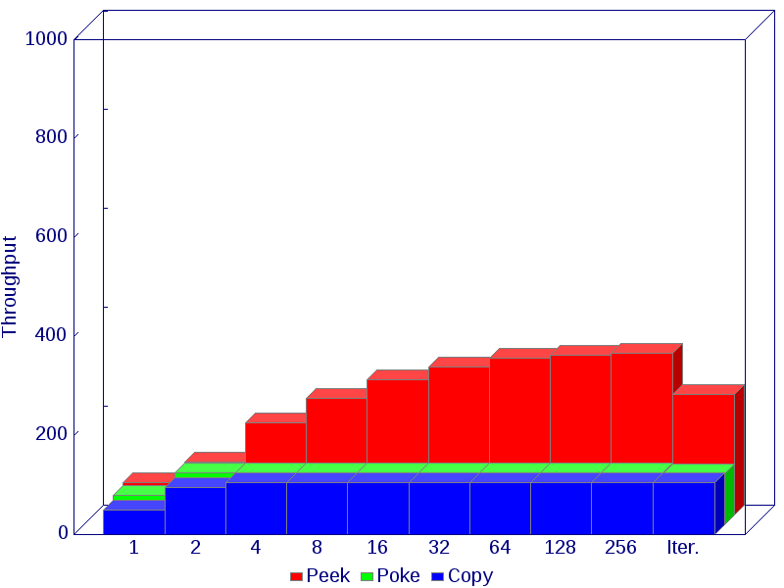 | 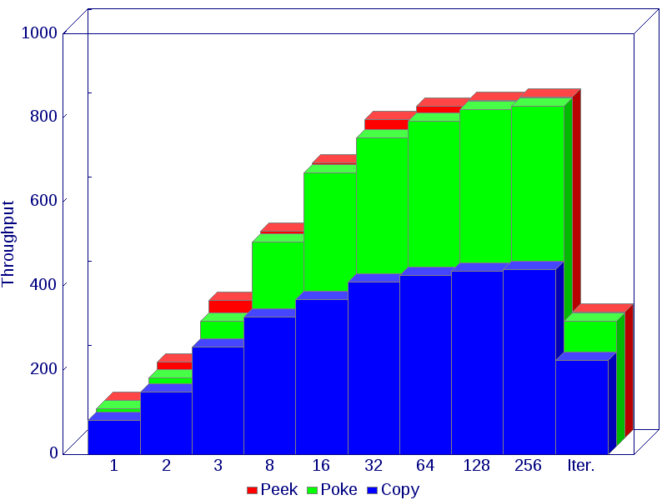

Pi-0 | M=1 | 2 | 3 | 8 | 16 | 32 | 64 | 128 | 256 | Iter.
Peek | 65.0 | 108.0 | 186.0 | 236.0 | 274.0 | 300.0 | 317.0 | 324.0 | 327.0 | 243.0
Poke | 59.8 | 106.0 | 106.0 | 106.0 | 106.0 | 106.0 | 106.0 | 106.0 | 106.0 | 104.0
Copy | 50.2 | 94.9 | 106.0 | 106.0 | 106.0 | 106.0 | 106.0 | 106.0 | 106.0 | 106.0
Pi-2 | M=1 | 2 | 3 | 8 | 16 | 32 | 64 | 128 | 256 | Iter.
Peek | 89.9 | 180.0 | 327.0 | 492.0 | 654.0 | 757.0 | 788.0 | 803.0 | 811.0 | 300.0
Poke | 89.3 | 162.0 | 298.0 | 485.0 | 650.0 | 733.0 | 773.0 | 800.0 | 808.0 | 298.0
Copy | 81.7 | 149.0 | 256.0 | 327.0 | 368.0 | 411.0 | 427.0 | 436.0 | 441.0 | 223.0

- Copy Buffer
A buffer of size N is copied (N:N) by Libc's memcpy, by Iter., and in operation-blocks of size M.
Pi-0 | Pi-2
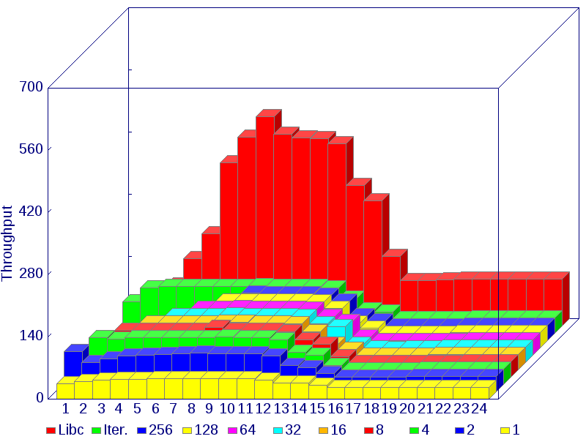 | 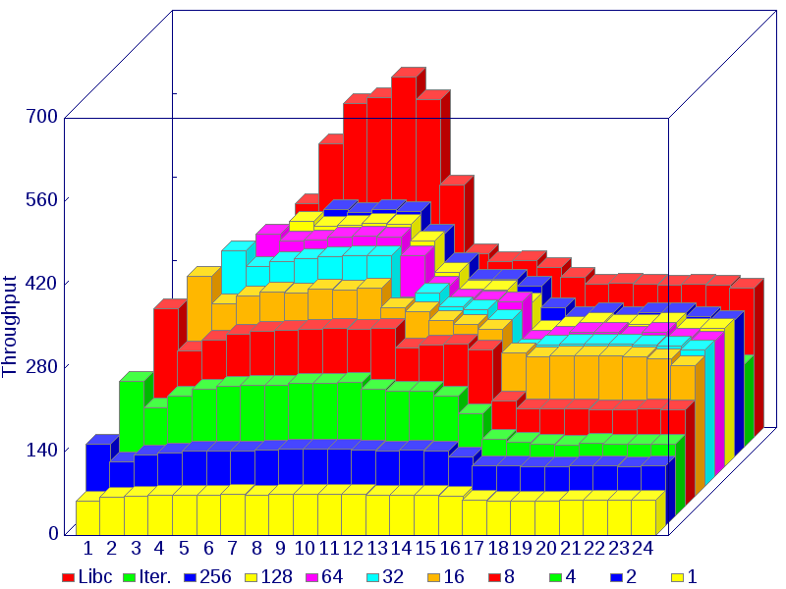

Pi-0 | N=2¹ | 2² | 2³ | 2⁴ | 2⁵ | 2⁶ | 2⁷ | 2⁸ | 2⁹ | 2¹⁰ | 2¹¹ | 2¹² | 2¹³ | 2¹⁴ | 2¹⁵ | 2¹⁶ | 2¹⁷ | 2¹⁸ | 2¹⁹ | 2²⁰ | 2²¹ | 2²² | 2²³ | 2²⁴
Libc | 28.6 | 55.6 | 92.7 | 151.0 | 208.0 | 367.0 | 425.0 | 471.0 | 432.0 | 423.0 | 422.0 | 410.0 | 316.0 | 282.0 | 156.0 | 102.0 | 103.0 | 104.0 | 105.0 | 105.0 | 106.0 | 106.0 | 106.0 | 106.0
Iter. | 71.4 | 103.0 | 106.0 | 106.0 | 106.0 | 106.0 | 106.0 | 107.0 | 106.0 | 106.0 | 106.0 | 103.0 | 79.2 | 52.4 | 48.0 | 33.0 | 33.0 | 33.2 | 33.6 | 33.9 | 34.0 | 34.2 | 34.2 | 34.2
256 | n/a | n/a | n/a | n/a | n/a | n/a | n/a | 107.0 | 106.0 | 106.0 | 105.0 | 103.0 | 88.3 | 56.0 | 44.7 | 33.7 | 32.4 | 33.5 | 33.7 | 33.9 | 34.0 | 33.9 | 34.1 | 34.2
128 | n/a | n/a | n/a | n/a | n/a | n/a | 106.0 | 106.0 | 106.0 | 106.0 | 105.0 | 104.0 | 88.7 | 56.5 | 44.8 | 32.7 | 32.5 | 33.0 | 33.7 | 33.9 | 34.0 | 34.1 | 34.2 | 34.2
64 | n/a | n/a | n/a | n/a | n/a | 106.0 | 106.0 | 107.0 | 106.0 | 106.0 | 105.0 | 104.0 | 87.9 | 76.4 | 41.1 | 33.8 | 32.2 | 33.2 | 33.7 | 33.8 | 34.1 | 34.2 | 34.1 | 34.2
32 | n/a | n/a | n/a | n/a | 106.0 | 106.0 | 106.0 | 107.0 | 106.0 | 106.0 | 105.0 | 104.0 | 86.8 | 80.5 | 41.5 | 33.7 | 32.1 | 33.2 | 33.5 | 33.9 | 34.1 | 34.2 | 34.2 | 34.1
16 | n/a | n/a | n/a | 106.0 | 106.0 | 106.0 | 106.0 | 108.0 | 107.0 | 106.0 | 105.0 | 104.0 | 85.6 | 56.9 | 45.8 | 33.7 | 33.4 | 33.2 | 33.7 | 34.0 | 34.2 | 34.2 | 34.2 | 34.2
8 | n/a | n/a | 106.0 | 106.0 | 106.0 | 106.0 | 106.0 | 112.0 | 106.0 | 106.0 | 106.0 | 103.0 | 83.5 | 74.7 | 45.6 | 33.7 | 32.4 | 33.1 | 33.8 | 33.8 | 33.7 | 34.1 | 34.2 | 34.1
4 | n/a | 106.0 | 102.0 | 106.0 | 106.0 | 106.0 | 106.0 | 106.0 | 108.0 | 106.0 | 106.0 | 101.0 | 72.5 | 66.3 | 43.4 | 33.5 | 32.5 | 33.4 | 33.6 | 33.9 | 34.1 | 34.1 | 34.2 | 34.2
2 | 90.4 | 65.7 | 74.6 | 80.1 | 83.1 | 84.7 | 85.3 | 88.2 | 86.1 | 86.3 | 86.2 | 80.0 | 59.1 | 54.7 | 40.5 | 32.7 | 32.9 | 33.4 | 33.6 | 33.9 | 34.0 | 34.1 | 34.1 | 34.1
M=1 | 34.6 | 39.5 | 42.4 | 43.9 | 45.0 | 45.4 | 45.5 | 45.6 | 45.7 | 45.7 | 45.7 | 43.6 | 37.1 | 35.7 | 30.6 | 26.2 | 26.2 | 26.3 | 26.4 | 26.5 | 26.6 | 26.6 | 26.6 | 26.6
Pi-2 | N=2¹ | 2² | 2³ | 2⁴ | 2⁵ | 2⁶ | 2⁷ | 2⁸ | 2⁹ | 2¹⁰ | 2¹¹ | 2¹² | 2¹³ | 2¹⁴ | 2¹⁵ | 2¹⁶ | 2¹⁷ | 2¹⁸ | 2¹⁹ | 2²⁰ | 2²¹ | 2²² | 2²³ | 2²⁴
Libc | 24.0 | 49.0 | 95.2 | 166.0 | 284.0 | 392.0 | 493.0 | 560.0 | 570.0 | 605.0 | 567.0 | 424.0 | 309.0 | 295.0 | 296.0 | 285.0 | 268.0 | 257.0 | 259.0 | 258.0 | 256.0 | 258.0 | 256.0 | 250.0
Iter. | 150.0 | 179.0 | 200.0 | 210.0 | 218.0 | 215.0 | 218.0 | 222.0 | 223.0 | 223.0 | 223.0 | 214.0 | 208.0 | 207.0 | 200.0 | 199.0 | 173.0 | 148.0 | 146.0 | 142.0 | 142.0 | 141.0 | 140.0 | 138.0
256 | n/a | n/a | n/a | n/a | n/a | n/a | n/a | 416.0 | 411.0 | 415.0 | 413.0 | 375.0 | 327.0 | 298.0 | 298.0 | 287.0 | 251.0 | 236.0 | 243.0 | 235.0 | 242.0 | 242.0 | 235.0 | 230.0
128 | n/a | n/a | n/a | n/a | n/a | n/a | 412.0 | 404.0 | 406.0 | 409.0 | 408.0 | 379.0 | 327.0 | 297.0 | 296.0 | 275.0 | 229.0 | 236.0 | 243.0 | 239.0 | 239.0 | 242.0 | 233.0 | 233.0
64 | n/a | n/a | n/a | n/a | n/a | 408.0 | 395.0 | 398.0 | 402.0 | 404.0 | 402.0 | 371.0 | 320.0 | 298.0 | 295.0 | 294.0 | 230.0 | 235.0 | 242.0 | 243.0 | 236.0 | 242.0 | 233.0 | 228.0
32 | n/a | n/a | n/a | n/a | 395.0 | 369.0 | 378.0 | 382.0 | 386.0 | 387.0 | 387.0 | 302.0 | 325.0 | 302.0 | 296.0 | 281.0 | 231.0 | 238.0 | 239.0 | 239.0 | 239.0 | 238.0 | 236.0 | 230.0
16 | n/a | n/a | n/a | 369.0 | 323.0 | 336.0 | 343.0 | 341.0 | 348.0 | 347.0 | 350.0 | 316.0 | 310.0 | 295.0 | 288.0 | 281.0 | 241.0 | 234.0 | 236.0 | 235.0 | 235.0 | 234.0 | 231.0 | 219.0
8 | n/a | n/a | 332.0 | 261.0 | 279.0 | 289.0 | 293.0 | 295.0 | 297.0 | 298.0 | 297.0 | 298.0 | 266.0 | 270.0 | 272.0 | 262.0 | 177.0 | 163.0 | 163.0 | 164.0 | 162.0 | 162.0 | 163.0 | 162.0
4 | n/a | 226.0 | 182.0 | 202.0 | 213.0 | 217.0 | 220.0 | 220.0 | 223.0 | 223.0 | 224.0 | 213.0 | 209.0 | 209.0 | 201.0 | 171.0 | 129.0 | 123.0 | 120.0 | 119.0 | 122.0 | 120.0 | 120.0 | 120.0
2 | 137.0 | 108.0 | 118.0 | 122.0 | 125.0 | 126.0 | 126.0 | 127.0 | 128.0 | 128.0 | 128.0 | 127.0 | 125.0 | 127.0 | 126.0 | 116.0 | 101.0 | 101.0 | 99.5 | 99.7 | 99.9 | 101.0 | 99.5 | 99.8
M=1 | 57.1 | 63.9 | 65.6 | 67.4 | 68.0 | 68.0 | 68.6 | 68.4 | 69.0 | 68.7 | 69.1 | 68.7 | 68.4 | 68.2 | 67.6 | 65.3 | 58.7 | 58.3 | 58.5 | 58.0 | 58.9 | 59.0 | 59.0 | 58.7
- Fill Buffer
A buffer of size N is filled (0:N) by Libc's memset, by Iter., and in operation-blocks of size M.
Pi-0 | Pi-2
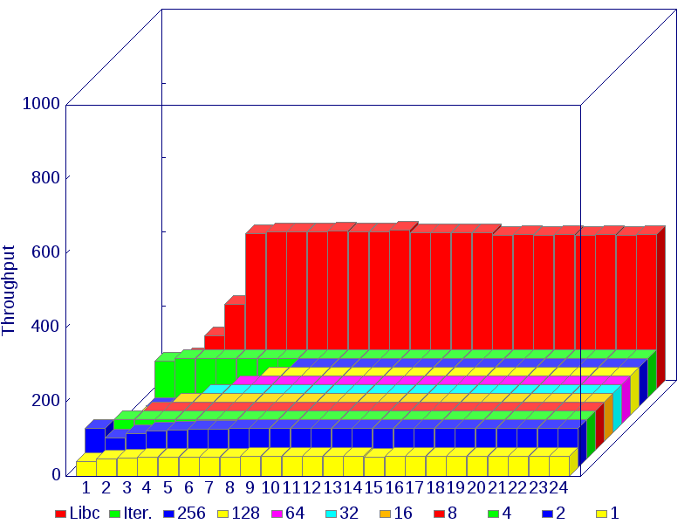 | 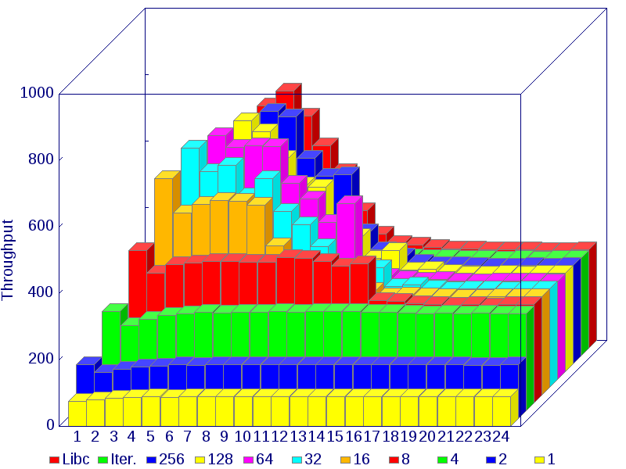

Pi-0 | N=2¹ | 2² | 2³ | 2⁴ | 2⁵ | 2⁶ | 2⁷ | 2⁸ | 2⁹ | 2¹⁰ | 2¹¹ | 2¹² | 2¹³ | 2¹⁴ | 2¹⁵ | 2¹⁶ | 2¹⁷ | 2¹⁸ | 2¹⁹ | 2²⁰ | 2²¹ | 2²² | 2²³ | 2²⁴
Libc | 43.3 | 86.7 | 144.0 | 228.0 | 419.0 | 423.0 | 424.0 | 425.0 | 426.0 | 425.0 | 424.0 | 428.0 | 422.0 | 421.0 | 422.0 | 422.0 | 415.0 | 417.0 | 414.0 | 417.0 | 415.0 | 416.0 | 414.0 | 416.0
Iter. | 100.0 | 106.0 | 106.0 | 106.0 | 106.0 | 106.0 | 106.0 | 106.0 | 106.0 | 106.0 | 106.0 | 106.0 | 106.0 | 106.0 | 106.0 | 106.0 | 106.0 | 106.0 | 106.0 | 106.0 | 106.0 | 106.0 | 106.0 | 106.0
256 | n/a | n/a | n/a | n/a | n/a | n/a | n/a | 106.0 | 106.0 | 106.0 | 107.0 | 106.0 | 106.0 | 106.0 | 106.0 | 106.0 | 106.0 | 106.0 | 106.0 | 106.0 | 106.0 | 105.0 | 106.0 | 106.0
128 | n/a | n/a | n/a | n/a | n/a | n/a | 106.0 | 106.0 | 106.0 | 106.0 | 106.0 | 107.0 | 106.0 | 106.0 | 106.0 | 106.0 | 106.0 | 106.0 | 106.0 | 106.0 | 106.0 | 106.0 | 106.0 | 106.0
64 | n/a | n/a | n/a | n/a | n/a | 106.0 | 106.0 | 106.0 | 106.0 | 106.0 | 107.0 | 106.0 | 106.0 | 106.0 | 106.0 | 106.0 | 105.0 | 106.0 | 106.0 | 106.0 | 106.0 | 106.0 | 106.0 | 106.0
32 | n/a | n/a | n/a | n/a | 106.0 | 106.0 | 106.0 | 106.0 | 106.0 | 106.0 | 107.0 | 106.0 | 106.0 | 106.0 | 106.0 | 106.0 | 106.0 | 106.0 | 106.0 | 106.0 | 106.0 | 106.0 | 106.0 | 106.0
16 | n/a | n/a | n/a | 106.0 | 106.0 | 106.0 | 106.0 | 106.0 | 106.0 | 106.0 | 107.0 | 106.0 | 106.0 | 106.0 | 106.0 | 106.0 | 106.0 | 106.0 | 106.0 | 106.0 | 106.0 | 106.0 | 106.0 | 106.0
8 | n/a | n/a | 106.0 | 106.0 | 106.0 | 106.0 | 106.0 | 106.0 | 106.0 | 106.0 | 106.0 | 106.0 | 106.0 | 106.0 | 106.0 | 106.0 | 106.0 | 106.0 | 106.0 | 106.0 | 106.0 | 105.0 | 106.0 | 106.0
4 | n/a | 106.0 | 106.0 | 106.0 | 106.0 | 106.0 | 106.0 | 106.0 | 106.0 | 106.0 | 107.0 | 106.0 | 107.0 | 106.0 | 106.0 | 106.0 | 106.0 | 106.0 | 106.0 | 105.0 | 106.0 | 106.0 | 106.0 | 106.0
2 | 106.0 | 81.0 | 91.2 | 98.0 | 102.0 | 103.0 | 104.0 | 105.0 | 105.0 | 105.0 | 105.0 | 106.0 | 105.0 | 105.0 | 105.0 | 105.0 | 105.0 | 105.0 | 105.0 | 105.0 | 105.0 | 105.0 | 105.0 | 105.0
M=1 | 40.9 | 46.2 | 49.4 | 51.2 | 52.2 | 52.7 | 52.7 | 53.0 | 53.1 | 53.2 | 53.2 | 53.2 | 53.2 | 53.2 | 53.0 | 53.2 | 53.4 | 53.4 | 53.4 | 53.4 | 53.4 | 53.3 | 53.2 | 53.2
Pi-2 | N=2¹ | 2² | 2³ | 2⁴ | 2⁵ | 2⁶ | 2⁷ | 2⁸ | 2⁹ | 2¹⁰ | 2¹¹ | 2¹² | 2¹³ | 2¹⁴ | 2¹⁵ | 2¹⁶ | 2¹⁷ | 2¹⁸ | 2¹⁹ | 2²⁰ | 2²¹ | 2²² | 2²³ | 2²⁴
Libc | 56.2 | 116.0 | 200.0 | 326.0 | 479.0 | 621.0 | 731.0 | 775.0 | 700.0 | 611.0 | 533.0 | 414.0 | 343.0 | 315.0 | 310.0 | 303.0 | 300.0 | 299.0 | 296.0 | 296.0 | 296.0 | 294.0 | 294.0 | 296.0
Iter. | 180.0 | 223.0 | 257.0 | 275.0 | 288.0 | 281.0 | 289.0 | 295.0 | 297.0 | 298.0 | 299.0 | 298.0 | 299.0 | 298.0 | 298.0 | 297.0 | 296.0 | 294.0 | 294.0 | 291.0 | 294.0 | 292.0 | 294.0 | 294.0
256 | n/a | n/a | n/a | n/a | n/a | n/a | n/a | 760.0 | 745.0 | 619.0 | 565.0 | 570.0 | 399.0 | 345.0 | 326.0 | 307.0 | 299.0 | 300.0 | 297.0 | 295.0 | 295.0 | 296.0 | 294.0 | 296.0
128 | n/a | n/a | n/a | n/a | n/a | n/a | 756.0 | 723.0 | 643.0 | 563.0 | 557.0 | 438.0 | 408.0 | 341.0 | 364.0 | 306.0 | 309.0 | 298.0 | 295.0 | 295.0 | 296.0 | 294.0 | 296.0 | 296.0
64 | n/a | n/a | n/a | n/a | n/a | 736.0 | 700.0 | 705.0 | 701.0 | 592.0 | 545.0 | 473.0 | 529.0 | 334.0 | 312.0 | 305.0 | 298.0 | 301.0 | 297.0 | 295.0 | 296.0 | 296.0 | 296.0 | 295.0
32 | n/a | n/a | n/a | n/a | 720.0 | 649.0 | 669.0 | 576.0 | 628.0 | 530.0 | 490.0 | 424.0 | 326.0 | 337.0 | 361.0 | 304.0 | 309.0 | 298.0 | 295.0 | 296.0 | 296.0 | 294.0 | 296.0 | 296.0
16 | n/a | n/a | n/a | 652.0 | 550.0 | 575.0 | 587.0 | 584.0 | 573.0 | 451.0 | 406.0 | 371.0 | 360.0 | 322.0 | 316.0 | 300.0 | 301.0 | 298.0 | 297.0 | 295.0 | 294.0 | 296.0 | 296.0 | 296.0
8 | n/a | n/a | 459.0 | 391.0 | 418.0 | 421.0 | 426.0 | 427.0 | 424.0 | 424.0 | 438.0 | 436.0 | 426.0 | 413.0 | 419.0 | 308.0 | 306.0 | 298.0 | 296.0 | 295.0 | 296.0 | 293.0 | 296.0 | 296.0
4 | n/a | 299.0 | 257.0 | 276.0 | 288.0 | 293.0 | 296.0 | 295.0 | 297.0 | 297.0 | 299.0 | 297.0 | 298.0 | 298.0 | 298.0 | 297.0 | 296.0 | 295.0 | 292.0 | 294.0 | 291.0 | 294.0 | 292.0 | 292.0
2 | 163.0 | 138.0 | 149.0 | 155.0 | 159.0 | 162.0 | 161.0 | 162.0 | 163.0 | 163.0 | 163.0 | 163.0 | 162.0 | 163.0 | 162.0 | 162.0 | 163.0 | 163.0 | 163.0 | 163.0 | 162.0 | 161.0 | 161.0 | 163.0
M=1 | 74.6 | 81.2 | 85.0 | 87.7 | 88.8 | 87.7 | 88.9 | 89.4 | 89.2 | 89.7 | 89.8 | 89.3 | 89.3 | 89.6 | 89.3 | 89.8 | 88.8 | 89.8 | 88.5 | 89.8 | 88.5 | 89.6 | 89.7 | 89.7

- Peek — Timer / Level / Event
A single words is read (1:0) from a peripheral port (Timer, Level, Event) by Iter., and in operation-blocks of size M.
Pi-0 | Pi-2
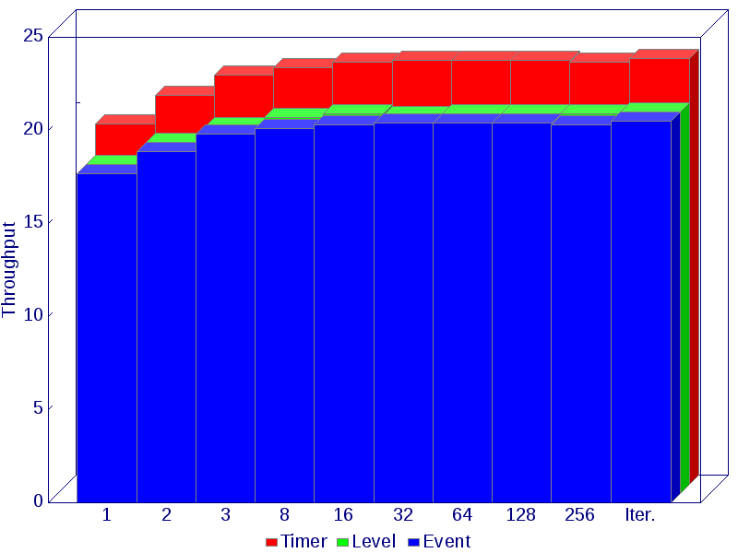 | 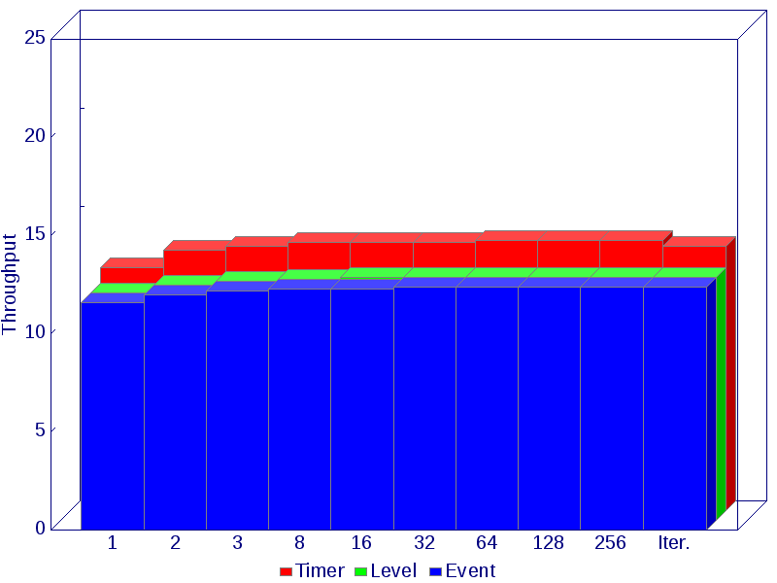

Pi-0 | M=1 | 2 | 4 | 8 | 16 | 32 | 64 | 128 | 256 | Iter.
Timer | 19.4 | 20.9 | 22.0 | 22.4 | 22.7 | 22.8 | 22.8 | 22.8 | 22.7 | 22.9
Level | 17.7 | 18.9 | 19.7 | 20.2 | 20.4 | 20.3 | 20.4 | 20.4 | 20.4 | 20.5
Event | 17.7 | 18.9 | 19.8 | 20.1 | 20.3 | 20.4 | 20.4 | 20.4 | 20.3 | 20.5
Pi-2 | M=1 | 2 | 4 | 8 | 16 | 32 | 64 | 128 | 256 | Iter.
Timer | 12.4 | 13.3 | 13.5 | 13.7 | 13.7 | 13.7 | 13.8 | 13.8 | 13.8 | 13.5
Level | 11.6 | 12.0 | 12.2 | 12.3 | 12.4 | 12.4 | 12.4 | 12.4 | 12.4 | 12.4
Event | 11.6 | 12.0 | 12.2 | 12.3 | 12.3 | 12.4 | 12.4 | 12.4 | 12.4 | 12.4

- Peek / Poke / Reset — Event
A poke (0:1), a peek (1:0) and a copy (1:1 to reset) operation are executed by Iter., and in operation-blocks of size M.
Pi-0 | Pi-2
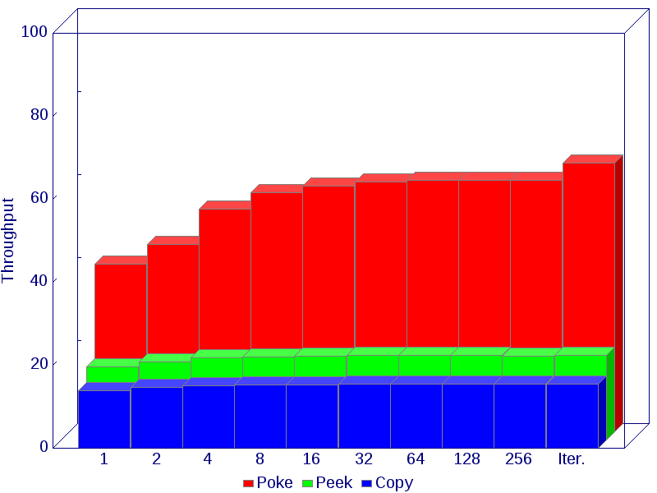 | 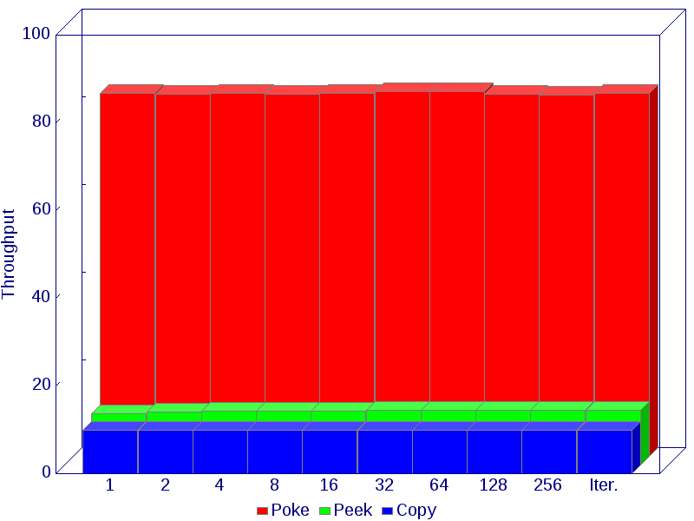

Pi-0 | M=1 | 2 | 4 | 8 | 16 | 32 | 64 | 128 | 256 | Iter.
Poke | 40.5 | 45.2 | 53.7 | 57.6 | 59.2 | 60.3 | 60.6 | 60.7 | 60.7 | 64.8
Peek | 17.7 | 18.9 | 19.8 | 20.1 | 20.3 | 20.4 | 20.4 | 20.4 | 20.3 | 20.5
Copy | 13.8 | 14.6 | 15.1 | 15.3 | 15.3 | 15.4 | 15.4 | 15.4 | 15.4 | 15.5
Pi-2 | M=1 | 2 | 4 | 8 | 16 | 32 | 64 | 128 | 256 | Iter.
Poke | 82.8 | 82.6 | 82.8 | 82.6 | 82.8 | 83.2 | 83.2 | 82.7 | 82.5 | 82.8
Peek | 11.6 | 12.0 | 12.2 | 12.3 | 12.3 | 12.4 | 12.4 | 12.4 | 12.4 | 12.4
Copy | 9.8 | 10.0 | 10.0 | 10.0 | 10.0 | 10.0 | 9.9 | 10.0 | 9.9 | 10.0

- Read Timer
A buffer of size N is filled (1:N) with the sampled Timer value by Iter., and in operation-blocks of size M.
Pi-0 | Pi-2
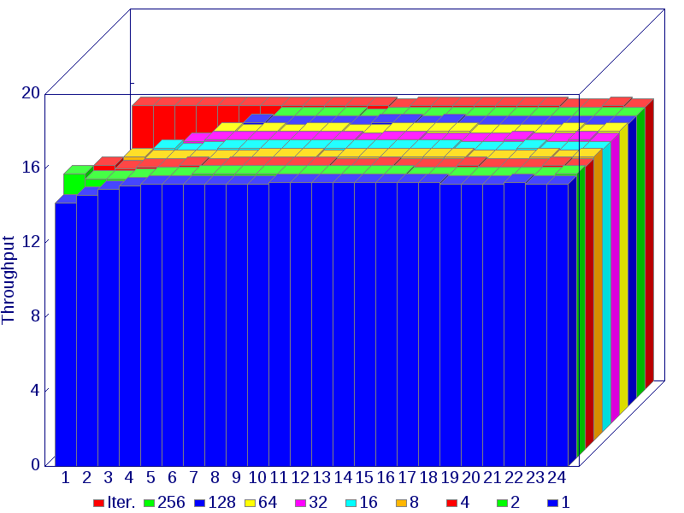 | 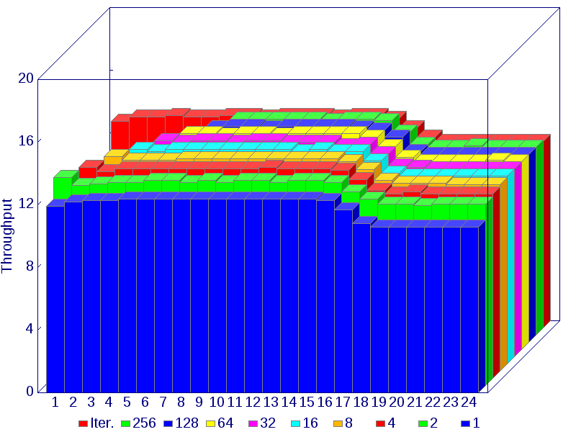

Pi-0 | N=2¹ | 2² | 2³ | 2⁴ | 2⁵ | 2⁶ | 2⁷ | 2⁸ | 2⁹ | 2¹⁰ | 2¹¹ | 2¹² | 2¹³ | 2¹⁴ | 2¹⁵ | 2¹⁶ | 2¹⁷ | 2¹⁸ | 2¹⁹ | 2²⁰ | 2²¹ | 2²² | 2²³ | 2²⁴
Iter. | 15.3 | 15.3 | 15.3 | 15.3 | 15.3 | 15.3 | 15.3 | 15.3 | 15.3 | 15.3 | 15.3 | 15.3 | 15.2 | 15.3 | 15.3 | 15.3 | 15.3 | 15.3 | 15.3 | 15.3 | 15.2 | 15.2 | 15.3 | 15.2
256 | n/a | n/a | n/a | n/a | n/a | n/a | n/a | 15.2 | 15.2 | 15.2 | 15.2 | 15.1 | 15.2 | 15.2 | 15.2 | 15.2 | 15.2 | 15.2 | 15.2 | 15.2 | 15.2 | 15.2 | 15.2 | 15.2
128 | n/a | n/a | n/a | n/a | n/a | n/a | 15.3 | 15.2 | 15.2 | 15.2 | 15.2 | 15.2 | 15.3 | 15.3 | 15.2 | 15.3 | 15.2 | 15.2 | 15.2 | 15.2 | 15.2 | 15.2 | 15.2 | 15.2
64 | n/a | n/a | n/a | n/a | n/a | 15.3 | 15.2 | 15.3 | 15.2 | 15.3 | 15.3 | 15.2 | 15.2 | 15.3 | 15.3 | 15.3 | 15.3 | 15.2 | 15.2 | 15.2 | 15.2 | 15.3 | 15.2 | 15.3
32 | n/a | n/a | n/a | n/a | 15.2 | 15.3 | 15.3 | 15.3 | 15.3 | 15.3 | 15.3 | 15.3 | 15.2 | 15.3 | 15.3 | 15.2 | 15.2 | 15.2 | 15.2 | 15.3 | 15.2 | 15.2 | 15.3 | 15.2
16 | n/a | n/a | n/a | 15.3 | 15.1 | 15.2 | 15.3 | 15.3 | 15.3 | 15.3 | 15.3 | 15.3 | 15.3 | 15.3 | 15.3 | 15.3 | 15.3 | 15.2 | 15.2 | 15.2 | 15.3 | 15.2 | 15.2 | 15.2
8 | n/a | n/a | 15.3 | 15.2 | 15.2 | 15.2 | 15.2 | 15.2 | 15.3 | 15.3 | 15.3 | 15.2 | 15.3 | 15.3 | 15.3 | 15.3 | 15.3 | 15.3 | 15.2 | 15.2 | 15.2 | 15.3 | 15.2 | 15.3
4 | n/a | 15.3 | 15.1 | 15.2 | 15.2 | 15.3 | 15.2 | 15.3 | 15.3 | 15.3 | 15.3 | 15.3 | 15.2 | 15.2 | 15.3 | 15.2 | 15.2 | 15.2 | 15.3 | 15.2 | 15.2 | 15.2 | 15.3 | 15.2
2 | 15.3 | 15.0 | 15.0 | 15.1 | 15.2 | 15.2 | 15.3 | 15.3 | 15.3 | 15.3 | 15.3 | 15.3 | 15.3 | 15.3 | 15.3 | 15.3 | 15.2 | 15.2 | 15.2 | 15.2 | 15.2 | 15.2 | 15.2 | 15.3
M=1 | 14.2 | 14.6 | 14.9 | 15.1 | 15.2 | 15.2 | 15.2 | 15.2 | 15.2 | 15.2 | 15.3 | 15.3 | 15.3 | 15.3 | 15.3 | 15.3 | 15.3 | 15.3 | 15.2 | 15.2 | 15.2 | 15.3 | 15.2 | 15.2
Pi-2 | N=2¹ | 2² | 2³ | 2⁴ | 2⁵ | 2⁶ | 2⁷ | 2⁸ | 2⁹ | 2¹⁰ | 2¹¹ | 2¹² | 2¹³ | 2¹⁴ | 2¹⁵ | 2¹⁶ | 2¹⁷ | 2¹⁸ | 2¹⁹ | 2²⁰ | 2²¹ | 2²² | 2²³ | 2²⁴
Iter. | 13.2 | 13.5 | 13.5 | 13.6 | 13.5 | 13.5 | 13.6 | 13.6 | 13.5 | 13.6 | 13.6 | 13.6 | 13.5 | 13.6 | 13.6 | 13.4 | 12.8 | 12.2 | 11.9 | 11.9 | 11.9 | 11.9 | 11.9 | 11.9
256 | n/a | n/a | n/a | n/a | n/a | n/a | n/a | 13.8 | 13.8 | 13.8 | 13.8 | 13.8 | 13.7 | 13.8 | 13.8 | 13.7 | 13.0 | 12.2 | 12.0 | 12.0 | 12.1 | 12.0 | 12.0 | 12.0
128 | n/a | n/a | n/a | n/a | n/a | n/a | 13.7 | 13.8 | 13.8 | 13.7 | 13.8 | 13.8 | 13.8 | 13.8 | 13.7 | 13.6 | 13.1 | 12.2 | 12.0 | 12.0 | 12.0 | 12.0 | 12.0 | 12.0
64 | n/a | n/a | n/a | n/a | n/a | 13.8 | 13.8 | 13.7 | 13.8 | 13.8 | 13.7 | 13.8 | 13.8 | 13.8 | 13.8 | 13.6 | 13.0 | 12.3 | 12.0 | 12.0 | 12.0 | 12.0 | 12.1 | 12.0
32 | n/a | n/a | n/a | n/a | 13.8 | 13.7 | 13.8 | 13.8 | 13.7 | 13.8 | 13.8 | 13.7 | 13.7 | 13.7 | 13.5 | 13.6 | 13.0 | 12.2 | 12.1 | 12.0 | 12.0 | 12.0 | 12.0 | 12.0
16 | n/a | n/a | n/a | 13.7 | 13.6 | 13.7 | 13.7 | 13.7 | 13.7 | 13.7 | 13.7 | 13.7 | 13.6 | 13.7 | 13.6 | 13.6 | 13.0 | 12.2 | 12.0 | 12.0 | 12.0 | 12.0 | 12.0 | 12.0
8 | n/a | n/a | 13.7 | 13.5 | 13.5 | 13.5 | 13.6 | 13.6 | 13.6 | 13.6 | 13.6 | 13.6 | 13.6 | 13.6 | 13.6 | 13.4 | 12.9 | 12.2 | 12.0 | 12.0 | 12.0 | 11.9 | 11.9 | 11.9
4 | n/a | 13.5 | 13.2 | 13.4 | 13.4 | 13.4 | 13.4 | 13.4 | 13.4 | 13.4 | 13.4 | 13.5 | 13.4 | 13.4 | 13.4 | 13.3 | 12.7 | 12.0 | 11.8 | 11.9 | 11.8 | 11.8 | 11.8 | 11.8
2 | 13.3 | 12.8 | 12.9 | 13.0 | 13.0 | 13.1 | 13.1 | 13.0 | 13.1 | 13.0 | 13.1 | 13.1 | 13.0 | 13.1 | 13.1 | 13.0 | 12.4 | 11.9 | 11.6 | 11.6 | 11.5 | 11.6 | 11.6 | 11.6
M=1 | 11.9 | 12.2 | 12.3 | 12.3 | 12.4 | 12.4 | 12.4 | 12.4 | 12.4 | 12.4 | 12.4 | 12.4 | 12.4 | 12.4 | 12.4 | 12.3 | 11.7 | 10.8 | 10.6 | 10.6 | 10.6 | 10.6 | 10.6 | 10.6

- Read Level
A buffer of size N is filled (1:N) with the sampled Level value by Iter., and in operation-blocks of size M.
Pi-0 | Pi-2
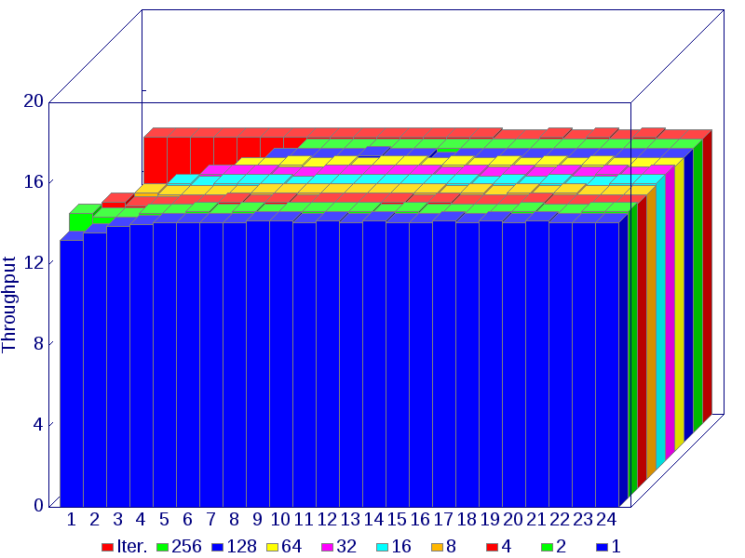 | 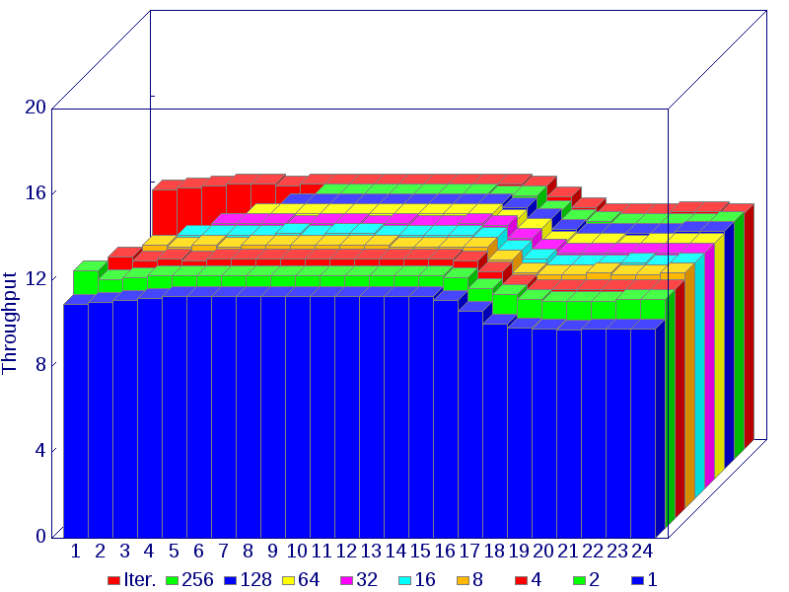

Pi-0 | N=2¹ | 2² | 2³ | 2⁴ | 2⁵ | 2⁶ | 2⁷ | 2⁸ | 2⁹ | 2¹⁰ | 2¹¹ | 2¹² | 2¹³ | 2¹⁴ | 2¹⁵ | 2¹⁶ | 2¹⁷ | 2¹⁸ | 2¹⁹ | 2²⁰ | 2²¹ | 2²² | 2²³ | 2²⁴
Iter. | 14.2 | 14.2 | 14.2 | 14.2 | 14.2 | 14.2 | 14.2 | 14.2 | 14.2 | 14.2 | 14.2 | 14.2 | 14.2 | 14.2 | 14.2 | 14.1 | 14.1 | 14.2 | 14.1 | 14.2 | 14.1 | 14.2 | 14.1 | 14.1
256 | n/a | n/a | n/a | n/a | n/a | n/a | n/a | 14.1 | 14.1 | 14.1 | 14.1 | 14.1 | 14.1 | 14.1 | 14.1 | 14.1 | 14.1 | 14.1 | 14.1 | 14.1 | 14.1 | 14.1 | 14.1 | 14.1
128 | n/a | n/a | n/a | n/a | n/a | n/a | 14.1 | 14.1 | 14.1 | 14.1 | 14.2 | 14.1 | 14.1 | 13.9 | 14.1 | 14.1 | 14.1 | 14.1 | 14.1 | 14.1 | 14.1 | 14.1 | 14.1 | 14.1
64 | n/a | n/a | n/a | n/a | n/a | 14.1 | 14.1 | 14.2 | 14.1 | 14.2 | 14.1 | 14.2 | 14.2 | 14.1 | 14.2 | 14.1 | 14.2 | 14.1 | 14.2 | 14.1 | 14.2 | 14.1 | 14.1 | 14.1
32 | n/a | n/a | n/a | n/a | 14.2 | 14.2 | 14.2 | 14.1 | 14.1 | 14.2 | 14.2 | 14.2 | 14.2 | 14.2 | 14.1 | 14.2 | 14.1 | 14.2 | 14.1 | 14.2 | 14.1 | 14.2 | 14.1 | 14.2
16 | n/a | n/a | n/a | 14.2 | 14.1 | 14.2 | 14.2 | 14.2 | 14.1 | 14.2 | 14.2 | 14.2 | 14.2 | 14.2 | 14.2 | 14.2 | 14.1 | 14.2 | 14.1 | 14.2 | 14.1 | 14.1 | 14.2 | 14.2
8 | n/a | n/a | 14.2 | 14.1 | 14.1 | 14.1 | 14.1 | 14.2 | 14.2 | 14.2 | 14.2 | 14.2 | 14.2 | 14.2 | 14.2 | 14.1 | 14.2 | 14.1 | 14.2 | 14.1 | 14.2 | 14.1 | 14.1 | 14.1
4 | n/a | 14.2 | 14.0 | 14.0 | 14.1 | 14.1 | 14.2 | 14.1 | 14.2 | 14.1 | 14.2 | 14.2 | 14.2 | 14.2 | 14.1 | 14.2 | 14.1 | 14.1 | 14.1 | 14.2 | 14.1 | 14.1 | 14.1 | 14.1
2 | 14.1 | 13.9 | 13.9 | 14.1 | 14.1 | 14.2 | 14.1 | 14.2 | 14.1 | 14.2 | 14.2 | 14.2 | 14.2 | 14.1 | 14.2 | 14.1 | 14.1 | 14.1 | 14.1 | 14.2 | 14.1 | 14.1 | 14.2 | 14.2
M=1 | 13.2 | 13.6 | 13.9 | 14.0 | 14.1 | 14.1 | 14.1 | 14.1 | 14.2 | 14.2 | 14.1 | 14.2 | 14.1 | 14.2 | 14.1 | 14.1 | 14.2 | 14.1 | 14.2 | 14.1 | 14.2 | 14.1 | 14.1 | 14.1
Pi-2 | N=2¹ | 2² | 2³ | 2⁴ | 2⁵ | 2⁶ | 2⁷ | 2⁸ | 2⁹ | 2¹⁰ | 2¹¹ | 2¹² | 2¹³ | 2¹⁴ | 2¹⁵ | 2¹⁶ | 2¹⁷ | 2¹⁸ | 2¹⁹ | 2²⁰ | 2²¹ | 2²² | 2²³ | 2²⁴
Iter. | 12.1 | 12.2 | 12.3 | 12.4 | 12.4 | 12.3 | 12.4 | 12.4 | 12.4 | 12.4 | 12.4 | 12.4 | 12.4 | 12.4 | 12.4 | 12.3 | 11.8 | 11.3 | 11.0 | 11.0 | 11.0 | 11.1 | 11.1 | 11.0
256 | n/a | n/a | n/a | n/a | n/a | n/a | n/a | 12.4 | 12.4 | 12.4 | 12.4 | 12.4 | 12.4 | 12.4 | 12.3 | 12.3 | 11.6 | 11.2 | 11.1 | 11.0 | 11.0 | 11.0 | 11.0 | 11.1
128 | n/a | n/a | n/a | n/a | n/a | n/a | 12.4 | 12.4 | 12.4 | 12.4 | 12.4 | 12.4 | 12.4 | 12.4 | 12.4 | 12.2 | 11.7 | 11.2 | 11.0 | 11.0 | 11.0 | 11.0 | 11.1 | 11.1
64 | n/a | n/a | n/a | n/a | n/a | 12.4 | 12.4 | 12.4 | 12.4 | 12.4 | 12.4 | 12.4 | 12.4 | 12.4 | 12.4 | 12.1 | 11.7 | 11.1 | 11.0 | 11.0 | 10.9 | 11.0 | 11.0 | 11.0
32 | n/a | n/a | n/a | n/a | 12.4 | 12.4 | 12.4 | 12.3 | 12.4 | 12.4 | 12.3 | 12.4 | 12.3 | 12.3 | 12.4 | 12.3 | 11.7 | 11.2 | 11.0 | 11.0 | 11.0 | 11.0 | 11.0 | 11.0
16 | n/a | n/a | n/a | 12.3 | 12.3 | 12.3 | 12.3 | 12.4 | 12.3 | 12.4 | 12.4 | 12.3 | 12.3 | 12.3 | 12.3 | 12.2 | 11.6 | 11.2 | 10.9 | 10.9 | 10.9 | 11.0 | 10.9 | 11.0
8 | n/a | n/a | 12.3 | 12.2 | 12.3 | 12.2 | 12.3 | 12.3 | 12.3 | 12.3 | 12.3 | 12.3 | 12.2 | 12.2 | 12.2 | 12.2 | 11.6 | 11.0 | 10.9 | 10.9 | 11.0 | 10.9 | 10.9 | 11.0
4 | n/a | 12.2 | 12.0 | 12.1 | 12.0 | 12.1 | 12.1 | 12.1 | 12.1 | 12.1 | 12.1 | 12.1 | 12.1 | 12.1 | 12.1 | 12.0 | 11.5 | 10.9 | 10.7 | 10.7 | 10.7 | 10.7 | 10.7 | 10.7
2 | 12.0 | 11.6 | 11.7 | 11.8 | 11.8 | 11.8 | 11.8 | 11.8 | 11.8 | 11.8 | 11.8 | 11.8 | 11.8 | 11.8 | 11.8 | 11.7 | 11.2 | 10.9 | 10.7 | 10.6 | 10.6 | 10.6 | 10.7 | 10.7
M=1 | 10.9 | 11.0 | 11.1 | 11.2 | 11.3 | 11.3 | 11.3 | 11.3 | 11.3 | 11.3 | 11.3 | 11.3 | 11.3 | 11.3 | 11.3 | 11.1 | 10.6 | 10.0 | 9.8 | 9.8 | 9.7 | 9.8 | 9.8 | 9.8

- Read Event
A buffer of size N is filled (1:N) with the sampled Event value by Iter., and in operation-blocks of size M.
Pi-0 | Pi-2
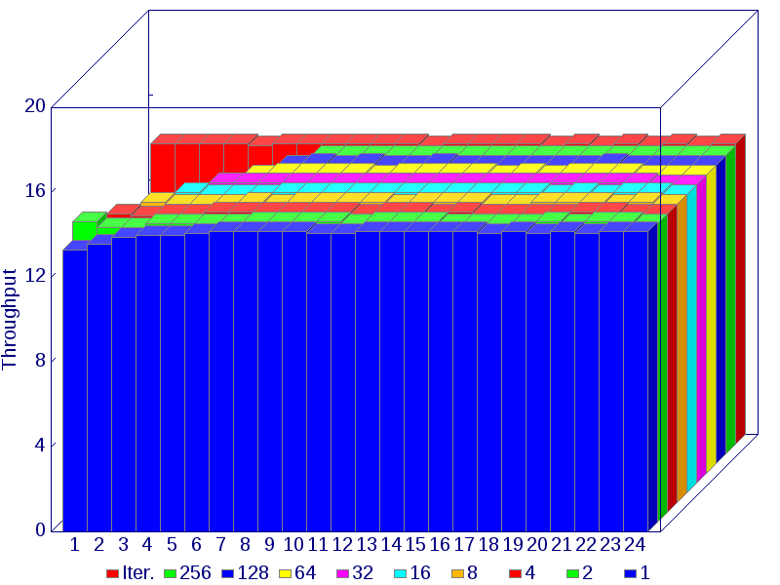 | 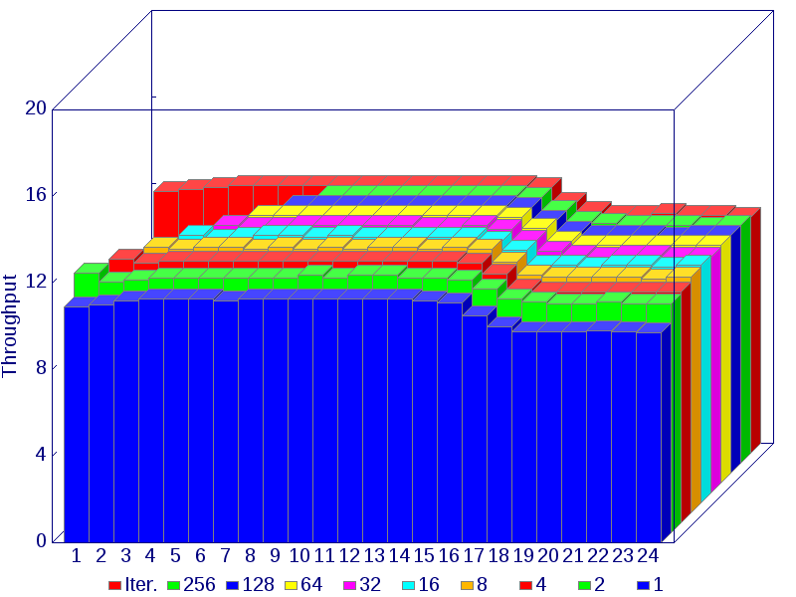

Pi-0 | N=2¹ | 2² | 2³ | 2⁴ | 2⁵ | 2⁶ | 2⁷ | 2⁸ | 2⁹ | 2¹⁰ | 2¹¹ | 2¹² | 2¹³ | 2¹⁴ | 2¹⁵ | 2¹⁶ | 2¹⁷ | 2¹⁸ | 2¹⁹ | 2²⁰ | 2²¹ | 2²² | 2²³ | 2²⁴
Iter. | 14.2 | 14.2 | 14.2 | 14.2 | 14.1 | 14.2 | 14.2 | 14.2 | 14.2 | 14.2 | 14.2 | 14.1 | 14.2 | 14.2 | 14.2 | 14.2 | 14.1 | 14.2 | 14.1 | 14.2 | 14.1 | 14.2 | 14.1 | 14.2
256 | n/a | n/a | n/a | n/a | n/a | n/a | n/a | 14.1 | 14.1 | 14.1 | 14.1 | 14.1 | 14.1 | 14.1 | 14.1 | 14.1 | 14.1 | 14.1 | 14.1 | 14.1 | 14.1 | 14.1 | 14.1 | 14.1
128 | n/a | n/a | n/a | n/a | n/a | n/a | 14.1 | 14.2 | 14.1 | 14.2 | 14.1 | 14.1 | 14.2 | 14.1 | 14.1 | 14.1 | 14.1 | 14.1 | 14.1 | 14.2 | 14.1 | 14.1 | 14.1 | 14.1
64 | n/a | n/a | n/a | n/a | n/a | 14.1 | 14.2 | 14.2 | 14.2 | 14.2 | 14.1 | 14.2 | 14.2 | 14.2 | 14.2 | 14.1 | 14.2 | 14.1 | 14.2 | 14.2 | 14.2 | 14.1 | 14.1 | 14.1
32 | n/a | n/a | n/a | n/a | 14.2 | 14.2 | 14.2 | 14.2 | 14.2 | 14.2 | 14.2 | 14.2 | 14.2 | 14.2 | 14.2 | 14.2 | 14.2 | 14.2 | 14.2 | 14.2 | 14.2 | 14.2 | 14.1 | 14.1
16 | n/a | n/a | n/a | 14.2 | 14.1 | 14.1 | 14.1 | 14.2 | 14.2 | 14.2 | 14.2 | 14.2 | 14.2 | 14.2 | 14.2 | 14.2 | 14.2 | 14.2 | 14.1 | 14.2 | 14.1 | 14.2 | 14.2 | 14.1
8 | n/a | n/a | 14.2 | 14.1 | 14.1 | 14.1 | 14.2 | 14.1 | 14.2 | 14.2 | 14.2 | 14.2 | 14.1 | 14.2 | 14.2 | 14.2 | 14.1 | 14.1 | 14.2 | 14.2 | 14.2 | 14.1 | 14.2 | 14.1
4 | n/a | 14.1 | 14.0 | 14.1 | 14.1 | 14.2 | 14.2 | 14.2 | 14.2 | 14.2 | 14.2 | 14.1 | 14.2 | 14.2 | 14.1 | 14.2 | 14.1 | 14.1 | 14.1 | 14.1 | 14.2 | 14.2 | 14.1 | 14.1
2 | 14.2 | 13.9 | 13.9 | 14.1 | 14.1 | 14.1 | 14.1 | 14.2 | 14.2 | 14.2 | 14.2 | 14.1 | 14.2 | 14.2 | 14.2 | 14.1 | 14.1 | 14.1 | 14.1 | 14.2 | 14.1 | 14.2 | 14.2 | 14.1
M=1 | 13.3 | 13.6 | 13.9 | 14.0 | 14.0 | 14.1 | 14.2 | 14.2 | 14.2 | 14.2 | 14.1 | 14.1 | 14.2 | 14.2 | 14.2 | 14.2 | 14.2 | 14.1 | 14.2 | 14.1 | 14.2 | 14.1 | 14.2 | 14.2
Pi-2 | N=2¹ | 2² | 2³ | 2⁴ | 2⁵ | 2⁶ | 2⁷ | 2⁸ | 2⁹ | 2¹⁰ | 2¹¹ | 2¹² | 2¹³ | 2¹⁴ | 2¹⁵ | 2¹⁶ | 2¹⁷ | 2¹⁸ | 2¹⁹ | 2²⁰ | 2²¹ | 2²² | 2²³ | 2²⁴
Iter. | 12.1 | 12.2 | 12.3 | 12.4 | 12.4 | 12.4 | 12.4 | 12.4 | 12.4 | 12.4 | 12.4 | 12.4 | 12.4 | 12.4 | 12.4 | 12.3 | 11.6 | 11.2 | 11.0 | 11.0 | 11.1 | 11.0 | 11.0 | 10.9
256 | n/a | n/a | n/a | n/a | n/a | n/a | n/a | 12.4 | 12.4 | 12.4 | 12.4 | 12.4 | 12.4 | 12.4 | 12.4 | 12.3 | 11.7 | 11.2 | 11.1 | 11.0 | 11.0 | 11.0 | 10.9 | 11.0
128 | n/a | n/a | n/a | n/a | n/a | n/a | 12.4 | 12.4 | 12.4 | 12.4 | 12.4 | 12.4 | 12.4 | 12.4 | 12.4 | 12.3 | 11.7 | 11.2 | 11.0 | 11.0 | 11.0 | 10.9 | 11.0 | 11.0
64 | n/a | n/a | n/a | n/a | n/a | 12.4 | 12.4 | 12.4 | 12.4 | 12.4 | 12.4 | 12.4 | 12.4 | 12.4 | 12.4 | 12.3 | 11.8 | 11.2 | 11.0 | 11.0 | 11.0 | 11.0 | 11.0 | 11.0
32 | n/a | n/a | n/a | n/a | 12.4 | 12.3 | 12.3 | 12.4 | 12.4 | 12.4 | 12.4 | 12.4 | 12.3 | 12.3 | 12.4 | 12.2 | 11.7 | 11.2 | 11.0 | 10.9 | 11.0 | 11.0 | 10.9 | 10.9
16 | n/a | n/a | n/a | 12.4 | 12.2 | 12.3 | 12.4 | 12.4 | 12.3 | 12.4 | 12.3 | 12.3 | 12.3 | 12.3 | 12.3 | 12.1 | 11.7 | 11.0 | 11.0 | 10.9 | 11.0 | 11.0 | 10.9 | 11.0
8 | n/a | n/a | 12.3 | 12.2 | 12.3 | 12.3 | 12.2 | 12.3 | 12.2 | 12.3 | 12.2 | 12.3 | 12.3 | 12.2 | 12.3 | 12.2 | 11.6 | 11.0 | 10.9 | 10.9 | 10.9 | 10.9 | 10.8 | 10.9
4 | n/a | 12.2 | 12.0 | 12.1 | 12.1 | 12.1 | 12.1 | 12.1 | 12.1 | 12.1 | 12.1 | 12.1 | 12.1 | 12.1 | 12.1 | 12.0 | 11.5 | 10.8 | 10.7 | 10.7 | 10.7 | 10.7 | 10.7 | 10.7
2 | 12.0 | 11.6 | 11.7 | 11.8 | 11.8 | 11.8 | 11.8 | 11.8 | 11.8 | 11.9 | 11.8 | 11.9 | 11.9 | 11.8 | 11.8 | 11.7 | 11.3 | 10.8 | 10.7 | 10.6 | 10.6 | 10.7 | 10.6 | 10.6
M=1 | 10.9 | 11.0 | 11.2 | 11.3 | 11.3 | 11.3 | 11.2 | 11.3 | 11.3 | 11.3 | 11.3 | 11.3 | 11.3 | 11.3 | 11.2 | 11.1 | 10.5 | 10.0 | 9.8 | 9.8 | 9.8 | 9.8 | 9.8 | 9.7

https://www.raspberrypi.org/
https://www.raspberrypi.org/wp-content/uploads/2012/02/BCM2835-ARM-Peripherals.pdf

