DESIGNING THE USER EXPERIENCE
Team Project – Deliverable 2
BUILDING THE APPLICATION
From wireframes to a working, global, accessible product

Implementation brief and submission template — team deliverable with individually graded contribution

Course | Designing the User Experience (ISTE.260)
Instructor | Aleksander Radovan
Academic year / semester | 2026
Deliverable | Deliverable 2 – Implementation of the application (team)
Builds on | Deliverable 1 – Wireframes in Three Ways
Weight in the final grade | 13,33%
Development period | From 19.10.20206. to 14.11.2026. , with a graded commit every week
Final submission deadline | 14.11.2026. at 23:59h
Submission channel | MyCourses assignment

One document per team, submitted as PDF. Keep the .docx. Everything claimed in this document must be verifiable in the team's GitHub repository — the repository is the primary evidence, this document is the guided tour through it.

Contents
Contents 2
1. What this deliverable is 5
1.1 Learning outcomes 5
1.2 What is graded, and how often 5
2. The product you have to build 6
2.1 Scope 6
2.2 Minimum functional requirements 6
2.3 Definition of done 6
3. Repository and ways of working 8
3.1 Repository setup 8
3.2 Branching model 8
3.3 Weekly commit requirement 8
3.4 Commit messages and pull requests 8
3.5 Issues and planning 9
3.6 What we look at in the git history 9
4. Database requirement 10
5. External REST API requirement 10
5.1 Rules 10
5.2 Candidate APIs by topic area 10
6. Internationalisation and localisation 13
6.1 Required locales 13
6.2 Engineering rules (i18n) 13
6.3 Localisation rules (L10n) 14
6.4 Layout rules 14
6.5 Cultural rules 14
7. Accessibility and universal design 15
7.1 Why this is not optional 15
7.2 Required practices 15
7.3 The ten-minute check 15
8. Weekly rhythm 17
9. Submission 17
9.1 What to submit 17
9.2 README requirements 18
9.3 Assessment 18
9.4 Academic integrity and AI use 18
1. Team, product and repository 20
1.1 Identification 20
1.2 Team members 20
1.3 The product in three sentences 20
1.4 Elevator demo path 20
2. Architecture and technology 22
2.1 Stack 22
2.2 Architecture diagram 22
2.3 Repository structure 22
3. From wireframes to screens 24
3.1 Merged screen map 24
3.2 What was dropped or merged, and why 24
3.3 Screens of the finished application 24
4. Database 26
4.1 Engine and justification 26
4.2 Entity-relationship diagram 26
4.3 Entities 26
4.4 Evidence that it works 27
5. External REST API integration 28
5.1 The service 28
5.2 Endpoints used 28
5.3 Failure handling 28
5.4 Caching and data volume 29
5.5 Evidence 29
6. Internationalisation and localisation 30
6.1 Locales implemented 30
6.2 How i18n is implemented 30
6.3 Plural rules 30
6.4 Locale-aware formatting 31
6.5 Same screen, three locales 32
6.6 Text expansion and layout 32
6.7 Direction and script 33
6.8 Cultural checks 33
7. Accessibility report 35
7.1 The ten-minute check 35
7.2 Tools used 35
7.3 Screen reader walkthrough 35
7.4 Contrast evidence 36
7.5 Known accessibility issues we did not fix 36
7.6 Inclusive design decisions 36
8. Git history and teamwork 38
8.1 Our branching model 38
8.2 Repository evidence 38
8.3 Commits per member per week 38
8.4 Pull requests 39
8.5 Honest account of the collaboration 39
9. Weekly progress log 41
10. Testing, quality and known issues 43
10.1 How the product was tested 43
10.2 Known bugs and limitations 43
10.3 What we would do next 43
11. Individual contribution statements 44
Member 1 44
Member 2 45
Member 3 46
Member 4 47
Member 5 48
12. AI usage declaration 49
13. Submission checklist 49

If the list above appears empty, click inside it and press F9 (Word) to update the field.

PART A — ASSIGNMENT BRIEF (read this first)

1. What this deliverable is
In Deliverable 1 each of you produced ten wireframes individually, covering a distinct feature area of the team's topic. In Deliverable 2 the team merges those feature areas into one coherent application and builds it. The product has to run, hold its own data, talk to a real external service, work in several languages, and be usable by people who do not see, hear, move or read the way the team does.
This is a team deliverable, but the grade is not purely collective. The repository records who did what and when, and the individual part of the grade is derived from that record.

1.1 Learning outcomes
- Turn a set of wireframes into a working application without quietly abandoning the design decisions they contained.
- Work as a team in a shared repository with branches, pull requests and review, producing a history that someone else can read.
- Design a data model that serves the interaction, and integrate a third-party REST API including its failure modes.
- Externalise every user-visible string and implement real internationalisation: plural rules, locale-aware formatting, text expansion, and right-to-left layout.
- Apply the universal-design and accessibility material from Week 07 to your own product and report honestly on what still fails.

1.2 What is graded, and how often
When | What happens | Graded?
Every week | Each team member commits work to the repository on a branch and opens or reviews at least one pull request | Yes — continuously, from the git history
Mid-point | Short in-class checkpoint: the application runs, data model and external API work | Yes — formative
Final | This document plus the tagged release in the repository | Yes — the main grade

A repository where all the work appears in the last week will be graded as such, regardless of how good the application is. The weekly rhythm is part of the assessed learning outcome, not an administrative formality.

2. The product you have to build

2.1 Scope
- The application implements the team's assigned topic, and it must be recognisably the product your wireframes described.
- Start from the merged screen map: every member's feature area from Deliverable 1 must be represented in the running product. If the team drops a feature area, say so explicitly in Part B, Section 3 and explain the decision — silent disappearance is treated as unfinished work.
- Target platform: web application, or mobile application, or both, consistent with the platform stated in your topic. A responsive web application is acceptable where the topic says “mobile”, provided it is designed mobile-first and demonstrated at phone width.
- Technology choice is free. Choose a stack that the whole team can actually run, and that has a mature internationalisation library — do not write your own translation layer.
- Authentication is required only where the topic needs it. If you implement it, never store passwords in plain text and never commit secrets.

2.2 Minimum functional requirements
# | Requirement | Minimum to pass
F1 | Core user journey from the wireframes is implemented end to end | A user can complete the main task of your topic from start to finish without a dead end
F2 | Persistent data in your own database | Data created by the user survives a restart of the application
F3 | Create, read, update and delete on the main entity | All four operations reachable from the interface, with confirmation on destructive actions
F4 | Integration with an external REST API related to the topic | Real data from the external service is visible in the interface and used for something, not just displayed
F5 | Internationalization in at least three locales | The whole interface switches language, including dates, numbers and plurals
F6 | Non-ideal states | Loading, empty, error and offline/unavailable states exist for every screen that fetches data
F7 | Accessibility baseline | The ten-minute check in Section 7 passes, or every failure is documented with a plan

2.3 Definition of done
A feature counts as finished only when all of the following are true. Use this list in your pull request descriptions.
- It works for the user flow in the wireframe, not only for the happy path the developer tested.
- No user-visible string is hardcoded; every string has a translation key and exists in all locales.
- Dates, numbers, currencies and plurals go through the formatting layer, never through string concatenation.
- Loading, empty and error states are implemented.
- It is reachable and operable with the keyboard alone, and the focus indicator is visible.
- It was merged through a pull request reviewed by another team member.

3. Repository and ways of working

3.1 Repository setup
- One GitHub repository per team, created in the first week of this phase.
- Add the instructor as a collaborator (with the username “ar-rit”) in the first week, not at the end.
- Every team member commits under their own GitHub account, with their real name in the git configuration. Commits authored by a shared account cannot be attributed and will not count.
- The repository must contain a README (Section 9.2), a .gitignore, and an open-source or course license file if you choose one.
- Secrets — API keys, database passwords, tokens — are never committed. Use environment variables and commit a .env.example with empty values. A leaked key in the history costs points even if it is removed later; rotate it and say so in the README.
git config user.name "Ime Prezime" && git config user.email "your.university@email"

3.2 Branching model
Use a simple, defensible model and describe it in Part B, Section 8.1. The expected baseline:
- main is always runnable. Nobody pushes directly to main.
- develop (optional but recommended) is the integration branch.
- One branch per feature or fix, named so that the purpose is readable: feature/locale-switcher, fix/empty-state-crash, chore/ci-setup.
- Branches are short-lived: open, work, review, merge, delete. A branch that lives for six weeks is a sign the team is not integrating.
- Protect main: require a pull request and at least one approving review before merge. This is a repository setting, and we will look at whether it is switched on.

3.3 Weekly commit requirement
Who | Every team member, individually
How often | At least one meaningful commit every week of the development period
What counts | Code, tests, migrations, translation files, documentation of substance
What does not count | Whitespace-only commits, a commit that only changes the README date, committing someone else's work on their behalf, ten commits pushed in one evening to cover four empty weeks
Absence | If you cannot commit in a given week (illness, exam), say so in the weekly log in Part B, Section 9. An explained gap is treated differently from an unexplained one

3.4 Commit messages and pull requests
- Write commit messages in the imperative, describing the change, not the activity: “Add plural rules for Croatian”, not “fixes”, “update”, “work” or “asdf”.
- A conventional prefix (feat:, fix:, docs:, refactor:, test:, chore:) is recommended and makes the history readable at a glance.
- Every pull request has a description saying what changed and why, links the issue it closes, and states which definition-of-done items are met.
- Every pull request is reviewed by a team member who did not write it. A review is a comment with substance — an instant approval on a 600-line change is visible in the timeline and counts as no review at all.
- Resolve merge conflicts in your branch; never force-push over a teammate's work on a shared branch.

3.5 Issues and planning
- Use GitHub Issues for the work items, and a project board or milestones for the weekly plan.
- Each issue has an assignee. The feature areas from Deliverable 1 are the natural starting allocation.
- Link commits and pull requests to issues (Closes #12) so the history explains itself.

3.6 What we look at in the git history
We look for | What a weak history looks like
Commits spread across all weeks, from all members | One member with 80% of the commits; three members with four commits each, all in the final week
Branches that were created, worked on, reviewed and merged | Everything committed straight to main
Pull requests with real review conversation | Pull requests opened and self-merged within one minute
Readable commit messages tied to issues | “update” × 40
Steady growth of the codebase | A single initial commit containing the entire finished application
Honest history | Rewritten history and fabricated commit dates. Backdating commits is academic dishonesty, and it is trivially detectable in the push timeline

4. Database requirement
The application must own its data. A spreadsheet, a JSON file in the repository, or data held only in browser storage does not satisfy this requirement.
- Any database engine is acceptable: PostgreSQL, MySQL/MariaDB, SQLite, MongoDB, Firebase or similar. Justify the choice in one sentence in Part B, Section 4.1.
- The schema must be in the repository as migrations or as a schema file — not only inside someone's local database.
- Provide seed data so that a reviewer can run the application and see something meaningful within minutes. Seed data must be realistic and not contain real personal data of real people.
- An entity-relationship diagram is required in Part B, Section 4.2. Entities, attributes, keys and cardinalities must match what is actually in the code.
- Include at least one relationship between entities. A single flat table is below the expected level for a team project.
- Text columns that hold user-visible content must be able to store non-Latin characters — use UTF-8 (utf8mb4 on MySQL). Test with Croatian diacritics and with one non-Latin script before you claim this works.
- Store timestamps in UTC and convert for display. Store a locale preference per user if your topic has user accounts.
- No credentials in the repository; connection strings come from environment variables.

5. External REST API requirement
The application must consume at least one external REST API whose data is genuinely related to the topic. The integration has to do work in the product: enrich, validate, calculate, locate or inform. Fetching a random quote and printing it in the footer does not qualify.

5.1 Rules
- The API is called from your own backend where a key is involved, so that the key is never exposed in client-side code.
- Handle the failure modes explicitly: network error, timeout, rate limit, empty result, malformed response, and the service being down. Each one must produce a sensible interface state, not a blank screen or a raw stack trace.
- Cache responses where the data does not change every second, and respect the provider's rate limits and terms of use. Note the limits in Part B, Section 5.
- Never send personal user data to a third-party API without a reason you can defend; say in Part B what you send and why.
- If the external data is displayed to the user, attribute the source where the provider requires it.
- The API must keep working in every locale — watch out for services that return English-only text, and decide how you present it.

5.2 Candidate APIs by topic area
A starting list. Availability, limits and terms change, so verify before you commit to one, and record what you found in Part B.
API | What it gives you | Key? | Fits topics such as
Open-Meteo | Weather, forecast, historical, UV, air quality | No | Social Battery Planner, Shade & Shelter, The Interface That Disappears
Nominatim + Overpass (OpenStreetMap) | Geocoding and real-world points: benches, fountains, shops, entrances | No (strict usage policy) | Shade & Shelter, Lost in the University, Borrow Before Buying
REST Countries | Countries, languages, currencies, calling codes, formats | No | Any application with a country or locale picker
Nager.Date | Public holidays per country and year | No | Queue Without Waiting, Paper Trail, Life Admin Inbox
Frankfurter (ECB rates) | Daily and historical exchange rates | No | Cost Per Use, Repair Route, Personal Carbon Trade-Offs
HNB API (Croatian National Bank) | Official Croatian exchange rate list | No | Any product that shows money to Croatian users
Open Food Facts | Products by barcode, ingredients, packaging, nutrition | No | Expiry Radar, Object Afterlife, Cost Per Use
Wikipedia / Wikidata REST API | Articles and structured entities, multilingual labels | No | Explain My Interface, Word Keeper, First Winter
dictionaryapi.dev | Word definitions, phonetics, examples | No | Word Keeper, Plain Language Layer
OpenAlex / Crossref | Scholarly works, authors, concepts | No | Academic Uncertainty Map, Error Museum
Open Library | Books, covers, editions, subjects | No | Shared Silence, Borrow Before Buying
OpenAQ | Air-quality measurements by location | Free key | Shade & Shelter, Personal Carbon Trade-Offs
Climatiq or Carbon Interface | Emission factors and carbon estimates | Free key | Personal Carbon Trade-Offs, Object Afterlife
iFixit | Repair guides and device teardowns | No / limited | Repair Confidence, Repair Route
LibreTranslate or DeepL API Free | Machine translation | Free key | Plain Language Layer, First Winter, Word Keeper
GitHub REST API | Repositories, issues, activity | Token | The Last 10%, Error Museum, Assignment Reality Check
Transitland or a local GTFS feed | Public transport stops, routes, schedules | Free key | Micro-Decision, Lost in the University, Context Switch

If none of these fits your topic, you may use any other public API, including one you find in a directory such as publicapis.io, freepublicapis.com or the public-apis list on GitHub. Check the licence and the rate limit first, and avoid services that require a paid plan or a credit card.

6. Internationalization and localization
This section applies the Week 07 lecture, “Designing for Universal, Global & Cultural Differences”, to your own product. Internationalization (i18n) is the engineering work that makes translation and adaptation possible; localization (L10n) is the adaptation to a specific locale. Both are graded.

6.1 Required locales
Locale | Status | Why
English (en) | Required | Source language and fallback
Croatian (hr) | Required | Forces real plural rules — one / few / other — and diacritics
A third locale that stresses the system | Required — choose one | Arabic (ar) or Hebrew (he) for right-to-left; Polish (pl) or Russian (ru) for a different plural system; German (de) or Finnish (fi) for text expansion; Japanese (ja) for line breaking without spaces
A fourth locale | Optional — bonus | Only if the first three are genuinely complete

Translations may be machine-assisted, but you must check them. A machine translation that produces nonsense in the interface is still your bug. If nobody in the team speaks the third language, choose one where you can get a native speaker to look at ten screens, and say in Part B who checked it.

6.2 Engineering rules (i18n)
- Not a single user-visible string is hardcoded in a component, including button labels, placeholders, validation messages, page titles, alt text, aria-labels, e-mail templates and error pages.
- Translations live in resource files in the repository (JSON, YAML, .properties, .resx, gettext — whatever your stack uses), one file per locale, under version control.
- Keys are semantic and hierarchical: cart.checkout.button, not button_1 and not the English sentence itself used as a key.
- Never build a sentence by concatenating translated fragments; word order differs between languages. Use one message with parameters.
- No text baked into images or icons; if a graphic contains words, it needs a localised version or the text must be a text layer.
- A missing key must fall back to a defined chain (hr → en) and must be visible in development, never shown to a user as a raw key.
- The HTML lang attribute changes with the locale, and dir changes for right-to-left locales. This matters for screen readers, hyphenation and search engines.
- The chosen locale is persisted (URL segment, cookie or user profile) and survives a reload. Do not infer the language from the IP address alone — a Croatian student in Zagreb may well want the interface in English.
// one message, parameters inside — never "You have " + n + " items" inbox.unread = "{count, plural, one {# nepročitana poruka} few {# nepročitane poruke} other {# nepročitanih poruka}}"

6.3 Localization rules (L10n)
- Plurals go through the locale's real plural rules. Croatian has three forms and Arabic has six; an if (n === 1) is wrong in both.
- Dates, times, numbers, percentages and currencies are formatted by the platform's internationalisation API (Intl.DateTimeFormat, Intl.NumberFormat, Intl.PluralRules, Intl.RelativeTimeFormat, Intl.ListFormat) or the equivalent in your stack — never with manual string building.
- Sorting of names and lists uses a locale-aware collator, not byte order. Č and Ć do not sort where ASCII puts them.
- Decimal and thousands separators, first day of the week, 12- versus 24-hour clock, and currency symbol position all follow the locale, not your habits.
- Timestamps are stored in UTC and rendered in the user's time zone.
- Address, postcode and phone fields accept international formats; a validation rule that demands a five-digit postcode excludes most of the world.
- Name fields: a single full-name field, generously sized, is safer than first/middle/last. Do not require a surname, do not reject apostrophes, hyphens, spaces or non-Latin characters, and do not force capitalisation.

6.4 Layout rules
- Text expansion: translations from English can grow by roughly a third, and short labels can grow much more. No fixed-width buttons, no single-line assumptions, no truncation that hides meaning. Test the layout with the longest locale.
- Right-to-left: if your third locale is Arabic or Hebrew, the layout mirrors. Use CSS logical properties (margin-inline-start, padding-inline-end, text-align: start) rather than left and right, set dir on the document, mirror directional icons such as back arrows, and leave clocks, media controls and checkmarks unmirrored. Numbers and Latin product names stay left-to-right inside right-to-left text.
- Line breaking differs: Japanese and Chinese break without spaces, German produces very long compounds. Do not rely on a specific wrap point.
- Fonts must actually contain the glyphs of all your locales, including diacritics. Check č, ć, đ, š, ž render correctly in every weight you use.

6.5 Cultural rules
- Colour meaning is not universal — check that any colour carrying meaning in your product (status, gain and loss, warning) is not the only carrier of that meaning, and is not actively misleading in another culture.
- Emoji and icons: gestures, animals and symbols carry different meanings across cultures, and an icon that is obvious to you may be meaningless elsewhere. Pair icons with text labels.
- Imagery and examples: default example data, placeholder names and sample avatars reveal who you imagined your user to be. Make them plural.
- If your product uses AI-generated content, be aware that models carry cultural bias and tend to produce Western-default answers; state in Part B how you handled this if it applies to your topic.

7. Accessibility and universal design
The target is WCAG 2.2 level AA. You are not expected to produce a fully conformant product in one semester; you are expected to design for it deliberately, test it, fix what you can, and report honestly on what remains.

7.1 Why this is not optional
Accessibility is a legal requirement for a large part of the digital market in Europe, and the industry baseline is poor — the overwhelming majority of home pages still fail automated checks, with low contrast, missing alternative text and unlabelled form fields at the top of the list every year. Those three failures are also the easiest ones to avoid in a project of this size, which is why they are explicitly graded here.

7.2 Required practices
- Semantic HTML first: real buttons, real headings in order, real lists, real form labels. A div with a click handler is not a button and will fail the keyboard check.
- Every image has an alt attribute: descriptive when the image carries meaning, empty when it is decorative.
- Every form control has a programmatically associated label, and errors are described in text, identified clearly, and linked to the field.
- Colour contrast at least 4.5:1 for normal text and 3:1 for large text and interface components.
- Colour is never the only way information is conveyed — pair it with text, shape or an icon.
- Full keyboard operation with a visible focus indicator and a logical tab order; no keyboard traps.
- Interactive targets at least 24 by 24 CSS pixels, with spacing; 44 pixels is the comfortable size on touch.
- The interface survives 200% zoom and a 320-pixel-wide viewport without loss of content or function.
- Respect prefers-reduced-motion; nothing flashes more than three times per second.
- Accessible names on icon-only buttons, and live regions for content that updates without a page load.

7.3 The ten-minute check
Run this on the finished product, record the result in Part B, Section 7, and fix what you can.
# | Check | How
1 | Unplug the mouse | Reach and operate every feature with Tab, Shift+Tab, Enter, Space and arrow keys
2 | Focus visible | Is it always obvious where you are? Never remove the outline without replacing it
3 | Zoom to 200% | Does anything disappear, overlap or stop working?
4 | Automated scan | Run an automated checker on your main pages and record the issues, remembering it catches only a fraction of problems
5 | Contrast | Check the real colours of text, buttons, disabled states and placeholder text
6 | Images | Does every image have a sensible alt, and are decorative ones empty?
7 | Forms | Click each label — does it focus its field? Submit an empty form — is the error understandable?
8 | Headings and language | Is the heading order sensible, and does the lang attribute change with the locale?
9 | Screen reader | Complete one full task with a screen reader (NVDA, VoiceOver, TalkBack or Narrator) and write down where you got lost
10 | Targets and motion | Are controls big enough and spaced, and does the interface calm down with reduced motion enabled?

8. Weekly rhythm
Dates are filled in by the instructor. The milestones are the expected state of the repository at the end of each week; a team that is ahead may reorder them, but every week must show work from every member.
Week | Dates | Expected state of the repository | Done
1 |  | Repository created, instructor added, README skeleton, project runs locally for everyone, branching model agreed and written down
1 |  | Merged screen map agreed; data model drafted; first migrations; issues created and assigned
1 |  | First vertical slice: one screen reading and writing real data through the database
2 |  | External REST API integrated behind a service layer, with error and empty states
2 |  | i18n infrastructure in place: all strings externalised, locale switcher working, English complete
2 |  | Croatian complete, including plurals and date/number formatting
2 |  | Third locale complete; text expansion and right-to-left (or line-breaking) checked
3 |  | Feature complete against the minimum requirements; non-ideal states everywhere
3 |  | Accessibility pass: ten-minute check run, issues logged as GitHub issues, the cheap ones fixed
3 |  | Testing, bug fixing, seed data, deployment or run instructions verified on a clean machine
4 |  | Documentation, this document completed, release tagged, demo rehearsed
4 |  | Final submission and presentation

9. Submission

9.1 What to submit
This document | Completed, exported to PDF, one per team
Repository link | Public, or private with the instructor added as a collaborator
Release tag | Tag the submitted state, for example v1.0-deliverable2, so we grade the same code you demonstrated
Run instructions | In the README: prerequisites, environment variables, how to seed the database, how to start
Demo video (optional) | A short walkthrough is welcome but does not replace a running application
Deployment (optional) | A live URL is a bonus, not a requirement; a free tier is enough

9.2 README requirements
- What the application does, in three sentences, and which topic it implements.
- The team, with GitHub usernames and the feature area each person owned.
- Technology stack and prerequisites with versions.
- Setup: install, environment variables (with .env.example), database creation, migrations, seed data, start command.
- Which external API is used and how to obtain a key, if one is needed.
- Supported locales and how to add a new one.
- Known limitations, including the accessibility issues you did not manage to fix.

9.3 Assessment
Criterion | Points | What is being judged
Working application against the wireframes | 20 | The core journey runs; the product is recognisably the one that was designed; non-ideal states exist
Git history and teamwork | 20 | Weekly commits from every member, branches, reviewed pull requests, readable history, issues used
Internationalisation and localisation | 20 | Three locales complete, no hardcoded strings, real plural rules, locale-aware formatting, expansion and direction handled
Accessibility and universal design | 15 | Ten-minute check performed and reported, semantic markup, contrast, keyboard operation, honest list of remaining issues
Database design and implementation | 10 | Model fits the interaction, migrations and seed data in the repository, diagram matches the code
External REST API integration | 10 | Relevant to the topic, used for something, failure modes handled, keys kept out of the repository
Documentation and submission quality | 5 | README lets a stranger run the project; this document is complete and matches the repository
Total | 100

Individual adjustment: the team grade is the starting point for every member, and is then adjusted up or down according to the contribution visible in the git history, the pull-request record and the weekly log. A member with no traceable contribution cannot pass on the strength of the team's work.

9.4 Academic integrity and AI use
- AI assistants may be used for code, and most of you will use them. Declare them in Part B, Section 12, and be able to explain any line of code in your repository during the presentation.
- Code you did not write and do not understand is the single most reliable way to fail the oral part of this deliverable.
- Generated code that introduces an accessibility or internationalisation defect is your responsibility — that is precisely what this deliverable teaches you to catch.
- Attribute third-party code, snippets and libraries in the README. Using libraries is expected and good; passing them off as your own work is not.
- Fabricated, backdated or rewritten git history to simulate weekly work is treated as academic dishonesty.

PART B — SUBMISSION TEMPLATE (fill this in)

1. Team, product and repository

1.1 Identification
Team name / number
Project topic (number and title)
Application name
Platform (web / mobile / both)
Repository URL
Release tag submitted
Live deployment URL (if any)
Date of submission

1.2 Team members
Name | GitHub username | Feature area owned (from Deliverable 1) | Main responsibility in the build

1.3 The product in three sentences
What it does, for whom, and what makes it different from the closest existing product.

1.4 Elevator demo path
The exact sequence of screens a reviewer should follow to see the product work. Be specific — this is what will be clicked during grading.
Step | Screen | What the reviewer should see | Which requirement it demonstrates

2. Architecture and technology

2.1 Stack
Layer | Technology and version | Why this choice
Frontend | Next.js 16.4 (App Router, React 19.3, TypeScript 5), Tailwind CSS 4.3 | One framework renders the pages on the server and ships only small client islands (forms, offline banner, locale switcher), which keeps the mobile-first screens fast on a phone. Server Components let every screen read the database directly without a separate API layer. Tailwind gives shared 44 px targets and focus rings through one class string (src/lib/ui.ts).
Backend / API | Next.js 16 Server Actions, Route Handlers and the proxy.ts middleware, Node.js 22 | The same process serves pages, handles form posts (create / edit / delete a document, change a step status, vote on a correction) and streams uploaded scans from /api/documents/[id]/file. Nothing user-facing talks to a third party from the browser.
Database | SQLite 3 through Prisma 7.10 with the better-sqlite3 driver adapter | Zero-setup for a reviewer (npm run db:migrate && npm run db:seed), file-based so the seed state is reproducible, UTF-8 by default. Prisma gives migrations, a typed client and a one-line switch to PostgreSQL for deployment.
i18n library | next-intl 4.15 (ICU MessageFormat, Intl.* under the hood) | Locale in the URL (/en, /hr, /ru), real plural rules, Intl.DateTimeFormat / NumberFormat / ListFormat / RelativeTimeFormat exposed through one useFormatter(), strict TypeScript typing of message keys so a hardcoded or misspelled string fails the build.
Testing | Node.js built-in test runner via tsx (npm test); axe-core 4.14 and Playwright for the accessibility evidence | The working-day arithmetic behind the waiting screen is pure and unit-tested (weekends, a public holiday, zero days, negative input). The browser checks are scripted so they can be re-run before each release.
CI / automation | ESLint 9 with eslint-config-next and the React Compiler rules, tsc --noEmit; npm run build must pass before a PR is opened | No hosted CI yet; branch protection on main requires a reviewed pull request.
Hosting | None (local only) | A free Postgres + Vercel deployment is possible via DATABASE_URL, but was not a requirement.

2.2 Architecture diagram
Components, where data flows, and where the external API sits. Hand-drawn and photographed is acceptable if it is legible.
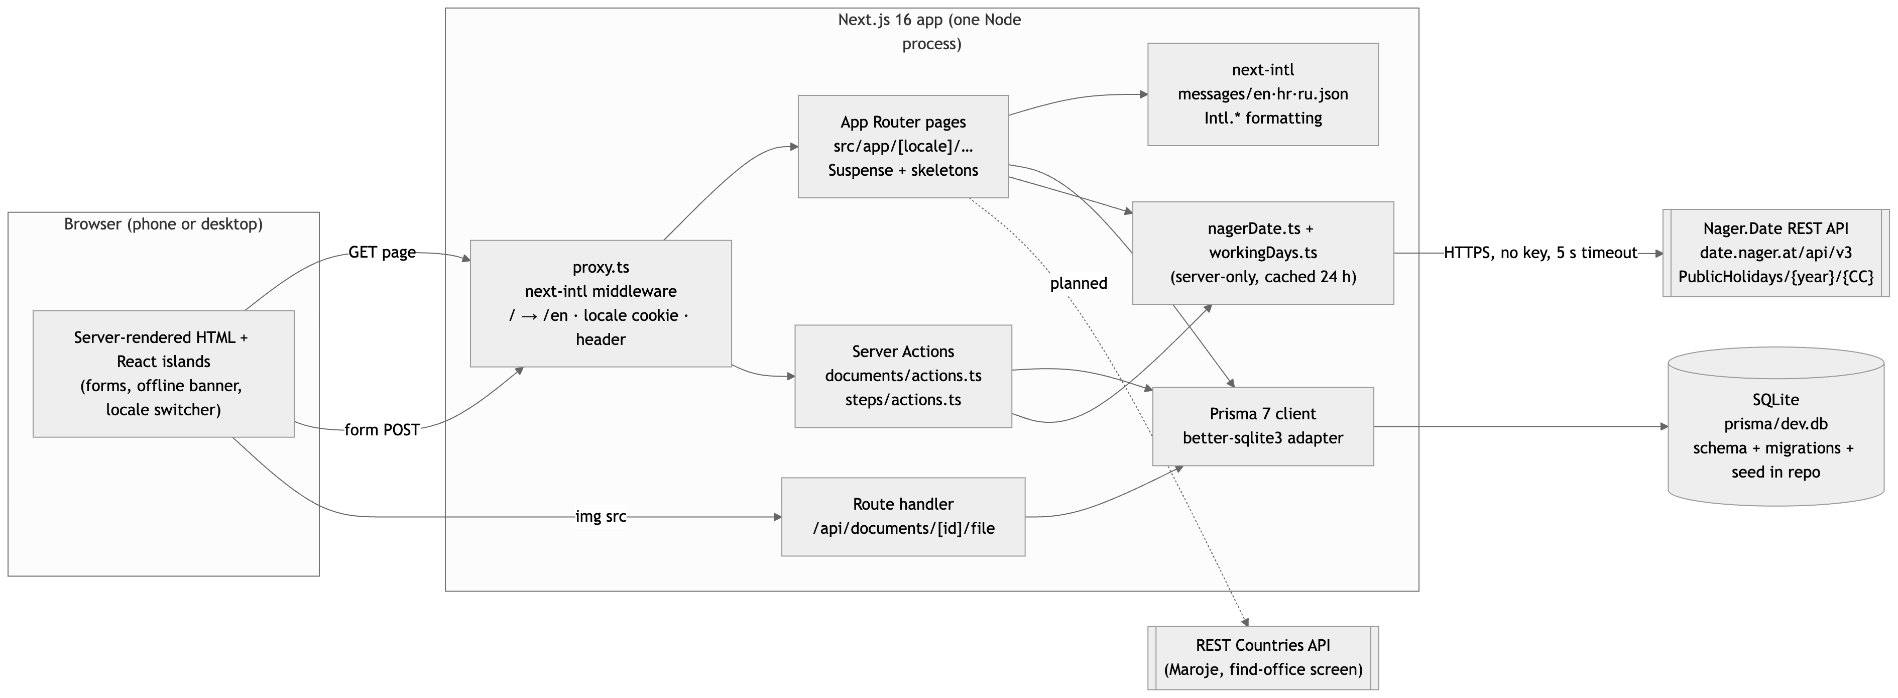
Figure 2.1 — system architecture
How a request flows: the browser asks for /hr/journeys/…/steps/…; proxy.ts validates the
locale segment, stores it in the NEXT_LOCALE cookie and forwards an X-NEXT-INTL-LOCALE header;
the page component loads the messages for that locale, reads the journey, step, attached documents
and corrections through Prisma, asks nagerDate.ts for the public holidays of the journey's
country (served from the 24-hour cache after the first call) and streams the HTML. The parts that
need the database are wrapped in <Suspense> with a localised loading skeleton, so the static
shell (header, navigation, locale switcher) arrives first. Form submissions go to Server Actions in
the same process, which write through Prisma, call revalidatePath and redirect.

2.3 Repository structure
The top-level folders and what lives in each. Keep it to the level a new team member would need.
`src/app/[locale]/` — Every screen, one folder per route: documents/ (wallet, screens 11–14), journeys/[journeyId]/steps/ (overview and step detail, screens 15–19), journeys/[journeyId]/complete/ (screen 20), dev/i18n/ (formatting and plural evidence page). Each route folder keeps its own actions.ts (Server Actions) and, where needed, error.tsx and not-found.tsx.
`src/app/api/` — Route handlers; today only documents/[id]/file which serves an uploaded scan.
`src/app/layout.tsx`, `src/app/[locale]/layout.tsx`, `globals.css` — Root HTML with lang and dir, the skip link, header navigation, offline banner, fonts (Inter with Latin-Extended and Cyrillic subsets).
`src/components/` — Shared client and server components: DocumentForm, ConfirmDelete (native <dialog>), SubmitButton (pending and offline aware), OfflineBanner, LoadingSkeleton, StatusBadge, LocaleSwitcher, CorrectionForm, JourneyShortcuts.
`src/lib/` — Framework-free logic: workingDays.ts (+ tests), nagerDate.ts (external API client), catalog.ts (typed access to catalogue translations), stepStatus.ts, documentFiles.ts (upload limits), ui.ts (shared class strings), db.ts (Prisma singleton), time.ts.
`src/i18n/` — next-intl configuration: routing.ts (locales, default, RTL set), request.ts (locale from the root param, message loading with en fallback), navigation.ts (locale-aware Link/redirect), actionLocale.ts (locale inside Server Actions).
`src/proxy.ts` — The next-intl middleware (Next 16 name for middleware).
`src/hooks/` — useOnline (navigator online state through useSyncExternalStore).
`messages/` — en.json (source), hr.json, ru.json; 213 keys each, nested by screen and by catalogue id.
`prisma/` — schema.prisma, migrations/ (one migration per schema change, applied with prisma migrate deploy), seed.ts, and the ignored dev.db.
`src/generated/prisma/` — The generated Prisma client (created on npm install, not committed).
`docs/part-b/` — This document's drafts and figures.
`public/` — Static assets (favicon only).
`.env.example`, `prisma.config.ts`, `next.config.ts`, `eslint.config.mjs`, `tsconfig.json` — Configuration. .env is ignored; DATABASE_URL and the optional NAGER_DATE_BASE_URL come from it.

3. From wireframes to screens

3.1 Merged screen map
Every screen in the running application, traced back to the wireframe it came from and the person who designed it.
# | Screen in the application | From whose Deliverable 1 set | Wireframe no. | Changed since the wireframe? How?
1
2
3
4
5
6
7
8
9
10
11
12
13
14

3.2 What was dropped or merged, and why
Feature areas or screens from Deliverable 1 that did not survive into the implementation, with the reason. Honesty here costs nothing; silent omission costs points.

3.3 Screens of the finished application
Add as many pairs as you need. Show the application as it actually looks, at the size a user would see it.
Screen: ______________ | Screen: ______________
[ Insert screenshot ] | [ Insert screenshot ]
Figure 3.1 — implemented screens
Screen: ______________ | Screen: ______________
[ Insert screenshot ] | [ Insert screenshot ]
Figure 3.2 — implemented screens
Screen: ______________ | Screen: ______________
[ Insert screenshot ] | [ Insert screenshot ]
Figure 3.3 — implemented screens

4. Database

4.1 Engine and justification
Database engine and version | SQLite 3 (bundled with better-sqlite3 13), accessed through Prisma 7.10 with @prisma/adapter-better-sqlite3.
Why this engine | A reviewer gets a working, seeded database in two commands with nothing to install, the file is reproducible, and Prisma keeps the schema portable: switching to PostgreSQL for deployment is a change of provider and DATABASE_URL.
Where the schema lives in the repository | prisma/schema.prisma (9 models with comments), prisma/migrations/20261111205634_init/migration.sql (the SQL that creates the 9 tables, indexes and foreign keys).
Migration tool / approach | Prisma Migrate. A schema change produces a new folder in prisma/migrations which is committed and reviewed; npm run db:migrate runs prisma migrate deploy. npm run db:reset drops, re-migrates and re-seeds.
How to load the seed data | npm run db:seed runs prisma/seed.ts: 2 life events, 9 step templates with dependencies, 10 document types, 23 step requirements, 1 example journey ("Selidba u Zagreb", HR) with 5 steps in different statuses, 3 wallet documents (two attached to a step) and 1 correction. No real personal data; the sample person "Ивана Šimunić" mixes Cyrillic and Croatian diacritics on purpose.
Character set / collation | UTF-8 (PRAGMA encoding → UTF-8). Verified by storing and listing "Osobna iskaznica · Ивана Šimunić" and "Ugovor o najmu – Savska cesta 41" unchanged (figure 4.2). Timestamps are stored as ISO 8601 UTC and rendered in the Europe/Zagreb time zone by next-intl. No credentials in the repository: the path comes from DATABASE_URL in .env (.env.example committed).

4.2 Entity-relationship diagram
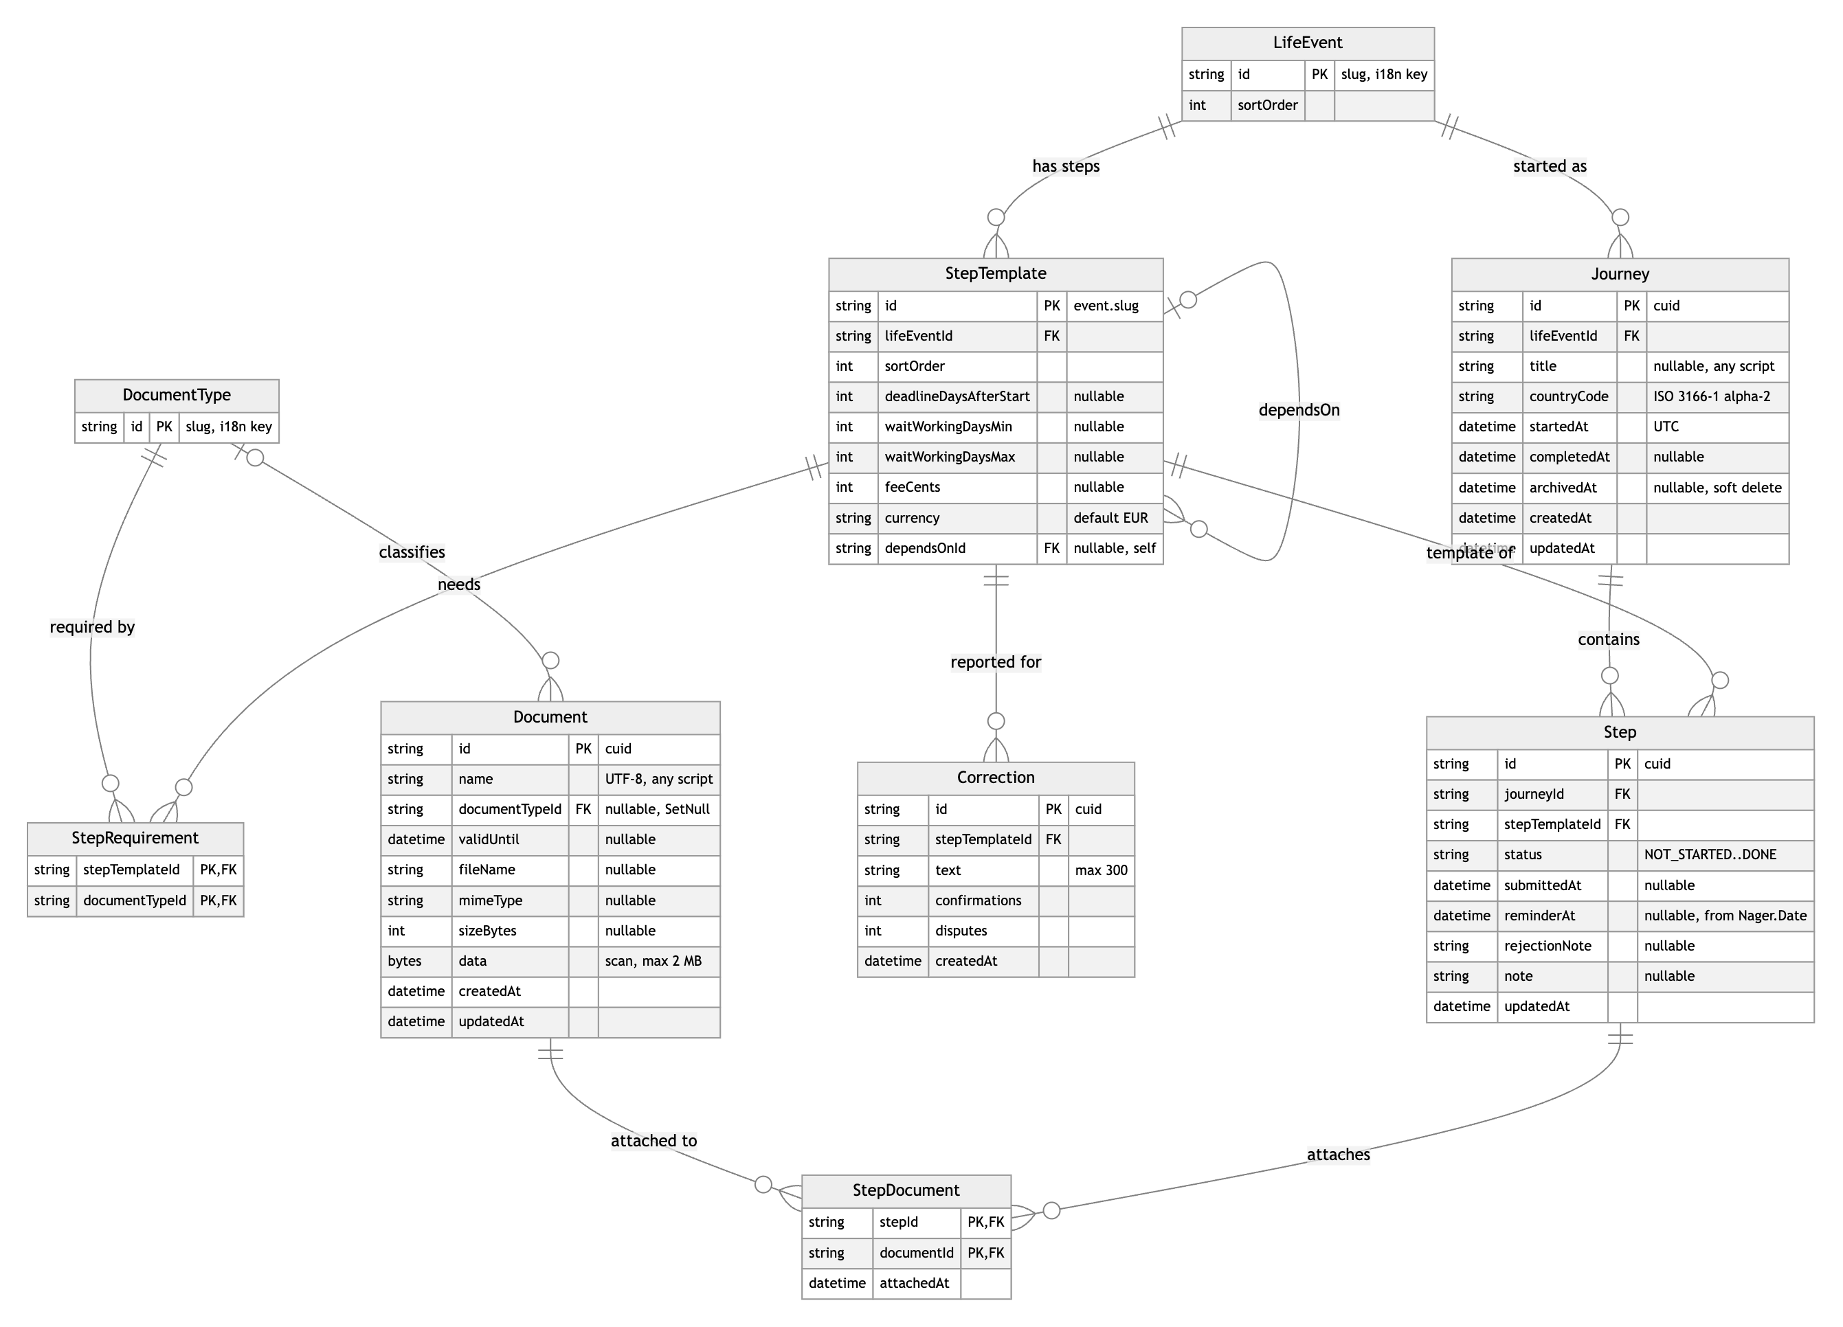
Figure 4.1 — entity-relationship diagram
Two layers: the catalogue (LifeEvent, StepTemplate, DocumentType, StepRequirement) is
seeded and its user-visible text lives in messages/<locale>.json under catalog.*, keyed by the
row id, so the catalogue is translatable without one row per language. User data (Journey,
Step, Document, StepDocument, Correction) is created through the interface.

4.3 Entities
Entity / table | What it holds | Key relationships | Notes (indexes, constraints, soft delete …)
LifeEvent | A life event a journey can be started for (move-abroad, start-university). | 1 → many StepTemplate, 1 → many Journey. | id is a slug and doubles as the i18n key catalog.events.<id>.
StepTemplate | One administrative step of an event: order, deadline in days from the journey start, typical waiting time in working days, fee, and which earlier step it depends on. | many → 1 LifeEvent; optional self-relation dependsOn (the step that must be DONE first); 1 → many StepRequirement, Step, Correction. | id = <event>.<slug>; composite index (lifeEventId, sortOrder); cascade delete with the event.
DocumentType | A kind of document (passport, lease-contract …). | 1 → many StepRequirement, 1 → many Document. | Slug id, i18n key catalog.documentTypes.<id>.
StepRequirement | Which document types a step needs (the "What to bring" list). | Join table StepTemplate ↔ DocumentType. | Composite primary key (stepTemplateId, documentTypeId); cascade on both sides.
Journey | A user's run through one life event: optional free-text title, country (ISO 3166-1 alpha-2, used for the holiday calendar), start, completion and archive timestamps. | many → 1 LifeEvent; 1 → many Step. | archivedAt is a soft delete (archived journeys disappear from lists, data stays); index on archivedAt; completedAt is set when the last step becomes DONE.
Step | Progress on one step of a journey: status (NOT_STARTED, IN_PROGRESS, SUBMITTED, REJECTED, DONE), when it was submitted, the reminder date computed from Nager.Date, the office's rejection reason, a free note. | many → 1 Journey (cascade), many → 1 StepTemplate; 1 → many StepDocument. | Unique (journeyId, stepTemplateId) so a journey has each step once. Status is a validated string (src/lib/stepStatus.ts), not an enum, because SQLite has no enums and the set must stay translatable.
Document | A wallet document (Hlib's full-CRUD entity): name in any script, optional type, validity date, and the uploaded scan (fileName, mimeType, sizeBytes, data). | many → 1 DocumentType (onDelete: SetNull keeps the document if a type is removed); 1 → many StepDocument. | data is a Bytes column limited to 2 MB by the upload validation; stored in the DB so the seed and offline reading stay self-contained. Deleting a document cascades to its attachments and is confirmed in a dialog first.
StepDocument | A wallet document attached to a journey step. | Join table Step ↔ Document. | Composite primary key (stepId, documentId); attachedAt; cascade on both sides.
Correction | A change reported by users for a step ("office moved to Savska 41") with confirmation and dispute counters. | many → 1 StepTemplate (cascade). | Index (stepTemplateId, createdAt) for the "recent corrections" list; text limited to 300 characters.

4.4 Evidence that it works
In the database | In the application
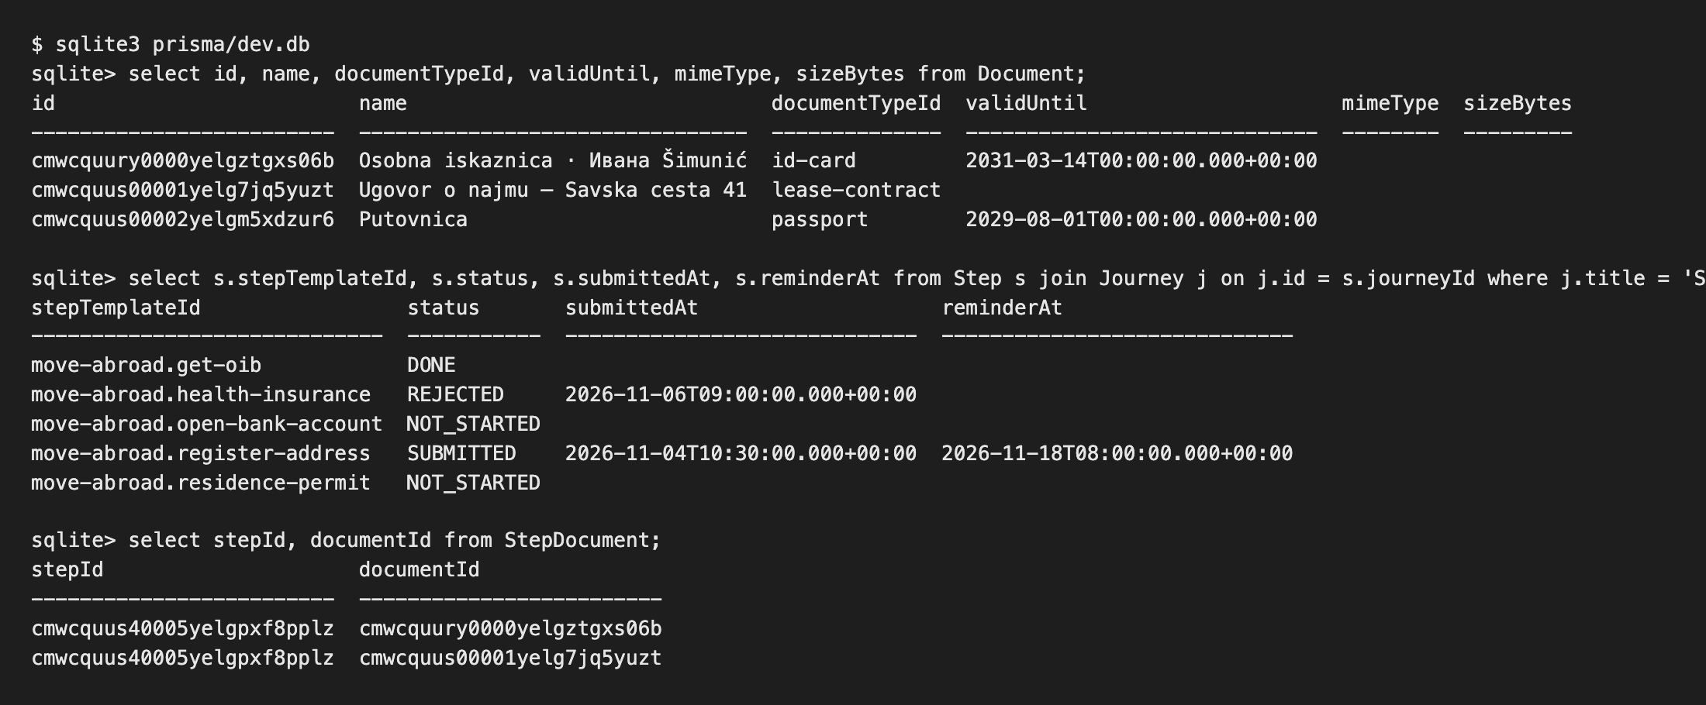 | 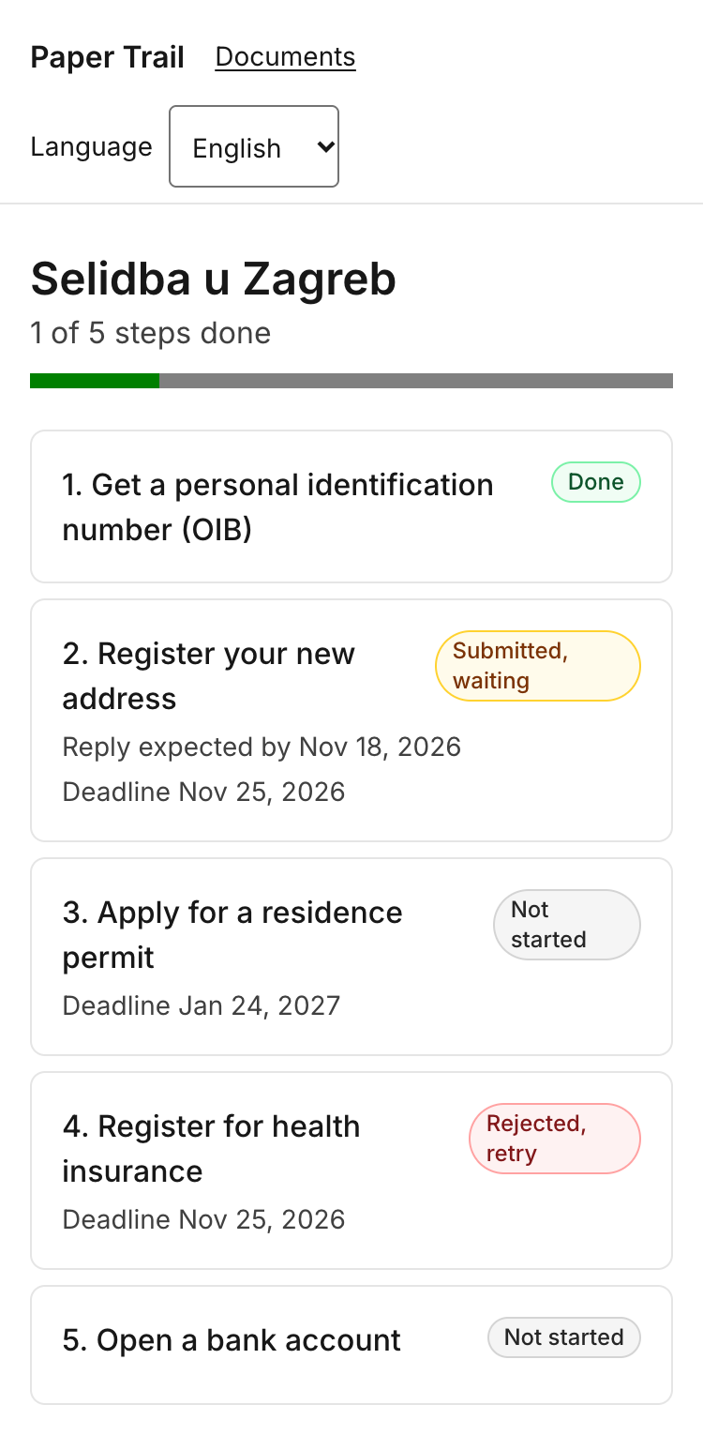
Figure 4.2 — persistence evidence

Describe one non-trivial query or operation in the application and why it is shaped that way.
One non-trivial operation. Changing a step's status (setStepStatus in src/app/[locale]/journeys/[journeyId]/steps/actions.ts) is more than an UPDATE:
1. It validates the new status against the allowed set and reads the step with its template.
2. For SUBMITTED it stores submittedAt = now and asks estimateReplyWindow() for the end of the typical waiting window, counting only working days of the journey's country (public holidays from Nager.Date, weekends from workingDays.ts); that date becomes reminderAt. REJECTED stores the office's reason; DONE clears the reminder; any other status resets all three fields.
3. It then counts the journey's steps that are not DONE; if none remain, Journey.completedAt is set (and cleared again if a step is reopened). That one query is what makes the "Path complete" screen (20) appear automatically.
4. After revalidatePath the user is redirected either back to the step or, when the journey just finished, to the completion screen. The two updates are sequential rather than wrapped in a transaction; with SQLite's single writer that is safe enough for this product, and it is noted here rather than hidden.
The step page itself loads the step, its template, the requirements with the document type, the attached documents and the latest corrections in one findUnique with nested include, plus one query for the wallet (to offer what can still be attached), so the screen costs two round trips to SQLite.

5. External REST API integration

5.1 The service
API name and provider | Nager.Date public holiday API, by Nager (Tino Hager), open source.
Documentation URL | https://date.nager.at/Api (Swagger: https://date.nager.at/swagger/index.html)
Why it is relevant to our topic | Offices quote processing times in working days ("5–10 radnih dana"). Paper Trail turns that into real calendar dates on the "Waiting for a reply" screen (17) and into the reminder date stored on the step, which is only honest if public holidays of the journey's country are skipped. On 18 November 2026 (Dan sjećanja na žrtve Domovinskog rata) nothing is processed in Croatia, so the window for the seeded step ends on the 19th, not the 18th.
Authentication (none / key / token) and where the secret lives | None. The call is still made only from the server (import "server-only"), so a keyed replacement would not change the client. The only configuration is the optional NAGER_DATE_BASE_URL in .env (documented in .env.example), used to demonstrate failure states.
Rate limits and terms we must respect | Free for public use, no published hard quota; the provider asks for sensible use and caching. We cache every answer for 24 hours per (year, country) and never call the API from the browser, so a reviewer session makes at most 2 requests (current and next year). The project and its data are MIT-licensed; the holiday names shown come straight from the API.
Attribution required by the provider? | Not required for the data; we credit Nager.Date in the README and here.
Where the integration lives in the code (file / module) | src/lib/nagerDate.ts (getPublicHolidays, estimateReplyWindow), src/lib/workingDays.ts (pure working-day arithmetic, tested in workingDays.test.ts). Used by src/app/[locale]/journeys/[journeyId]/steps/[stepId]/page.tsx (screen 17) and …/steps/actions.ts (setStepStatus, sets Step.reminderAt).

5.2 Endpoints used
Endpoint | Method | What we send | What we use from the response | Where it appears in the UI
https://date.nager.at/api/v3/PublicHolidays/{year}/{countryCode} | GET | Only the year and the journey's ISO 3166-1 alpha-2 country code (e.g. 2026, HR). No personal data: no names, dates of submission, documents or identifiers leave the server. Header accept: application/json, 5 s timeout. | date (to skip the day in the working-day count), localName (shown to the user, in the country's language), name, global / counties (regional holidays are excluded so a national estimate is not shortened by a county holiday). | Screen 17 Waiting for a reply: "Expect an answer between 11 Nov 2026 and 19 Nov 2026", the progress bar "6 working days of 10 passed", the list "1 public holiday in this window: Dan sjećanja na žrtve Domovinskog rata (18 Nov 2026)". Also the step overview (16) "reply by" line and the reminder date stored when a step is marked submitted.
The same endpoint is called for the submission year and the following year, because a window that
starts in December crosses into January.

5.3 Failure handling
Every outcome of getPublicHolidays() is a typed result, { ok: true, holidays } or
{ ok: false, reason }, so the screen never sees an exception. When the reason is set, the dates
are computed with weekends only and the screen says why (steps.waiting.fallback.<reason> in the
three locales). The user is never left with a blank panel or a stack trace.
Failure mode | What the user sees | What the system does
Network unavailable / offline | The waiting window is still shown, computed from weekends only, with the sentence "Public holidays couldn't be loaded (no connection), so the dates count weekends only." Above it the global offline banner appears and submit buttons are disabled. | fetch throws → reason offline; estimateReplyWindow returns fallback: "offline" and an empty holiday set. Nothing is cached, so the next render retries.
Request timeout | "The holiday service took too long to answer, so the dates count weekends only." | AbortSignal.timeout(5000) aborts the request; TimeoutError/AbortError → reason timeout. The page still renders within the timeout because the holidays are awaited inside the Suspense boundary of the step page.
Rate limit reached (429) | "The holiday service is busy right now, so the dates count weekends only." | HTTP 429 → reason rate-limited; no retry storm, the 24 h cache means a successful answer is reused for every user and screen.
Empty result set | Normal screen without the holiday list: "Expect an answer between … and …", no "public holidays in this window" line. | An empty array is a valid answer (a country with no national holidays in the window); the working-day count simply skips only weekends.
Malformed or unexpected response | "The holiday service sent an unexpected answer, so the dates count weekends only." | Body is parsed and every element validated (date as YYYY-MM-DD, localName and name strings); anything else → reason malformed. Invalid JSON is caught the same way.
Service down (5xx) | "The holiday service is down, so the dates count weekends only." | Any non-OK status other than 404/429 → reason server-error.
Invalid or expired key | Not applicable: the API has no key. The equivalent case, an unknown or unsupported country code (HTTP 404, or a journey without a country) shows "No holiday calendar for this country, so the dates count weekends only." | Country code validated as two capital letters before calling; 404 → reason unsupported-country.

5.4 Caching and data volume
Answers are cached by Next.js's fetch cache for 24 hours per (year, country) (next: { revalidate: 86400 }). Public holidays change a few times a year at most, and a reminder date being a day off because a government announced a new holiday is acceptable for a day; the window is recomputed from the cache on every render anyway. A typical reviewer session (open the step overview, open the submitted step, mark something submitted) makes 2 external calls on a cold server (2026 and 2027 for HR) and 0 afterwards. One response for Croatia is about 2.7 KB (14 holidays in 2026). Nothing is persisted from the API except the derived reminderAt date on the step.

5.5 Evidence
Working state | Failure state
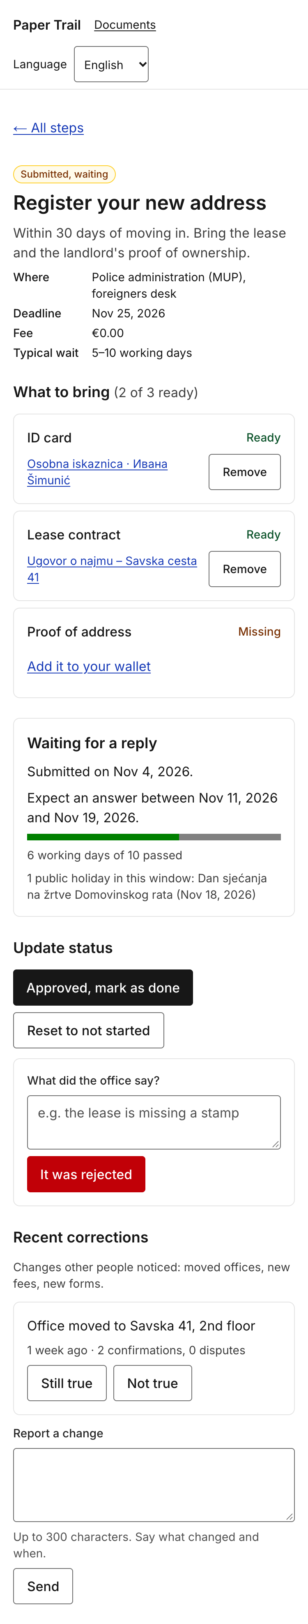 | 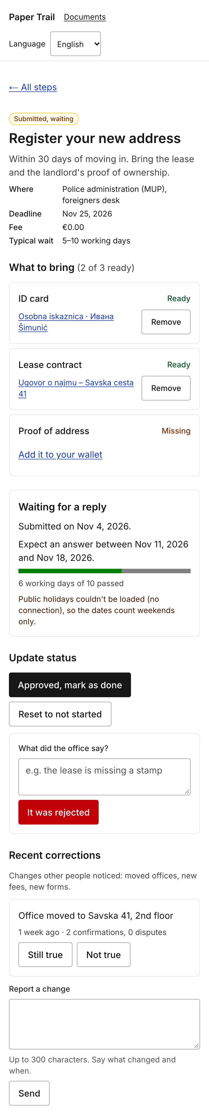
Figure 5.1 — external API in use, and when it is not available
external API in use (window 11–19 Nov 2026, holiday on 18 Nov listed) and when it is not available (NAGER_DATE_BASE_URL pointed at a closed port: window 11–18 Nov, explanation shown, rest of the screen unchanged).

6. Internationalization and localization

6.1 Locales implemented
Locale | Language | Completeness (%) | Who produced it | Who checked it | Why this locale
en | English |  |  |  | Source language
hr | Croatian |  |  |  | Plural rules, diacritics

6.2 How i18n is implemented
Library / framework used | next-intl 4.15 on Next.js 16.4 (ICU MessageFormat via intl-messageformat, formatting via the platform Intl.* APIs).
Where the translation files live | messages/en.json, messages/hr.json, messages/ru.json in the repository root, one file per locale, under version control.
File format and key naming convention | JSON, nested objects. Keys are semantic and hierarchical by screen or domain: documents.form.errors.fileTooLarge, steps.waiting.fallback.timeout, catalog.steps.move-abroad.register-address.title. Catalogue text is keyed by the database row id so a step added to the seed gets its text in the three files, never in the table. Keys are never English sentences and never contain dots (next-intl uses them for nesting). The message types are generated from en.json, so t("documents.fom.title") is a TypeScript error and a hardcoded string in a component is caught in review.
Number of translation keys | 213 leaf keys in each file (parity checked with a script; CI would fail the build on a missing key in en.json because of the strict types).
Fallback chain | <locale> → en. src/i18n/request.ts deep-merges the English file under the requested locale's file, so a key missing from hr.json is served in English.
How the locale is detected and persisted | The locale is a URL segment (/en/…, /hr/…, /ru/…, localePrefix: "always"). src/proxy.ts (next-intl middleware) redirects / to the best match from the NEXT_LOCALE cookie, then the Accept-Language header, then the default en; every visit rewrites the cookie, so the choice survives a reload and a new tab. The IP address is never used. The switcher in the header swaps only the locale segment and keeps the current page. Unknown segments (/de/...) render the 404 page.
How a missing key behaves | Development: onError logs [i18n] MISSING_MESSAGE … to the server console and the screen shows ⚠ namespace.key so it is impossible to miss. Production: the English fallback is rendered (see fallback chain); if even English lacks the key the message renders empty rather than as a raw key.
How lang and dir attributes are set | src/app/[locale]/layout.tsx renders <html lang={locale} dir={getDirection(locale)}>; getDirection in src/i18n/routing.ts returns rtl for locales in the RTL_LOCALES set (empty today, so ltr for en/hr/ru). Verified with axe-core on every screen 11–20: lang="hr" on /hr/…, lang="en" on /en/…. The <option> elements of the locale switcher carry their own lang so "Hrvatski" and "Русский" are pronounced correctly, and holiday names from Nager.Date (always in the country's language) are wrapped in <span lang> of that language (holidayLanguage() in src/lib/nagerDate.ts), found in the screen reader walkthrough (7.3).
Other engineering rules from 6.2 of the brief, as implemented:
– No sentence is concatenated. "6 working days of 10 passed" is one message with two parameters ({days, plural, …} of {max} passed), and the holiday list is Intl.ListFormat, not join(", ").
– No text in images: the only image in screens 11–20 is the user's own scan, with a localised alt ("Scan of {name}").
– Page titles, the skip link, aria-label of the navigation, the loading text of skeletons, validation errors, the 404 and error pages and the confirm-delete dialog are all translated.

6.3 Plural rules
Paste the message that proves you are using real plural rules, in English and in Croatian, and show it rendering for 1, 2 and 5.
Message definition (i18nDemo.documentsCount, the same pattern is used for steps.waiting.elapsed,
steps.waiting.holidays, steps.corrections.votes, complete.stepsCount, complete.daysCount,
documents.list.count):
"en": "{count, plural, =0 {No documents} one {# document} other {# documents}}",
"hr": "{count, plural, =0 {Nema dokumenata} one {# dokument} few {# dokumenta} other {# dokumenata}}",
"ru": "{count, plural, =0 {Нет документов} one {# документ} few {# документа} many {# документов} other {# документа}}"
Rendered by the running product at /<locale>/dev/i18n (copied from the page, not typed):
count | en | hr | ru
0 | No documents | Nema dokumenata | Нет документов
1 | 1 document | 1 dokument | 1 документ
2 | 2 documents | 2 dokumenta | 2 документа
5 | 5 documents | 5 dokumenata | 5 документов
21 | 21 documents | 21 dokument | 21 документ
25 | 25 documents | 25 dokumenata | 25 документов
21 is the proof that the CLDR rules are used and not n === 1: Croatian and Russian treat 21 as
one (ends in 1 but not 11), 25 as other / many.

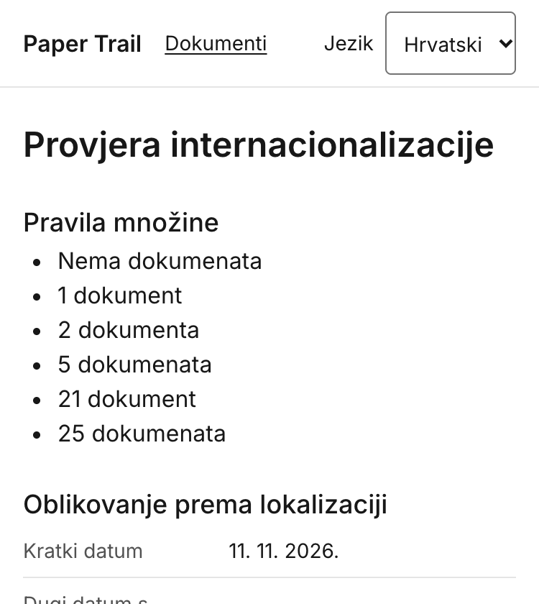
Figure 6.1 — plural forms: one / few / other

6.4 Locale-aware formatting
Fill in what your application actually renders in each locale — copy the values from the running product, not from the documentation.
Every value is produced by next-intl's useFormatter() / getFormatter() (which wrap
Intl.DateTimeFormat, Intl.NumberFormat, Intl.RelativeTimeFormat, Intl.ListFormat) or by
Intl.Collator; the component never builds a string by hand. Values copied from /en/dev/i18n,
/hr/dev/i18n, /ru/dev/i18n on 2026-11-12 (reference instant 2026-11-11 14:05 UTC, time zone
Europe/Zagreb):
What | en | hr | Third locale: ru | Formatted by
Short date | 11/11/26 | 11. 11. 2026. | 11.11.2026 | format.dateTime(d, { dateStyle: "short" })
Long date with weekday | Wednesday, November 11, 2026 | srijeda, 11. studenoga 2026. | среда, 11 ноября 2026 г. | format.dateTime(d, { dateStyle: "full" })
Time | 3:05 PM | 15:05 | 15:05 | format.dateTime(d, { timeStyle: "short" }) — 12 h clock in en, 24 h in hr and ru
Relative time ("3 days ago") | 3 days ago | prije 3 dana | 3 дня назад | format.relativeTime(then, now)
Large number | 1,234,567 | 1.234.567 | 1 234 567 | format.number(1234567) — ru uses a narrow no-break space
Decimal number | 1,234.56 | 1.234,56 | 1 234,56 | format.number(1234.56)
Percentage | 26% | 26 % | 26 % | format.number(0.256, { style: "percent" })
Currency | €49.90 | 49,90 € | 49,90 € | format.number(49.9, { style: "currency", currency: "EUR" }) — symbol position follows the locale; step fees on screens 15–16 use the same call with the template's currency
List of three items | ID card, Lease contract, and Proof of address | Osobna iskaznica, Ugovor o najmu i Dokaz o adresi | Удостоверение личности, Договор аренды и Подтверждение адреса | format.list([...]) — Oxford comma in en, "i"/"и" without comma in hr/ru; the holiday list on screen 17 uses the same
Sorted list of names with Č, Ć, Š | Ana, Čedo, Ćiril, Cvita, Đuro, Šimun, Zoran | Ana, Cvita, Čedo, Ćiril, Đuro, Šimun, Zoran | Ana, Čedo, Ćiril, Cvita, Đuro, Šimun, Zoran | [...names].sort(new Intl.Collator(locale).compare) — Croatian collation puts Č, Ć after C and Đ after D; ASCII order would put all of them after Z
Dates and times in the product are stored as UTC in SQLite (DateTime columns, ISO 8601) and
rendered in Europe/Zagreb through the same formatter (timeZone in src/i18n/request.ts), e.g.
"Submitted on Nov 4, 2026" / "Predano 4. stu 2026." / "Подано 4 нояб. 2026 г." on screen 17.

6.5 Same screen, three locales
English | Croatian
[ Insert screenshot: en ] | [ Insert screenshot: hr ]
Figure 6.2 — the same screen in English and Croatian
[ Insert screenshot: the same screen in the third locale ]
Figure 6.3 — the same screen in the third locale

6.6 Text expansion and layout
Longest locale in our interface
Worst expansion found (label, before → after, % growth)
What broke, and how it was fixed
Where truncation is still used, and why it is safe there

Shortest | Longest
[ Insert screenshot: shortest locale ] | [ Insert screenshot: longest locale, same screen ]
Figure 6.4 — the same layout under text expansion

6.7 Direction and script
Complete this section if your third locale is right-to-left. If it is not, state which script or line-breaking challenge you handled instead, and show the evidence.
Right-to-left locale implemented? | No. The third locale is Russian (Cyrillic, left-to-right).
How direction is switched | Ready but unused: dir={getDirection(locale)} on <html>, with RTL_LOCALES in src/i18n/routing.ts as the single place to add ar or he.
Logical CSS properties used instead of left/right? | Yes, throughout: Tailwind logical utilities ps-* / pe-* / ms-* / text-start are used instead of pl / pr / ml / text-left (e.g. the <th scope="row" class="pe-4 text-start"> on the formatting table, ps-6 on lists), so a future RTL locale mirrors without touching components.
Which icons are mirrored, and which are deliberately not | The product uses no icon font; the only directional glyph is the "←" in "← Back to documents" / "← All steps", which lives in the message string so an RTL translation would simply use "→". Check marks and the progress bar would stay unmirrored.
How numbers and Latin names behave inside RTL text | Not exercised (no RTL locale). The same mechanism that is exercised — the Unicode bidi algorithm handling mixed scripts — is what keeps "Osobna iskaznica · Ивана Šimunić" readable inside a Russian sentence and inside an English one.
If not RTL: what script or line-breaking issue was handled instead | Mixed scripts in one line. Document names, Croatian holiday names and office names come from the database or from the API in Latin script with diacritics (č ć đ š ž) and appear inside Cyrillic sentences in the Russian locale: "1 праздник в этом интервале: Dan sjećanja na žrtve Domovinskog rata (18 нояб. 2026 г.)". Two things had to be right: (1) the font — Inter is loaded with the latin, latin-ext and cyrillic subsets in every weight used, so there is no fallback-font mismatch between "Ивана" and "Šimunić" in the same name; (2) storage and transport — SQLite UTF-8, Content-Disposition: inline; filename*=UTF-8''… on the scan route so a file named in Cyrillic downloads with its name. Line breaking: Croatian and Russian both produce long words ("internacionalizacije", "Подтверждение"), so nothing in screens 11–20 assumes a single line: buttons are inline-flex with min-h-11 and wrap, labels sit above fields, the step header is a <dl> that stacks on narrow screens, and break-words is on the document name heading so a long name without spaces cannot push the layout sideways (verified at 320 px, see 7.1 check 3).

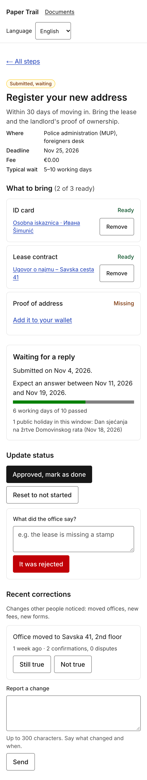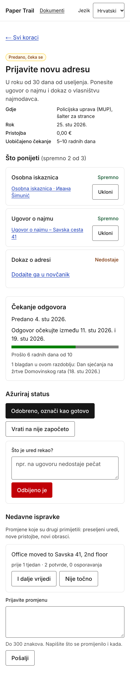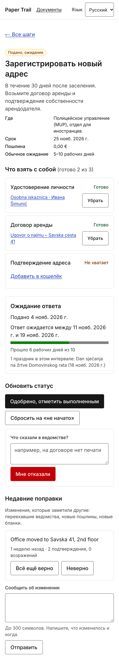
Figure 6.5 — direction and script handling
the waiting screen (17) in three scripts; the mixed-script document name and the Croatian holiday name appear unchanged inside Cyrillic text.

6.8 Cultural checks
Element | What we checked | What we changed
Colours that carry meaning
Icons and emoji
Example data, placeholder names, avatars
Name, address and phone fields
Anything AI-generated in the product

7. Accessibility report
Scope: documents wallet (11 list, 12 add/scan, 13 reading/loading state, 14 detail with edit and
confirmed delete), step requirements (15), step status (16), waiting for a reply (17), rejected
(18), recent corrections and offline (19), path complete (20). Run on 2026-11-12 against the seed
database with Chrome 157 (Playwright) at 375 × 740 CSS px; the screen reader walkthrough (7.3) was
added the same evening and led to a second round of fixes. Maroje adds the same table for screens
01–10. Target: WCAG 2.2 AA.

7.1 The ten-minute check
# | Check | Result | Issues found | Fixed?
1 | Keyboard only — everything reachable and operable | Pass | Tab order recorded on every screen: skip link → "Paper Trail" → "Documents" → language select → page content in reading order (e.g. screen 17: back link, 2 document links, 2 Remove buttons, Add it to your wallet, 3 status buttons, rejection note, It was rejected, Still true, Not true, correction textarea, Send). All 8–18 controls per screen are real <a>, <button>, <input>, <select>, <textarea>; the delete confirmation is a native <dialog> opened with showModal() (focus moves to Cancel, Esc closes, focus is trapped by the browser). No keyboard trap found. The Next.js dev-tools badge is the last tab stop in development only. Found in 7.3: after every form action (save, attach, change status) focus returned to the top of the document, so the result had to be searched for; and the three Remove buttons on screen 15 had identical names. | Yes — every action now redirects to #section and FocusOnHash moves focus to the heading that changed; Remove buttons are named "Remove <document>".
2 | Focus indicator always visible | Pass after fix | Content controls already had a 2 px blue-700 outline with 2 px offset (focus-visible). The header links and the language <select> relied on Chrome's default 1 px auto ring, which is visible but inconsistent and thin. The 4th tab stop inside the native date input (the calendar icon) shows no outline; that is Chrome's internal control. | Yes — ui.focus applied to the header links and the locale select (this PR). Date picker icon: browser-internal, not fixed.
3 | 200% zoom / 320 px width | Pass after fix | At 320 px every screen overflowed horizontally by 13 px: the "Language" label + select in the header did not fit beside the two navigation links (scrollWidth 333). At 1280 px and CSS zoom 200 % no overflow, no overlap, nothing hidden. | Yes — header is flex-wrap, the switcher drops to its own line below 350 px; re-measured scrollWidth = 320 on all six screens.
4 | Automated scan | Pass | axe-core 4.14 (wcag2a, wcag2aa, wcag22aa, best-practice) on screens 11, 12, 12-with-error, 14, 14-dialog, 16, 17, 18, 20 and /hr/dev/i18n: 0 violations, 0 incomplete, 37–44 passed rules per screen (landmarks, labels, lang, heading order, colour contrast, list semantics, button names, aria-* validity). | n/a
5 | Colour contrast | Pass after fix | Measured from rendered colours: body text 17.9:1, muted text (neutral-700) 10.4:1, hint text (neutral-600) 7.8:1, link blue-800 8.8:1, primary button 17.9:1, danger button white on red-700 6.4:1, status badges 8.7–13.9:1, "Missing"/"Ready" labels 9.1:1 / 8.4:1, focus ring blue-700 on white 6.8:1. Two failures: placeholder text was 3.4:1 (Tailwind's default 50 % current colour, needs 4.5:1), and the border of inputs, textareas, the select and secondary buttons (neutral-400) was 2.6:1 against white, below the 3:1 minimum for component edges (1.4.11). Disabled buttons: white on neutral-400 = 2.6:1 (exempt under 1.4.3, logged anyway). | Both: yes — placeholder:text-neutral-600 (7.8:1) and border-neutral-500 (4.7:1). Disabled buttons: no, see 7.5 (#6).
6 | Images and alt text | Pass | The only <img> in these screens is the user's scan on screen 14, alt="Scan of {document name}", localised. PDF uploads are a link, not an image. No decorative images; status is text, not icons. | n/a
7 | Form labels and error messages | Pass | Every control has a <label for> (axe label rule and a DOM check: 0 unlabeled fields on 12, 14, 17, 18). Clicking a label focuses its field. Submitting the empty add-document form: role="alert" "Give the document a name.", the field gets aria-invalid="true" and aria-describedby pointing at the message; the correction form behaves the same ("Write what changed."). File too large / wrong type / invalid date each have their own translated message. Required fields are marked with text, not colour. Found in 7.3: after a failed submit focus stayed on the button, so the alert was heard once and then lost. | Yes — focus moves to the first invalid field, which reads the message again through aria-describedby.
8 | Heading order and lang attribute | Pass after fix | One <h1> per screen, sections under <h2> with aria-labelledby (screen 17: h1 → "What to bring", "Waiting for a reply", "Update status", "Recent corrections"; screen 14: h1 → "Used in 1 step", "Edit", "Delete this document"). <html lang> is en/hr/ru per URL, dir="ltr"; <option lang> on the language names. Two failures found in 7.3: every page's <title> was just "Paper Trail" (the layout had the %s · Paper Trail template but no page set a title, so a screen reader announced the same name on every screen, WCAG 2.4.2); and Croatian holiday names on screen 17 had no lang, so an English voice read them with English pronunciation (3.1.2). | Yes — screens 11–20 set a translated title (document name, step name, journey name, "Add a document", "Path complete"); holiday names are wrapped in <span lang> derived from the journey's country.
9 | Screen reader — one complete task | Pass after fix | Task: add a document with a scan → attach it on screen 15 → mark the step submitted → read the reply window on screen 17 (details and transcript in 7.3). Announcements that worked first time: "Reading your scan…" once, validation alerts, link names on the overview ("2. Register your new address, In progress, Deadline Nov 25, 2026", aria-current="step"), the progress bar name "0 working days of 10 passed", the Croatian version of the waiting section. Five problems found (identical page titles, silent results after each action, focus not moved to the invalid field, three identical "Remove" buttons, Croatian names read by an English voice) — all fixed and re-verified with a second recorded run (#8). | Yes (this PR). A listen-through with VoiceOver audio is still recommended before the final tag, see 7.3.
10 | Target size, spacing and reduced motion | Pass | Every interactive element measured ≥ 44 × 44 CSS px (min-h-11 on buttons, links, inputs and the select; smallest measured 44 px on all screens), with gap-2/gap-3 spacing; the skip link is 1 × 1 px only while hidden and 40 px tall when focused. The only animation is the loading skeleton's pulse; with prefers-reduced-motion: reduce emulated, animation-name resolves to none on all skeleton rows (motion-reduce:animate-none, added in this PR). Nothing flashes. | Reduced motion: yes (this PR).

7.2 Tools used
Tool | Where it was run | Summary of result
axe-core 4.14.0 (injected via Playwright) | Screens 11, 12 (+ error state), 14 (+ delete dialog), 16, 17, 18, 20, /hr/dev/i18n; en and hr | 0 violations, 0 incomplete on every screen.
Playwright 1.65 + Chrome 157, scripted checks | Same screens at 375 px, 320 px and 1280 px @ 200 % | Tab order, focus outline per stop, bounding boxes of all interactive elements, scrollWidth vs viewport, heading list, lang/dir, unlabeled-control count, animation-name under reduced motion. Found the 320 px overflow and the thin header focus ring.
Contrast probe (getComputedStyle + canvas, WCAG 2.x formula) | 12, 14, 16, 17 | Ratios in 7.1 #5; found the placeholder and the input-border failures.
Chrome DevTools, manual | 12, 14, 17 | Label click → field focus; Esc closes the dialog; date input keyboard entry.
Accessibility-tree walkthrough (Playwright ariaSnapshot() of every screen and of the focused element at each Tab stop, plus a MutationObserver logging every aria-live / role="status" / role="alert" change — i.e. what a screen reader is given to speak) | The complete task of 7.3 on screens 12 → 14 → 16 → 15 → 17, en and hr | Before fixes: 5 problems (see 7.1 #1, #7, #8, #9). After fixes: titles, focus targets, button names and lang confirmed; transcripts in figures/sr-walkthrough-before.txt and figures/sr-walkthrough-after.txt.
npm run lint (eslint-config-next incl. jsx-a11y rules) | whole src/ | Clean.

7.3 Screen reader walkthrough
Which screen reader, which task, and what actually happened. Where did you get lost, and what did you change?
Screen reader and method. The walkthrough was recorded through the accessibility tree that screen readers read, in Chrome 157: Playwright's ariaSnapshot() for every screen and for the focused element at each Tab stop (role, accessible name, state, aria-describedby text), and a MutationObserver on every live region (aria-live, role="status", role="alert") that logs what would be spoken and when. That is the input VoiceOver and NVDA work from, so the transcript (figures/sr-walkthrough-before.txt, figures/sr-walkthrough-after.txt) shows the announcements rather than our memory of them. A listen-through with VoiceOver audio (macOS Safari, iOS) has not been done yet and is the one thing we would still do before the release tag; the two things it can reveal that the tree cannot are verbosity and voice switching.
Task. Add "Dokaz o adresi · Savska 41" with a scan (screen 12) → open the journey overview (16) → open Register your new address → attach the new document on screen 15 → press I submitted it → read the reply window on screen 17. Keyboard only, 375 px, English; the waiting section re-read in Croatian.
What actually happened, and where we got lost
1. Screen 12, before. The page title was "Paper Trail" — and so was every other page's. The form itself read well: "Name, edit text, How you call it, e.g. Passport…", "Type, combo box, Not set", "Scan or photo, button, JPEG, PNG, WebP or PDF up to 2 MB. On a phone this opens the camera", "Save document, button". The native date field is three stops (month, day, year) plus a fourth, the calendar icon, which has no accessible name (browser-internal, logged in 7.5).
2. Saving the scan. "Reading your scan…" was announced exactly once (polite), then "Loading…" from the skeleton — and then nothing. Focus was at the start of the document and the title was still "Paper Trail", so a blind user had no confirmation that the document existed. Lost here. After the fix the title is "Dokaz o adresi · Savska 41 · Paper Trail" and focus lands on the <h1>, which is announced.
3. Validation. Submitting the empty form: "Saving…", then the alert "Give the document a name." — heard once, focus still on the button, so a user who missed it had to search. After the fix focus moves to the Name field: "Name, edit text, invalid, Give the document a name."
4. Screen 16. Good as it was: "1 of 5 steps done, progress bar", then each step as one link — "2. Register your new address, In progress, Deadline Nov 25, 2026, current step".
5. Screen 15. The requirement list reads "Proof of address, Missing — Pick from your wallet, combo box, Dokaz o adresi · Savska 41 — Attach, button". But the three Remove buttons were all named "Remove", useless when navigating by buttons; now "Remove Osobna iskaznica · Ивана Šimunić" etc. (the visible label stays "Remove").
6. Attach. "Saving…", then silence with focus at the top of the page (lost again). After the fix the action redirects to #req-heading and focus lands on "What to bring (3 of 3 ready), heading level 2" — the heading is the confirmation.
7. I submitted it. Before: "Saving…", then the new section appeared without a sound. After: focus lands on "Waiting for a reply, heading level 2", and reading on gives "Submitted on Nov 12, 2026. Expect an answer between Nov 20, 2026 and Nov 27, 2026. Progress bar, 0 working days of 10 passed. 0 working days of 10 passed. 1 public holiday in this window: Dan sjećanja na žrtve Domovinskog rata (Nov 18, 2026)." The progress value is heard twice (bar name and the text line under it); we kept both because the text is what sighted users read and the bar is what AT reports. The holiday name is Croatian inside an English sentence; it now carries lang="hr" (derived from the journey's country) so a screen reader can switch voice.
8. Croatian. Same section in /hr: "Čekanje odgovora. Predano 12. stu 2026. Odgovor očekujte između 20. stu 2026. i 27. stu 2026. Prošlo 0 radnih dana od 10 …". Document names in mixed script ("Osobna iskaznica · Ивана Šimunić") cannot carry a lang attribute because their language is whatever the user typed; listed in 7.5.
What we changed (commit "fix(a11y): what the screen reader walkthrough found"): translated <title> on every screen 11–20; actions redirect to the section that changed and FocusOnHash moves focus there; focus to the first invalid field after a failed submit (document and correction forms); per-document names on Remove buttons (aria-label, visible text unchanged); lang on holiday names. axe-core re-run after the changes: still 0 violations on every screen.

7.4 Contrast evidence
Measured | Fixed
Placeholder "e.g. the lease is missing a stamp": oklab(0.205 0 0 / 0.5) on white = 3.41:1 (fail). Input border neutral-400 oklch(70.8% 0 0) on white = 2.58:1 (fail, 1.4.11). Disabled primary button: white on the same neutral-400 = 2.58:1 (exempt). Danger button: white on red-700 = 6.42:1. Badge "Submitted, waiting": amber-900 on amber-50 = 8.73:1.  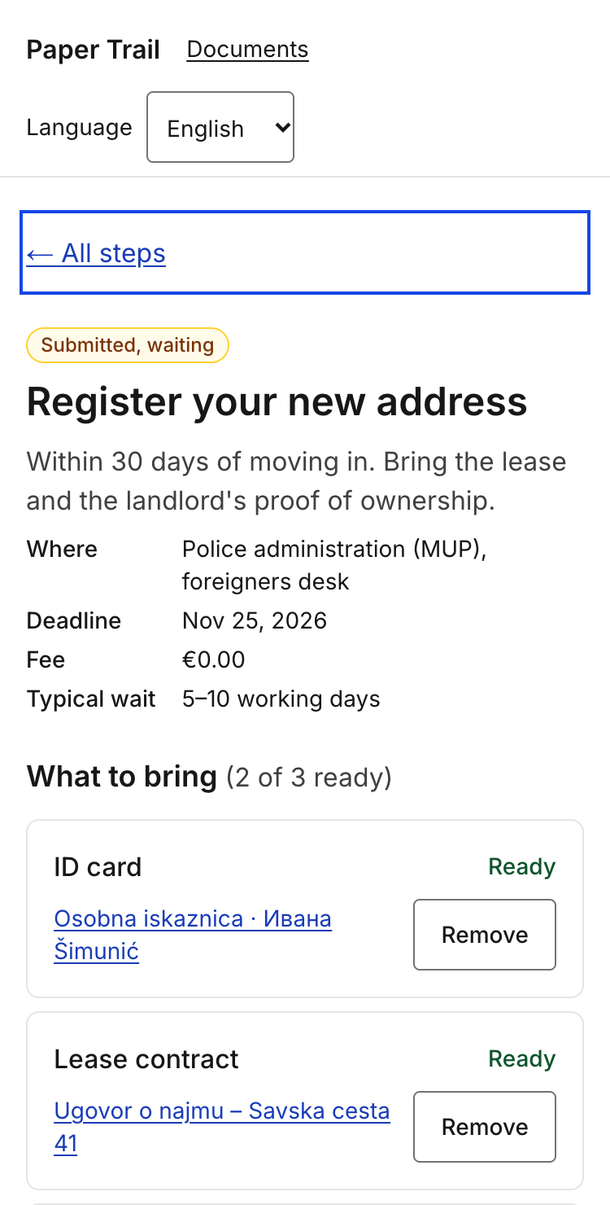 | Placeholder after placeholder:text-neutral-600: lab(34.9 0 0) on white = 7.81:1. Input border after border-neutral-500: lab(48.5 0 0) on white = 4.74:1.  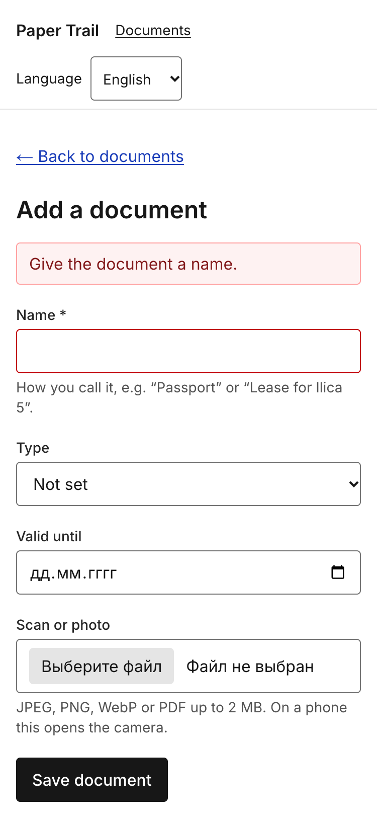
Figure 7.1 — contrast checks
contrast checks: the measured values above come from the rendered page; the screenshots show the focus ring (2 px blue-700, offset 2 px) on screen 17 and the error state of the add form.
Further evidence — 320 px viewport, 200 % zoom and the delete dialog:
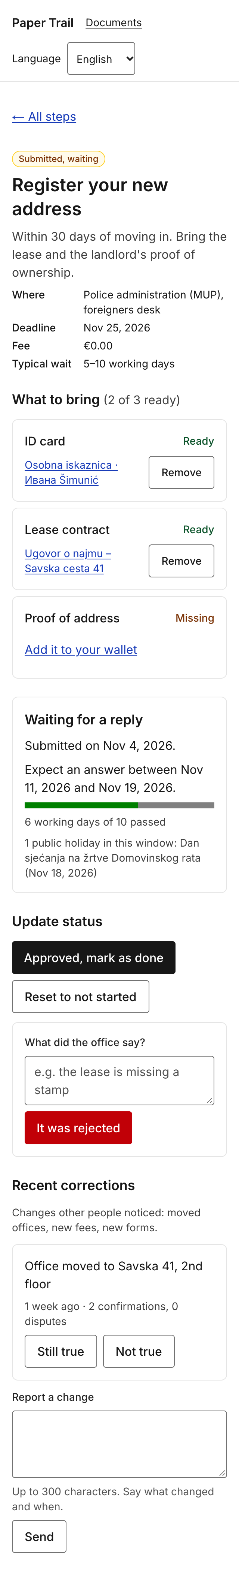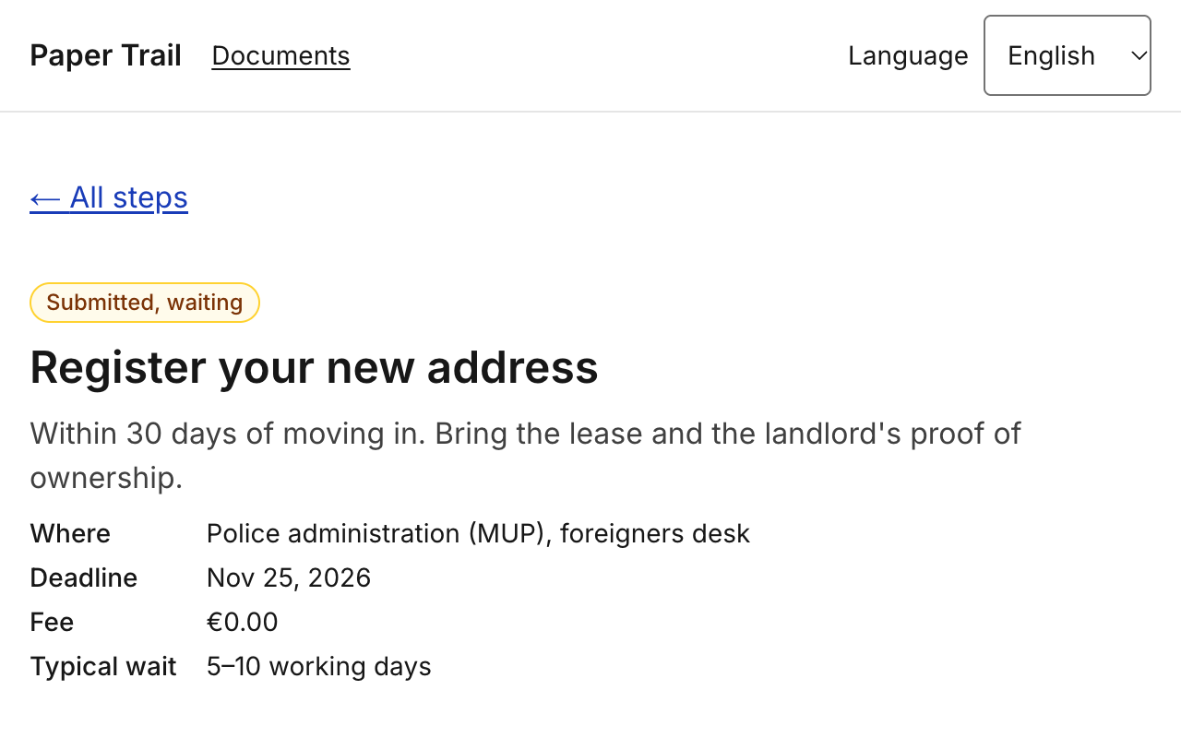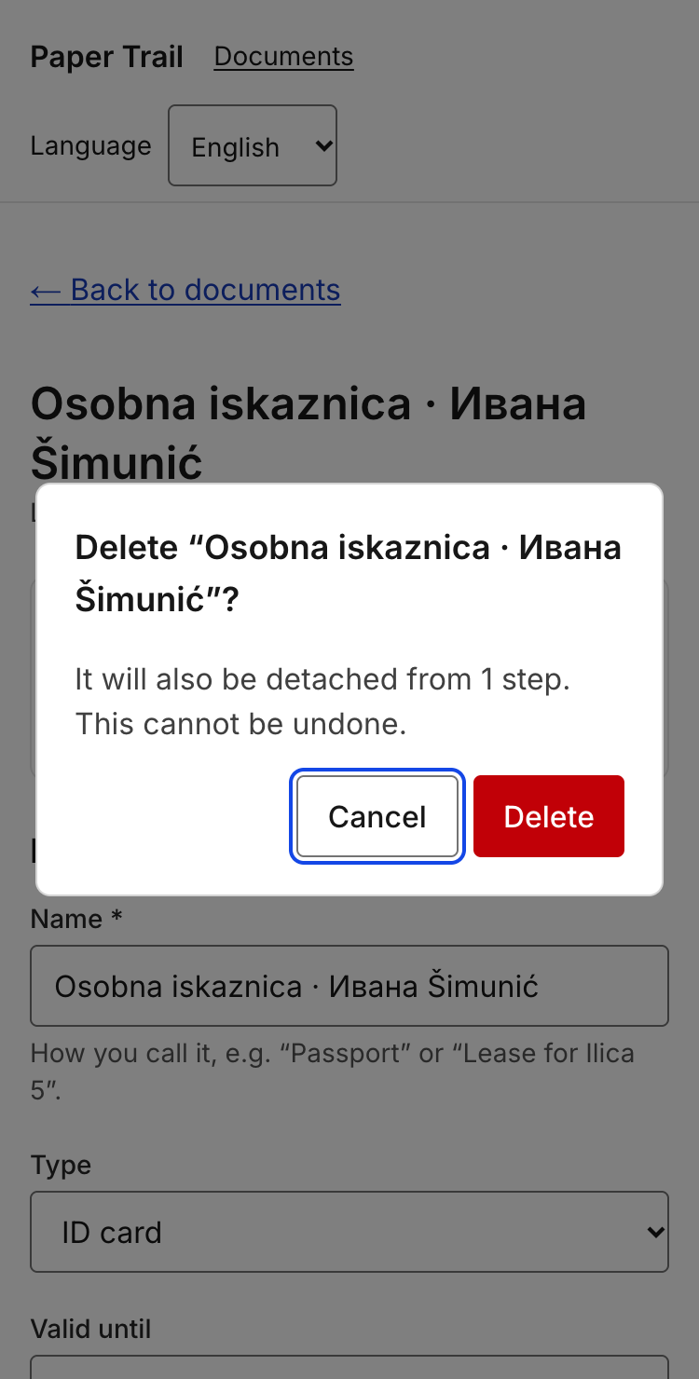

7.5 Known accessibility issues we did not fix
An honest list scores better than an empty one. Link each to a GitHub issue.
Issue | Who it affects | Severity | Why it is still open | Issue link
Unknown document / journey id renders the not-found screen but with HTTP status 200 (the page streams) | Search engines, link checkers; screen-reader users still get the "Not found" heading | Low | Fixing it means resolving the id before the Suspense boundary and giving up the static shell; postponed | #5
Disabled submit buttons (offline, or while saving) have 2.6:1 label contrast | Low-vision users reading a disabled label | Low (exempt under WCAG 1.4.3, but the offline hint next to the button is what makes the state understandable) | Needs a design decision on the disabled style shared with Maroje's screens | #6
Cold load without a network connection shows the browser's error page (no service worker); open pages stay readable and forms are disabled with an explanation | Everyone without connectivity, in particular inside government buildings | Medium | A service worker and offline page are a feature of their own; out of scope for this deliverable | #7
Document names typed by the user ("Osobna iskaznica · Ивана Šimunić") carry no lang, so a screen reader reads them with the page's voice | Screen reader users with documents named in another script | Low | The language of free text is unknown; guessing from the script is unreliable for Latin names | — (noted here)
On screen 17 the progress value is announced twice (the <progress> name and the visible text under it) | Screen reader users | Low | Deliberate for now: the text is what sighted users read; hiding it from AT would remove the only place the value is read in sequence | — (noted here)
Native <input type="date"> is operated with Chrome's own segment controls, whose focus style we cannot change; the calendar icon shows no visible focus ring | Keyboard users on screen 12/14 | Low | Browser-internal; a custom date picker would cost more than it gives | — (noted here)

7.6 Inclusive design decisions
Where did the persona spectrum, the social model of disability or the curb-cut effect change a decision in this product? Name the decision, not the concept.
– Status is never colour alone. Every step badge and requirement label is text ("Done", "Submitted, waiting", "Missing", "Ready"); the colour only reinforces it. Decided for colour-blind users, it also made the Russian and Croatian versions trivial because there was no icon legend to translate (curb-cut effect).
– Native `<dialog>` for delete confirmation instead of a custom modal. Focus management, Esc and the backdrop come from the browser; the dialog opens on Cancel so a slip on the keyboard cannot delete. A persona with a tremor and a persona in a hurry on the bus both benefit.
– Offline is a state, not an error. The banner explains what still works, and submit buttons are disabled with a visible and aria-describedby hint rather than failing silently. Designed for the "no signal in the MUP building" scenario, it also protects anyone on a flaky connection.
– 44 px targets everywhere, including links in lists. The wallet entries and step cards are full- width links with min-h-11, chosen for touch, equally useful with a mouse and reduced motor control.
– Working days, not calendar days. The waiting screen translates "5–10 working days" into dates and says why a holiday moved them; cognitive load the user would otherwise carry alone, and an honest fallback message when the holiday service is down.
– Any script, any name. A single generously sized name field with no character restriction (Ивана Šimunić is the seed example), because the first thing bureaucracy does to people with "unusual" names is reject them.

8. Git history and teamwork

8.1 Our branching model
Describe the model the team actually used: branch names, who merges, what protects main, how conflicts were handled.

8.2 Repository evidence
[ Insert screenshot: the network / commit graph showing branches and merges ]
Figure 8.1 — branch and merge history
[ Insert screenshot: contributors view showing commits per member over time ]
Figure 8.2 — contribution over time

8.3 Commits per member per week
Fill from the repository insights (Insights → Contributors, or git shortlog). Write each member's name in the header.
Week | Member 1: ________ | Member 2: ________ | Member 3: ________ | Member 4: ________ | Member 5: ________
W1
W2
W3
W4
W5
W6
W7
W8
W9
W10
W11
W12
Total

8.4 Pull requests
PR # | Title | Author | Reviewer | What the review changed

8.5 Honest account of the collaboration
What worked in the way the team organised itself, what did not, and what you would set up differently at the start of the next project. Merge conflicts, uneven load, blocked work — describe it as it happened.

9. Weekly progress log
One row per week per member, filled in during the week rather than reconstructed at the end. Keep it short: what was built, and the branch or pull request where it lives.
Week | Member | What was built or decided | Branch / PR | Blocked by

10. Testing, quality and known issues

10.1 How the product was tested
Type | What was covered | Where it lives / how to run it
Automated tests (if any)
Manual test pass
Cross-browser / device check
Locale check
Accessibility check

10.2 Known bugs and limitations
Issue | Impact on the user | Workaround | Issue link

10.3 What we would do next
The next three things you would build, in order, and why that order.

11. Individual contribution statements
One block per team member, written by that member. The claims here must be traceable in the repository.

Member 1
Name
GitHub username
What I built (features, files, modules)
My commits / PRs that show it
What I learned that I did not know before
Weeks I could not contribute, and why
Signature / date

Member 2
Name
GitHub username
What I built (features, files, modules)
My commits / PRs that show it
What I learned that I did not know before
Weeks I could not contribute, and why
Signature / date

Member 3
Name
GitHub username
What I built (features, files, modules)
My commits / PRs that show it
What I learned that I did not know before
Weeks I could not contribute, and why
Signature / date

Member 4
Name
GitHub username
What I built (features, files, modules)
My commits / PRs that show it
What I learned that I did not know before
Weeks I could not contribute, and why
Signature / date

Member 5
Name
GitHub username
What I built (features, files, modules)
My commits / PRs that show it
What I learned that I did not know before
Weeks I could not contribute, and why
Signature / date

12. AI usage declaration
Declare every AI assistant used for code, translation, documentation or design during this deliverable. Declaring use costs nothing; undeclared use that surfaces during the presentation costs a great deal.
Tool / model | Used for what | Who used it | How the output was verified

We confirm that every member of the team can explain any part of the submitted code, that the git history has not been fabricated or backdated, that no secrets are committed to the repository, and that third-party code and libraries are attributed in the README.

Name | Signature | Date

13. Submission checklist
☐ Repository link works, instructor has access, release tagged
☐ README lets a stranger run the project on a clean machine
☐ No secrets in the repository; .env.example present
☐ Every member has commits in most weeks of the development period
☐ Branches used, pull requests reviewed by someone other than the author
☐ Database schema and migrations in the repository, seed data loads
☐ ERD matches the implemented schema
☐ External API integrated, failure modes handled, attribution where required
☐ All user-visible strings externalised; no hardcoded text anywhere
☐ Three locales complete, including plurals and locale-aware formatting
☐ Text expansion and direction (or script) handled, with screenshots
☐ Ten-minute accessibility check completed and reported, remaining issues logged
☐ Screen map traces every screen back to a Deliverable 1 wireframe
☐ Weekly log filled in, individual contribution statements signed
☐ AI usage declared
☐ Exported to PDF, named Team00_UX_Deliverable2.pdf

