Past, Present& Future of Computer
Introduction
Computer is an electronic programmable machine that accepts data as inputs through input devices them store and processes it under the influence of a set of instructions called programs to produce the desired output generally referred to as information.
Past of computer
- Early computers such as ENIVAC were large and expensive.
- Computers were based on the vacuum tube& transistors technology.
- Machine language were used i.e programming was difficult.
- They used magnetic tapes and magnetic disk for secondary storage.
Examples: Universal Automatic Computer (UNIVAC), Electronic Numerical Integrator and Calculator (ENIAC), PDP-8, PDP-11 e.t.c
- The computers in past were mainly used for performing calculations and data processing.
- Only government, universities, and large organizations could afford them.

Disadvantages of past computers
- Computers were expensive and huge in size unlike present computers which fit on our lap.
- Programmers had to learn machine language which made programming difficult.
- Compared to modern computers, they performed calculations much more slowly and could only store small amounts of data.
- Computers required a large amount of electricity and became very hot easily and needed special cooling systems.
- Due to their large size moving them was quite hard.

Present of computer
- Present computers are microprocessor-based computers using Large Scale Integration (LSI) and the Very Large-Scale Integration (VLSI) technology.
- They are used in education, healthcare, banking, business, entertainment, and scientific research.
- Present computers have connected people across world through the internet, social media, and video conferencing.
- Educational software and virtual classrooms have changed traditional learning methods.
- Computers help doctors diagnose diseases, maintain patient records, and perform advanced medical research.
- AI-powered systems are being used in customer service, translation, recommendation systems, and data analysis.
- Large amounts of personal data are stored on computers and online systems.
- Computers increase productivity by automating repetitive tasks.
- Data and applications can now be stored online rather than on a single device which allows easier collaboration and access from anywhere.
- Although computers have greatly improved communication, education, healthcare, and productivity, they have also introduced challenges such as cybersecurity risks, privacy concerns, technological dependence, and environmental issues.

Disadvantages of Present Computer
- If not managed well personal data can be collected and misused.
- Automation can reduce some employment opportunity causing employment problems.
- People rely on computers heavily which affects physical and mental health.
- Electronic waste and energy consumption are growing concerns.

Future of Computer
- ULSI technology-based Bio-chips will be used as processing components.
- The research and advancement in quantum computation and molecular and technology could be utilized in future.
- Computers will be based on Artificial Intelligence (AI) which tries to simulate the human way of thinking and reasoning.
- Quantum computers may solve problems that today’s computers cannot solve efficiently.
- Voice commands, gestures, and even brain computer interfaces may become common.
- Robots may help in hospitals, industries, agriculture, and disaster response.
- AI systems may influence decisions in healthcare, education, law, and employment.
- Future generations may become increasingly dependent on computers for daily activities.
- Future computing technologies may require significant energy and resources. Hence sustainable and energy-efficient solutions will be necessary to reduce environmental harm.
- Technology such as brain computer interfaces could transform communication and healthcare.
Disadvantages of Future Computer
- Human jobs may be replaced by AI and other intelligent machines.
- Society may become overly dependent on computers for decision making.
- AI systems may make biased or unfair decision.
- Excessive reliability may reduce critical thinking and problem-solving skills.

Conclusion
Over time computers have become a daily part of human life allowing humans to make their daily task simpler. Computer advancement has helped humans save their time and apply those time for something more meaningful and also to get enough time for rest. Although technology advancement has brought remarkable benefits, they have also created important social, ethical, and security challenges. As technology continues to advance, balancing our daily screen time and allowing frequent social interaction will become mandatory.
Appendix
Fig: Past Computer
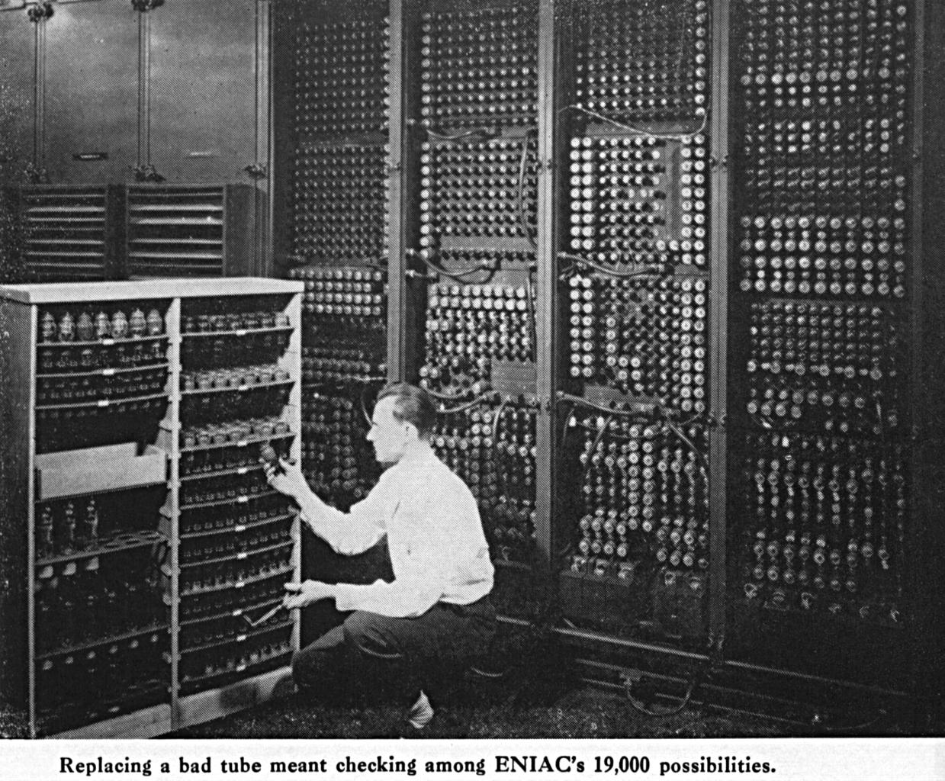

Fig: Present Computer
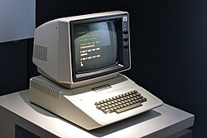

Fig: Future Computer
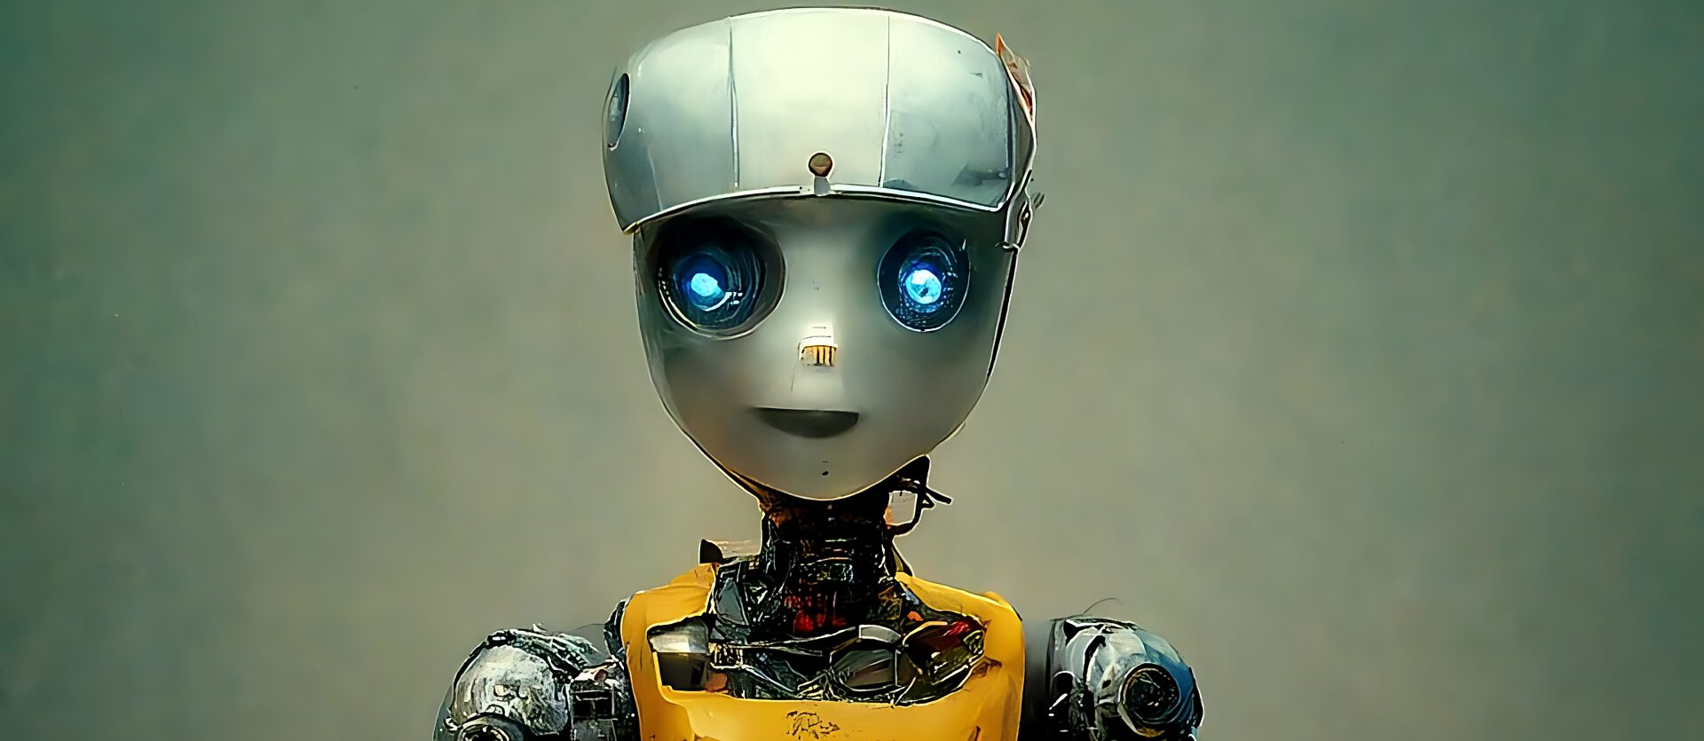

Submitted by: Aakriti Ghimire
Roll No: 01 (First Semester)
Program: BITM
Submitted to: Laxman Sign Khati

