My Document using Quarto

Soichi Matsuura

目次

# section

ここに文章を書く。

## subsection

library(ggplot2)  
ggplot(cars) + aes(speed, dist) + geom_point()

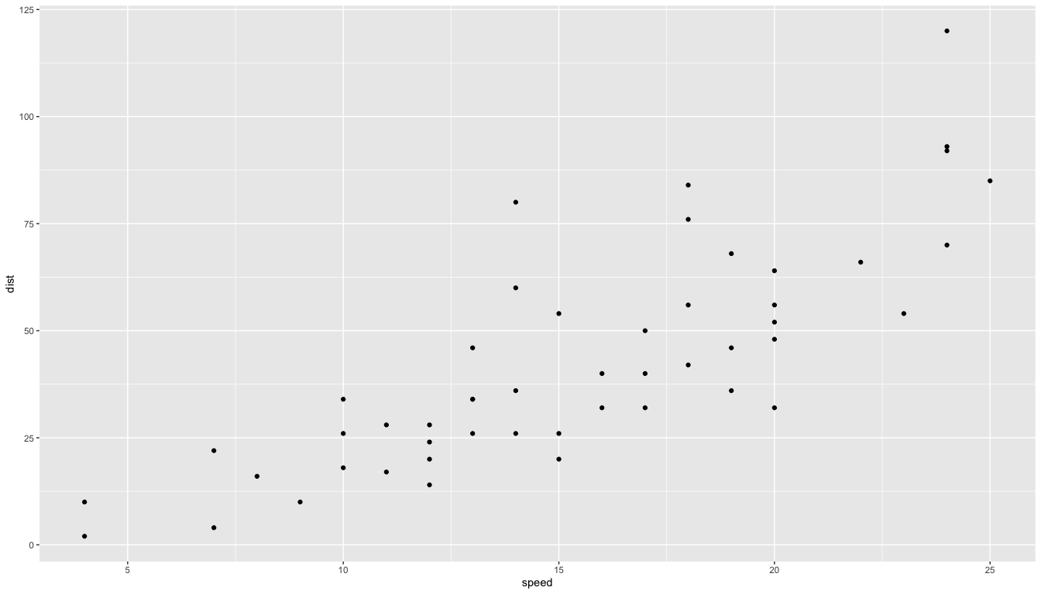

### subsubsection