ACM Hackathon
Team : PEC
MEMBERS :
1. Pritish Thakkar
2. Sahil Khosla

Topic : TIC TAC TOE using socket programming

OS : Ubuntu 16.04

Software / Framework : Netbeans

Language : JAVA

IDEA : When i was learning java i create a simple chatting app using socket programming and i extend that simple chatting app to make this multiplayer game. That’s why my project name is chatting app.

GUI : Whole GUI is created using drag and drop option in Netbeans.

Game Files :
1. HOSTPLAYER.java : This program is for the player who wants to host the game i.e. want to act as a server.
2. CLIENTPLAYER.java : As the name suggests it’s for player who will send a request to host player for connection. This program will ask for ip address for the host player.

HOW TO RUN THE GAME ?

1. Install Netbeans IDE
2. Extract the files from zip folder i’ve uploaded on hackerearth.
3. Open Netbeans.
4. Go to File > Open Project ..
5. Now Locate the folder chat_java-master.

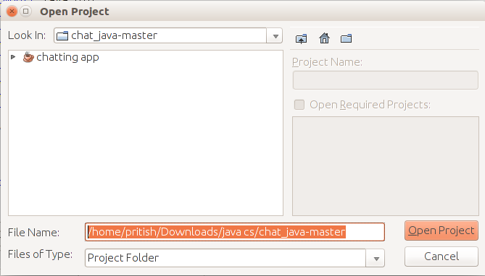
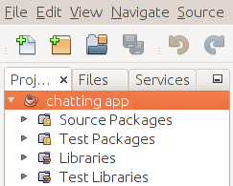
6. Click on chatting app and then open project.
7. And now following packages will be included in Netbeans.
8. Now Click in the following order chatting app > Source Packages > chatting.app
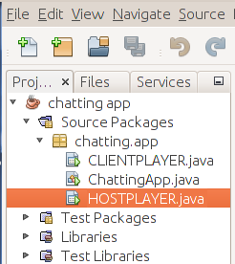

9. Right click on HOSTPLAYER.java and click Run File.

10. Following screen will appear.

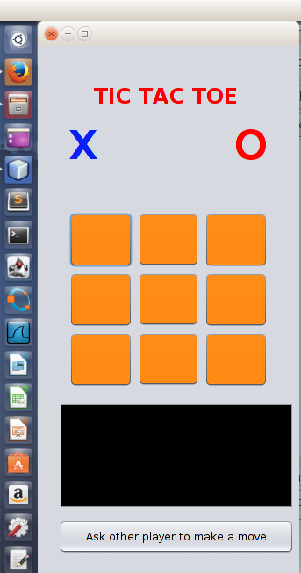

11. Similarly run CLIENTPLAYER.java.

12. Following screen will appear.

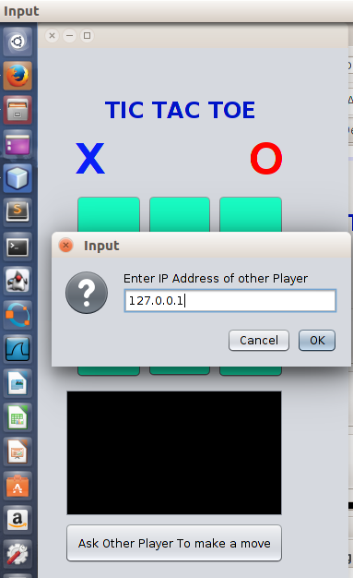

13. As we are running our app on LocalHost so use IP address i used “127.0.0.1”.
14. Now 2 Players can play the game.
15. This is for testing purposes only.
16. If the programms are properly installed on 2 different machines and IP address of HOSTPLAER is known the program will successfully run on 2 different Computers.

SCREENSHOTS AND SOME NOTES :

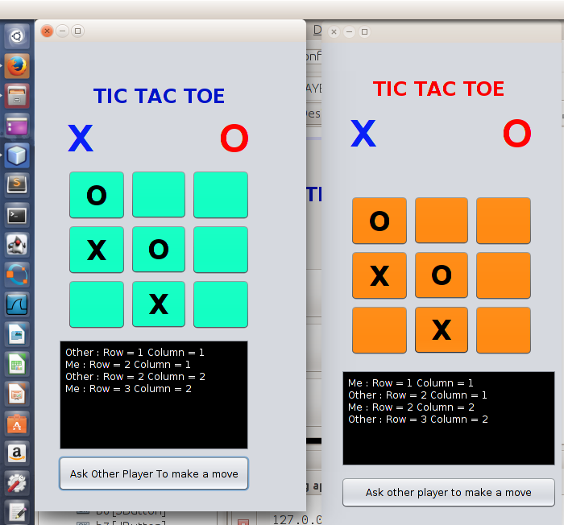

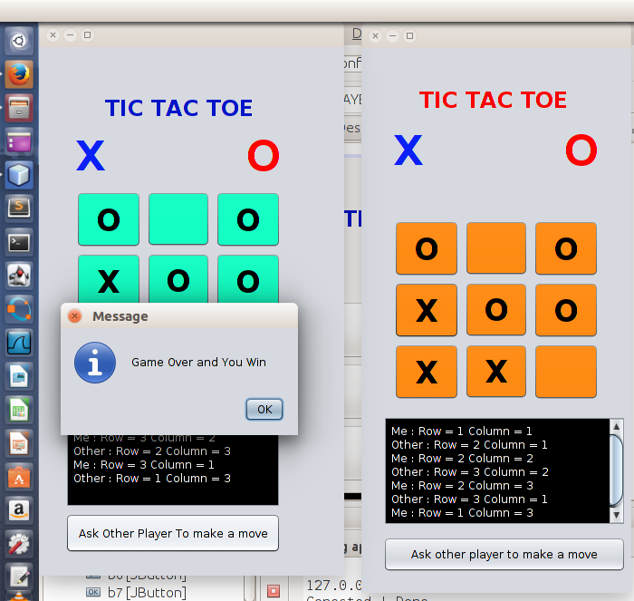

Note :
> In above picture Green player won and orange player lose.
> As soon as the green player click ok, a similar message dialog will get appeared on orange’s player screen :
“GAME OVER AND YOU LOSE”
> This game also tests for TIE and a message dialog will appear “GAME OVER AND MATCH DRAW”
> Port Number we are using is 3000.

“THANK YOU”

